by Glenn N. Holliman
Below, Gary V. Hodges interpreting the common great grandfather of many reading this posting, John Wilcoxson (1720-1782) at the July 2014 Boone, North Carolina Greer-Wilson and Associated Families seminar. In the foreground, left to right are Shirley Sorrell, Connie Burns and Bina Ankers.

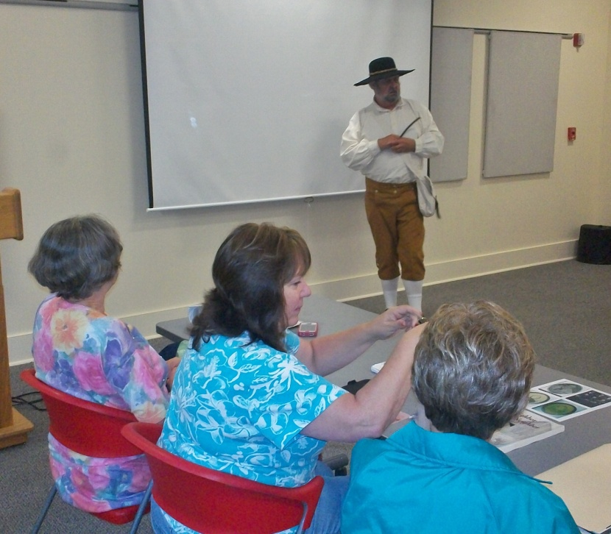
One of the delights of the Internet is to work with distant cousins to 'fine tune' family lineages. Gary V. Hodges of Virginia and I share a common 5th great grandfather, Benjamin Greer (1745-1816). From February to June 2011 in this space I posted a number of articles on Ben's amazing life fighting Native Americans, Tories and British. As he had fifteen children by two wives, he also had to deal with an occasional recalcitrant child, one being my 4th great grandfather, Jesse Greer, Sr, of whom I have written also in this space.
Here is a list of Ben's children which I published in February 2011. Blogs are recorded in chronological order, so if you are interested, return to my previous articles.

"My 5th great grandmother, Nancy Wilcoxson Greer, was born May 17, 1745, and died October 31, 1790, at the age of 45. The children Benjamin and she had were:
Rachel Greer (sometimes spelled Grear) - b 1/16/1770
William Greer - b 1/21, 1772 (Gary Hodges' 4th great grandfather)
Benjamin Greer - b 2/14/1774
Anna Greer - b 4/26/1776
Jesse Greer, Sr. - 11/14/1778 - 9/20/1869 (this writer's generation's 4th great grandfather)
David Greer - 2/2/1781
James Greer - 9/17/1783 (the person whose sons are in question)
Samuel Greer - 11/28/1785
Joshua Greer - 4/8/1788
John Greer - birth date unknown
A Wilkes County marriage bond in the State Archives in Raleigh, NC, dated 4/26/1791 lists Benjamin Greer and Sarah Jones as married. This would be Mrs. Sallie Atkinson Jones, widow of Thomas Jones who died from a Revolutionary War wound. She reared children by both husbands.
By widow Sallie, five children were fathered by Benjamin Greer. They were:
Edmund Greer
Sally Greer
Elizabeth Greer
Mary Polly Greer
Aquilla Greer - b 1797"

Cousin Gary has been assisting other cousins in their search to clarify their blood line to Benjamin Greer through two of his grandsons, Andrew S. and Alexander Greer, sons of James. Gary writes the following of his recent research journey. Perhaps one of our readers can assist?

"The only help I have been able to render so far is obtaining a copy of Benjamin's handwritten will. I had already found an extract of his will so I had a head start. I then contacted Green County, Kentucky and asked if they had records going back that far. I was informed they did not but the older records may have been sent to the state archive for safe keeping.

I called up the Kentucky State Archive and sure enough Green County had sent their old records to them. The records they had for Green County go back to the year before Benjamin's will was filed. I sent off for the will and low and behold they had it. I got a certified copy of the will in the mail a couple of days ago. Took me a couple of days to get up the energy to scan the document and save it to my thumb drive.

Below is the first page of the Will of Benjamin Greer. The cover states it is in fragile condition. At the bottom of this article is the 'translation' of the will from another source. If one would wish the entire copy of the original document, one can email me at gary.hodges1@verizon.net.
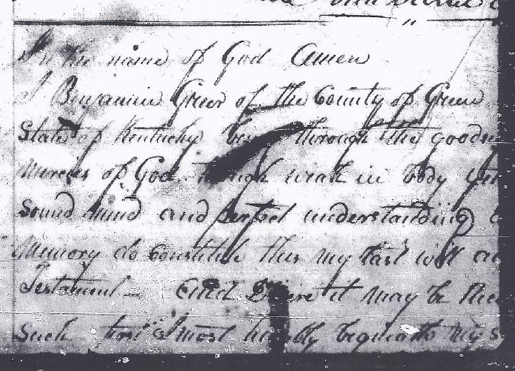

Keep in mind, the Daughters of the American Revolution and Sons of the American Revolution do not always accept a transcript of a will without a copy of the original document.

So, I am still at an impasse trying to document the blood line of James Greer's two sons Andrew S. and Alexander. Ben's will lists James as a son of Benjamin, but I cannot find a will for James.

Benjamin's will does help me with my War of 1812 research. It proves John Greer was a son of Benjamin and brother of my distant great grandfather, William Greer. John Greer was a member of the Militia and served in the War of 1812.

Unlike the SAR and DAR, the Society of the War of 1812 allows men to join through co-lateral ancestors (for example multi-great uncles). I now have documentation for our one Greer family member who served and two Wilcoxson brothers who also served. There were three Wilcoxson brothers but I can not find documentation to prove one of them. I did find records to prove all four of these uncles did serve in the North Carolina Militia in the War of 1812.

Here is that transcription of the Will of Benjamin Greer from 1816:

"In the name of God, Amen. I, Benjamin Greer, of the County of Green, State of Kentucky, being through the goodness and mercies of God though weak in body, yet of a sound mind and perfect understanding and memory, do constitute this my last will and testament and desire it may be recorded as such. I most humbly bequeath my soul to God who gave it, beseeching ... (page was torn and taped at this point and part missing) ... and my body buried like seed in the ground, not to be lost, but here buried to remain till the morning of the Resurrection through Jesus Christ our Lord. As to my burial, I do desire to be interred, at the discretion of my Executors, thereafter named, who, I doubt not will arrange it with prudence.

As to my worldly estate, I will, and positively order that all my debts be paid. First, I do bequeath to my two youngest sons namely Aquilla and Edmond Greer, the two tracts of land I now live on to be equally divided between them: and the rest of my estate to be equally divided between my three daughters: namely Sally, Elizabeth and Polly Greer; but my wife, Sarah Greer, to hold the same in her hands during live; but the said children to have their equal part as they become of age or marry. At the discretion of my Executors to which I do appoint my wife Sarah Greer, Aquilla Greer and Robert Erwin, and do constitute the executors of this my last will and testament and trustees for my wife and children.

In witness whereof I have hereunto set my hand and seal this twenty first day of February in the year of our Lord one thousand Eight hundred and sixteen. N. B. and I do will that all my other children namely, John, Rachel, William, Benjamin, Ann, Jesse, David, Samuel, Joshua and James have one dollar each out of my estate. Signed Benjamin (X) Greer, witnesses: Benjamin Bayly, Christopher Hinker, James (X) Lile" (Green County, Kentucky Will Records.)
Hopefully someone reading this may be able to identify the children of James Greer (b 1783), and help some other cousins finalize their lineages. I found the Ben Greer will but have hit a brick wall with some of the next generation." - Gary V. Hodges

Gary Hodges | 9:58am Jan 5
The only accounts of Ben being at the BKM are family stories. The Wilkes Militia muster rolls for BKM have disappeared if they ever existed.
One BKM researcher listed Ben being there but she admitted that was through inference only. Ben was a Captain in the Wilkes Militia under Colonel Benjamin Cleveland. Since Cleveland and the Wilkes Militia participated in the battle Ben was probably there.
There is a society of decendants of BKM participants and I contacted them a few years ago. They are supposed to be the authority on this subject. They told me about the one list Ben is on and why. Unless a contemporary list is discovered with Ben on it we can only say he was probably there.
I have positive proof Benjamin Greer was a Captain. It comes from the RW Pension application of Amos Church. I have a copy of the written application that is in the National Archive and a transcript of the application. Amos said he served under Captain Benjamin Greer and specifies the action. I keep my fingers crossed and hunt when I can.

