Excerts from the Bible of Isaac Greer 1822-1864)

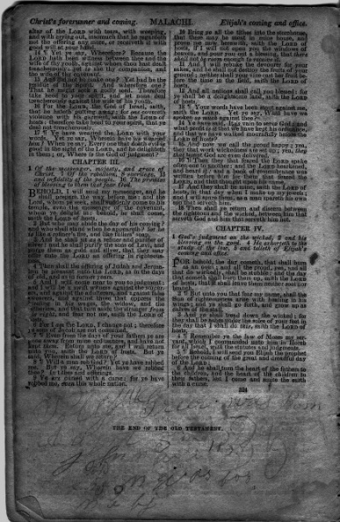
Excert from above. Believe writing reports 'Polly Greer was born??? John ????"
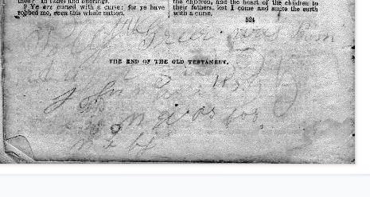

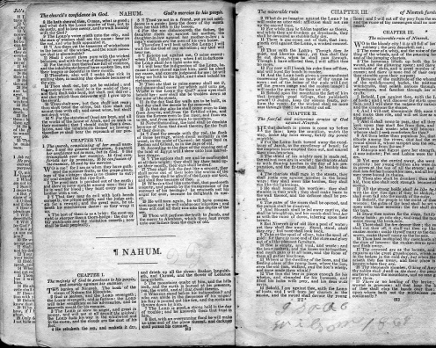
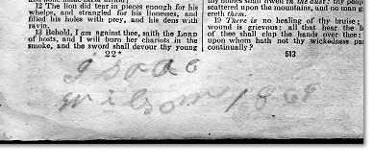Exert evidently states 'Isaac Wilson 1864' the year of his death.

