1919 Wilson Reunion in Wilson Cove, Sutherland, North Carolina
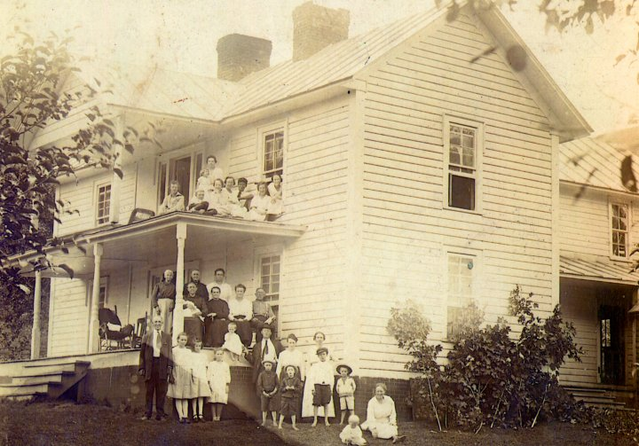
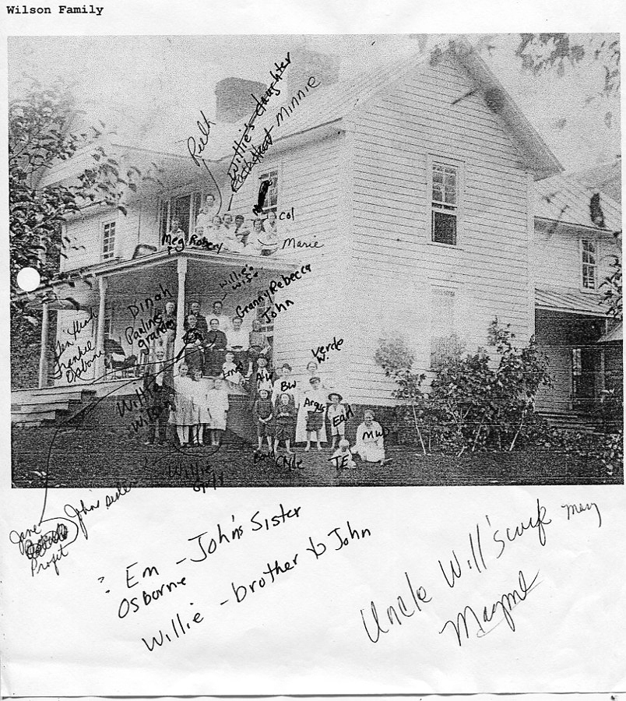

Commentary on the reunion by Bishop Osborne, grandson of Isaac and Caroline Greer Wilson and son of George W. and Frances Wilson Osborne.
