by Glenn N. Holliman

Thanks once more to Shirley Sorrell for making available these photographs from 1935 of the John and Rebecca Wilson family reunion in Sutherland, North Carolina. Shirley has identified the ten surviving children. John Wilson, born 1855, died in 1928.

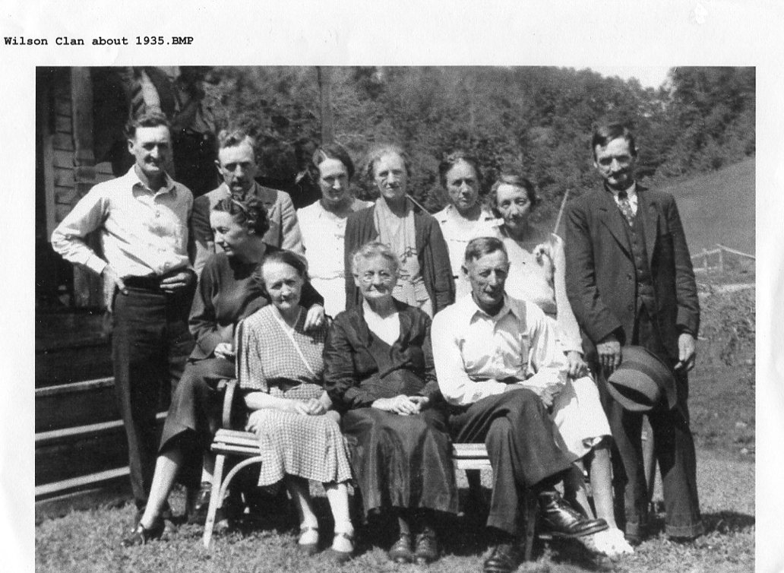
Front row: Ruth Wilson Hurt (1903-1999) , Bessie Wilson Wilson (1887-1976), Rebecca Wilson Wilson (1862-1954), and Conley Wilson (1882-1957). Back row: Preston (1900-1989), Robert (1906-1987), Cal (1898-1999) , Margaret (1894-1992), Mayme (1892-1975), Minnie (1896-1987) and Don (1890-1975).

Four children died in infancy or childhood - Nora (1881-1887), Edgar (1883-1885), Boyd (1885) and Nancy (1912).

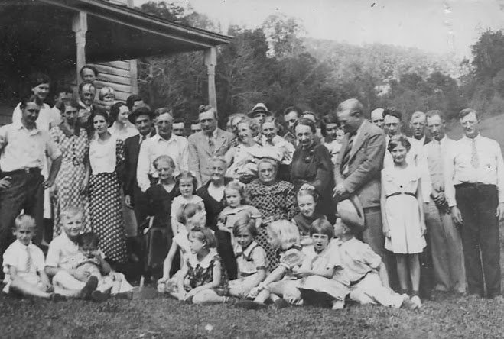

Above, from the same reunion, we have this picture of several generations, and according to Shirley, a few unidentified friends who were present for the occasion. Can one of our cousins take a stab at perhaps numbering the persons and then listing names known or unknown?

Below also from 1935 is another John and Rebecca descendant's reunion picture. Their names are listed on the back of the picture. Any changes?
