FORRESTER-WILSON FAMILY TOUR 2015

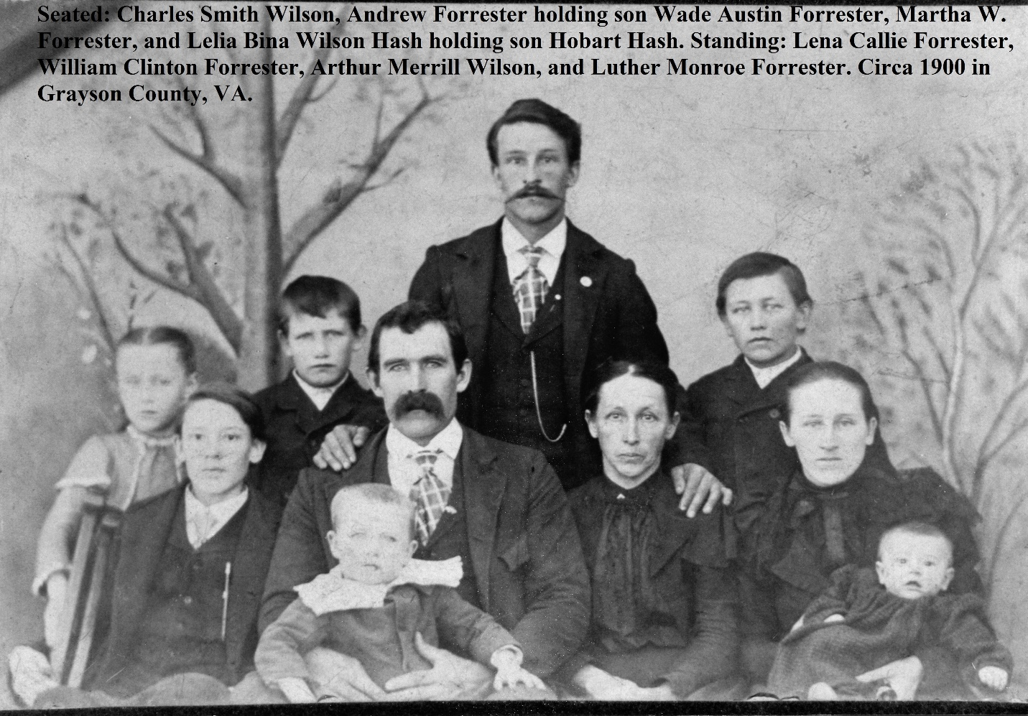

On Saturday morning, May 23, 2015, nine descendants of Martha Wilson Forrester and one descendant of John Wilburn Wilson gathered in the Pine Branch Community of Grayson County, Virginia. They toured the former property of Martha Wilson Forrester (1857-1904) and her husband Andrew Johnson Forrester (1866-1938). Martha Evaline Wilson Forrester was the fifth child and last daughter of Isaac Wilson (1822-1864) and Caroline Nancy Greer Wilson (1828-1911) of Wilson Branch, Ashe County, NC. In 1898, Andrew and Martha and four of their children traveled by covered wagon to Grayson County, Virginia to make their new home. At this writing, we are not certain why they moved away, but two of Martha’s adult children lived in the Pine Branch Community on Kendrick Mountain and that is where they built their new home.
As they built a new home, it was necessary to plant an apple orchard and a maple tree to provide apples for desserts and syrup to sweeten their stack cakes. Martha’s sister Jane used a slight bit of molasses or maple syrup to sweeten her cornbread, so the Forresters may have done the same. Their Grandma Frankie Greer also grew a maple to provide syrup. Hurricane Hugo in 1986 destroyed all but a few of the apple trees in the original orchard and a maple still exists to this day.
On the Forrester farm was a barn for the horses and other outbuildings such as a corncrib. The barn no longer stands, but some of the other outbuildings do.

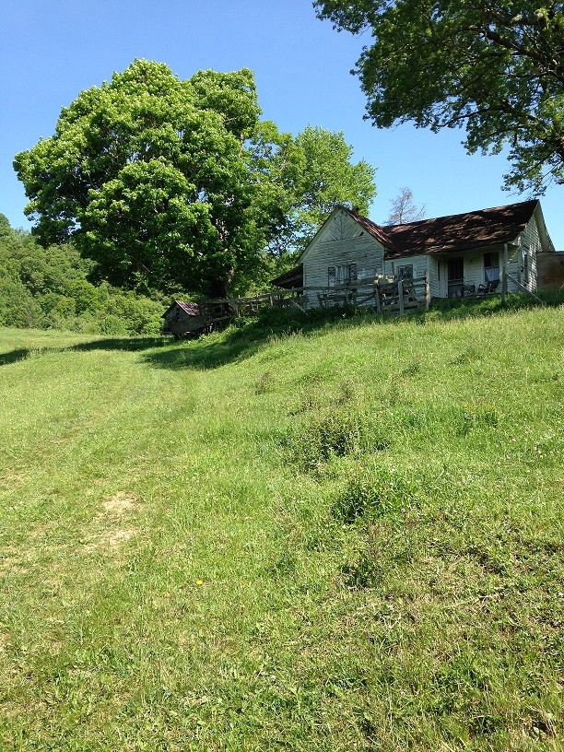
Home of the Forrester Family built circa 1898

The tour began early in the morning at Mouth of Wilson. Ten Wilson descendants drove on to the Pine Branch Community that began at the Roger Cole Family Farm.
Our gracious hosts, Mr. and Mrs. Roger Cole took us up to the former Forrester farm that is still a part of their land. We went inside the house and toured the inside and tried to imagine the Forresters living inside of the various rooms.
Immediately after we took a family photo in front of the house, we drove on to see the cemetery where Martha and her daughter Lelia Wilson Hash are buried, as well as Martha’s youngest daughter, Callie Forrester Anderson. After we explored the cemetery, we went to tour the inside of the present Pine Branch Baptist Church where we discovered a pew with a memorial plaque dedicated to Lee and Lelia Wilson Hash.
Before we left the Cole Farm, Mrs. Cole presented this author with several jars of homemade apple butter made from the Forrester apple tree. Each Wilson descendant took home a jar of apple butter.
The tour ended at Ciro’s Restaurant in Independence where two more family members met this group for lunch. All family members had a great time and discussed getting together again in the near future.

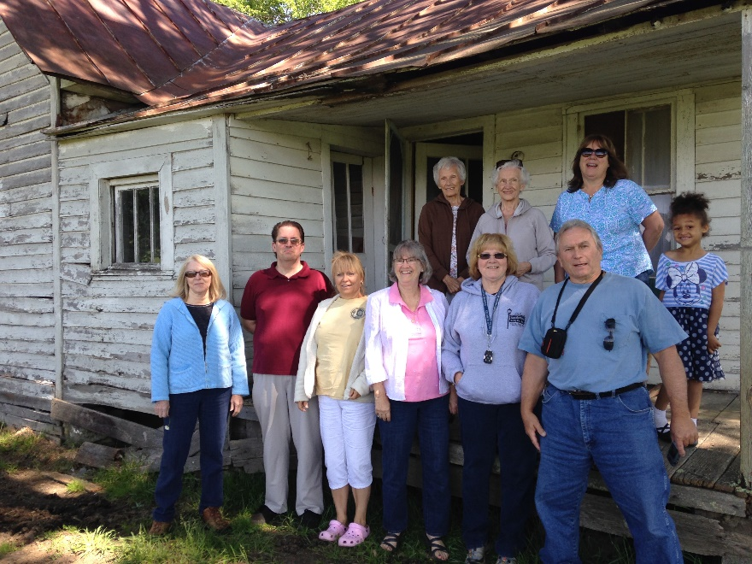
Back: Bina Gray, Betty Ankers, Connie Burns, Alexis Lilly. Front: Sandy Gentry, Clinton Getzinger, Phyllis Watt, Shirley Sorrell, Vickie Stamper, Phillip Marcus

