ACKNOWLEDGEMENTS
In my search for Holliman family roots, I stand on the shoulders of many. At the risk of leaving out persons, I salute the work of the late Cecil Rhodes Holliman, a son of James Monroe Holliman, and his son, Dr. Rhodes Holliman. Second cousins Glenda Norris, Ron Holliman and Bobby Prince have been exploring and collecting information for decades. More distant Holliman cousins such the late George A. Holleman, the late Walter O. Holliman, Maxine Wright, Joe Parker, Jeanette Stewart, Tina Peddie and others deserved a bucket of thanks for their earlier work.
In the United Kingdom, I have been greatly assisted by the research of Bob Hollyman-Mawson of Wales, who has compiled an awesome directory of Holliman names. Fred Cooper, whose mother-in-law in Bristol, England was a Hollyman, has researched over 400 years of Somerset Hollymans and has shared his massive material with me.
The various shire archives in England have revealed abundance of original source material and in this venture. I have been encouraged by genealogist Peter Smith of Bedfordshire.
It is an awesome feeling to hold in one’s hands a paper signed by a distant English ancestor in the early 1500s, half a millennium ago! Below are Holyman wills and signatures from the 1520s in the Buckinghamshire Archives, England. Photo by Glenn Holliman 2012.
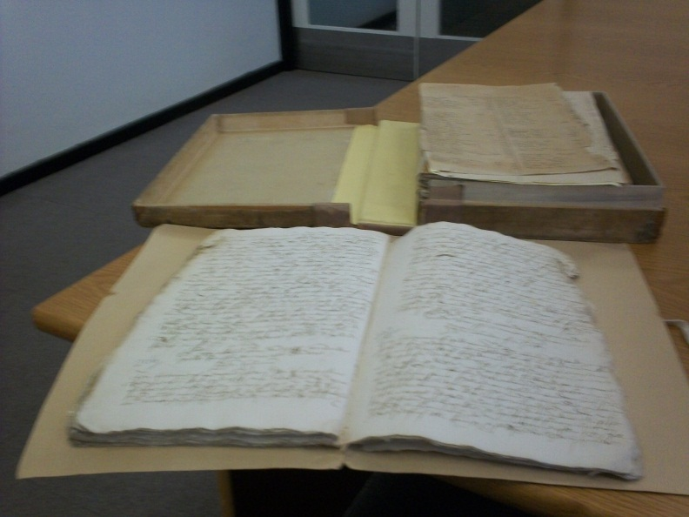
For 20th Century Hollimans, in personal visits, many first cousins to date have made available photos and letters. These persons to date are Mary and E.C. Herrin, Patti Holliman Hairston, Charles H. Ferrell, John Melton Ferrell, Carolyn Ferrell Tatum, Tommie Holliman Allen, Jean Holliman, Joel and Ann Holliman Phillips, Robert Daly, Jr., Susan Cornelius Williams and Carol Cornelius Morton. Linda Bradley and Clayton Herrin have encouraged and assisted me. My Uncle Ralph Holliman took me into his home and shared memories and photos. I hope eventually to visit all my cousins, copy their memorabilia, record their memories and make all available to the enlarging family.
Of course, my own father, Bishop Holliman, born 1919, continues to be a foundation of nostalgia, memoirs and memories. It is a wonder to share his reflections on the Great Depression and World War II with succeeding generations. My two sisters, Rebecca Holliman Payne and Alice Holliman Murphy, have encouraged my writings and assisted in collecting photographs. My children, Grace (who taught me how to blog) and Chris, patiently have listened often to their father’s latest enthusiastic sharing of family history. My wife, Barbara, has been long suffering in my history obsessions.
“The paternal fore bearer of the Holliman name came from England in the mid-1600s. Therefore, we American Hollimans share in the complexity of our British heritage. We are composed of Neolithic, Celtic, Roman, Angle, Saxon, Jute, Danish, Viking and French Norman DNA.
Mix this together, stir for several thousand years and one becomes British. Sail to the New World, add yet more cultures and races, plus several hundred additional years and one becomes an American.” – Glenn N. Holliman 2012
THE PATERNAL FAMILY TREE OF
THE ULYSS S. HOLLIMAN FAMILY

Richard Holyman (unproven), Cuddington, Buckinghamshire, England

Thomas Holyman (1500 ca - 1558), Cuddington, Buckinghamshire, England
Possible Son of Richard

Christopher Holyman ( - 1588), Sherington, Buckinghamshire, England
Son of Thomas

Thomas Holyman (1580 ca - ), Bedford, Bedfordshire, England
Son of Christopher

Christopher Holyman Sr. (1618 - 1691), Isle of Wight County, Virginia
Son of Thomas

Richard Holliman (1660 ca - 1711), Surry County, Virginia
Son of Christopher

Samuel Holliman (1709 - 1789), Johnston County, North Carolina
Son of Richard

James Grantson Holliman (1750 - 1836), Lancaster County, South Carolina
Son of Samuel

Cornelius Holliman (1792 - 1862), Fayette County, Alabama
Son of James Grantson

Uriah Holliman (1817 - 1862), Fayette County, Alabama
Son of Cornelius

John Thomas Holliman (1844 - 1930), Fayette, Alabama
Son of Uriah

Ulysses Selman Holliman (1884 - 1965), Irondale, Alabama
Son of John Thomas
Married to Pearl Elmer Caine (1887-1955), Irondale, Alabama

Seven Children: Melton, Vena, Euhal, Loudelle, Bishop, Virginia and Ralph
19 Grandchildren

The Hollimans are English
The name Holliman (or Holyman, Hollyman, Holleman, Holloman, etc) is English. While possibly of London origin after surnames began to be used extensively in the 13th Century, persons with the name of Holyman could be found by the 1400s and 1500s in records in Nottinghamshire, Worcestershire, Hertfordshire and Buckinghamshire.
The first Holyman name to appear in history from which I believe we are descended was one Richard Holiman, a member of Parliament from Buckinghamshire in 1386 during the reign of Richard II. That was the decade in which Chaucer wrote Canterbury Tales who also joined Parliament that session with Richard. Our Parliamentarian ancestor was from Chipping Wycomb, now called High Wycomb. The city is located at an M-40 exit, a 20th Century super highway that connects London with Birmingham.
The map below shows Cuddington, Buckinghamshire, United Kingdom circled in black. The M-40, which runs south of the village, carries traffic from Birmingham (to the north) to London (to the southeast). The Buckinghamshire Archives is located just east of Cuddington in Aylesbury. High Wycomb is located in the bottom right corner, uncircled, approximately 15 miles from Cuddington where, if my thesis is correct, our branch of the Holymans lived by the 1400s.
.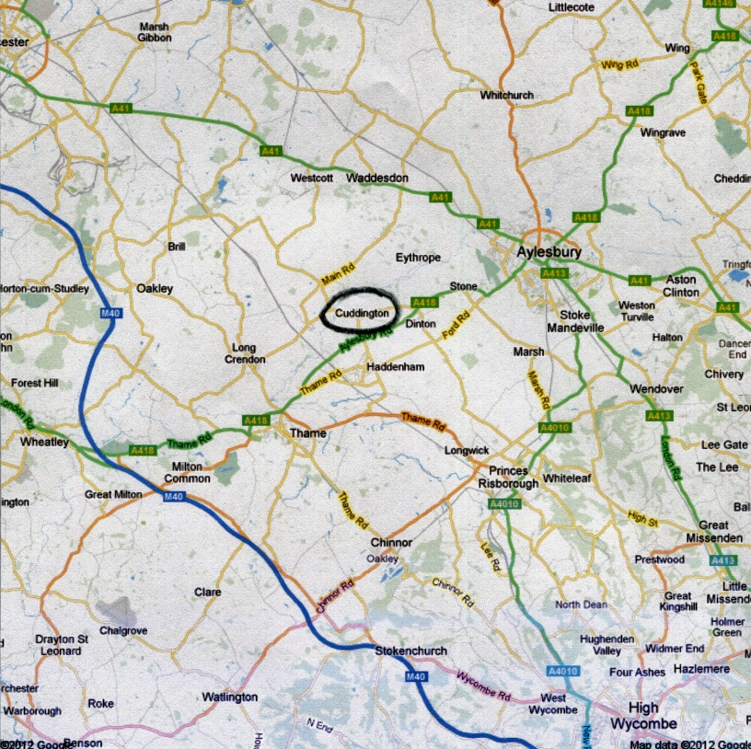
The next Holyman so far discovered pops up several generations later in 1444. His name is William, also of Cuddington, Buckinghamshire, obviously a descendant of Richard’s family. In that generation, the Kingdom was experiencing difficult times. Attempts by King Henry V and others, after his premature death, to incorporate France into the realm of England were floundering. The French Maid of Orleans was leading a counter-attack against English influence, armies and territory on the continent.
An English child king, regency intrigues, royal mental illness and rapacious appetite for family power were realities leading England into the generational strife known as the War of the Roses. Two extended factions, one Yorkish and one Lancastrian, were fighting for royal power. The conflict ended after thirty years in 1485 when the young Tudor King Henry VII defeated Richard III at Bosworth Field. This founder of the Tudor line successfully passed along royal power to a series of dynamic offspring in the 16th Century.
Somehow during this long English civil war of the middle to late 1400s, the Holyman family maintained its wealth and influence in a small manor located on the western edge of Cuddington, Buckinghamshire. These are our ancestors, the Holymans.
Popular Internet genealogical sites have stated that the village Tring, Hertfordshire, approximately 45 miles northwest of London, is our ancestral home. My research the past two years tweaks this thesis and moves us ten or so miles to the west. We have a record of William Holyman (mentioned earlier) of Cuddington, Buckinghamshire being involved in a court case concerning trespass.2
A visit to the village of Cuddington in 2010, still less than 1,000 in population, uncovered a wealth of information. The remains of manor farm on the western edge of Cuddington are known to this day as The Holyman Farm. Below a grazing field occupies the site of the former Holyman Manor House, long since decayed.3
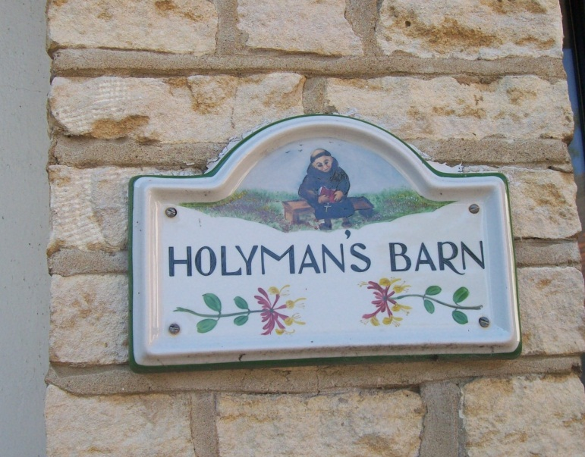This sign is on the renovated mews of the Holyman Farm in Cuddington, Buckinghamshire, England. The monk represents The Rt. Rev. John Holyman (1495-1558) who was a Roman Catholic brother before becoming Bishop of Bristol, England, 1554-1558. Photos by Barbara Holliman, 2010.
I am the first to admit that more research is required, but after a search of four shire archives, several English libraries and personal interviews, the following scenario emerges.
These first Holymans, possibly from London, were on the rise economically and socially. Richard Holyman has been a member of Parliament. William Holyman was not sued for trespass unless he had something for which to be sued, i.e. real property or otherwise. Nor was one selected to serve on a jury unless one was a respected man and of property. William in the summer of 1444 was in court twice, once as a defendant (which must have been settled in his favor) and shortly thereafter he served on a jury to oversee another legal matter.
What happened to the family between this date and our next listing of Holymans, I have not yet fully explored. The family was no doubt multiplying as several Holyman branches in Cuddington are recorded at the beginning the 16th Century.
We do know that in 1495, one John Holyman was born in Cuddington, and grew up to be the second Bishop of Bristol, England.4 This is the century of which most Americans know more about than any other thanks to the Tudor monarchs of Henry VIII, ‘Bloody Mary’ and Elizabeth I.
Our priest ancestor, John Holyman, was appointed a bishop during the reign of Queen Mary Tudor who attempted to restore the Roman Catholic Church in her brief reign of seven years. To this end, between 1554 and 1558 (both Queen and Bishop died that year), Bishop John Holyman in his diocese allowed five Protestants to be burned at the stake for failure to recant their radical beliefs.
Being a celibate priest, this John is not the direct father of our line, but is an uncle or cousin. Is John the brother of one Thomas Holyman of Cuddington (who appears to be a son and grandson of two earlier Richard Holymans) whose will states he also died in 1558, leaving some of his estate to his second son, Christopher Holyman?
This Christopher (observe how the names alternate) died in 1588 in Cuddington but the will was probated in Sherington, Buckinghamshire, a parish town approximately 25 miles north of Cuddington and 12 miles west of Bedford, Bedfordshire. Christopher did own property in Sherington and was an influential lay leader in his Anglican parish.5
The map below shows London in relationship to Bedford, Bedfordshire. The northern X is the location of Sherington. The southern X marks the community of Cuddington.
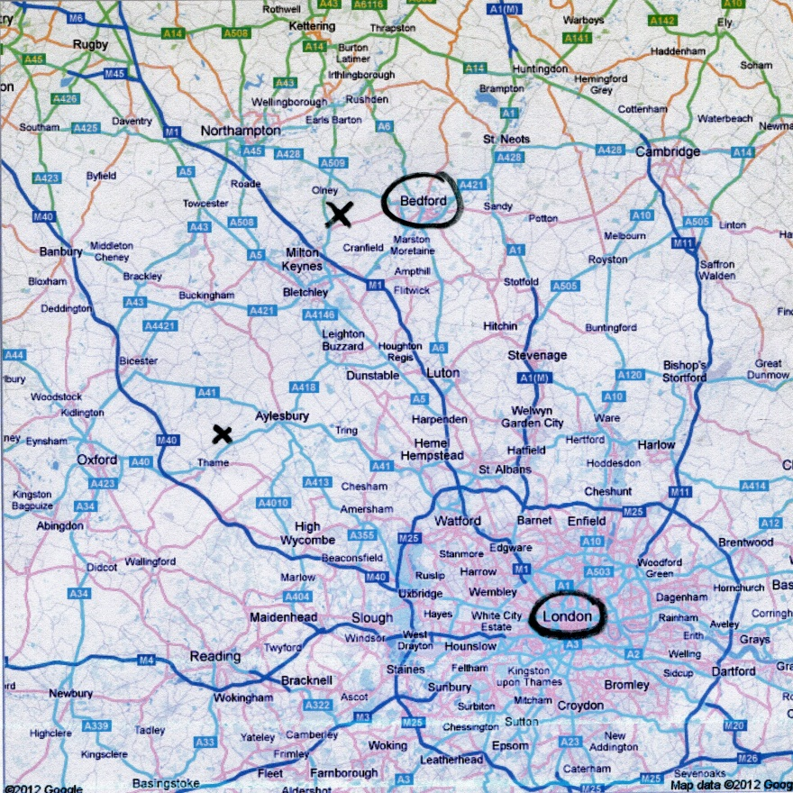
The 1589 Christopher, whose Sherington life is recorded in several places left some property to his second son, Thomas Holyman, who also is listed in several records in Sherington.
My thesis is this Thomas married a Heleana Poynard (spelled several ways) in Bedford in 1609. Bedford is a market town only a dozen miles from Sherington by road and an obvious location for a second son to seek his fortune. I have found no Thomas Holyman or any Holyman living in Bedford prior to our Thomas.6
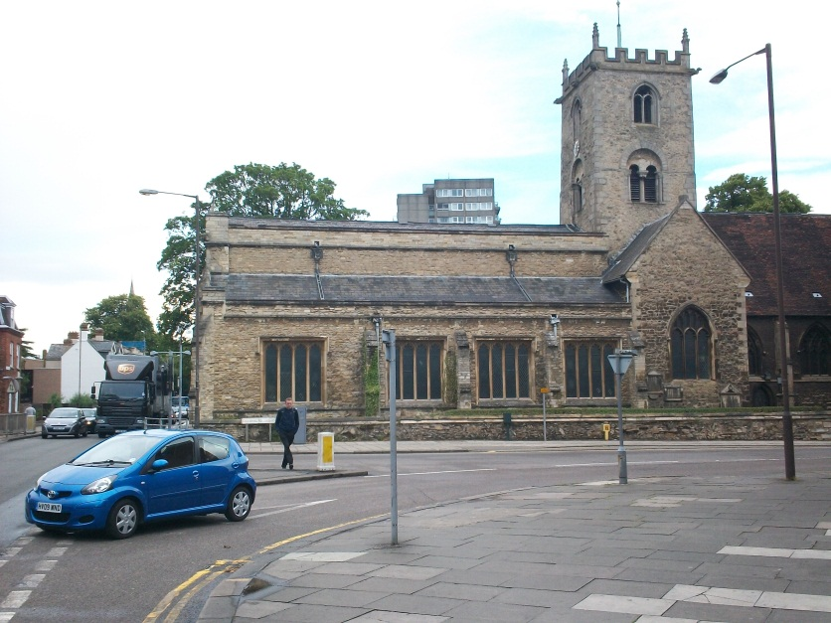
Above near the Ouse River in Bedford, Bedfordshire stands the old parish church of St. Mary’s. Christopher, Judith and other children of Thomas and Heleana (Eleanor in some places) Holyman were baptized here. Photo by Glenn Holliman, an 8th great grandson in 2011.
Thomas and Eleanor’s second son was named Christopher and born in 1618. In my opinion this is the Christopher Holyman (1618-1691) who arrived in Jamestown, Virginia in 1650 with his sister, Judith, born 1621, also in Bedford and baptized at St. Mary’s parish astride the Ouse River.
Generally speaking, second sons did not inherit very much in the way of real property. After a few generations, our soon-to-be American Christopher must have had significant economic reasons for migrating to Virginia. A second major reason might have been another English Civil War.

After Elizabeth I died in 1603, the Stuarts of Scotland came to the throne. Shakespeare wrote MacBeth and King James Stuart insured a modern version of the Bible was properly translated into English. Unfortunately, after the death of James I, his son, Charles I, proceeded in arrogant ways to antagonize Parliament. Who had the power to tax and rule? The House of Commons or a kingship encased in Divine Right theory?
In the 1640s, a civil war broke out, Charles eventually lost his head and Oliver Cromwell came to rule the English Commonwealth. Within a year of King Charles’ death, Christopher and Judith Holyman migrated to Virginia.

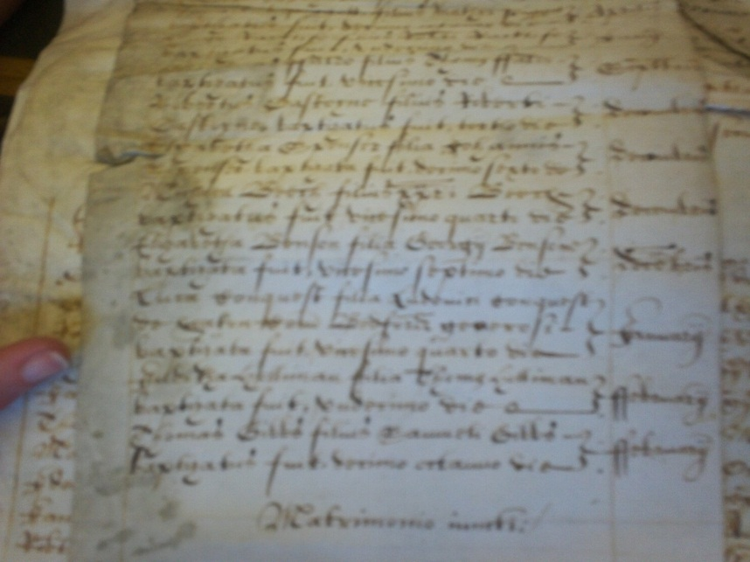
Above, the actual transcripts from the Church of England’s Bedfordshire Diocesan records from 1618 listing the birth of Christopher Holyman, founder of the American Holliman family. – Photo taken by Glenn N. Holliman, Bedford, England 2011

Holymans in Colonial Times
Why the migration? Probably for lack of economic opportunities in an England recovering from war and still at war in Ireland. Christopher, the second son of a second son of a third son, needed to make a living. A few other Holymans, at least one a distant cousin, were already in North America, and perhaps knowledge of their passage enticed our great-grandfather to move.
One distant cousin, Ezekiel Holyman, descended from the Cuddington Holymans, had been living in New England since the early 1630s. Ezekiel baptized Roger Williams, founder of Rhode Island, and helped found the American Baptist Church. His great-great uncle The Rt. John Holyman, must have turned in his Roman Catholic grave (which is located in Long Hanborough, Oxfordshire).7
Another Holyman, John, was living in Virginia where he died and left a will, two weeks before our Christopher arrived in 1650. Perhaps John was a Sherington or Cuddington Holyman? He was not a brother of Christopher as a brother named John elected to remain in Bedford and begin his own family (so parish records reveal). This John left no family. Another young man coming of age in Bedford at this time was John Bunyan, a Puritan Protestant who wrote Pilgrim’s Progress.
In May of 1650, our Christopher, my generation’s 7th great-grandfather, stepped ashore in Jamestown, Virginia. Perhaps 20,000 or so English persons then lived in the Virginia colony which had barely survived starving times, disease and numerous Indian attacks since its 1607 founding.8
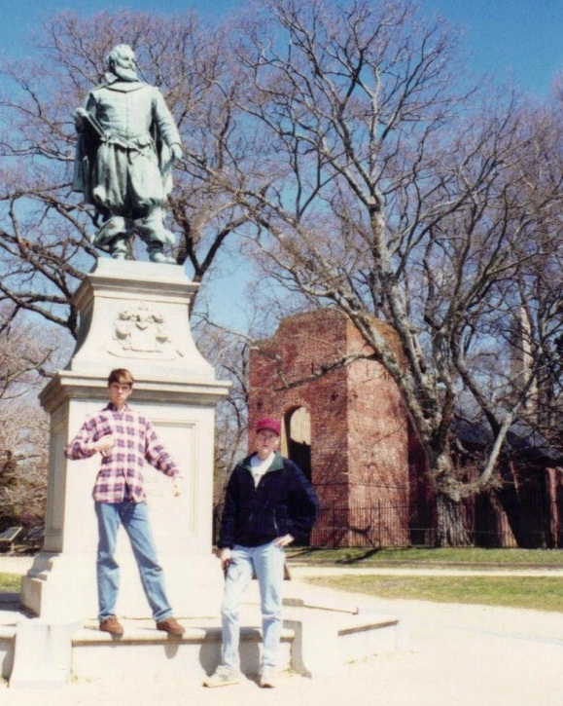
Right, Christopher S. Holliman, born 1978, along with Bryan D. Payne, born 1977, in 1993 visit Jamestown, Virginia where their 8th great grandfather, Christopher Holyman, stepped ashore in May 1650. Standing in front of a statue in tribute to Captain John Smith, one can see behind the young men, the brick ruins of the Anglican Church in which the first Christopher Holyman probably worshipped giving thanks for safe passage across the dangerous North Atlantic.

The Virginia map below shows Jamestown, Smithfield and X marks the spot of the Christopher Holyman, Sr. plantation where Hollemans live to this day.
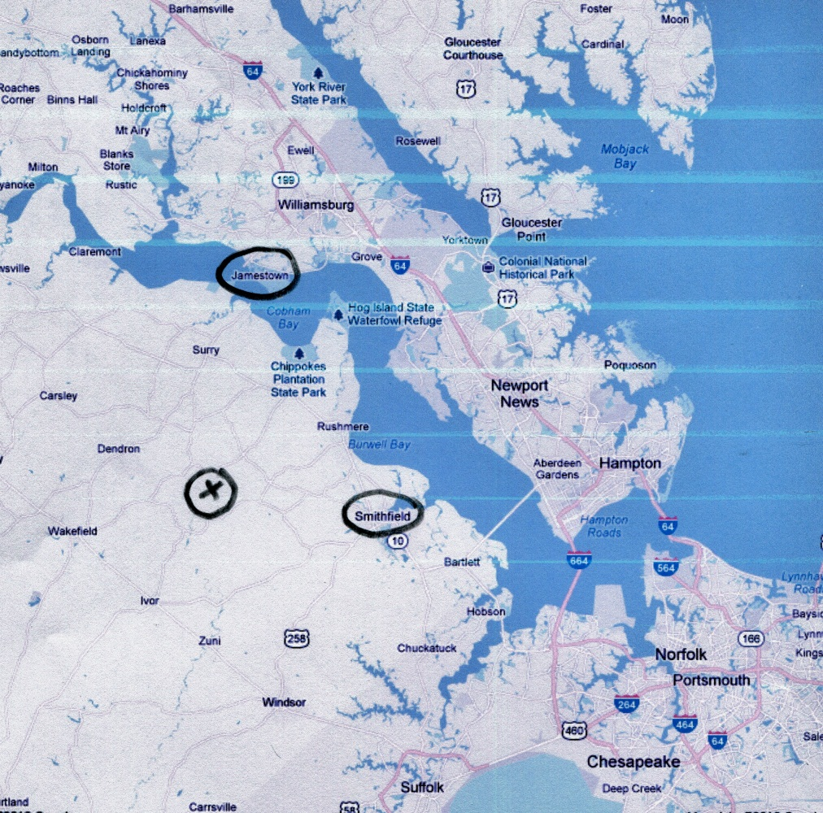
We know by 1661, Christopher purchased land across the James River in Isle of Wight, County along the Pagan and Cypress Rivers in what is today the town of Smithfield. A wife, Anne, co-signed the deed. Her last name is lost to history.
The second wife was named Mary Gray. Anne and Christopher did have six children, four boys and two girls. Christopher did well owning 1,020 acres when he died in 1691 on his plantation along the Blackwater River and swamps. Our first American ancestor lived out the American dream of economic prosperity!
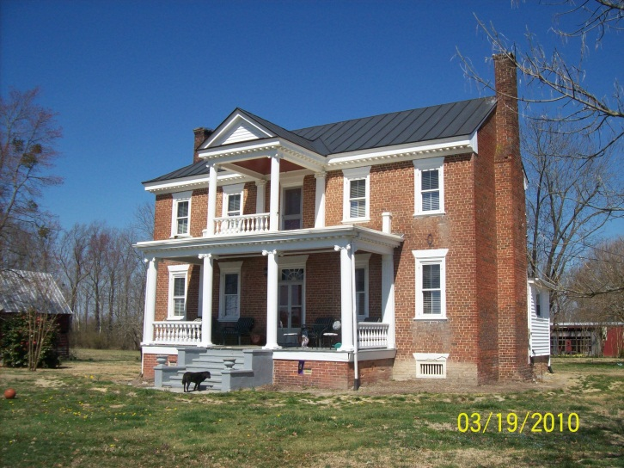
Built in the early 1830s, this Federal period home named the Holleman House, stands on the site of the original plantation of Christopher Holyman who died in 1691. The first Holyman would have lived in a log house, long since decayed. A family cemetery stands 50 yards from the present house and may be the burial place of Christopher. Hollemans have lived continuously at this location since the 1680s in Isle of Wight, Virginia, bordering Surry County and the Blackwater River. Photo by Glenn N. Holliman.
One of the sons was named Richard Holliman (the spelling begins to change and is recorded in various forms with ‘y’,‘e’ and ‘o’). Richard (1660 ca – 1711) must have been something of a scamp. He seems to have imported immigrants and inflated the numbers in order to secure more acres under the ‘head right’ system. For every person he ‘imported’ to Virginia, one received 50 acres outright. By the early 1700s, bordering his family’s property he owed over 1,000 acres.9
Richard took up with a widow in the late 1690s, Margaret Jordan House, and managed to get her pregnant without benefit of marriage. She was forced in court to admit to ‘fornication’ and name Richard as the father. They did marry, other children came, one being a Samuel Holliman (1707-1789). Richard died in 1711, leaving 4 year old Samuel and other children without a father.10

From Virginia to North Carolina
It is said North Carolina is the only state of the original 13 that never had a birth day. The Tar Heel colony gradually spun off from South Carolina as the 1700s progressed. South Carolina had been founded in the 1680s by some English gentlemen, one named Granville whose ancestors held on to his grant until the America Revolution.
Native Americans in the Carolinas took umbrage to European Americans encroaching on their hunting lands and disturbing their village plantings of corn and beans. In the 1710s, the Tuscarora tribe in north eastern North Carolina migrated to the New York colony after being violently routed by the Carolina militia. With the exception of the Cherokee occupation in the western part of North Carolina, nestled in the foothills and mountains, the colony was open to settlement. Virginians, including Hollimans, began to move south.
Southern colonial farmers did not fertilize and strengthen exhausted farm soil. And soil depleted rapidly with tobacco farming. Three seasons and the land needed decades to recover. Rather than spend time and energy on maintaining the richness of the earth, early settlers with growing families found it easier just to pull up stakes and move south or west from Virginia.
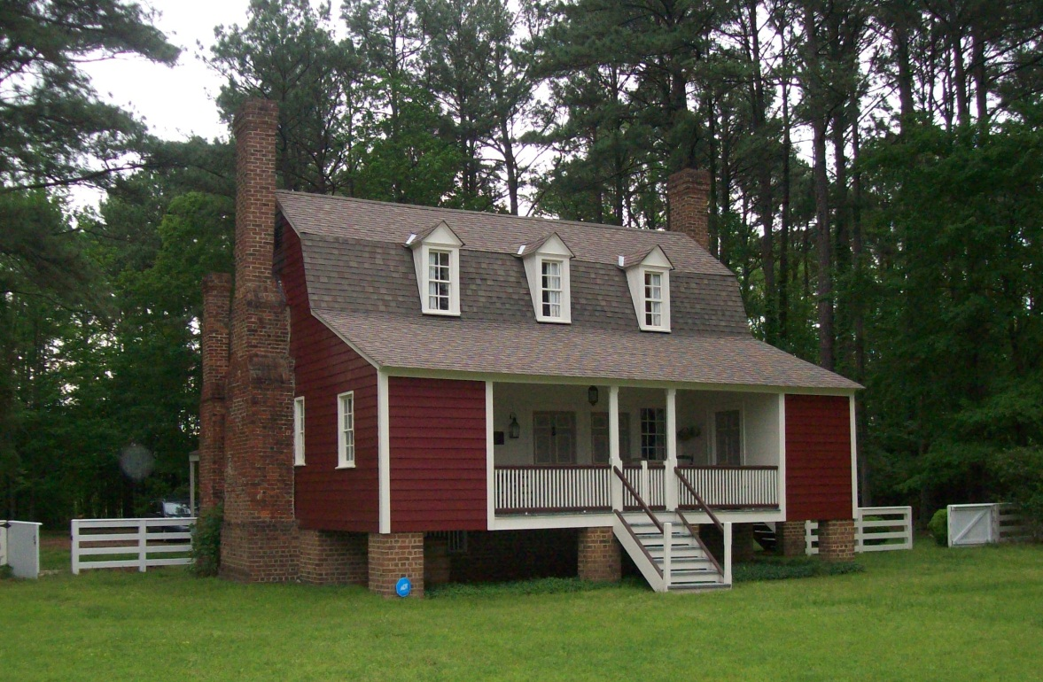
The Samuel Holliman house, built in 1742, has been restored numerous times, and remains one of the oldest habitable homes in eastern North Carolina. Photo 2011 by Glenn N. Holliman, a 5th great grandson.
By 1742, Samuel Holliman lived in Edgecombe County, North Carolina and did well enough to build a substantial wooden cabin near Rocky Mount. So well-built that after many do-overs, it still stands and is a local historical structure. Samuel continued to move around a bit and eventually settled on the Neuse River in Johnston County, North Carolina, not far west of I-95 which dissects the eastern part of the state in the 21st Century. Samuel’s wife’s name was Elizabeth Jones. They had plenty of children. One boy born in 1750 along the New River was James Grantson Holliman (1750-1836), my 4th great-grandfather.11
Below on the map Battleboro, just above Rocky Mount, North Carolina, is the location of the Samuel Holliman’s 1742 home. Circled further south is Smithfield, North Carolina, the area where James Grantson Holliman was born in 1750. His home until the 1790s was near his father’s, probably closer to Clayton, half way between Raleigh and Smithfield, North Carolina.
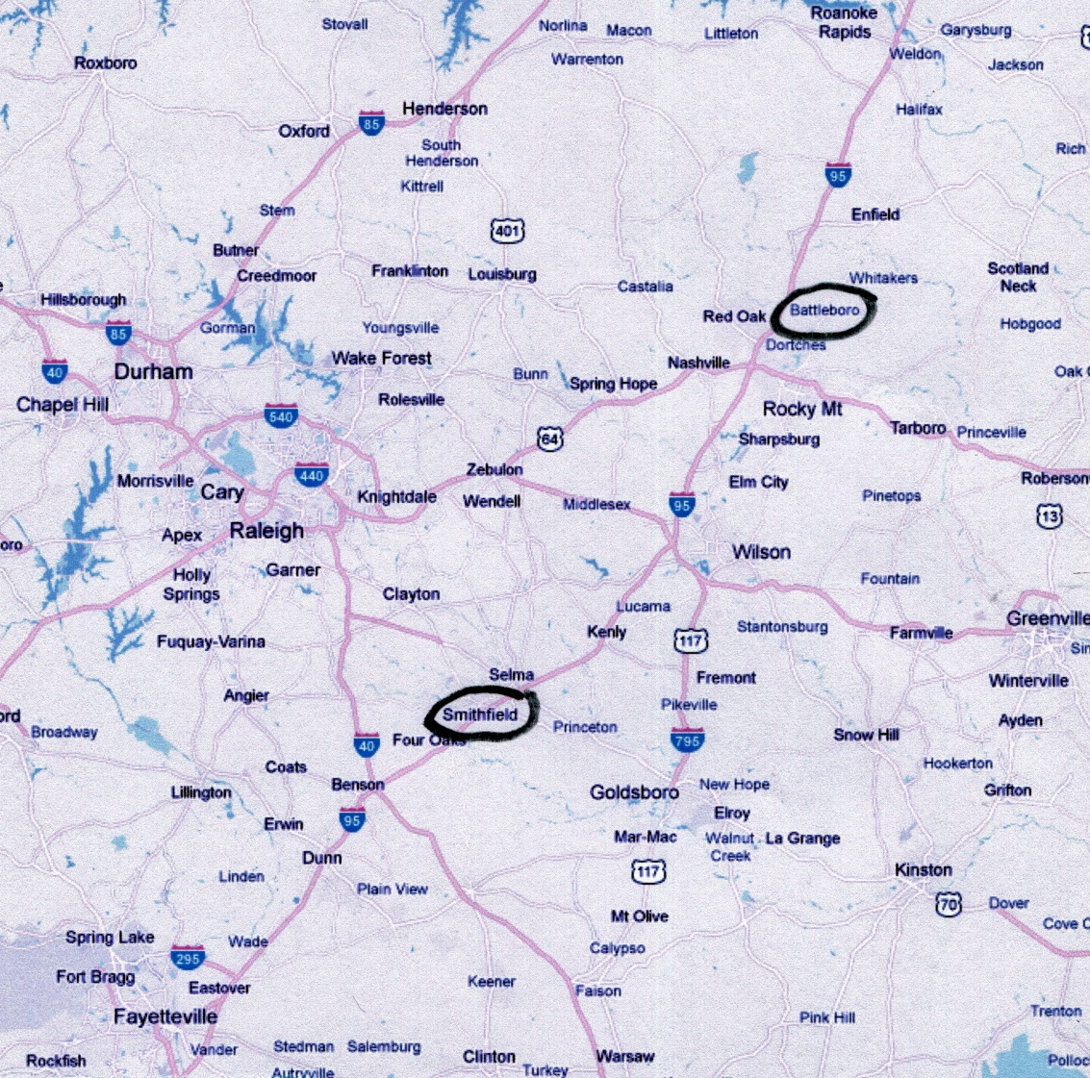
James Grantson Holliman (1750–1836) married Elizabeth Bryan(t), a member of an emerging prominent family in Johnston County. When Cornwallis invaded the Carolinas in 1780–81, Elizabeth’s male relatives led the local Patriot militia which James Grantson joined as an enlisted man. He served two 90 day tours in and around Johnston County, NC in those years, often guarding Tory prisoners of war.
A farmer as had been every Holliman since 1650, James migrated in the 1790s a bit south and west to Lancaster County, South Carolina. His land straddled the state line of North Carolina’s Anson County. A few years before he died he helped found Zoar Methodist Church and, I presume, is buried there. I have circled Pageland, South Carolina on the map below. The Holliman property was located just north.
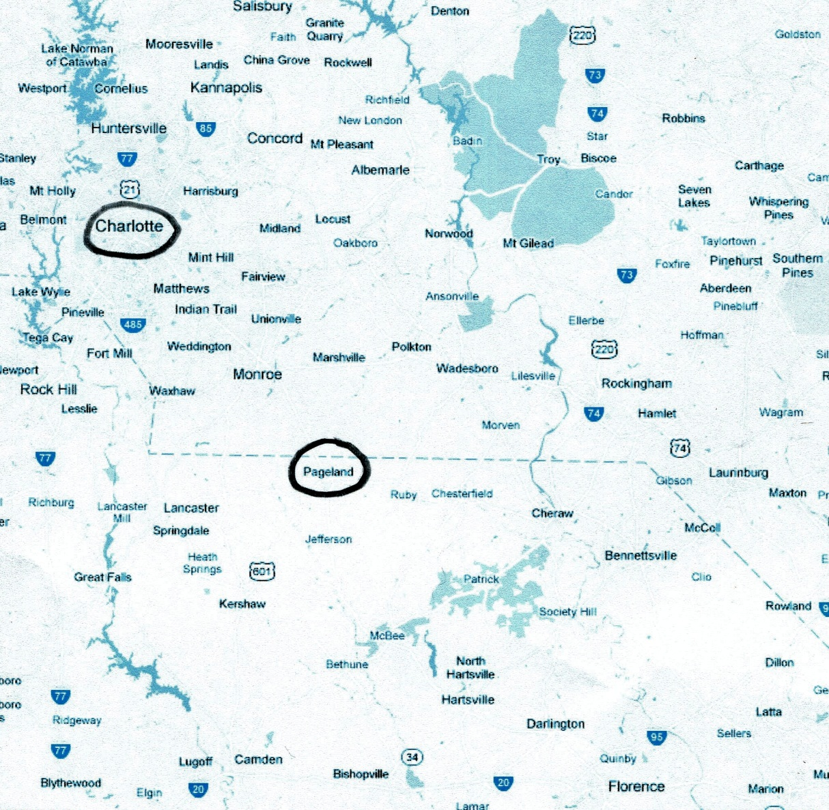

Our Hollimans Move West to Alabama
From 3 million Americans in 1790, all from 13 states along the Eastern Seaboard, the U.S. would explode in size in the next 110 years stretching over both the Appalachian and Rocky Mountain chains, leaping all major rivers and moving into the Pacific acquiring Alaska, Hawaii, Guam and the Philippines. By 1900 the population of the nation and its territories exceeded 100 million, an incredible increase!
This growth was not without wretched change as Americans had to fight another war of independence from Great Britain in 1812 (in which Cornelius Holliman served), a conflict with Mexico over Texas and western land, and then violently decide in the 1860s if the nation would remain one-eighth slave or not.
Holliman families were decimated in the vortex of the Civil War from 1861-65. It would take several generations for our Holliman family to recover from the devastation and emotional trauma of the War Between the States. And irony of ironies, the Hollimans, from whom Ulyss S. Holliman descended, owned no slaves.
Below on the map, the left circle is of Fayette, Alabama, the region to where the Carolina Hollimans moved in 1836. In the 1910s, various Holliman families, including Ulyss and Pearl Holliman, moved to the Birmingham area for economic reasons.
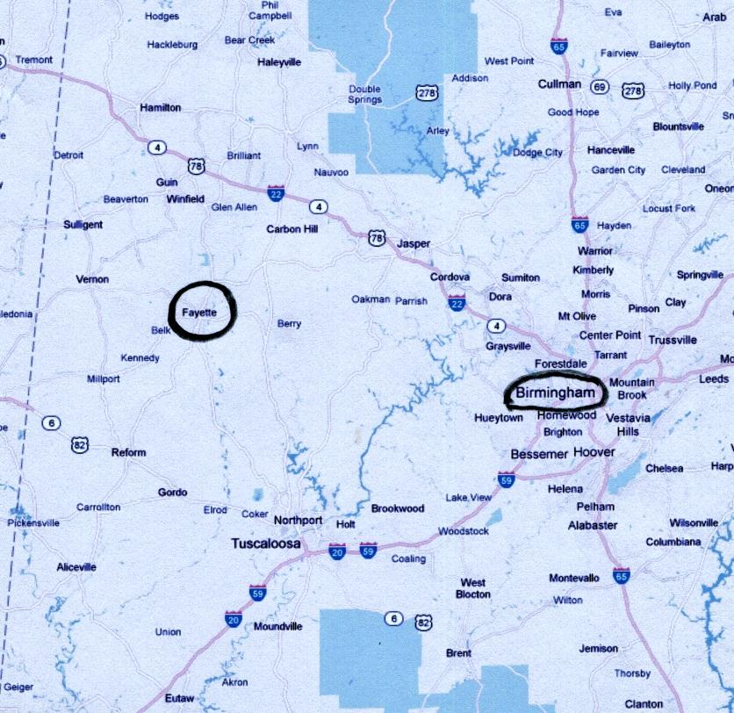
James Grantson Holliman had many children, perhaps 12 or 13. Three of the younger brothers, Charles, Cornelius and Warren, in the winter of 1835 visited the recently vacated Chickasaw Indian land in west Alabama. All tribes east of the Mississippi had been forcibly removed to Oklahoma in the early 1830s in one of the most disgraceful episodes in American history.
As with thousands of other Southerners, the brothers caught ‘Alabama Fever’ and in the spring of 1836, the year in which their father died, the three brothers and their families migrated west. Perhaps, with some neighbors, they traveled on primitive roads carrying their modest worldly goods on wagons, and driving some cattle and hogs. It probably took four to six weeks traveling maybe ten miles a day. At last they arrived in Fayette County, Alabama, a hill and ravine country drained by the Sipsey River.
Warren Holliman still had wanderlust and after a few years traveled on with his family to Arkansas. Cornelius and Charles stayed in Fayette, and in time their off spring populated Lamar, Fayette and other surrounding counties, some moving across the border to Mississippi.
My generation’s third great-grandfather, Cornelius Holliman (1792-1862) married first Elizabeth Pyler, probably the girl from a neighboring farm back in South Carolina. They had numerous children, one being Uriah Holliman (1817–1862). In time Uriah purchased Fayette County land near his father and other kin, and married another South Carolina transplant, Mary “Polly” Lucas (1819-1913). Uriah and Polly are my generation’s second great-grandparents.12
Uriah prospered, had many children and, as the Civil War approached, purchased 800 acres of new land to farm. And he farmed without slaves. Unfortunately, Uriah was to lose everything in the War, including his life.

The American Civil War Devastates the Holliman Family
In 1860, one out of eight Americans in the land of liberty lived in a brutal form of human slavery, well-protected by the 1789 U.S. Constitution. Laws allowed African-American husbands and wives to be sold away from each other and most tragically, children from their mothers. Many southern states by 1860 had even forbidden owners to manumit their slaves.
The roots of the Civil War grew from the same soil where Christopher Holyman stepped ashore from England. In Jamestown, Virginia in 1619, the first African slaves were sold. In time America’s birth defect morphed into a tyrannical bondage that denied human beings that precious concept called hope. They had no need to work harder or more efficiently as in almost all cases, they had no possibility of working their way to freedom or improving their economic status. In general, the more economically and energetically they worked, the wealthier their masters’ became.
Ironically, very ironically, the hallmark of American representative democracy was also founded in Jamestown in 1619. The Virginia House of Burgesses met with representatives from the fledgling counties and plantation parishes. Over time this Virginia assembly, a model for other colonies, would evolve into the leading advocate for the 1775 American Revolution that insisted that all men were born with inalienable rights including liberty and the pursuit of happiness.
The paradox of slavery and freedom living side by side would eventually become so incongruous to so many Americans that an irrepressible conflict arose. This war would engulf the nation and over 600,000 would die out of a population of 30 million.
Absorbed into the furnace of war was the family of Uriah and Polly Lucas Holliman. At age 44 in 1861, Uriah, a successful Fayette County, Alabama farmer, joined his local Confederate regiment to defend, as he saw it, his state. He and his eldest son, Charles Daniel Holliman, were at the Battles of Shiloh and Corinth, Mississippi. By May of 1862, they were both dead, not of wounds, but of the measles and pneumonia. More soldiers, Union and Confederate, would die from camp diseases than from shot or shell. Another soldier son of Uriah’s, Elijah, died in 1864 in LaGrange, Georgia of disease.
Our focus is on one John Thomas Holliman (1844-1930), who at age 18 in May of 1862, while his father lay dying, enlisted in the 41st Alabama Regiment and without furlough or leave, remained with this unit until February 1865. At this young age, the tall, shy, poorly educated farm boy fought side by side with cousins at the Battles of Stones River, Jackson, Mississippi, Chickamauga, Knoxville, Drewry’s Bluff, Virginia, the Crater and the long siege of Petersburg, Virginia. He served under Generals Braxton Bragg, James Longstreet and Robert E. Lee. Near the end, depravations and insanity of war proved too much for John Thomas. He would later call the conflict, “A rich man’s war and a poor man’s fight”.
On the night of February 16, 1865, John Thomas, starving, barefoot, freezing and ill clothed, suffering from cold and traumas unimaginable, accompanied by two Fayette County boys, deserted the Confederate Army. They left the trenches of Petersburg and gave themselves over to the Union. Seven weeks later Lee surrendered what was left of his Army of Virginia, and the War effectively ended.
He was sent to Indianapolis, Indiana to work for a farmer as part of his parole. In September 1865, John Thomas walked home, crossing the Ohio, Cumberland and Tennessee Rivers back to Fayette County, Alabama.
A great-grandson of John Thomas, Dr. Rhodes Holliman postulates, wisely I think, that John Thomas suffered from what we call today post-traumatic stress syndrome. Photographs generally show John Thomas staring into a space and time that no one else can see. He had seen and done things no one should experience. Above, John Thomas Holliman ca. 1900.
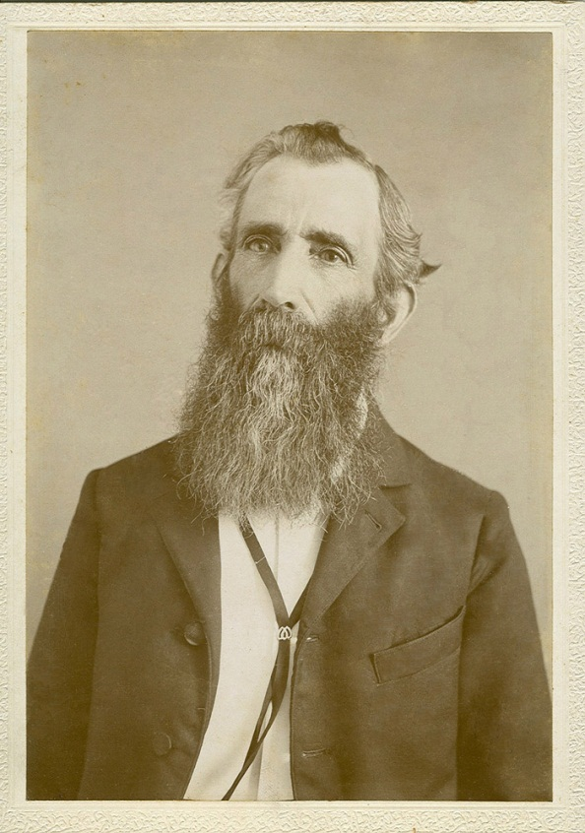
He was at the Crater, a most vicious battle in July 1864 that saw hand to hand fighting with no quarter given between Black Union troops and Confederates. He cradled a cousin in August 1864 who died of a sniper bullet at Petersburg and buried him in darkness. His ability to cope with stress was severely depleted as the Confederacy in the winter of 1865 shrank in size to a strip of land around Richmond, Virginia and a bit of North Carolina. The War, for which he had given so much, was clearly lost.
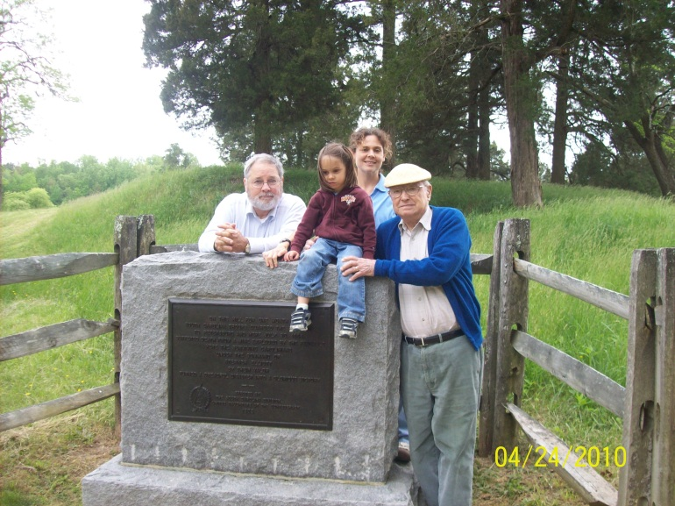
Above in 2010 at the Crater Battlefield in Petersburg, Virginia are left to right, Glenn Holliman, Holly (Holliman) Jahn, Grace Holliman and Bishop Holliman, who is the father of Glenn, grandfather of Grace and great-grandfather of Holly. Bishop’s grandfather, John Thomas Holliman, and great grandfather, Samuel Walker, both fought at this failed Union attempt in July 1864 to break the Confederate line. Nine months later the line collapsed as did the feeble remains of the Confederacy.
John Thomas’s brother, an officer in the War, James Franklin Holliman, survived as a prisoner of war and became a school teacher in Fayette County. Back home from the north, John Thomas attended this school for all of five days before quitting.
Ill-educated, he started farming four miles south of Fayette. His first wife, Jane Corbett died in childbirth giving Bill Holliman to the world in 1872. A second wife, Martha Jane Walker, gave him five more sons, the last being Ulyss Holliman (1884-1965), my generation’s grandfather.
Interestingly, Martha Jane’s father had fought at Gettysburg and later at the Crater with her husband, John Thomas. Samuel Walker (1820–1900), my generation’s great-great-grandfather, surrendered with Lee at Appomattox, one of only 7,000 or so troops remaining.

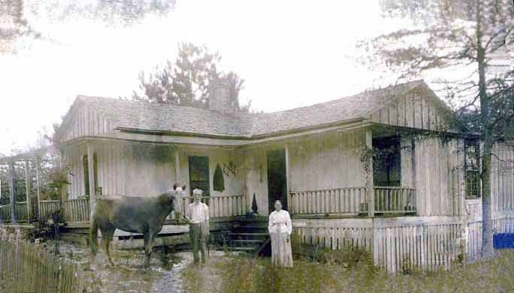
Left, John Thomas and Martha Jane Walker Holliman at their home in Fayette, Alabama. They lived in this house for 20 years prior to their deaths in the early 1930s.
John Thomas died in 1930, age 86, tall and thin, and in poverty. There was no Alabama Confederate pension for a deserter nor Social Security or governmental financial assistance prior to the New Deal. The sons helped support their parents. Mary Jane Walker Holliman died in 1931, closing a sad chapter for their Civil War generation.
In 1935, the five surviving sons of John Thomas Holliman reunited at Caine’s Ridge Baptist Church, Fayette, Alabama. The are left to right of the marriage to Sarah Jane Corbett, William Perry (1872-1941). Of the marriage to Martha Jane Walker, Silas Green (1876-1943), James Monroe(1878-1938), Thomas Leland (1880-1970), Andrew Eckford (1882-1926) and Ulyss Selman Holliman (1884-1965). The missing space is for Eck.
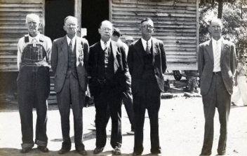
The Hollimans in the 20th Century, Depression, War and Prosperity
Ulyss S. Holliman (1884–1965) grew to manhood working on the struggling family farm in Fayette County. In 1906 he courted and married Pearl Elmer Caine (1887-1955), a daughter of Lula Hocutt Caine (1861-1957) of Fayette County. Lula’s father, Manassas Hocutt (1838-1863), fought at Stones River as had John Thomas Holliman. However, Manassas died of wounds in Murfreesboro, Tennessee less than three weeks after the battle. The Holliman family had been truly engulfed by the War.13
In the Census of 1910, Ulyss is recorded as a general farmer, but we know he worked at the lumber mill in Fayette and lived not far from the center of town. After the birth of his fourth child, he migrated in 1917 with his young family to the growing city of Birmingham, Alabama. He was a carpenter with the Birmingham Electric Company which ran the city’s wooden street cars. After renting for four years, he saved enough to build a house in Irondale, Alabama in 1921. Pearl’s mother, Lula, and two sisters, Maude Caine Cook and Vista Caine Humber, joined them in Irondale. One of his brothers, James Monroe Holliman, an attorney, moved to Birmingham in 1915.
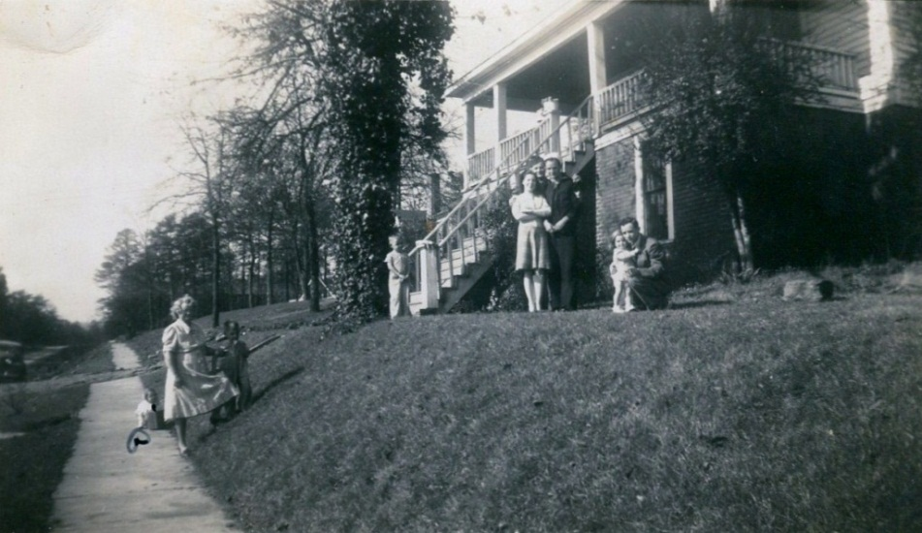Photographed in February 1945 at 2300 N. 3rd Avenue, Irondale, Alabama are left to right Jean Holliman, Pearl Caine Holliman (Grand Mama Holliman), Terry Holliman, Jerry Holliman, Gerry Stansbery Holliman, Melton Holliman, Bishop Holliman (the sailor), Anne Holliman Phillips and Euhal Holliman.

When Ulyss Holliman was born, Birmingham had no street cars. When he died, Birmingham had no street cars but from 1918 until retirement in 1949, he helped maintain an urban transportation system. This photo was taken in Gadsden, Alabama, 1964 at age 80, perhaps the last picture taken of Ulyss who died in spring 1965. His neck is thin, and he is gaunt like his father, John Thomas Holliman, was at that age.
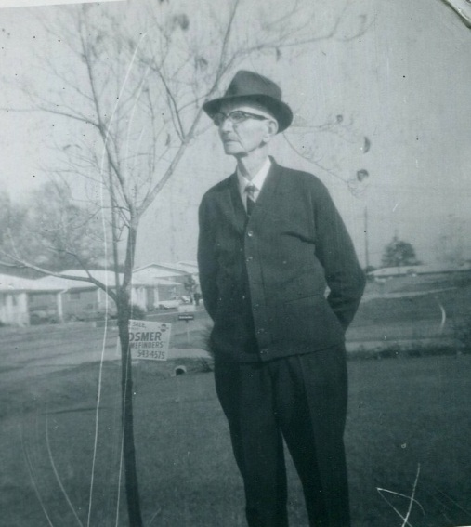
At Christmas 1950, the seven siblings and families gathered at the Irondale home of their parents. With their backs to the front window and door, all dressed formally, they are left to right front row: Vena, Virginia, Ulyss, Pearl, and Loudelle. The sons on the back row are Ralph, Bishop, Melton and Euhal. Notice the photo of Virginia and Walter Cornelius behind Ralph’s head. Today the picture is in the procession of her daughter, Susan Cornelius Williams.
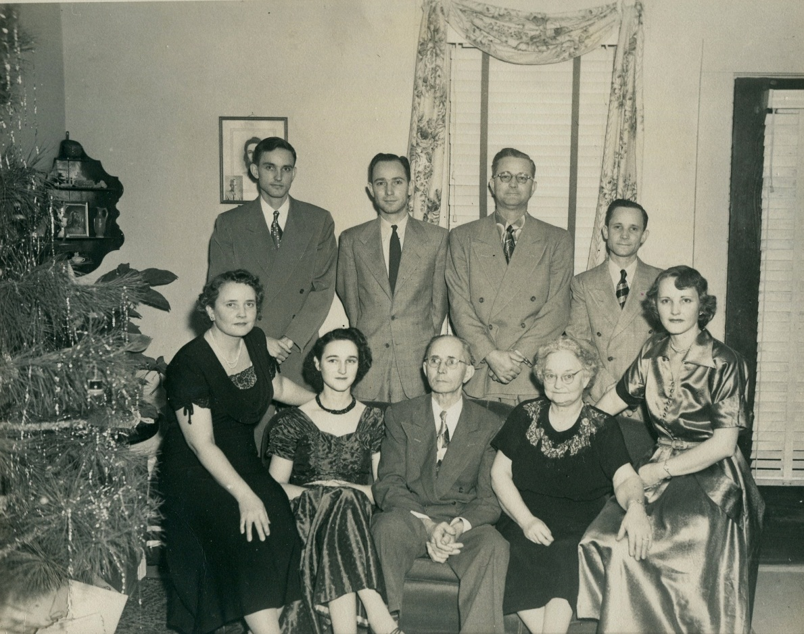
In addition, at that Christmas 1950, a family photo was snapped of all the descendants born by that time. This is the last group picture taken of the seven siblings, their spouses and children. Note the Hopalong Cassidy cowboy costumes of the time!
Front row kneeling are: Robert W. Daly, Jr., Jerry and Terry Holliman, Anne Holliman Phillips, Jean Holliman, Carol Cornelius Morton and Glenn N. Holliman. 2nd row: standing Charles Halford Ferrell, Susan Cornelius Williams held by her mother, Virginia Holliman Cornelius, Ulyss and Pearl Holliman (who is holding Rebecca Holliman Payne), Carolyn Ferrell Tatum holding Pam Holliman, Patti Holliman Hairston and John Melton Ferrell. 3rd row: Euhal and Edna Westbrook Holliman, Vena Holliman Daly, Mary Daly Herrin, Robert W. Daly, Sr., The Rev. Charles Ferrell, Loudelle Holliman Ferrell, Ralph and Motie Chism Holliman, Melton and Ida Hughes Holliman and Geraldine Stansbery Holliman holding hands with Bishop Holliman. Behind them is Walter Cornelius.
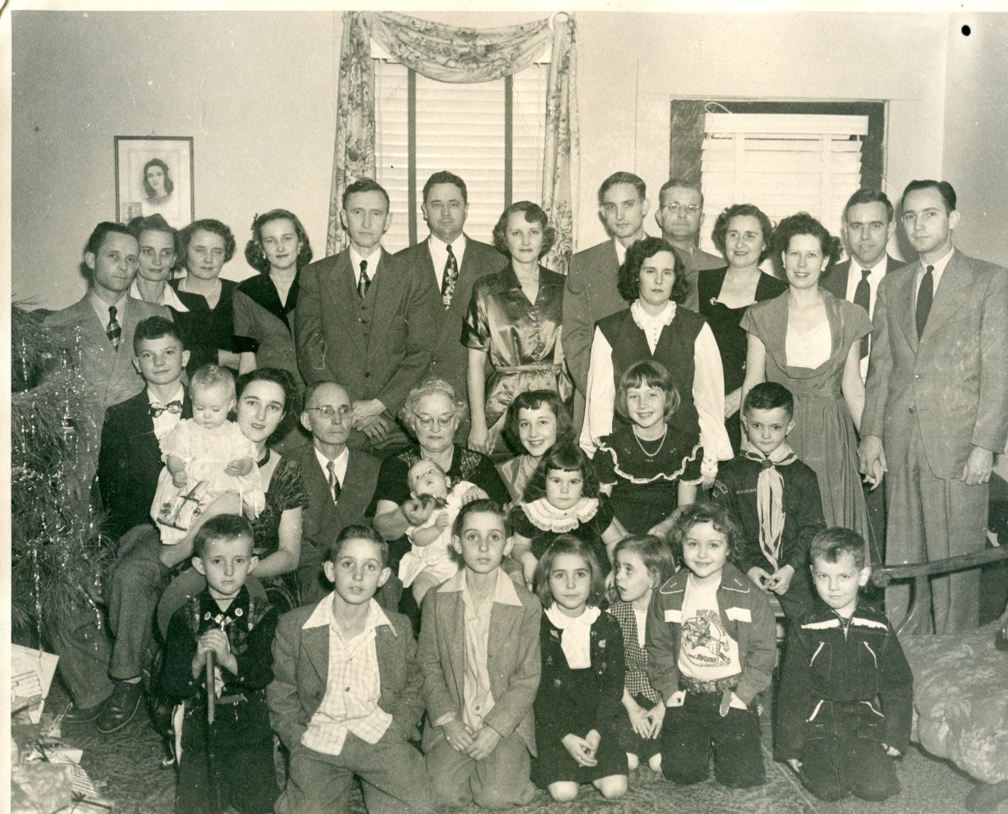
Four first cousins were yet to be born: Kathy Holliman, Tommie Holliman Allen, Billy Joe Holliman and Alice Holliman Murphy.
Seven Brief Accounts of the Children of Ulyss and Pearl
More detailed biographies may be found in the archives of http://ulyssfamily.blogspot.com/ .
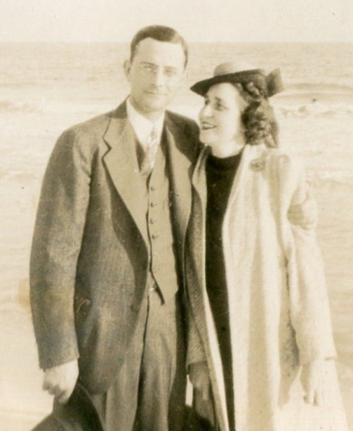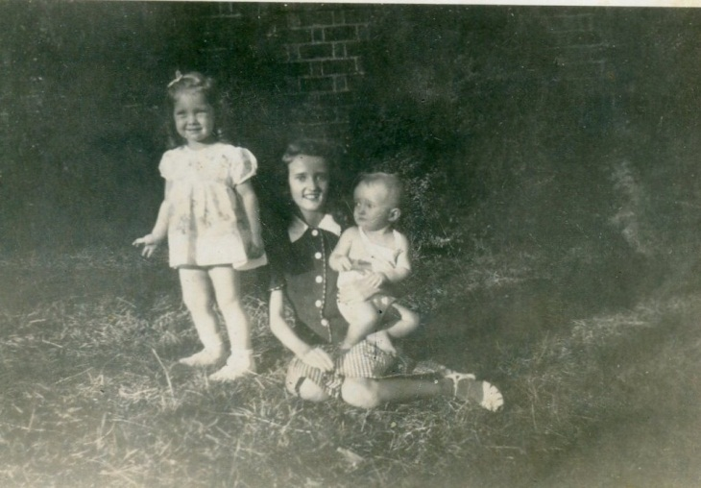
Above, Melton P. Holliman (1908-1958) married Ida Hughes (1905-1995) in 1932. Their daughter is Patti Holliman Hairston. Melton was a successful pharmaceutical salesman, church leader and a U.S. Army veteran of World War II. They lived in Mobile, Alabama from the early 1940s until his death. The second photo is, from left to right in 1945, Patti Holliman Hairston, Mary Daly Herrin and Robert Daly, Jr. The picture below is of Patti and John Melton Ferrell, ca 1944.
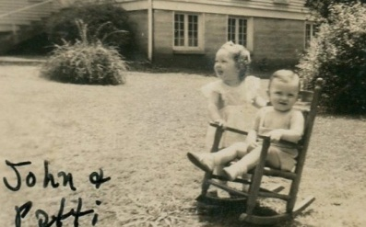
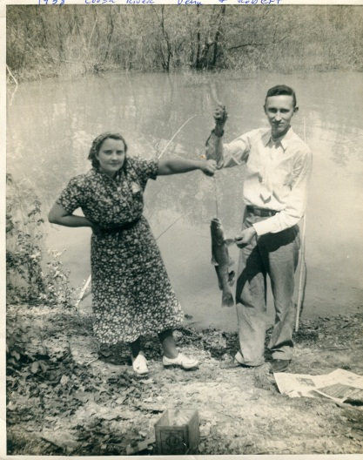
Vena Holliman Daly Bucheit (1909-1990) married Robert W. Daly, Sr. (1901-1959) in 1928. Their children are Mary Daly Herrin and Dr. Robert W. Daly, Jr. Robert Daly was a beloved mentor to his in-laws and a Woodlawn, Alabama banker. Photo 1938 along the Coosa River.

Below photo from 1973, E.C., Mary and Clayton Herrin stand to the left of this extremely long car with Virginia Holliman Cornelius on the far right.

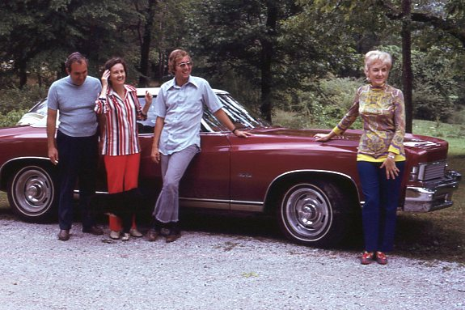
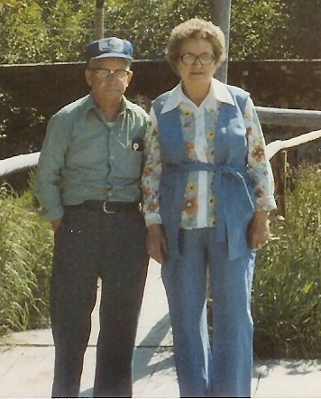
Euhal Holliman (1912-1989) married Edna Westbrook (1916-1992) in 1936. Their children are, Jerry and Terry Holliman, Anne Holliman Phillips Jean Holliman, Tommie Holliman Allen and Bill Holliman. Euhal was a grocer and active in the labor movement fighting for a living wage and benefits for grocery workers. After retirement, he was an Irondale, Alabama civic leader serving as an auxiliary policeman and president of the Lions Club. Photo above taken in 1982 in Alaska.
Photo below celebrating 50 years of marriage in 1986 are Tommie Holliman Allen, Jean Holliman, Anne Holliman Phillips, Euhal and Edna Holliman, the celebrants, Terry and Jerry Holliman and Bill Holliman.
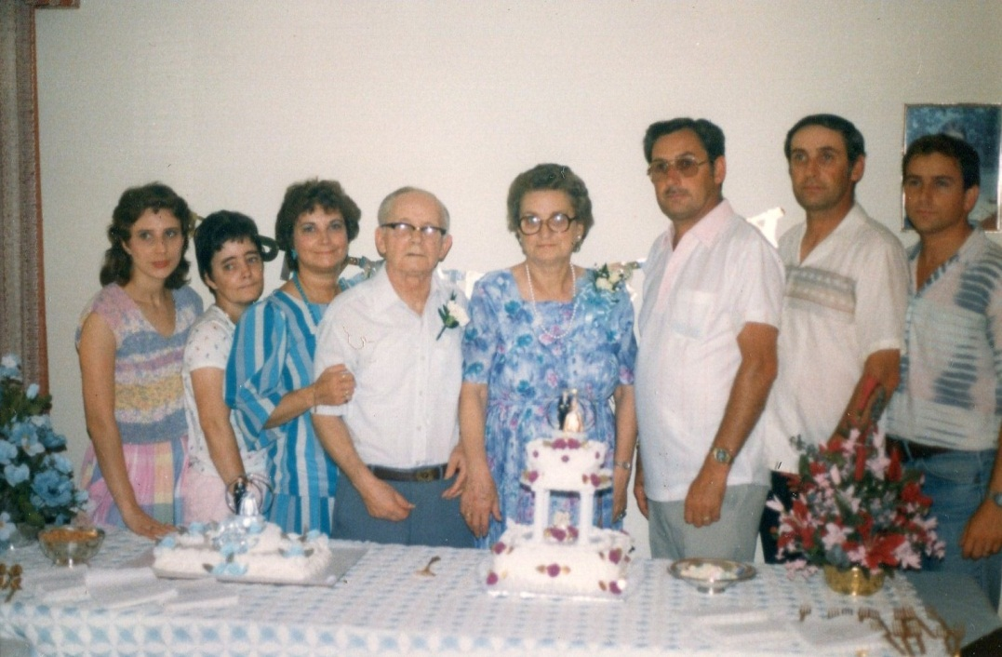
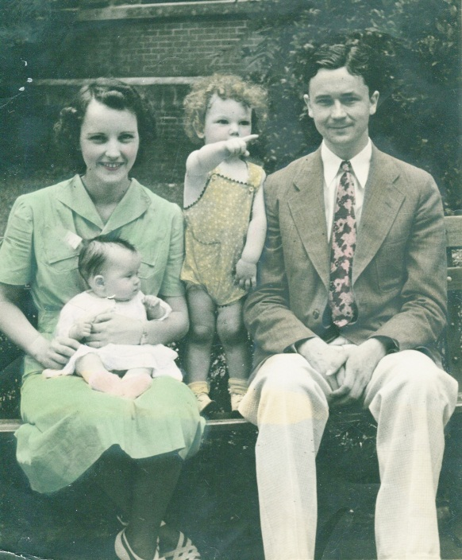
Loudelle Holliman Ferrell (1914-1998) married Charles Ferrell (1907-1999) in 1935. Their children are Charles H. Ferrell, Carolyn Ferrell Tatum and John Melton Ferrell. Charles Ferrell was a graduate of Yale Divinity School and helped his in-laws enroll in Birmingham-Southern College prior to World War II service. Photo left taken 1938. Left to right are Loudelle, Carolyn Ferrell Tatum, Charles Halford Ferrell and Charles Ferrell.

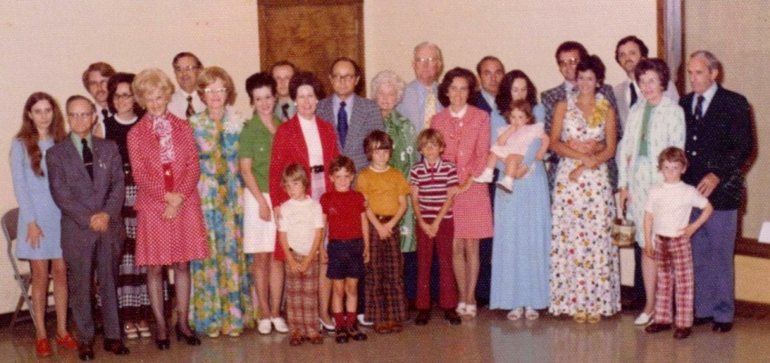
Above Ferrells, Tatums, Dalys, Buckheits, Herrins, Corneliuses, Hollimans and more gather in 1973 to celebrate The Rev. Charles Ferrell’s retirement as an active United Methodist Church pastor. Loudelle Holliman Ferrell is 7th from the left.
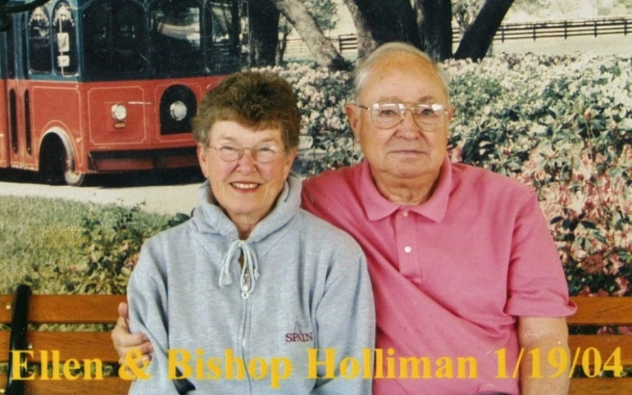
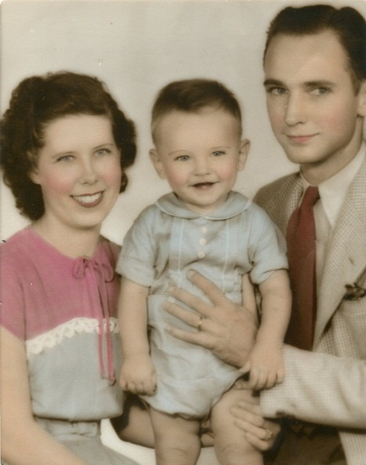
Homer Bishop Holliman (1919) married Geraldine Stansbery (1923) in 1945. Their children are Glenn N. Holliman, Rebecca L. Holliman Payne and Alice Lynn Holliman Murphy. Bishop has been married to Anne McLaughlin and after her death to Ellen Cox. He is a U.S. Navy veteran of WWII, church and civic leader and a retired manager of a Social Security Office in Cookeville, Tennessee.

Above, Geraldine, Glenn and Bishop Holliman in 1947. Left photograph is of Bishop and Ellen Cox Holliman in 2004. Below in 2009 on his 90th birthday are Alice Murphy, Becky Payne and Glenn Holliman.
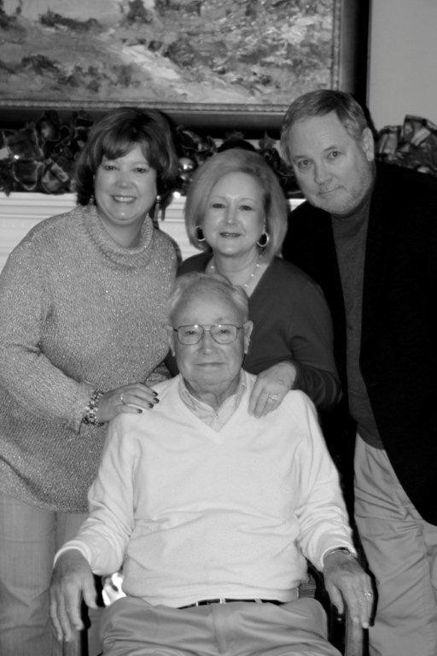
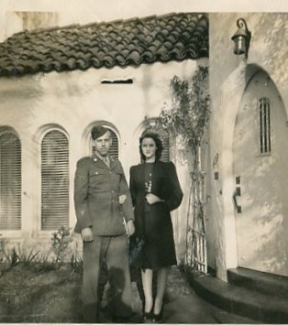
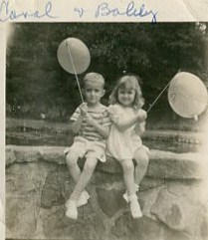
Virginia Holliman Cornelius (1922-2011) married Walter Cornelius (1922-2006) in 1942, her high school boy friend. Their children are Carol Cornelius Morton and Susan Cornelius Williams. Walter was an attorney in Birmingham, Alabama. Virginia broke the glass ceiling for women bank executives during her career at First Alabama Bank, Birmingham, Alabama, retiring as a vice president. Photo taken during World War II when Walter was a member of the U.S. Army Air Corp. Walter was stationed in Saipan in 1945.
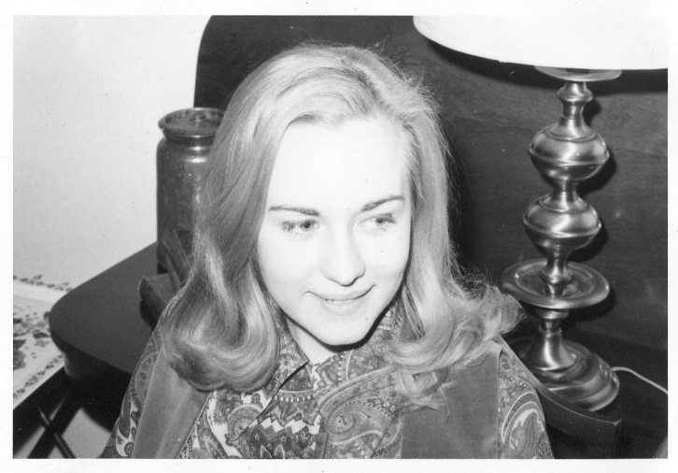
Above in 1970 at an Irondale, Alabama reunion – Susan Cornelius Williams. Right, childhood best cousins are Bob Daly and Carol Cornelius Morton, ca. 1949.

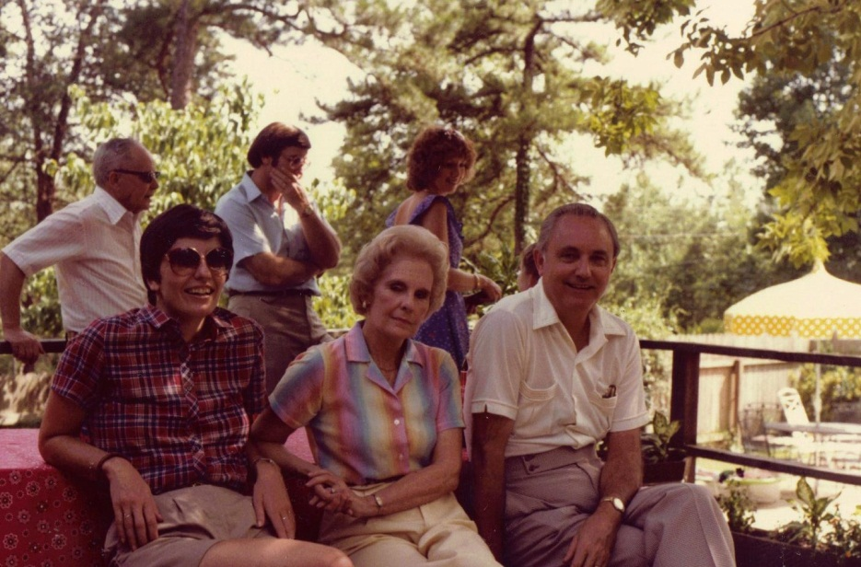
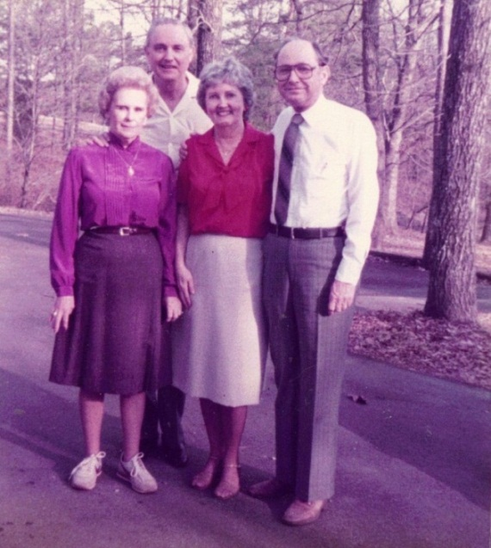
William Ralph Holliman (1924) married Motie Chism (1925-2003) in 1943. Their children are Dr. Pamela Holliman and Kathy Holliman. Ralph is married today to Laura Stanley. He is a retired V.P. of Operations of the American Bakeries Company and U.S. Army World War II veteran.
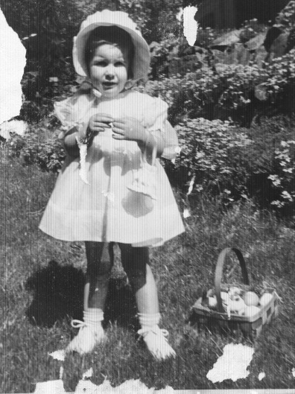
Top left in 1984 are Motie, Ralph, Mary Daly Herrin and Bishop. Top right, Pam at Easter in 1949. Bottom right, 2007, Kathy with her husband, Tim Donald.

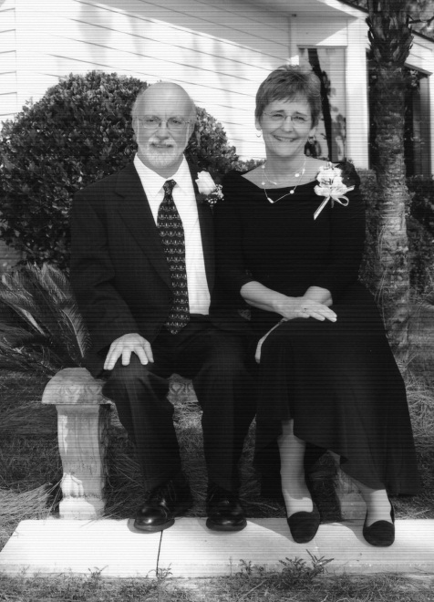
Above, at the 1982 Irondale reunion, Pam, Motie and Ralph. In the background are Euhal Holliman, George and Patti Holliman Hairston.

The 21st Century Hollimans
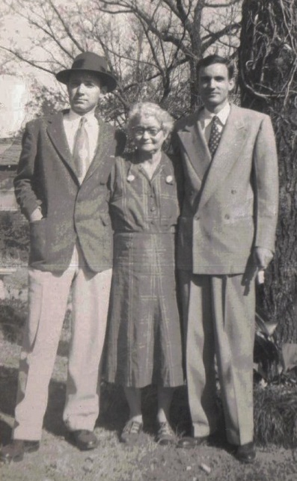
Of the two surviving children of Ulyss and Pearl Holliman, Bishop lives in Avila, Indiana and Ralph in Gulf Shores, Alabama. Left is the last photograph Bishop and Ralph Holliman had taken with their beloved mother, Pearl Caine Holliman, Christmas 1954.
There were 19 first cousins born to the seven children of Ulyss and Pearl Caine Holliman. Eighteen are still living; twin Jerry Holliman, son of Euhal and Edna Holliman, died in Alaska of heart disease in 2003. Of the remainder, seven live in Alabama, one in Arizona, one in Mississippi, three in Texas, one in Tennessee, two in Pennsylvania, one in Illinois, one in North Carolina and one in Massachusetts.
The 19 cousins are listed here in order of birth: Mary Daly Herrin, Charles Halford Ferrell, Carolyn Ferrell Tatum, Jerry and Terry Holliman, John Melton Ferrell, Patti Holliman Hairston, Anne Holliman Phillips, Jean Holliman, Robert W. Daly, Jr., Carol Cornelius Morton, Glenn Holliman, Pamela Holliman, Susan Cornelius Williams, Rebecca Holliman Payne, Kathy Holliman, Tommie Holliman Allen, Bill Holliman and Alice Holliman Murphy. The children and grandchildren of these first cousins are scattered throughout the United States.
The generation of seven children born to Ulyss and Pearl Caine Holliman - Melton, Vena, Euhal, Loudelle, Bishop, Virginia and Ralph -were part of an incredible age of American growth and economic prosperity. In their time the American South recovered economically from the Civil War and the Great Depression, fought World War II, went through an agonizing readjustment in human racial relations and with firm patience survived a Global Cold War.
Today, their descendants enjoy the benefits provided by 20th Century Hollimans who served their country and families in peace and war.

FOOTNOTES
Below are some of the sources used to prepare this abbreviated history of our family.
- Bob Holyman-Mawson of Carnaervon, Wales discovered at Wycombe.comx the information on Richard Holyman of 1386.

- Information on William Holyman of 1444 is found in the book, A History of Tring by Sheila Richards, 1974 which I reviewed in 2012 in the Tring, Hertfordshire library.

- Professor Caroline Stonman of Cuddington, Buckinghamshire, England is the current owner of The Holyman Farm. She provided notes and materials during my visit in 2010.

- Mrs. Peggy Cattell of Cuddington, the local historian, kindly shared with me her biographical paper on The Rt. Rev. John Holyman. He is found also in many sources of the Tudor period.

- Bob Holyman-Mawson shared his research on Thomas Holyman’s 1558 will. Christopher Holyman of Sherington and his 1588 will, I reviewed in Buckinghamshire Archives. Additional biography on Christopher and his son, Thomas Holyman (married 1609 in Bedford) were found in the Milton-Keynes, Buckinghamshire public library local history section which I visited in 2011. In 2012 I collected more information on the 1500 Holymans of Cuddington at the Archives in Aylsbury.

- Information on Christopher and Judith Holyman, brother and sister, were found in Bedfordshire, England archives parish records in 2011. Both are listed in LDS records on the web.

- Ezekiel Holyman’s story is found at Baptist web sites and Wedon Family records in The Register of New England Families, which state his relationship to Cuddington Holymans.

- George A. Holleman in 1953 wrote the first important work on the history of the Holliman families in Virginia. Numerous Virginia land and will records tell the story of Christopher Holyman, Sr. (1618-1691).

- Again numerous Virginia land, court and estate records relate the stories of Margaret House and Richard Holliman. A visit to the Library of Virginia in Richmond reveals the 17th and 18th Centuries of Colonial Virginia.

- Samuel Holliman’s history has been well-documented by family historians Joe Parker, Jeanette Stewart and the late Walter O. Holliman. I have visited the 1742 Holliman home in Edgecombe County, North Carolina and the Johnston County Archives.

- James Grantson Holliman’s Revolutionary War record, his land sales and his involvement in Zoar Methodist Church have been documented extensively, found on the web and the Walter O. Holliman collection.

- The lives of Cornelius Holliman, his son Uriah, Polly Lucas Holliman and John Thomas Holliman and his wife, Martha Jane Walker Holliman have been extremely well documented by the late Cecil Rhodes Holliman and his son, Dr. Rhodes Holliman, both descendants of the above and James Monroe Holliman. James Monroe Holliman is a brother of my grandfather, Ulyss Holliman.

- Information on Manassas Hocutt, my great, great grandfather, is provided by Bob Prince, a great-grandson of Lula Hocutt Caine, mother of my grandmother, Pearl Caine Holliman.

- The remainder of material is from the papers, memories and memoirs of my father, H. B. Holliman, and oral interviews with Ralph Holliman and my first cousins.

Errors and omissions are my responsibility, and I welcome corrections and observations. This continues to be a work in progress.

I encourage all cousins to assist me in enlarging our family tree with their various branches at Ancestry.com.

If you would like to be a contributor to this site or participate in my blog work, please contact me at glennhistory@gmail.com and arrangements will be made.

Glenn N. Holliman
P.O. Box 240
Newport, PA 17074
717-567-3006

June 2012

