An English History

of the American Holliman Family

by Glenn N. Holliman, October 2011

Introduction

Since early 2010 I have been writing and posting articles on the Internet regarding Holliman family history (httt://hollimanfamilyhistory.blogspot.com/). In this publication, I have reproduced my articles on our Medieval English roots and my research in England. Over the next few years, I hope to enlarge this publication with additional episodes in my branch of the Holyman family tree, specifically the colonial years in Virginia and the Carolinas and Alabama in the 19th and 20th Centuries.
Family history is usually a composite of research by numerous ancestors, researchers, historians and family members still living. Such is the case with this compilation. In each ‘chapter’, I have attempted to credit my relatives and friends with their research. Interpretations and errors of commission and omission are mind alone.
Genealogy is both art and science. As new research and documents become available, the story may change. Critique and additional information are always welcome. This publication is for educational purposes and not for commercial gain.
I can be reached at Glennhistory@gmail.com and can email photos and materials that may be difficult to read in this publication.

Section I

A Holyman Family from England to North Alabama

1650 - 2010: 360 Years of American History in one Family

Christopher Holyman, Sr. arrived in Jamestown, Virginia in 1650, along with his sister, Judith. He and his immediate descendants lived approximately a century in Isle of Wight County and adjacent counties. However, around 1740, my direct Holliman descendants from this great grandfather began moving south and west searching for land and increased fortune.

For my line of Hollimans, the chronology is approximately as follows. Of course, sons and daughters were always splitting off and moving to other parts of what is the United States. Many in the late 1700s and early 1800s would move to Tennessee, Georgia and Kentucky. For the most part, my branch of this colonial family would migrate to and through the southern states, although there are exceptions.

Prior to 1650 – The origin of American family is England, with Christopher Holliman, Sr. born 1618 in Bedford, Bedfordshire, England with probable other relatives in Buckinghamshire and Hertfordshire, England. Research to date does not support the reported John Holyman (d 1650) of Tring, England and Southampton, Virginia as the father of Christopher Sr.

The parents of Christopher Sr. appear to be Thomas and Helene Poynard of Bedford. Research in 2011 provides evidence to take the story even further back to a Christopher Hollyman who died in Sherington, Buckinghamshire in 1589, who had a son named Thomas.

1. 1650 to 1740s - Most of my direct descendants lived in Isle of Wight County and adjoining counties in Virginia. Naturally, many descendants under the names of Holleman, Hollomon, etc. reside in southern Virginia to this day. Christopher Holyman, Sr. (1618 – 1691) was the American founder, arriving in Jamestown, Virginia in 1650. Richard and Samuel Holliman are my probable grandfathers between Christopher, Sr. and James Grantson Holliman.

2. 1740s to 1790s - Through the parents and relatives of James Grantson Holliman, the Johnston County, North Carolina area became home for my branch of the family.

3. 1790s to 1836 - In the 1790s Anson County, North Carolina and Lancaster County, South Carolina (border counties) became the location of this James Grantson Holliman family.

4. 1836 - 1918 - In 1836, three sons of James Grantson Holliman moved their families to Fayette County, Alabama. The families of Charles and Cornelius Holliman stayed in Alabama and descendants live in the area to this day. Warren Holliman moved with others to Arkansas, and there remain many Hollimans. Others of these extended families moved to Mississippi, Texas, Louisiana and other parts of the southwest and middle Great Plains.

5. 1918 - 1960s - My generation's grandfather, Ulyss S. Holliman (1884 - 1965), a son of John Thomas, grandson of Uriah and great grandson of Cornelius, moved his family from Fayetteville, Alabama to Irondale, Alabama, a suburb of Birmingham in 1917. Several other families migrated to the economic attractions of the 'Magic City' also, including James Monroe Holliman, a brother of Ulyss, and his children. Others of Ulyss' brothers scattered throughout North Alabama; one half-brother, Bill Holliman, remained in Fayette County, dying there in 1940.

1960s to the present - While many of my first cousins remain in the Birmingham and North Alabama region, and 2nd and 3rd cousins in Fayette Country area, many grand and great grandchildren of Ulyss and Pearl Caine Holliman, have relocated across the country living at this writing in Chicago, Boston, Pennsylvania, South Carolina, Texas, Virginia, North Carolina, Tennessee, Massachusetts, Alaska, Arizona and other states. As with many American families, advances in education, transportation and career opportunities have led to the dispersion of formally regionally located kinfolk to every part of the country.

The Family of Christopher Holyman (d 1589) through John Thomas Holliman (d 1930) – Latest family lineage based on research in England 2010 and 2011.

Christopher Hollyman (d 1589) Sherington, Buckinghamshire. Possible descendant of the 15th and 16 Century Holymans from Cuddington, Buckinghamshire.
Thomas Hollyman (son of Christopher and a school student in Lathbury, Buckinghamshire in 1595). Married Henea Poynard, October 23, 1609 at St. Mary’s parish, Bedford, Bedfordshire, England.
Christopher Holliman, Sr. (b 1618, Bedford, England – d 1691, Isle of Wight Co., Virginia);
Richard Holliman (b abt 1665 - 1711), Isle of Wight County, Virginia. Married Margaret House ca. 1700.
Samuel Holliman (b ca 1708 - 1787 ca), died Johnston County, North Carolina. Circumstantial evidence indicates this is the probable father of James Grantson Holliman. Time, place and ruling out others focus our attention on Samuel.
James Grantson Holliman (b 1750, Johnston Co., North Carolina – d 1836, Mecklenburg Co., North Carolina). Wife was Elizabeth Bryant;
Cornelius Holliman (b 1792, Anson Co., North Carolina - d 1862, Fayette Co., Alabama) First wife and mother of Uriah, Mary Elizabeth Plyler (1793-1835);
Uriah Holliman ( b 1817, Lancaster, Co., South Carolina - d 1862, Okolona, Mississippi after the Battle of Corinth). Wife was Mary Polly Lucas (1819-1913);
John Thomas Holliman (b 1844, Fayette Co., Alabama – d 1930, Fayetteville, Alabama). Of the marriage to Sarah Corbett, William Perry Holliman (1871-1941) was the surviving child. Of the marriage to Martha Jane Walker, five sons were born: Silas Green Holliman (1876-1943), James Monroe (1878-1938), Thomas Leland (1880-1970), Andrew Eckford (1882-1926) and Ulysses Selman Holliman (1884-1965).

Section II

When We Were English

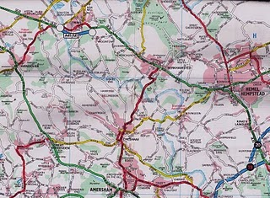
Some First Thoughts on Our English Roots
This map is somewhat dated, but in the upper left hand corner is Tring, Hertfordshire, England. Just to the east of it is the little village of Aldbury and south is Cholesbury. To the west of Hemel Hempstead is Berkhamsted. Toward the lower right hand corner is the tiny village of Chipperfield. In left center is Wendover, and to the west, but not on this map, is Cuddington. London is off the map to the southeast. Holymans and Hollimans lived in these villages and towns from the 1400s through the 1600s according to English records.
I have had the pleasure of traveling to England numerous times in my life. As I have become older, my interest in family history has grown. In 2010, my wife, Barb and I invested a number of days researching Holliman history in an area approximately 25 to 30 miles from the center of London. These towns and villages were Tring, Aldbury, Cholesbury, Cuddington, Chipperfield and Berkhamstead in both Hertfordshire and Buckinghamshire.
In graduate school, (gasp 1970!) I studied history and know that primary evidence is crucial to any research. There is a popular and well-researched Holliman family tree website that lists John Holyman (1572 - 1650) as the direct line of our family, born in Tring, Hertfordshire and died in Southampton, Virginia. Unfortunately, no one has yet shared with me the hard evidence of this birth and death date or the fact that the gentleman ever existed. This does not mean that facts do not exist somewhere; it is just that I have not seen such or discovered it in my research.
Let me quickly say that hard primary evidence exists for our first American Holliman, one Christopher Holliman, Sr, who died in Isle of Wight County, Virginia in 1691. We have his will and many legal records. Evidence exists that Christopher and his sister, Judith, are from Bedford, Bedfordshire, England, a strong possibility we shall explore later. For now, let us begin our journey in the Chiltern Hills around Tring, Hertfordshire.
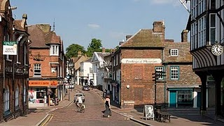
High Street in downtown Tring, Hertfordshire.
Note: Holliman in both England and the U.S.A. is spelled in numerous ways. As literacy and sounds varied in both countries, the surname has been produced in numerous ways such as Holyman, Hollyman, Hollman, Holliman, Holleman, Holloman, Hollomon, etc. As I write of our ancestors in the transition in the 1600s from England to Virginia, I find myself flipping back and forth from Holyman to Holliman.

The Monuments at Chipperfield, England

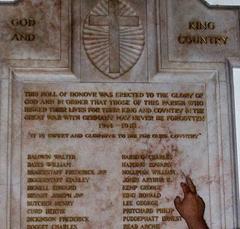
With the exception of the historical painting of Elizabeth I below, the other photos in this article are of memorials to Hollimans and others in St. Paul's parish, Chipperfield, Hertfordshire, approximately 25 miles northwest of Central London.
August 31, 1997, my wife, Barb, and I assembled for the baptism for our godson, Joseph Jeffries, at St. Paul's Anglican parish in Chipperfield, Hertfordshire, England. What should have been a day of joy instead was a sad morning. Princess Diana, formerly Princess of Wales, and her boyfriend, Dody Fahad, had died in the early hours in a Paris car crash.
The priest, a lady of whose gender there were only a few at that time in all the English Church, prayed for the repose of the departed souls as she attempted to turn the congregation’s attention to the welcoming of Joseph into the Christian family. Ironically, Diana’s accident occurred in a tunnel just a block from where Barb worked the year before at the capital campaign for the American Cathedral in France.

With these conflicting thoughts tumbling through our heads, we ventured to gaze around the lovely neo-gothic nave. Good grief! The walls were covered with war memorial plaques in memory of Hollimans and other villagers! Had we stumbled on to the ancestral home of the Holliman clan? Much evidence indicates that yes, the English Hollimans (or Holleman, Hollyman, Hollomon, etc.) did establish themselves or at least some of the family in Hertfordshire, England around the villages of Chipperfield and Tring, located 30 or so miles northwest of London proper. Other villages with Hollymans were Berkhamstead, Aldbury, Cholesbury, Haddenham and Cuddington.

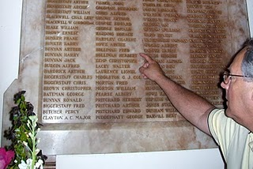

It is obvious from these memorials that in the last two World Wars, numerous Holliman kinsmen mustered with their English regiments, and sadly all did not return.

Until 2010, most of our American genealogical trees began with one John Holyman, allegedly born 1572 in Tring, Hertfordshire. This was during the reign (and rule) of that magnificent Tudor queen, Elizabeth I. Anglicanism had replaced the Roman Catholic faith in the land, helped along by several burnings at stakes of recalcitrant Catholics and not a few Spanish Jesuits who sought to return England to the Old Faith. The friction between Spain and England, exacerbated by privateers Drake and Raleigh, eventually led to the sailing of the Spanish Armada of 1588.

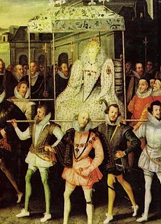

This is Robert Peale's painting of Queen Elizabeth being carried by her devoted courtiers.
Elizabeth called out the able bodied men of England to repel the invader if the embryonic English fleet was not able to do so. One wonders if our Holyman kinsmen did not muster on a village green with pike in hand? Evidence discovered in 2011 indicates that at least one Christopher Hollyman, served in Sherington, Buckinghamshire as a Guard of the Queen.

A Holyman in the Late Middle Ages

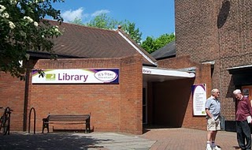

In the local history section of the Tring, Hertfordshire library (photo with patrons in front) there is a book entitled A History of Tring by Sheila Richards, a denizen of the area. Published in 1974 by the Tring Urban Council in Hertfordshire, it contains many stories, family names and records. While pursuing this work I found on page 53 the following information that was translated from Middle English.
From the Court Rolls of the Manor of Tring - Courts 28 May, 18 June and 9 July 1444 (yes, 1444, not 1944!)
"Plaint Continued: the plaint between William Holyman, defendant, and Richard Brame of Chedyngdon, plaintiff, in a plea of trespass, is continued by order."

Observations?

1. Holymans had surnames by the 1400s as did most English by this century.
2. Holymans lived in Tring two centuries before American founder, Christopher Holliman, sailed for Virginia in 1650.
3. This complaint of trespass may have involved a stray animal or William planting a crop on Brame's leasehold. Everyone leased from the Lord of the Manor or shared the common fields surrounding Tring. This lack of personal land is what attracted many of our ancestors to America.
4. As the complaint was continued to another day, perhaps it was settled out of court (just as most legal complaints are today).
There is another mention of William on page 54. He is listed as a juror to decide a leasehold inheritance on shared common town lands known as Goldfield and Bulbourne crofts surrounding Tring.
Observations on this entry?
1. Whatever William's issue in the trespass complaint, it did not keep the judge from appointing him to a jury that summer.
2. Although English common law was in its infancy, the jury system was working, wills were common and so were lawsuits in England by the 1400s.
3. To be appointed to a jury is a compliment indicating some standing in the community.
There was nothing else in this book on William Holyman. Thomas Cromwell, Henry VIII's chancellor, in 1538 required all churches to keep parish records on baptisms, marriages and deaths. Too late for this 15th century William. So where to look? Manorial Court records? Yes. And where are they? At the Public Record Office in Kew, near London. Did this William have a will? Here is an English government web site to explore: http://www.nationalarchives.gov.uk/.

The Middle Ages were Ending
What was happening in our England of 1444 when this possible Holyman ancestor was having legal troubles?
A weak king, Henry VI (photo below) occupied the throne from the first year of his life 1422 until deposed in 1461. He would have made an excellent monk, but was a poor king. He is the only English sovereign to have been crowned in both England and France. His mind was unbalanced, and when a protector stepped in to serve the crown, a civil war broke out. The Houses of Lancaster and York began fighting the War of the Roses.
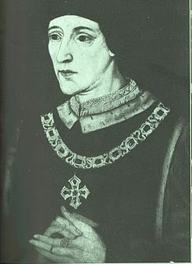
France and England were near the end of their Hundred Years War. Henry's father, Henry V, had conquered a considerable portion of France during his short reign. However, the French reclaimed almost all of their land during Henry VI's time on the throne.
This was the period when the charismatic Joan of Arc (her photo below) revitalized the French army. The English nobles, not at all pleased by such a turn of events, burned her at the stake as a witch. Remember, this was the Middle Ages, and burnings would continue even in the English colony of New York until the 1700s. Nasty way to shuffle off one's mortal coil.
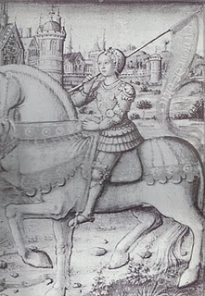

Above, Joan of Arc of France

The Turbulent Life of The Rt. Rev. John Holyman, First Installment
It was while researching Holymans in the Tring Library, I came upon the incredible news that a Holyman farm existed in nearby Cuddington, and that a Bishop John Holyman had been born there. Cousin Maxine Wright of Arkansas had emailed a blurb on this John Holyman several months earlier alerting me to the existence of this particular Holliman. Within the hour, my wife and I drove to the village and indeed visited the Holyman farm, met the present owner, and the next day interviewed one of the village historians, Miss Peggy Cattell. We spent several hours with Miss Cattell and her sister, Nancy, collecting information and papers.
The small village of Cuddington, Buckinghamshire, England is approximately 12 miles from Tring, Hertfordshire. A probable ancestor, The Rt. Rev. John Holyman, lived during the eventful times of the Tudor kings and queens. This John played a role in attempting to forestall the Protestant Reformation in England. Time, place and name suggest we American Hollimans carry some of his family DNA. An ancestral cousin or uncle? I would say the odds favor such, and perhaps with more research we can connect all the dots.
What follows is the first portion of a paper presented in 2005 to the local historical society by Miss Peggy Cattell (photo on next page) which we reproduce with her permission.

"They Lived In Cuddington" by Peggy Cattell (photo below)
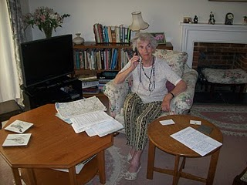
"It was in 1495 that John Holyman was born. Records don't give any further information about his life in Cuddington, other than that he was born here but the family home was probably a manor house in the field near to the present Holyman's Farmhouse."
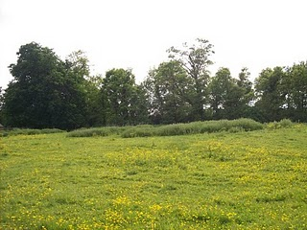
On the site of this grassy rise on the west side of Cuddington stood the manor house of the Holyman family in the 15, 16 and 17th centuries. Today this field stands fallow for sheep pasture on still existing farm land."
Another and more accurate assumption can be made that he must have been baptized in Cuddington Church, in the font which we still use. The font goes back well before his day. We know that the font was moved into its present position in the south aisle from the north aisle in the later part of the nineteenth century."
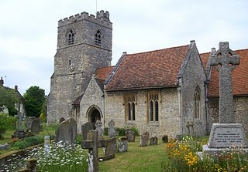
The photo above is the exterior of the Cuddington parish. The lower photo is of the baptismal font which is over 500 years old. Miss Nancy Cattell, the sister of Peggy Cattell, is on the left, and the author on the right taking notes. Photos by Barbara Holliman.
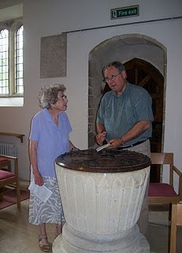.
"We can say for certain that his parents brought him through the present north doorway, and from the list of vicars we can assume that the incumbent of that time - William Burtone, priest from 1494 to 1511 - must have performed the baptism."

The Turbulent Life of The Right Rev. John Holyman, Installment 2
Below we continue the paper of The Rt. Rev. John Holyman that Miss Peggy Cattell presented in 2005 to the Cuddington Historical Society, Buckinghamshire.
"John went to school in Winchester (a prestigious school, second only to Eaton), probably at the age of eleven and developed into a fine scholar. From there he entered New College, Oxford and was awarded the Bachelor of Divinity in 1526. For a short time he was rector in Colerne (in Ireland) but this did not suit him. He turned to Oxford, this time to Exeter College, where he acquired a Doctor of Divinity degree.

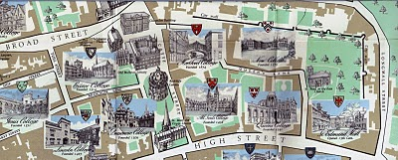New College, top right on the above map, is just inside the Old City Wall in Oxford. Not so new, New College was founded in 1379. Center left of the map is Exeter College, a bit older founded in 1314.
"After this second time at Oxford, Dr. Holyman became a monk at St. Mary's Abbey, Reading."
"By this time, he was known as a brilliant scholar, a man of great piety and most eloquent preacher - fine qualities but not ones to blaze his name over the country, but this was soon to come. "

This stained glass window at the Bristol, England Cathedral is of the founder of the abbey which later became the Cathedral where The Rt. Rev. John Holyman presided from 1554 - 1558. Brother John Holyman, when a monk, would have worn a habit such as above and had tonsured hair. Photograph by Barbara Holliman, 2010
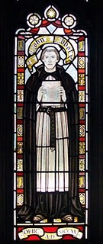 .

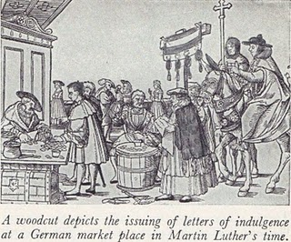
"The age in which he was living was one of great religious upheaval. Up to 1517 all of Europe belonged to the Roman Catholic Church owing allegiance to the Pope. In Germany, Martin Luther spoke out again the selling of indulgences - that is people being offered the chance to buy themselves absolution from their sins. Luther believed that only through faith in Jesus Christ could sins be absolved. His concerns spread and a wide rift developed in the church. Those who protested again the Pope and Roman Catholic Church came to be known as Protestants.”
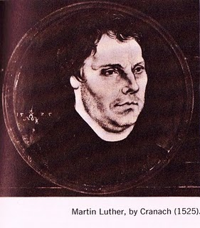

"Holyman's abbot became concerned at what he described as this Lutheran Heresy spreading to England. He sent his best preacher up to London to speak against these thoughts at St. Paul's Cross. And so Holyman was thrust into the centre of this important conflict!" (Speaking at St. Paul's Cross in the 1500s would be today's equivalent of appearing on all the major television news channels and having a Facebook page.)

The Turbulent Life of The Rt. Rev. John Holyman,
Installment 3
Historian Nancy Cattell continues her paper on Cuddington, Buckinghamshire resident John Holyman.
"While in London Brother John embroiled himself in not just Reformation issues but also the marriage crisis of King Henry VIII (1591 - 1547). Henry had decided that he must ask the Pope to grant him a divorce from his first wife, Catherine of Aragon. He claimed that because she had been his brother's widow he should not have been given the dispensation to marry her. This 'sin' was smoting him."
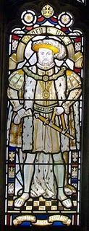
This likeness of King Henry VIII is in the Cathedral at Bristol, England, the Cathedral from which Bishop John Holyman presided 1554 to 1558. Photo by Barbara Holliman.
"This after 20 years of marriage, but of course the real reasons for his desire for a divorce were (a) that Catherine had not provided him the son he wanted and (b) much more important - he had fallen desperately in love with Anne Boleyn and wanted to marry her.”
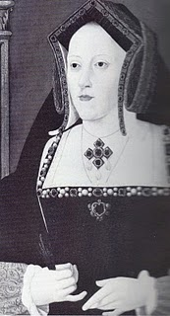Catherine, the rejected Queen
"The Pope refused Henry's request, and good Catholic that he was Brother Holyman started preaching in favour of the validity of the marriage to Catherine. This was a very courageous act or if you like, a very foolhardy one for Henry did not approve of criticism."
Anne Boleyn, the mother of Queen Elizabeth I.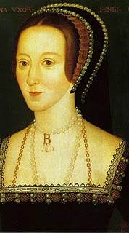.
"Holyman must have made a discreet move from London otherwise he would surely have lost his head - one book I read told me that his abbot did and certainly the Abbey was dissolved during Thomas Cromwell's 'displacement'. "
"As we know when the Pope refused to grant the divorce, Henry cut the Church in England off from the Roman Catholic Church and thus the Church of England came into being. Henry declared himself the head of the Church and so obtained his divorce from his new Archbishop Thomas Cranmer."
"Brother John Holyman left London and sought refuge in Long Hanborough, near Woodstock where he became the rector (and kept his head and kept it down)."
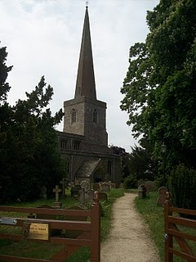
The parish church in Long Hanbourgh stands today between Oxford and the historic town of Woodstock, the home of Blenheim Palace and the birthplace of Sir Winston Churchill. Photo by Barbara Holliman in 2010.

The Turbulent Life of The Rt. Rev. John Holyman, Installment 4 by Nancy Cattell
During the last years of Henry VIII and the reign of the boy king, Edward VI, our John Holyman served as priest at Long Hanborough, near Oxford, and later vicar at Wing, near Tring, Hertfordshire.
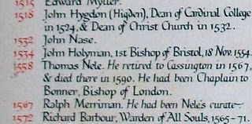
The name John Holyman appears (above) on this list of rectors who have served the parish in Hanborough. This roster hangs on the church wall. There is an error; John Holyman was the second, not first Bishop of Bristol.
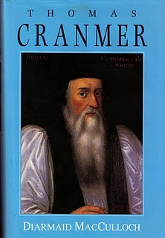
The photo of a book of Archbishop Thomas Cranmer is the latest in many excellent works on this pivotal priest during the Reformation. Some of the activities of our Bishop of Bristol are recorded in Diarmaid MacCulloch's biography which was published Yale University Press in 1996.
During the English Reformation, out went certain Roman traditions and services and in came a more simplistic style of worship and church decorations. English, not Latin, became the language of the pulpit and altar. Cranmer wrote the first Anglican Church prayer books, the model and language which survive even into the 21st century in the American Episcopal Church.
How did this strongly Roman Catholic John Holyman retain his priesthood and parishes in all this change? Discretion must have been his middle name.
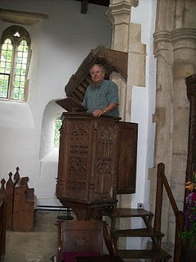
However, one of his distant descendants practices an indiscretion, standing in the 15th century pulpit where John Holyman preached in the 1540s in Long Hanborough.
The Turbulent Life of The Rt. Rev. John Holyman, Installment 5 by Nancy Cattell

The life of John Holyman reached a climax during the reign of Queen Mary Tudor, or 'Bloody Mary' as she was termed by Protestants.

Nancy Cattell of Cuddington, Buckinghamshire, England concludes her story of this distant ancestor.

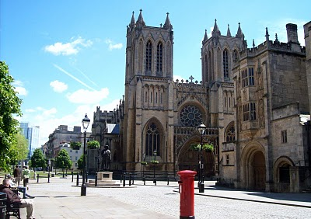

The west entrance to the Bristol Cathedral with a quintessential Royal Post Box in foreground. From 1554 to 1558 The Rt. Rev. John Holyman occupied this Episcopate. Photo by Glenn Holliman
"Upon the accession of the Catholic Mary, daughter of Catherine of Aragon, John Holyman was appointed Bishop of Bristol, obviously as a reward for his support of her mother. Once again Holyman was into the limelight for now the Protestants who had supported Kings Henry VIII and Edward VI were to be tried. Bishop Holyman was included in the commission that tried Latimer, Bishop of Worchester and Ridley, Bishop of London. They were found guilty of heresy. In 1554, Holyman also participated in the disputation of Archbishop of Canterbury, Thomas Cranmer." 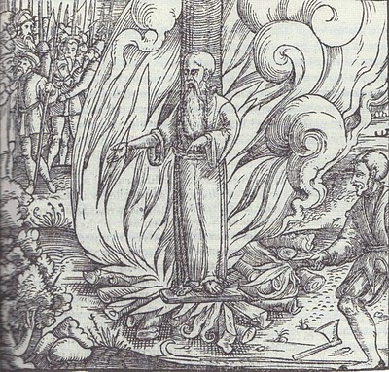All three Protestant bishops were burned at the stake at Canditch in Oxford for their 'heresy'. The above woodcut is of Cranmer's death from the famous Fox's Book of Martyrs. In Bristol from 1554 - 1558, five more Protestants found martyrdom as 'candles' for Protestantism. In fairness to The Rt. Rev. John Holyman, he is reported to have opposed such actions, but they did occur during his episcopate.
"In 1558, Mary died and was succeeded by the Protestant Elizabeth. So once again the tables were turned and the Catholics were now put on trial. Bishop John Holyman avoided a violent death, as he died of natural causes a month after the accession of Queen Elizabeth I. His burial took place at Hanborough Church."
"I am so amazed that anyone born in the 16th century in what must have been at that time the most obscure of little villages should have produced a man who was at the centre of all the important happenings of that tumultuous time." - Nancy Cattell, Cuddington, Buckinghamshire, UK 2005

Paul Bushe, the first Bishop of Bristol received an ornate tomb with effigy (photo of the
Bushe tomb at the Cathedral sanctuary).

.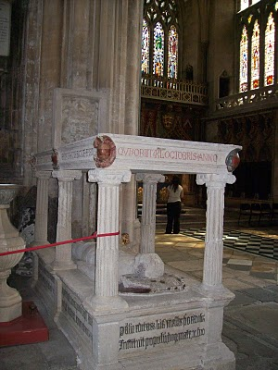

But the second bishop, much more controversial and in disrepute at his death, lies buried in Long Hanborough in his former parish church. John Holyman's remains lie under or near this 16th century memorial (photo on next page) in the small village parish near Oxford. Photos by Barbara Holliman.

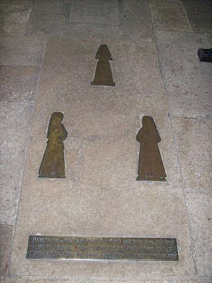
Burial spot in Long Hanborough of Bishop John Holyman, 1558.
Bishop John Holyman's Will, 1558

During my 2010 visit to the village of Cuddington, Buckinghamshire, England, this photograph (below) was taken of Mrs. Caroline Stonham and myself in the back garden of her 17th Century thatch cottage.

What is remarkable about this cottage is that it rests on the Holyman farm, and Holymans used to live in the residence in this photograph!
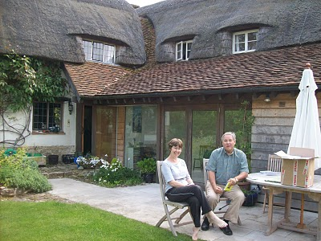
In a previous chapter, I dropped in a photograph of the location of the old 'manor' house where 16th century Holymans lived, approximately 200 yards from where Caroline and I are sitting.

We are reviewing Holyman papers she has collected in the twenty years she has lived on the farm. She is a geography teacher and has a keen appreciation of the history of her home. She kindly shared of her research and gatherings with me, allowing my wife to photograph the many documents. With her permission, I now share them with you.

One of the papers we reviewed follows. It is the 1558 will of Bishop John Holyman. It is a transcription but it does contain a bit of Shakespeare era English. Being celibate, John had no children, but he did have servants whom he remembered and he left funds to colleges and the parish where he is interred. Notice he left funds to pray for the repose of his soul. For one who had been a monk, and had taken a vow of poverty, he left a sizable estate although no land. But he was a bishop which was the top of the ecclesiastical hierarchy.
We owe a debt of gratitude to Bob Hollyman-Mawson of Wales for seeing to the transcription of this will.

Page 1
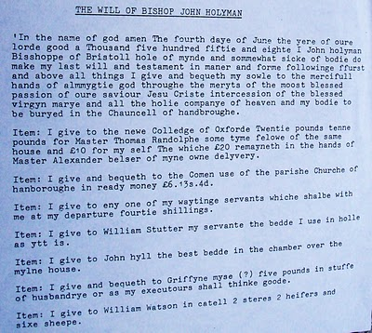

Page 2
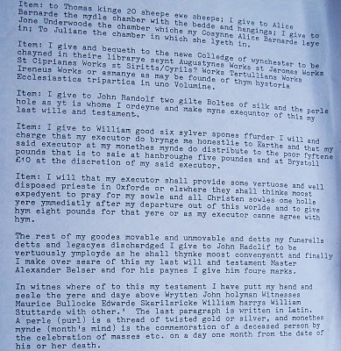

Continuing the Search for our Ancestors in England

What follows are copies of research from Caroline Stonham, current proprietor of the Holyman Farm in Cuddington, Buckinghamshire.

Page 1
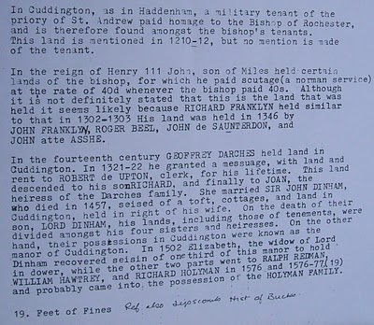
Page 2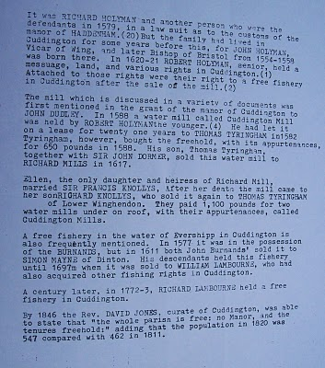These documents may be of use to any Hollimans who research our English roots....

After research in 2011 in England, my eye is directed to Thomas Tyringham in the story above. A prominent Tyringham family lived a few miles from Sherington, Buckinghamshire, the home of a prominent Christopher Holyman in the 1580s. Is this a connection tying the Cuddington Holymans to the Sherington Holymans and hence to our Christopher Holliman (1618 – 1691)? Tantalizing, is it not?

More on the Holyman Farm, Cuddington, Buckinghamshire, England

In the past few posts, I have been sharing information and photographs of a Holyman farm, described in some English sources as a former 15th century manor house. In the next photo is a contemporary plaque attached to one of the barns, now a residence. This sign celebrates the name of the farm and its most famous namesake, Brother John Holyman (1495 - 1558), a monk and later the Rt. Rev. John Holyman of Bristol.

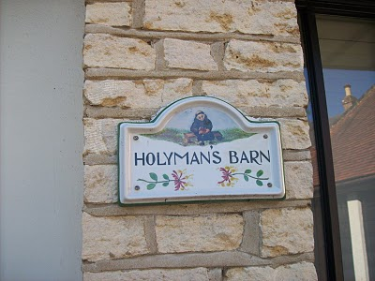
Below from “The Monuments of Buckinghamshire” is a description of the 17th century thatched Holyman cottage that we have featured in previous posts.
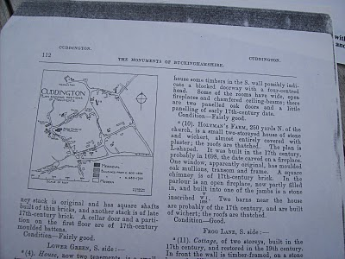

The current owner of Holyman Farm, Mrs. Caroline Stonham, has prepared the following family tree of the Holyman family and others that lived on the property. Perhaps it is of some use to those studying deeply into our English past. Through it one may be able to connect the family to our other English ancestors reportedly from Tring and/or Bedford. Where there are no last names, insert Holyman. Photos by Barbara Holliman.
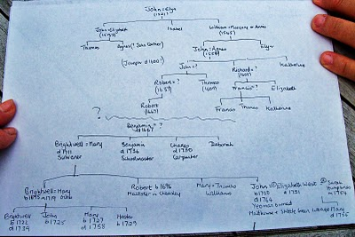
The Holyman Farm of Cuddington has Secrets to Reveal
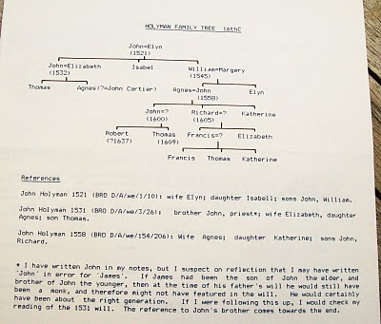
Previous is a typed family tree of the Holyman farm prepared by its present owner, Caroline Stonham. Below is a wing of the 1698 thatched cottage on the Holyman Farm.
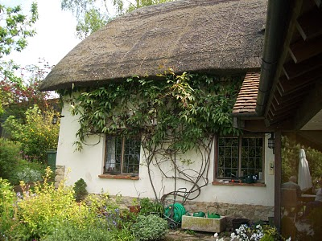

Leaving the Lovely Village of Cuddington

Below a photograph of sheep grazing on a Chiltern hillside near Cuddington, Buckinghamshire. This pastoral scene is typical of the landscape around Tring, Cholesbury, Aldbury and Berkhamstead where the name Holyman pops up in parish registers and legal documents in the 15th, 16th and 17th Centuries.
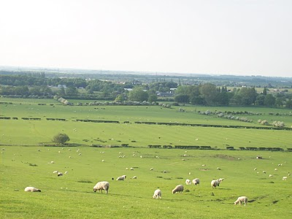

The folk of Cuddington, including Peggy Cattell and Caroline Stonham, were kind and generous with their information on the Holyman family. Below is Nancy Cattell who showed us around the parish church and village. Notice the thatch cottage on the right. It dates to the 1500s.
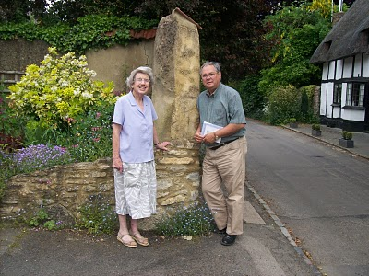

Below is a diagram of a typical small farmers thatch cottage of earlier centuries.

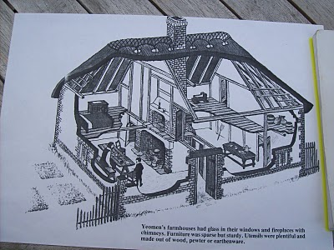
A Family Tree from Cuddington

An email by cousin Betty in the Tina Peddie chat room asking more about the family tree from the farm sent me deeper into my research papers. I reviewed again scattered papers from Lipscomb's “A History of the County of Buckinghamshire, Vs. 1 & 2” photocopied from Miss Peggy Catell's collection of genealogical materials.

Then I pulled out from other historical records (listed below) of Holyman material and have created a time line, which I hope will be of some benefit someday to someone. I then compared this time line to the family tree of Caroline Stonham's. This can be confusing so do not feel one has to memorize the article.

Let's begin with this photo below from 1965 supplied by Mrs. Stonham, current owner of the Holyman Farm. This picture shows a working farm 45 years ago. The thatch cottage is the same one I have been posting, constructed during the time of William and Mary, 1689. The farmer in front wears a typical English sweater and cap. Notice the stone fence. Quintessential England!

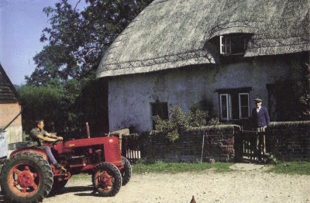
Below, a Time Line of the Holyman Farm using the Buckinghamshire History, the 1522 Certificate of Musters in Cuddington, the 1555 Manorial Survey and the HolymanFamily Tree prepared by Carolyn Stonham of Cuddington

1495 - The Rt. Rev. John Holyman born at the manor. His father was John Holyman (d 1521) married to Elyn in the Stonham family tree.

1511 - A Richard Hollyman receives receipts on behalf of the Priory of Rochester which was at that time still 'lord of the manor'. No mention is made of a Richard Holyman in the Stonhamtree. As noted in the Manorial Survey of 1555, the farm had been divided and Richard probably was a brother or uncle of Bishop John Holyman.

1522 - The Certificate of Musters from Buckinghamshire in 1522 (Aylesbury, 1973), p. 72 listed the villagers of Cuddington for tax purposes. The following Holymans were listed as holders of land:

John Holliman (deceased that year and father of Bishop Holyman)

John (James) Holiman Jr. (as son of the above who d 1521)

William Holiman (a son of the above who d 1521)

Ellin Holiman (wife of John (d 1521) and mother of James and William)

Thomas Holiman, son of John (James) Holiman, Jr.

1527 - A John (James) Hollyman took over the 'farm' of Cuddingtonfrom the Priory for a lease of 30 years. This would be a son of John (d 1521). This John (James) had a brother named William who married Margery or Annis. William died in 1545. William and John, according to Stonham, were brothers of Bishop John Holyman. Stonham believes the records reads "James" not John Holyman as is printed in her Holyman family tree.

1531 - John (James) dies in 1531 and wills the lease and 'bedding' to his son Thomas Hollyman. This John makes provision in his will for the repair of the Cuddington bridge. This is in agreement with the Stonham family tree showing a John (James) Holyman, married to Elizabeth dying in 1532 (when the will was probated or by the old calendar).

1539 - Henry VIII dissolves all monasteries and nunneries, and this king takes legal possession of the Farm. Thomas Hollyman, 'farmer' of Cuddington now leases from the king and no longer the Priory of Rochester. The Stonham document does not list the date of Thomas' death unfortunately or any further children, but we do have Thomas still listed in a 1555 manorial survey.

1542 - Thomas made a profit of over 20 pounds from the farm.

1545 - Elizabeth Holyman of Cuddington in her will wrote (as normal in those days), "I bequeath my soulle to the great mercye of all mightie God and to his mother Marie and all the saints in hevyne." (Remember at this time in England, almost all were Roman Catholics and the Anglican Church was just emerging from the Reformation in Europe.) According to Stonham, Elizabeth was Thomas's mother.

1545 - William Holyman of Cuddington leaves a bequest in his will to mend and repair the bryg waye (by way or road) in the village. (It was common for individual charity to maintain roads in the 16th century.) As noted above, Stonham agrees with this death date. Again William was a brother of Bishop Holyman.

1530s - The Rev. John Holyman writes two books in Latin – “A Treatise against the teaching of Martin Luther” and “A Defence of the Marriage of Queen Catherine with King Henry VIII”. The works do not survive, but his politically explosive books resulted in a new title for John. He was now 'an enemy to the King's cause'. Not good for the Holyman family!!

Fr. John is thought to have retired to the Farm at Cuddington and stayed until he was appointed to the vicarage of Wing in 1546. Later he would be vicar at Handborough prior to becoming Bishop of Bristol. According to Stonham, this elder John would be staying with his nephews - Thomas, the son of John and Elizabeth and John, a son of William who died in 1545. This younger John dies in 1558, ironically the same year as his famous uncle.

1554 - 1558 - John Holyman appointed Roman Catholic bishop of Bristol by Cardinal Pole under Queen Mary Tudor. Bishop Holyman involved in the trials for four of the five bishops executed for heresy during 'Bloody Mary's' reign: Cranmer, Latiner, Ridley and Hooper.

1555 - A Manorial Survey from the Public Record Office in London listed Thomas Holyman as the holder of manor from Queen Mary Tudor which included all houses, lands, a water mill and four acres of pasture land. His nephew, John Holyman, son of the late William Hollyman also held considerable lands as a copy holder.

1574 - Richard Hollyman, the younger, of Cuddington initiated a legal suit against Richard Beake over the custom of bedripp or an extra harvest duty. (Yes, people have quarreled always about taxes. Notice this is Richard the Younger.) According to Stonham, this Richard would be a great nephew of Bishop Holyman. This Richard died in 1605 considerably outliving his father, John (d 1558) who was the son of William (d 1545), who was the son of John (d 1521). This Richard was then a great, great nephew of Bishop Holyman.

1582 – Richard Hollyman leases land, and later sells it to Thomas Tyringham and his son. Although the name of Christopher Hollyman is not mentioned, the Tyringhams would become major land owners near a Christopher Hollyman’s late 1500s home in Sherington, Buckinghamshire. Is this the connection tying the Cuddington Hollymans to the Virginia Holymans in the middle 1600s?!

1600s - Manor remains crown land until reign of James I.

1689 - Thatched cottage (see above) built. Date is on fireplace mantel in main room of the house.

1700s - The Farm evidently stayed in the Holyman family (according to Stonham) until at least the late 1700s.

1900 - Approximately around the turn of the century, the last Holyman dies in poverty in Cuddington.

So what to make of the above?

While this family tree and supporting evidence appears firm, one of the above Holymans, perhaps one of Bishop John Holyman's two brothers - John (James) and William had a male offspring who moved at some point to Tring and Cholesbury. Unfortunately Caroline Stonham does not take the family tree out of Cuddington.

Below a map of the Holyman Farm in the 1500s.

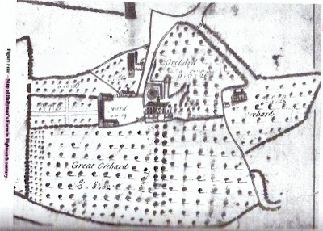

Making Sense of Our Cloudy and Confusing English Past
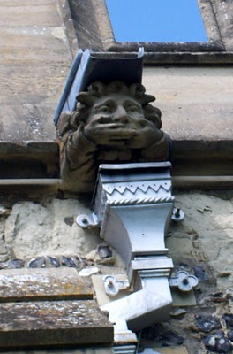This gargoyle on the parish church at Tring, Hertfordshire, England represents the challenges to discover our Holliman roots. The 'past', this gargoyle, seemingly does not wish to tell us what we long to hear clearly....who are our ancestors? Photos by Barbara Holliman

Indeed, research provided by cousins Maxine Wright and Joe Parker is moving the focus of our search from Tring to Bedford, Bedfordshire, England, approximately 35 miles to the north.

In the meantime, I continue to share some findings in Buckinghamshire and Hertfordshire, about 25 to 30 miles northwest of London. Below is a map of the villages where Holymans lived in the 16th and early 17 centuries: Cuddington, Tring, Cholesbury, Berkhamstead and Aldbury. They are shadowed in a yellow marker.

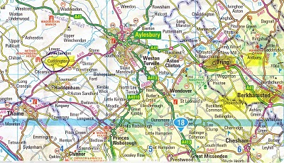

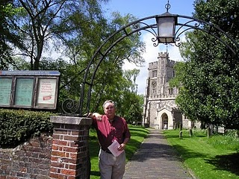
In the photo above, I stand in front of the Tring, Hertfordshire parish church, which has been reconstructed several times since its 11th Century founding. The present structure was erected in 1470. In this sacred space in England some of our distant ancestors probably worshiped and their remains may linger in the ground behind me.
After visiting the Tring parish church a first time in 2005, my wife and I stepped down the block to visit a charity shop (seeking yet more royal coronation ware, a vice of mine). The kind clerk showed us the local telephone book. Yes, seven or eight Hollimans were listed in the local exchange. Hmm… Later we motored to a pub for roast lamb and red wine (and I remember little more of that day!).
Connecting Cuddington Holymans to Cholesbury Holymans and Tring Holymans

Cousin Jeanette Holiman Stewart shared information on the Holyman and Weedon (Wedon) families of Hertfordshire, England from the “English Origins of New England Families”. Before reviewing her excellent research, I had been preparing the article below which echoes and strengthens her findings. I attempt to weave her public work into the growing narrative of the Holymans in Tring and Cuddington, England in the 16th and 17th centuries. My thanks to Jeanette, Joe Parker and all for making available to the larger Holliman, Holleman, Hollimon, etc. families their increasing knowledge of our historic roots.

Earlier another cousin, Maxine Wright, a relentless researcher in pursuit of Holliman origins, had mailed me the following information of one Richard Wedon or Weedon, who lived in Botley, a small village near Cholesbury and Tring. As one can read in the first paragraph of this p. 187 of “The Register”, published 1954, Richard had to pay a fine in 1567 for breaking the head on another man's servant. Hmmm....

Richard must have matured because nine years later, in 1576 he married Jayne Holyman in Cholesbury, near Tring. The information below states that this Jayne Holyman was from 'a yeoman family of good standing in Cuddington', descendants of Bishop John Holyman, whose life we have reviewed in previous blogs.

Several other items leap out at us. Richard and Jayne had a son named James who evidently immigrated to Rhode Island! Did James join a cousin named Ezekiel of Tring in Rhode Island? One remembers that Ezekiel Holyman, an Anabaptist, baptised Roger Williams the founder of Rhode Island!
Notice that Richard Wedon writes a will in 1618 (it is probated in 1624, presumably the year of his death). The will is witnessed by William Holyman.
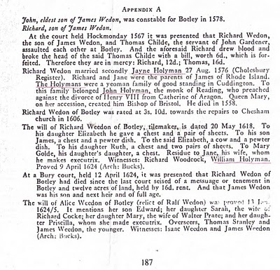
Now the issue grows more complicated. Above we have Jayne Holliman married to Richard Wedon. Below in another section of “The Register”, we have a John Holyman appearing in marriage in 1593 and dying a few years later. Goodbye to this John who had no children.

However, now William Holyman, the eldest son of another William Holyman, appears again (noticed who witnessed Richard Wedon's will), baptized June 1583 and his sister Priscilla February 1584/5. They have a brother named Ezekiel.

This Ezekiel, according to many web sites and those who have researched Baptist Church history, is the Ezekiel who sailed to Massachusetts and helped found Rhode Island!

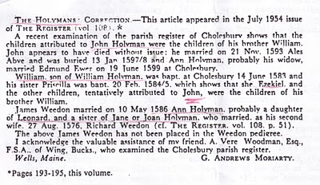

Notice in the next paragraph an Ann Holyman married another Wedon May 1586, and is noted as a probable daughter of Leonard Holyman and a sister of Jane Holyman.

Confusing? Yes, but stay with me. In the next article, we are going to examine Leonard Holyman and his offspring. In web sites, Leonard is listed as the father of Ezekiel Holyman.

So, two thoughts emerge:

1. Leonard Holyman and other Holymans of Tring and Cholesbury, including Ezekiel, are indeed descendants of the family of Bishop John Holyman of Cuddington.

2. Bishop John Holyman, a devout Roman Catholic, therefore is probably a great or great great uncle or cousin of Ezekiel Holyman, who was religiously antithetical by 180 degrees, to his prominent descendant, an Anabaptist in America!

For those interested in religious history this is an amazing family!! One generation burns Protestants at the stake; another helps establish the Baptist Church in Rhode Island.

So are all these interesting Holymans our direct ancestors? Ancestors, most probably yes. Direct? - more work to do.

Continuing the Search for John Holyman (1572 - 1650)

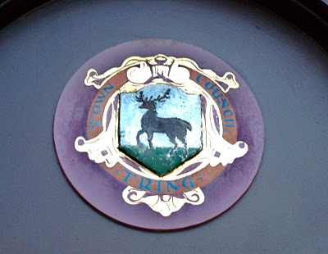Tring, Hertfordshire traces it roots to Anglo-Saxon times, and was located just west of the Danelaw in the 900s. The hamlet is listed in William of Normandy's Doomsday Book. The above is the town logo.(Photo by Barbara Holliman)
I am still looking for that elusive John Holyman who, according to one prominent Holliman genealogical website and the LDS records, was born in Tring, Hertfordshire in 1572. John is the widely reported father of Christopher Holliman, Sr., who is our ancestor of solid record. However, I have grown dubious that this John Holyman ever existed.

We do know a John Holyman did die in Southampton, Virginia in 1650 and left a will which devolved property to a friend, not family. As readers of this web log know, there was a Bishop John Holyman (1495-1558) and an Ezekiel Holyman (1586 - 1659), both religious leaders. One was Roman Catholic and the other a Baptist Protestant. The evidence supports that they are related.

Cousin Jeanette Holiman Stewart shared by email information that in the “English Origins of New England Families, Vol. III”, pages 193 - 195, one will find an article by G. Andrews Moriarty entitled 'The Holymans'. In this article Moriarty quotes “The Register”, an English genealogical publication, that the Holymans were a family of 'substantial yeomen' with branches in Cuddington, Cholesbury and Chesham. The Rt. Rev. John Holyman, Bishop of Bristol from 1554 to 1558 was a member of this family as was one Jayne Holyman (1552 - 1632) and her nephew, Ezekiel Holyman.

From the Latter Day Saints genealogical website, we have the following:

One Leonard Holyman (1520 - 1573) was born in Cholesbury and died in Tring. From the above source we know that Leonard is related to the Cuddington Holymans. Leonard is a contemporary of Bishop John Holyman. Were they brothers or cousins? Cuddington, as the earlier map notes, is an hour or two by horse from Tring and Cholesbury.

Leonard married a Joan (b 1525) also of Cholesbury. They had at least seven children. One was the Jane (Jayne), referred to above, b 1552 in Tring, Cholesbury, died 1636 and is buried in Chesham (near Cholesbury). She married Richard Weedon, as noted in the last posting. One of their sons, James, immigrated to Rhode Island, as did Jayne's nephew, Ezekiel.

Jayne's brother, John Holyman (1548 - 1597), was a weaver and had a wife named Ales (Alice). There were a number of children of this marriage, one being Ezekiel Holyman, who would immigrate to New England and help found the Baptist Church in America. Another child, Eljsabeth, married into the Weedon family herself.

Two of Leonard's sons, Edward and William, left wills of which I found and made copies while in the Hertfordshire Archives. There was a third son, John, whose will is below and lifted from the “English Origins of New England Families”.

The Will of John Holyman (1548 - 1597)
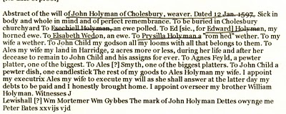

Now John Holyman (d 1597) left a will (abstract above) which does not list a son named John Holyman (remembering we are looking for a possible John Holyman, b. 1572 in Tring). John (d 1597) does list a godchild, whom he terms John Child. To this godchild, Holyman left his 'looms and all that belongs to them'. His own children received much less, Ezekiel only getting a ewe. Why did he favor the godchild over his natural children? Perhaps John Child had an aptitude for weaving while the others did not? But this John also left John Child his land after his wife's death.

Why favor John Child over one's own children?

Could John Child have taken the last name Holyman from his godfather, John Holyman? Could this John Child be the elusive John Holyman (d 1650 in Virginia)? The dates work. Could this godchild be a natural offspring of John Holyman (d 1597), given perhaps a last name (Child) to obscure a birth out of wedlock? This is only speculation on my part, but the bequests are odd.

So John Holyman (d 1650) is still hidden in history as far as primary sources are concerned, if he be from the Tring area if he existed at all. As cousins Maxine Wright and Joe Parker have revealed, there is evidence John Holyman (d 1650) may have been from twenty-five to thirty miles north in Bedford. If so, why are so many web sites placing him in Tring?

The Will of William Holyman (1550 - 1623), Part I

In the Hertfordshire archives in Hertford, England, one will find several large rooms filled with books, manuscripts microfilm and photographs of local, family and national history. In the short time I was there, the friendly staff pointed me in several directions.

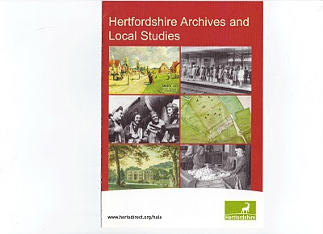

This brochure may be of help to those reading this blog.
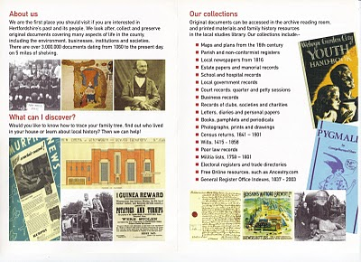
While there I reproduced from microfilm the wills of Edward Holyman and his brother William Holyman. Before I post them and attempt to transcribe, let me share with readers the way our English alphabet looked in the late 16th and early 17th century. (See next page)

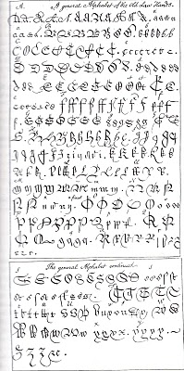
This really is your great grandfather's alphabet! Yes, it is A to Z with several samples for each letter. Some are easy to identify; others are a mystery. It makes interesting reading.

The Will of William Holyman (1550 - 1623) of Tring, Part II

In the index of wills in the Hertfordshire Archives in Hertford, England, I found and copied the last words of William Holyman, son of Leonard Holyman (1520 - 1573). Bear in mind, I was looking for the John Holyman, the reported ancestor of the American Hollimans. While this will does not disclose our elusive direct ancestor, this document does reveal information on the lives and times of our distant cousins, uncles and aunts when we Hollimans were English. The document is divided into two parts due to my scanner only taking a section at a time.
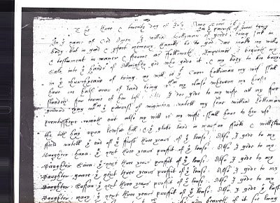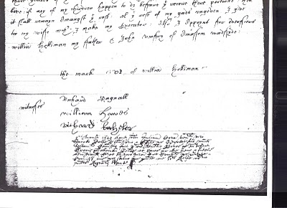

What does it say? As no expert, here is my attempt to transcribe the writing form of early 1600s English script.

"The ___ and twentieth day of July Anno Domi 1623 ___ In the Name of God Amen. I, William Holyman of Great (in the parish of Great Tring) being poor in body, but in good and perfect memory, thanks be to God, do make my will and testament in manner and form as followeth,

First, I bequeath my soul into the hands of the Almighty God, who gave it and my body to be buried in the church yard of Tring.

My will is that Grace Holyman, my wife, shall have on half acre of land lying between my house __ for ___ (rest?) of her life. Also I do give to my wife all f___ ___ ___ ___ that ___ of ___. ___ my son William ___ ___ ___ out also my wish is to my wife ___ ___ to her rest the __ hay upon ___ hill; and the glebe land in ma___ field and one of the ___ of the first three years of the field lease. Also I give to my daughter, Hanna, the next ___ years profit of the lease; also I give to my daughter, 'Saiva' or 'Eva', the next three years profit of the ___. Also I give to my daughter, 'Grace' the next ___ profit of ___. I give to my daughter, 'Saffon', the next ___ years profit of the ___. Also I give to my daughter Mary the ___ ___ ___ profit of the ___. Also I give the ___ three ___ of the ___. Unto the ___ my wife ___ ___ if it ___ ___ ___. If any of my children happen to die before they received their portion, then it shall remain amongst the ___. All this ___ of my ___ I give to my wife ___ I make my executor. Also I appoint for administrators (?) William Holyman my father and John Romsy of ___ ___.

The Mark of William Holyman, submitted"

My opinion? Here we have described a yeoman farmer living in Tring, to be buried in Tring and farming fields just outside of Tring. He has few worldly goods other than a lease hold on the land.

Looking for John Holyman in Edward Hollyman's Will of 1617

Just to remind all, the William listed in the last post is the uncle of Ezekiel Holliman, one of the founders of the Baptist Church in Rhode Island and the person who baptized Roger Williams, an architect of American religious liberties.

The Edward Hollyman in this post is also Ezekiel's uncle. John Holyman, a brother of William and Edward, is Ezekiel's father.

So here we are knowing Bishop John Holyman (1495 - 1558), devout Roman Catholic who burned Protestants at the stake during the reign of Mary Tudor, is a great uncle or second or so cousin of Ezekiel. Now in all this where is the mysterious John Holyman of Tring (1572 - 1650), stated by one prominent Holyman web site to be the founder of American Hollimans in Virginia?

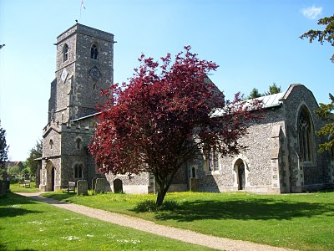The parish church in Aldbury, located a few miles east of Tring, Hertfordshire. Are our relatives buried here also? Photo by Barbara Holliman, 2010.
In the last posting we explored the 1623 will of William Holyman of Tring, son of Leonard Holyman. In this article we reproduce below from the Hertfordshire Archives, the will of Edward Hollyman of Aldbury, brother of William. Aldbury is only a few miles from Tring. Edward lived from 1546 to 1617, and spelled his name with two 'L's. Edward was more prosperous listing furniture and household items to be dispersed as well as land holdings. Note brother William Holyman witnessed this will. As the scanner cannot record the entire will at once, it is divided into two parts.
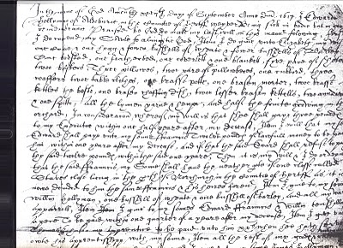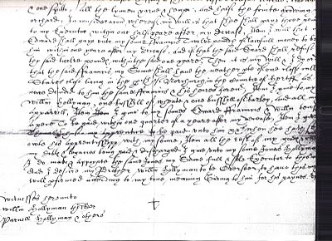

I have not attempted to transcribe this document, but have studied closely the bequests and names. This will seems more difficult to read than William's. A name intrigues, and I remain puzzled over it. Look closely at the second section and notice the fourth line from the bottom of the will. Beginning in the middle, you will read the words which I transcribe as "I give unto my sons Jonas Hollyman," then words are obscure.

I have pondered and pondered this clause. Is this word John in Latin, Medieval French or 16th century English script? What to do about this? One avenue is to check the Aldbury Church of England register. Remember Thomas Cromwell as of 1538, Henry VIII's chancellor, decreed that all parishes register baptisms, marriages and funerals.

However, I cannot find in Edward's will (as in William's) that he asked to be buried in the parish church lawn. Had Edward joined a non-conformist church (Puritan or even more controversial – the Anabaptists for example) by 1617, as obviously had his nephew Ezekiel? If so, Edward's demise would not be recorded in Anglican Church records.

So I will search the Internet to see what can be found, and if nothing can be found, well, back to the Hertfordshire Archives my next trip to England. A clue, a weak one, but....could this be the not-yet-found John Holyman, d. 1650 in Jamestown, Virginia?

I agree, this is a big, huge stretch and even if this name be John, would it also be our John, English founder of our American family....? No, I don’t think so.

Below, is a family memorial in the Aldbury parish. No, not a Hollyman plaque, as it remembers another departed family. This ghastly, but fascinating 17th Century monument, vividly displays that century's view of morbidity. Our ancestors were part of this culture.

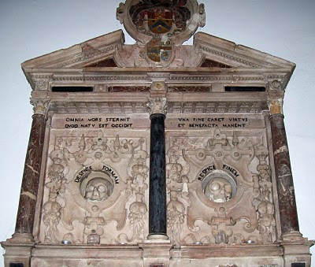Photo 2010 by Barbara Holliman
We are all immigrants from the past...from our families.....

Weddings and Witches
In the Hertfordshire Archives is a book entitled “Hertfordshire Parish Registers” by Phillomore's, 1907, 3 volumes. Of course out of print, and I had precious few hours to review it. It is on my list to revisit someday. However, I did find several weddings of Holyman females to local males. For the record, they are listed below.

By the way, the first two marriages were from yet another village, just a few miles also from Tring - Berkhamstead. Below is a view of its High Street in 2010.
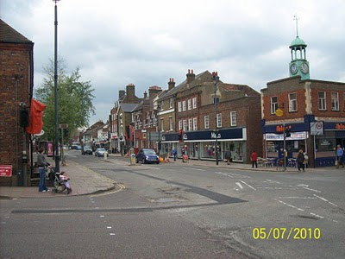

The Berkhamstead Marriages:

Franncys Hadden to Margery Hollyman on 6 May 1601.

Henry Lawrence to Jane Hollyman (Holeman) on 7 February 1638.

Here are two Tring marriages in the same publication:

William Hollyman to Grace Neelie on 20 July 1607 (This is the son of William of Tring whose will we reviewed in When We Were English, Part XIX).

Goff Babylong to Anna Holliman on 7 May 1634

My on-site research failed to turn up the mysterious John Holyman, possibily born in Tring, but I did find a host of very interesting Holymans who impacted English and American religious history. Sometimes it is not what one finds in genealogical research, it is also what one does not find. And sometimes, one may feel bewitched and frustrated not to collect more information. That leads me to my closing historical tidbit you may enjoy.

While reading in the Tring library the 1940 work by Arthur MacDonald, “That Tring Air”, I found that the year 1596 must have been very stressful to our ancestors. They must have observed the following outbreak of, well, witchcraft in their own community!!

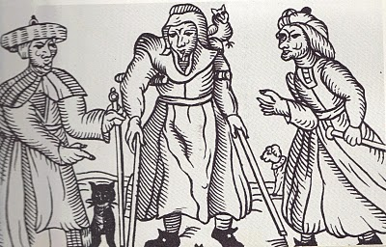
Above a 16th century drawing of three English witches. Rather ugly creatures. Note the black cat.
That year in Tring, one Alice Crutch 'bewitched one Hugh Walden who languished and died'. Nor did the episode of nefarious deeds end there. Another woman, named Elizabeth, put a curse on Thomas Grace's valuable horse and it died!!

For their witchery, these two ladies were 'suspended by neck until dead'!

As I first wrote this article on the Hallowed Eve, think on all the quaint customs of England and Europe that passed through our families to our New World, which we celebrate to this day!

Are the Virginia Holymans from Bedford, rather than Tring?

On the map below, one can see Bedford within the red circle almost due north of London. Tring (unnamed) is located at the red dot just northeast of London.
South west of Bedford is Milton Keynes, whose archives I also visited. Between Bedford and Milton Keynes if the little village of Sherington, where one Christopher Hollyman died in 1589. This gets interesting!
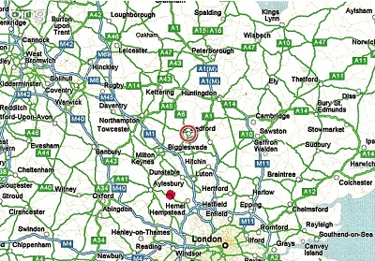

As readers of these articles know, I have spent many chapters expounding on research of our Holyman (Holliman, Holleman, Holloman, etc.) origins. In the late 1990s, a Holyman family tree was posted on the Internet, and many of us took it as gospel. This site, still posted, lists one John Holyman (1572 - 1650) of Tring, Hertfordshire as the English father of our Holliman families in America.

A John Holyman really did die in 1650 in Virginia, as recorded by Virginia records.
However, a continuing search of Internet archives, family trees, research by others, and my own exploration in the Hertfordshire Archives has failed to turn up this elusive character in Tring or surrounding villages, although we have found an abundance of Holymans with some fascinating biographies. I believe they are our relations in some form or fashion.

However, this begs the question concerning John Holyman - have we been looking in the wrong places?

Alas, thanks to research by cousins Maxine Wright, Joe Parker and others, an interesting parish register has turned up in Bedford, Bedfordshire, England. The parish is St. Mary's, now a redundant facility administered by a trust. Bedford is located approximately 50 miles north of London, and about 25 miles or so from Tring. (See map above) The following information is taken directly from the parish register, and can be found in RootsWeb and LDS internet files.

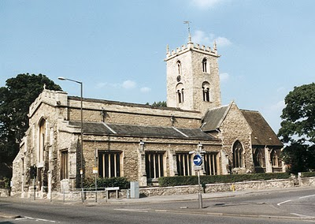St. Mary's parish church, although closed, still stands just south of the River Great Ouse in Bedford. A few blocks away are the Bedfordshire and Luton Archives.

For those of you cognizant of the names of early Virginia Hollimans, these Bedford names are nothing less than amazing. Remember our Christopher Holyman, Sr. arrived 1650 (the same year a John Holyman died) along with a woman named Judith, believed to be his mother or sister. Another Christopher Holliman and another Judith arrived in 1653. Our Christopher Sr. was first married to a woman (our great grandmother!) named Mary.

Be aware, according to colonial records, a Thomas was already in Virginia at Martin's Hundred, one of America's first real estate developments (so to speak).

Now look at these names from the parish registers of Bedford!

1609 - This Thomas Hollyman married Helena Poynard on Oct. 23, however at St. Peter’s in Bedford, not St. Mary’s. Their children are listed below.

1610 - September 16, one John Holliman baptized at St. Mary’s. Is this our elusive John, a reputed American founder of our family who died in South Hampton, Virginia in 1650? John married a Mary Parrell on July 25, 1641.

1612 - On September 13, Ellenora Holliman baptised.

1613 - On November 14, Joan Holliman baptised.

1616 - Thomas Holloman baptised on March 20. Is this the Thomas of Martin's Hundred near Jamestown who took land in the 1630s?

1618 - Christopher Hollaman baptisted on September 2. Is this our Christopher Holyman Senior who immigrated to Jamestown in 1650, raises a large family, makes his earthly fortune and dies 1691?! Is this my generation's 7th great grandfather? The date and names strongly suggest this is so.

1621 - Judith Holliman baptised on February 11. Is this the Judith who arrives in Jamestown with Christopher in 1650 or later in 1653?!

1623 - On May 14, Eleanor Hollyman baptised at St. Mary's. (Her sister, the first Eleanor had died earlier.)

1625 - Stephen Holloman baptised on December 24.

1628 - Mary Holiman baptised on September 13.

So the question is begged - have we found the Holyman family that settled in Isle of Wight, Virginia in the early 1650s?

If we have, then Thomas and Helena Poynard of Bedford, Bedfordshire are our English fore parents, and not a John Holyman of Tring (who may never existed).

I will leave you here to ponder on the above, and to allow me time to gather further notes 'to push this envelope'. Again, this research belongs to Maxine Wright and Joe Parker and someone who entered the above in LDS records. My continuing thanks to them. If I have omitted others, please allow me to correct the record and give credit where credit is due.

This Holyman history gets more and more interesting....(if you are addicted to family history!)

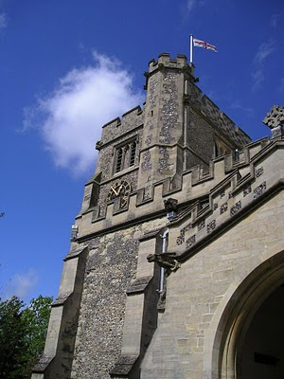

Before We Leave England in 2010
Above the parish church of St. Peter's and St. Paul's in Tring, Hertfordshire. Photo 2010 by Barbara Holliman.

Findings as of Summer 2010

1. I have not found evidence that John Holyman (1572 - 1650) who died in Virginia is our great grandfather, nor have I found information that this elusive, but widely reported fore bearer of our family name, is from the Tring, Hertfordshire area. Or for that matter, even existed. This person is recorded in a widespread web site as the 'founder' of the American Hollimans, and the father of Christopher Holyman, Sr. (1630 ca - 1691). I doubt it.

2. In and around the Tring area were many Holymans in the 15th to 17th centuries, some such as Ezekiel Holliman who immigrated to Massachusetts and helped found the American Baptist Church. Another Holyman was the Roman Catholic Bishop of Bristol (1495 - 1558) during the reign of Queen Mary Tudor. The 'manor' farm of The Rt. Rev. John Holyman still exists in Cuddington, Buckinghamshire and can be visited. I think it probable that these persons are distant cousins and great uncles and aunts.

3. Research by Joe Parker, Maxine Wright and others (LDS records i.e.) reveals that a Holyman family lived not far from Tring in Bedford, Bedfordshire in the late 1500s and 1600s. As I expounded in my last posting, these names - John, Thomas, Christopher and Judith - are the names that show up in recorded records in Virginia from 1630s to 1650s. I join Joe and Maxine in believing it highly probable this is our 'Founding Family'.

4. DNA testing conducted through Tina Peddie's good offices revealed I and others are descendants of Christopher Holyman, Sr. (D 1691) of Virginia who emigrated from England in 1650 with his probable sister, Judith.

Work to be Done

1. Continue to research the Tring records in the 16th and 17th centuries looking for this John Holyman. There are more files and registers to explore.

2. Dig deeper into the family history of the Thomas Holyman family of Bedford. This can be done on-line and on-site at the Bedford-Luton Archives. I have plans to visit these archives in the spring of 2011, Good Lord willing. I note an LDS record lists Thomas Holyman's father as a John Holyman. As a wealth of information was found in the Hertfordshire Archives and Tring library, I strongly suspect a richness of material awaits a Holliman researcher in Bedford and at the National Archives in Kew (a suburb of London).

3. Establish relationships with Holyman's in Bedford and Tring and kindly ask for DNA testing.

4. Explore what ties exist between Bedford Holymans and Tring Hollimans. Geographically speaking, these communities are only twenty five to thirty miles apart, but in the 1500s, this was a two day walk. It is possible (probable?) that a Holyman from Tring moved to the Bedford area in the 1400s or 1500s and established a family.

5. Do not ignore other Holymans in England in the 17th century. Jeanette Holiman Stewart notes Holymans lived in the early 1600s in Worchestershire, England. As with all genealogical research, be open minded and willing to change interpretations based on the evidence and critical inquiry.

To Summarize

Whether Tring or Bedford, the Holliman line is English, no ifs, ands or buts. Our great grand parents brought to Virginia the customs and culture of England - its forms of government, justice, religion and social mores. Of course, this culture was modified in a new environment that was, ironically, both hostile and welcoming.

To know from whence you come, study the history of England - it is our story. The Stuart, Tudor and Plantagenets - these are the monarchs of our family. The Normans, the Vikings, the Angles and Saxons, the Romans and Celts - these peoples too are part of our DNA, our genetic code, our human family.

2011 - Back to England for More Research!
by Glenn N. Holliman

As I have written in earlier posts, in the spring of 2010, my wife and I did considerable research on the Holyman family in the Tring, Hertfordshire and Cuddington, Buckinghamshire areas of England. The two villages are approximately a dozen or so miles apart, and in the 15th to 17th Centuries contained families named Holliman (Hollyman, etc.)

As described several of these Holymans became prominent; one The Rt. Rev. John Holyman (1495 – 1558) was the Roman Catholic Bishop of Bristol, England and was caught up in the English Counter Reformation. Another Holyman, Ezekiel, a great nephew of Bishop Holyman, ironically helped found the Baptist Church in Rhode Island.

Additional research by cousins in the States in 2010 revealed parish records of St. Mary’s in Bedford, Bedfordshire, England that registered a Holliman family that in the early 1600s gave birth to children named, among others, Christopher (b 1618) and Judith ( b 1621)). Two persons with these names migrated to Jamestown, Virginia in 1650.

Judith disappears to history (probably married to one of the surplus males in the colony) and Christopher to marry, have six children and prosper financially. He left a plantation of 1,020 acres at his death in 1691, and is credited with being the founder of all the Hollimans and various spellings in the now United States. He is my 7th great grandfather.

And So to Bedfordshire

In the spring of 2011, my wife and I sailed to England to research further the Holliman family (with its various spellings). In addition to American cousins doing considerable research, we have been assisted by a family researcher in Bedfordshire, one Peter Smith, seen in the photo with the author in May 2011. We are reviewing materials over lunch at the historic Swan Hotel in Bedford, Bedfordshire, north of London.

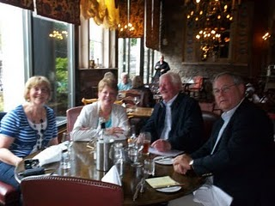
In May 2011, two couples met at the historic Swan Hotel in Bedford, Bedfordshire, England to review genealogical materials pertinent to the Holyman family. Left to right are Maureen Smith, Barbara Holliman, my wife, Peter Smith, a family historian and member of the local genealogical society, and yours truly. One can observe that not all family history research and sharing occurs in a musty archives. More of that later.

Peter had not found (nor did I) Holymans in Bedford before the 1609 marriage of Thomas Holyman, and the subsequent birth of his children. Peter, in his research, however, had found a John Holman born 1560 in Woburn, Bedfordshire, approximately 15 miles south of Bedford and 15 miles north of Tring, Hertfordshire. This John married early – 1575, but no wife is named.

While young, it may have been a required marriage as one Thomas Holiman was born in Woburn in 1576. Two other children are recorded of that marriage – Robert, b 1581 and Joan, 1586, both born in Woburn. Hmmm…..interesting. Could this Thomas be Christopher Holyman, Sr.’s father?

.
Are We Bedfordshire Holymans?
by Glenn N. Holliman

According to parish records, Thomas Holiman of Bedford, who may or may not have been born fifteen or so miles south in Woburn, my generation’s probable 8th great grandfather, married at St. Peter’s Church in Bedford in 1609 to Helenara Poynard. Roger Smith suggests the name Helena might be Eleanor, and Poynard, which is not yet found in other Bedford records, may be P’nard or Peynard. Spellings were not yet ‘settled’ nor is the handwriting of parish administrators always legible.

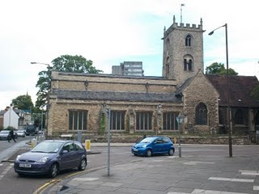
St. Mary's parish is today an archaeological trust facility, and has long since ceased to be a place of Anglican worship. The building and cemetery stand on a busy street corner, two blocks from the river and across the street from Bedford College. Imagine if you will three hundred years ago, no automobiles, only muddy streets, horse carts and the Holyman couple having their children baptised in this parish. How many of them now reside in the cemetery? We don't know.

Again according to parish records, this couple had the following children, all baptized at St. Mary’s Church in south Bedford, two blocks from the River Great Ouse (a wonderful name!).

John, b 1610 (was he named after a grandfather?)

Eleanor, b and d 1612 (may have been named after her mother)

Joan, b 1613

Thomas, b 1616 (named after his father)

Christopher, b 1618 (the believed to be emigrant to Jamestown, Virginia in 1650)

Judith, b 1621 (the believed to be emigrant to Jamestown, Virginia in 1650)

Eleanor, b 1625 (named after her mother and deceased sister)

Stephen, b 1625

Mary, b 1628
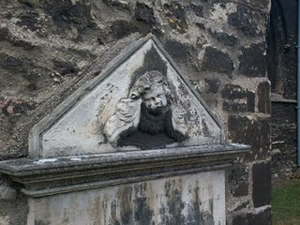

Tombstones were rare in 17th Century England (as in Virginia). This one of a grieving angel in St. Mary's grave yard, is only from the 1800s. Coal smoke and pollution have worn away the stone carving. The cemetery, like the church, is abandoned but the lawn is kept up and the grass mowed. Does our 8th great grandfather, Thomas, and his wife lie in these grounds?

As discussed in earlier articles, a John Holiman died in Virginia in 1650, and a Thomas Holiman took possession of land at Martin’s Hundred, Virginia in 1636. Are John and Thomas from this same family, and is this the encouragement that led to Christopher and Judith to leave for Jamestown, Virginia?

Encouragement Christopher and Judith undoubtedly had, but the 1636 Thomas in Virginia is most probably not the off spring of Thomas who married in Bedford in 1609. Parish records indicate a Thomas Holiman married in 1639 at St. Paul’s, Bedford, and my guess this is the second son of the 1609 marriage. Tragically, a son Matthew, died was buried at St. Paul's in 1640.

Next posting….a visit to Woburn and the Heritage Center there.

ARE WE WOBURN, BEDFORDSHIRE HOLLIMANS?
by Glenn Holliman

Woburn is the home of the Dukes of Bedford, whose families have occupied the Abby property there since the 1500s when Henry VIII dissolved the monasteries. For centuries the village was a staging station for travelers moving north and south from and to London, approximately 40 miles to the south. The village today was rebuilt after a fire in the early 1700s, and retains a Georgian architectural look as viewed in the next photograph.

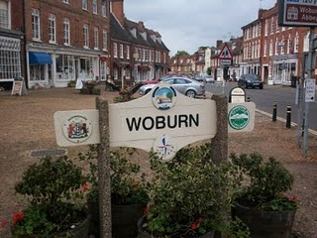

The name Holman concerns me. In other shires, Holyman is plainly written, as it is in Bedford St. Mary’s parish records. One grants handwriting is often a guess as many of the parish clerks were near illiterate in the late 1500s and letter formation had not yet finalized as it is in today’s English script.

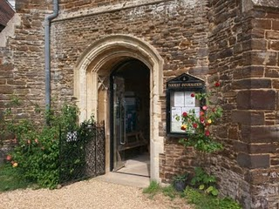

Photographed next is an index of Woburn parish records located in the Heritage Centre (pictured above - the former parish church which is now the museum and Centre). Beginning in 1538, Henry VIII’s chancellor, Thomas Cromwell, required all church’s to record all baptisms, marriages and burials. This Cromwell helped convict Anne Boleyn of treason that led to her beheading. Later Chancellor Cromwell lost his own head to Henry’s bad temper!

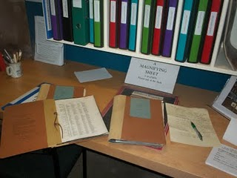

In these Woburn records (pictured above), one will find a host of Holmans and Hollmans but that middle vowel is always missing, no ‘i’, ‘e’ , ‘o’ or ‘y’. Hmmm….There are numerous families whose head of households were named Robert, John, William and Thomas. There is even one Judith Holman, baptized February 16, 1609, daughter of Kath Holman and Henry Dally….hmmmm….born evidently out of wedlock.
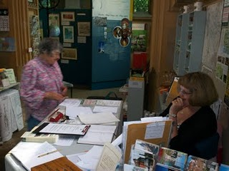
Above, as is common in England, kindly volunteers and staff do all they can to assist Americans in their search for English ancestors.

Yes, there is a Thomas Holman, son of Jn Holman, baptized March 4, 1576, but nary a Christopher born, married or died in Woburn between 1567 and 1670. But if Thomas moved to Bedford, married and had his children, one would not expect to discover such in Woburn. So Woburn cannot be ruled out totally even though the name does not quite match.

Let’s go back to Bedford and search some more.

A LOOK DEEP INTO THE BEDFORDSHIRE ARCHIVES
by Glenn N. Holliman

With the help of Bedfordshire family historian, Peter Smith (photo below), we explored the Bedfordshire, England Archives.

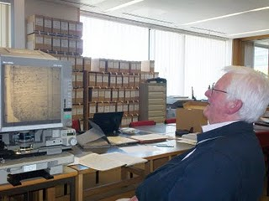

In addition to our reading microfilm of 17th Century parish records, the archivists (see photo below) open the files of the almost 400 year old Bishop’s Transcripts (copies held by the dioceses of parish records).

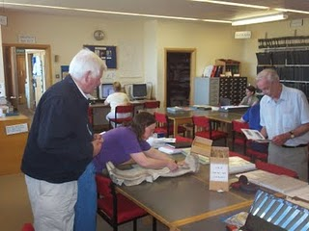

I held the transcripts and viewed the names of Christopher and Judith Holyman (see next photo), born in 1618 and 1621. The father’s name is given as Thomas.

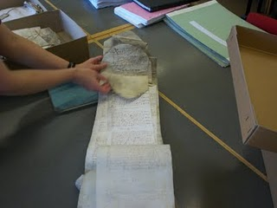

If there be any question about the authenticity of these two persons, that is put to rest. Bedford records, I have held in my own hands.

Is this then truly the Christopher who sailed to Jamestown and inhabited the Isle of Wight County? Were there other Christopher’s in England at this time? Can we find more evidence to support the Bedford thesis or disprove it?

Can we find the birthplace of Thomas Holyman who married in 1609 and sired Christopher Holyman, born 1618? When did this Thomas die and where? The parish records do not tell us, yet.

Are there other places and archives in England to investigate?

Let’s keep looking….

ARE WE WORCESTERSHIRE HOLLIMANS?
by Glenn N. Holliman

Cousin Jeanette Holiman Stewart pointed out in 2010 that there were numerous Hollymans living in Worcestershire, England in the 1500 and 1600s, according to the International Genealogical Index. Could one of these Holymans be the origin of our Christopher Holyman, Sr., founder of the American family?

Could one be Thomas or John Holiman who lived in Virginia in 1636 and 1650 respectively? Or other Hollymans who appeared in the 1650s and 1660s?
Worcester is located 40 miles or so east by northeast from our cottage near Stow in the Wold, so we took a day and motored over to the Family Heritage Centre there.
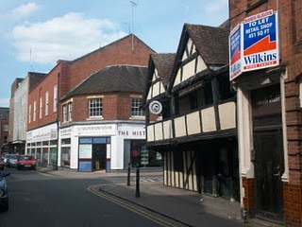

Above on the corner of this Worcester photograph stands the Heritage Centre of Worcestershire which holds many family records. We spent several hours exploring the files and local histories. Unfortunately the parish records were not indexed as in Bedfordshire, which means one must go through reams of microfilm, time which we did not have on this trip. Yes, there is more investigation to do in Worcester, but we found considerable Holyman information which I share in the next post.

The Tudor building in the foreground (above) is one of the oldest structures in the shire, dating back to the 1500s. Did some of our ancestors enjoy a pint of ale in that former inn, now preserved in a historical trust?

Oh, yes, many Hollimans lived in Worcestershire in previous centuries! They left many wills. Would we find evidence that this area, 80 or so miles west of Buckingham and Bedford Shires, could be the origin of the American Hollimans, or at least some of them?

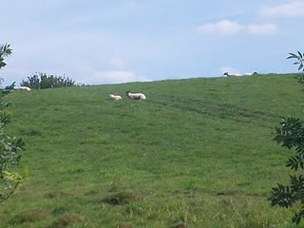

Just a few miles from the centre of Worcester, one encounters a countryside still providing pasture of the sheep. Wool was and is a source of wealth for the English farmer. This particular pastoral scene (photo before) is in Leigh, Worcestershire. Many Holymans lived in and around this village in the 1500s.
My search of the various archives of England made very evident to me that groups of Holyman families lived in several parts of the country in the 15th to 17th Centuries. From where did they originate and why were they scattered?

Distant cousin Jim Maule of Philadelphia, Pennsylvania shared a theory with me recently as to why there are several locations where obviously dozens of Holymans lived. He believes the shortage of labour due to the late 14th Century Black Death led to varioius Hollimans moving to different parts of the country and establishing groups of Holliman. This makes good sense to me.

A Look at the Holymans of Worcestershire
by Glenn N. Holliman

During my visit to the Worcestershire Archives I explored several volumes. My first was in Wills and Administrations , Volume 1, 1451 – 1600 by the Worcestershire Historical Society, 1904. These names are indexed for wills as follows. Unfortunately transcripts of the wills has not be published thus requiring, eventually, a look at all the wills to build a family tree.

Spellings of towns vary as certain names were spelled by sound.

1541 – Richard Holyman, Sturbridge.
1553 – Thomas Holyman, the Elder, Lye. (Leigh).
1558 – Elizabeth Holyman, Lyghe (Leigh).
1575 – Hufrey Holyma(n), Blakesall, Wolverley.
1582 – Thomas Holyman(n), Woluley (Wolverley), a M. bond to Alice Stower.
1593 – Thomas Holliman, husbandman, Lyghe (Leigh).
1596, Nov. 23 –William Holliman, victualer, St. Peter’s, Worcester.
1597, Feb. 13 – Thomas Holliman, husbandman, Leigh.

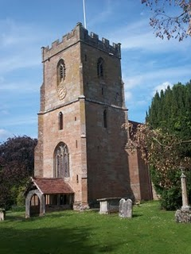
The parish church of St. Edburga at Leigh, Worcestershire. Holymans must lie in the church cemetery.

Then from Wills and Administrations, Probate Registry of Worcester, 1601 – 1652, one finds:

1607 – Roger Hollyman, labourer, Kidderminister.
1608 – Thomas Holliman, husbandman, Leigh.
1610 – John Holliman, Purshullgreene.
1611 – Humfrey Holleymon, yeoman, Wolverley.
1614 – Ann Hollyman, widow, Leigh.
1627 – Samuel Hollyman, Wolverly.
1629 – Francis Holliman, Chadisley (Chaddesley) Corbertt, a scythesmith left a total of 82 pounds (A sizeable sum in the 17th Century. A scythesmith was a metalworker.)
1642 – Richard Hollyman, yeoman, Leigh.

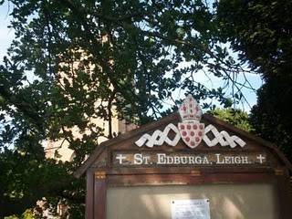

Some More Names and Thoughts on Worcester Holymans

From the Calendar of Wills and Administrations of the Consistory Court of the Bishop of Worchester, 1661 – 1699, we have more names of Holymans who wrote wills. In Bedfordshire, there are few wills of Holymans; in Worcestershire during the same time period, many. Strange. The archivist in Bedford told me only about 5% of the population in that shire wrote wills in the 1600s. More did so in Worcester.

1672, Aug. 21, John Hollyman, Bromsgrove.
1687, May 9 – Hugh Hollyman, Leigh.
1691, Aug. 7, Thomas Holliman, Bromsgrove.

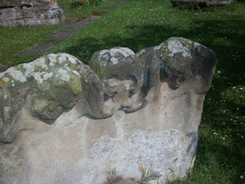
At the Leigh St. Edburga parish from a 1700s tombstone, these eroded figures of two children and grisly skull remind us that young people died often before reaching adulthood.

As my research time was limited, I cannot say that a Judith and Christopher Holyman or other Virginia Holymans did not come from Worcester. Additional hours must be dedicated to reading the microfilm of each will (looking for names) and parish records, as no parish index exists for Worcestershire (sigh…). Only then will be able to rule out or welcome Worcestershire as the ancestral home of at least some of the Hollimans. So much more work to be done.

BUT no name of Christopher or Judith leaped out as such as surfaced in Bedford, England. So for now, I still favor the Bedford Holymans as the origin of our Virginia family.
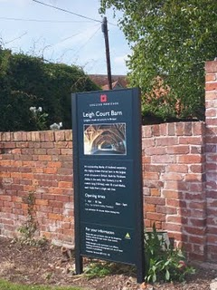
Adjacent to St. Edburga parish is the medieval tithe barn, now maintained by English Heritage. Members of the community were required to support the church (and the civil functions it carried out) through a 10% 'tax' on their harvest. Hence the need for a parish barn to hold the 'tithe'.

A closing thought – the Severn River runs south from Worcester into the Bristol Channel. Bristol, we are told by historians, was the chief port for English relocating to the American colonies. So if one wanted to immigrate to America, Worcestershire would be a convenient location from which to begin an odyssey to the New World.

Therefore as a note of interest, as Christopher and Judith Holyman were transported to Virginia in 1650 sponsored by a man named John Cox, I found this recording in “The Complete Book of Emigrants, 1607-1660” by Peter Wilson Coldham, Baltimore, Genealogical Publishing, 1987:

“April 9, 1650 – Sir Henry Chicheley to be released and allowed to pass to Virginia on the usual security . Pass also for Thomas Cox and Robert Pigge to go to Virginia.” Hmm....

ARE WE BUCKINGHAMSHIRE HOLLIMANS?
by Glenn N. Holliman

As one recalls in 2010, I began my research in Hertfordshire before discovering the Holyman 15th Century farm in Cuddington, Buckinghamshire. So in June 2011, after exploring the Shire Archives in Bedford and Worcester, with the help of family historian, Peter Smith, delved into the Aylesbury, Buckinghamshire Archives.

And here, I found treasure!

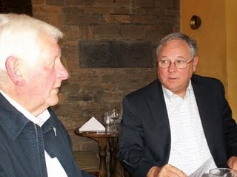
Family history 'detective' Peter Smith and the writer discuss findings over lunch.

A look at the Buckinghamshire Probate Records wills index revealed a plethora of Holliman names. Unfortunately, the wills are not printed out but must be viewed in the original one at a time. Here are their names. Note the ones from Cuddington, the home of the former Holyman Farm and manor house.

1521 – John Holyman, Cuddington. (see earlier articles for all Cuddington names)

1525 – Joan Holyman, Chesham, Leicester.

1525 – John Holyman, Chesham.

1525 – William Holyman, Chesham.

1533 – John Holyman, husbandman, Cuddington.

1545 – William Holyman, husbandman, Cuddington.

1547 – Elizabeth Holyman, Cuddington.

1557 – William Holliman, husbandman, Cuddington (estate valued at 18 pounds).

1558 – John Holyma(n), husbandman, Cuddington.

1573 – Leonard Holyman, weaver, Cholesbury. (see article posted September 7, 2010 for Leonard Holyman)

1589 – Christopher Hollyman, Sherington, testator. (Yes, my eyes doubled in size when I spotted this one!)

1598 – John Holyman, weaver, Cholesbury.

1600 – John Holyman, husbandman, Cuddington

1603 – Francis Holliman, yeoman, Cuddington.

1607 – Richard Holyman, labourer, Haddenham.

1618 – John Holeman, shoemaker, Newport Pagnell.

1623 – Thomas Holliman, the elder, yeoman, Cuddington.

1624 – Joseph Hollyman, Haddenham.

1638 – Roberet Hollyman, yeoman, Cuddington.

1648 – Richard Holyman, yeoman, Haddenham.

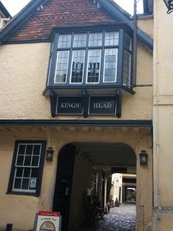
Several blocks from the Aylesburg Archives is the Kings Head Pub, one of the few ever to be listed on England's National Trust. Henry VIII and Anne Boylen spent the night here on at least one occasion. Whilst in the Archive's the wives of Peter Smith and Glenn Holliman retired for a repast here (after some shopping on High Street!)

A Treasure Found - the Will of Christopher Holyman, 1589!

I could not look at all of the Holliman wills in the Buckinghamshire Archives, but three that seemed to match time, place and name, I explored closely. Now I am not talking about microfilm.

The actual wills were hand carried to me by a lady garbed in a white coat, much like a physician. She place three 'ancient' parchments in front of me on a pillow so bindings would not break, and then (gasp) with my uncovered but clean fingers, I turned the pages and held in my 21st Century hands a will signed in 1589 by Christopher Holyman!!!

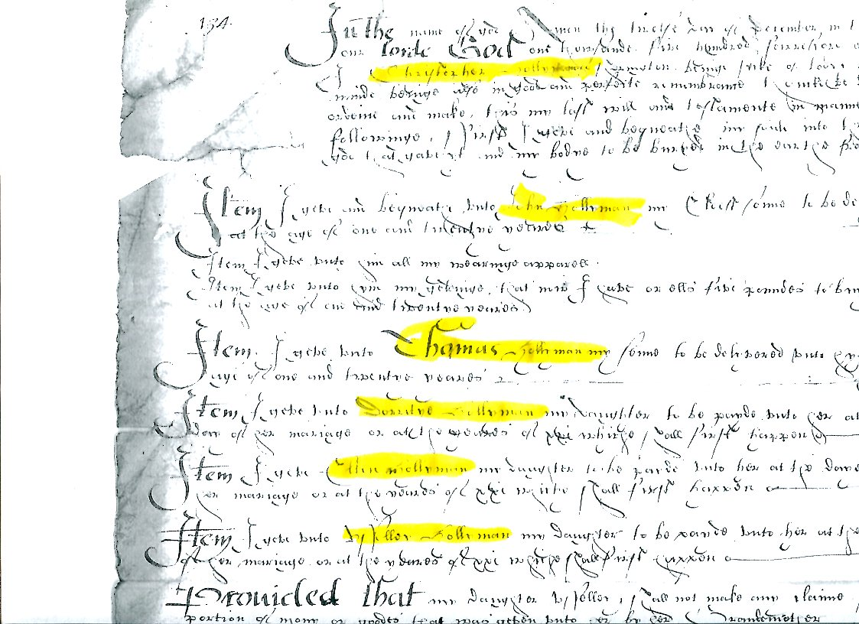

Above the partial will of Christopher Hollyman (d 1589). Note the third line lists Christopher’s name and the huge Thomas Hollyman name further down the page.

Was I holding a document signed by my 9th great grandfather???? Could this be the grandfather of Christopher Holyman, Sr. (1618 – 1691) of Isle of Wight, Virginia? Let me tell you what I found and what it may, repeat, may mean.

1. This Christopher Hollyman lived in Sherington, Buckinghamshire.

2. He had children, whose names I make out to be:

A. John
B. Thomas, a minor in 1589
C. Dorothy (?), a minor
D. Ellin, a minor
E. (?) lloy, a minor
F. Ami, a minor

The wife’s name was Margaret. He appointed his brother, Thomas Hollyman, as executor. Were these persons my 9th great grandmother and a very great uncle?

Yes, for 4 pounds, 20 pence (about $7) I asked for a copy of the will. It did not reproduce well, but chills down my back at this point at this point. Darn, I forgot to film the document, I was so excited.

So I race to the Sherington, Buckinghamshire parish records to ascertain the baptism records, marriage and burial records of this Hollyman family. Tragedy!! No parish records from Sherington UNTIL 1603. Curses, no way to find out the birth dates of the children.

What next?

ARE WE FROM SHERINGTON, NEAR MILTON KEYNES, BUCKINGHAMSHIRE?

On a tip from family historian Peter Smith, I ventured to the local history section of the Milton Keynes library, about 15 miles north of Aylesbury, Buckinghamshire. Hopefully there I would find the missing parish records of Sherington, Buckinghamshire.

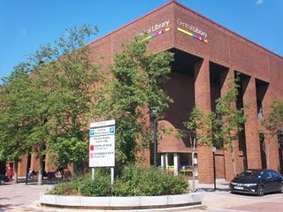
The modern library and local history room in Milton Keynes is located in the 1960s planned development section featuring plenty of parking, rectangle office and store blocks and urban boredom.

Milton Keynes is a medieval market town that received a planning make over in the 1960s. Now a ‘planned community’ of round-abouts and rectangular business plazas, several blocks in length, it does feature plenty of parking even if there be a dreary sameness to its governmental and commercial centre. Charm, there is none.

Alas, the parish records I sought were still ‘missing’ and after several hours of squinting at microfilm of 17th Century wills, baptisms and burials from 1603 to 1720, I came up with precious few clues on the Holyman family. However, sometimes it is not what one finds, but what one does not find. Evidently, the Holyman family, citizens of Sherington in the late 1500s, did not live there in the 1600s after this 1589 Christopher’s death.

So where did the children go? To Bedford, if they be a second son, such as Thomas Holyman?

Well, as I was about to leave (my parking was expiring), I glanced at the shelf of local parish publications. My eye caught a title – “Fiefs and Fields of a Buckinghamshire Village” by A.C. Chibnall. The work was published in 1965 by Cambridge University Press of Cambridge. I flipped to the index, not expecting to find anything, when, lo and behold, up popped the names Christopher Holyman and Thomas Holyman!

On page 178 of the work, I find this: “Two leading inhabitants (of Sherington) Edward Ardes and Christopher Hollyman, visited the bishop in 1575 in Buckden to lodge a complaint on rector Henry Barlow, a dissolute fellow.”

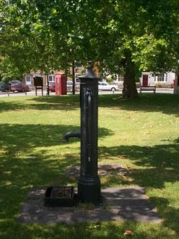

Ye ole village pump stands even today on the small village green in Sherington. The now disappearing British Telephone red box is in the background, and across the street, a closed facility labeled, I think ironically given our family history, the Virginia Store!

Another page over on 179, the author reports Christopher Hollyman serving in Queen Elizabeth’s guard and leasing the rectory for 50 pds annum. This Christopher Hollyman (p. 188) died in 1589 after securing more land from his ‘good friend Richard Ardes’ (probable son of Edward Ardes).

Remember in his 1589 will, Christopher Hollyman records a second son, a minor, named Thomas Hollyman. Well, on pages 193 and 194 of Chibnall’s tome, we are told of a grammar school, 6 or 7 miles from Sherington in Lathbury. One of the 14 boys listed as attending in 1695 was a Thomas Hollyman! This would make him the right age to be married in 1609 twelve miles away in Bedford!

So Have We Found the English Family of Christopher Holyman, Sr. of Virginia?

Let’s play family history detective. Here are the facts and what can be deduced.

1. Christopher, according to family historian Peter Smith of Bedfordshire, was an uncommon first name in the 1500s and 1600s, so locating the name in 1589 is important. In all my research, I have not found it ANY WHERE ELSE in England attached to the surname Holyman or one of its various spellings.

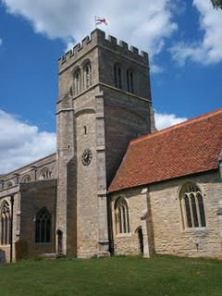
The parish church in Sherington, Buckinghamshire is named after St. Laud of France. It is just possible that my generation's 9th great grandfather, Christopher Holyman's dust, may be embedded in the grounds surrounding this ancient edifice.

2. First names are often repeated from one generation to another. Thomas of 1589 and 1595, is he the same Thomas Hollyman who marries in Bedford, Bedfordshire at St. Peter’s in 1609?

3. And the Christopher Holyman born in Bedford in 1618 to Thomas, is he a grandson and named after the 1589 Christopher of Sherington, Buckinghamshire?

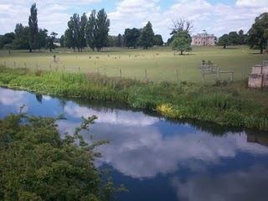
The Great River Ouse (yes, that is the name of this lazy 'river') flows from Sherington to Bedford. Here the stream meanders past Tyringham House, a great county estate a few miles west of Sherington. Yes, the river flows west for a bit and then turns north and finally east, moving through Bedford and eventually to the North Sea.

4. Sherington is upriver on the Great River Ouse which flows through Bedford, two blocks from St. Mary’s parish where Christopher Holyman, b. 1618, was baptized. Sherington is approximately 12 walking miles from Bedford.

5. We can find no records of Holymans in Sherington parish records after 1602 (and no records exist prior to 1603, except 1576 and no Hollymans that year).

6. No records exist in Bedford, Bedfordshire prior to 1609 on Hollymans.

7. No records exist in Bedford recording the death of Christopher Holyman, b. 1618, or his sister, Judith, b 1621, in Bedford.

A Connection to Cuddington and Bishop John Holyman? Maybe So

In the 1580s, Richard Holyman of Cuddington had real estate dealings with Thomas Tyringham, whose family home was near Sherington. (See earlier article) Could a Richard Holyman’s relative be our Christopher Hollyman of 1589 in Sherington? Could this be the tie to the Cuddington Holymans, approximately 30 miles south of Sherington?

Therefore, a scenario can be constructed that Christopher Holyman, Sr. who died Isle of Wight, Virginia in 1691, was the son of Thomas Hollyman, probably born in Sherington, who by 1609 was earning a living in Bedford and married that year at St. Peter’s parish.

And this Thomas, a second son who inherited some assets, but not family property, from Christopher Holyman (will of 1589) of Sherington, is the same Thomas Hollyman who went to grammar school in Lathbury, Buckinghamshire in 1595.

And while more research is needed, this 1589 Christopher Hollyman of Sherington may have moved to the area from the central part of Buckinghamshire, the Cuddington, Tring or Cholesbury area, perhaps being born sometime from 1530 to 1550. Perhaps!

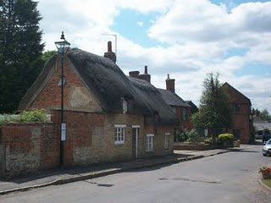
Thatched roofs in Sherington, Buckinghamshire. Did Holymans centuries past sleep and live under thatch?

Now who then is the Christopher 1589’s father?!!! Are we on the edge of taking the family tree another one hundred years or so back in time, to the time when The Rt. Rev. John Holyman, Counter-Reformation Bishop, was born in 1495 in Cuddington, Buckinghamshire? (See blog article of September )

Notwithstanding the significant number of Holliman families in Worcestershire, is this Christopher Hollyman of Sherington, Buckinghamshire the grandfather of the Christopher Holyman who sailed to Virginia in 1650? Have we found my generation’s 9th great grandfather?

I and others will continue to research and explore, but the circumstantial evidence is building that from this part of England our ancestors left to find new opportunities in North America. We reading this are the result of that migration.

