Top of Form

Bottom of Form

|  |
| --- |
|  |
| Inbox | | x |



|  |  |  |  |  |
| --- | --- | --- | --- | --- |
| |  | | --- | | **Maxine Wright** | | Attachments6:21 PM (11 hours ago)  https://mail.google.com/mail/u/0/images/cleardot.gif |  |  |
|  |  |  |
| |  |  | | --- | --- | | |  | | --- | | to me, Jeanette  https://mail.google.com/mail/u/0/images/cleardot.gif | |   This pictures of Our AAron Hollimans Family.Charles Warren was AARon Holliman’s, Son,Aaron was Charles and Barbara WALTERS HOLLINAN  youngest son.Who went to OK after Civil WAR.  Thought you would like to have these pictures  Maxine  **From:** [anjelkepr@aol.com](mailto:anjelkepr@aol.com)  **Sent:** Friday, February 20, 2015 2:39 PM  **To:** [maxine026@live.com](mailto:maxine026@live.com)  **Subject:** Re: Request reply to e-mail    1st Picture is Will Jackson Holliman ( My Father )  2nd  Is Charles Warren Holliman & wife Ardena and family the smallest son is my father  3rd is Charles Warren and Ardena's Head Stone  Sorry if these aren't new to you, I just I ran into them by accident.  My daughter is getting married tomorrow so things are still in an up roar.  Hopefully that will complete all the confusion.  And I can actually start a normal routine again.  Hope your doing well!  Phyllis  -----Original Message----- From: Maxine Wright <[maxine026@live.com](mailto:maxine026@live.com)> To: anjelkepr <[anjelkepr@aol.com](mailto:anjelkepr@aol.com)> Sent: Tue, Feb 10, 2015 12:42 pm Subject: Re: Request reply to e-mail  Thank you for the update. Sorry about all the things going on.I do know how that is  I am in the process of getting my house roofed.  Yes I would love to have copies of any pictures of our HOLLIMAN CLAN>  Maxine    **From:** [anjelkepr@aol.com](mailto:anjelkepr@aol.com)  **Sent:** Tuesday, February 10, 2015 2:34 PM  **To:** [maxine026@live.com](mailto:maxine026@live.com)  **Subject:** Re: Request reply to e-mail    Sorry Maxine,  I still have to follow up with oncology, I have a planted port, that still has to be maintained, and have had difficulty with it lately.  Then I have had a death in the family, and my daughter recently moved in with me.  Takes some getting use too.  I did find a couple cd's with information on them, but to be honest I haven't been able to concentrate, there is so much confusion right now in the house, I can't remember if I'm coming or going.  Hopefully things will calm down soon.  And I can get pictures and things I have that possibly you don't have.    Thank you!   Phyllis    -----Original Message----- From: Maxine Wright <[maxine026@live.com](mailto:maxine026@live.com)> To: anjelkepr <[anjelkepr@aol.com](mailto:anjelkepr@aol.com)> Sent: Tue, Feb 10, 2015 9:12 am Subject: Re: Request reply to e-mail  Where are you, Have not heard from you lately  cousin Maxine    **From:** [anjelkepr@aol.com](mailto:anjelkepr@aol.com)  **Sent:** Saturday, January 17, 2015 8:50 PM  **To:** [maxine026@live.com](mailto:maxine026@live.com)  **Subject:** Re: Request reply to e-mail    Hi Maxine,    I certainly hope your health issues, are in the past now!  I too had health issues, trying to recover from Chemo and Radiation.  It's a very slow process.  I just turn 69.    I also found Aaron and Cynthia, and her Mother. But never found her Father.  Yes I read about Aaron in the Civil War, then signing up with the Union side.  I can only imagine the guilt feelings with that. Sounds like Your GranFather Elijah, was a smart man.  I have never found out for sure when or where Aaron died. Nor his wife Cynthia Ann Tolson.   I saw where his second wife Sarah Ann Hulsey, was a widow in Arkansas, before moving to California.  Also I believe they had a daughter named Lillie ,can't find her either, and she wasn't listed on the censes with Sarah, stating that she was a widow.  My memory is getting horrible, and I get so confused, that I have to stop and walk away for a while, then try again.  Any little thing I find I get so excited.  I got to meet my Grand Mother Ardena Hunt, but My Grandfather Charles Warren, had already passed, by the time I was old enough to remember him.  But I do have a picture of her with me in it.  So special!   And a picture of Charles Warren and family, my father was very young in it.    I hope your doing well Maxine!    Phyllis      -----Original Message----- From: Maxine Wright <[maxine026@live.com](mailto:maxine026@live.com)> To: anjelkepr <[anjelkepr@aol.com](mailto:anjelkepr@aol.com)> Sent: Thu, Jan 15, 2015 4:25 pm Subject: Re: Request reply to e-mail  Hi Phyllis  I do know how it is. I lost my Husband 11 years ago.  I have had some health issues as well .  My grandmother had ask where her uncle AAron Had gone. She passed on 1946. I of course found him  some time back.  I am sure you know that he was in civil war from Ala and was captured and then he signed up with the UNION side  That caused some guilt feelings from all sides. I have heard that My great granfather Elijah Holliman had told him he should not do that.  I have census of AARON HOLLIMAN both in ALA AND MISSISSIPPI Later in OK.  I do understand  I have now reached the ripe old age of 88. I am just now getting back in looking  at things  Maxine      **From:** [anjelkepr@aol.com](mailto:anjelkepr@aol.com)  **Sent:** Thursday, January 15, 2015 5:25 PM  **To:** [maxine026@live.com](mailto:maxine026@live.com)  **Subject:** Request reply to e-mail    Hello Maxine,      What a wonderful surprise!   I am just now starting on Ancestry, originally it was my Husbands account,  after he past I more or less just kept it active. But now is time I start life again.   I would love to have you look at some of the things that I do have..to see if I am on the right track.  I really get  confused easily, and have to just stop, and give it a rest.    Thank you for the request, gave me a real boost.  Sincerely Phyllis  3 Attachments | | | | |

[Preview attachment 73441abd-1560-4a3a-98b5-0337df30eb3a.jpg](https://mail.google.com/mail/u/0/?ui=2&ik=9e29275475&view=att&th=14ba94bcb1e7920b&attid=0.1&disp=safe&zw" \t "_blank)

[[https://ssl.gstatic.com/docs/doclist/images/mediatype/icon_1_image_x32.png](https://mail.google.com/mail/u/0/?ui=2&ik=9e29275475&view=att&th=14ba94bcb1e7920b&attid=0.1&disp=safe&zw)](https://mail.google.com/mail/u/0/?ui=2&ik=9e29275475&view=att&th=14ba94bcb1e7920b&attid=0.1&disp=safe&zw" \t "_blank)

[Preview attachment 26bf325b-1242-4c30-819e-8bd07de8ce4d.jpg](https://mail.google.com/mail/u/0/?ui=2&ik=9e29275475&view=att&th=14ba94bcb1e7920b&attid=0.2&disp=safe&zw" \t "_blank)

[[https://ssl.gstatic.com/docs/doclist/images/mediatype/icon_1_image_x32.png](https://mail.google.com/mail/u/0/?ui=2&ik=9e29275475&view=att&th=14ba94bcb1e7920b&attid=0.2&disp=safe&zw)](https://mail.google.com/mail/u/0/?ui=2&ik=9e29275475&view=att&th=14ba94bcb1e7920b&attid=0.2&disp=safe&zw" \t "_blank)

[Preview attachment 0e976a98-660a-4b14-bb89-d19069038477.jpg](https://mail.google.com/mail/u/0/?ui=2&ik=9e29275475&view=att&th=14ba94bcb1e7920b&attid=0.3&disp=safe&zw" \t "_blank)

[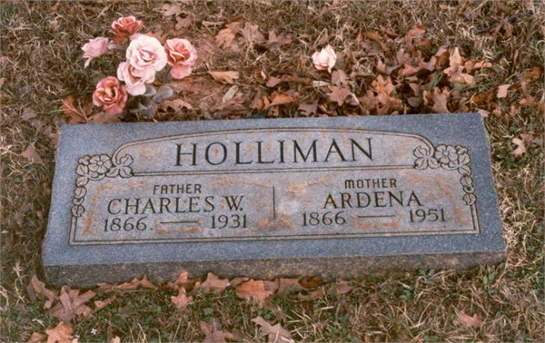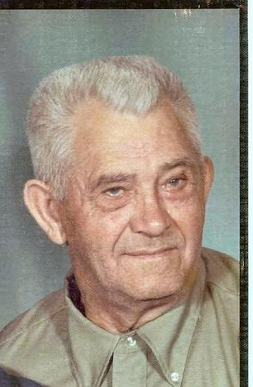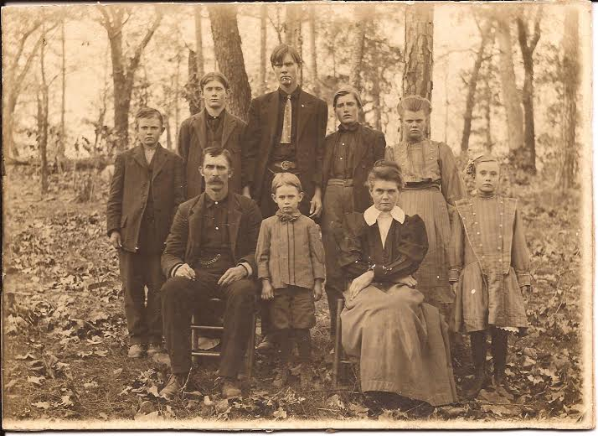](https://mail.google.com/mail/u/0/?ui=2&ik=9e29275475&view=att&th=14ba94bcb1e7920b&attid=0.3&disp=safe&zw" \t "_blank)

[[https://ssl.gstatic.com/docs/doclist/images/mediatype/icon_1_image_x32.png](https://mail.google.com/mail/u/0/?ui=2&ik=9e29275475&view=att&th=14ba94bcb1e7920b&attid=0.3&disp=safe&zw)](https://mail.google.com/mail/u/0/?ui=2&ik=9e29275475&view=att&th=14ba94bcb1e7920b&attid=0.3&disp=safe&zw" \t "_blank)



|  |  |  |  |  |
| --- | --- | --- | --- | --- |
| |  | | --- | | **Jeanette Stewart** | | 7:17 PM (10 hours ago)  https://mail.google.com/mail/u/0/images/cleardot.gif |  |  |
|  |  |  |
| |  |  | | --- | --- | | |  | | --- | | to Maxine, me  https://mail.google.com/mail/u/0/images/cleardot.gif | |   Thanks Maxine. I will attach them to the project tree.  Take care, Jeanette  Sent from my iPhone  <73441abd-1560-4a3a-98b5-0337df30eb3a.jpg>  <26bf325b-1242-4c30-819e-8bd07de8ce4d.jpg>  <0e976a98-660a-4b14-bb89-d19069038477.jpg>   |  |  | | --- | --- | | https://ssl.gstatic.com/ui/v1/icons/mail/no_photo.png | Click here to Reply, Reply to all, or Forward |   13.93 GB (92%) of 15 GB used  [Manage](https://accounts.google.com/b/0/ManageStorage?hl=en)  ©2015 Google - [Terms](https://www.google.com/intl/en/policies/terms/) - [Privacy](https://www.google.com/intl/en/policies/privacy/)  Last account activity: 9 hours ago  Details | | | | |  | People (2)   |  |  | | --- | --- | |  | Jeanette Stewart | | stuffnsuch50@hotmail.com | |  | |

|  |
| --- |
| Show details |