This past Friday Adolph and I had to go up to Fayette Court House to check on a deed and while there just browsed through records of Thomas Blakeney and A.B. Lowery.

We found a record where John T.Blakney and J.M. Ayers were submitting Thomas' will for probate and record stating they were the executors of said will. It stated that Thomas Blakeney died " on or about the 2nd day of June, 1896." I'm sure some one has this record but we did not remember seeing it, this may be old news.

We also checked A.B. Lowery where Thomas petitioned to be guardians of Kizzies children, Simon Lowery and Dicie Lowery. Thomas was identified as their grandfather. Another record was there that identified these children as "minor heirs of Simon Poe". I have transcribed one of these records and will get it typed and out one day this week.

Kay
Dear Doc,

Al and I were just browsing through the index to records at Fayette. Went to check on a deed and decided to get the reference for the record on A.B. Lowery. Then we find these two records relating to Thomas. They are on legal size paper and don't think they would scan very well. I will be at Kinko's soon and will just make you a copy and send by snail mail. Will let you know when I drop it in the box. ( I don't remember if these two were mentioned in the will that Reed gave us copies. We did not check the will thinking we had a copy. Do we need to recheck when back in Fayette?)

I think you will find them interesting. One has a list of all his heirs, there are numerous Hollimans. It also appears from a brief reading that Kizzie had a husband named Wilson. If I read it correctly. I will also send a copy of the record requesting guardianship of the Lowery children. I don't know where Thomas put all these children.

I have tried to read the Ayers letters. I can make out most of the writing, but have to keep moving the page from left to right. Tried to print and it comes out with only half the page. The left hand side of the letter. I put it on print preview and tried to reduce it, but no luck. I did gather that J.M. Ayers was "Marsh".

The last update on the stall plate was really great work. I have shared all this info about Lord William with Barry and he finds it interesting. I told him to check it out on his next visit to England. He has been to Westminster Abbey but had no idea there was a Blakeney resting nearby. In case you need it his email is blb090955@bisdex.com

All is well here. Yesterday Al and I were pulling the briars out of the blueberry bushes and I was under the bush and Al was pulling. Somehow a branch came loose and found my right eye and rubbed across and back. I thought something was in my eye so we went to the doc in the box that we use for such things. After 3 hours we got to leave. I had a patch over my eye and had a nice abrasion on the cornea. The doc said that blinking across the abrasion was what made me think something was in my eye. At any rate, was lucky. It is better today, recheck tomorrow. I think we learned the lesson to use safety goggles from now on, especially when crawling under bushes.

This is way to long. Take care, love, Kay and Al
Dear Kay:

My mistake on William's death date. He died after Chickamauga and Missionary Ridge Battles which would be Nov. 25th, 1863. Just a typo error on my part.

I knew that Reed's daughter, Debbie, had a recurrent brain tumor and was supposed to move to Boston for proton beam treatment. I don't know about the other one. Can you bring me up to date ?

Mrs. Della Yerby lives at 5603 County Road 371, Evergreen, MS 39330

dyerby@msn.com

She knows the story about him being shot through a window but didn't know the circumstances.

I've seen the Mortality schedule on Sarah and I would expect the date of Feb., 1860 is probably correct. Whoever made tombstones in Fayette County back then was notorious for getting the facts wrong. Just take Thomas' stone, Warren C. Holliman's stone and others as examples.

I'm spending 12 - 13 hours a day on photo restorations ! Have the stall plate about 1/3rd finished.

Love, Doc

Doc,

As best I can tell it is the same person, but somewhere along the way the initials got mixed up. Sort of like on S.C. Yerby. If you read in the probate record Kizzie's marriage to J.J. Branyon in Sanford County, now Lamar, is noted in the document. I don't know what happened to her husband or where he is buried. I believe her son, Simon Lowery, is buried near her at the Branyon Cemetery in Lamar County. There is a Simon Lowery there along with an Emily Lowery, which I suspect is his wife. I mentioned the initials being different on this record and the census to the lady at the probate office.The initials on the probate record are clearly A.B. If you notice the name is spelled Lowrey in some places and Lowery in others. She reminded me that the census records sometimes got the names incorrect. This is all I know. I have suggested to Al that when you come in October that the two of you manage to get by the office of the Branyon Oil Co. in Fayette and see if anyone of the Branyon's are interested in the family and have any additional information. I bet your cousin, Louis Moore, knows one of the Branyons in this company.

This past week end my brother was here and he showed me how to shrink the writing on Walt's material. So I was able to read page 2. And as Rhonda once said about a mistake she made, my chubby cheeks are red! If I have it right this time, the Kizzie Wilson mentioned as an heir to Thomas was a child of Polly Holliman. Tell me if this is correct this time. I have not had time to see if I remember how to do this so I can read the Ayers letter. This week I am working on getting our tax info ready for the accountant Friday morning.

love, Kay

----- Original Message -----

From: Doc. Holliman
To: Al and Kay Blakeney
Sent: Monday, February 23, 2004 9:11 PM
Subject: Lowrey

Dear Kay:

Is the M. L. Lowrey, who married Kizzie Blakeney, any relation to the A. B. Lowery in the probated will ? Where are these fellows buried ?

Love, Doc
Dear Kay:

I don't think that Walt's date is exactly accurate. I would go by the date on her grave stone (ATTACHED). I don't think that her grave stone had been found at the time Walt announced his date of 1860.

She will be dead 143 years this Friday !

Love, Doc
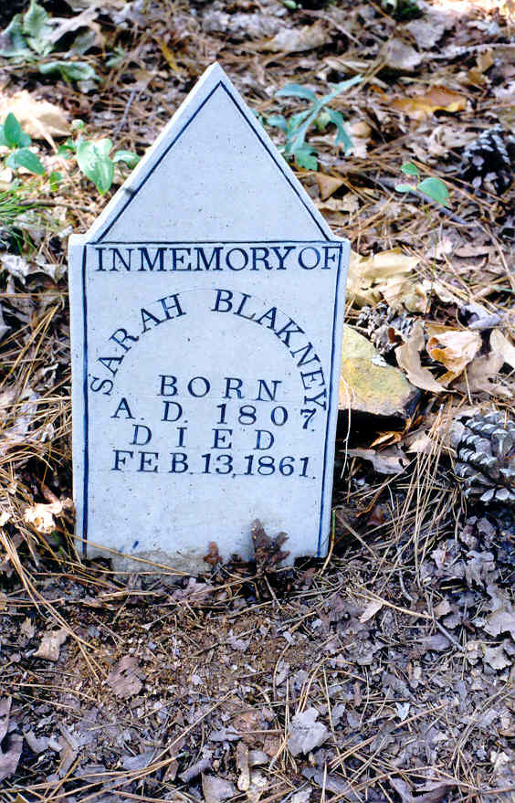

Dear Doc,

I am so glad that the stall plate photo has arrived. It is so interesting, good colors, and will be really impressive when you get finished with the restoration. Al looked at it and wants to know if this is the family coat of arms. It is some what different from the one he has seen before.

Doc, I know you are busy, but could you look in the cemetery list that Pauline made for us and find the burial place for John Thomas. this is what I have for him: born Dec 25, 1849, died 1928. Married to Lydia Ann Nabors in 1968. I just need to know where they are buried. Also, is Ashcraft Memorial Cemetery in Fayette or Pickens. You have Fayette and Walt has Pickens. Pauline should have this in her list. I can't find mine because all my files are packed away waiting for me to refile them in my new file cabinet. I am almost finished with the narrative and this is all the info I need.

I am ready to finish this project.

Again, thanks for sending the "before " picture, lots of hard work ahead. Everyone appreciates your dedication to these tedious projects. I know I do.

love, Kay

Phyllis,

I have finally got around to retyping the probate record for A.B.Lowery that I told you about at the last reunion. Sorry it took me so long to get it done. I decided to get the reference from the Fayette Court house.Feel free to send it to anyone else you think might be interested.

Hope all is well with you, we are fine. Have had spring like weather the last two days. Makes it bad when the cold comes back, as it always does.

Take care, Kay

Probate Record for A.B.Lowery.In addition to the record transcribed below another court record pertaining to this case can be found in Fayette County Probate Record Book 4, new series, p.134-135. In this record Simon P. Lowery and Dicie D. Lowery are identified as “minor heirs of Simon Poe”. (Transcribed by Kay Blakeney February 2004.)

Probate Court Minutes of Fayette County, Ala, Book 2, p.708-709
A.B.LOWREY ESTATE: State of Alabama, Fayette County the 19th day of March, 1877, this day comes Thomas Blakeney and filed his petition in writing and under oath praying to be appointed guardian of Simon P. Lowery and Dicie Lowrey minor children of A.B. Lowrey, deceased, and representing that said minors has an estate of their own right coming from the estate of Simon Poe deceased, that said minors are aged respectively by about fifteen and eighteen years, that one of said minors resides in Mississippi and the other with his mother in Sanford County and his mother has intermarried with one J.J.Branyon, that their interest in said estate of Simon Poe deceased will be about one hundred dollars and not probably more which would in a short time be ready to be paid over to them or their guardian and he being at the same time filed his bond in the sum of two hundred dollars with A.A.Walden and J.T. Ashcraft his securities therein and he being the grandfather of said children and appearing to be a suitable person to become their guardian and their estate being in this county in the hands of the administrator of Simon Poe deceased, and said bond being ------- ------- and approved by the judge of probate of said county, it is therefore ordered, adjudged, and decread by the court that the said Thomas Blakeney -------- and he is hereby appointed guardian of the estate of said minors aforesaid, and that the proper letters do I put to him forthwith as such guardian, It is further ordered by the court that said petition, bond, letters, be filed and recorded and that said guardian pay the cost of this proceeding for which let execution ----------.

Winthrup B.W. Williams, Judge

A.B. Lowery was the husband of Kizziah Blakeney
Sanford County is now Lamar County
Dear Kay:

You have been so busy transcribing Blakeney wills that I haven't heard of your progress with the study on William's children. I'll try to help a little with some photos and dates. I have very little on William and first wife, Elizabeth Corder ("Lizzie") but a goodly amount on William and second wife, Elizabeth Clanton (also known as "Lizzie" !) I'll process these photos one at a time with captions and send as attachments.

We were iced in last night but it seems to be melting. I hope my Photoshop class can meet tonight.

Love, Doc

