While checking the History of Shepherd Church I realized I had Sarah Blakeney's date of death incorrectly stated. I rechecked Walt's dates and she died in 1860 NOT 1850 as I have noted. Therefore she was still alive when E. Corder died in1854.

I will definitely have this changed in the 2nd draft. Sorry. Kay
Dear Kay and Al:

John Thomas and Lidia are buried in the Zion Baptist Cemetery in Pickens County. Same cemetery where Elizabeth Clanton Blakeney Ashcraft is buried. Zion isn't 500 yards over into Pickens County from Fayette County.

Ashcraft Memorial Cemetery is in Fayette County. Almost on the Pickens-Fayette line.

Here is a photo of the Blakeney family plot in Zion containing John Thomas and Lidia. You can probably read John Thomas' name closest to the camera.

The coat of arms on the stall shield is the one used by Sir William, and it is certainly not like the one I have on file that came from Phyllis Lyday. Don't have an answer for the difference.

A lady over in Enterprise, MS, Della Yerby, got my address off of George Wright's website:

www.geocities.com/coh41/41stALalbum.html

Della knows all the Yerbys that lived around Newtonville and is a bottomless source of antique photos. I think that I sent you the one of Hogan Yerby who is buried at Pilgrim Rest. Hogan and Thomas Blakeney arrived in Newtonville at about the same time and I'm sure were good friends. I've been sending Della all the pics and info that I have on Yerbys. My Uncle Mute's wife was Ila Yerby and she had a brother named Vertus. They are in the Newtonville Cemetery.

You need to look at Geo. Wright's website. It loads slowly, then scroll down. You will see photos that you recognize. Maybe this stuff will help.

I got an article accepted by CIVIL WAR TIMES and it will be published all over the world, even in foreign languages. It concerns a love letter written by my great great uncle, Lt. James Franklin Holliman during the Civil War to his bride-to-be, Rebecca Utley Stewart. I'll send you a copy when it is published.

The weather is COLD and WET. Lots of ice. My cousin's husband fell and broke a leg, and Phyllis' brother had a fresh arthroscopy and fell 5 days later and really messed up the bad knee.

Gotta quit and write Della Yerby. She has messed up some info that I sent her on Saturday. Love, Doc

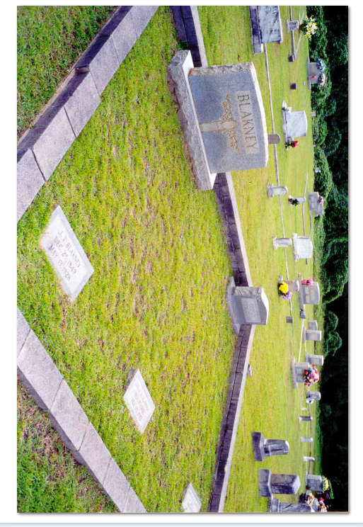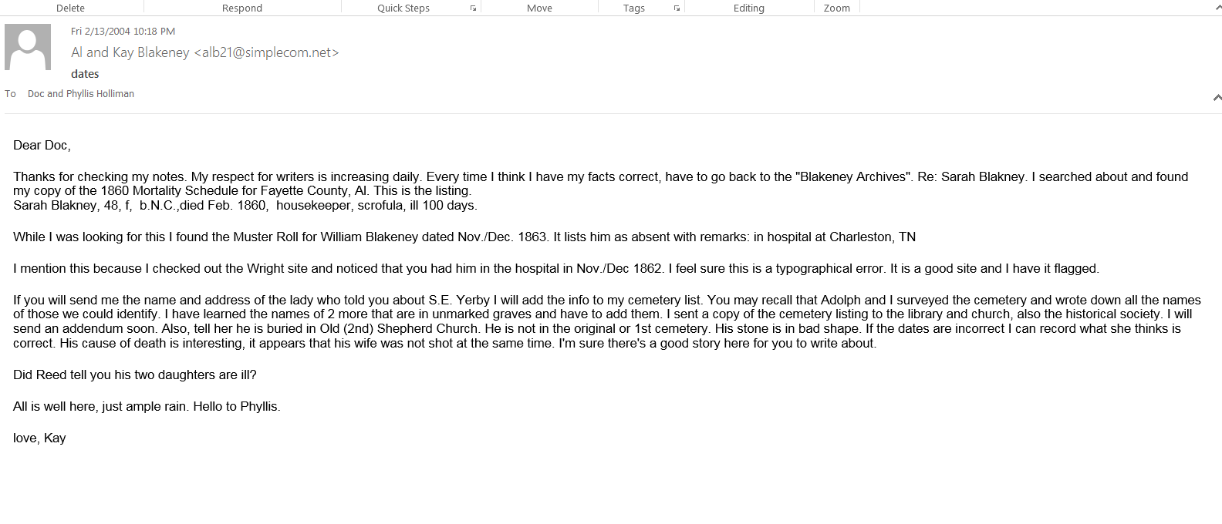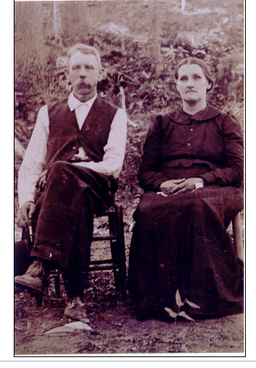James Vincent was the second child of William and Elizabeth Corder. The first child of this union was John Thomas Blakeney.

Here are James Vincent and Sarah Elizabeth Thornton. His dates: B. May 1, 1850; D. April 30, 1936. Her dates: B. Jan. 15, 1855; D. Jan. 7, 1942. Both buried at Ashcraft Memorial Cemetery, Ashcraft Corners, Fayette County, AL.

Martha Jane was the youngest child of William Blakeney and Elizabeth Clanton. She was born in 1861, and died in 1936. In the family she was known as "Aunt Mattie". She married Thomas Raymond Wright, born Dec. 4, 1858 and died on Nov. 2, 1917. They had 7 children. Both are buried at the Chapel Hill Cemetery on County Route 12, just west of Newtonville, Fayette County, AL. 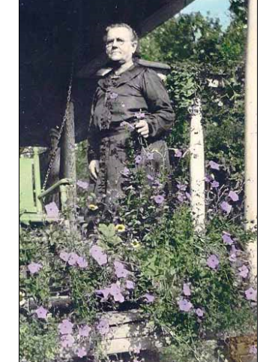
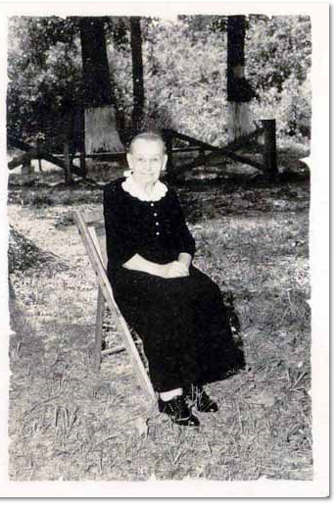

Newton David Blakeney was the oldest child of William Blakeney and Elizabeth Clanton. Elizabeth Clanton Blakeney married Thomas Ashcraft after William's death in 1863 in the Civil War. William's grave site unknown. Lizzie Ashcraft is buried at Zion Cemetery, Ashcraft Corners, in Pickens County. Her son, Newton David, is the only one of 3 children mentioned on her grave marker.

Newton David Blakeney, born Feb. 8, 1857, died Nov. 5, 1937. Married Mollie F. Lindsey. They had 3 children. She was born on Feb. 8, 1867 and died on Sept. 17, 1914. Newton and she are buried in Chapel Hill Cemetery on County Route 12, west of Newtonville, AL, Fayette County. Three attachments. The last shows Newton David with his sister, Belzy Ann Blakeney Baker, in Virgil Gibson's yard at Newtonville in May, 1937. This was the last picture made of Uncle Newt. He died in Nov., 1937.

The portrait of Newton was painted when he was a young man.

The photo with the child, Cecil C. Blakeney was made about 1909. Cecil was about 9 years old.

