James C. Greene with wife Mary Wilson and their daughter Bertha. Mary Wilson Greene was one of two daughters born to our Uncle Albert Pinkney Wilson 1825-1928. Uncle Albert was Grandpa Isaac's brother.unnamed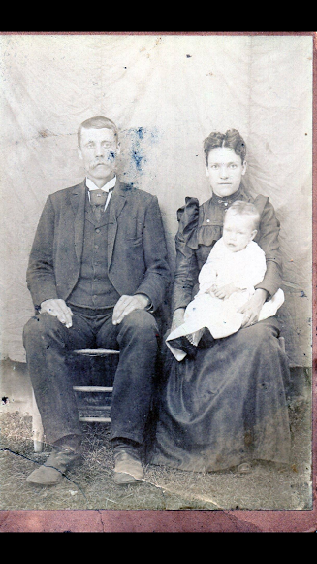

Family of Ashe County, NC. Albert Pinkney Wilson served in the Civil War, fighting for the South at Gettysburg, PA.

