We continue with our series on Allen Holleman's ancestors who migrated Virginia to North Carolina in search of productive farm land in the early 19th century. In a previous post, Allen wrote of Jordan Holleman, a 4th great uncle, who left a paper trail that paints a picture of life in the 19th Century is a largely rural North Carolina. In this article, an 1829 county court case reveals a startling act of humanity that went against the norms and laws of a society engulfed in the 'particular institution', human slavery! - GNH

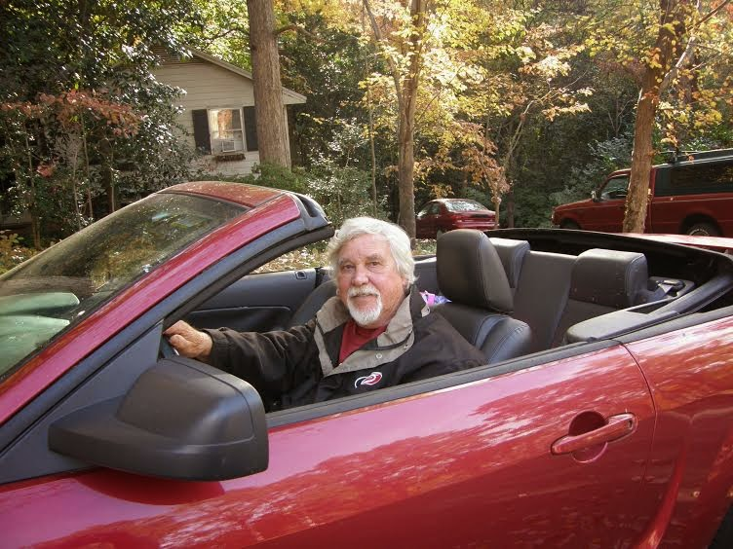
Above Allen Holleman in his latest Mustang!
Allen Holleman writes Part 2 of his Story of Jordan Holleman, his 4th great uncle....

Jordan Holleman (1782-1875) in the middle 1800s lived mainly in Buckhorn Township in Wake County, North Carolina near and on the old Fayetteville Road (between New Hill and Holly Springs, route of present day New Hill-Holleman Rd.) This third great grandson of Christopher Hollyman (1618-1691), moved to the Piedmont area of North Carolina sometime after 1810, eventually owning land in both Wake and Chatham Counties.

The point of the red dot is located at Holleman Crossroads, just south of U.S. Highway 1 adjacent to Harris Lake in Wake County, North Carolina.

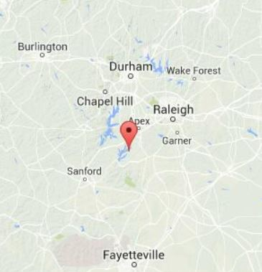
Below is a closer view of the area where Jordan Holleman and his relations lived southwest of Raleigh.
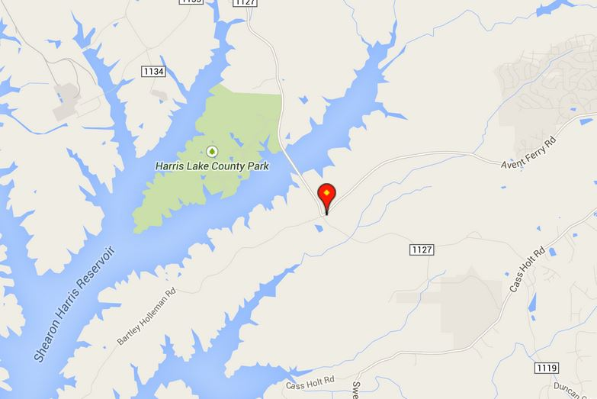

The farm of a Jordan great nephew still can be seen today and is known as the Samuel Bartley Holliman House, located at the intersection of Avent Ferry Road and Bartley Holleman Rd. This is known as Holleman's Crossroads. Some of former Holleman land is also under the Harris Reservoir.

The Samuel Bartley Holliman House

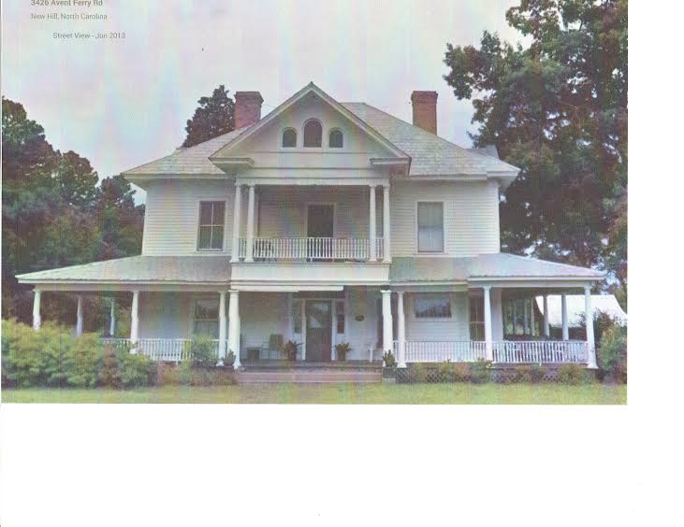
JORDAN HOLLEMAN IS ACCUSED OF BREAKING A SOCIAL TABOO - THE GRAND JURY INDICTMENT OF 1829
Note: The cover for this document says - State vs. Jordan Holloman - Forging a Free Pass for a Slave
"State of North Carolina, County of Chatham: Superior court of Law- Fall Term, A.D. 1829:
The Jurors for the State upon their Oath present, that heretofore, to wit on and before the first day of January A.D. 1829, a certain Thomas Bell was owner of a Negro slave named Willis, the said slave Willis being then a runaway and having left his master's service and that one Jordan Holloman, late of the county of Chatham aforesaid, farmer, on the day and year aforesaid in the County aforesaid,
fraudulently and deceitfully did forge make and counterfeit a certain written pass, commonly called " a free pass" for and on behalf of the said slave Willis which said "pass" is as follows, that is to say_
'State of North Carolina Chatham County this will certify that the Barrer Isaac Evans (an alias) a man of Color is of Free Parentage, was born'd and Raised in the County afores'd and a person of a Moral Character, is about six feet high and served 'is' (his) apprenticeship under me as a farmer and was of age the 15th of December in the year of our Lord Eighteen Hundred and nine and the same Registered in the county etc.'
James O'Kelly Test: Lesly O'Kelly which said free pass: he, the said Jordon Holloman then and there delivered and caused to be delivered to the said Willis, slave as aforesaid, and then and there well knowing that the said Willis was a slave and then and there " a runaway" to the great injury of the said Thomas Bell and against the peace and dignity of the state.
John Scott Sol'r Gen'l (Solicitor General) Thomas Bell Junr.Pros.; Wit.Wm. Rencher, Geo. Williams, Allen Wilson, Henry Moore Sworn; sub. Sept. Term, 1829
C. J. Williams, C.S.C. A true bill - Jno Linth? Henth? Foreman"
Note just above, “Thomas Bell, Junr, Pros. If that means prosecutor, it would seem to be a conflict of interest as his father was bringing the suit. In searching Chatham Co. and state records, I have found nothing further about this indictment and suspect it was never brought to trial. Perhaps it was settled out of court or the prosecutor to the grand jury being family made it seem a fair trial was not possible.
As the senior Jordan Holleman (who had properties in both Wake and Chatham counties) was a slave “owner”, (with one field-hand), it’s hard to imagine him creating a document that would have been such a violation of the laws at the time and an affront to his friends and neighbors.
Another possibility might have been that this was a younger Jordan Holleman, the senior Jordan’s great-nephew, grandson of his brother John and son of Jeremiah. This Jordan was born 1810 in Wake. He would have been 19-20 years old and the ‘pass’ might have been the result of the impetuosity and rebelliousness of youth. His family also had holdings in both Wake and Chatham.
Afterwards he moved on to Georgia and then to Mississippi. I have found only this abstract, not the original court record nor any disposition.
I have seen the will of Thos. Bell (Sr.) above with some indications he was a reasonably decent fellow – if that can be said of anyone who held other humans in enforced servitude: slavery. He does state that he does not believe in separating husband and wife and further that their children are to be considered ‘property’ of the parents and to remain with them and are NOT to be considered as part of his estate and binding his heirs to these provisions.
JORDAN WAS ENUMERATED TWICE IN THE 1850 CENSUS
Twenty years later, Jordan's wife, Mary, had recently died, and he seemed at loose ends. As written earlier, he seems to like lots of people around him and appears also to be moving around a bit in Wake County. The census–taker was Stephen Stephenson who wrote with a beautiful hand, but couldn’t seem to even spell Smith correctly. He certainly never got Holleman right but I guess it works phonetically. Apparently the folks being counted did not see the pages as all of the men could read and write and many of the ladies could as well by then, and they all spelled Holleman when signing. Oh well.
First, Jordan is living with son Wiley Wilkins Holleman (1818-1890) and daughter Mary J, both unmarried with eldest son Wyatt next door. They were in the White Oak area of south west Wake County, between New Hill and Holly Springs. Brother John and his sons Davis and Edwin were also nearby and close to Hollemans Crossroads of today.1
Amazingly, in a second counting in the same 1850 census, Jordan is living with a family Stephenson, last name spelled as Wibbern and Wilbern 2 and we see Jordan’s sense of humor. This would be Henry Wilborn and wife Cynthia Fuquay. I suspect either he was visiting the Wilberns on that day and was messing with Stephen when he claimed to be living there and gave his occupation as shoemaker – which he never was but he might have just ‘fixed’ one of his own. Or they were farming on one of Jordan’s properties. These folks had a distrust of government even then.
JORDAN MOVES AGAIN
The census of 1860 finds Jordan listed with his youngest daughter Mary J. Matthews (1828-1876) and her 2nd husband, Israel and five children. This time he says he’s a carpenter ³. While it is likely he built quite a few structures, there’s no indication that he ever did it for anyone else. The census fellow was Wm. M. Tompkins and his spelling is as poor as Stephen’s and his writing is hard to decipher. He has my ancestor as Jordain Holomon.
The latest deed I found was in March 1849 where Jordan took a fair sized farm of 57 acres in settlement of a debt, and he found folks to work the lands as who would be known later as sharecroppers or tenant farmers.
By 1870 he was pretty much retired as a farmer and was living with his daughter Susannah and her husband James Phillips in New Hill, Wake County. There are no children listed, but in the household were two other ladies: seven year old Eliza Overby and Jane Ricroft, 49. Jordan at 88 was the head of household so this is likely his property.
In the rural South, people looked after each other, family or friends. Orphans and widows were taken in and found homes with folks they had long known. Older family members remained with family. This was community at its best.

Below, Wyatt Holleman's bible recording his father's, Jordan Holleman, death.

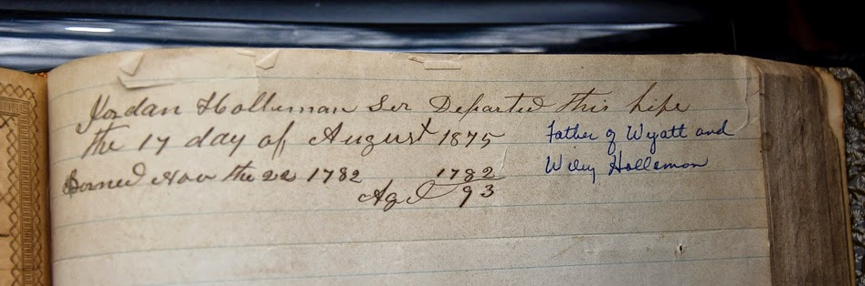Jordan Holleman lived his last twenty-five years without his beloved Polly (Mary) and those must have been hard years for him, but he lived with and among family and friends and being an active do’er, he surely made the best of the life he had. He passed away on August 17, 1875 at 93 and was surely missed by those who knew and loved him.
I cannot imagine Jordan, so used to deeds and records as he was, not leaving a will to specify how his estate was to be handled but so far I haven’t discovered one. Unless he had already divided his properties: real and personal while still living and made any other provisions known but there should be deeds for those.

FOOTNOTES:

¹Many of these farms are now beneath water as the White Oak Creek was dammed to create Harris Lake in the 1970’s. Recreational yes, but mainly a cooling pond for a nuclear power plant today. Holleman’s Crossroads seems to have gained that name in the 1890’s when Samuel Bartley Holleman built a large house on the NE corner, that is today on the National Register of Historic Places. This is at the intersection of New Hill-Holleman Rd. and Bartley Holleman Rd., west of Holly Springs. See below.
Insert house photo
2Jordan’s son, Wyatt, in several censuses, named himself a carpenter – more like what today we would call a contractor, as he was the businessman in charge -and it’s possible the father may have worked with him some but at 78 it seems likely he might have been spoofing the census taker. In the 1850 census he was listed as age 68 (twice, remember) and that is correct but in 1860, he says he’s 75. Wouldn’t we all like to age just seven years in ten?

³Jordan’s brother, Jonathan, had children who moved south: Barnett the oldest son went to Houston Co. GA and his sister Charity did as well and married Oliver H. P. Wellborn there. Later Jonathan’s widow moved there to live with her daughter who was also widowed by then. Recognize the name of her husband? He was named for the hero Commodore of the War of 1812 – Oliver Hazard Perry and the nearest town was Perry. I have not found a direct connection between the Wilberns and Wellborns but we can suspect they were related and a generation earlier had moved to Georgia.
- Allen Holleman, North Carolina
With this post, we continue the series of articles by Allen Holleman of North Carolina, USA who explores the lives of his ancestors. Readers may have noticed one posting for 19th Century Virginia and then the next posting, 19th Century England. Both branches descend from Thomas Holyman, d. 1558 in Cuddington, Buckinghamshire, United Kingdom and it is interesting to note the differing lives and occupations of these distant cousins, separated by time and space.
"As kids we would listen, open-mouthed, to the tales Dad told us which his grandfather, JORDAN HOLLEMAN, told him about the trip from Isle of Wight County, Virginia, the home of Jordan's father, JESSE HOLLEMAN. They cut trees, for there were no roads in 1815 to where they wanted to go. Trees and mud were a pest most of the way to Wake County, where Jordan settled on farmland in what is now Apex. He and then his son Wiley Wilkins HOLLEMAN became a stabilizing part of the community. They helped found Salem Baptist Church in 1840 and started a Masonic group."-Terrine HOLLEMAN Woodlief ^{1 and 2}

^{Allen Holleman writes....}

My great-great-grandaddy may have embellished the tales a bit as there were certainly roads to, in and through Wake County as folks had been moving there for years from Virginia. But they might have needed to clear a path or two. I have found that Uncle Jordan (he was a 4th Great-Uncle of mine) was a bit of a character and we'll see he had quite a sense of humor.

JORDAN HOLLEMAN, b. 22 November 1782, was the 3rd Great-Grandson of CHRISTOPHER HOLYMAN (1618-1691) who arrived in Virginia in 1650, settled in Isle of Wight County and amassed a farm of 1020 acres. Jordan’s father was JESSE HOLLEMAN, the patriarch of our Wake County lines, though he never left Virginia.

As with all of Jesse’s sons, Jordan had a basic education, could read and write and knew some math, as well. And certainly had experience in farming.

JORDAN HOLLEMAN, PLANTER

We find him in the 1810 census at 28, with his own farm in Isle of Wight County, VA. (IOW).
Jordan seems to have liked having lots of folks around him as the 1810 census shows him head of household with another male 16-25, two females 16-25, seven other “free white” and two slaves. We cannot account for the others with any certainty as only the head of house was named before 1850. More than likely they were relatives - cousins perhaps as they were listed as part of the household. His younger brother, Jonathan, and bride of one year were listed two houses/farms away. I had thought the other young lady may have been a sister but they were already married themselves.³ The other seven free persons would likely be field-hands living on the farm.

We have not found the marriage record but that census leads us to think he and MARY SIMMONS known as Polly, of Southampton Co had married before the 1810 census, accounting for the other young woman, and they then began their own family.
In November of 1812 WYATT JACK HOLLEMAN death date? was born in the year of a and a major event in our country's history – The War of 1812.

Jordan Holleman had been serving as a sergeant in the 29th Regiment of the Virginia Militia, known as Ballard's Regiment under the commander, Major Joseph W. Ballard. His company commander was Capt. Simmons Gwaltney. In January 1813, the 29th came under the command of the US Army, but an April 1813 poll in IOW, indicates they were not deployed, and remained at home as reserves with farms and families to protect from the evil Brits.

The British warship, HMS Plantagenet, a 74 gun frigate, for several months lay off the "Rocks"⁵ in the James River. Her very presence and occasional changing of position kept the 29th busy watching her movements. It must be presumed that this ship was to intercept any vessels sailing from the James.
In June 1813 the British attempted a landing, and were soundly beaten back by the accurate and well-placed fire from the excellent riflemen of the 29th who had almost been born with a rifle and developed great accuracy in hunting. With the aborted landing at the "Rocks" (where?), the Royal Navy re-learned a lesson from the Revolution about how good the Americans were with firearms. Although the Plantagenet remained at her station, they never made another attempt at a landing. ⁶

Capt. SIMMONS GWALTNEY was married to Jordan's sister, SARAH and also in the company were Jordan's brothers: Lt. JOSIAH HOLLEMAN the 2nd in command and Corporal JONATHAN HOLLEMAN. Along with them were several other Gwaltneys and Cofers, Dews, Delks, Stringfield, Crocker, Gray, names we know and are related to some of them, a Who's Who of Isle of Wight County.
After the war, in 1815 Jordan and Mary decided to follow his older brothers, John and Jesse (Jr.) to North Carolina and first settled in western Wake County near them. This was close to Chatham County, and land must have been less costly there as they bought additional properties across the line on the New Hope River. ⁷

THERE WERE NUMEROUS PROPERTY TRANSACTIONS

Jordan's first property in Wake County seems to have been purchased from the estate of Stephen Mann in 1815. Over the years there are records of him buying and selling properties in Wake and Chatham, some involved his older brother John, as well. It seems they were partners in the land business.

One 1818 deed says, “Jordan HOLLEMAN of Chatham Co to Archibald Haralson (spelling?) of Orange County, for seven hundred and fifty cents, tract on the waters of New Hope, adj. .. containing 168 acres” Either that was mighty poor land or if the amount shown was one of his witticisms or the clerk writing it failed to include ‘dollars’. But just adding the ‘fifty cents’ would have been a bit of a joke.⁷

He did sell 54 acres in Chatham Co. for $216 in 1819 that was likely his youngest brother Jonathan’s first property in North Carolina. That was prime land on a stream for irrigation, at $4.00 an acre.

A Grand Jury Indictment and the Growing Issue of Slavery...

{ Note: The cover for this document says - State vs. Jordan Holloman Forging a free pass for a slave}

"State of North Carolina, County of Chatham: Superior court of Law- Fall Term, A.D. 1829:
The Jurors for the State upon their Oath present, that heretofore, to wit on and before the first day of January A.D. 1829, a certain Thomas Bell was owner of a Negro slave named Willis, the said slave Willis being then a runaway and having left his master's service and that one Jordan Holloman, late of the county of Chathm aforesaid, farmer, on the day and year aforesaid in the County aforesaid, fraudulently and deceitfully did forge make and counterfeit a certain written pass, commonly called " a free pass" for and on behalf of the said slave Willis which said "pass" is as follows, that is to say_ 'State of North Carolina Chatham County this will certify that the Barrer Isaac Evans (an alias) a man of Color is of Free Parantage, was born'd and Raised in the County afores'd and a person of a Moral Character, is about six feet high and served 'is' (his) apprenticeship under me as a farmer and was of age the 15th of December in the year of our Lord Eighteen Hundred and nine and the same Registered in the county etc.'

James O'Kelly Test: Lesly O'Kelly which said free pass: he, the said Jordon Holloman then and there delivered and caused to be delivered to the said Willis, slave as aforesaid, and then and there well knowing that the said Willis was a slave and then and there " a runaway" to the great injury of the said Thomas Bell and against the peace and dignity of the state.
John Scott Sol'r Gen'l (Solicitor General) Thomas Bell Junr.Pros.; Wit.Wm. Rencher, Geo. Williams, Allen Wilson, Henry Moore Sworn &amp; sub. Sept. Term, 1829
C. J. Williams, C.S.C. A true bill - Jno Linth? Henth? Foreman"

As the senior Jordan Holleman (who had properties in both Wake and Chatham counties) was a slave “owner”, (with one field-hand), it’s hard to imagine him creating a document that would have been such a violation of the laws at the time and an affront to his friends and neighbors.

Another possibility might have been a younger Jordan Holleman, the senior Jordan’s great-nephew, grandson of his brother John and son of Jeremiah. This Jordan was born 1810 in Wake. He would have been 19-20 years old and the ‘pass’ might have been the result of the impetuosity and rebelliousness of youth. His family also had holdings in both Wake and Chatham. Afterwards he moved on to Georgia and then to Mississippi. I have found only this abstract, not the original court record nor the disposition.

I have seen the will of Thos. Bell (Sr.) above with some indications he was a reasonably decent fellow – if that can be said of anyone who held other humans in enforced servitude: slavery. He does state that he does not believe in separating husband and wife and further that their children are to be considered ‘property’ of the parents and to remain with them and are NOT to be considered as part of his estate and binding his heirs to these provisions.

JORDAN WAS ENUMERATED TWICE IN THE 1850 CENSUS
His wife Mary had recently died, and he seems at loose ends. As seen earlier, he seems to
like lots of people around him and appears also to be moving around a bit. The census–taker was Stephen Stephenson who wrote with a beautiful hand but couldn’t seem to even spell Smith correctly. He certainly never got Holleman right but I guess it works phonetically. Apparently the folks being counted didn’t see the pages as all of the men could read and write and many of the ladies could as well by then, and they all spelled Holleman when signing. Oh well.

First, Jordan is living with son Wiley Wilkins Holleman and daughter Mary J both unmarried with eldest son Wyatt next door. They were in the White Oak area of SW Wake, between New Hill and Holly Springs. Brother John and his sons Davis and Edwin were also nearby and near Hollemans Crossroads of today. ⁸

The second counting was with a family Stephen spelled as Wibbern and Wilbern⁹ and we see his sense of humor. This would be Henry Wilborn and wife Cynthia Fuquay. I suspect either: he was visiting on that day and was messing with Stephen when he claimed to be living there and gave his occupation as shoemaker – which he never was. Or they were farming on one of Jordan’s properties. These folks had a distrust of government even then.

JORDAN MOVES AGAIN
The census of 1860 finds Jordan listed with his youngest daughter Mary Matthews and her 2nd husband, Israel and their five children. This time he says he’s a carpenter ⁹. While it’s likely he built quite a few structures, there’s no indication that he ever did it for anyone else. The census fellow here is Wm. M. Tompkins and his spelling is as poor as Stephen’s and his writing is hard to decipher. He has my ancestor as Jordain Holomon.

The latest deed I’ve found was in March 1849 where Jordan took a fair sized farm of 57 acres in settlement of a debt, and he found folks to work the lands as what would be known later as sharecroppers or tenant farmers.

By 1870 he was pretty much retired as a farmer and was living with his daughter Susannah and her husband James Phillips in New Hill. There are no children listed but in the household were two other ladies: seven year old Eliza Overby and Jane Ricroft, 49. Jordan at 88 was the head of household so this is likely his property.

In the rural South, people looked after each other, family or friends. Orphans and widows were taken in and found homes with folks they had long known. Older family members remained with family. This was community at its best.

Jordan Holleman lived his last twenty-five years without his beloved Mary and those must have been hard years for him but he lived with and among family and friends and being an active do’er, he surely made the best of the life he had. He passed away on August 17, 1875 at 93 and was surely missed by those who knew and loved him.

I cannot imagine Jordan, so used to deeds and records as he was, not leaving a will to specify how his estate was to be handled but so far I haven’t discovered one. Unless he had already divided his properties: real and personal while still living and made any other provisions known but there should be deeds for those.

FOOTNOTES:
¹ (From: HISTORY OF WAKE COUNTY, NC, 1983, pg.373: Elizabeth Murray Reid)
²The Masonic Lodge that Jordan helped found would have been the Western Sun Lodge, that existed from 1817 to 1827 at New Hill. Jordan's oldest son, Wyatt J. Holleman, helped to found the Cary Masonic Lodge about 25 years later and served as Grand master for over 10 years and his son, Joel was Secretary . He was also part of the founding of the Town of Cary - if a city of 150,000, that stretches from Raleigh on the east side to a portion in Chatham County to the west can be called a town, as it is even today.
³ Of Jordan’s older brothers were two whom we know nothing of besides birthdate and probably died young, Josiah was living in Smithfield, VA in public service and his family was with him. The two eldest, John and Jesse, Jr. were already in North Carolina.
⁴ Mary Simmons was the daughter of Sprately Simmons and Ann Drewry. He was a Sergeant in the 15th Virginia Regiment active in the American Revolution and was at Valley Forge in 1778.
⁵ The "Rocks" refers to a shore lined with natural marl, made up of petrified oyster shells.
⁶From a history of IoW by Col. W. M. Morrison
⁷Which in the 1970's, for flood control and water supply, was dammed where it joined the Cape Fear River to become Jordan Lake. I have found a copy of that deed and it does look like ‘seven hundred and fifty cents but there is a tick on the left edge where I suspect the clerk added a ‘$’ as he left off the word ‘dollars’ but that was not clear on the copy.
⁸Many of these farms are now beneath water as the White Oak Creek was dammed to create Harris Lake in the 1970’s. Recreational yes but mainly a cooling pond for a nuclear power plant today. Holleman’s Crossroads seems to have gained that name in the 1890’s when Samuel Bartley Holleman built a large house on the NE corner, that is today on the National Register of Historic Places. This is at the intersection of New Hill-Holleman Rd. and Bartley Holleman Rd., west of Holly Springs.
⁹Jordan’s son, Wyatt, in several censuses, named himself a carpenter – more like what today we would call a contractor, as he was the businessman in charge -and it’s possible the father may have worked with him some but at 78 it seems likely he might have been spoofing the census taker. In the 1850 census he was listed as age 68 (twice, remember) and that is correct but in 1860, he says he’s 75. Wouldn’t we all like to age just seven years in ten?
¹⁰Jordan’s brother, Jonathan, had children who moved south: Barnett the oldest son went to Houston Co. GA and his sister Charity did as well and married Oliver H. P. Wellborn there. Later Jonathan’s widow moved there to live with her daughter who was also widowed by then. Recognize the name of her husband? He was named for the hero Commodore of the War of 1812 – Oliver Hazard Perry and the nearest town was Perry. I have not found a direct connection between the Wilberns and Wellborns but we can suspect they were related and a generation earlier had moved to Georgia.- Allen Holleman, North Carolina
by Glenn N. Holliman
I am happy to post another article by cousin Allen Holleman who continues to research and write of his ancestors, direct descendants of Christopher Holyman (1618-1691) who migrated from Bedford, Bedfordshire, England with his sister, Judith (b 1621), and made his home in Isle of Wight, Virginia.
Drop in photo of Allen here
A Holleman Family leaves Virginia....by descendant Allen Holleman, 4th great grandson of John Holleman (1766-??)
My previous article (May 3, 1014) was about JESSE HOLLEMAN, great-grandson of CHRISTOPHER HOLLYMAN, and only briefly mentioned his nine sons and four daughters. While the daughters are important, the focus is on the boys as they carried the family name directly forward. We have very little to relate on four of them and Glenn Holliman has given us so much knowledge on the second son Josiah, who with his children were a well regarded and successful family in Isle of Wight County, Virginia in colonial times, early America and even today. I will concentrate on the four sons who chose to migrate to North Carolina, leaving the legacy and property of 150 years and family behind. Why...?
JOHN HOLLEMAN, the eldest of Jesse and Charity Cofer Holliman's sons was named for his grandfather and born 4 Feb 1766 in Newport Parish in western Isle of Wight County, VA on the family land by the Blackwater River. We don't know a lot about his early years but can surmise much just because he was the son of Jesse and much was expected of him being the firstborn.
He was schooled in the basics and could read and write and learned math as well. Most of his real-world education was from Jesse and seems to be mainly in farming, and 18th century land and farming economics. He doesn't seem to have taken up surveying, one of his father's professions. Yet we see he learned about land appraisal and trading. In 1796 he appraised the estate of his uncle, James Cofer.
About 1783 at age 17, he married NANCY WOMBLE, the daughter of Thomas and Rebecca Womble. It is most likely that in early marriage they lived with Jesse and Charity. Son Axum was born in 1784 and Davis in 1785. The family farm was well looked after but getting rather crowded, with other siblings. John inherited land from his grandfather THOMAS COFER in 1784 and he and Nancy likely moved there and farmed that until tobacco drained the soils of nutrients.
The original patent of Christopher Hollyman's original 1020 acres had been well divided by 1800, and there was not a lot of available farmland nearby. The Holleman boys, being adventurous sorts, needed to make their fortunes and futures as Christopher had done in leaving England for Virginia. North Carolina had become a draw for many, with a lot of available land and an emerging "civilization", especially in Wake County near the new state capital, Raleigh.
All eight of John and Nancy's children were born in Virginia and moved to North Carolina with them. That would have been after 1802 when the youngest, Edwin was born. Axum, the eldest, bought farmland from Mark Cook in 1804 and sold another parcel in 1807 both in Chatham County, NC. If he moved south with his family that would place them at least that early. Axum was an independent sort and may have moved first and influenced the others.
I can't place John in Wake County solidly until witnessing an 1810 land sale, where his son, Jeremiah bought farmland from Richard Levens. Generally, witnesses to legal transactions, such as deeds and wills, were substantial citizens - landowners, so he and his sons were well established there already.
Between 1812 and 1848, John became quite a land trader as he is named on numerous deeds as buyer or seller. He also witnessed several deeds for others, and executor of several wills establishing that he was a respected and trusted citizen of the county.
John seems to have been a money lender also and some did not go well as he had to take property in settlement of some debts. That may not have been all bad but it must have been difficult to foreclose on friends and neighbors. We don't know how many of these there might have been as only the problem loans were recorded by the county. And we might think he wasn't particularly avaricious as he signed notes as security for others, promising to cover their debts. Again, only those that didn't go well were legally noted. Even though the debts were discharged by sale of property, it must have been a hassle to have to travel 25 miles to Raleigh - much of the day by horse, and then deal with the legal issues.
A Remarriage and Legal Troubles...
John's wife, NANCY WOMBLE was on the 1840 census but died before 1844 when he marries another NANCY, nee UTLEY. We don't know whether she was a spinster at 50 or had been married to an Utley but suspect the former as the bondsman was Hinton Utley. John would have been quite a catch to support her in her later years and he certainly needed a wife to cook and keep house for him. But, as we shall see, it may not have been a match made in heaven.
The last land sale I have for John is an important issue, even after he passes away in August 1850, as you will see as the history of my 4th GGF comes to a close.
Wake County, NC, Deeds, Book 18: pp. 584-585:
10 Apr 1848.
John HOLLEMAN of Wake Co to Edwin HOLLEMAN of Wake Co
for $125, tract adj. Johnson Busbee, Allen Jones, Burwell Utley, containing 279-3/4 acres.
Signed: John HOLLEMAN
Witness: John Bennett
Many of us are familiar with an abbreviated abstract of the will of John Holleman but it leaves out some wording that is significant and indicating some strained relationships, shown in italics.
Wake County, NC, Wills- Book 27:pp. 088-089:
Will of JOHN HOLLEMAN SR. of Wake Co, NC.
To beloved wife NANCY HOLLEMAN the interest of $500, to be paid by executor during life tenure or widowhood then the $500 to be divided among my heirs.
Wife Nancy HOLLEMAN to have all of property she brought to my house when I married her.
It is my will and desire that my beloved wife NANCY HOLLEMAN have the interest of five hundred dollars as before named and what property she brought to my house as before named and no more. It is my will and desire that she have that much of my estate as her only shear (sic) in my estate in any way what ever=
To son JOHN HOLLEMAN $1 as his only shear in any and all in any way whatever=.
To lawful heirs of son Jeremiah HOLLEMAN dec'd. $1 to be equally divided among them all and as there only shear in any and all of my estate in any way what ever=
Furthermore it is my will and desire that my executor herein after named shall sell all of my property consisting of land, negros and perishable property... and furthermore collect all debts due to me - and all the moneys arising from the sale of all my property...
to be equally divided among children whose names follow: AXUM HOLLEMAN, DAVIS HOLLEMAN, EDWIN HOLLEMAN, PEGGY BRIGHT, BETSY WILSON, NANCY DUPREE.
...appoint son Edwin HOLLEMAN executor. 13 Oct 1846. Signed: JOHN HOLLEMAN Witnesses: R.M. Brown, John Brummet Proved August term 1850 by R.M. Brown and John Bennet
John died in August of 1850. Nancy, surely in a state of grief and confusion and inexperienced in legal matters, likely thinking she would be able to remain in the home and on the property she had shared with her husband and perhaps thinking she was to receive the $500 stated, gave agreement of the will, by receipts to Edwin, son and executor. Then finding the ugly facts: that the interest only of $500 was not enough to live on and worse, she was not to remain in the house nor did she inherit any property. Beloved wife indeed? It was customary then for a widow to be granted a place to live for her life or widowhood - unless she remarried.
We can only speculate as to how and why the will was written this way. Was John so callus as to toss her out even after he was gone? Was she so difficult he just didn't care? Or did he just see her as a cook and housekeeper and no more? Was his mental state in his 80's such that he didn't realize how this would affect her? Or was he so influenced by his progeny - Edwin, in particular, as claimed? Or was this an inadvertent omission? We cannot know for sure but we can surmise, considering the very specific wording of the will. It was very direct.
After the realization that she had a problem, through a lawyer named Saunders, she filed suit against Edwin and the other heirs, in the Wake Court of Pleas and Quarter. Claiming that her husband had a personal property estate of "$8000 or some such large amount" (a LOT of money in 1850) and asking for 1/3 of all the real property he "seized and possessed" further that "through some improper influence, left her without a home".
Pleas and Quarter was more of an administrative court handling relatively minor cases and staffed by Justices of the Peace. And a panel of three JP's twice considered this case, in Nov. 1850 and in 1851, decided that she was not entitled to additional properties but that she should be supported and twice awarded a years supply of household supplies and foods paid for by the estate.
The lists of foods is informative in that it tells us what was normally available.
Most was preserved by drying, smoking or salting. List of Nov. 1850: 2 barrels corn, 300 lbs. pork (most likely smoked or salted bacon or hams), 1 barrel flour, 20 lbs. coffee, 4 gallons molasses, 20 lbs. lard, pepper, spices and ginger, 1 bushel salt, 15 lbs. cotton, 5 lbs. wool, 10 lbs. butter, 2 gal. vinegar.
Again in 1851 the court awarded: 2 barrels corn, 200 lbs. bacon, 30 lbs. sugar, 25 lbs. coffee, 5 gallons molasses, 20 lbs. lard, 20 lbs. butter, 1 bushel salt, 4 gallons vinegar, pepper, spices and ginger, 15 bushels potatoes, 5 bushels Irish potatoes, a lot of vegetables. (I don’t know if this meant a specified amount or grouping or just a whole bunch of vegetables.)

It is presumed that she went back to live with her Utley relatives and we lose track of her. The other progeny went on to live their lives and we have quite a lot of records on them.
Next we'll examine the three other brothers of John who had moved to North Carolina....Allen Holleman, 2014

