An Alabama Family during World War II
by Glenn N. Holliman

From 1939 until 1945, violence, unprecedented destruction of life and property and mass movements of military, forced workers and refugees swept Europe, North Africa and Asia. Scarcely an American was not affected by the investment of the United States in armaments and the training and positioning of 13 million soldiers, sailors and airmen during World War II. Over 200,000 Americans died among the 50 million or so who perished across the battered planet. Six thousand Alabamians lost their lives among the 260,000 who mobilized.
In the United States, rearmament, a massive government stimulus plan if you will, led to full employment after a decade of the Depression. Jobs went begging as millions of young men were conscripted into the military. For the first time in American history, large numbers of women worked outside of the home, filling positions once held exclusively by men. Women experienced increased independence with their own pay checks. Millions of men and women left home and relocated to work in war industries or to serve in the military. Geographical, gender, class and racial divides were narrowed. Customs and mores altered under the pressures and stresses of world war and rapid change.
The United States and one Alabama family would be different in 1945 compared to 1939. The Ulyss Holliman family, with seven offspring born between 1908 - 1924, saw three sons and a son-in-law go to war, a daughter launched into a career track and three children married during the conflict. Two sons would use the G.I. Bill to further their educations and go on to expanded careers in government and business.
This family saved many of the letters that were sent to the sons and the sons sent home. In this work, based on these letters, family interviews and my father's memoirs, I have divided each month of the war into 'The War Front' and "The Home Front', allowing a look into the events that so affected the lives of this extended family. I am grateful to the Ferrell, Daly, Herrin, Cornelius and several Holliman families for preserving and sharing these irreplaceable resources on the war.
My WWII sources, other than a life time of reading and an M.A. in history, are Alabama, WWII, etc.

These articles are written with several audiences in mind:
- One, for the descendants of this family.
- Two, to provide some wartime history of Irondale, Alabama and other families mentioned in the letters.
- Three, to add to the record the story of the World War II generation that saw their world upended and their lives forever changed.

September 1939 - The Storm Rises
For my father, Bishop Holliman, the War began with a letter, a factious typed letter he banged out with two fingers, probably teased out of him by his brother in law, Robert W. Daly, Sr. My Uncle Robert was famous for 'egging' his young in-laws, verbally sparing good naturedly with them just for the sake of argument and on just about any subject.
Bishop was the fifth of seven children, born 1919, and whose life would go in different directions because of the War. Robert was a mentor and 'big brother' figure for the three youngest Hollimans who stilled lived at home in 1939. In addition to Bishop, Virginia (1922-2011) and Ralph, born 1924, resided at 2300 3rd Avenue North with their parents, Ulyss (1884-1965) and Pearl Caine Holliman (1887-1955).
Four older children had left the nest earlier. They were Melton (1908-1958), Vena (1909-1990), Loudelle (1912-1996) and Euhal (1914-1989).
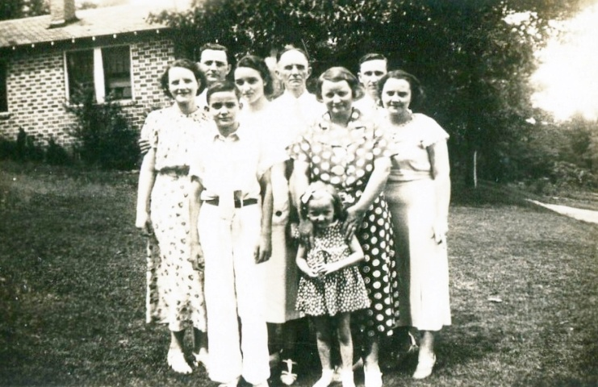
Left to right in 1937 Irondale, Alabama with the Daly House in the background: Ida and Melton Holliman, Ralph, Virginia, Ulyss, Mary Daly in front of her grandmother, Pearl, Robert W. Daly, Sr. and wife in foreground, Vena Holliman Daly. Pearl would age dramatically during the war, consumed by worry for her children and their sacrifices.

Robert Daly was an Irishman, his family only sixty years American when the Second World War began. His grandfather, a civil engineer, had helped plan the Alabama Central Railroad. His father, Karl Daly, had been an Irondale, Alabama farmer. By the 21st Century, the fields had long been subdivided into large housing tracts for suburban commuters. Robert had left the farm and become a bank manager. He was a generous mentor to his wife's, Vena, three youngest siblings - Bishop, Virginia and Ralph Holliman.
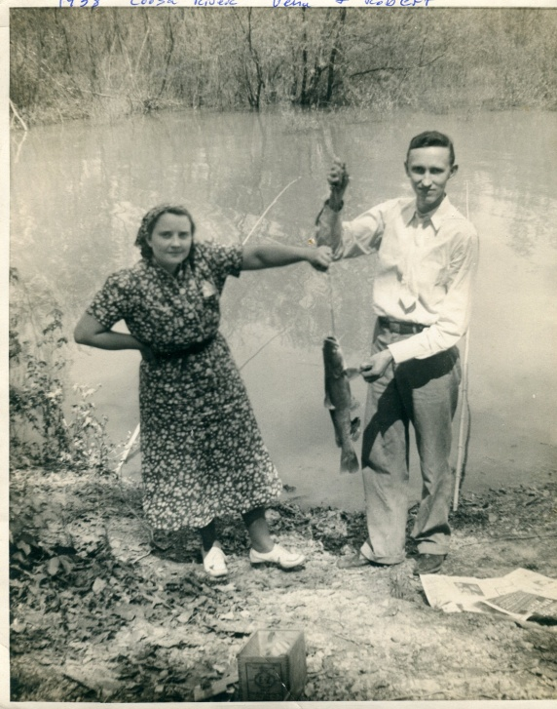
Vena and Robert Daly fishing along the Coosa River in 1938. Although Vena wore a bandana to protect herself from the Deep South sun, Robert fished in a dress shirt and tie. It was indeed a more formal era.
In 1931 Robert built two brick houses in the 2300 3rd Avenue North block of Irondale, on the steep hill overlooking the railroad switching yard. Vena, his wife, had come of age in the house next door, the home of Ulyss and Pearl Caine Holliman since 1921. There were seven children born to this Fayette County, Alabama couple. Vena Vivian was the first to marry in 1928. Husband Robert, born 1901, wise and full of mischievous good will, managed a bank in Woodlawn, Alabama.
Ulyss moved his growing family from Fayette in 1917, seeking employment in the bustling, hard-nosed, blue collar steel city of Birmingham. He found his carpentry skills in demand by the Birmingham Electric Company that ran the street car line. From that year until his retirement in 1949, he repaired the wooden trolleys. In 1953, the last street car ran in Birmingham and an era closed. But Ulyss had earned enough to support his family during Depression and World Wars.
By 1939, a new World War had already engulfed both Asia and Europe. The military government of Japan invaded China in 1937, a snake trying to swallow an elephant. On September 1, 1939, a half-mad, anti-Semitic dictator of a resurgent Germany ordered a Blitzkrieg, a lighting war, on Poland. In the name of reclaiming lands lost by the 1919 Versailles Treaty, Adolph Hitler, who came to power in 1933, vigorously pursued his dream of a Greater Germany that would dominate Europe.

Spurred on by lively conversations with Robert Daly, Homer Bishop Holliman, born the year of the infamous Versailles Treaty, a college history major, wrote the following tongue-in-cheek letter to himself. While meant to be humorous, Bishop, captured the ambiguous feelings of many Americans as Europe once again plunged itself into an abbess. Notice in the letter, he refers to the issues of the embargo and neutrality.
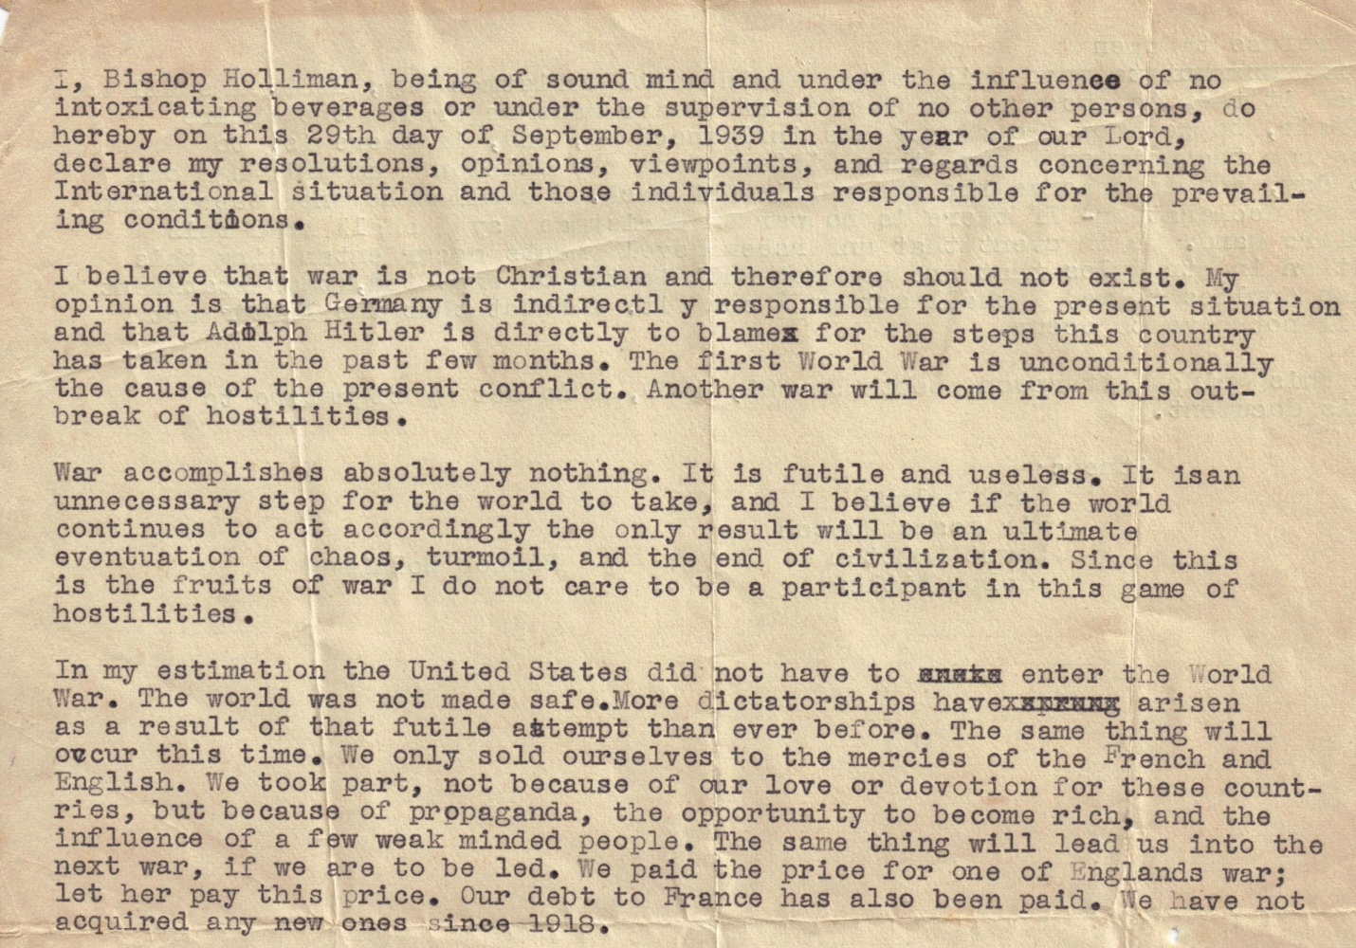
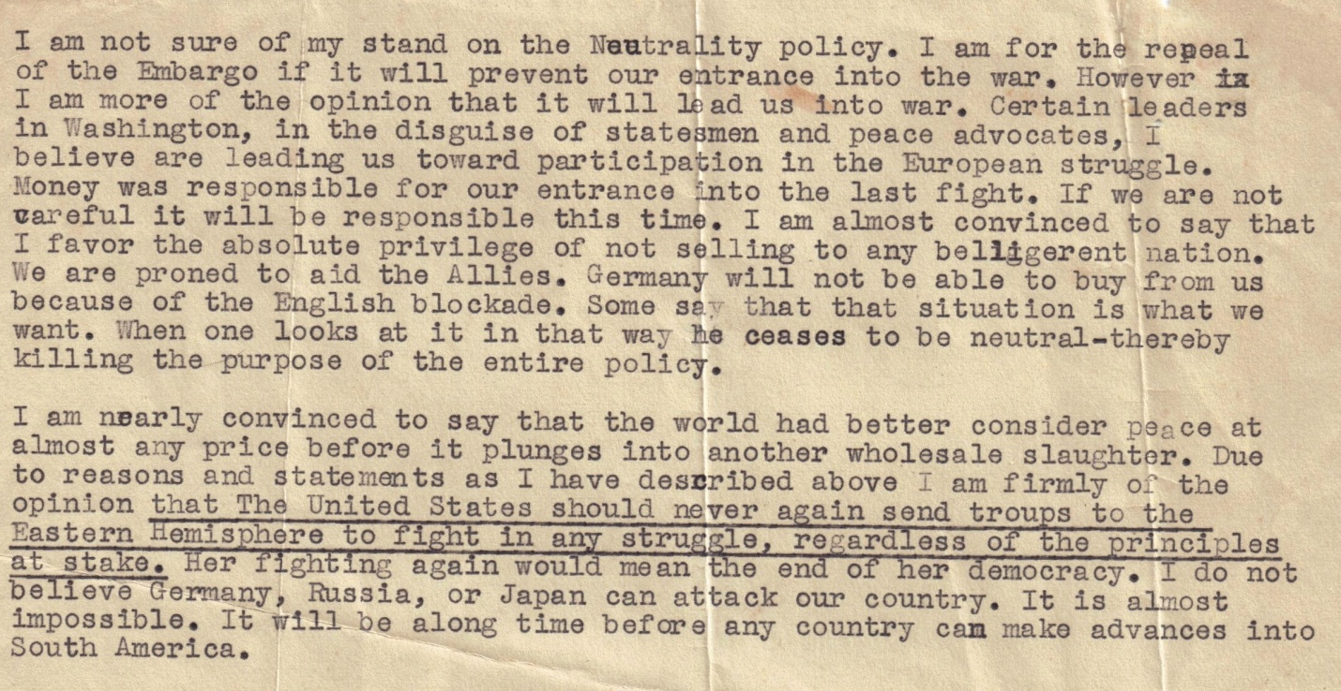
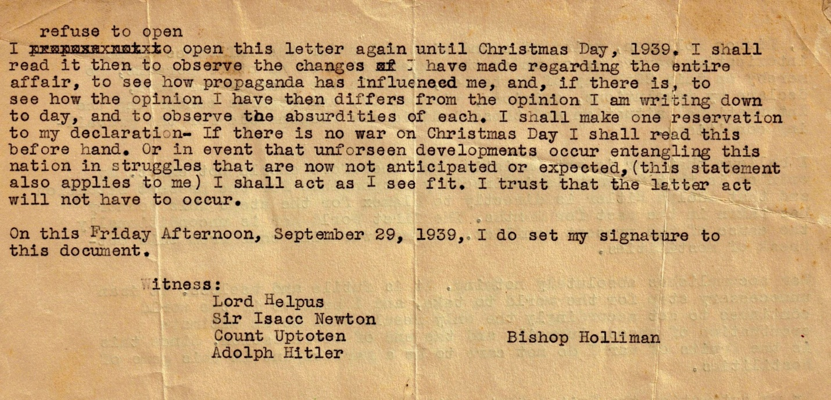

Summer 1940
At this time in his life two decades after the Great War, Bishop Holliman was, as were millions of other Americans, an isolationist, one who wanted no involvement in European conflicts. This opinion was shared by many during the 1930s. However, by summer 1940 Czechoslovakia, Poland, France, Belgium, the Netherlands, Norway and Denmark had all fallen before the Nazi war machine. These frightening events moved more and more Americans to support rearmament and aid to England. Great Britain stood alone against increasing fears of a world dominated by an aggressive government of Germany, a militant Japan and a Mediterranean bully, Benito Mussolini's Italy. Collectively, these were the Axis powers of World War II.

Ulyss and Pearl Holliman were devout Christians, and had raised their family as Methodists. Their second daughter, Loudelle, married a Methodist minister in 1935, Charles H. Ferrell, Sr., born in Mississippi, and educated at Birmingham-Southern College and Yale Divinity School. Loudelle and Charles helped Bishop obtain a part time job as youth director with the North Alabama Methodist Conference. This work, several summer youth conferences and his own deep commitment to the Christian faith are evident in Bishop's pacifistic and humane opinions captured in his somewhat humorous but serious letter.
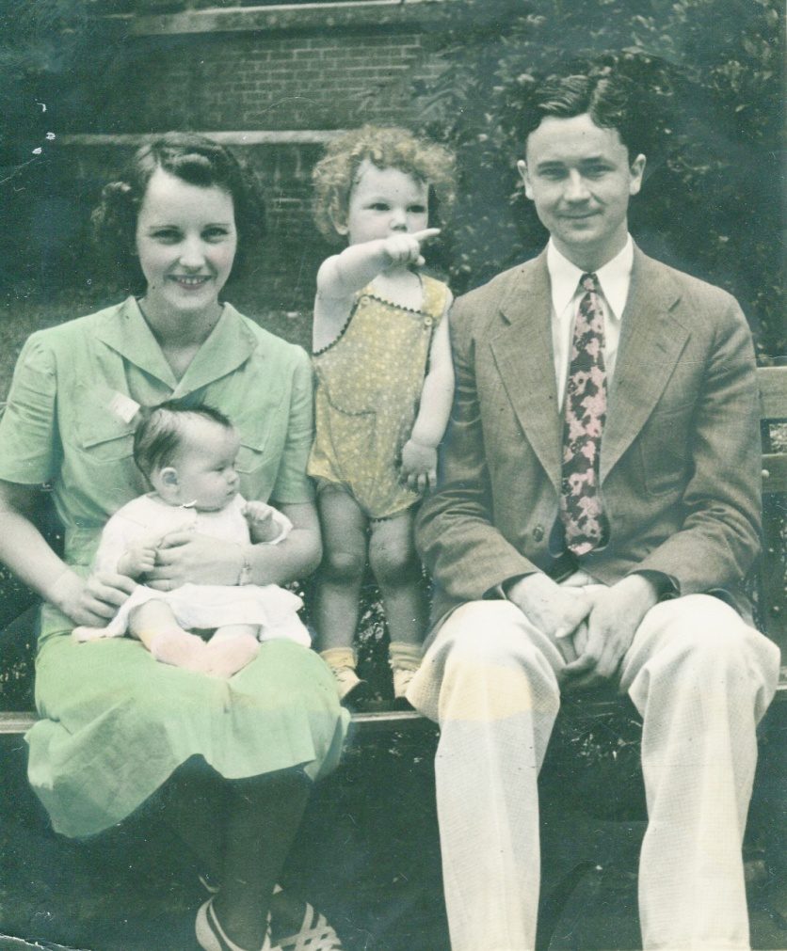
The Charles H. Ferrell family in 1939 - Loudelle holding Carolyn, and Charles Halford, Jr. pointing his finger past his father's line of vision.
But Bishop along with two brothers, Melton and Ralph and a brother-in-law, Walter Cornelius, were soon to be swept into the growing maelstrom. War would come to this Alabama family.

With the fall of World War I ally France, the U.S. Congress passed a conscription act to begin the building of an American army which in early 1940 was only the ---th largest in the world. Later that year, President Franklin D. Roosevelt asked Congress to pass the Lend-Lease bill that gave assistance to Great Britain, aid short of war.
At the same time, relations between Japan and the U.S. continued to deteriorate. Japan pursued its war in China, and cast covetous eyes on the Dutch and French colonies in southeast Asia.
No matter how isolated the U.S. was in the Western Hemisphere, the world had become a dangerous place. Led by FDR, Congress began to appropriate massive funds for naval, air and army armament.

Summer 1941
22 June 1941, full of hubris and more than mildly insane, Adolph Hitler launched his war machine east against the Soviet Union. Earlier that spring, his Wehrmacht had swallowed the Balkans, Greece and Crete and joined the Italians in North Africa. German foreign minister Von Ribbentrop wrapped Nazi arms around Hungary, Bulgaria, Romania and Finland. Britain, supported by her dominions Canada, Australia, New Zealand and South Africa, stood on the continental fringes of Europe facing foes Italy and Germany.
Mad with ambition, a loathing of communism, racial and religious hatred and swollen with excessive confidence in his armies, Hitler hurled over 3 million men against another sadist dictator of the 20th Century, Joseph Stalin, the communist autocrat of the largest geographical nation on the planet. The battle of two titans commenced, and the world held its breath.
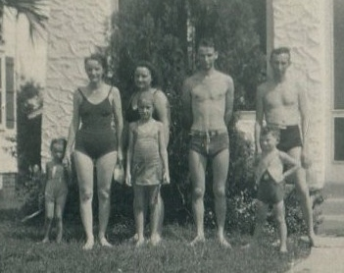
Pictured in the last summer of peace for the Holliman family, many vacationed together at Daytona Beach, Florida in August 1941. Left to right, Carolyn Ferrell, her mother, Loudelle Holliman Ferrell, Vena Holliman Daly standing behind Mary Daly (Herrin), Bishop Holliman and his brother-in-law Robert W. Daly, Sr. standing in front of their nephew, Charles Halford Ferrell standing smartly with hands on his hips.

Autumn 1941
By November the Soviet armies and cold weather finally slowed the mighty German army in front of Leningrad and Moscow. Casualties were monumental on both sides. In the Pacific, a Japanese fleet of aircraft carriers prepared to sail as relations between the Emperor's military government and the Roosevelt administration neared a breaking point.
From 1937 until 1941, Bishop attended Birmingham-Southern College, continued his job with the Methodist Church and cast a worrisome eye on events. While enjoying a Florida vacation in August 1941, he received a telegram from his Mother telling him the local draft board had written and he had better get home. His sister Loudelle cut short their vacation, and the Ferrells promptly drove him to Alabama.
Rather than take the Army draft, Bishop decided to join the U.S. Navy. November 1941, his parents, brother Ralph and the Dalys saw him climb aboard the Seaboard ____ and take the train to Norfolk, Virginia. Bishop's war had begun.

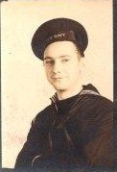
Dated November 29, 1941, the first letter written to the Ferrells from Bishop at Navy boot camp to home. He complains about 4:45 am wake up, running two miles every morning, drilling, doing laundry and inspection. Thanksgiving dinner was generous, the Navy chaplain humane and mail received twice a day. In spite of his miserable lot as a new recruit, he took time to think of Carolyn and Hal, Loudelle and Charles' children, hoping Santa Clause will visit them. The letter head reads Jacksonville, Alabama, stationery no doubt donated by the Ferrells who pastored the Methodist Church there in 1941. 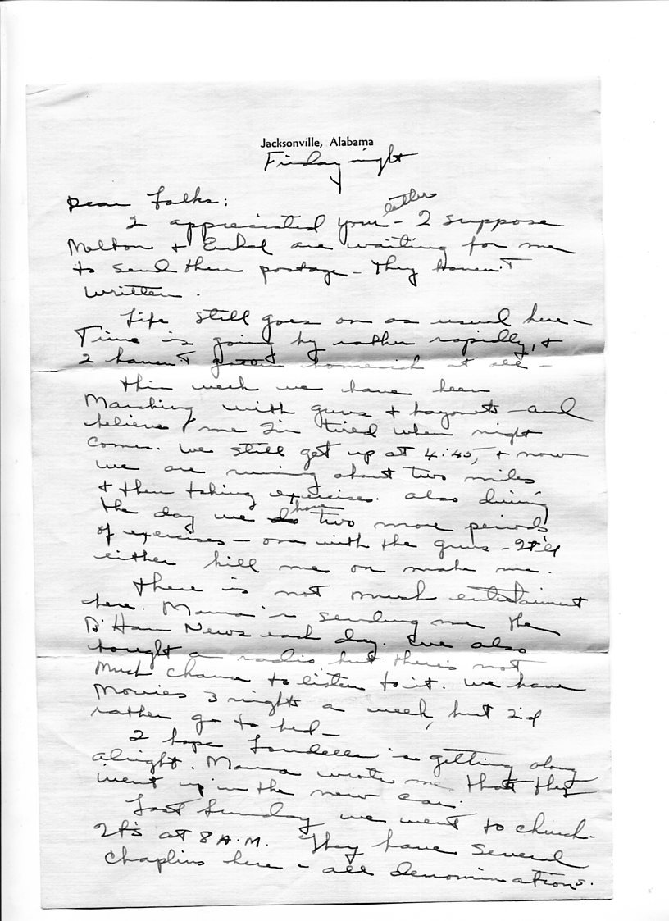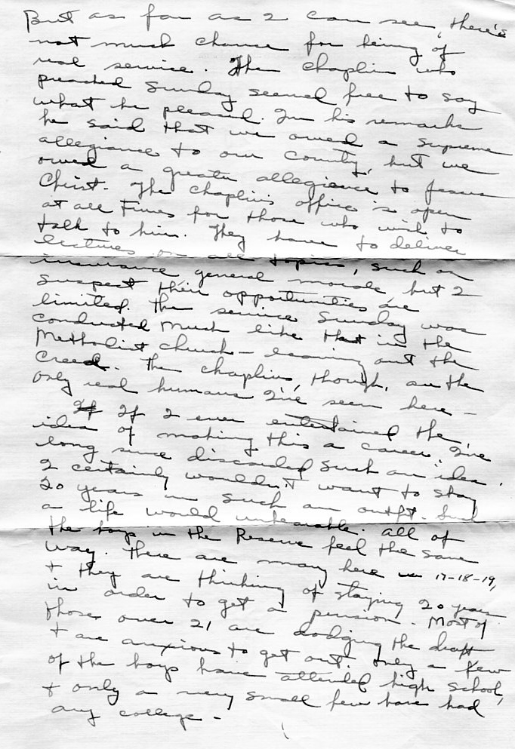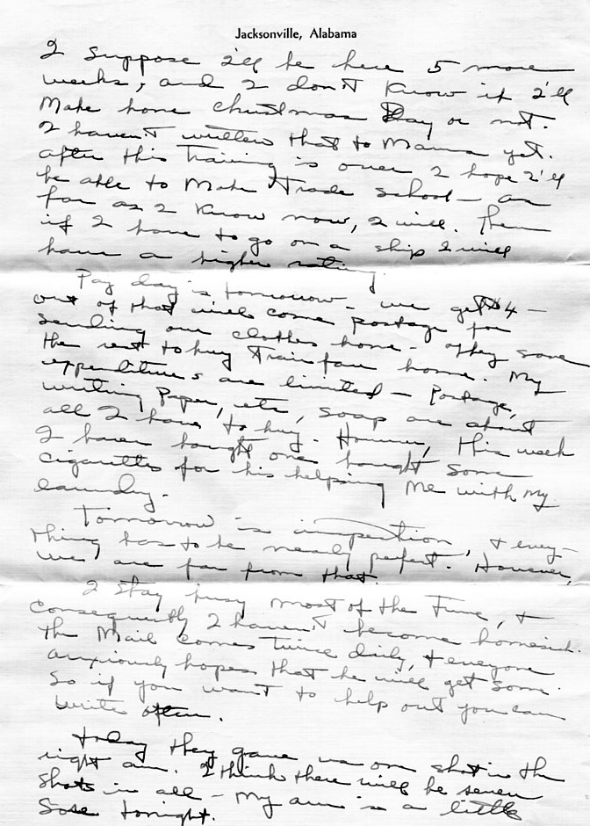
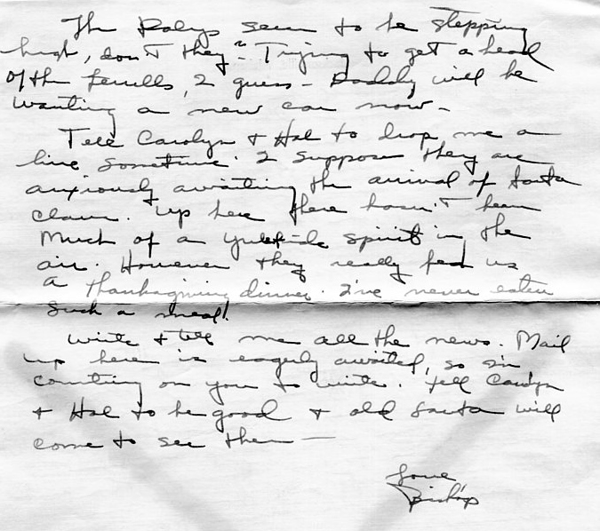

One of the first letters received by Bishop and saved was from his wise-cracking and affectionate brother-in-law, Robert W. Daly, Sr. Robert eludes to the decline in young female morale since Bishop left, the sinking of the British aircraft carrier the Ark Royal, brother Melton's career success, a painting of his daughter, Mary Daly and a new bank building in Leeds. This one is dated November 15, 1941. Pa and Maw are Ulyss and Pearl Caine Holliman, Bishop's parents. Vena is Robert Daily's wife. All had gone to the train station to see Bishop off.

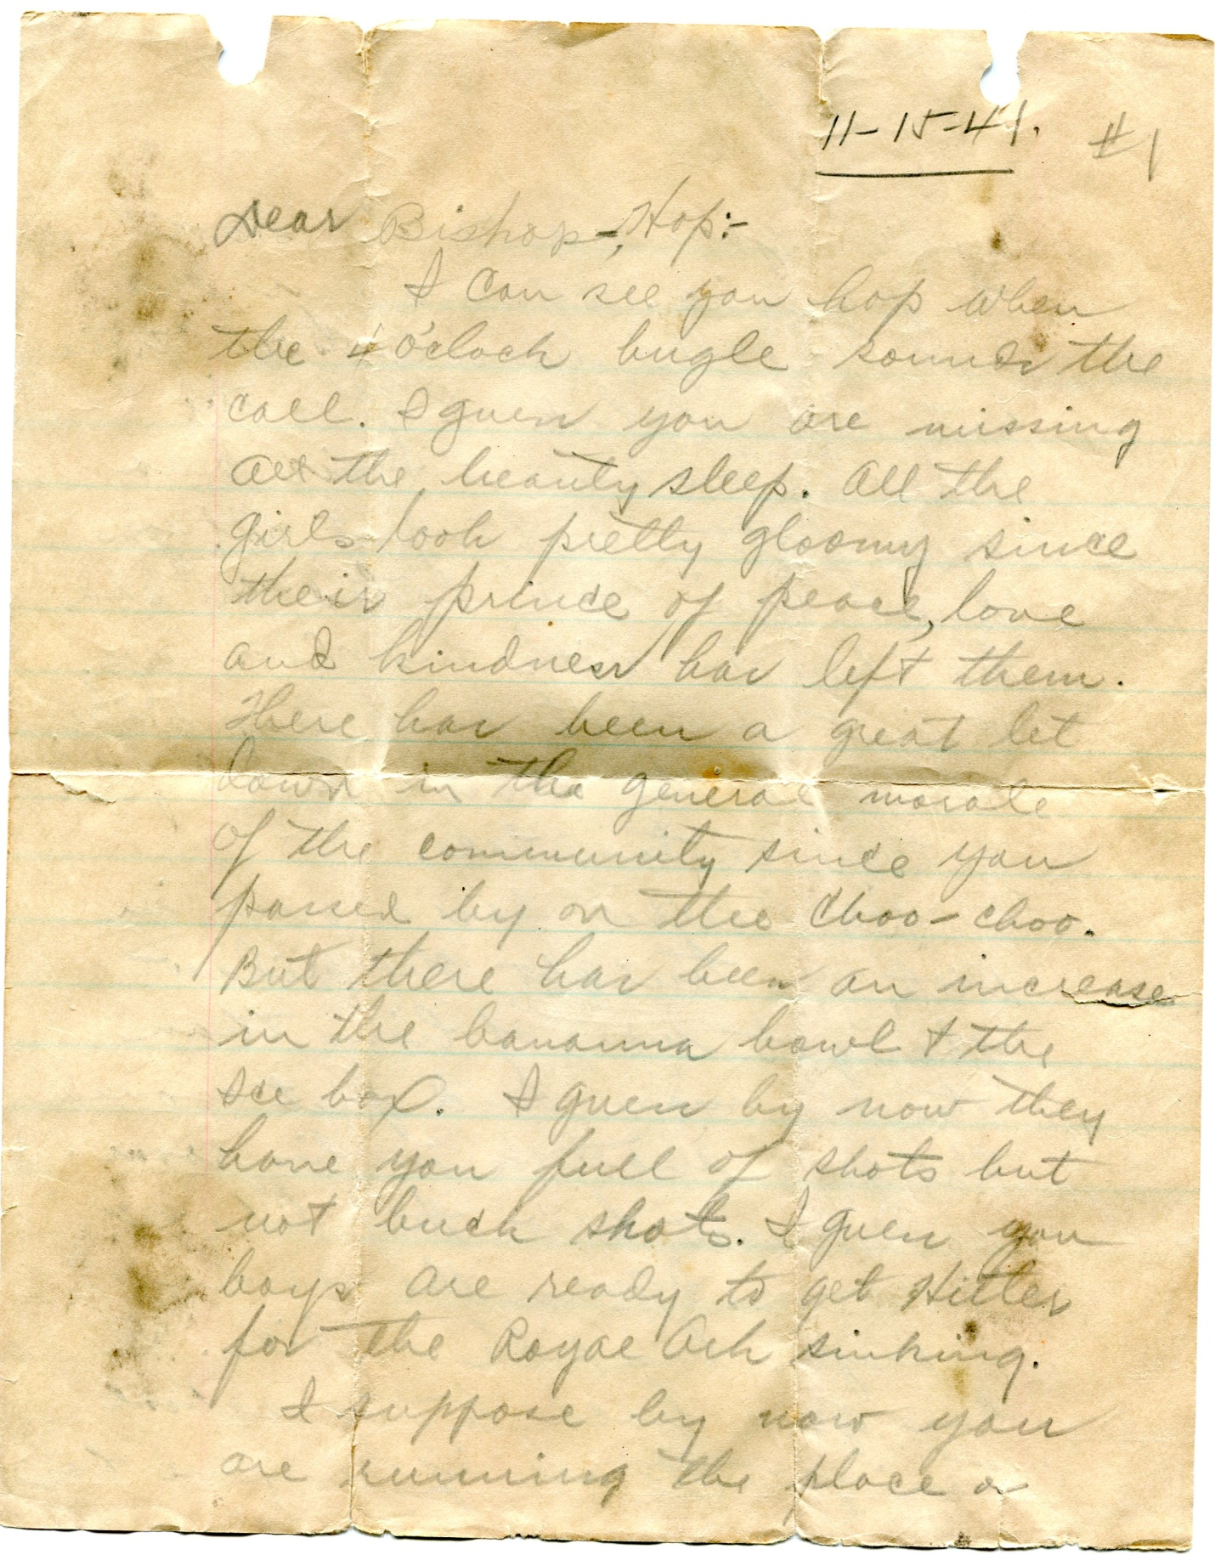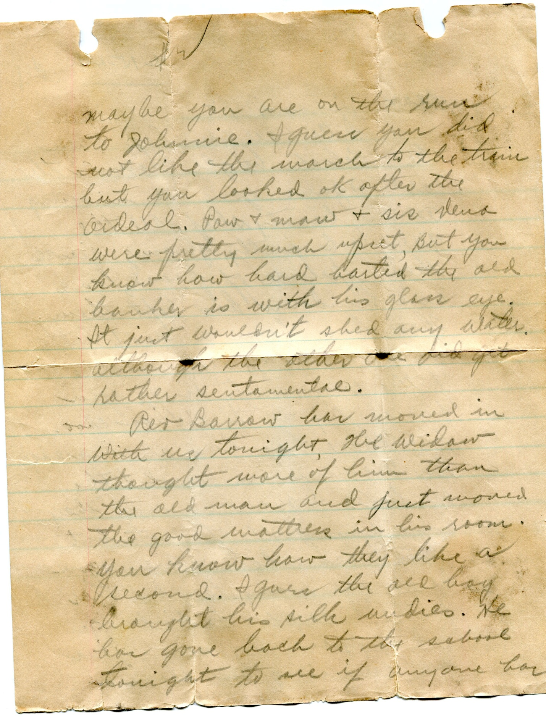

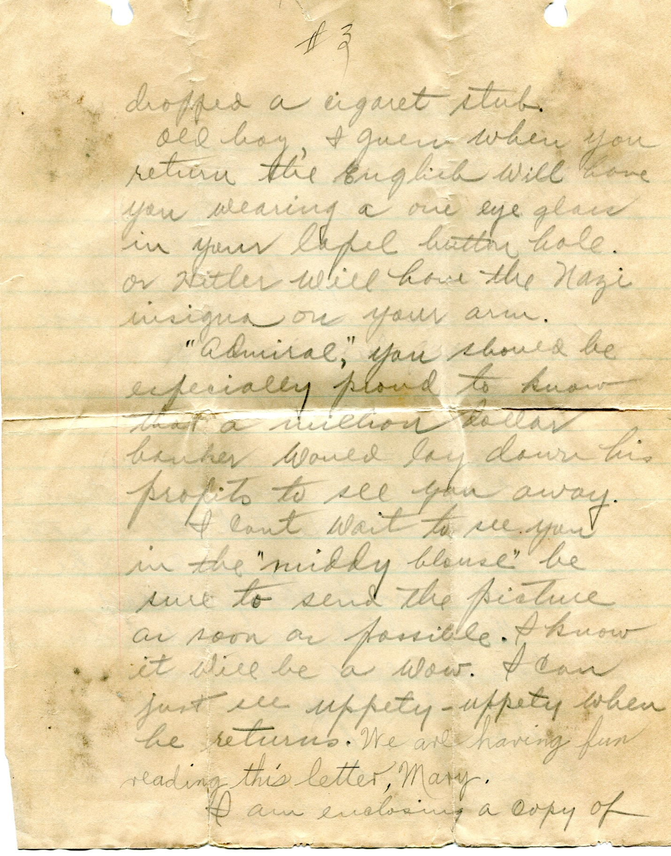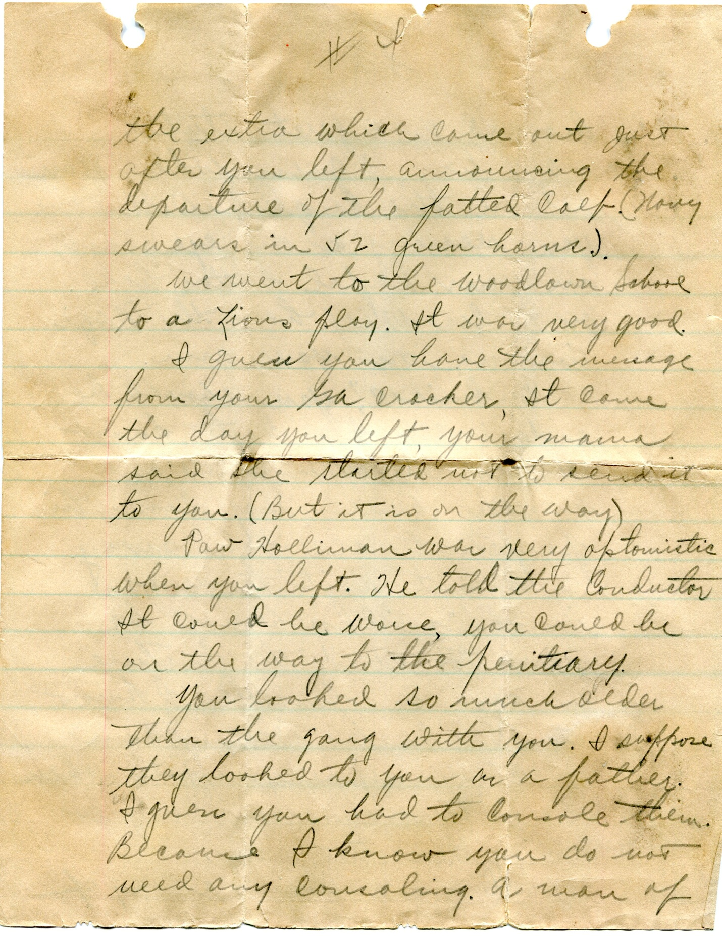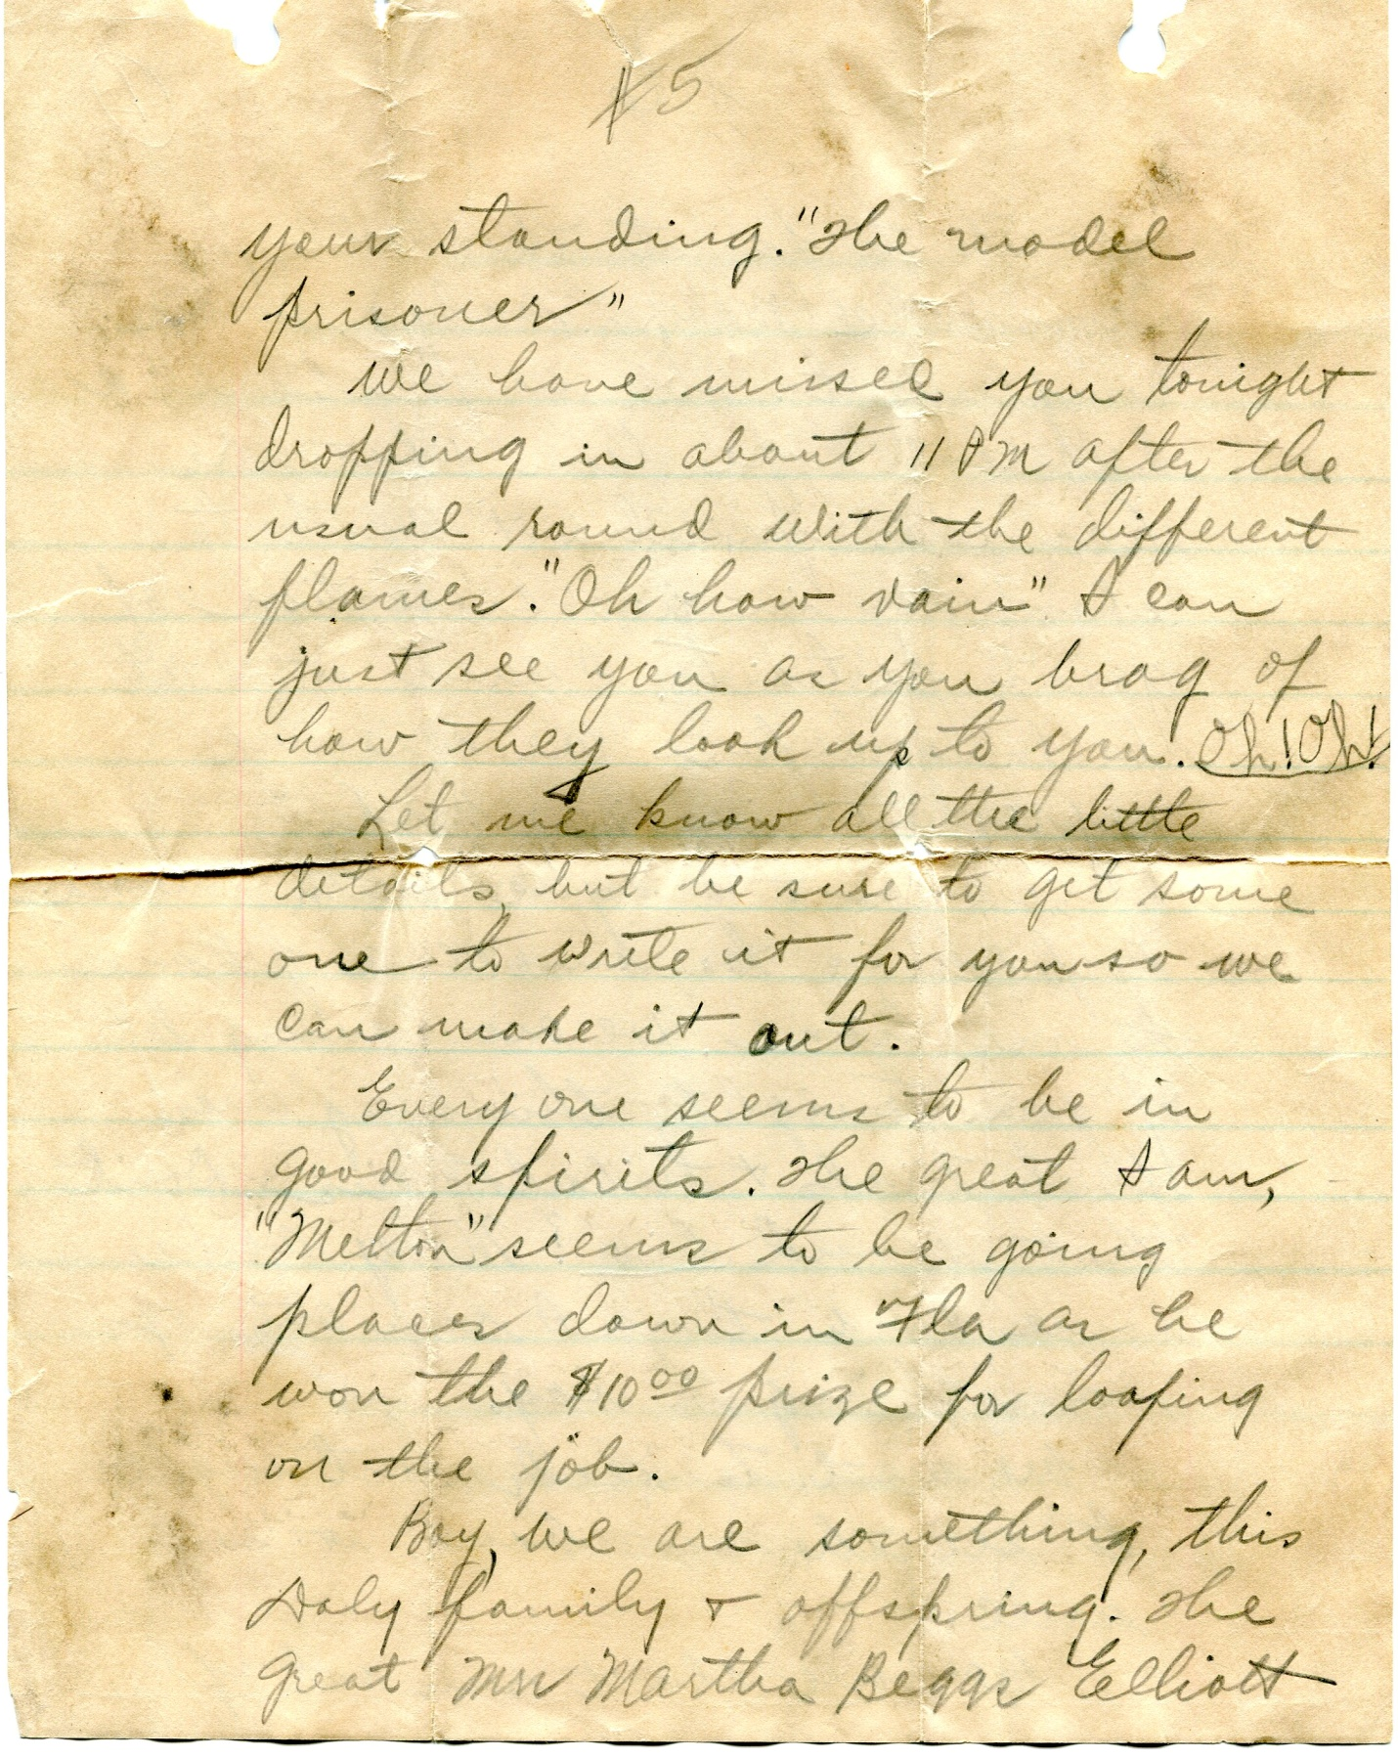
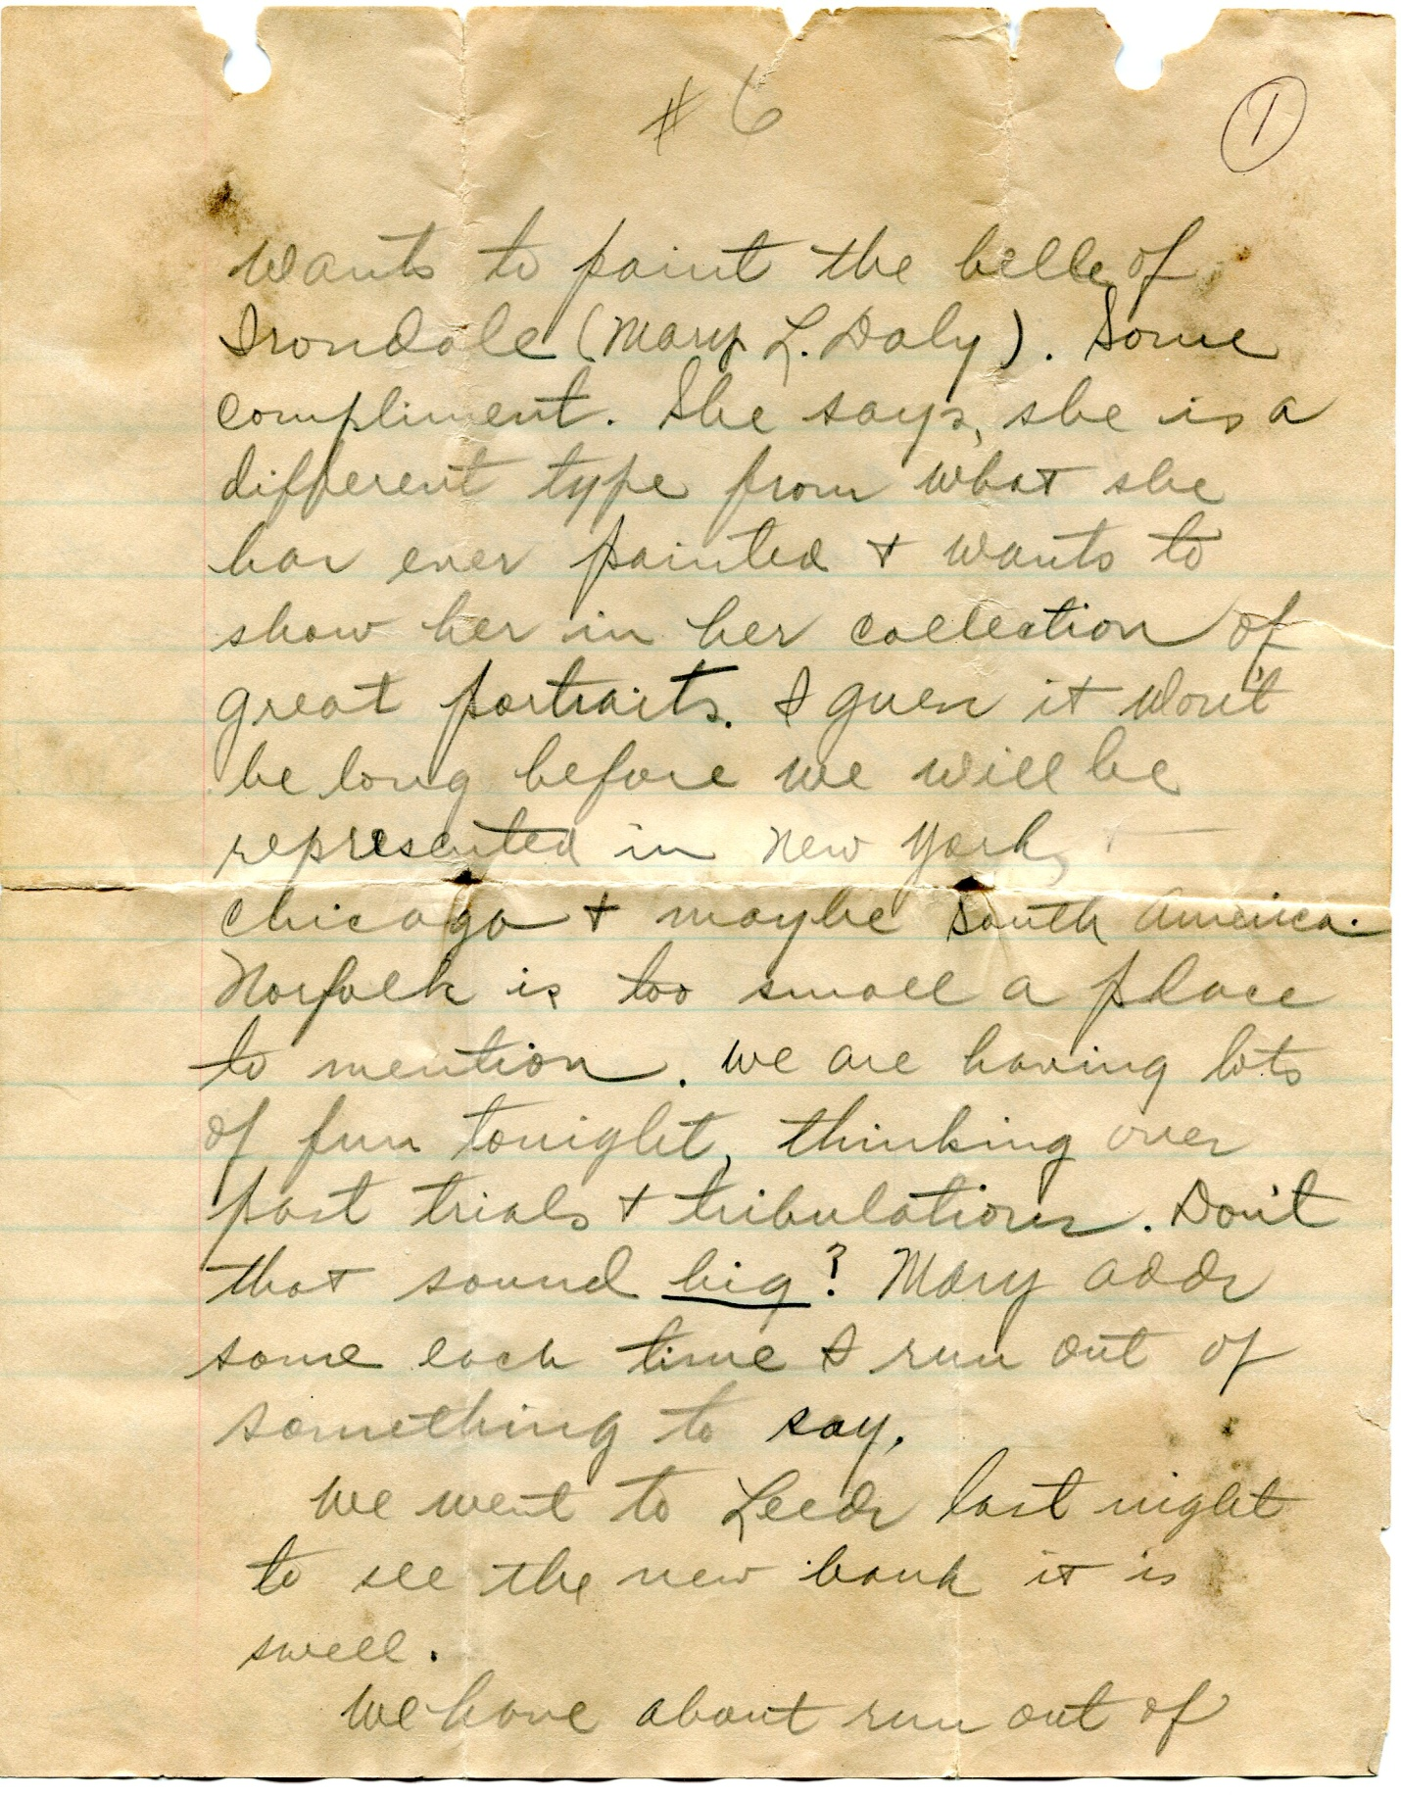
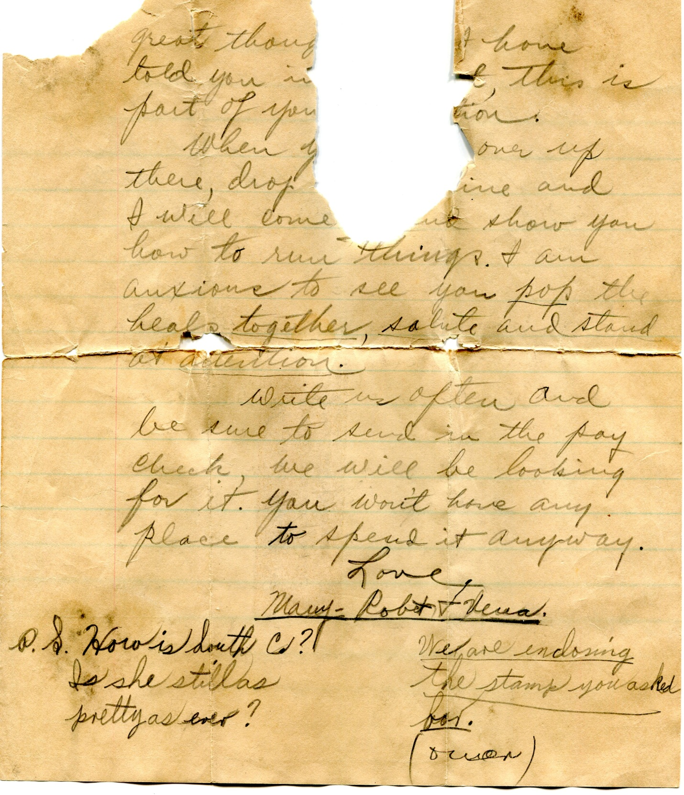
In closing Robert refers to South Carolina, Anne McGouphlin, a belle Bishop met at his summer Methodist camps in Lake Junaluska, North Carolina. The romance would fade during the war, but in 1990, the two would marry, after the collapse of Bishop's 43 year war time marriage. Anne would die of cancer in 1999. Martha Biggs Elliot was a local portrait painter. Robert poked fun at Bishop's interesting handwriting.
Notice how often Robert talks of Hitler, and yet the U.S. was not at war with Germany, yet. The pending conflict with Japan, not mentioned in Robert's letter, would be a dreadful surprise to the American people a few weeks later.

December 1941 - The War Front
Early on December 7, 1941, the Japanese Navy Air Fleet attacked without warning U.S. military installations at Pearl Harbor, Hawaii. The damage was horrific, thousands died, but the surprise raid united the American people. On December 8th, Congress recognized that because of that 'day of infamy', a state of war existed between the two Pacific powers. Fulfilling his treaty with Japan, an arrogant Adolph Hitler swiftly enjoined Germany in the fight against the U.S.
That same week, the Soviet army, strengthened by new troops from Siberia, began pushing the German Wehrmarcht from the gates of Moscow. The first reversal of the Nazi Army on the Russian front occurred the same week an over extended Germany foolishly expanded the war. Isolationism was no longer an issue; the U.S. declared war on Germany and Italy on December 11, 1941.
Still in Navy basic training, Bishop wrote again to the Ferrells. Interestingly he reported that a few days prior to Pearl Harbor there had been forewarnings at the Norfolk, Virginia Naval Base. He lamented Christmas at home would no longer be possible and continued to worry about what his job would be in the Navy.

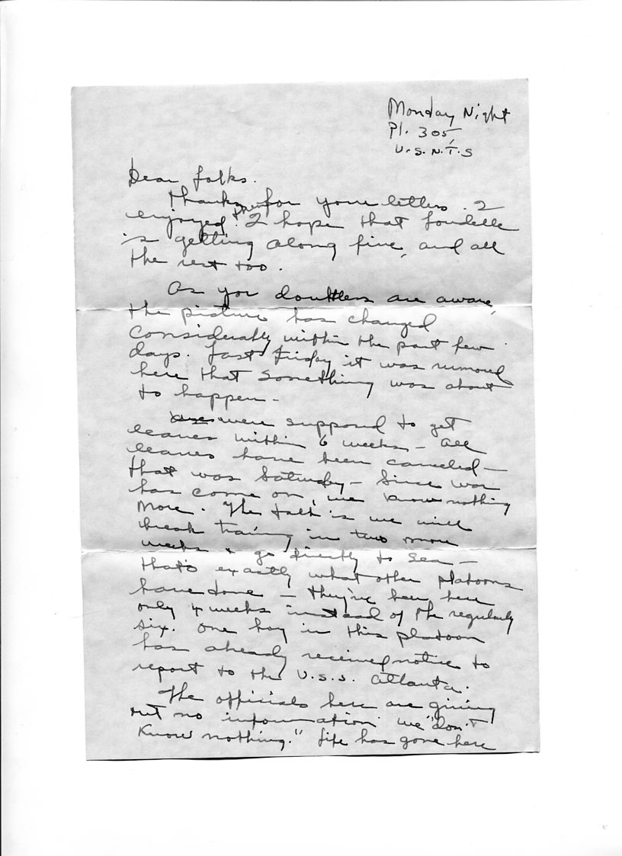

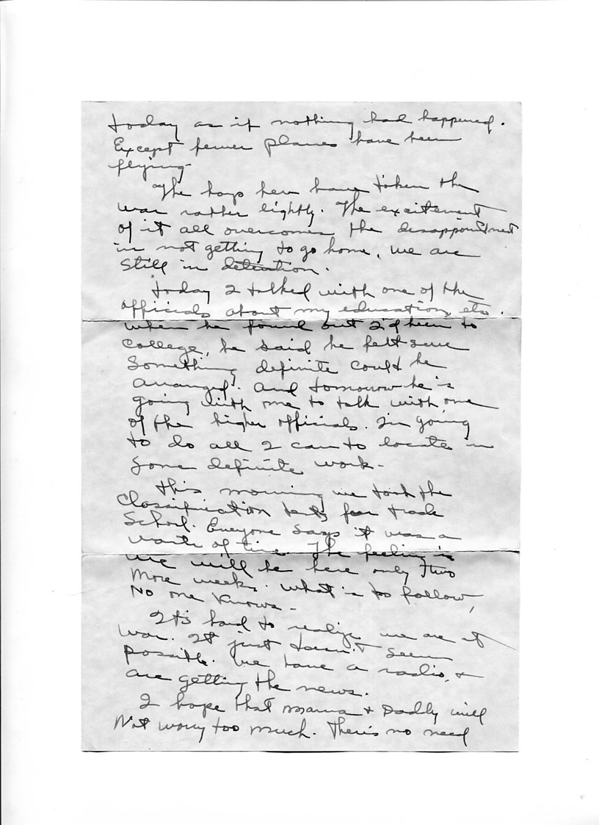
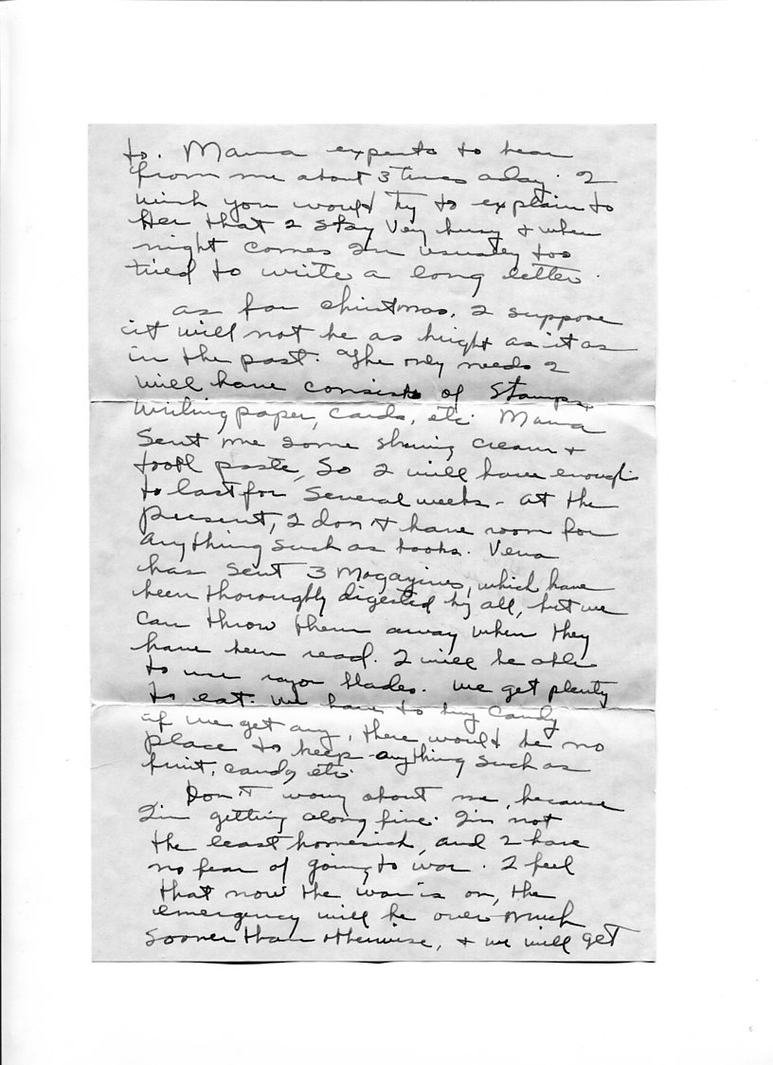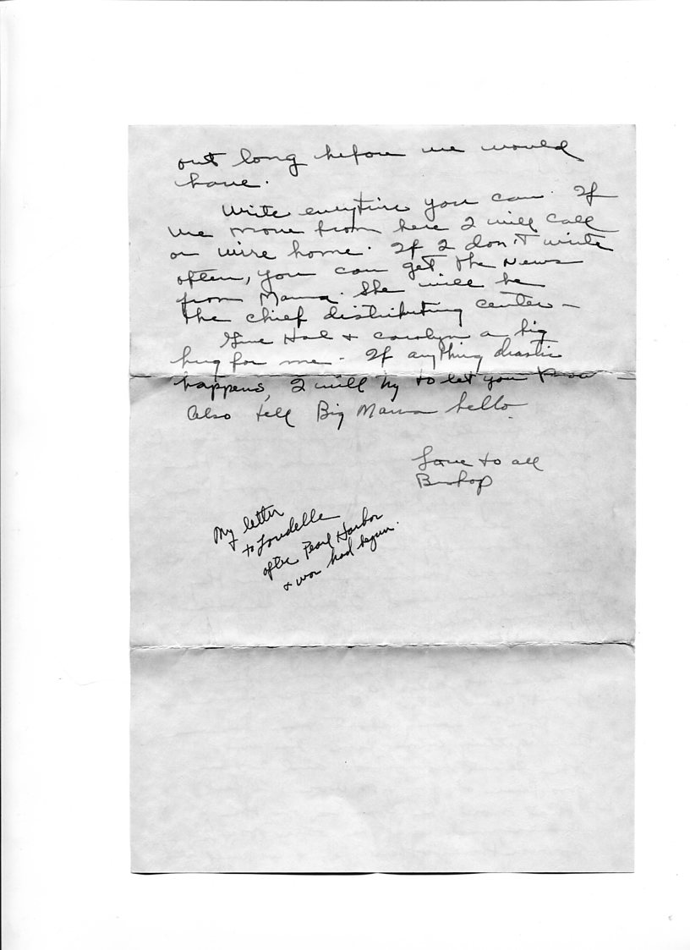
Bishop lamented that his mother, Pearl Caine Holliman (1887 - 1955) wanted her over burdened son to write more often. Sadly he wrote of the 'emergency' being over sooner. For Bishop an additional 44 months of service awaited him as was not discharged until after Japan's surrender, September 1945.

December 1941 - The Home Front
Bishop saved this penny post card from his mother. She wrote that the Dalys had gone to the Birmingham Christmas parade and someone had asked if he was receiving the Birmingham News she had ordered for him. Dreadfully worried about her only son in the military, she wrote of her disappointment if she did not hear from him daily. "Ma' is Lula Hocutt Caine (1861-1957), known to the family as Grandma Caine, who lived also in Irondale. Mr. Barrow was the local school principal, a major influence on the family, who lived for a time with the Robert W. Dalys. Glenn Barrow would join the military but die of cancer in 1943. Bishop named his only son, Glenn, after this influential educator.
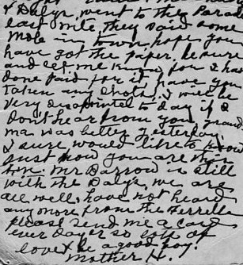
Loudelle Ferrell (1914-1996) wrote on December 30, 1941 of Christmas at the family home in Irondale. Mr. Button is The Rev. Stewart Butten, the Irondale Presbyterian minister and a great friend of the Daly and Holliman families. Charles is The Rev. Charles H. Ferrell, Sr., the husband Loudelle married in 1935. They have two children, Charles Jr. and Carolyn, by December 1941 with another, John, to be born in 1942.
Euhal is the 3rd child of Ulyss and Pearl Holliman (1912-1989) who married Edna Westbrook (1915-1992) in 1936. At Christmas 1941, they parented twin boys, Terry and Jerry (1940-2003). Ida Hughes (1906-1998) is the wife of Melton Holliman (1908-1958). They married in 1932 and adopted a lovely red head daughter, Patti, in the spring of 1943, a few months before Melton was drafted into the Army.
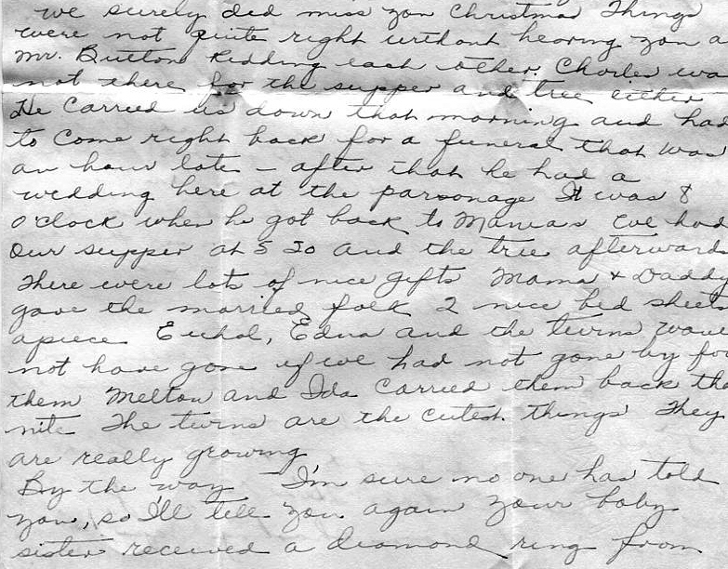
The diamond ring is from Walter Cornelius (1922-2006) to the sixth child of Ulyss and Pearl, Virginia (1922-2011). Loudelle's words foreshadowed what would be a difficult marriage, ending in divorce in 1972. Loudelle wrote in this letter she felt Virginia was 'throwing herself away' by marrying too early and not pursuing her education at local Howard College (now Samford University).
Virginia had done well in high school, graduating from Shades Cahaba in 1940, president of several organizations. and an accomplished public speaker. She would go on to much with her life, giving birth to two daughters, and fashioning a prominent career as the first woman vice-president of a major bank in Alabama.
Loudelle ended her Christmas letter by lamenting how her son, Charles, was playing with his toy rifle. The new enemies of America were articulated by Charles Jr. (Hal) (b 1936) shooting imaginary Japanese. Little Carolyn ( b 1938) had incorporated into her thinking a wartime image of Germans. "Big Mama" was Loudelle's mother-in-law, Ferrell. Irondale local, Margaret Shamburger, had run off with an Army sergeant sending her mother to the edge of a breakdown. Under the influence of war, engagements and marriages were accelerating as young couples dealt with the rapid changes they faced.

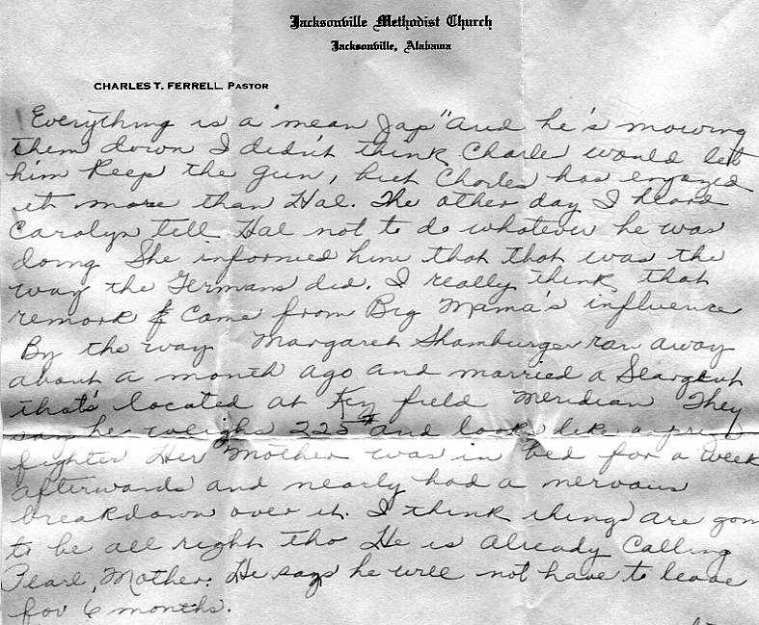

January 1942 - The War Front
For the first months of the war, Japan ran roughshod across the Pacific and Southeast Asia. Hong Kong and Singapore, British colonies, fell with little fight to the Nipponese. The U.S. colony, the Philippines, suffered a December Japanese invasion. Manila was declared an open city, and General Douglas MacArthur pulled his combination American-Filipino forces back to Bataan and Corregidor. MacArthur's former staff officer, a 50 year old Dwight D. Eisenhower, was quickly called from Texas to Washington to see what could be done, if anything, to assist the besieged forces.
Bishop Holliman finished boot camp and transferred to Key West, Florida to take courses in sonar, a precursor to being posted to a destroyer, a vessel used to escort convoys and to protect against German U-boats.
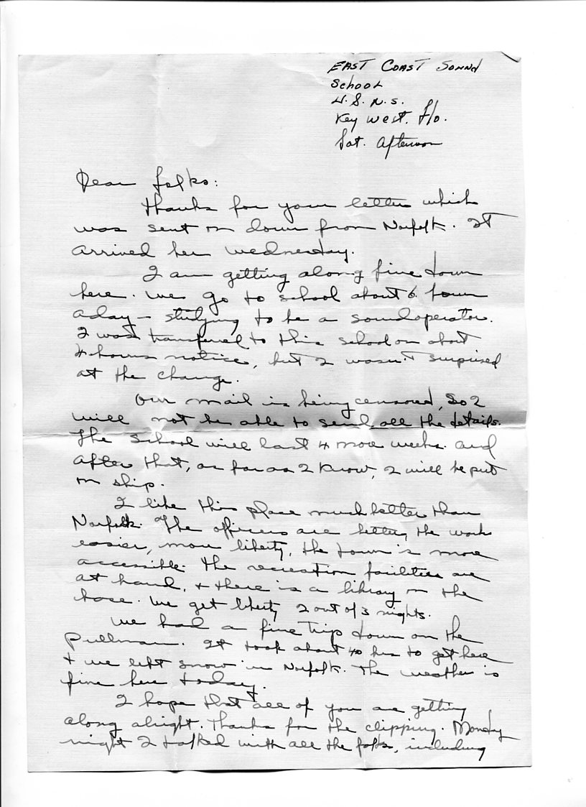
After boot camp, advanced training provided more time for liberty, sleep, a library and church where kindly people took Bishop home for lunch after services.

January 1942 - The Home Front
Few letters survive from this month of the war. Robert Daly wrote toward the end of December that Melton had purchased a new Ford car, one of the last to be sold in Birmingham. Domestic automobile manufacturing had given way to tanks and airplanes. Later that month, Charles and Loudelle Ferrell, Ralph and his parents, Ulyss and Pearl Holliman, drove from Irondale to Key West, Florida to visit Bishop no doubt worried he would soon be posted to a ship and sent into dangerous waters. They knew not when they would see him again.
There was another issue stressing the family, and that was the impending marriage of Virginia to Walter Cornelius.
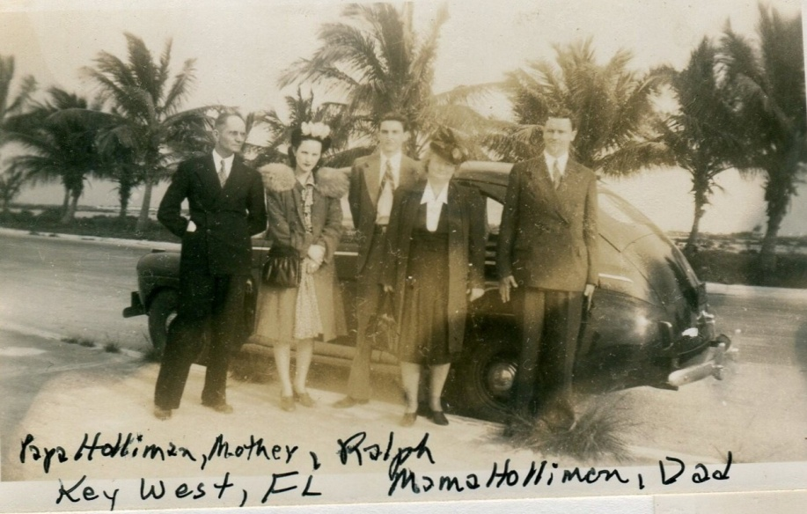
Left to right, Ulyss Holliman, Loudelle Ferrell, Ralph Holliman, Pearl Caine Holliman and The Rev. Charles H. Ferrell in Key West, visiting Bishop, the only family member at that time in the service. Photo courtesy of Charles H. Ferrell, Jr.

February 1942 - The War Front
U-boats prowled uninhibitedly off the Gulf and East coasts sinking tankers and coating beaches with oil. Japan continued its initial advances in the Pacific without pause. In Washington, General George C. Marshall, Army Chief of Staff, impressed by Eisenhower's competence, began to enlarge the younger general's responsibilities, to include coordinating joint military action with Great Britain. Bishop continued his training, and waited for an assignment to a ship.

The Home Front
Bishop's mother wrote of his boyhood friend, Charles Pugh being called before the draft board, her nephew, James A. Cook, had dental problems and Robert Daly wrote that tires were being rationed, two of his bank tellers joined the Navy, and details on the wedding of Virginia and Walter at their home.
Virginia's mother, Pearl, did not approve of the marriage of her daughter, Virginia, to Walter Cornelius, and took the late January trip to Key West to see Bishop, not distressed to miss the wedding of her third daughter. Vena and Robert Daly kindly offered their home for the ceremony. Brother Jones, the Irondale Methodist minister, officiated before a crowd of 35 who later enjoyed ice cream and cake.
Some level of tension between Virginia and her mother evidently continued throughout the war. Walter would become a successful Birmingham attorney in the 1950. His father ran a general store in rural Shelby County, and sold illegal liquor to this patrons. Musically inclined, Walter mastered the guitar and sang in a band. He was very different from his new, strait-laced, parents-in-law, and that difference may have attracted Virginia.
Perhaps the two women were too different; Virginia, bright, successful in school and ambitious to get on with life. Her mother, a traditional homemaker, increasingly conservative in her fundamentalist faith. Just as the war speeded up marriages, so the loss of male bankers offered Virginia her first opening to the business world. When her banking brother-in-law, Robert, lost tellers, he offered Virginia a position. She took it, blossomed at the work and after the war, made a career of banking. Below Virginia and Walter Cornelius in Irondale during the war.
Within the space of 2 1/2 months, two of the remaining three children of Ulyss and Pearl, had left home. Change had come rapidly to the family as the war accelerated.
