An Isle of Wight, Virginia Story....

Below, Glenn Holliman, left and Sandi Royal, right, both descendants of Isle of Wight, Virginia first families, compare notes over lunch in July 2012. Sandi, a semi-retired CPA, contacted me through this blog several months ago seeking more information on her Holliman ancestors.
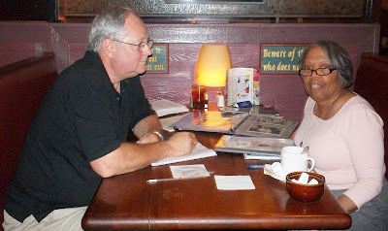
Sandi Royal's great grandfather is Isaac Henry Holliman, born approximately 1824 and died before 1900 in Isle of Wight, County, Virginia. He was born a slave and his racial make up was mulatto, that is of mixed African and European American heritage. His father and mother are not known, not usual for a time of extreme racial prejudice and no official listing of births yet being recorded by the State.

One recent DNA test did not test positive for Isaac being a descendant of Christopher Holyman, Sr. (d 1691). However the surname does substantiate that Isaac took his name from a Holliman family, undoubtedly his 'owner' in the first half of the 19th Century. We do not know who that family is, yet.

Sandi's great grandmother is one Ann Gray, who according to family tradition, was white. Their first of numerous children were born in 1871. The U.S. Census of 1880 records Isaac as being 56 years old and Ann, 37. She would die sometime in the 1930s and is buried with Isaac in Winsor, Virginia. There is uncertainty as to who her parents are although there are at least two options being reviewed. One strong possibility has been suggested by descendant Nonnie Holliman, that being that William and Matelda Gray of Isle of Wight were her parents. More digging into records is required.

Isaac Holliman's descendants tell the remarkable and horrific story of an 1860s couple fleeing from her parents, hiding and living in the Virginia woods to escape an irate father. This couple, evidently much in love, broke not only racist social taboos of the time, but also rigid Virginia law. Yet, under the most trying circumstances imaginable in late 19th Century America, the marriage succeeded, and numerous descendants of this remarkable couple prosper today in a freer, more tolerate country.

Each year near Zuni, Virginia, this extended Holliman family gathers, enjoy several meals of regional foods and share the amazing story of a former slave who ran off with a young woman believed to be a slave owner's daughter.

Sandi and distant cousin, Tammy Hunt, have told me this story and with their permission, I share it with the larger family. There is more research to be done to grasp further the details of this stirring saga. Hopefully, we can publish more later.

In the Story of Family, one finds the Story of America....

