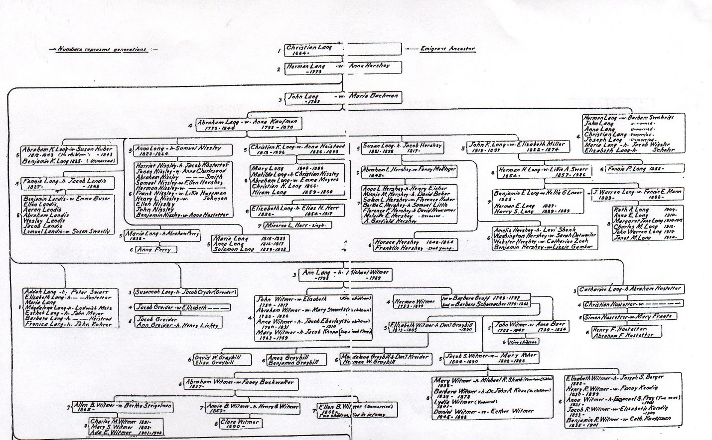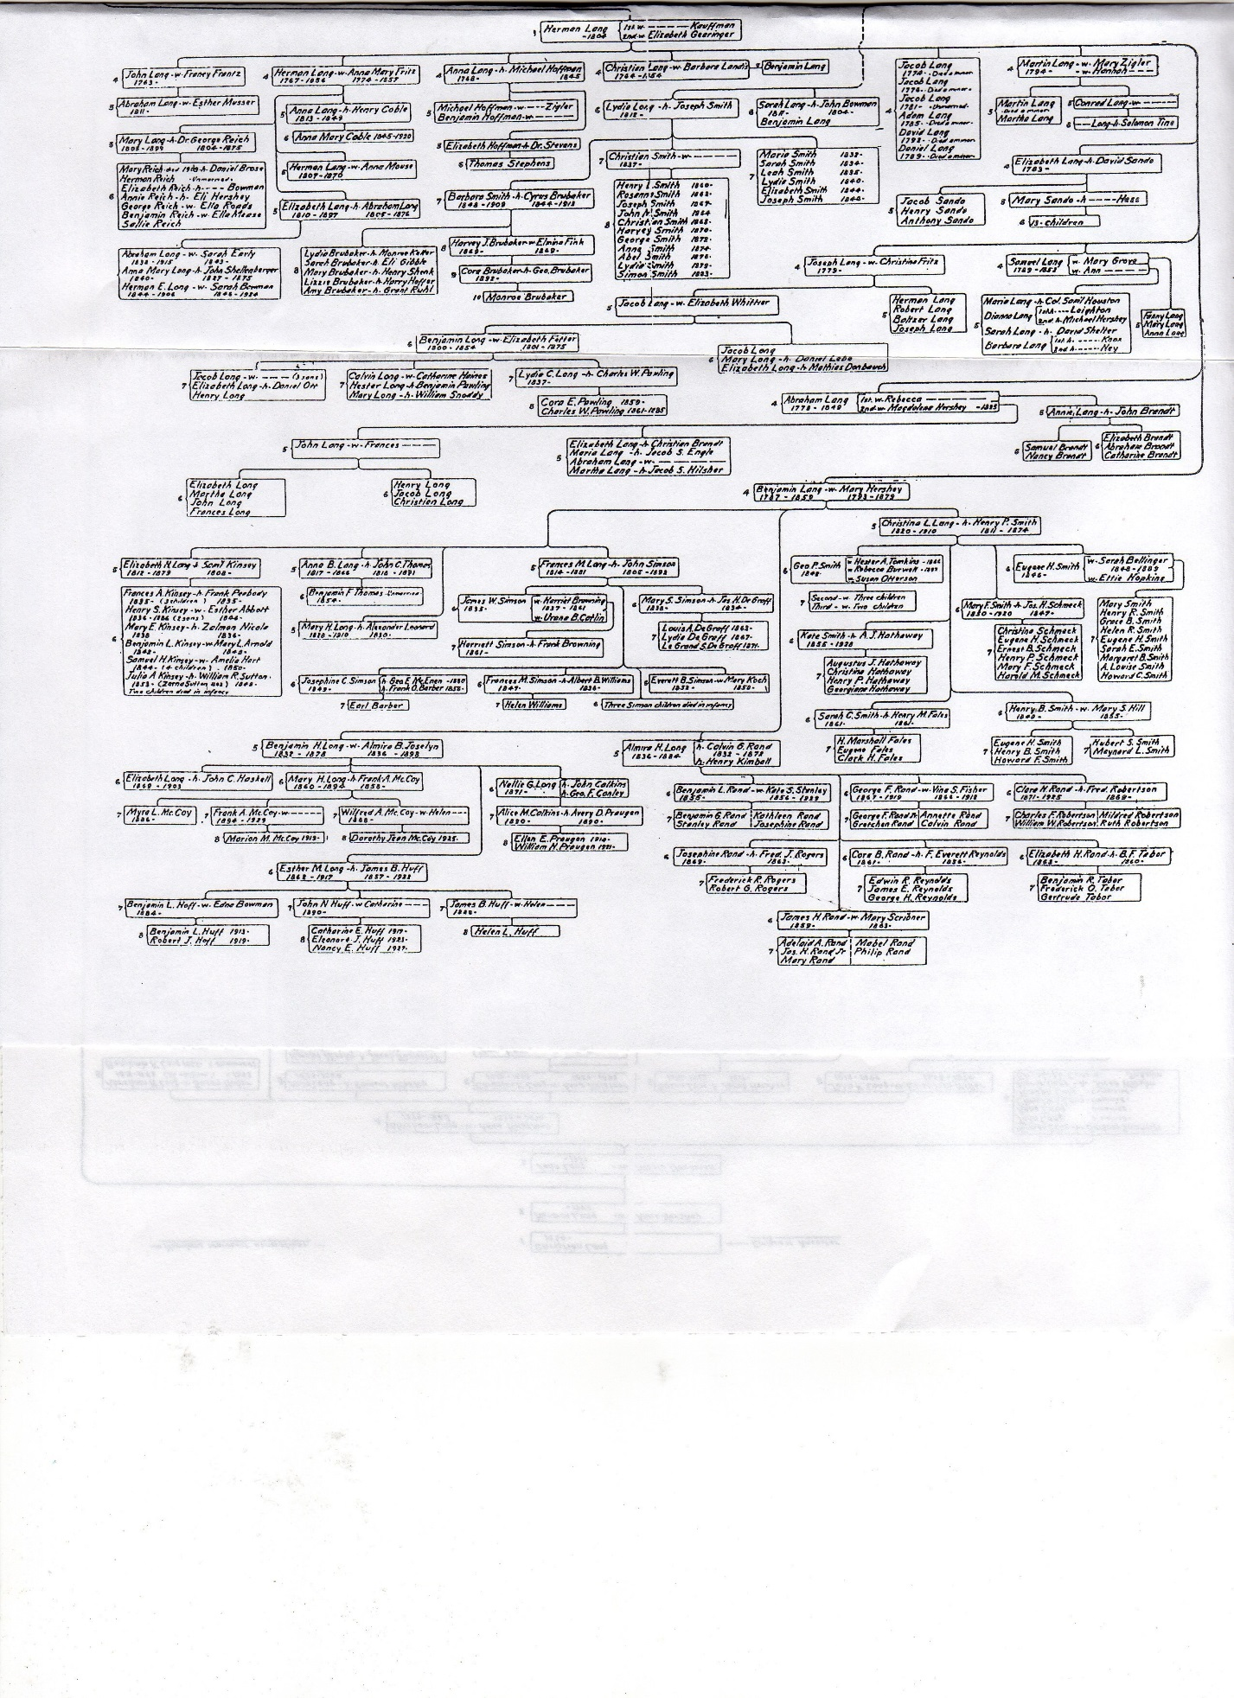
 | Melinda EVANS |  | Household
 |  | Female
 | Other Information:
 |  | Birth Year | <1838>
 |  | Birthplace | NY
 |  | Age | 42
 |  | Occupation | Keeping House
 |  | Marital Status | M <Married>
 |  | Race | W <White>
 |  | Head of Household | Chas. F. EVANS
 |  | Relation | Wife
 |  | Father's Birthplace | PA
 |  | Mother's Birthplace | PA
 | Source Information:
 |  | Census Place | 3rd Ward, Lockport, Niagara, New York
 |  | Family History Library Film | 1254901
 |  | NA Film Number | T9-0901
 |  | Page Number | 555B
1880 Census
