Alabama hollimans, a series of articles by glenn n. holliman

FRIDAY, FEBRUARY 26, 2010
ACKNOWLEDGEMENTS
Family histories are put together with work and support from many people. My daughter, Grace, and I are pleased to collect writings, photos and memoirs of others and share them with a growing extended family. In this posting we present the writings of our cousin Dr. Rhodes Holliman, Dublin, Virginia, on Mary Polly Lucas Holliman, John homas Holliman and James Franklin Holliman.
Rhodes notes that he is building on the work of others; specifically from the research of his father, Cecil Rhodes Holliman and a distant cousin, Walter Orien Holliman. A great deal of what we know of the John Thomas Holliman siblings, and recent ancestors, comes from the work of. these men .
Walter Orien Holliman, a meticulous family researcher, passed away in 2003. Walt's father was Moses Holliman, who was the son of Warren C. Holliman, who was the son of Charles Holliman, who was the son of James Grantson Holliman (1750-1836), a common grandfather to almost all reading this blog.
Another cousin with whom we have been in contact is Ron Holliman of Dothan, Alabama. For several decades he has researched the Holliman tree and has amassed considerable information. He is a grandson of Greene Holliman, a son of John Thomas and Martha Jane Holliman. We look forward to his contributions in future blog posts.
Glenda Norris of Alabaster, Alabama, a great great granddaughter of John Thomas Holliman, is preparing an article on Samuel Taylor Walker. Walker is the father of Martha Jane Walker Holliman, her great great grandmother, and wife of John Thomas.
We look forward to continuing contact and compiling memorabilia from other members of the extended family.
Feature Story: Mary Polly Lucas Holliman
In 21 years of married life, Mary Polly and Uriah Holliman would produce 13 children – seven boys and six girls. Polly could hitch up a mule to a plow and till the soil as well as any man. While maintaining her farm, she became the only source of medical assistance in her community. Often she had to travel many miles by mule to help those in need.

A COMPASSIONATE HEROINE
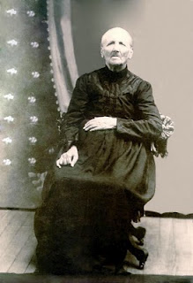Part I – The Story of Mary Polly Lucas Holliman (pictured here in 1913) by Dr. Rhodes Holliman, originally published in Southern Times Magazine of Tuscaloosa and West Alabama, issue no. 125.
The daughter of Charles Daniel Lucas and Mary Hastings was born in South Carolina on January 2, 1819. She died at Vernon, Alabama on July 5, 1913. She married Uriah Holliman in Tuscaloosa County on August 29, 1836 and together they had 13 children, all delivered by herself. She is buried in Springhill Baptist Cemetery, in Bluff, Alabama.
Very little has been published on the privations suffered by southern farm housewives who were widowed by their husband’s deaths in the Civil War. The following story is a documented history of one such woman, this writer’s great-great grandmother, who lived 94 years in poverty by our current standards, yet became the post-war heroine of her backwoods county in northwest Alabama.
Mary Polly Lucas Holliman of Marlboro County, South Carolina, as noted was the daughter of Charles Daniel Lucas, born in South Carolina on July 30, 1771. Charles Lucas died in Newtonville, Alabama on May 31, 1853. Her mother was Mary Hastings, born in South Carolina on September 10, 1786 and died in Fayette County, Alabama on January 21, 1867. Charles Daniel Lucas and Mary had 10 children.
Charles was reputed to be a large man (6’4” to 6’6”) and had great strength. May Polly loved to tell the story of how he killed a panther with his bare hands. He was also a man of hot temper and a disciplinary tyrant, but that is another story. He was a tailor by trade and after moving to Alabama, a Federal Indian Agent and stock dipper. Charles Daniel was buried in an Indian burial ground on top of a wood hill about seven miles south of Fayette, Alabama.
This writer can remember that graveyard from my childhood (1930s), but it was accessible only by a long hike with a guide over cultivated fields and forests, several miles from the nearest road. Charles Daniel and Mary came to the Newtonville, Alabama community in the 1830s, and purchased land patents from the government.
Mary Polly Lucas married Uriah Holliman in Tuscaloosa County on August 29, 1836. The marriage was performed by the Rev. John Walters, M.G. Uriah Holliman was born in Lancaster County, South Carolina on July 6, 1816 and died at Okolona, Mississippi on May 8, 1862 while in the service of the Confederate Army.
He was the son of Cornelius Holliman, born in Lancaster County, South Carolina on September 25, 1792. Cornelius married Elizabeth Plyler in 1813. She was born in South Carolina in the late 1700s, and died in Fayette County in 1838. She is buried in as tack-rock grave at the Springhill Cemetery in northern Tuscaloosa County, near Moore’s Bridge, just off Route 171. They had five children. He is buried at Old Blooming Grove Cemetery in eastern Lamar County, Alabama. As a veteran of the War of 1812, a memorial stone has been placed in that cemetery to his memory.
Over a period of several years, Uriah obtained a total of 320 acres of government patent homestead land in northwest Fayette County and developed a large, productive farm. It would prove essential to feed his rapidly expanding brood. In 21 years of married life, Mary Polly and Uriah would produce 13 children. All reached adult life except the first, Mary, who lived four years. With medical assistance unavailable and the remoteness of their farm, Mary Polly delivered all of her own children, which gave her valuable experience for events to come.
As the clouds of the Civil war appeared, five of her family joined the Confederate Army: her husband, Uriah at age of 46, and sons, James Franklin, Charles Daniel, John Thomas and Elijah. Her daughter, Sarah Jane, married an Italian immigrant who volunteered as a Confederate soldier.
Only two of her military family would survive the war: her sons Lt. James Franklin Holliman, Company B, 58th Alabama Infantry Regiment, and Pvt. John Thomas Holliman, Company H, 41st Alabama Infantry Regiment. James Franklin is buried in the Holliman-Steward cemetery south of Bluff, Alabama and John Thomas, this writer’s great grandfather, is buried at Caine’s Ridge Cemetery just south of Fayette, Alabama.
The Grandfather and Father of Mary Polly Lucas Holliman
Source: Genealogy of the Dodson, Lucas, Pyles, Rochester and Allied Families by S. Emmett Lucas, Jr. Privately printed 1959, Birmingham, Alabama.
There seems to be no information concerning the Lucas family prior to these great grandfathers. Emmett Lucas speculates the family may have been Welsh in origin and from Pennsylvania.
Charles Lucas, Sr. b before 1755; d ca 1805-1810. Wife: Dorcas, b before 1755; d ca. 1805-1819. Lived in Marlboro Co., SC, known as a tailor.
Charles Daniel Lucas, son of Charles Lucas, Sr., b 6/30/1771; d 5/31/1853. Wife Mary Hastings, b 9/10/1786; d 1/21/1867.

The Story of Her Father and Grandfather
Contributions from Glenda Norris, Rhodes Holliman and S. Emmett Lucas, Jr. Prepared by Glenn Holliman
Mary Polly Lucas, was the daughter of Charles Daniel Lucas (1778- 1853) and Mary Hastings (9/10/1786 - 1/21/1867), all originally from South Carolina. Polly Lucas became the wife of Uriah Holliman on 8/29/1836 in Tuscaloosa, AL. Uriah and Polly had many children, one being John Thomas Holliman, the direct ancestor of most persons reading this information.
Charles Lucas Sr. (1755 - 1810?) was the grandfather of Polly Lucas. Charles was probably a tailor who lived in Marlboro County, SC, along the Pee Dee River near the North Carolina line. Glenda Norris reports that Charles was married to Dorcus (maiden name unknown) who is thought to have been an American Indian. One of their sons was Charles Daniel Lucas, Polly’s father.
Charles Daniel Lucas (1771-1853) stood six-foot-four and according to Polly, he once killed a panther with his bare hands. In 1819 Charles Daniel moved his family from South Carolina to the new state of Alabama (just as the Holliman family did in 1836).
Rhodes Holliman, a great great great grandson of Charles Daniel, reports that Charles had a fierce temper yet managed to serve as a deacon in the 1830s at the Springhill Baptist Church near Moore’s Bridge, Fayette County. Family lore states that Charles Daniel hit one of his sons causing his wife, Mary Hastings Lucas, to move herself and children from Newtonville to the Bluff Community northwest of Fayette.
Charles Daniel died in 1853 after having served as a Federal Indian agent. He is buried in an Indian burial site seven miles from Fayette toward Newtonville. In death, as in life, Charles Daniel Lucas was not completely at peace. In 1870 grave robbers attempted to disinter him but were scared off in the process.
Charles Daniel’s wife, Mary, is buried in an unmarked grave at the Springhill Baptist Church Cemetery in Fayette Co., along with their daughter, Mary Polly Lucas Holliman, and John Thomas Holliman’s first wife, Sarah E. Corbett.
In the picture below Glenda Norris (Alabaster, AL) and her uncle, Dr. Rhodes Holliman (Dublin, VA), visit the gravesite of Charles Daniel Lucas in Fayette Co., AL near Newtonville in 2007

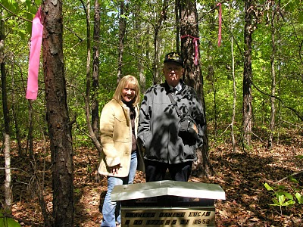

Glenda (b 1959), is the daughter of Cecile Eugenia Holliman Youngblood ( 1937-2012), who is the daughter of Cecil Rhodes Holliman, (1902 – 1986), who is the son of James Monroe Holliman (1878 – 1938) who is the son of John Thomas Holliman (1844 – 1930) who is the son of Uriah and Mary Polly Lucas Holliman. Rhodes (b 1928) is the son of Cecil Holliman, the grandson of James Monroe Holliman, and great grandson of John Thomas Holliman.

SATURDAY, MARCH 6, 2010

Mary Polly Lucas Holliman Part II

The photo below is of Norman S. Holliman of Tennessee taken by the gravesite of his great, great grandmother, Mary Polly Lucas Holliman in Bluff, Alabama. She is a grandmother of almost all reading this story.
A native of Rockdale, Texas, Norman is the son of the late August Harold Holliman, who is the son of Cornelius Elmer, who is the son of Cornelius Holliman, who is the eighth child of Uriah and Polly Lucas Holliman.
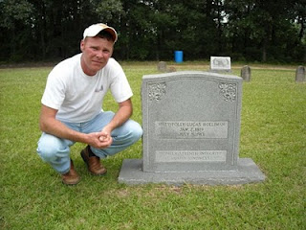
Part II –A Compassionate Heroine: The Story of Mary Polly Lucas Holliman
By Dr. Rhodes Holliman, originally published in Southern Times Magazine of Tuscaloosa and West Alabama, issue no. 125.
In May of 1862, Mary Polly in her home in Fayette Co., Alabama heard from some source, that her husband Uriah and son, Charles Daniel, were sick in Okolona, Mississippi, where a very congested camp had been established after the retreat from Corinth (Battle of Shiloh). They were trapped in an epidemic of measles and pneumonia that enveloped the camp. She hitched up the mule to a wagon and traveled the primitive dirt roads and trails to Okolona, a distance in excess of 70 miles to attempt to care for her sick husband and son. Uriah died on May 8, 1862, and Charles Daniel died on May 12, 1862.
She stayed long enough to bury her husband and son, and then drove the wagon back to the home place near Bluff, while suffering the ravages of measles contracted while acting as caregiver to her family. Their graves are among the many ‘unknowns’ in the Okolona Confederate Cemetery. She remained in desperate condition while convalescing at home. One can only imagine the tragedy what would have occurred if she had died, orphaning seven children at home between the ages of 14 and two. She survived this frightening ordeal to become one of the great, compassionate, pioneer ladies of northwestern Fayette County.
In 1865, when James Franklin and John Thomas returned from the war, Mary Polly had nine of her 13 children at home for a short time. James and John, at ages 26 and 21, would soon be married and moving out to start their own families. The remaining children: females aged 17, 11, nine and seven, and boys aged 16, 13 and fiver, were the ‘work force’ on which May Polly depended to handle all the many chores inherent in sustaining a successful farm. She could hitch up a mule to a plow and till the soil as well as any man. As her brood began to mature over the next 12 years, she saw two boys and two girls marry local sweethearts and move away to Texas, the new frontier for patent land. Another daughter would marry a Holliman cousin and move to Oklahoma, leaving only one daughter and one son to assist in maintaining the farm.
As children abandoned the old homestead for ‘greener pastures’, Mary Polly developed a vocational interest that would endear her to the population of northwest Fayette county and enhance the qualities of her character that are engraved on her grave stone: “Pioneer Strength – Integrity – Human Kindness!”
Professional medical services were virtually unknown in post-war Fayette County so, while maintaining her farm, she became the only source of medical assistance in her community as an herb doctor, caregiver and midwife to many of her neighbors. As her reputation of competency spread, her medical ‘practice’ spread geographically. She would accept appeals for help from all over the area, then saddle up a mule and ride out to provide services.
She charged $5 for midwife services, which included prenatal checkups, moving in to the expectant mother’s home and performing the delivery, staying for a week or more of postnatal care of mother and infant, plus cooking for the family, doing the washing and cleaning the house. If ever a grave stone spoke the truth to the memory of the one interred, it is her stone. One of God’s great compassionate mothers is at rest in Springhill Baptist Cemetery in Bluff Community, Fayette County, Alabama.
Mary Polly finished her days at the home of her youngest son, Joshua Warren Holliman (1860-1944) in Vernon Alabama, Lamar County. This writer had the privilege of talking to Joshua in the 1930s and hunting on his farm as a boy. One of the last recollections that Joshua had of his mother comes from our family archives. She was ‘sitting in a rocking chair on the front porch of an old dog-trot house, smoking a corn cob pipe, dipping snuff and nipping from a quart of Four Roses whiskey that was sitting on the floor beside her chair!” What a unique way to remember a lady whose life-long work ethic brought comfort and support to so many.
There are many tales to tell about Mary Polly Lucas Holliman and her large family. There is a separate, exciting story about each one of them. There are very few cemeteries in Fayette County where you can’t find one or more Hollimans descended from Mary Polly. Her descendants spread out over Mississippi, Oklahoma, Texas and Alabama.
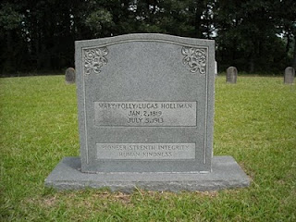Tombstone of Mary Polly Lucas Holliman (photo courtesy of Norman Holliman)

FRIDAY, MARCH 12, 2010

John Thomas Holliman, A Survivor and Casualty of the Civil War

In this posting, Dr. Rhodes Holliman examines the Civil War life of one of the sons of Uriah and Mary Polly Lucas Holliman. Many of you reading this are descendants of John Thomas Holliman (1844-1930). Others will recognize John Thomas as a distant cousin, a great grandson of James Grantson Holliman (1750-1836).

Whatever your relation, this life of John Thomas captures the pathos and violence of war, and its difficult aftermath. Note the sad reality as John Thomas assembled with his regiment in Tuscaloosa only one week after his father and brother died following the Battle of Corinth, Mississippi.

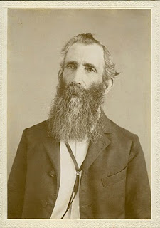 John Thomas Holliman, ca 1900

UNBEARABLE ENDURANCE, Part I
by Dr. Rhodes B. Holliman of Dublin, Virginia.
This article first appeared in Southern Times, Magazine of Tuscaloosa and West Alabama, issue No. 124.
John Thomas Holliman was born on April 23, 1844, in Fayette County, Alabama. He was the fifth child of 13 of Uriah Holliman and Mary Polly Lucas Holliman. In his family, two of his older brothers and his father joined the Confederate Army plus a younger brother and a brother-in-law. Of these volunteers, only two would survive the War: John Thomas and his oldest brother, Lt. James Franklin Holliman of the 58th Alabama Infantry. His was a poor, backwoods, farming family who never owned slaves but who stood ready to defend their homeland.
We will never know the motivation that drove John Thomas, his father and 3 brothers to join the Confederate Army. Peer pressure, community pressure, the excitement of travel away from the farm, a patriotic resolve to defend the homeland and their way of life, a distorted view of what combat would really be like and no idea of the privations that lay ahead could have influenced their decisions. John Thomas and his siblings had never been more than 25 miles away from home.
The fallacious idea that war would be fun and exciting and would be over in a few weeks pervaded the minds of so many volunteers of that time in both Union and Confederate armies. The Holliman boys were basically illiterate, and they had no background in the study of history and the horrors of war. As far as we know, James Franklin Holliman was the only member of this family group who could read or write.
At age 18, John Thomas joined Company H of the 41st Alabama Infantry Volunteers as a Private in April, 1862, in the town of Fayette. He would never be promoted. The 41st was made up of volunteers from Tuscaloosa, Greene, Fayette, Perry and Pickens counties, with Fayette County enlisting the most men in Companies B (88), H (132), and I (110). This was 26 % of the 1284 volunteers in the 41st from all counties.
The 41st was assembled in Tuscaloosa, AL, on May 16, 1862, to begin training. The sudden crowding of these men who were accustomed to living on isolated farms remote from individuals with contagious disease, and the subsequent exposure to polluted water, poor rations and unsanitary conditions of camp life, created an environment for an epidemic (measles, typhoid, pneumonia). There was no effort made to quarantine contagious individuals because the microbial source of infection was not discovered until the work of Pasteur and Koch in the late 1800s.
From May through July there were many deaths due to disease so that the first engagement at Chattanooga, TN, in August, 1862, found only 700 men fit for duty. John Thomas fought skirmishes along the Tennessee River in the fall and was hotly engaged in the carnage of Stones River (Murfreesboro, TN, campaign) in early January, 1863. Thereafter, the 41st was deployed along The Army of Tennessee Defense Line at Manchester, Allisona, Tullahoma and McMinnville with frequent skirmishes through the spring of 1863.
In an effort to reinforce troops in the Mississippi Campaign, on May 23 rd, the 41st was transferred by rail to Chattanooga, Atlanta, Montgomery and Mobile, Meridian and Jackson. Arriving too late to be of help at Vicksburg, the 41st was outstanding in the Second Battle for Jackson, MS. After a month long rest, the 41st retraced its steps to Chattanooga. John Thomas was yet to face the blood bath at Chickamauga on Sept. 20th and the following siege of Chattanooga.
The 41st left their positions on Missionary Ridge on November 19th and marched to Tyner’s Station to join Gen. Gracie’s brigade for the assault to retake Knoxville. Little did they anticipate that Union forces would overrun Missionary Ridge on November 25th whereupon John’s brother, Lt. James Franklin, was captured and imprisoned for the remainder of the War in the Confederate Officer prison camp on Johnson’s Island in Lake Erie near Sandusky, Ohio.

FRIDAY, MARCH 19, 2010

John Thomas Holliman, A Survivor and Casualty of the Civil War

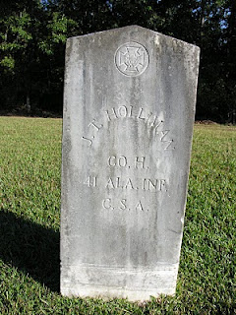
Photo courtesy of Glenda Norris, a great, great grand daughter. Grave is located at Caine's Ridge Baptist Cemetery, Fayette County, Alabama.
In the previous posting, John Thomas enlisted in the Confederate Army and engaged in a number of battles. As the fall of 1863 approaches, he has been in the Army for a year and a half and has had no leave or furlough. The Union Armies of Grant and Sherman have pushed deep into the South, and Lee has been repulsed at Gettysburg. The Southern cause has become desperate.
UNBEARABLE ENDURANCE, Part II
by Dr. Rhodes B. Holliman of Dublin, Virginia.
This article first appeared in Southern Times, Magazine of Tuscaloosa and West Alabama, issue No. 124.
John Thomas was now without shoes or winter clothing and the severe winter of 1863 - 1864 was closing in. The 41st Infantry Regiment marched from Tyner’s Station to Knoxville, a distance of over 100 miles.
The attack on the Union fortifications at Knoxville was a catastrophe forcing the 41st to retreat toward Bean’s Station over icy ground in freezing rain and snow. At this point John Thomas had no blanket, coat or shoes. He was leaving bloody tracks with every step. A battle at Bean’s Station on December 14th left the 41st with about 350 men and officers: about 1/3rd the original enlistment. Winter encampment was made at Morristown, TN, and the Regiment marched into Bristol, VA, in April of 1864. They soon marched north to Abingdon where they boarded a train on April 16th for Richmond.
Their next campaign began at Drewry’s Bluff on the James River south of Richmond: an effort to prevent Union gunboats from sailing up to the Confederate capitol. The victory at Drewry’s Bluff would become “the finest hour” for the 41st AL. On June 17th, the 41st moved into the trenches at Petersburg for the exhausting 9 month siege to follow. John Thomas would endure the unrelenting rifle and artillery fire until Feb. 1865.
No words can describe the carnage of events in the trenches at Petersburg. During this time he would see two of his cousins from Co.B seriously wounded and one killed. He participated in the effort to bury his cousin from the trenches of Gracie’s Brigade but was thwarted by Union sniper fire. He and 2 other cousins dragged the body at night to the Confederate burial ground in Old Blanford Cemetery near the spot of the Crater Explosion and finally accomplished their mission while dodging Union rifle fire.
On February. 15th, 1865, John Thomas was near death from starvation and exposure in a frozen wasteland. He still did not have shoes, a coat or blanket. He and two of his Company buddies, Sgt. Miles Bobo and Pvt. John Anders South, pooled their money ($17 Confederate) and bought a pone of cornbread being peddled by a free black woman in the trenches. They ate it, put up a white flag on a ramrod and walked over into the Union lines. The Federal Archives state that John Thomas was sent to Washington, D.C., given the oath of allegiance, and then sent to Holly Springs, Mississippi, to await discharge. This statement is correct for Bobo and South but John Thomas’ fate was totally different. This writer is in possession of a note written by a post-war confidant of John Thomas that reads:
“In Co. H - 41 Ala at Petersburg Va. On Feb 15 1865 about dark - went over to Union. John South, Miles Bobo. Carried Gard (sic) House that night - Asked by officers to disclose conditions and were carried from post to post disclosing conditions in Conf. (Gracies Army) Was in U S Army about 1 week. Was then sent to Washington and took Oath - was sent to Baltimore Md - then throug (sic)Pa to Indianapolis Ind & stayed in Inda (sic) about 6 mo - war closed.”

John Thomas was furloughed, really indentured, to a farmer in Indiana and he promised to stay and “make a crop”. Good to his word, he stayed until the fall of 1865. He had earned enough to purchase new shoes and, to limit the wear, he tied the shoelaces together, slung them over his shoulder and, to quote his exact words, “came on home.” He walked cross country, alone and barefoot, about 600 miles to his home in Fayette County in west Alabama!
John Thomas did not receive a single furlough during his 3 ½ years of service. He hated the War and frequently declared it was “a rich man’s war and a poor man’s fight.” He was held in contempt by some of his neighbors for the remainder of his life for his surrender.
His brother, Lt. James Franklin, after release from Johnson’s Island Prison in June, 1865, opened a one room school in the northwest part of the county and enrolled 8 grades of children and adults. John Thomas, at age 21, tried schooling for about a week but quickly withdrew. After his experiences of the previous 3 ½ years, school was not for him.
His first marriage in 1867 produced 3 children, only one of whom, a son, lived to maturity. His wife died in 1872 from “childbed fever” (septicemia) giving birth to their third child, a stillborn infant. He married again in 1875 and produced 5 sons. He was a profound victim of post war traumatic stress and his countenance and personality reflected this condition until his death on July 12th, 1930, from prostate cancer, at age 86.
He had been subjected to unspeakable visions of death and hardship. He was denied a veteran’s pension in his old age and died in poverty. He is buried next to his second wife in Caine’s Ridge Primitive Baptist Cemetery on State Route 159 just south of Fayette, AL. From his 6 sons, there are 6 branches of the Holliman family who have enjoyed life because their ancestor was prudent enough to recognize when death was imminent and the mission was doomed to failure.
The 41st AL went on to fight at Hatcher’s Run and the retreat to Appomattox where 98 of the original 1,284 stood ready to answer the final roll call.
In reading the campaign history of the 41st Alabama, one recognizes the futility of the endless marching and the confusion of battle plans created primarily by lack of communication between combat units. It will never cease to be amazing that logistics and tactics could coordinate and the endurance and sacrifice of the individual soldier was beyond comprehension.

Monday, April 18, 2011

The Hollimans of Alabama
by Glenn N. Holliman
Back to the 19th Century...A Series of Articles on the Hollimans and Related Families of Fayette County, Alabama
By 1836, several sons of James Grantson Holliman (1750 - 1836) and other associated families had migrated to Fayette County, Alabama from Lancaster, South Carolina. Cornelius (1792 - 1862), Charles (1795 - 1850) and Warren Holliman (1801 - 1876) were part of the westward movement of the American nation and my family in the 19th Century.
Warren would later move on to Arkansas and father many Holliman descendants in that part of the United States. Cornelius, Charles and many of their descendants remained in Fayette and adjoining counties. Many others went to Mississippi, Louisiana and Texas.
An Excursion into History....
On April 9, 2011, Glenda Norris, a descendant of James Grantson and Cornelius Holliman families, led fifteen of her distant cousins through the cemeteries of her many great grandparents to share their stories. She would be the first to tell you that she stands on the shoulders of her grandfather, Cecil Rhodes Holliman, and his son, her uncle, Dr. Rhodes Holliman. The research about to be shared comes from their hands and also of the late Walt Holliman, a descendant of James Grantson and Charles Holliman, his son.
Glenda Norris reports:
"The first stop of the tour was Charles Daniel Lucas, Jr. burial site. It was unseasonably hot for April (92f) even for the Deep South. But that didn’t slow anyone down. Everyone was more than willing to take a short ‘hike’ into the woods, up a small hill and then a left turn into the forest to view the ‘old Indian burial ground” where Charles Daniel Lucas, Jr. gravesite is located.

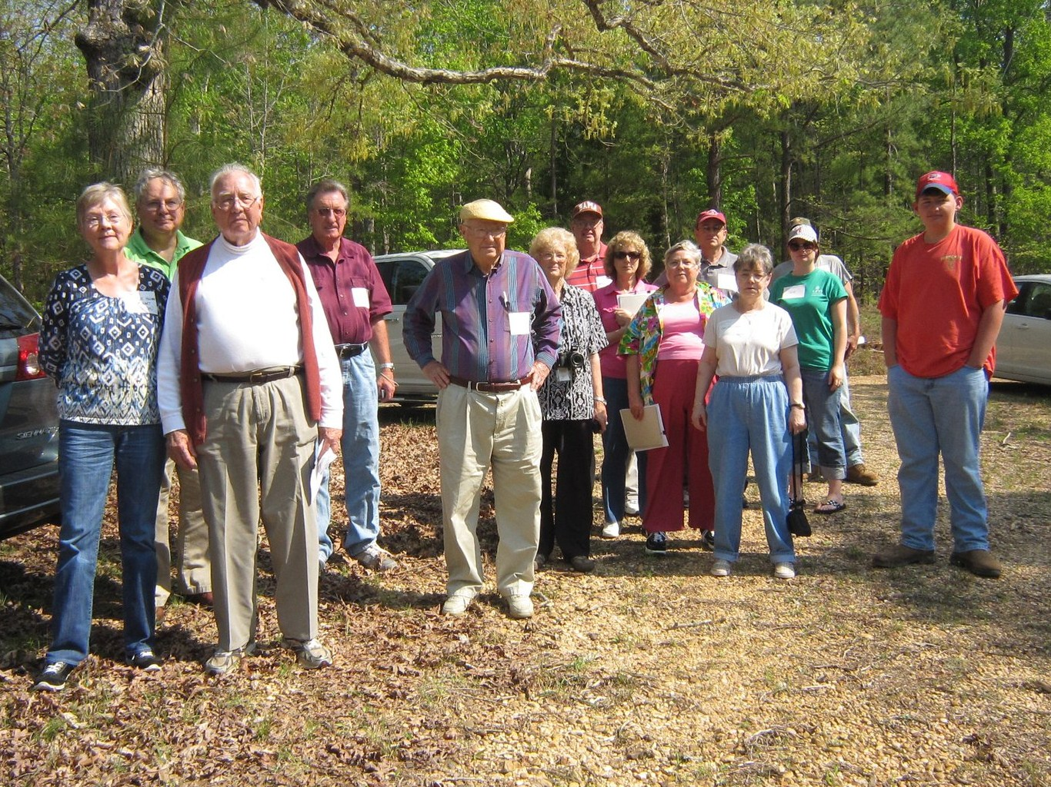
Here is a photo of everyone getting ready to make the walk. Left to right are: Jeanette Holiman Stewart (Austin, Texas), Glenn Holliman (Newport, Pennsylvania), Lenwood Holliman (Gordo, Alabama), James Franklin Holliman (Sulligent, Alabama), Bishop Holliman (in cap from Avilla, Indiana and the oldest at 91), Laura Vonceil Duckworth (Reform, Alabama), Wally and Tommie Holliman Allen (Irondale, Alabama), Faye Gardner (Kennedy, Alabama), Bill Holliman (Horn Lake, Mississippi), Jean Holliman (Irondale, Alabama), Joey Holliman (Florence, Alabama) and Tyler Duckworth (Tuscaloosa, Alabama and at age 15, the youngest on the trip). Obscured is Robert Holliman and taking the photograph is Norman Holliman (both brothers from Marysville, Tennessee)."
All the above are either descendants of Charles (about 1795 - before 1850) or Cornelius Holliman (1792 - 1862). Of course, all have the DNA of Christopher Holyman, Sr. (1618 - 1691), the Englishman who left Bedford, Bedfordshire and immigrated to Jamestown, Virginia in 1650.
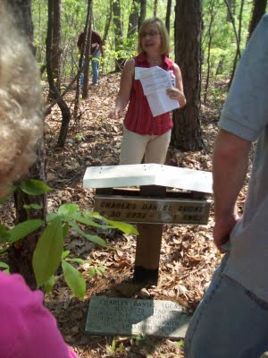
Above, Glenda Norris shares information at the grave site of her 4th great grandfather, Charles Daniel Lucas Jr. whose daughter, Mary 'Polly' Lucas married Uriah Holliman, a son of Cornelius Holliman. Below, Glenda points out a Creek Indian burial site. Charles Daniel Lucas, Jr. was a Federal Indian agent and may have been the son of a Catawba Indian mother from South Carolina. When he died, he requested to be buried with his Native American friends. His wish was granted and he lies today sharing the sandy soil with first Alabamians.
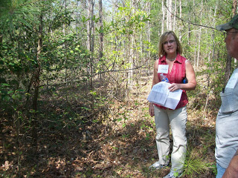

Monday, April 25, 2011
The Hollimans of Alabama
by Glenn N. HollimanBack to the 19th Century...A Series of Articles on the Hollimans and Related Families of Fayette County, Alabama
Below are observations by Holliman family historian, Glenda Norris. She credits much of her knowledge to Dr. Rhodes Holliman, her uncle. It was Rhodes who, as a boy in the 1930s, would hike several miles into the piney woods, dodging more than a few snakes to re-discover the location for the family. Several monuments now mark this spot.
Glenda Norris reports: "Charles Daniel Lucas, Jr. was the son of Charles Daniel Lucas, Sr. and 'Dorcas' (no last name has been found). It is believed that the mother of Charles Daniel Lucas, Jr. could be a Catawba Indian from the Pee Dee River area in Marlboro County, South Carolina. She was only 13 years old when she married Charles Daniel Lucas, Sr., a tailor. Their son, Charles Jr., was born on June 30, 1771 and died May 31, 1853."
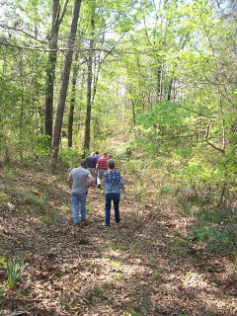

Above, on April 9, 2011, Holliman and Lucas descendants take the trail to the Lucas and Indian graves which are located several hundred yards through the woods off County Road 100 in south Fayette County.
"Charles Daniel Lucas, Jr. was a traveler and migrated from South Carolina to Alabama before the Holliman brothers. His first homestead was in Marengo County, Alabama where he purchased 80 acres on October 20, 1823 and then 80 more the next spring. Two years later, he established a homestead in Fayette County, and still ambitious, 40 acres on October 16, 1834 in Tuscaloosa County.
The Fayette and Tuscaloosa properties were connected, almost touching Highway 171 on its east side. He was a deacon at the Spring Hill Baptist Church in Tuscaloosa County. A monument at the church celebrates he and Cornelius Holliman, a son-in-law, as ‘founders’ of this church.
Charles Jr. earned his living 'stock dipping' and as a Federal Indian agent. Newtonville, Alabama straddled the line between the territory of the Chickasaw (north) and the Choctaw (south). By 1836, all these land claims were extinguished. In a dreadful and, even in that day, controversial act, most of the Native Americans remaining were removed to Indian Territory (present day Oklahoma).
With the dispersal of the tribes, the Federal government sold the land to immigrant families from the south east U.S. - the Hollimans, Lucases and other associated families.
Charles Lucas, Jr. claimed to be ‘black Dutch’, a term at the time to obscure one's possible Indian ancestry but this has not been proven, only speculated. He was a man of large stature (6’4” - 6’6”) and had great strength. It has been passed down through generations that Charles Daniel killed a panther with his bare hands.
His burial site is in southern Fayette County, Newtonville area off of County Road 100 (Walnut Lane). At one time this land belonged to Charles Jr. and his home was not far from the burial site. His grave is on a ridge line, over looking a ravine. The site is an Indian burial ground as he chose to be buried with his friends."
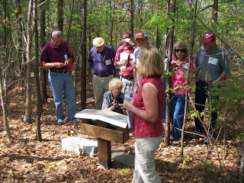
Glenda Norris, foreground, provides information at the internment site and memorials to Charles Daniel Lucas, Jr. The site contains numerous Choctaw or Chickasaw Indian burials, disturbed in an earlier century by grave robbers.
"Charles Daniel Jr. was married to Mary Hasten (in some places spelled Hastings). They had 10 children together. Family historians suggest that Charles Daniel ‘over disciplined’ one of his children with his cane. This did not go over very well with his family and because of his temper, his wife, Mary and the rest of his children left him and moved to the Bluff community. Due to this estrangement Mary Hasten Lucas was buried at the Spring Hill Cemetery, 20 or so miles north of this pioneer’s resting place."

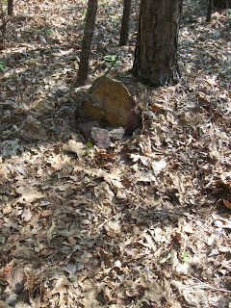
This original stone marker stands on the burial site of Charles Daniel Lucas, Jr., pioneer and Indian agent, who helped open Northwest Alabama to Anglo and African American settlement in the early 19th Century.
When Charles Daniel Lucas, Jr. was born, George III, was sovereign over the American colonies. When Charles Jr. died, Franklin Pierce had just become president of the United States, a union on the verge of dissolving."

For additional information on Charles Daniel Lucas, Jr., go to Archives and the February 13 and 26, 2010 editions of this blog. Rhodes Holliman incorporated his own research and that of his father, Cecil Holliman and the late Walt Holliman to create some excellent articles that are available for all to read. Some of the general information for these postings comes also from Robert Scott Davis's book, "Tracing your Alabama Past" (University of Mississippi Press, 2003).

Monday, May 2, 2011

The Hollimans of Alabama
by Glenn N. Holliman
Back to the 19th Century...A Series of Articles on the Hollimans and Related Families of Fayette County, Alabama
We continue our series of the April 9, 2011 tour of Holliman sites in Fayette County, Alabama led by Glenda Norris, descendant of Christopher Holyman, Sr (1618 - 1691).
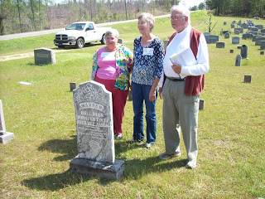
Above at the Chapel Hill Cemetery near Newtonville, Alabama are from left to right: Faye Gardner (Reform, Alabama), Jeanette Holiman Stewart (Austin, Texas) and Lenwood Holliman (Gordo, Alabama). In this April 9, 2011 photograph, they stand behind the grave of Civil War veteran Warren Holliman (1833 - 1908), a son of Charles Holliman (1795 - 1852), of whom the three are descended. Warren is misspelled Warron on his tombstone.
Warren Holliman's story...
In 1836, numerous children accompanied the three brothers, Cornelius, Charles and Warren Holliman, on their journey from the North Carolina/South Carolina border to Fayette County. One of the children of Charles Holliman and wife, Barberry (sometimes Barbara) Walters, was their son, Warren, age 3 at the time.
According to U.S. Census records Fayette County had a population of over 3,000 in 1830, and would more than double in size to over 6,000 in 1840 as immigrates moved west to the yet untitled soil of Alabama.
Warren married Mary Polly Blakeney, the daughter of Thomas and Sarah Kemp (or Roberts?) Blakeney. Thomas (1800 - 1892) was a son of William Blakeney and a grandson of Capt. John Blekeney (1732 - 1832). The Blakeneys had migrated to Alabama from Chesterfield, South Carolina. Warren and Polly would have 11 children, 3 girls and 8 boys which helped entrench the Holliman name in the area.
Warren's generation came of age as the American Union dissolved and Civil War engulfed our ancestors. Warren and his two brothers, Cornelius and Elijah, and cousins (including my great grandfather, John Thomas Holliman) joined with other Fayette Countians in enlisting in the 41st Alabama Infantry Regiment. Warren was known as the 'strong man' of the county. He could pick up a bale of cotton (500 pounds) and walk with it!
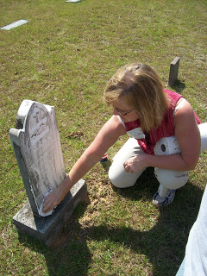
Glenda Norris uses a genealogical technique she learned from Rhodes Holliman, the application of shaving cream to faded tombstones, to reveal hidden names and dates. This is Warren Holliman's grave site.
In the next post, Warren Holliman's historic war service with the 41st Alabama Infantry Regiment....

Monday, May 9, 2011

The Hollimans of Alabama
by Glenn N. Holliman
Back to the 19th Century...A Series of Articles on the Hollimans and Related Families of Fayette County, Alabama
Warren Holliman (1833 - 1908), A Civil War Veteran of the 41st Alabama Infantry Regiment
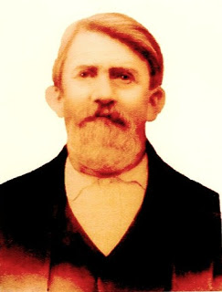
Above Warren Holliman (1833 - 1908) took a .58 mini-ball to the arm on August 17, 1864 during the siege of Petersburg, Virginia, knocking him out of the Civil War. At age 29, he signed up for the conflict with his relatives and neighbors with the 41st Confederate Alabama Infantry.
This storied regiment was at Stones River, Chattanooga, Knoxville, Richmond and Petersburg before surrendering with General Robert E. Lee at Appomattox, Virginia in April 1865.
After three months in a Richmond hospital, Warren was sent home in November 1864, his war effectively over. Photo and information from the extensive files of Dr. Rhodes Holliman, family historian, and Vonceil Duckworth, descendant of Cornelius Holliman. More on Warren and his military adventures in later posts.
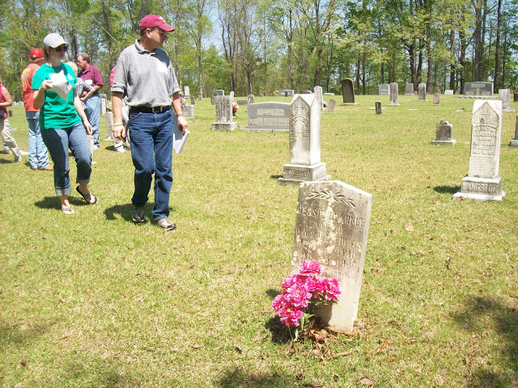
Above on a warm, sunny April day, 2011, Bill and his daughter, Joey Holliman, look for Holliman grave stones at Chapel Hill Cemetery in Fayette County, Alabama. Warren Holliman and his two wives are buried at Chapel Hill (see previous article). Bill Holliman, a multi-great nephew of Warren, is a 3rd great grandson of Cornelius Holliman (1792 - 1862).
Now living in Mississippi, Bill grew up in Irondale, Alabama, a grandson of Ulyss (1884 - 1965) and Pearl Caine Holliman (1887 - 1955), who migrated from Fayette County to Jefferson County in 1917 to take advantage of employment opportunities in the Birmingham area. This migration from rural Alabama communities to metropolitan areas accelerated during the World War I era. Today, descendants such as Joey and Bill return to Fayette, Lamar and Tuscaloosa Counties to discover family roots and stories.
Monday, May 23, 2011

The Hollimans of Alabama
by Glenn N. Holliman
Back to the 19th Century...A Series of Articles on the Hollimans and Related Families of Fayette County, Alabama

Below, H. Bishop Holliman, great grandson of Samuel T. Walker, and Glenda Norris, 3 great grand daughter of Samuel, stand at his grave at Pilgrim's Rest Church in Fayette County, Alabama. Glenda led a tour on April 9, 2011 of Holliman and associated family cemetery sites. Glenda and two cousins, Norman and Robert Holliman, are attempting to have installed a Confederate tombstone marking the incredible military service of this family ancestor. Samuel (1820 - 1900) was one of the 7,000 or so troops left in Lee's army when he surrendered at Appomattox!
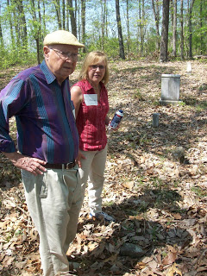
The late Cecil Rhodes Holliman (1901 - 1980) has written extensively on the Walker family and in later postings the history of the Walkers and especially Samuel will be explored. One of Samuel Walker's daughter's, Martha Jane, married John Thomas Holliman (1844 - 1930), a grandson of Cornelius Holliman and son of Uriah Holliman (1820 - 1862). John Thomas and Martha Janes Holliman had five children, one being Glenda's great grandfather, James Monroe Holliman. Another child was Ulyss Holliman (1884 - 1965), the father of Bishop Holliman, above.
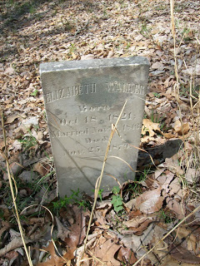
Located near Samuel's resting place at Pilgrim's Rest is his wife, Elizabeth Walker (1821 - 1879), mother of Martha Jane Walker Holliman.
Tuesday, May 31, 2011

The Hollimans of Alabama
By Glenn N. Holliman
Back to the 19th Century...A Series of Articles on the Hollimans and Related Families of Fayette County, Alabama
April 9, 2011 distant cousins from six states gathered in Fayette County, Alabama to discover and rediscover ancestral grave sites. The picture below was taken at Caine's Ridge Baptist Church cemetery where lie John Thomas and Martha Jane Walker Holliman and members of the associated family of Caine.
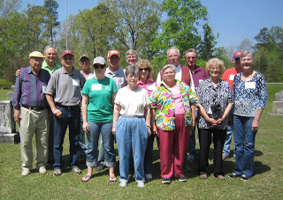
Left to right, Bishop Holliman (Indiana), Glenn Holliman (Pennsylvania), Bill Holliman (Mississippi), Robert Holliman (Tennessee), Joey Holliman (Alabama), Norman Holliman (Tennessee), Wally Allen, Jean Holliman, Tommie Holliman Allen, Faye Gardner, Lenwood Holliman, James Franklin (Frank) Holliman, Vonceil Duckworth, Tyler Duckworth (all from Alabama) and Jeanette Holiman Stewart (Texas). The photograph was taken by Glenda Norris, organizer of the excursion.
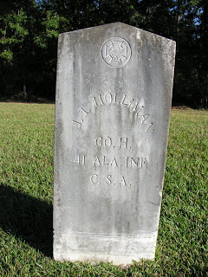
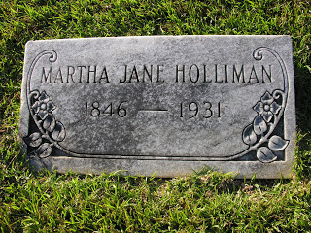
The earthly remains of John Thomas and Martha Jane Walker Holliman lie side by side at Caine's Ridge, a few miles south of their former home in Fayette. The story of John Thomas Holliman is told in its sad glory by one of his great grandson's Rhodes Holliman in this blog, February and March 2010. Please go to the Archives function and to seek the articles.

Tuesday, June 7, 2011

The Hollimans of Alabama
by Glenn N. Holliman
Back to the 19th Century...A Series of Articles on the Hollimans and Related Families of Fayette County, Alabama
The Visit to Caine's Ridge, a Family Excursion in 2011
Lecturing on family history near the burial sites of this paternal and maternal grandparents is 91 year old H. Bishop Holliman (in purple shirt with cap). As a boy he used to visit John Thomas and Martha Jane Walker Holliman, his paternal grandparents at their last home near the Fayette train depot. One of his memories is sitting on their porch on the south side of town watching the trains come into town.
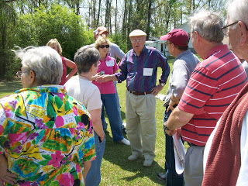
Below in a photograph taken in either 1928 or 1929 are John Thomas and Martha Jane Walker Holliman standing in front of their home in Fayette. John would died in 1930 and Martha Jane in 1931. The young man sitting on the porch in a white shirt and tie on the far right is 10 year old Bishop Holliman.
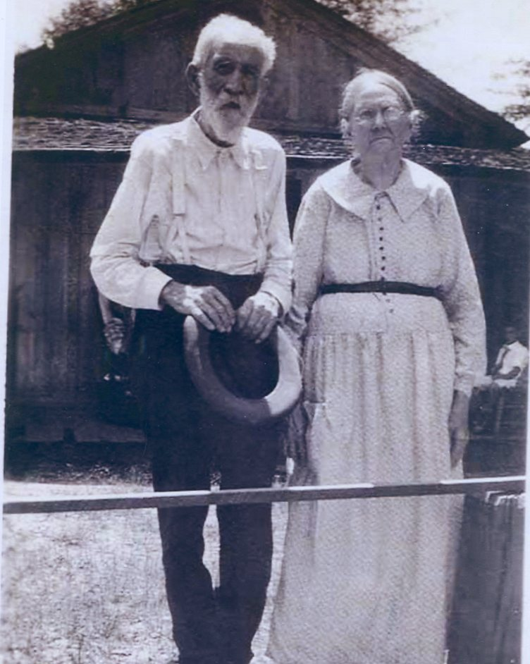

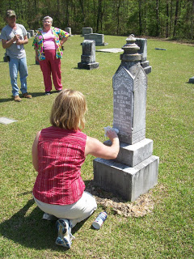
Cleaning the Caine monument is Glenda Norris using shaving cream. When gently scrapped off, the cream reveals difficult to read letters. Glenda credits her Uncle Rhodes Holliman for the process. In the background are Robert Holliman and Faye Gardner.
Bishop Holliman's father was Ulyss Holliman (1884 - 1965) who grew up in Fayette, married Pearl Caine (1887 - 1955) in 1906, and removed to Jefferson County, Alabama in 1917 in search of increased income for his growing family. Pearl Caine's grandparents, William Ellison and Melissa Anthony Caine, lie buried under the gravestone above. It was Pearl's grandfather who gave the land for the church.

Tuesday, June 14, 2011

The Hollimans of Alabama
by Glenn N. Holliman
Back to the 19th Century...A Series of Articles on the Hollimans and Related Families of Fayette County, Alabama
Spring Hill Cemetery in Bluff, Alabama is the final resting place of a pioneer ancestor who made the trek from the Carolinas to Alabama in 1836, raised a large family, survived the Civil War although losing a husband and two sons, farmed, midwifed and lived to be 94 years old. Family lore has her enjoying her 'flowers' - her 'Four Roses' - deep into her final years.
"Mary Polly Lucas Holliman, January 2, 1819 - July 5, 1913, Pioneer Strength, Integrity, Human Kindness"
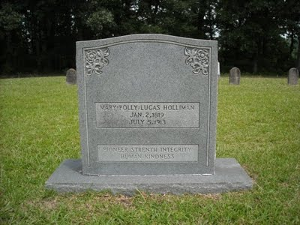
Even thought 'strenth' may be mis-spelled, this grave stone speaks eloquently of the wife of Uriah Holliman, 1817 - 1862. As Dr. Rhodes Holliman, a great, great grandson has written (see Archives of this blog, March 2010 and copy below), Polly buried a husband and son (Charles Daniel Holliman) at Okalona, Mississippi after the Battle of Shiloh in 1862. Sick herself, she rode home, raised the children remaining and lived to the age of 94. During the decades after the war she served as a mid-wife, delivering many of her own grandchildren.
"In 21 years of married life, Mary Polly and Uriah would produce 13 children - seven boys and six girls. She could hitch up a mule to a plow and till the soil as well as any man. While maintaining her farm, she became the only source of medical assistance in her community as a herb doctor, caregiver, and midwife to many of her neighbors. She would accept appeals for help from all over the area, saddle up a mule and ride out to provide services." - Dr. Rhodes Holliman
Below family members, four of whom are direct descendants of Polly Lucas Holliman, gaze over the Spring Hill Cemetery in the Bluff community of Fayette, County. Left to right: Wally Allen, Jean Holliman, Tommie Holliman Allen, Bill Holliman, Bishop Holliman (great grandson of Polly Lucas) and Jeanette Holiman Stewart. Bishop Holliman,b 1919, is a first cousin of Rhodes Holliman's father, Cecil Rhodes Holliman (1903 - 1982).
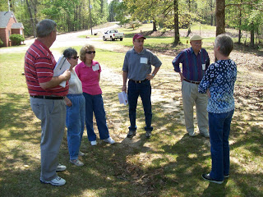
On that early April day in 2011, when sixteen Holliman descendants traveled through Fayette County, the trees were leafing out in pastel green. One noticed that the soil of Fayette County could not decide if it wanted to be red clay or sandy stone and rock. Both pine and oak thrive in the ravines and on the ridges adjacent to the Sipsey River that flows north to south through the county. Swamps cover many areas near the river bottoms. From this soil our 19th Century ancestors harvested cotton, corn and lumber. Hogs and cattle grazed in the woods and pastures.

Below the ground, coal emerged, and today oil and gas flow deep from the Alabama earth.
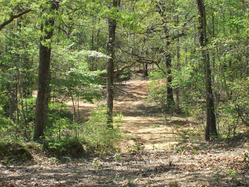
Above, a dirt road winds off from the Bluff cemetery

Tuesday, June 21, 2011

The Hollimans of Alabama
by Glenn N. Holliman
Back to the 19th Century...A Series of Articles on the Hollimans and Related Families of Fayette County, Alabama
Nancy Palestine Holliman, one of the thirteen children of Uriah and Polly Lucas Holliman, is buried at Springhill Cemetery in the Bluff Community of Fayette County, Alabama near her mother, Mary Polly Lucas Holliman. Although her name is listed as Holliman on the stone, Nancy Palestine is reported by Rhodes Holliman to have been married to John Pinion, but they had no children.
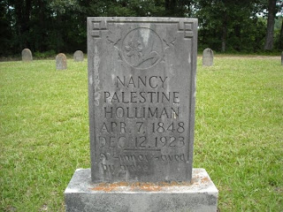
Below, J. Frank Holliman, a second great grandson of Uriah and Polly Lucas Holliman, tells the tale of the winter time burial of his great aunt, Palestine, at the Bluff community, Spring Hill Cemetery. His great grandfather and other relatives dug the grave on a cold, stormy night in 1923.
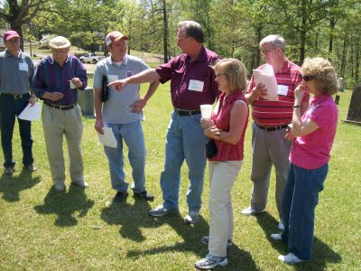
Left to right are Bill Holliman, Bishop Holliman, Norman Holliman, James Franklin (Frank) Holliman, Glenda Norris, Wally and Tommie Holliman Allen. Frank Holliman, who still lives on and near the land farmed by Uriah Holliman prior to the Civil War, is most familiar with Holliman ancestors in the northern part of Fayette County and southern part of Lamar County, Alabama. This excursion to north central Alabama on April 9, 2011 was organized by Uriah and Polly Lucas Holliman's 3rd great grand daughter, Glenda Norris.
More next post on the Hollimans of Fayette County....

Tuesday, June 28, 2011

The Hollimans of Alabama
by Glenn N. Holliman
Back to the 19th Century...A Series of Articles on the Hollimans and Related Families of Fayette County, Alabama

Visiting the Grave site of James Franklin Holliman, An Officer and a Teacher
Below the 21st Century James Franklin Holliman stands by the grave of his great grandfather, James Franklin (1839 - 1908) and his great grandmother, Bertha Lee Holliman. James Franklin Holliman's first wife, Rebecca Stewart, the one to whom he wrote a series of letters during the Civil War, lies on the other side of his grave. The location is the Steward-Holliman Cemetery near the Bluff community.
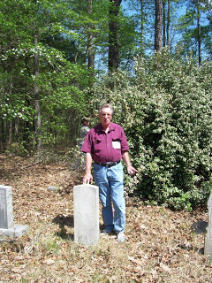
Below Robert Holliman, a great great grandson of Uriah and Polly Lucas Holliman clears brush near the grave site of his great, great uncle, James Franklin Holliman at the Stewart-Holliman Cemetery.
Lt. James Franklin Holliman of the Alabama 58th Regiment, Co. B, was captured at Missionary Ridge, Tennessee. After incarceration for two years at the infamous Johnson's Island in Lake Erie, Ohio, on June 13, 1865, he was released, and walked home to Alabama, At home he did some thing even more heroic - he started a school in his own community and devoted his life to educating the citizens of northern Fayette County. The school was located a few miles from his grave site in the Bluff community. This information courtesy of Rhodes Holliman.
More on this Cemetery in the next post....

Wednesday, July 6, 2011

The Hollimans of Alabama
by Glenn N. Holliman
Back to the 19th Century...A Series of Articles on the Hollimans and Related Families of Fayette County, Alabama
More on the Civil War Veteran who became a School Teacher
Below on April 9, 2011, Holliman descendant Faye Gardner snaps photographs of Holliman and Stewart grave sites while Robert Holliman and his brother, Norman (not visible) work at removing vines and bushes from covered grave sites of Hollimans and Stewarts near Bluff, Alabama.

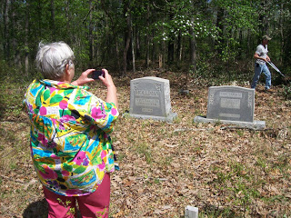
Below, Glenda Norris stands by the memorial stone for Daniel F. Holliman, son of James Franklin and Bertha Lee Holliman - Oct 20, 1895 - May 27, 1897. Lt. James Franklin Holliman is a great, great uncle of hers.
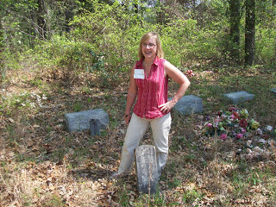
Below, James Franklin Holliman in the early 1900s. This Civil War veteran dedicated his life to school teaching after the violence of his military service from 1861 - 1865. Photo from the collection of Dr. Rhodes Holliman, a great nephew of James Franklin.
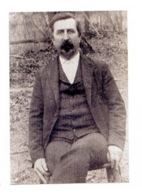
Saturday, July 16, 2011

The Hollimans of Alabama
by Glenn N. Holliman
Back to the 19th Century...A Series of Articles on the Hollimans and Related Families of Fayette County, Alabama
Frank Holliman shares information with Bill Holliman, left, and Bill's Uncle Bishop Holliman at the Holliman-Stewart Cemetery in the Bluff Community of Fayette County, Alabama.
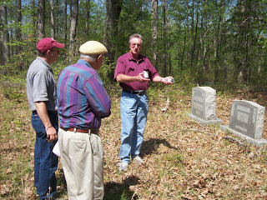
Pictured is the gravestone of Frank Holliman's grandfather, William Bailey Holliman, a son of James Franklin Holliman and Rebecca Stewart Holliman.
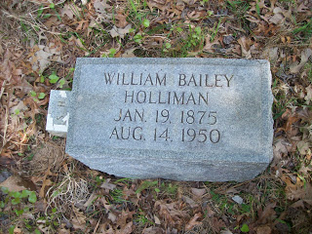

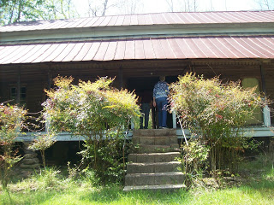
Above, located near the Holliman-Stewart Cemetery is the old home of William Bailey Holliman, a classic early 19th Century 'dog-trot'. The name originated as the family dogs would sleep or trot through the opening between the two sides of the cabin. Generally one side was built to hold the kitchen with its wood stove (not comfortable in the summer) and the living rooms on the other side. Of course, no running water, central heat or air, or electricity. Those were the good ole days?

Wednesday, July 20, 2011

The Hollimans of Alabama
by Glenn N. Holliman
Back to the 19th Century...A Series of Articles on the Hollimans and Related Families of Fayette County, Alabama
One of the more unusual stops on our April 9th, 2011 excursion was a visit to memorial for some Hollimans who fought in the Civil War. While not a burial spot, a well-meaning distant cousin ordered and set up near the William Bailey Holliman home a series of memorial stones honoring James Franklin Holliman, John Thomas Holliman, Uriah Holliman and Elijah Holliman.
Future generations, please be aware many of the dates are incorrect and some facts are wrong on the stones.
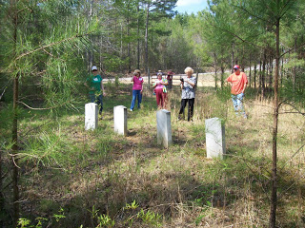
Surveying the memorial stones are left to right, Joey Holliman, Tommie Holliman Allen, Faye Gardner, Jeanette Holliman and Tyler Duckworth. A front view of the stones reveals an old barn in a collapsed state in the background. Pictured below are Bill Holliman and Robert Holliman.
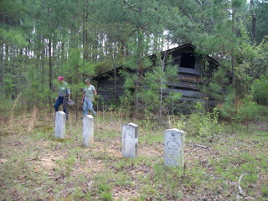

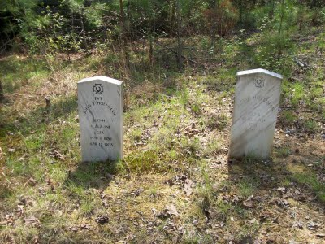
The date on John T. Holliman's stone is incorrect. He died in 1930. While these are not grave sites, one notes that several of these persons did not come home. Elijah Holliman died not at Petersburg, Virginia, but rather at La Grange, Georgia of typhoid fever. He is buried there having served with the 56th Alabama Partisan Rangers. Uriah Holliman died in Okalona, Mississippi along with his son, Charles Daniel Holliman.
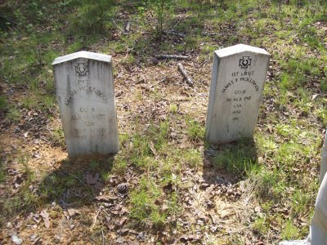
James F. Holliman is NOT buried in this plot but in the Stewart-Holliman Cemetery.
Uriah Holliman was born on July 6, 1816, in Lancaster County, SC. He married Mary "Polly" Lucas in
Tuscaloosa County, AL on Aug. 31, 1836. Performing the ceremony was the Rev. John Walters. Mary was 17 years old. The couple later settled southwest of Bluff in Fayette County, where government land records show that Uriah received patents for more than 320 acres in the late 1850s. Uriah joined the Confederate Army in 1861 at the age of 45! He was Pvt. Uriah H. Holliman, Co. B of the 9th Alabama
Battalion of Volunteers, 26th Regiment, CSA.
He died of measles and pneumonia at Okolona, Chickasaw County, MS, on May 8, 1862, attended by his wife until death. Their son, Charles Daniel Holliman, same military unit, same place, died on May 12, 1862, of the same diseases. Their grave sites are unknown but probably in the Confederate Cemetery in Okolona, MS. Fayette County, Alabama. - Information provided by Dr. Rhodes Holliman, great, great grandson of Uriah Holliman.
I leave this blog up as a caution to those who stumble on the stones near Bluff, Alabama sometime in the future. They are not accurate.

Monday, July 25, 2011

The Hollimans of Alabama
by Glenn N . Holliman
Back to the 19th Century...A Series of Articles on the Hollimans and Related Families of Fayette County, Alabama
Below Norman Holliman photographs his distant cousin, Glenda Norris, at the head stone of a common great grandfather, Cornelius Holliman, 1792 - 1862. Cornelius is buried in the Old Blooming Grove Cemetery in the Bluff community of Fayette County. It was wretched year for the Holliman family. A son and grandson of Cornelius, Uriah and Charles Daniel Holliman, died in May of 1862 after the Battle of Shiloh. Now in the autumn of that tragic year of 1862, Cornelius, passed away from natural causes. Born in North Carolina, he rests in Alabama soil.
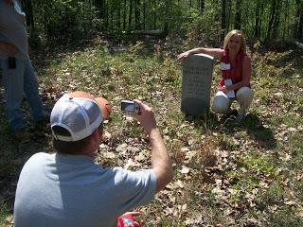

Below members of the Holliman excursion view graves at Old Blooming Grove Cemetery. It was early spring, the trees were leafing out and the brush and weeds were still few and low to the ground.
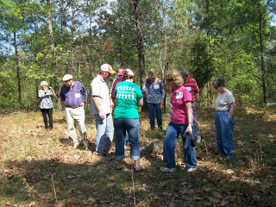
Here Bishop Holliman, b 1919, and great, great grandson of Cornelius, stands with his son, Glenn N. Holliman, b 1946 at the headstone of the pioneer who left the Carolinas and by horse and wagon in 1836 crossed Georgia and much of Alabama to reach the ravine and river bottom country of Fayette County. One hundred and twenty-five years later, some of his many descendants paid homage to his courage and energy and those of his brothers, Charles and Warren, and their wives and children who trekked west with them.
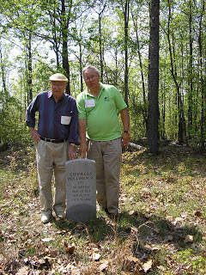

Monday, August 1, 2011

The Hollimans of Alabama
by Glenn N. Holliman
Back to the 19th Century...A Series of Articles on the Hollimans and Related Families of Fayette County, Alabama
Actually this article is about a Baptist Church just south of Fayette County and Newtonville. Spring Hill Baptist Church is located just over the Tuscaloosa County line. The memorial stone below in front of the church honors to of my generations's three great grandfathers - Charles Daniel Lucas and Cornelius Holliman. Their graves were visited on April 9, 2011 by some of their descendants.
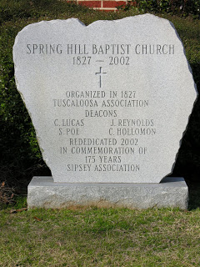
Below the church with the memorial stone in front.
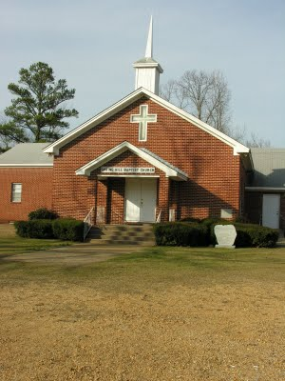
As we know, Charles Daniel Lucas is buried several miles away in an Indian grave site. Cornelius is at peace twenty or so miles north at Old Blooming Grove in the Bluff Community. Glenda Norris believes Cornelius's wife, Elizabeth Plyler, is buried inside the gates of the Spring Hill Cemetery. However, her grave is lost.
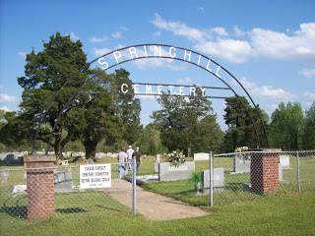
Friday, August 5, 2011

The Hollimans of Alabama
by Glenn N. Holliman
Back to the 19th Century...A Series of Articles on the Hollimans and Related Families of Fayette County, Alabama
This is my last post on the April 9, 2011 Fayette County, Alabama excursion organized by my second cousin, Glenda Norris. Working with information from her Uncle Rhodes and Grandfather Cecil Rhodes Holliman, Glenda scheduled the day, and even did a 'test drive' before leading 15 of her distant cousins on a trip through family history. Below in the Tuscaloosa County, Spring Hill Baptist Church Cemetery, Glenda in the background cleans a tombstone while her husband, Scott, and Norman Holliman look on. Robert Holliman in the foreground takes photos.
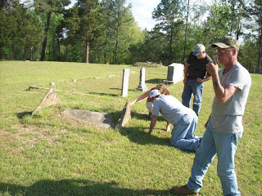
In this cemetery is the unmarked grave of my generation's third great grandmother, Elizabeth Holliman, wife of Cornelius. They led their family by horse and wagon in 1836 from Lancaster County, South Carolina near the North Carolina line through George to west Alabama. Here on recently released Indian land, the family purchased land and began farming. Two brothers, Warren and Charles Holliman, made the trek also, although Warren moved on in a few years to Arkansas to put down roots and establish the Holliman name there. In the photo below, 91 year old H. Bishop Holliman, who visited Fayette County for the first time in the 1920s (He was born in Irondale, Alabama in the 1919) explores the cemetery.
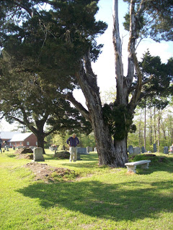
Several earthen grave sites dot the Spring Hill Cemetery. In one of these resting places, may be the remains of Elizabeth Plyler Holliman, pioneer Mother and Grandmother
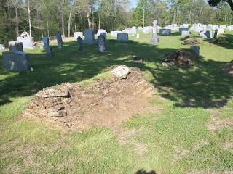
Saturday, December 10, 2011

A Gathering of Hollimans, Part I
by Glenn N. Holliman

In the small community of Fayette, Alabama on October 14 and 15, 2011, a dozen blood-related Hollimans, all descended from Christopher Holyman, Sr. (1618 – 1691), gathered to share research and pose questions as to their common lineage.
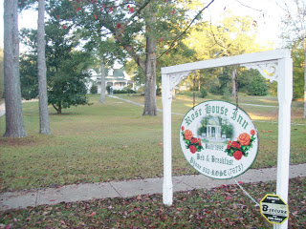
Those who came overnight lodged at the Rose House Inn (above) in Fayette, a quiet community, forty or so miles west of Birmingham and the same distance north of Tuscaloosa. It was in this frontier county that three Holliman brothers, Warren, Charles and Cornelius settled in 1836, emigrating from South Carolina. All three were sons of James Grantson Holliman (1750 – 1836). Warren and his family moved on to Arkansas. Charles, Cornelius and hundreds of their descendants stayed in Fayette and surrounding counties.

Not wasting a moment, Joe Parker (left below) and Lynn Holliman (right) immediately upon arriving began sharing information on the front porch of the Inn’s guest house. Both had driven from Texas, and planned to travel further east on family vacations and research. Joe had prepared a software disk of Hollimans (and various spellings) and their locations in the United States.
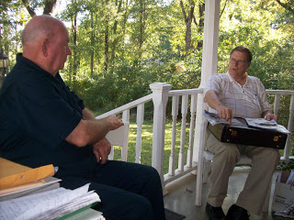
During the evening, Joe, Lynn and yours truly examined papers on James Grantson Holliman from the Walt O. Holliman collection recently donated by his children for review by other family members.
With combined research and the work done by Walt in previous decades, we concluded that the evidence is overwhelming that Samuel Holliman (1707c - 1789), a grandson of Christopher Holyman, Sr. (1618 - 1691), must be the father of James Grantson. The name of James Grantson Holliman's father has bedeviled family historians for decades.
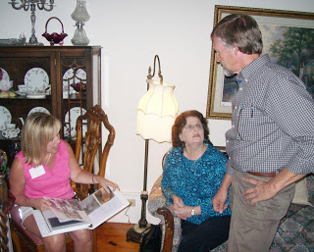
On the Friday evening, a reception was held and, those of us who knew each other only by email, began to share stories in person. Above seminar organizer Glenda Norris, (left in pink) of the Birmingham, Alabama suburbs, reviews a family history prepared by Raiford Brandon (right) and his wife, Shelia (in blue).
The Brandons had traveled from their home near Hattiesburg, Mississippi. Raiford’s family tree not only is connected to England through his Holliman roots, but also has branches leading to members of the Tudor Royal Court of the 1500s.
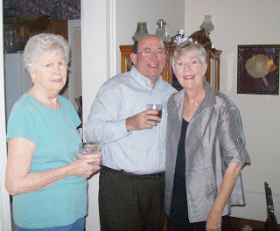
Also traveling from Texas to Alabama were Gladys Parker, above left, and Jim and Jeanette Holiman Stewart, all of the Lone Star state, representing some of the many family members that continued west from the Deep South. Gladys, Joe Parker’s better half, is a serious genealogist herself.

Saturday, December 17, 2011

A Gathering of Hollimans, Part II
by Glenn N. Holliman
In mid-October 2011, a dozen descendants of Christopher Holyman, Sr. (1618 - 1691),born an Englishman and died a Virginian, gathered in Fayette, Alabama for a seminar on the family. In 1836 three Holliman brothers arrived in Fayette County in West Alabama. Today their descendants live in Fayette, adjacent counties and states, and literally all over the country. In these articles we look at Fayette and also family, some living and some passed on.
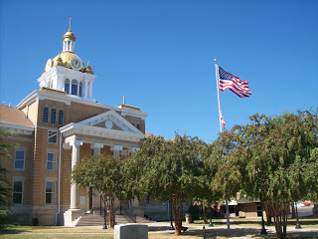

Above, Fayette County’s legal system and records resides in its one hundred year old gold domed court house. A fire in 1911 destroyed much of the down town taking many early records with it.
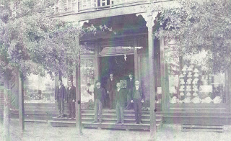
Above and far left James Monroe Holliman, Glenda Norris’ great grandfather, stands in front of Harkin’s Store which was destroyed by the 1911 disastrous fire that swept through the west Alabama community. Later, James became a successful attorney in Birmingham, Alabama (1878 - 1938).
Today, (below) the front street across from the Court House reflects the gentle pace of life during a Friday afternoon in autumn.
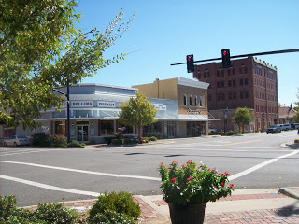

Below, James Franklin Holliman (right) inspects the materials Raiford Brandon (left) brought to the Fayette Round Table. Frank is a descendent of Cornelius Holliman and Raiford of Charles Holliman. All present were descended from Christopher Holyman, Sr. (1618 – 1691) and his son, Richard Holyman (1660c – 1711) with the exception of Joe Parker, who descended from Christopher Holyman, Sr. through a different son; that being Christopher Holyman, Jr.
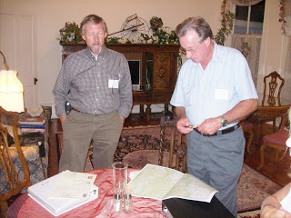

Below, two blocks from the Court House is the old train depot which survived the 1911 disastrous fire, now a community museum and visitor’s center. Just a few blocks away stood the home of John Thomas Holliman (1844 – 1930), the great grandfather of Glenn Holliman and great, great grandfather of Glenda Norris.
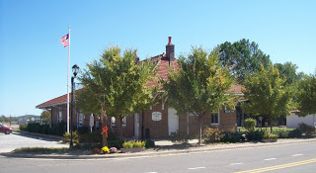

Below, holding the bridle of his horse, John Thomas Holliman, and Martha Jane Walker Holliman (1845 – 1931), his wife, stand in the 1920s in front of their Fayette home, only four blocks from the County Court House and close to the depot. The house is now gone.
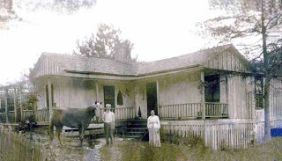

Like almost all Alabama white men and his male relatives of that era and age, John Thomas Holliman was a Confederate veteran. He fought at Stone’s River in the West and the Petersburg, Virginia Crater in the East. Martha Jane’s father, Samuel Walker (1822 – 1900) also of Fayette County, was one of the remaining 7,000 who surrendered with Robert E. Lee at Appomattox. (A fascinating article on John Thomas Holliman by Dr. Rhodes Holliman, grandson of James Monroe Holliman, can be found in the Archives, March 2010.)

Saturday, December 24, 2011

A Gathering of Hollimans, Part III
by Glenn N. Holliman
This is the third in a series of articles concerning the October 14/15, 2011 family seminar held in Fayette, Alabama, the ancestral location of many Hollimans living today.
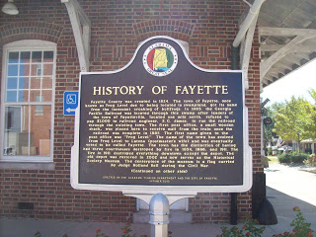
At the Georgia-Pacific Railroad Depot in Fayette stands a historical sign. The Depot is now a visitor’s center and museum where in the 1880s the rail road reached Fayette. In 1917, this writer's grandfather and grandmother rode this train with their four children to start life over in Irondale, Alabama, a blue collar suburb of Birmingham.

There Ulyss and Pearl Caine Holliman increased their family by three more children (one my father b. 1919 H. Bishop Holliman). Their movement during World War I foreshadowed the disapra that the Holliman families and tens of millions of American families would experience from the middle to the end of the 20th Century.
On October 15, 2011, seminar and round table discussions were held at the Fayetteville Civic Center. Some of those attending were below left to right, David Jennings and his uncle Bill Holliman, both of Pickens's County, Alabama. Later, after consulting the papers of the late Walt O. Holliman, it was determined they are descendants of Charles Holliman (1795 – 1841 ca), one of the three brothers who immigrated to west Alabama in 1836 from South Carolina. Bill is a retired college music professor.

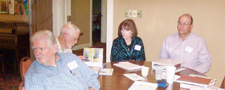

Above, same photo on the right, from the Selma, Alabama area were Jimmy and Kathleen Holliman. Jimmy is a descendant also of Charles Holliman, and is a professor with the University of Auburn Agricultural Extension Service.

Keeping notes at the meeting was Jeanette Holiman Stewart of Texas, below. Jeanette has entered over 10,000 Holliman names in her database! Behind Jeanette, left, is Frank Holliman who still retains some of the original land settled by the pioneering Holliman families in Fayette County.

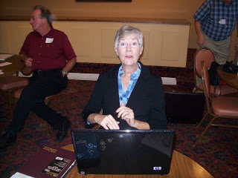

Below, Joe Parker flanked on his left by Lynn Holliman delivers a point during the discussions. Joe provided information on the Holliman lines from Christopher Sr. (1618 – 1691) to the present. His knowledge of the various Holliman branches through their Southern migrations is encyclopedic in scope.

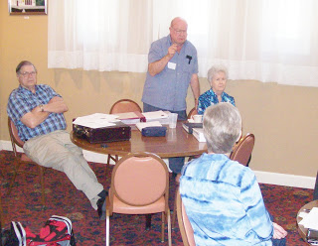

At the meeting, we remembered many Holliman pioneers, both living and deceased who could not be present. Undoubtedly this is only a partial list, and I apologize for not having information to include all. Additions to this Holliman (and all its spellings) Hall of Fame are welcome.
Recognized were Maxine Wright of Arkansas and Dr. Rhodes Holliman of Virginia. Both descend from James Grantson Holliman and have accomplished through the decades a mountain of research. Dr. Sidney Arthur Holleman’s 2003 publication of his branch of the family (Texas) was praised also. Ron Holliman of Dothan, Alabama, a descendant of James Grantson and John Thomas Holliman, also has compiled significant records but due to business and family could not be with us.
Among those whose earthly journeys are over and recognized as contributing significantly to our knowledge of this American family are Cecil Rhodes Holliman, Glenda Norris’s grandfather, Walt O. Holliman, also late of Alabama, whose research has been preserved by his children, and Dr. Charles Holliman, late of North Carolina whose work lives on the writings of others.
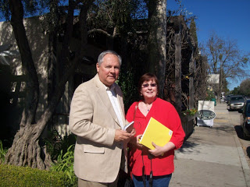
Above Glenn Holliman and Tina Peddie in February 2011 near her home in California. In addition to being an accomplished genealogist, Tina conducts searches for adopted children seeking biological parents.
Tina Peddie’s establishment of the Hollyman Internet chat room in 1999 has been instrumental in the sharing of family information and networking of various Holliman researchers. Her contributions from her home in California also include the re-publication, with the just deceased at age 93, Dr. Jeremiah Holliman, of the George E. Holleman 1953 ground breaking genealogical book on the family. Her achievements and George E. Holliman's tome, the first known publication concerning the family, were recognized with appreciation.

SATURDAY, DECEMBER 31, 2011

A Gathering of Hollimans, Part IV
by Glenn N. Holliman
This is the fourth in a series of articles concerning the October 14/15, 2011 family seminar held in Fayette, Alabama, the ancestral location of many Hollimans living today.
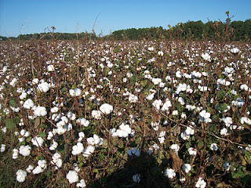
On the outskirts of Fayette last October were many cotton fields (above) waiting for the harvest. This crop was important to Southern Holliman families for several centuries. The farm land in the Sipsy River bottoms and the the timber and minerals of the ridge and ravine topography of the area have provided income to generations of Hollimans in that part of west Alabama.
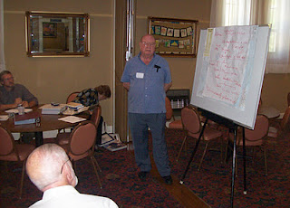
Above at the Fayette, Alabama seminar for Holliman descendants, Raiford Brandon, Bill Holliman and Vonceil Duckworth took notes while Joe Parker (above) shared his many insights in the Holliman family.
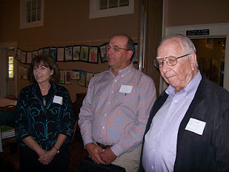
The gathering did not lack for educational expertise. In addition to Kathleen and Jimmy Holliman (above left), a professor at Auburn, was Lenwood Holliman (above right) of Lamar County, Alabama, a retired superintendent of schools. Both Lenwood and Jimmy descend through Charles Holliman, a son of James Grantson Holliman.

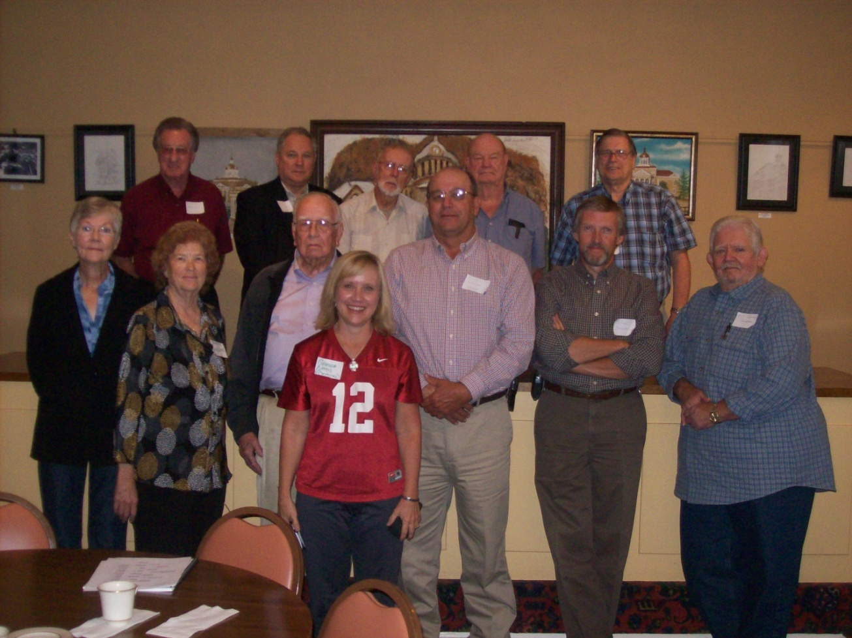

The Hollimans attending, sans spouses, were left to right front row: Jeanette Holiman Stewart, Vonceil Duckworth, Lenwood Holliman, Glenda Norris(number 12), Jimmy Holliman, Raiford Brandon andDavid Jennings. Back row: James Franklin Holliman, Glenn Holliman, Bill Holliman, Joe Parker and Lynn Holliman.

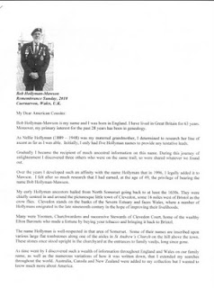

Sending greetings to Alabama from Caernarvon, Wales in Great Britain was cousin Bob Hollyman-Mawson (left) who forwarded some of his humerous findings on Holyman behaviors in Nottingham, England in the 1500s. His article, which generated chuckles, was distributed at the seminar.
Finally after a presentation on our English heritage to the Fayette group, an accumulation of my articles on English Holymans, was distributed (see below). If anyone would like a copy of Bob Hollyman-Mawson's article and/or mine, I am happy to email. My email address isGlennhistory@gmail.com.
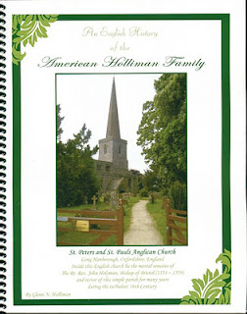
This publication describes my adventures during 2010 and 2011 in the search of the Holliman families of England before our ancestors became Americans. The parish church on the cover is Long Hanborough, Oxfordfordshire, England where a very great uncle of the America Hollimans was born in 1495. This uncle became The Rt. Rev. John Holyman, appointed a bishop during the turbulent reign of Queen Mary Tudor.
One cannot close our visit to Fayette, Alabama without a word of thanks to the Rose Hill Inn for their generous hospitality, the staff at the Fayette County Civic Center who worked on a Saturday for us, and my genealogical partner and second cousin, Glenda Norris who donated great time and energy to insuring the Holliman Round Table event would occur.
And much thanks to those who came so far and shared knowledge and asked good questions as we all sought to know better our ancestral roots.

January 6, 2012

Some Notes on a West Alabama Family by Laura Vonceil Duckworth, Reform, Alabama.

One of the joys of exploring family history is learning from 2nd, 3rd and 4th cousins of great uncles and aunts who lived in different times and places. Laura Vonceil Duckworth of Pickens County, Alabama and I visited twice in 2011 and have traded emails about descendants of James Grantson Holliman (1750 - 1836), our common 4 GGF.
What follows below is in no way comprehensive of Elijah Holliman's Civil War struggles but does allow us to begin to know of his life and offspring. Our thanks to Vonceil for this glimpse of her family and their lives in West Alabama. Any errors in these articles belong to me, and I welcome additions and corrections. - GNH

“My great grandfather was the famed Civil War veteran Elijah Holliman, born on 12 July 1839 in Newtonville, Fayette County, Alabama. He was the son of Charles and Barbara Walters Holliman who emigrated from South Carolina in 1836.

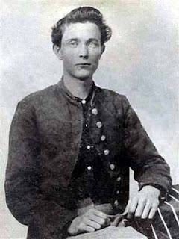
Elijah Holliman in his Confederate uniform during the Civil War
Elijah married three times. His first marriage was to Mary Shaw of whom three children were born: Sarah Melissa Holliman, Mary Elizabeth Holliman and Peter Aaron Holliman.

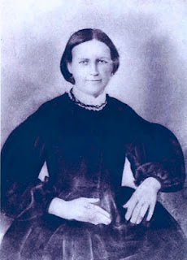
Mary Shaw Holliman
His second marriage was to Permelia Gibson ( 1834-1873). She is my great grandmother. From this union there were two children: William Green Holliman and Laura Jane (Jannie) Holliman, my grandmother. Unfortunately I do not have a photograph of Permelia or even know where she is buried.
Elijah’s third wife (photo below) was Malinda Elmina Levisa Jane Johnson, born December 23, 1846 and died September 12, 1926. She is buried in Springhill Southern Baptist Cemetery, five miles west of Millport, Alabama next to Elijah.

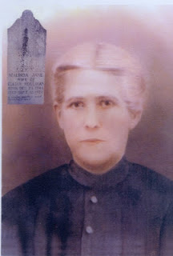

Nest posting more on Vonceil Duckworth's Holliman ancestors....

FRIDAY, JANUARY 13, 2012
Some Notes on a West Alabama Family by Laura Vonceil Duckworth, Reform, Alabama.
This is second in a series of four postings on the family and ancestors of Laura Vonceil Duckworth, a descendant of Christopher Holyman (1618 - 1691) of Isle of Wight, Virginia.

"My ancestor, Charles Holliman migrated to Fayette County, Alabama with his two brothers, Warren and Cornelius, from the family home in Lancaster, South Carolina of their father, James Grantson Holliman (1850 – 1836) in 1836.

Elijah’s Civil War record would take pages to tell. For now, I continue to share my family tree below with several photographs. My great grandmother, his second wife, Permelia Gibson Holliman, was the 6th child of Tillman Gibson of Fayette, Alabama.

My grandmother, Laura Jannie Holliman (29 August 1873 – 6 December 1936) married Virgil Constantine Clemmons, son of Woodson Clemmons and Rebecca Reece Clemmons. Jannie is buried at Bethlehem Baptist Church Cemetery, Reform, Alabama, Pickens County along with her husband. These are my grandparents, Jannie and Virgil Clemmons. Their photographs are below.
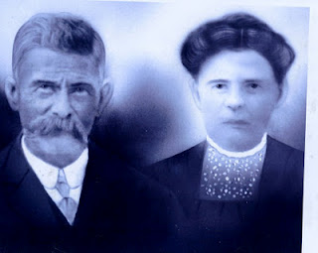

Their children are Melinda Elizabeth ‘Lizabeth’ Clemmons (1893 – 1895), William Edward Clemmons, Thomas Tillman Clemmons, Elvin Elijah Clemmons, Charlie Dennis Clemmons, Minnie Lee Clemmons and Mamie Lou Clemmons.

On July 12, 1935, the extended family gathered in Lamar County, Alabama for Elijah Holliman’s 96th birthday. He was the oldest Confederate veteran in his county when he died May 11, 1937.

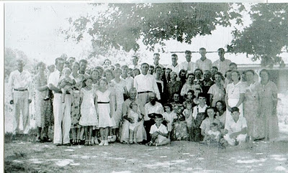
Above the family of Elijah Holliman, center for his birthday in Reform, Alabama in 1935. Assistance is sought from his family to identify persons in the photo above. Please contact glennhistory@gmail.com, a close family member or leave a comment below.
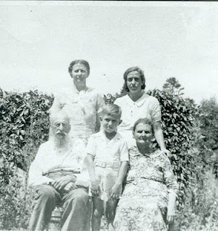
Above at the 1935 reunion are front row left to right, Elijah Holliman, his great, great grandson, Sonny Cunningham and Mary Elizabeth Shaw, Elijah's daughter by his first wife, Mary Shaw. Back row, left to right are grand daughter, Pattie Holliman Whaley and great granddaughter Mary Sue Whaley Cunningham.
One of the children of Virgil and Jannie Holliman Clemmons was my mother, Mamie Lou Clemmons (14 August 1918 – 13 January 1984) who married my father, Dewey Delmer Bonner on 29 December 1937.
Their seven children were Dewey Max Bonner (13 June 1939), Laura Vonceil Bonner Duckworth (18 December 1941), Shelby Marie Bonner McDaniel (13 June 1944), Johnnie Mae Bonner Babb (20 January 1946), Jimmy Keith Bonner (25 November 1950), Clayton Gregory Bonner (5 November 1953), and Frances Marilyn Bonner Elmore (12 March 1956)."

SATURDAY, JANUARY 21, 2012
Some Notes on a West Alabama Family by Laura Vonceil Duckworth, Reform, Alabama.
This is the third article in a series of four postings on the family and ancestors of Laura Vonceil Duckworth, a descendant of Christopher Holyman (1618 - 1691) of Isle of Wight, Virginia.
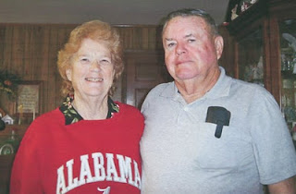
Wearing a shirt seen all over Alabama every autumn is Vonceil Bonner Duckworth with her husband of almost 50 years, Lonnie Morris Duckworth.
" I married Lonnie Morris Duckworth on 14 December 1962. Our children are – Kenneth Morris Duckworth (7 February 1964) and Michael Keith Duckworth (19 November 1967).
My siblings are as follows:
Dewey Max Bonner married Dorothy Faye Holliman, daughter of Kenneth Holliman, son of Frank and Kesta Howard Holliman in June 1958. Their children are Wanda Faye Bonner Hicks (13 May 1960), Franklin Max Bonner (12 April 1964), Camelia ‘Millie’ Diane Bonner Elkins (15 September 1961) and Jeffrey Dale Bonner 8 December 1965)."
Shelby Marie Bonner married Allen Wilson McDaniel. They have one child, Allen Mitchell McDaniel.

Johnnie Bonner married Charles Babb, and their children are: Steven Gregory Babb, Kristen Michelle Babb Hill.
Jimmy Keith Bonner’s two children are Amanda McDaniel Sullivan and Brandon Keith Bonner.

Clayton Gregory Bonner married Linda Ann Junkin Bonner (now divorced). Their children are Jason Gregory Bonner and Lezlee Ann Bonner.

Frances Marilyn Bonner married Jimmy Donald Elmore. Their children are: Jacy Elmore, Jared Donald Elmore and Jala Dawn Elmore.
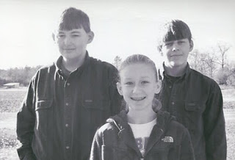
Above, Tyler and Tim, twins, and their cousin, Lauren Duckworth

Tyler, Tim and Lauren Duckworth are our grandchildren. The twins are the children of our son Kenneth Morris Duckworth and Judy Renee Gray Duckworth, now divorced. Lauren is the daughter of son Keith and Amy Duckworth. Through their Holliman line, these grandchildren can trace their lineage all the way back to the Tutor age in England."

TUESDAY, JANUARY 31, 2012
Some Notes on a West Alabama Family by Laura Vonceil Duckworth, Reform, Alabama.
In this final article of a series of postings by Laura Vonceil Duckworth of Reform, Alabama, she writes a tribute to her late mother, whose words reflect the respectful wisdom of the family-oriented culture of the Deep South. Both are descendants of Christopher Holyman, Sr. (1618 - 1691).
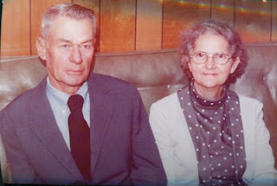
Right, Mamie Lou Clemmons and Dewey Bonner in the 1970s
My mother, Mamie Lou Clemmons, a descendant of Hollimans, had a great influence on my life. She always was at home taking care of seven brats. Very few times was a switch used, but she used her soft voice for corrections, teaching us that it was wrong to talk about others.

West Alabama Wisdom from Mamie Lou Clemmons

- ‘If you can't say anything good about other people, it is best not to say anything.

- Never take anything for granted.

- Always give a helping hand when you can, as you never know when you might need help.

- Learn and use your mistakes when you have children of your own.

- Always tell the truth and then you don’t get into trouble because your daddy has checked the mileage of the old car.

- Other people will look at you and know what kind of parents you have by the way you act.

- Your education can never be taken away.’

Mom’s parents passed away while she was still a teenager. She dropped out of school in the ninth grade, and she married at the age of nineteen. Dewey D. Bonner was fourteen years older, but he provided well for her. He always said she was different from any of the other women he had dated.

Never in my life did I hear my mother utter a curse word. One of the most wonderful things I ever heard her say was, 'The greatest thing I get out of life is helping others.' What a tribute to leave behind.

She passed away on January 13, 1984 in Birmingham, Alabama from complications of acute leukemia. She had been diagnosed two weeks before while in a hospital in Columbus, Mississippi. She had a heart attack the day she left that hospital and a stroke the same night. What a defeat.
Or was it? She longed to see her husband whom had passed away May 16, 1979. I say she was received with open arms.”

Soon another reminiscence of West Alabama by Dr. Rhodes Holliman, a prominent Holliman family historian....

Saturday, March 17, 2012
Those Were the Days!
by Dr. Rhodes B. Holliman, Dublin, Virginia

Rhodes Holliman, who has had a distinguished college career in teaching and biological research, recorded in 2007 his boyhood memories of Fayette County, Alabama and some memories of his Holliman, Blakeney and Baker relatives. He captures nostalgically an earlier time in a rural America in the 1930s then largely still untouched by 20th Century domestic conveniences.– GNH, his second cousin

"As a boy, I lived for the opportunity to leave my home in Birmingham, Alabama to travel to Fayette County, Alabama in the Newtonville area, approximately thirty miles north of Tuscaloosa. I would stay with great aunts and uncles. I would hunt, fish and get back to the frontier environment away from the clamor of city life.

My pleading to my father, Cecil Rhodes Holliman, who was an attorney in Birmingham, was perpetual, and seasoned, ‘Let’s go see Uncle Eura, Aunt Mae, Uncle Mute, Aunt Ila, Uncle Virgil and Aunt Pearl’, knowing full well that the roads might be impassable in wet weather and the old 1929 Ford A-Model sedan might break down."
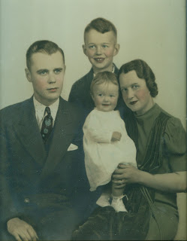

Above Dr. Rhodes Holliman, center top, poses with his family in the 1930s. Rhode's father, Cecil Rhodes Holliman is left; center is his sister, Cecile Eugenia Holliman Youngblood and his mother, Ruby Burns Holliman, right. Like his father, Cecil, Rhodes has invested countless hours in researching his family history.

"This was a time, the 1930s, when the crossroads at Newtonville seemed almost as primitive as when the Native Americans moved out and my ancestors migrated in from South Carolina in the 1830s. There was no pavement south of Fayette, which was known as the rail road town. There was no electricity, only crank phones, no municipal water and no sewage treatment. Instead of having six rooms and a bath, most of the homes were dog trots, ‘4 rooms and a path!’"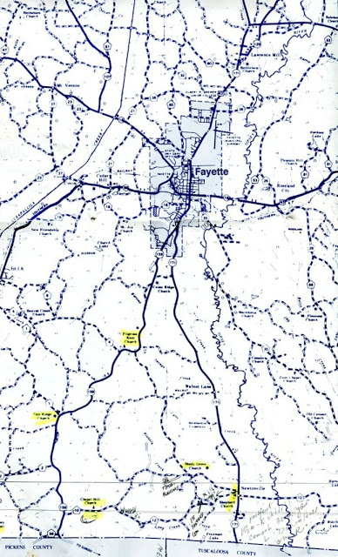

The above map of Fayette County, Alabama is from the Walt O. Holliman Resource Collection for Holliman and Associated Families. Walt (1927 - 2003) marked in yellow numerous Holliman family cemeteries. Newtonville is in the lower right corner near Shepherd's Church. The county seat of Fayette is further north. Walt Holliman's notes and use of a yellow marker are visible on the map. Many of the Bakers are buried at Shepherd Cemetery.- GNH
Glenda Norris, a niece of Dr. Rhodes Holliman, has helped identify the aunts and uncles mentioned above. They are:
Eura Carter (1878 - Nov 4, 1956)
Allie Mae Baker Carter, (b. 1888)
J. Mutius Baker (Aug 23, 1885 - Apr 28, 1965), husband of Ila Yerby Baker
Ila Lula Yerby Baker (July 9, 1891 - Apr 22, 1975), wife of J. Mutius Baker
Virgil Benton Gibson
Pearl Baker Gibson
The parents of the above Baker children, all of whom were born in Newtonville, Alabama, are George W. (March 13, 1851 - November 21, 1928) and Belzy Ann Blakeney Baker (September 1859 - March 16, 1960).
Additional Baker children are Anna Elizabeth, who married James Monroe Holliman (the grandparents of the writer, Rhodes Holliman, of this article); Francis Hillman, who married Elsie Dunscomb; Ruth Guyton, who was married first to B. T. Lovette and then to F.N. Henderson; Pearl, who married Virgil Benton Gibson; Montie Lea, who married Lynn Davis Boshell; Frederick Coleman, who married first to Fleta Williams and second to a lady from Ohio whose first name was Bernadetta; Georgia Bell, who married Earl Ray; Nora Louise, who died at the age of six years and two infants who died shortly after birth. Several of the mates of George and Belzy Baker's children were also descendants of Newtonville, Alabama pioneers such as the Yerbys, Gibsons, Rays and Hollimans.
Friday, March 23, 2012
Those Were the Days
by Dr. Rhodes Holliman

My second cousin, Dr. Rhodes Holliman continues his touching memoir of his childhood in rural Fayette County, Alabama in the 1930s. Rhodes, along with his father, Cecil Rhodes Holliman, and his niece, Glenda Norris, has done much to preserve Holliman family history. - GNH

"Hunting was my passion. A great uncle named Eura Carter lived in southern Fayette County near Patton’s Chapel and very close to the Sipsey River. He had a fox terrier named ‘Beans’ that was the finest squirrel dog that ever put a nose to the ground.

Beans was a silent tracker. He did not bark until he had the squirrel treed and then would bark one time. You had to keep Beans in sight because if you did not hear his solo bark, you could lose him and he would hold a squirrel up a tree for hours. He was never a house pet. The only time he ever showed any friendly emotion was when we came out of the house with a shotgun and indicated that we were going hunting. Then he was bundle of energy leading the way."

Below, young Rhodes Holliman grew up in Birmingham, Alabama, but looked forward to summer days and school holidays in the country side of West Alabama.
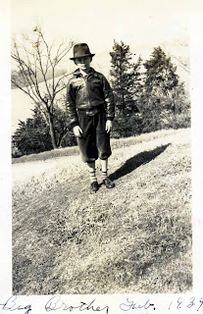

"In those days the virgin timber in the Sipsey Bottoms was composed of giant gum, water oak, beech, hickory and other trees that grew 100 plus feet tall and produced a canopy so dense that sunlight could not reach the forest floor except in the dead of winter. There was very little undergrowth and you could walk through the forest without being encumbered by thickets of briars, brush and saplings. It was in this pristine wilderness that I first went hunting at age 4 with my Dad, Cecil Rhodes Holliman, Uncle Eura and Beans.

Beans trotted along ahead, nose to the ground and presently he barked, and we saw him. If you couldn’t see the squirrel, you just got down on your knees and looked up Beans’ nose and there was the quarry! If the squirrel moved, Beans would move, always keeping his nose pointing dead on target. Well, Beans was pointing, Dad was loading his shotgun and I was standing under the tree looking straight up. There was a tremendous ‘BANG’, a thrashing in the tree top, and the squirrel fell directly on my head. Luckily, the squirrel was DOA (dead on arrival) and did not bite or claw me.

From that moment on, I was hooked to squirrel hunting and my question arose immediately, ‘when can I have a gun?’ Such a question today would probably instill a sense of horror and fear in a city bred parent but, ‘in the good old days’, a conservative father, reared on a farm, would give this question some serious consideration. I had to wait until I was 6 years old and learn hunter safety and be strong enough to carry a firearm.

At 6, I became the happiest child in the Sipsey Swamps with my new .410 single barrel while Dad carried the ammunition. Beans would find the squirrel, Dad would stand behind me and hand me a shell and another squirrel would ‘bite the dust’. That gun produced a mighty kick for a 6 year old but the harvest it produced offset the pain and bruises."

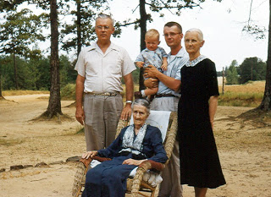
Left to right, Cecil Rhodes Holliman, Jim Holliman, Dr. Rhodes Holliman and Elizabeth Baker Holliman (widow of James Monroe Holliman). Rocking in front is Belzy Anne Blakeney Baker, mother of Elizabeth. This picture was made ca. 1955.
"In the days of the Great Depression, squirrel meat was a staple source of protein in Fayette County and many other rural areas of the South. We would par-boil the squirrel first --then fry them up or cook them to make squirrel dumplings. Yum! I learned quickly that the hunter is responsible for cleaning his harvest and Uncle Eura was a master teacher of the techniques for skinning squirrel. Any coon hounds standing around would be happy to eat the raw squirrel hides, hair and all, in one gulp!"

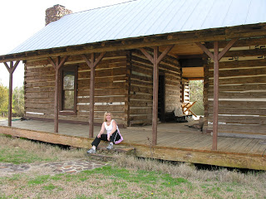
Glenda Norris, a niece of Dr. Rhodes Holliman and daughter of Cecile Eugenia Holliman Youngblood, poses on the porch of her ancestor, Thomas Blakeney's dog trot home in Newtonville, Alabama in 2006. The home still stands serving as a reminder of life in the 19th Century Deep South.
"There was much sadness when Beans departed this life. I continued to hunt squirrels with hounds but none of them could ever match the skill of Beans. After a while I would just go into the woods without a hound and find a good spot near a beech or hickory mast. I would look for a squirrel den in a hollow tree and there I would wait, sitting very still, watching for movement.
Using this technique at only 14 years of age brought me a bounty of 6 squirrels from one giant red oak den. I would shoot and the squirrel would hit the ground. Each time I would mark the spot but not move and wait for the next one to appear. This kind of hunting took a lot of patience and perseverance especially for a young boy. As I grew older, night time coon and possum hunting were added to my list of favorite things to do down by the Sipsey in Fayette County, Alabama."

Next Posting, more on life in rural Alabama in an earlier generation....

Friday, March 30, 2012
Those Were the Days!
by Dr. Rhodes B. Holliman, Dublin, Virginia
Dr. Rhodes Holliman, a descendant of pioneer families in Fayette County, Alabama, concludes his reflections on visiting his aunts and uncles in Newtonville, Alabama in the 1930s, a time gone by. - GNH
"These wonderful kinfolks never owned a gas or electric stove, a refrigerator or even an ice box; there was no washing machine or dryer and electric lights. No running water, tub or shower. No indoor plumbing whatsoever. If you wanted water there was a hand-dug well in the back yard."
Below is a Fayette County example of a 'dog trot' home prevalent in the 19th Century. While not his Uncle Eura's home, this rustic building has a middle hall way with an enclosed room on each side. Usually one built first one cabin and then as one prospered added a second side. Often one side was a kitchen. The wood stove made it extremely hot in Alabama summers, so the family lived in the opposite room. Photo courtesy of Dr. Rhodes Holliman and his niece, Glenda Norris
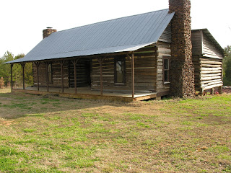
"Needed to wash clothes? There was a big, cast iron, 3 legged pot in the back yard, in which you put water and under which you built a fire. When the water was hot, you would put the dirty clothes in the pot with some homemade lye soap. You would pull out the wet garments and scrub them over a wash board and then rinse with cold water.

Needed a cook stove? There was a chop block near the well where you would split stove wood. Needed a bath? There was a 16 gallon washtub in front of the hearth or wood stove. Needed lights? Kerosene lamps did the trick. Needed to store cooked food? There was the pie safe. Needed heat in the winter? Back to the chop block or cross cut saw. Needed air conditioning? Get out your cardboard church fan.
Needed to go somewhere? There was a buggy and a horse or mule in the barn. A few wealthy folk had a Model T or A Ford. Needed groceries? Go to the storm cellar and pick up home canned vegetables and/or take a sack of corn or grain to the local grist mill and come back with meal or flour. Needed meat? Go out to the smokehouse and cut down a ham, bacon or sow belly."
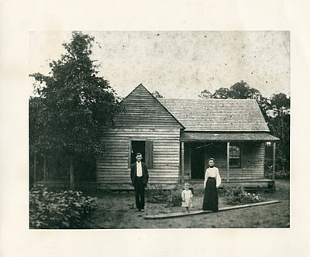
Above, approximately 1905, James Monroe Holliman, Cecil Rhodes Holliman and Elizabeth Baker Holliman at their turn of the 20th Century home in Newtonville, Alabama. James Monroe Holliman, the writer's grandfather, would become a lawyer, and as many during World War I, he took his family to an urban area, in this case Birmingham, Alabama and became a successful attorney. Many of his grandchildren and great grandchildren follow the same profession today in Birmingham.
"Needed a doctor? Dr. Blakeney could be reached on your crank phone and he would come to your house in his antique car or on horseback. Need to satisfy a sense of visceral urgency? There was a path to the outhouse. It could be a one holer or a two holer. Worried about cholesterol? What was cholesterol?

In my boyhood mind, everyone was happy and did not seem to miss anything in life and always looked forward to family visiting, family reunions, church homecomings and revivals and all day singing and ‘eating on the grounds’. It was in this wonderful world of simplicity that I grew to manhood never feeling that I missed anything."

Next posting, a return to our English roots....

Tuesday, October 30, 2012

From the Galaxy of Holliman Cousins and Great Uncles and Aunts
by Glenn N. Holliman
The Biology Professor who became the Alabama Holliman Family Expert....
No one living knows as much about the Cornelius Holliman (1792-1862) family that migrated from South Carolina to Alabama in 1836 than Dr. Rhodes Burns Holliman of Virginia. When I started writing this blog 2 1/2 years ago, the first articles on John Thomas Holliman (1844-1930), Martha Jane Walker Holliman (1846-1931) and James Franklin Holliman (1839-1911) were by Rhodes.
Earlier this year I posted a three part series by Rhodes on his summers in Fayette County, Alabama in the 1930s and how different life was then than now in the country. According to my blog counter, this is one of the most read series that has been posted in this space.
Below, Rhodes at his desk, composing articles and saving photographs of 19th Century family members such as the Hollimans, Blakeneys and Bakers of central Alabama.
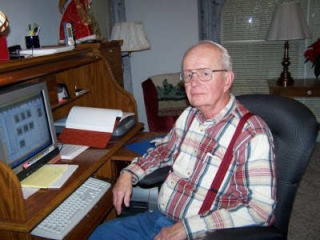
Last posting in this space, I wrote of Rhodes' dedicated physician son, Jim Holliman. Jim, as does Rhodes, follows in a line of talented ancestors. Jim's grandfather was Cecil Rhodes Holliman (1902-1986), a distinguished Birmingham, Alabama attorney, who eagerly collected family stories and wrote a major manuscript on the Samuel T. Walker (1821-1900) families. One of Cecil's grandfathers was Samuel Taylor Walker, a Confederate Civil War veteran.
Below Cecil Rhodes Holliman as a 1921 cadet at the Marion Military Institute, Marion, Alabama. Dr. Rhodes Holliman, a specialist in exotic diseases and retired professor from Virginia Tech, acquired his love of family history from his father, Cecil. This photograph and the one below are from the Rhodes Holliman collection.
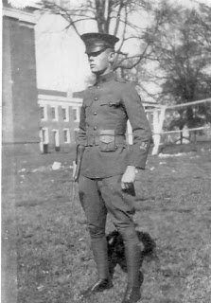
Cecil's father was the dynamic pioneer of this branch, James Monroe Holliman (1878-1938), who married a Fayette County girl, Elizabeth Ann Baker in 1899. James studied law, served as county solicitor, and later moved to Birmingham to set up a law practice that continues to this day under his great and great, great nephews, Jim and John Holliman, attorneys at law.﻿
Below, James Monroe Holliman in a 1924 photograph, who left the farm run by his father, John Thomas Holliman, and by his wits and enterprise became a successful Alabama attorney. He sired a distinguished prodigy of children, grandchildren and great grandchildren.
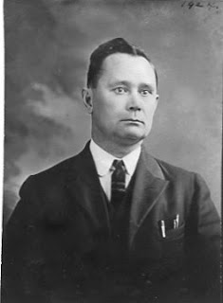
Next post, more on my cousins, great aunts and uncles from this distinguished and successful branch of the Holliman family....

Friday, November 9, 2012

From the Galaxy of Holliman Cousins and Great Uncles and Aunts
by Glenn N. Holliman
This continues the series on Dr. Rhodes B. Holliman and his ancestors and associated families....
Below in 2002, my son, Christopher S. Holliman rendezvoused in Virginia with Dr. Rhodes Holliman, who passed along to Chris a book shelf constructed by Ulyss S. Holliman (1884-1965) in the 1920s. Ulyss was Chris's great grandfather and Rhodes's great, great uncle. Chris is a librarian and Rhodes, a Ph.D. in biology, who chronicles the history of the Holliman family with emphasis on Alabama since 1836.
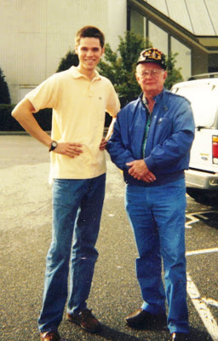
Rhodes's great grandfather was James Monroe Holliman. James was the first of the Holliman sons of John Thomas and Martha Jane Walker Holliman to leave farming as a profession and enter a service industry - an attorney-at-law. Until 1920, half of all Americans, according to the Census of that year, lived in a rural environment. But the industrialization of the country, the decline in farm prices and more than anything, the rise of modern transportation, revolutionised how people earned their livings,
In the lives of sons of John Thomas Holliman, four of the six left farming for other pursuits at the turn of the 20th Century. Their father, caught up in the seemingly never ending farm crisis's of the 1890s and 1920s died in near poverty in 1930 at a time of no Social Security and no modern safety net for seniors.
James Monroe Holliman (1878- 1938) was determined to earn his living by his mind and mental talents. He also married well - Elizabeth Ann Baker, a descendant of another Fayette County, Alabama pioneer family.
Below, James Monroe and Elizabeth Baker Holliman in October 1899 leave Newtonville, Alabama for their honey moon. Note the clothing styles and the buggy that carried them away to married life.
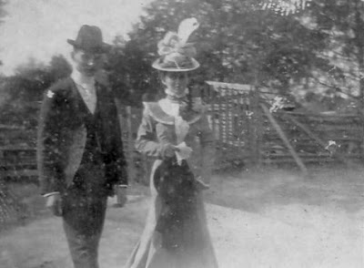
. ﻿
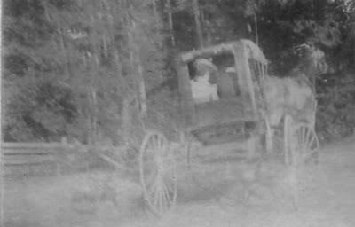
The 19th Century pictures above are from the collection of Dr. Rhodes Holliman, who received them from his father, Cecil and grandfather, James Monroe Holliman. In 1899, the horse and buggy world was about to give way to gasoline and automobiles. Cruelly, James would die of infection when his finger were caught in a slamming car door in 1938. He was only age 60, but he left behind a legacy of descendants to carry on the family names and service to the communities in which they lived.
Next post...more on Fayette, Alabama and one of its citizens....

Thursday, November 22, 2012

From the Galaxy of Holliman Cousins and Great Uncles and Aunts, 2
by Glenn N. Holliman
This continues the series on Dr. Rhodes B. Holliman and his ancestors and associated families....I am grateful to him for access to his historic photographs of Fayette, Alabama and family.
Below James Monroe Holliman (1878-1938), third son of Civil War veteran, John Thomas Holliman (1844-1930). The photograph below is dated 1896, when James was 18, three years away from marriage to Anne Elizabeth Baker. They would have two boys who lived to maturity - Cecil Rhodes Holliman and Charles Baker Holliman.
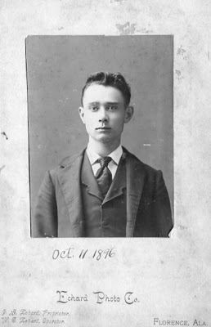
The year before James married Anne Elizabeth Baker, the Baker family which lived in Newtonville, Alabama posed for this photograph which caught the a southern family in 1898 wearing their Sunday best. Note James Mutius Baker on the far right in wing tip collar and hat.
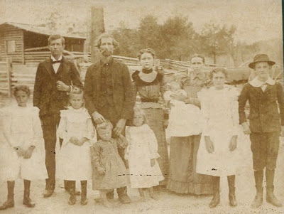
Back row, left to right: Frances Hillman Baker, George Washington Baker, Anne Elizabeth Baker, Belzy Ann Blakeney Baker, Georgia Bell Baker (babe in arms). Front row, left to right: Guyton Baker, Pearl Baker, Frederick Coleman Baker, Montie Lea Baker, Allie Mac Baker, James Mutius Baker.
Below, the Fayette County, Alabama courthouse in 1898. It was destroyed in the town fire of 1911.

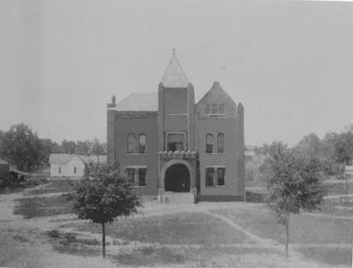
Fayette in 1898 was still captured by the cotton culture of the old South as this picture taken in front of the Court House suggests. Family farmers all over the nation suffered in the 1890s giving rise to the Populist movement which flowered briefly and then faded in Alabama.
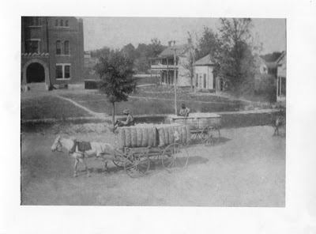
Two of James's brothers would work as farmers all their lives. Not James. He first practiced law in Fayette, Alabama serving as county solicitor in the 1910s. A horrible fire swept through Fayette in 1911 destroying much of the downtown.
The fire, the inability to advance in a political career running as a Republican in the solid Democratic South and the lure of the Magic City of Birmingham, must have moved James to make an important move around age 40. As with millions of other Americans, north or south, James Monroe Holliman would head to the big city.
In the future more on James Monroe Holliman and his brother, however, next post, back to England and our European roots....

Sunday, December 2, 2012

From the Galaxy of Holliman Cousins, Part IV
by Glenn N. Holliman
Another Look at Alabama Roots....
Over the Thanksgiving holidays, distant cousin Tom Hughes from North Carolina visited his brother and relatives in Alabama. For those of you who have been reading in this space the memories and photographs of Dr. Rhodes Holliman, you may find Tom's 2012 reflections of interest. Tom writes a blog at
http://tahughesnc.wordpress.com/2012/11/27/discovering-my-rural-alabama-heritage/ , and he invites one to read and ponder.
Tom was visiting cemeteries over the holidays looking for Hughes and Wilson memorials in Lamar County in west central Alabama. He stumbled on several Holliman grave sites at Ashcraft Corner Baptist Church and Wilson Cemetery, both in Lamar County . He sent photographs of his findings thinking they might be of interest to those who follow Holliman genealogy closely. He gave me kind permission to share with you.
These Holliman and one Duckworth resting sites pricked my interest as in this space in January/February 2012, cousin Vonceil Duckworth of Lamar County shared her family lineage and photographs with us. Below the Wilson Cemetery, Kennedy, Lamar County, Alabama.

The Wilson Cemetery
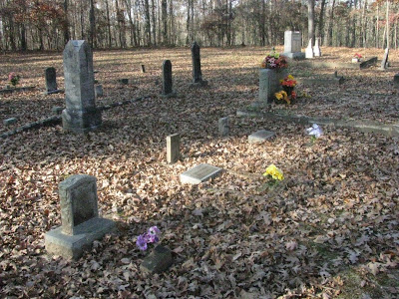
One will find the shared graves of James Wilton Holliman (4/5/1880 - 9'27/1953) and Beulah Holliman (9/11/1876 - 9/11/1959) at the Wilson Cemetery.
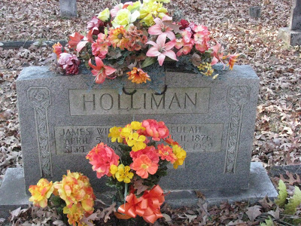
Maurine Holliman, daughter of James Wilton and Beulah Holliman, born 4/10/1914, must have died as a child as no death date is given. Maurine is listed in Mary David Elmore's The Community of Kennedy, Alabama as the daughter of "Wilson Holliman and wife", a possible slight typographical error.
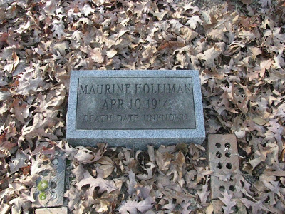
Nor is there a death date for a Manley Holliman, born 10/8/1902.
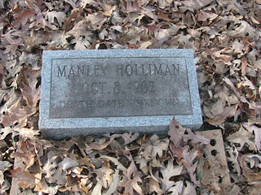
Below, Anita Duckworth (12/27/1940 - 6/4/1941) lies also in the Wilson Cemetery. The Duckworths and Hollimans intermarried on occasion in Lamar County, according to the family tree of Vonceil Duckworth but this infant was not a close relation of Vonceil's.
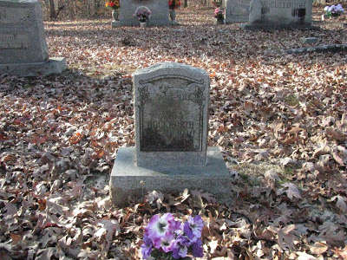
The Ashcraft Corner Cemetery
Murlee W. Holliman (10/4/1902 - 10/9/1965) although buried in Ashcraft Corner Cemetery, is a child of James W. and Beulah Holliman, buried a few miles away in the Wilson Cemetery.
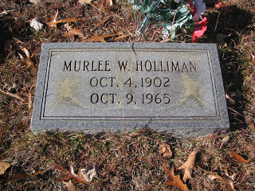
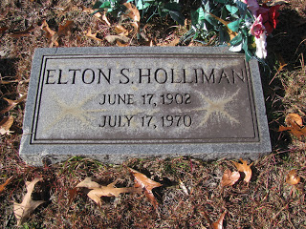
Mary David Elmore in her 1995 book lists Elton Holliman as a deacon at the Pleasant Ridge/Ashcraft Corner Baptist Church from 1921 to 1924. Is this Elton the son of Deacon Holliman?
Our thanks to Tom Hughes, a distant cousin, for sharing his Thanksgiving genealogy and photographs with us. Hopefully they will prove helpful to a searching genealogist. If you are related to these Hollimans listed above, we would enjoy hearing from you and learning more about this branch of the family.

