From the Galaxy of Holliman Cousins, Part I

Saturday, September 22, 2012
by Glenn N. Holliman
An Isle of Wight, Virginia Story....
Below, Glenn Holliman, left and Sandi Royal, right, both descendants of Isle of Wight, Virginia first families, compare notes over lunch in July 2012. Sandi, a CPA, contacted me through this blog several months ago seeking more information on her Holliman ancestors.
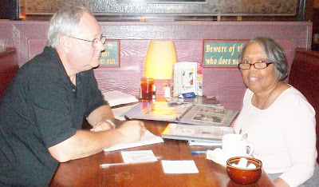
Sandi Royal's great grandfather is Isaac Henry Holliman, born approximately 1824 and died before 1900 in Isle of Wight, County, Virginia. He was born a slave, and his racial make up was of mixed African and European American heritage. His father and mother are not known, not usual for a time of extreme racial prejudice and no official listing of births yet being recorded by the State.
A recent DNA test did not test positive for an Isaac male descendant being in the Christopher Holyman, Sr. (d 1691) line although future testing may yield different results. The surname does substantiate that Isaac took his name from a Holliman family, undoubtedly his 'owner' in the first half of the 19th Century. We do not know who that family is, yet.
Sandi's great grandmother is one Ann Gray, who according to family tradition, was white. Their first of numerous children were born in 1871. The U.S. Census of 1880 records Isaac as being 56 years old and Ann, 37. She would die sometime in the 1930s and is buried with Isaac in Winsor, Virginia. There is uncertainty as to who her parents are although there are at least two options being reviewed. One strong possibility has been suggested by descendant Joshua Holliman, that being that William and Matelida Gray of Isle of Wight were her parents.
Isaac Holliman's descendants tell the remarkable and horrific story of an 1860s couple fleeing from her parents, hiding and living in the Virginia woods to escape an irate father. This couple, evidently much in love, broke not only racist social taboos of the time, but also rigid Virginia law. Yet, under the most trying circumstances imaginable in 19th Century America, the marriage succeeded, and numerous descendants of this remarkable couple prosper today in a freer society and country.
Each year in Suffolk, Virginia, this extended Holliman family gathers, enjoy several meals of regional foods and share the amazing story of a former slave who ran off with a young woman believed to be a slave owner's daughter.
Sandi and distant cousin, Tammy Hunt, have told me this story and with their permission, I share it with the larger family. There is more research to be done to grasp further the details of this stirring saga. Hopefully, we can publish more later. I am grateful to Sandi and Tammy for contacting this site and telling this American story. Cousin Jeanette Stewart also contributed with her usual diligent research.
In the Story of Family, one finds the Story of America....

Thursday, October 4, 2012

From the Galaxy of Holliman Cousins, Part II
by Glenn N. Holliman
Recently distant cousin Allen Holleman (photo below) of North Carolina and I met and shared a meal. I had noticed Allen's comments and thoughtful questions on the Tina Peddie Holyman Group chat room, and thought as I would be in his area, would like to meet him. As we indulged in our common passion for comfort food and Holliman/Holleman history, it was an enjoyable and long lunch.
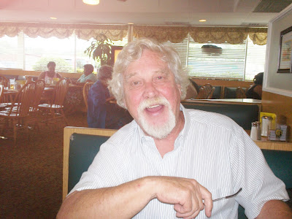

Over three glasses of an iced beverage (unsweetened) he told me his family branches, which intrigued me because I knew a lot of Holleman/Hollimans had moved across the Virginia border into North Carolina, not long after the unpleasantness with the Tuscarora tribe ended in the early 1700s. For many the western march meant moving south by southwest as did my branch of the family. Allen's moved into Wake County after the Revolutionary War. His ancestors put down roots and some, such as Allen, remain in the Raleigh area to this day.
His lineage begins in America as does mine with the arrival in Jamestown, Virginia in 1650 of Christopher Holyman, Sr. who had four sons and two daughters. The daughters married Atkinsons. The four sons married and had children and swoosh, the family branches started multiplying.
Allen's branch emerged from Christopher, Jr. (mine from Richard Holyman, one of his brothers) who begat John who begat Jesse, the husband of Charity Cofer. Their son, John Holliman, left Virginia and moved to Wake County, North Carolina. Then came David Holleman, John Austin Holleman , Junius Dowd Holleman and then Joseph Holleman, Allen's grandfather, a carpenter - the first Holleman in this branch to leave the occupation of farming.
Allen's father, Joseph Allen Holleman, Sr., was in the building business. Joseph Allen Holleman, Sr., our Allen, joined him, bought and sold it and other business and has thrived as a creative entrepreneur. He now claims he is retired (which I doubt given his high energy level), but he looks great in his blue Mustang convertible.
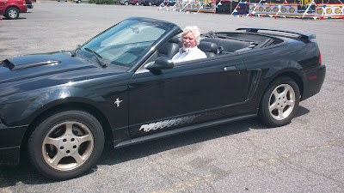
Allen's resume is amazing - scuba diver, car race driver and U.S. Marine helicopter gunner in Viet Nam - are just a few of his endeavours. Indeed, he must have the same DNA as Christopher Holyman, Sr. who in the 17th Century left England, sailed a dangerous sea, scratched a farm out of a wilderness and kept a look out for wild animals and angry Indians as he stripped his tobacco. A salute to both Allen and his 8th great grandfather, Christopher, Sr. for their spunk and achievements!
Another post next week from our amazing Galaxy of Holliman cousins....

Saturday, October 20, 2012

From the Galaxy of Holliman Cousins, Part III
by Glenn N. Holliman
"Medicine is the Venue to Peace"
Over dinner in July 2012, Dr. Jim Holliman of Pennsylvania, son and grandson of family historians, Dr. Rhodes Holliman and Cecil Rhodes Holliman, Esq., shared the above wisdom. The occasion was an evening with Jim and our two wives, Karen - his, and Barb, mine. We had been trying to find time to meet for several years. With Jim's incredible schedule of travelling and speaking, this had been difficult.
Below, Glenn Holliman, left, and Jim Holliman, right. John T. Holliman (1844-1930) is Glenn's great grandfather and Jim's great, great grandfather.
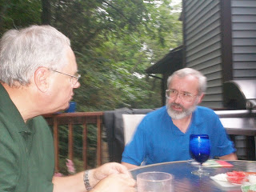
Jim is this country's and probably the world's foremost expert on Emergency Medical Trauma, having written six books on the subject, and visited 50 countries on six continents practising and establishing emergency medicine programs, teaching and supervising. Raised in the stimulating home of two professors at Virginia Tech in the 1960s, he did his undergraduate work at Duke and gathered his M.D. at George Washington in St. Louis. After residency in Utah and practise in Reading, Pennsylvania, he settled in 1989 in Central Pennsylvania at the famed Hershey Medical Center.
Since then he has served in three wars for the Department of Defence, taught at the United Services University in Bethesda, Maryland, and directed the Center for Disaster and Humanitarian Assistance Medicine. Presently he is president-elect of the International Emergency Medicine Consortium, a global organization of regional and national agencies dedicated to improving emergency medical care. The walls of the home cannot hold the large number of awards and gifts he has received over the past few decades from grateful nations and organizations.
Below, four of the numerous books, Jim has authored or co-authored.
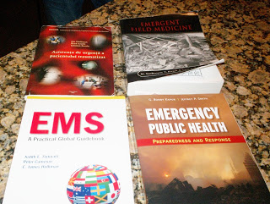
His wife, Karen, has experienced an important career herself in paediatrics rehabilitation helping children with developmental and autistic challenges. This talented couple met in medical school, and have two grown children. They are about to become grandparents for the first time.

Below, Karen and Jim Holliman visiting the Glenn and Barbara Hollimans, September 2012.
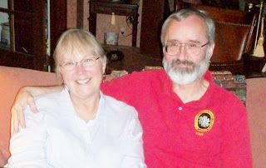

Jim has seen much pain and injury in his career across the world. Having been up close to our recent wars in the Middle East, he thought carefully when I asked him what summary statement would he make for our extended Holliman family to ponder. He did not hesitate - "Medicine is the venue to peace". Truly Karen and Jim know the truth of that statement as both their lives have been dedicated to reducing human suffering.
For more on Jim, visit the web site EPIjournal.com to read some of his articles. He welcomes hearing from cousins, especially those in or who might be considering the medicine as a career. Jim has been and remains a mentor to many. With permission, his email address is jholliman@cdham.org.
Note: Jim Holliman is also a first cousin of Glenda Norris, a frequent contributer to this blog and the understanding of Holliman family history in Alabama.
As always, an education and inspiration when I visit with Holliman cousins both near and far....more later.

