From the Scrapbook of Bruce and Torrence Donnelly...
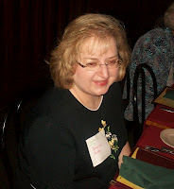
Cousin Jennifer Leigh Knight Bundy, left, recently has made available some mid-20th Century photographs of the Wilson and Donnelly families of Sutherland, North Carolina. What follows is her family lineage and snapshots from the Bruce and Torrence Wilson Donnelly scrapbook held by Jennifer's family.

Jennifer, her husband and son, and twenty other cousins toured Sutherland, the Wilson Cemetery and the Donnelly Store in June 2012. These Wilson photographs augment the numerous family pictures printed in Neighbor to Neighbor (2007) available at the Appalanchian State University book store.

Today the original mid-19th Century farm of Isaac and Caroline Greer Wilson is subdivided with several homes and farm steads. The topographical maps name the road into the cove as the Oscar Wilson Road, leading off State Highway 88. - Glenn N. Holliman

Isaac (12/16/1822-6/17/1864) and Caroline Greer Wilson (12/16/1828-9/8/1911) had seven children, one being Robert 'Bob' Wilson. Caroline had an 8th child, Sarah Marilla Wilson Osborne, several years after her husband's murder by 'bushwhackers' in June 1864. In this article, we trace one branch of the family.

Bob Wilson (1/4/1860-2/7/1949) married a cousin, Sara Ellen Wilson (1866-1952). One of their children was Torrance Wilson who married a neighbor, Bruce Donnelly. Bruce's parents were Gustavous and Flora Latham Donnelly. The Donnelly's were neighbors, right?
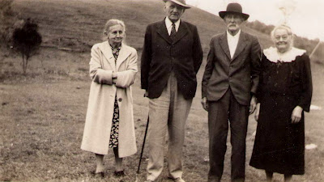
Taken prior to Bob Wilson's death in 1949, left to right are Flora Latham Donnelly, Gustavus Donnelly, Robert Wilson, the son of Isaac and Caroline Greer Wilson, and Robert's wife, Ellen Wilson, mother of Torrance Wilson who married Bruce Donnelly.

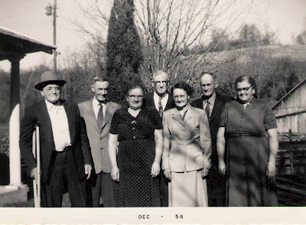
Above the children of Robert and Ellen Wilson in 1956. Left to right are Lee, Grover DeWitt (2/4/1885-3/24/1957), Edna Wilson Osborn, Edgar, Neva Wilson Hashe (7/7/1905-11/23/2003), Oscar T. (2/24/1989- 8/28/1985) and Torrance Wilson Donnelly. Torrance is the great grandmother of Jennifer Bundy. Do you have the birth and death dates of these individuals? Where is Woodrow Wilson, deceased?
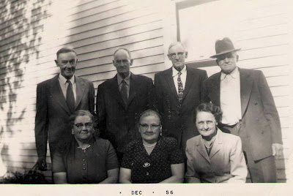
Another photograph of same children left to right - Witt, Oscar, Edgar, Lee, Torrance, Edna and Neva. These photographs are believed taken at the Wilson-Donnelly farm in Sutherland, North Carolina.
Next post, more photographs from the Bruce and Torrence Donnelly Scrapbook....

