From the Scrapbook of Bruce and Torrence Donnelly...part 2
We continue with old photographs from the scrapbook of Bruce and Torrance Donnelly. Torrance was a grand daughter of Isaac and Carolina Greer Wilson and daughter of Bob and Ellen Wilson. A great grand daughter of Torrance, Jennifer Bundy, made these pictures available. - Glenn N. Holliman

Below, Jennifer Bundy, a librarian, shares lunch with her distant cousin, Bryan Payne during the June 2012 Wilson-Greer Family Tour in Ashe County, North Carolina. Both are great, great, great grandchildren of Isaac and Caroline Wilson Greer of Sutherland, NC.
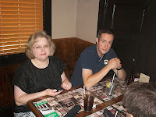
Below, Bruce and Torrance Wilson celebrated their 50th wedding anniversary in 1956. Their marriage in 1906 was dramatic. Her parents opposed the marriage so the couple eloped over the mountains to Tennessee, the bride climbing out of a second story window, after a first attempt had been halted by her father!
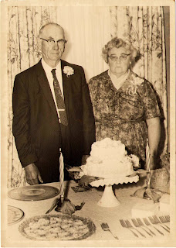

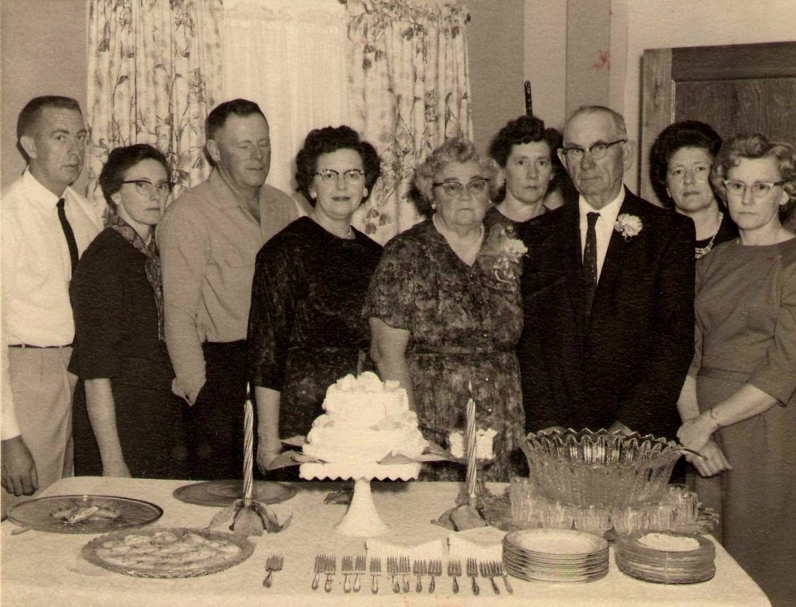
Above at the celebration are Bruce and Torrance with their children on their 50th anniversary. Left to right: Joe, Grace, Raymond, Virginia (Jennifer Bundy's grandmother), Torrance, Annabelle, Bruce, Margaret, Ruth. Do you have a photo of your grandmother and mother we could use, with permission? Can you give the last names of the women and any birth and death dates?

Jennifer Knight Bundy's lineage is as follows. She is the daughter of Meredith Lewis Knight and Jackie Ruth Lewis Farrington. Jackie Ruth Lewis Farrington is the daughter of Marris Franklin and Virginia Dare Donnelly Lewis. Virginia Dare Donnelly Lewis is the daughter of Bruce and Torrance Wilson Donnelly. Torrance Wilson Donnelly is the daughter of Bob and Ellen Wilson. Bob Wilson is the son of Isaac and Caroline Greer Wilson.

Our thanks to Jennifer and her family for sharing these photographs....

