**From the Scrapbook of Bruce and Torrence Donnelly...Part 2**

We continue with photographs from the scrapbook of Bruce and Torrence Donnelly. Torrence was a grand daughter of Isaac and Carolina Greer Wilson and daughter of Bob and Ellen Wilson. A great grand daughter of Torrence, Jennifer Bundy, made these pictures available. - Glenn N. Holliman

Below, ***Jennifer Bundy***, a librarian, shares lunch with her distant cousin, ***Bryan Payne*** during the June 2012 Wilson-Greer Family Tour in Ashe County, North Carolina. Both are great, great, great grandchildren of ***Isaac*** and ***Caroline Wilson Greer*** of Sutherland, NC.

[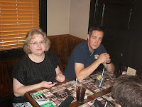](http://1.bp.blogspot.com/-R35QgDDP9pw/UFDr_cC-BuI/AAAAAAAAEbU/P9yjg2FYfQI/s1600/2012+6+Jefferson%252C+NC+Jennifer+Bundy+and+Bryan+Payne.JPG)

Below, ***Bruce*** and ***Torrence Wilson,*** Jeffiner's great grandparents***,*** celebrated their 50th wedding anniversary in 1956.

[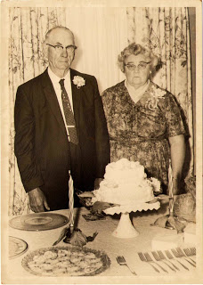](http://4.bp.blogspot.com/-o2ge83UpQg0/UFDsEJ-PHgI/AAAAAAAAEbc/ybNy6E7x5w0/s1600/Pic4+Bruce+and+Torrance+Wilson+Donnelly+on+their+50th+wedding+anniversaryPic4.jpg)

Above, Bruce and Torrence with their children on their 50th anniversary. Left to right: Joseph Bruce Donnelly, Grace Elizabeth Donnelly Wilson, Raymond Charles Donnelly, Virginia Dare Donnelly (Jennifer Bundy's grandmother), Torrence Lillian Wilson Donnelly, Anna Belle Donnelly Ragan, Bruce Donnelly, Margaret Donnelly Wallace and Ruth Frances Donnelly Duncan.

Jennifer provided the following data on Bruce and Torrence Donnelly and their children.

**Bruce Charles Donnelly** (11/26/1893 - 11/1/1989) married **Torrence Lillian Wilson**(12/18/1899 - 8/10/1986).

Their children are:

**Grace Elizabeth Donnelly** (11/26/1916 - 1/14/1998) married **Conley Argus Wilson** (10/3/1909 -1/3/1994). There was a second late marriage to **Ed Wallace**.

**Raymond Charles Donnelly** (9/25/1919 - 4/3/2002) married **Edith Irene Younce** (4/15/1923- 5/27/1989).

**Virginia Dare Donnelly** (7/2/1921 - 2/26/2008) married (1) **Morris Franklin Lewis** (7/13/1917 -10/20/2003), Jennifer Bundy's grandfather, (2) **Burl Ray Winebarger** (7/3/1915 - 7/5/1969, (3) **James Louis Johnson** (1/1/1929 - 1/26/1975), (4) and (5) twice married **Willard Glenn Lewis** (10/2/1916 -10/10/2004).

**Anna Belle Donnelly** (3/22/1923) married **Tipton Ragan** (5/10/1918 – 11/21/1990).

**Ruth Frances Donnelly** (5/2/1925) married **Meredith Brooks Duncan** (1/20/1924 – 8/17/1969).

**Margaret Donnelly** (6/18/1930) - married **James Kermit Wallace** (12/14/1926 – 10/25/2007).

**Joseph Bruce Donnelly** (10/28/1932 – 1/4/2012) married **Joann Wallace** who survives.

Below, Joann Wallace in red with **Shirley Sorrell** at the Donnelly Store in Sutherland at the end of Oscar Wilson Road, the historic farm land of Isaac and Caroline Greer Wilson. Joe Donnelly had passed away a few months before this photo was made in June 2012.

[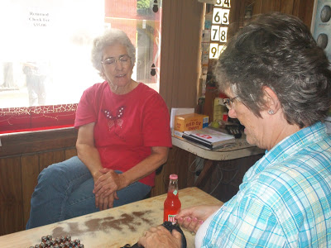](http://4.bp.blogspot.com/-AsjPjtVLOWA/UW37x0IhCjI/AAAAAAAAF6U/QS4Y3Utmp34/s1600/2012+6+Sutherland,+NC+Joane+Donnelly+and+Shirley+Sorrell.JPG)

***More on the Bob Wilson family in the next post....***

More information on the relationships of Greers, Wilsons, Osbornes, Stansberys and others can be found at this writer's Ancestry.com site. Please write glennhistory@gmail.com for access or to add information. For information on the Forrester Family Reunion in White Stone, Virginia, Sunday, October 6, 2013, email Diane Goss at dangel54@yahoo.com for details.

﻿