WHEN WE WERE ENGLISH
By Glenn N. Holliman
A series of articles published in the blog http://hollimanfamilyhistory.blogspot.com/ from 2010 to 2013.

WEDNESDAY, JUNE 16, 2010

When We Were English, Part I
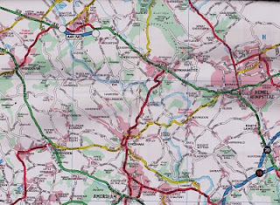
Some First Thoughts on Our English Roots
by Glenn N. Holliman
This map is somewhat dated, but in the upper left hand corner is Tring, Hertfordshire, England. Just to the east of it is the little village of Aldbury and south is Cholesbury. To the west of Hemel Hempstead is Berkhamsted. Toward the lower right hand corner is the tiny village of Chipperfield. In left center is Wendover, and to the west, but not on this map, is Cuddington. London is off the map to the southeast. There is evidence that Holymans and Hollimans lived in these villages and towns.
I have had the pleasure of traveling to England numerous times in my life. As I have become older, my interest in family history has grown. Recently, my wife and I invested a number of days researching Holliman history in an area approximately 25 to 30 miles from the center of London. These towns and villages were Tring, Aldbury, Cholesbury, Cuddington, Chipperfield and Berkhamsted in both Hertfordshire and Buckinghamshire.
In graduate school, (gasp 40 years ago!) I studied history and know that primary evidence is crucial to any research. There is a popular and evidently well-researched Holliman family tree website that lists John Holyman (1572 - 1650) as the direct line of our family, born in Tring, Hertfordshire and died in Southampton, Virginia. Unfortunately, no one has yet shared with me the hard evidence of this birth and death date or the fact that the gentleman ever existed. This does not mean that facts do not exist somewhere; it is just that I have not seen such or discovered it in my research.
Let me quickly say that hard primary evidence exists for our first American Holliman, one Christopher Holliman, Sr, who died in Isle of Wight County, Virginia in 1691. We have his will and many legal records. Unfortunately his birth place and date are still a matter of conjecture.
You might want to review the map above because in our next post we will explore our English roots. Internet sites suggest this is not the only part of England where Hollimans may have lived in the 17th Century, but I'll begin our journey in the Chiltern Hills around Tring. More on this subject soon.
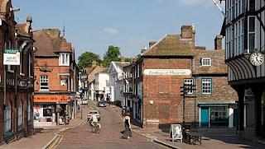
High Street in downtown Tring, Hertfordshire, a town over 1,000 years old.

mONDAY, JUNE 21, 2010

When We Were English, Part II
by Glenn N. Holliman
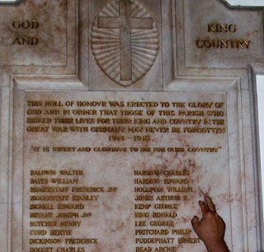With the exception of the historical painting of Elizabeth I below, the other photos in this blog are of memorials to Hollimans and others in St. Paul's parish, Chipperfield, Hertfordshire, approximately 25 miles northwest of Central London.
August 31, 1997, my wife, Barb, and I assembled for the baptism for our godson, Joseph Jeffries, at St. Paul's Anglican parish in Chipperfield, Hertfordshire, England. What should have been a day of joy, instead was a sad morning. Princess Dianna, formerly Princess of Wales, and her boyfriend, Dody Fahad, had died in the early hours in a Paris car crash.
The priest, a lady of whose gender there were only a few at that time in all the England Church, prayed for the repose of the departed souls as she attempted to turn the congregation’s attention to the welcoming of Joseph into the Christian family. Ironically, Diana’s car had smashed itself to a compressed block of metal, plastic and human flesh in a tunnel just a block from where Barb worked the year before at the capital campaign for the American Cathedral in France.
With these conflicting thoughts tumbling through our heads, we ventured to gaze around the lovely neo-gothic nave. Good grief! The walls were covered with war memorial plaques in memory of Hollimans and other villagers! Had we stumbled on to the ancestral home of the Holliman clan? Much evidence indicates that yes, the English Hollimans (or Holleman, Hollyman, Hollomon, etc.) did establish themselves or at least some of the family in Hertfordshire, England around the villages of Chipperfield and Tring, located 30 or so miles northwest of London proper. Other villages with Hollymans were Berkhamsted, Aldbury, Cholesbury and Cuddington.
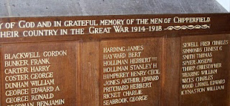
In 2010, most of our American genealogical trees begin with one John Holyman, born 1572 in Tring, Hertfordshire. (In my research I would grow to reject this lineage.)This was during the reign (and rule) of that magnificent Tudor queen, Elizabeth I. Anglicanism had replaced the Roman Catholic faith in the land, helped along by several burnings at stakes of recalcitrant Catholics and not a few Spanish Jesuits who sought to return England to the Old Faith. The friction between Spain and England, exacerbated by privateers Drake and Raleigh, eventually led to the sailing of the Spanish Armada of 1588.
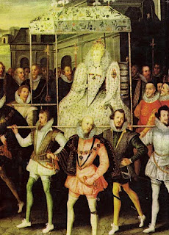
Above, is Robert Peale's painting of Queen Elizabeth being carried by her devoted courtiers.
Elizabeth called out the able bodied men of England to repel the invader if the embryonic English fleet was not able to do so. One wonders if John Holyman and our kinsmen did not muster on a village green with pike in hand?
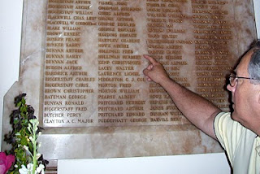
It is obvious from these memorials that in the last two World Wars, numerous Holliman kinsmen mustered with their English regiments, and sadly all did not return.

FRIDAY, JUNE 25, 2010

When We Were English, Part III
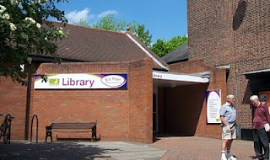
A Holyman in the Late Middle Ages
by Glenn N. Holliman
In the local history section of the Tring, Hertfordshire library (photo to the left with patrons in front) there is a book entitled A History of Tring by Sheila Richards, a denizen of the area. Published in 1974 by the Tring Urban Council in Hertfordshire, it contains many stories, family names and records. While recently pursuing this work I found on page 53 the following information that was translated from Middle English.
From the Court Rolls of the Manor of Tring - Courts 28 May, 18 June and 9 July 1444 (yes, 1444, not 1944!)
"Plaint Continued: the plaint between William Holyman, defendant, and Richard Brame of Chedyngdon, (Cuddington) plaintiff, in a pleas of trespass, is continued by order."
Observations?
1. Holymans had surnames by the 1400s as did most English by this century.
2. Holymans lived in Tring two centuries before American founder, Christopher Holliman, sailed for Virginia in 1650.
3. This complaint of trespass may have involved a stray animal or William planting a crop on Brame's leasehold. Everyone leased from the Lord of the Manor or shared the common fields surrounding Tring. This lack of personal land is what attracted many of our ancestors to America.
4. As the complaint was continued to another day, perhaps it was settled out of court (just as most legal complaints are today).

5. The complaint is in Cuddington, Buckinghamshire, historical home of the Holyman family.
There is another mention of William on page 54. He is listed as a juror to decide a leasehold inheritance on shared common town lands known as Goldfield and Bulbourne crofts surrounding Tring.
Observations on this entry?
1. Whatever William's issue in the trespass complaint, it did not keep the judge from appointing him to a jury that summer.
2. Although English common law was in its infancy, the jury system was working, wills were common and so were lawsuits in England by the 1400s.
3. To be appointed to a jury is a compliment indicating some standing in the community. Hats off to our William Holyman. I hope he is one of our great grandfathers. At least he lives in the community which we believe saw the birth to Christopher Holliman, Sr.
Unfortunately, I have found no further records on this William YET. Nothing else in this book on him. Thomas Cromwell, Henry VIII's chancellor, in 1538 required all churches to keep parish records on baptisms, marriages and deaths. Too late for this 15th century William. So where to look? Manorial Court records? Yes. And where are they? Alas, at the Public Record Office in Kew, near London. Did this William have a will? Here is an English government web site to explore: http://www.nationalarchives.gov.uk/.
The Middle Ages were Ending
What was happening in our England of 1444 when this possible Holyman ancestor was having legal troubles?
A weak king, Henry VI (photo below) occupied the throne from the first year of his life 1422 until deposed in 1461. He would have made an excellent monk, but was a poor king. He is the only English sovereign to have been crowned in both England and France. His mind was unbalanced and when a protector stepped in to serve the crown, a civil war broke out. The Houses of Lancaster and York began fighting the War of the Roses.
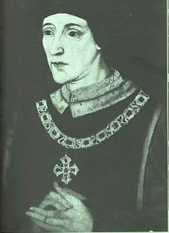
France and England were near the end of their Hundred Years War. Henry's father, Henry V, had conquered a considerable portion of France during his short reign. However, the French reclaimed almost all of their land during Henry VI's time on the throne.
This was the period when the charismatic Joan of Arc (her photo below) revitalized the French army. The English nobles, not at all pleased by such a turn of events, burned her at the stake as a witch. Remember, this was the Middle Ages, and burnings would continue even in the English colony of New York until the 1700s. Nasty way to shuffle off one's mortal coil.
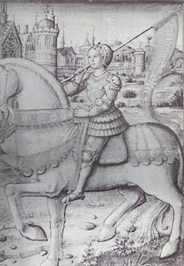

Next post, more adventures with our Holyman ancestors

MONDAY, JUNE 28, 2010

When We Were English, Part IV
The Turbulent Life of The Rt. Rev. John Holyman, First Installment
by Glenn N. Holliman
The small village of Cuddington, Buckinghamshire, England is approximately 12 miles from Tring, Hertfordshire, the believed home site of John Holyman (1572 - 1650). Another John Holyman, The Rt. Rev. John Holyman, lived earlier during the eventful times of the Tudor kings and queens. This earlier John played a role in attempting to forestall the Protestant Reformation in England. While we do not know his lineage, time, place and name suggest we American Hollimans carry some of his DNA. An ancestral cousin or uncle? I would say the odds favor such, and perhaps someday we can connect all the dots.
It was while researching Holymans in the Tring Library, I came upon the incredible news that a Holyman farm existed in nearby Cuddington, and that Bishop John Holyman had been born there. Cousin Maxine Wright of Arkansas had emailed a blurb on this John Holyman several months earlier alerting me to the existence of this particular Holliman. Within the hour, my wife and I drove to the village and indeed visited the Holyman farm, met the present owner, and the next day interviewed one of the village historians, Miss Peggy Castell. We spent several hours with Miss Cattell and her sister, Nancy, collecting information and papers.
What follows is the first portion of a paper presented in 2005 to the local historical by Miss Peggy Cattell (photo below) which we reproduce with her permission.
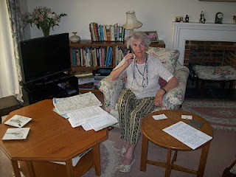
"They Lived In Cuddington"
" It was in 1495 that John Holyman was born. Records don't give any further information about his life in Cuddington, other than that he was born here but the family home was probably a manor house in the field near to the present Holyman's Farmhouse."
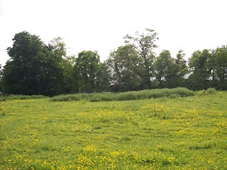
On the site of this grassy knole on the west side of Cuddington stood the manor house of the Holyman family in the 15, 16 and 17th centuries. Today this field stands fallow on still existing farm land.
"Another and more accurate assumption can be made that he must have been baptized in Cuddington Church, in the font which we still use. The font goes back well before his day. We know that the font was moved into its present position in the south aisle from the north aisle in the later part of the nineteenth century."
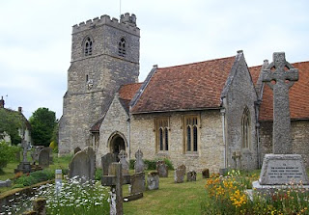
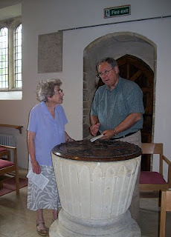
The photo above right is the exterior of the Cuddington parish. The above photo is of the baptismal font which is over 500 years old. Miss Nancy Cattell is on the left, and the author on the right taking notes. Photos by Barbara Holliman
"We can say for certain that his parents brought him through the present north doorway, and from the list of vicars we can assume that the incumbent of that time - William Burtone, priest from 1494 to 1511 - must have performed the baptism."
In the next post, we continue our study of the turbulent life of Bishop John Holyman....

SUNDAY, JULY 4, 2010

When We Were English, Part V
The Turbulent Life of The Right Rev. John Holyman, Installment 2
by Glenn N. Holliman
Below we continue the paper of John Holyman that Miss Peggy Cattell presented in 2005 to the Cuddington Historical Society, Buckinghamshire, England.
"John went to school in Winchester (a prestigious school, second only to Eaton), probably at the age of eleven and developed into a fine scholar. From there he entered New College, Oxford and was awarded the Bachelor of Divinity in 1526. For a short time he was rector in Colerne (in Ireland) but this did not suit him. He turned to Oxford, this time to Exeter College, where he acquired a Doctor of Divinity degree.
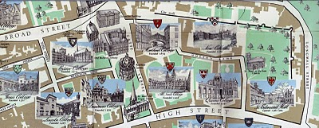New College, top right on the above map, is just inside the Old City Wall in Oxford. Not so new, New College was founded in 1379. Center left of the map is Exeter College, a bit older founded in 1314.
"After this second time at Oxford, Dr. Holyman became a monk at St. Mary's Abbey, Reading."
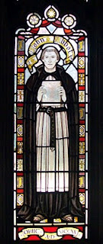This stained glass window at the Bristol, England Cathedral is of the founder of the abbey which later became the Cathedral where The Rt. Rev. John Holyman presided from 1554 - 1558. Brother John Holyman, when a monk, would have worn a habit such as above and had tonsured hair. Photo by Barbara Holliman.
"By this time, he was known as a brilliant scholar, a man of great piety and most eloquent preacher - fine qualities but not ones to blaze his name over the country, but this was soon to come. "
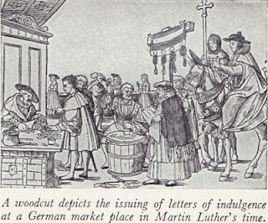"The age in which he was living was one of great religious upheaval. Up to 1517 all of Europe belonged to the Roman Catholic Church owing allegiance to the Pope. In Germany, Martin Luther spoke out again the selling of indulgences - that is people being offered the chance to buy themselves absolution from their sins. Luther believed that only through faith in Jesus Christ could sins be absolved. His concerns spread and a wide rift developed in the church. Those who protested again the Pope and Roman Catholic Church came to be known as Protestants."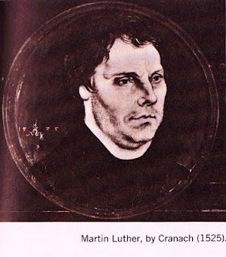

“Holyman’s abbot became concerned at what he described as this Lutheran Heresy spreading to England and he sent his best preacher up to London to speak against these thoughts at St. Paul's Cross. And so Holyman was thrust into the center of this important conflict!" (Speaking at St. Paul's Cross in the 1500s would be today's equivalent of appearing on all the major television news channels.)
In the next posting, the Reformation and a Royal divorce engulf King Henry VIII, his Queens Catherine and Ann Boleyn, Cardinal Thomas Wolsey, Sir Thomas More and our own Brother John Holyman.

FRIDAY, JULY 9, 2010

When We Were English, Part VI
The Turbulent Life of The Rt. Rev. JohnHolyman, Installment 3
by Glenn N. Holliman
Historian Nancy Cattell continues her paper on Cuddington, Buckinghamshire resident John Holyman.
"While in London Brother John embroiled himself in not just Reformation issues but also the marriage crisis of King Henry VIII (1581 - 1547). Henry had decided that must ask the Pope to grant him a divorce from his first wife, Catherine of Aragon. He claimed that because she had been his brother's widow he should not have been given the dispensation to marry her. This 'sin' was smoting him."
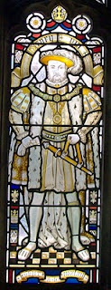This likeness of King Henry VIII is in the Cathedral at Bristol, England, the Cathedral from which Bishop John Holyman presided 1554 to 1558. Photo by Barbara Holliman.
"This after 20 years of marriage, but of course the real reasons for his desire for a divorce were (a) that Catherine had not provided him the son he wanted and (b) much more important - he had fallen desperately in love with Ann Boleyn and wanted to marry her."
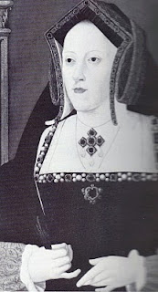
Catherine is the mother of Queen Mary Tudor.
"The Pope refused Henry's request and good Catholic that he was Brother Holyman started preaching in favor of the validity of the marriage to Catherine (photo above). This was a very courageous act or if you like, a very foolhardy one for Henry did not approve of criticism."
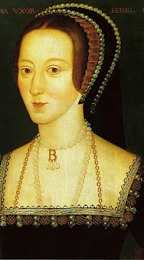
Anne Boleyn, the mother of Queen Elizabeth I
"Holyman must have made a discreet move from London otherwise he would surely have lost his head - one book I read told me that his abbot did and certainly the Abbey was dissolved during Thomas Cromwell's 'displacement'. "
"As we know when the Pope refused to grant the divorce, Henry cut the Church in England off from the Roman Catholic Church and thus the Church of England came into being. Henry declared himself the head of the Church and so obtained his divorce from his new Archbishop Thomas Cranmer."
"Brother John Holyman left London and sought refuge in Long Handborough, near Woodstock where he became the rector (and kept his head and kept it down)."
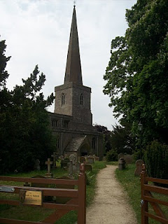
The parish church in Long Handbourgh stands today between Oxford and the historic town of Woodstock, the home of Blenhein Palace and the birthplace of Sir Winston Churchill.
Next posting, more on the career of Bishop John Holyman....

SATURDAY, JULY 10, 2010

When We Were English, Part VII
The Turbulent Life of The Rt. Rev. John Holyman, Installment 4
by Glenn N. Holliman
During the last years of Henry VIII and the reign of the boy king, Edward VI, our John Holyman served as priest at Long Handborough, near Oxford, and later vicar at Wing, near Tring, Hertfordshire.
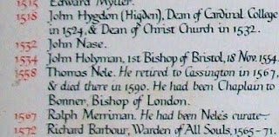
The name John Holyman appears (above) on this list of rectors who have served the parish in Handborough. This roster hangs on the church wall. There is an error; John Holyman was the second, not first Bishop of Bristol.
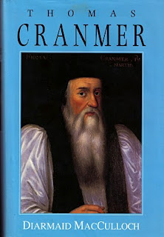
The photo of the book of Archbishop Thomas Cranmer is the latest in many excellent works on this pivotal priest during the Reformation. Some of the activities of our Bishop of Bristol are recorded in Diarmaid MacCulloch's biography which was published Yale University Press in 1996.
During the English Reformation, out went certain Roman traditions and services and in came a more simplistic style of worship and church decorations. English, not Latin, became the language of the pulpit and altar. Cranmer wrote the first Anglican Church prayer books, the model and language which survive even into the 21st century in the American Episcopal Church.
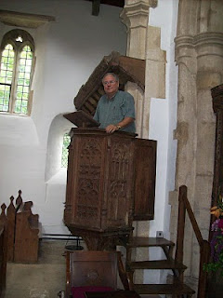
However, one of his distant descendants practices an indiscretion, standing in the 15th century pulpit where John Holyman preached in the 1540s in Long Handborough. Photo by Barbara Holliman, wife of the bogus preacher.
Next posting, we continue with the paper on ancestor John Holyman (1495 - 1558) presented by Peggy Cattell of Cuddington, Buckinghamshire, England.
TUESDAY, JULY 20, 2010

When We Were English, Part VIII
by Glenn N. Holliman

The Turbulent Life of The Rt. Rev. John Holyman, Installment 5

The life of John Holyman reached a climax during the reign of Queen Mary Tudor, or 'Bloody Mary' as she was termed by Protestants. Nancy Cattell of Cuddington, Buckinghamshire, England concludes her story of this distant ancestor.

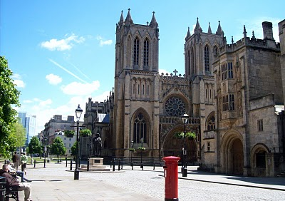The west entrance to the Bristol Cathedral with a quintessential Royal Post Box in foreground. From 1554 to 1558 The Rt. Rev. John Holyman occupied this Episcopate. Photo by Glenn Holliman
"Upon the accession of the Catholic Mary, daughter of Catherine of Aragon, John Holyman was appointed Bishop of Bristol, obviously as a reward for his support of her mother. Once again Holyman was into the limelight for now the Protestants who had supported Kings Henry VIII and Edward VI were to be tried. Bishop Holyman was included in the commission that tried Latimer, Bishop of Worchester and Ridley, Bishop of London. They were found guilty of heresy. In 1554, Holyman also participated in the disputation of Archbishop of Canterbury, Thomas Cranmer."
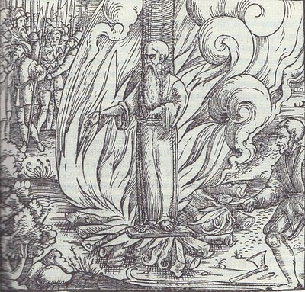
All three Protestant bishops were burned at the stake at Canditch in Oxford for their 'heresy'. The above woodcut is of Cranmer's death from the famous Fox's Book of Martyrs. In Bristol from 1554 - 1558, five more Protestants found martyrdom as 'candles' for Protestantism. In fairness to The Rt. Rev. John Holyman, he is reported to have opposed such actions, but they did occur during his episcopate.
"In 1558, Mary died and was succeeded by the Protestant Elizabeth. So once again the tables were turned and the Catholics were now put on trial. Bishop John Holyman avoided a violent death, as he died of natural causes a month after the accession of Queen Elizabeth I. His burial took place at Hanborough Church."
"I am so amazed that anyone born in the 16th century in what must have been at that time the most obscure of little villages should have produced a man who was at the center of all the important happenings of that tumultuous time." - Nancy Cattell, Cuddington, Buckinghamshire, UK 2005
Paul Bushe, the first Bishop of Bristol received an ornate tomb with effigy (photo below of Cathedral sanctuary).
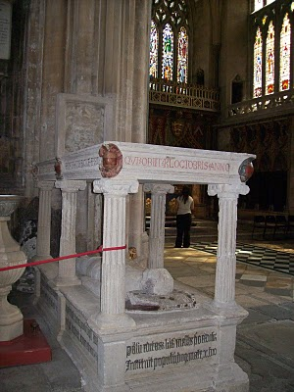
But the second bishop, much more controversial and in disrepute at his death, lies buried in Longhand borough in his former parish church. John Holyman's remains lie under or near this 16th century memorial (photo below) in the small village parish near Oxford. Photos by Barbara Holliman
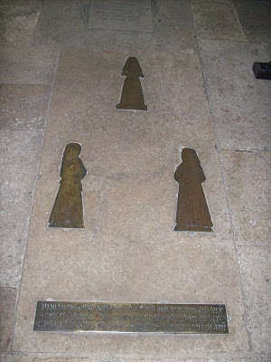

Next post, a visit to the Holyman farm in Cuddington, Buckinghamshire....

WEDNESDAY, JULY 21, 2010

When We Were English, Part IX
by Glenn N. Holliman
Bishop John Holyman's Will, 1558

In my recent postings, I have been chronicling the life and times of The Rt. Rev. John Holyman, probably a distant uncle of our Holliman family. During my recent visit to the village of Cuddington, Buckinghamshire, England, this photograph (below) was taken of Mrs. Caroline Stonham and me in the back garden of her 17thcentury thatch cottage.

What is remarkable about this cottage is that it rests on the Holyman farm, and Holymans used to live in the residence in this photograph!
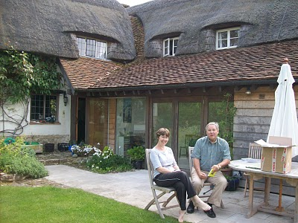
In an earlier posting, I dropped in a photograph of the location of the old 'manor' house where 16th century Holymans lived, approximately 200 yards from where Caroline and I are sitting.

We are reviewing Holyman papers she has collected in the twenty years she has lived on the farm. She is a geography teacher and has a keen appreciation of the history of her home. She kindly shared of her research and gatherings with me, allowing my wife to photograph the many documents. With her permission, I now share them with you.

One of the papers we reviewed is below. It is the 1558 will of Bishop John Holyman. It is a transcription but it does contain a bit of Shakespeare era English. Being celibate, John had no children, but he did have servants whom he remembered and he left funds to colleges and the parish where he is interred. Notice he left funds to pray for the repose of his soul. For one who had been a monk, and had taken a vow of poverty, he left a sizable estate although no land.
If one places the cursor over the document and clicks, the will should enlarge for easier reading.
Page 1
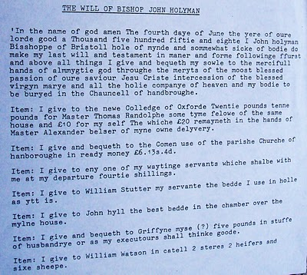
Page 2
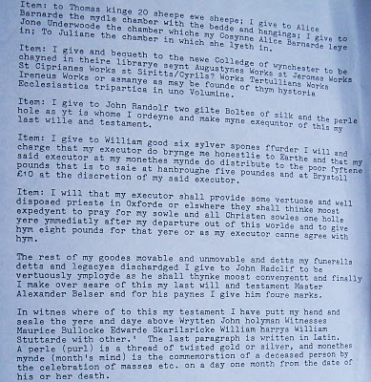
This will was transcribed under the direction of Bob Hollyman-Mawson of Wales, for whom we all are indebted.
Next posting, more on the Holyman farm and family documents in Cuddington, Buckinghamshire, England....

FRIDAY, JULY 23, 2010

When We Were English, Part X
by Glenn N. Holliman
Continuing the Search for our Ancestors in England
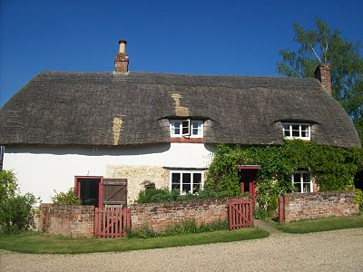In the above 17th century thatch cottage lived great nieces and nephews of The Rt. Rev. John Holyman who was born on this farm in 1495. Numerous legal papers and research tell of the family. Below are copies of research from Caroline Stonham, current proprietor of the Holyman Farm in Cuddington, Buckinghamshire. Click on the documents to enlarge them.
Page 1
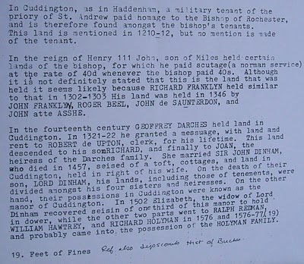
Page 2
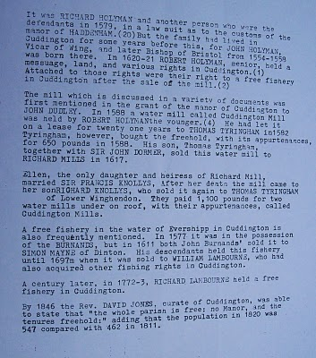These documents may be of use to any Hollimans who research our English roots....unfortunately the names of JohnHolyman (1572 - 1650) and Christopher Holliman (1631? - 1691) have not appeared in documents from the Holyman Farm. The search continues for our direct ancestors....

WEDNESDAY, JULY 28, 2010

When We Were English, Part XI
by Glenn N. Holliman
More on the Holyman Farm, Cuddington, Buckinghamshire, England

In the past few posts, I have been sharing information and photographs of a Holyman farm, described in some English sources as a former 15th century manor house. In the photo below is a contemporary plaque attached to one of the barns, now a residence. This sign celebrates the name of the farm and its most famous namesake, Brother John Holyman (1495 - 1558), a monk and later the Rt. Rev. John Holyman of Bristol. Photo by Barbara Holliman
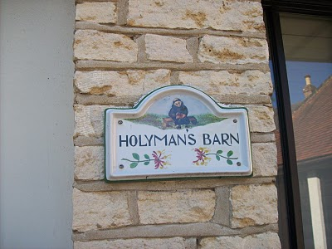
Below from The Monuments of Buckinghamshire is a description of the 17th century thatched cottage that we have featured in previous posts (see archives). Click twice and the manuscript will enlarge.
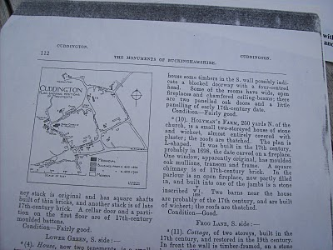
The current owner of Holyman Farm, Mrs. Caroline Stonham, has prepared the following family tree of the Holyman family and others that lived on the property. Perhaps it is of some use to those studying deeply into our English past. Through it one may be able to connect the family to our other English ancestors reportedly from Tring and/or Bedford. Where there are no last names, insert Holyman. Again, click twice and the document will enlarge. Photos by Barbara Holliman
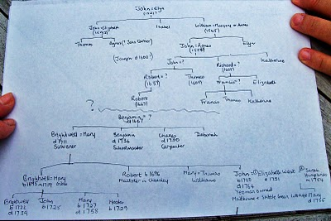
Next posting, more research on our English roots....

TUESDAY, AUGUST 3, 2010

When We Were English, Part XII

The Holyman Farm of Cuddington has Secrets to Reveal by Glenn N. Holliman
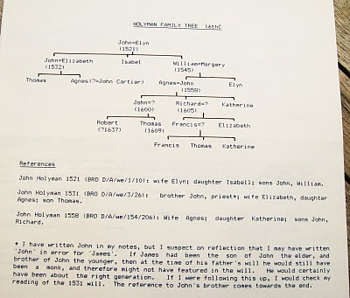
Above is a typed family tree of the Holyman farm prepared by its present owner, Caroline Stonham.

Below is a 19th century description of the farm from the Buckinghamshire County Museum. In the 1800s a Mr. Scott owned the property. Double click to enlarge. Photos by Barb Holliman.

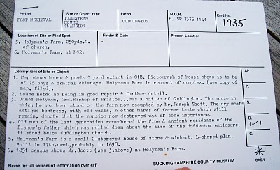
Below is a wing of the 1698 thatched cottage on the Holyman Farm.
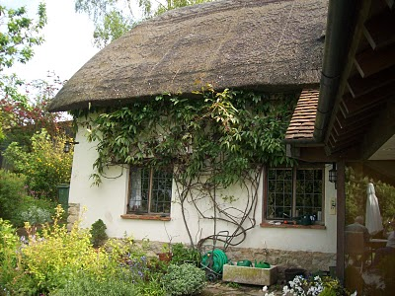
Next post, we say good bye to our eventful visit to Cuddington....

MONDAY, AUGUST 9, 2010

When We Were English, Part XIII
by Glenn N. Holliman
Leaving the Lovely Village of Cuddington

Below a photograph of sheep grazing on a Chiltern hillside near Cuddington, Buckinghamshire. This pastoral scene is typical of the landscape around Tring, Cholesbury, Aldbury and Berkhamsted where the name Holyman pops up in parish registers and legal documents in the 17th and 16th centuries.

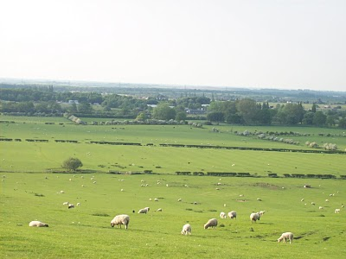

The folk of Cuddington, including Peggy Cattell and Caroline Stonham, were kind and generous with their information on the Holyman family. Below is Nancy Cattell who showed us around the parish church and village. Notice the thatch cottage on the right. It dates to the 1500s. The last reproduction (bottom photo) gives some idea of what an English cottage looked like in the 1600s, something akin to how our ancestors were domiciled.
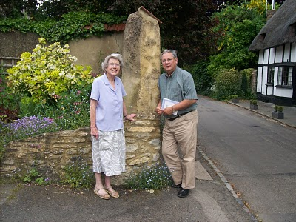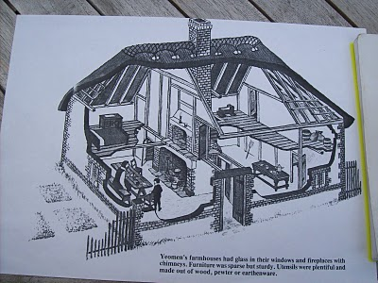
Next we try to connect some ancestral dots....

SUNDAY, AUGUST 15, 2010

When We Were English, Part XIV
by Glenn N. Holliman

Before We Leave Cuddington, England...
and yes, Holliman in this posting is spelled several ways as recorded in primary source material

I had not planned to write more on the Holyman farm in Cuddington, but an email by cousin Betty in the Tina Peddie chat room asking more about the family tree from the farm sent me deeper into my research papers. Alas, I reviewed again scattered papers from Lipscomb's A History of the County of Buckinghamshire, Vs. 1 & 2, photocopied from Miss Peggy Cattell's collection of genealogical materials.

Then I pulled out from other historical records (listed below) of Holyman material and have created a time line, which I hope will be of some benefit someday to someone. I then compared this time line to the family tree of Caroline Stonham's (see When We Were English, Part XII in the archive).

This can be confusing so do not feel one has to memorize the article. I plan to tie all this to Tring Holyman's very soon.

Let's begin with this photo below from 1965 supplied by Mrs. Stonham, current owner of the Holyman farm. This picture shows a working farm 45 years ago. The thatch cottage is the same one I have been posting, constructed during the time of William and Mary, 1689. The farmer in front wears a typical English sweater and cap. Notice the stone fence. Quintessential England!
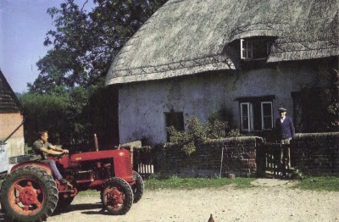
Below, a Time Line of the Holyman Farm using the Buckinghamshire History, The 1522 Certificate of Musters in Cuddington, the 1555 Manorial Survey and the HolymanFamily Tree prepared by Carolyn Stonham of Cuddington

1495 - The Rt. Rev. John Holyman born at the manor. His father was John Holyman (d 1521) married to Elyn in the Stonham family tree.

1511 - A Richard Hollyman receives receipts on behalf of the Priory of Rochester which was at that time still 'lord of the manor'. No mention is made of a Richard Holyman in the Stonham tree. As noted in the Manorial Survey of 1555, the farm had been divided and Richard probably was an uncle of Bishop John Holyman.

1522 - The Certificate of Musters from Buckinghamshire in 1522 (Aylesbury, 1973), p. 72 listed the villagers of Cuddington for tax purposes. The following Holymans were listed as holders of land:

John Holliman (deceased that year and father of Bishop Holyman)

John (James) Holiman Jr. (as son of the above who d 1521)

William Holiman (a son of the above who d 1521)

Ellin Holiman (wife of John (d 1521) and mother of James and William)

Thomas Holiman, son of John (James) Holiman, Jr.

1527 - A John (James) Hollyman took over the 'farm' of Cuddington from the Priory for a lease of 30 years. This would be a son of John (d 1521). This John (James) had a brother named William who married Margery or Annis. William died in 1545. William and John, according to Stonham, were brothers of Bishop John Holyman. Stonham believes the records reads "James" not John Holyman as is printed in her Holyman family tree.

1531 - John (James) dies in 1531 and wills the lease and 'bedding' to his son Thomas Hollyman. This John makes provision in his will for the repair of the Cuddington bridge. This is in agreement with the Stonham family tree showing a John (James)Holyman, married to Elizabeth dying in 1532 (when the will was probated by the old calendar).

1539 - Henry VIII dissolves all monasteries and nunneries, and this king takes legal possession of the Farm. Thomas Hollyman, 'farmer' of Cuddington now leases from the king and no longer the Priory of Rochester. The Stonham document does not list the date of Thomas' death unfortunately or any further children, but we do have Thomas still listed in a 1555 manorial survey.

This insert is written in August 2012. Later research reveals a will written by Thomas Holyman who died in 1558. Thomas left part of his estate to a son, Christopher, whom I believe is the person who died in 1588 of Cuddington birth who passed away in Sherington, Buckinghamshire. This Christopher left part of his estate to a second son, Thomas, who is believed to be the father of Christopher Holyman, Sr. (1618-1691).

So let me interrupt further this narrative. Here is the lineage as I now believe it to be. John Holyman died 1521.
John or James, d 1531, who begat Thomas, d 1558, who begat Christopher, d 1588, who begat Thomas who begat Christopher, Sr. b 1618-1691, our American founder. GNH

1542 - Thomas made a profit of over 20 pounds from the farm.

1545 - Elizabeth Holyman of Cuddington in her will wrote (as normal in those days), "I bequeath my soulle to the great mercye of all mightie God and to his mother Marie and all the saints in hevyne." (Remember at this time in England, almost all were Roman Catholics and the Anglican Church was just emerging from the Reformation in Europe.) According to Stonham, Elizabeth was Thomas's mother.

1545 - William Holyman of Cuddington leaves a bequest in his will to mend and repair the bryg waye (by way or road) in the village. (It was common for individual charity to maintain roads in the 16thcentury.) As noted above, Stonham agrees with this death date. Again William was a brother of Bishop Holyman.

1530s - The Rev. John Holyman writes two books in Latin - A Treatise against the teaching of Martin Luther and A Defense of the Marriage of Queen Catherine with King Henry VIII. The works do not survive, but his politically explosive books resulted a new title for John. He was now 'an enemy to the King's cause'. Not good for the Holyman family!!

Fr. John is thought to have retired to the Farm at Cuddington and stayed until he was appointed to the vicarage of Wing in 1546. Later he would be vicar at Hanborough prior to becoming Bishop of Bristol. According to Stonham, this elder John would be staying with his nephews - Thomas, the son of John and Elizabeth and John, a son of William who died in 1545. This younger John dies in 1558, ironically the same year as his famous uncle.

1554 - 1558 - John Holyman appointed Roman Catholic bishop of Bristol by Cardinal Pole under Queen Mary Tudor. Bishop Holyman involved in the trials for four of the five bishops executed for heresy during 'Bloody Mary's' reign: Cranmer, Latiner, Ridley and Hooper.

1555 - A Manorial Survey from the Public Record Office in London listed Thomas Holyman as the holder of manor from Queen Mary Tudor which included all houses, lands, a water mill and four acres of pasture land. His nephew, John Holyman, son of the late William Hollyman also held considerable lands as a copy holder.

1574 - Richard Hollyman, the younger, of Cuddington initiated a legal suit against Richard Beake over the custom of bedripp or an extra harvest duty. (Yes, people have quarreled always about taxes. Notice this is Richard the Younger.) According to Stonham, this Richard would be a great nephew of Bishop Holyman. This Richard died in 1605 considerably outliving his father, John (d 1558) who was the son of William (d 1545), who was the son of John (d 1521). This Richard was then a great, great nephew of Bishop Holyman.

1600s - Manor remains crown land until reign of James I.

1689 - Thatched cottage (see above) built. Date is on fireplace mantel in main room of the house.

1700s - The Farm evidently stayed in the Holyman family (according to Stonham) until at least the late 1700s.

1900 - Approximately around the turn of the century, the last Holyman dies in poverty in Cuddington.

So what to make of the above?

While this family tree and supporting evidence appears firm, one of the above Holymans, perhaps one of Bishop John Holyman's two brothers - John (James) and William had a male offspring who moved at some point to Tring and Cholesbury. Unfortunately Caroline Stonham does not take the family tree out of Cuddington.

I now believe that male off spring of James (John d 1533) had a grandson named Christopher, son of Thomas, son of the above (James) Holyman. GNH August 8, 2012

Below a map of the Holyman Farm in the 1500s.
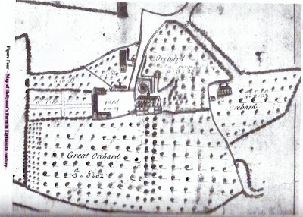
In the next posting, we travel a few miles to Tring to begin to connect this Cuddington family to one Ezekiel Holyman, a founder of Rhode Island and perhaps our mysterious John Holyman who died in Virginia in 1650.

MONDAY, AUGUST 23, 2010

When We Were English, Part XV
Making Sense of Our Cloudy and Confusing English Past
by Glenn N. Holliman
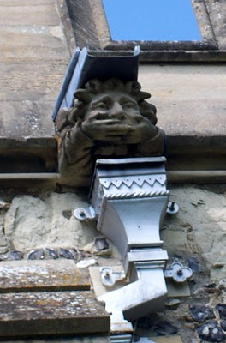This gargoyle on the parish church at Tring, Hertfordshire, England represents the challenges to discover our Holliman roots. The 'past', this gargoyle, seemingly does not wish to tell us what we long to hear....who are our ancestors? Photos by Barbara Holliman

Indeed, new research provided by cousins Maxine Wright and Joe Parker is moving the focus of our search from Tring to Bedford, Bedfordshire, England, approximately 35 miles to the north.

In the meantime, I continue to share some findings in Buckinghamshire and Hertfordshire, about 25 to 30 miles northwest of London. Below is a map of the villages where Holymans lived in the 16th and early 17 centuries: Cuddington, Tring, Cholesbury, Berkhamsted and Aldbury. They are overshadowed in a yellow marker. Double click to make larger.

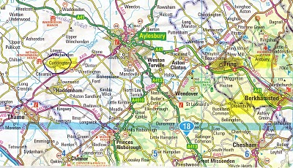
The gargoyle at the top of this posting is from the Tring parish in the photo below.
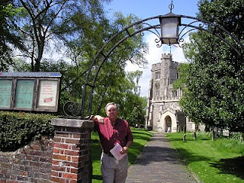
In the photo above, I stand in front of the Tring, Hertfordshire parish church, which has been reconstructed several times since its 11thcentury founding. The present structure was erected in 1470. In this sacred space in England some of our distant ancestors probably worshiped and their remains may linger in the ground behind me.
After visiting the Tring parish church a first time in 2005, my wife and I stepped down the block to visit a charity shop (seeking yet more royal coronation ware, a vice of mine). The kind clerk showed us the local telephone book. Yes, seven or eight Hollimans were listed in the local exchange. Hmm… Later we motored to a pub for roast lamb and red wine (and I remember little more that day!).
Next posting, we continue to explore the villages and paperwork that connects Holymans in Cuddington to Cholesbury and Cholesbury to Tring and Tring to Berkhamsted and Aldbury.

WEDNESDAY, AUGUST 25, 2010

When We Were English, Part XVI
by Glenn N. Holliman
Connecting Cuddington Holymans to Cholesbury Holymans and Tring Holymans

Cousin Jeanette Holiman Stewart recently shared in Holliman chat room information on the Holyman and Weedon (Wedon) families of Hertfordshire, England from the English Origins of New England Families. Before reviewing her excellent research, I had been preparing the article below which echoes and strengthens her findings.

In future postings, I will attempt to weave her public work into the growing narrative of the Holymans in Tring and Cuddington, England in the 16th and 17th centuries. My thanks to Jeanette, Joe Parker and all for making available to the larger Holliman, Holleman, Hollimon, etc. families their increasing knowledge of our historic roots.

Last spring my cousin Maxine Wright, a relentless researcher in pursuit of Holliman origins, mailed me the following information of one Richard Wedon, who lived in Botley, a small village near Cholesbury and Tring. As one can read in the first paragraph of this p. 187 of The Register, published 1954, Richard had to pay a fine in 1567 for breaking the head on another man's servant. Hmmm....

Richard must have matured because nine years later, in 1576 he married Jayne Holyman in Cholesbury, near Tring. The information below states that this Jayne Holyman was from 'a yeoman family of good standing in Cuddington', descendants of Bishop John Holyman, whose life we have reviewed in previous blogs.

Several other items leap out at us. Richard and Jayne had a son named James who evidently immigrated to Rhode Island! Did James join a cousin named Ezekiel of Tring in Rhode Island? One remembers that Ezekiel Holyman, an Anabaptist, baptized Roger Williams the founder of Rhode Island!
Notice that Richard Wedon writes a will in 1618 (it is probated in 1624, presumably the year of his death). The will is witnessed by William Holyman. Double click to enlarge.
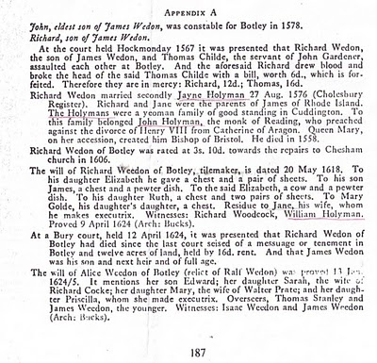
Now the issue grows more complicated. Above we have Jayne Holliman married to Richard Wedon. Below in another section of the Register, we have a John Holyman appearing in marriage in 1593 and dying a few years later. Goodbye to this John who had no children.

However, now William Holyman, the eldest son of another William Holyman, appears again (noticed who witnessed Richard Wedon's will), baptized June 1583 and his sister Priscilla February 1584/5. They have a brother named Ezekiel.

This Ezekiel according to many web sites and those who have researched Baptist Church history is the Ezekiel who sailed to Massachusetts and helped found Rhode Island!

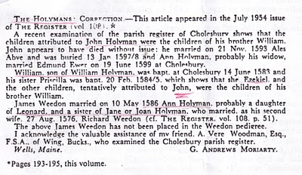
Notice in the next paragraph an Ann Holyman married another Wedon May 1586, and is noted as a probable daughter of Leonard Holyman and a sister of Jane Holyman.

Confusing? Yes, but stay with me. In the next blog, we are going to examine Leonard Holyman and his offspring. In web sites, Leonard is listed as the father of Ezekiel Holyman.

So, two thoughts emerge:

1. Leonard Holyman and other Holymans of Tring and Cholesbury, including Ezekiel, are indeed descendants of Bishop John Holyman of Cuddington.

2. Bishop John Holyman, a devout Roman Catholic, therefore is probably a great or great great uncle or cousin of Ezekiel Holyman, who was religiously antithetical by 180 degrees, to his prominent descendant, an Anabaptist in America!

For those interested in religious history this is an amazing journey for a family. One generation burns Protestants at the stake; another helps establish the Baptist Church in Rhode Island.

So are all these interesting Holymans our direct ancestors? Ancestors, most probably yes; direct, we still do not know.

The elusive John Holyman, who died in Virginia in 1650 and is named in various web sites as the father of Christopher Holliman, Sr. (whom we know is the father of the American Hollimans), still has not appeared in the Tring records many of us have researched.

More in the next posting on resolving this mystery. Is our Christopher Sr. really from Bedford, Bedfordshire, another 30 miles or so up the road from Tring? Stayed tuned for more research....

TUESDAY, SEPTEMBER 7, 2010

When We Were English, Part XVII
by Glenn N. Holliman

Continuing the Search for John Holyman (1572 - 1650)
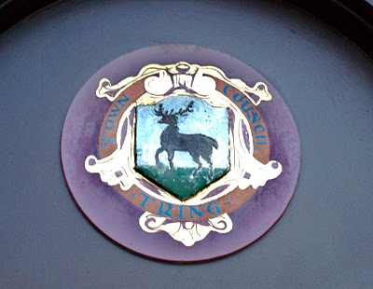Tring, Hertfordshire traces its roots to Anglo-Saxon times, and was located just west of the Dane law in the 900s. The hamlet is listed in William of Normandy's Doomsday Book. The above is the town logo.(Photo by Barbara Holliman)
I am still looking for that elusive John Holyman who, according to one prominent Holliman genealogical website and the LDS records, was born in Tring, Hertfordshire in 1572. John is the widely reported father of Christopher Holliman, Sr., who is our ancestor of solid record.

We do know a John Holyman did die in Southampton, Virginia in 1650 and left a will which devolved property to a friend, not family. For the past few months, I have been posting information found during an excursion to England seeking Holyman roots and our reported very great grandfather. I continue.

As readers of this web log know, there was a Bishop John Holyman (1495-1558) and an Ezekiel Holyman (1586 - 1659), both religious leaders. One was Roman Catholic and the other a Baptist Protestant. The evidence supports that they are related.

Cousin Jeannette Stewart shared by email information that in the English Origins of New England Families, Vol. III, pages 193 - 195, one will find an article by G. Andrews Moriarty entitled The Holymans. In this article Moriarty quotes The Register, an English genealogical publication, that the Holymans were a family of 'substantial yeomen' with branches in Cuddington, Cholesbury and Chesham. The Rt. Rev. John Holyman, Bishop of Bristol from 1554 to 1558 was a member of this family as was one Jayne Holyman (1552 - 1632) and her nephew, Ezekiel Holyman.

From the Latter Day Saints genealogical website, we have the following:

One Leonard Holyman (1520 - 1573) was born in Cholesbury and died in Tring. From the above source we know that Leonard is related to the Cuddington Holymans. I refer all to my post of August 23, 2010, 'When We Were England, Part XV'. Leonard is a contemporary of Bishop John Holyman. Were they brothers or cousins? Cuddington, as the earlier map notes, is an hour or two by horse from Tring and Cholesbury.

Leonard married a Joan (b 1525) also of Cholesbury. They had at least seven children. One was the Jane (Jayne), referred to above, b 1552 in Tring, Cholesbury, died 1636 and is buried in Chesham (near Cholesbury). She married Richard Weedon, as noted in the last posting. One of their sons, James, immigrated to Rhode Island, as did Jayne's nephew, Ezekiel.

Jayne's brother John Holyman (1548 - 1597) was a weaver and had a wife named Ales (Alice). There were a number of children of this marriage, one being Ezekiel Holyman, who would immigrate to New England and help found the Baptist Church in America. Another child, Elisabeth, married into the Weedon family herself.

Two of Leonard's sons, Edward and William, left wills of which I found and made copies while in the Hertfordshire Archives. I will be publishing these wills later and transcribing what I can. There was a third son, John, whose will is below and lifted from the English Origins of New England Families.

The Will of John Holyman (1548 - 1597)
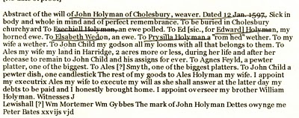

Now John Holyman (d 1597) left a will (abstract above) which does not list a son named John Holyman (remembering we are looking for a John Holyman, b. 1572 in Tring). John (d 1597) does list a godchild, whom he terms John Child. To this godchild, Holyman left his 'looms and all that belongs to them'. His own children received much less, Ezekiel only getting a ewe. Why did he favor the godchild over his natural children? Perhaps John Child had an aptitude for weaving while the others did not? But this John also left John Child his land after his wife's death.

Why favor John Child over one's own children?

Could John Child have taken the last name Holyman from his godfather, John Holyman? Could this John Child be the elusive John Holyman (d 1650 in Virginia)? The dates work. Could this godchild be a natural offspring of John Holyman (d 1597), given perhaps a last name (Child) to obscure a birth out of wedlock? This is only speculation on my part, but the bequests are odd.

So John Holyman (d 1650) is still hidden in history as far as primary sources are concerned, if he be from the Tring area. As cousins Maxine Wright and Joe Parker have revealed, there is evidence John Holyman (d 1650) may have been from twenty-five to thirty miles north in Bedford. If so, why are so many web sites placing him in Tring?

So are the Bedford and Tring area relatives very closely related, perhaps a branch just recently relocated to Bedford from Tring in the late 1500s? Perhaps, somewhere, someplace, some Holyman stated to an authority, "Yes, my family is originally from Tring, before recently moving to Bedford."

I will look further. Thank you for your patience as I attempt to place all this research by several persons and sources in narrative format and on the record. As ever, I am grateful to my distant cousins for their sharing of knowledge and evidence. Opinions expressed and conclusions drawn, as well as errors, are mine alone.

Next posting....looking at the will of William Holyman, a son of John Holyman (d 1597).

MONDAY, SEPTEMBER 13, 2010

When We Were English, Part XVIII
by Glenn N. Holliman

The Will of William Holyman (1550 - 1623), Part I
In the Hertfordshire archives in Hertford, England, one will find several large rooms filled with books, manuscripts microfilm and photographs of local, family and national history. In the short time I was there, the friendly staff pointed me in several directions.

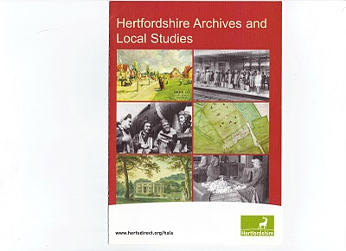

This brochure may be of help to those reading this blog. Click twice to enlarge.
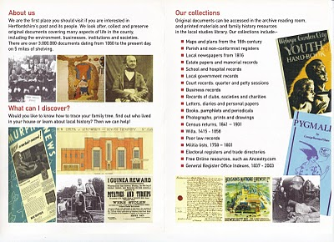

While there I reproduced from microfilm the wills of Edward Holyman and his brother William Holyman. Before I post them and attempt to transcribe, let me share with readers the way our English alphabet looked in the late 16th and early 17th century. (See below)

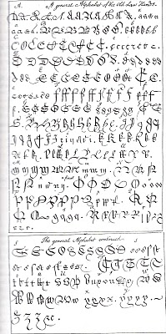

This really is your great grandfather's alphabet! Yes, it is A to Z with several samples for each letter. Some are easy to identify; others are a mystery. It makes interesting reading. Will it get us any closer to the elusive JohnHolyman (1572 - 1650)?
(Again click the reproduction twice to enlarge.)

In Part II of this article, next posting, we will examine William's 1623 will from Tring.

MONDAY, SEPTEMBER 20, 2010

When We Were English, Part XIX
by Glenn N. Holliman

The Will of William Holyman (1550 - 1623) of Tring, Part II
Still Looking for John Holyman of Tring....

In the index of wills in the Hertfordshire Archives in Hertford, England, I found and copied the last words of William Holyman, son of Leonard Holyman (1520 - 1573). Bear in mind, I was looking for the John Holyman, the reported ancestor of the American Hollimans. While this will does not disclose our elusive direct ancestor, this document does reveal information on the lives and times of our distant cousins, uncles and aunts when we Hollimans were English. Click twice to enlarge. The document is divided into two parts due to my scanner only taking part at a time.
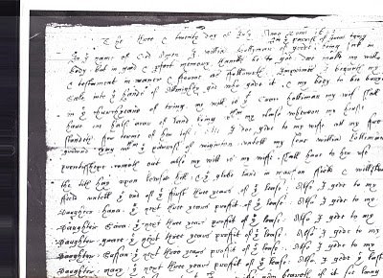
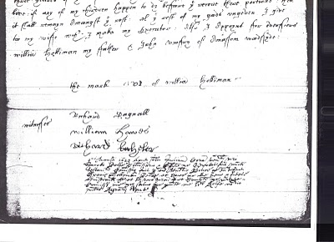What does it say? As no expert, here is my attempt to transcribe the writing form of early 1600s English script.

"The ___ and twentieth day of July Anno Domi 1623 ___ In the Name of God Amen. I, William Holyman of Great (in the parish of Great Tring) being poor in body, but in good and perfect memory, thanks be to God, do make my will and testament in manner and form as followeth,

First, I bequeath my soul into the hands of the Almighty God, who gave it and my body to be buried in the church yard of Tring.

My will is that Grace Holyman, my wife, shall have on half acre of land lying between my house __ for ___ (rest?) of her life. Also I do give to my wife all f___ ___ ___ ___ that ___ of ___. ___ my son William ___ ___ ___ out also my wish is to my wife ___ ___ to her rest the __ hay upon ___ hill; and the glebe land in ma___ field and one of the ___ of the first three years of the field lease. Also I give to my daughter, Hanna, the next ___ year’s profit of the lease; also I give to my daughter, 'Saiva' or 'Eva', the next three years profit of the ___. Also I give to my daughter, 'Grace' the next ___ profit of ___. I give to my daughter, 'Saffon', the next ___ year’s profit of the ___. Also I give to my daughter Mary the ___ ___ ___ profit of the ___. Also I give the ___ three ___ of the ___. Unto the ___ my wife ___ ___ if it ___ ___ ___. If any of my children happen to die before they received their portion, then it shall remain amongst the ___. All this ___ of my ___ I give to my wife ___ I make my executor. Also I appoint for administrators (?) William Holyman my father and John Romsy of ___ ___.

The Mark of William Holyman, submitted"

My opinion? Here we have described a yeoman farmer living in Tring, to be buried in Tring and farming fields just outside of Tring. He has few worldly goods other than a lease hold on the land.

And to our disappointment, no son named John Holyman.

So the search for the elusive John Holyman continues....

MONDAY, SEPTEMBER 27, 2010

When We Were English, Part XX
by Glenn N. Holliman

Looking for John Holyman in Edward Hollyman's Will of 1617

Just to remind all, the William listed in the last post is the uncle of Ezekiel Holliman, one of the founders of the Baptist Church in Rhode Island and the person who baptized Roger Williams, an architect of American religious liberties. The Edward Hollyman in this post is also Ezekiel's uncle. John Holyman (see Post When we Were English, Part XVII), a brother of William and Edward, is Ezekiel's father.

So here we are knowing Bishop John Holyman (1495 - 1558), devout Roman Catholic who burned Protestants at the stake during the reign of Mary Tudor, is a great uncle or second or so cousin of Ezekiel. Now in all this where is the mysterious John Holyman of Tring (1572 - 1650), believed by many to be the founder of American Hollimans in Virginia?

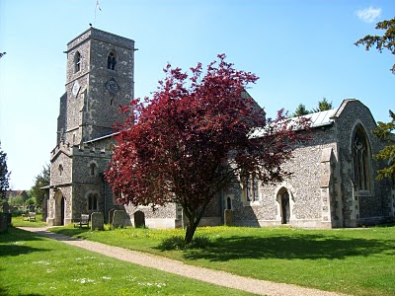The parish church in Aldbury, located a few miles east of Tring, Hertfordshire. Are our relatives buried here also? Photo by Barbara Holliman, 2010.
In the last posting we explored the 1623 will of William Holyman of Tring, son of Leonard Holyman. In this article we reproduce below from the Hertfordshire Archives, the will of Edward Hollyman of Aldbury, brother of William. Aldbury is only a few miles from Tring. Edward lived from 1546 to 1617, and spelled his name with two 'L's. Edward was more prosperous listing furniture and household items to be dispersed as well as land holdings. Note brother William Holyman witnessed this will. As the scanner cannot record the entire will at once, it is divided into two parts. Click twice to enlarge.
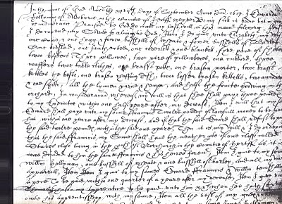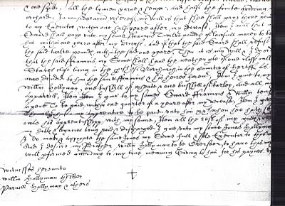
I have not attempted to transcribe this document, but have studied closely the bequests and names. This will seems more difficult to read than William's. A name intrigues, and I remain puzzled over it. Double click the second section and look at the fourth line from the bottom of the will. Beginning in the middle, you will read the words which I transcribe as "I give unto my sons Jonas Hollyman," then words are obscure.

I have pondered and pondered this clause. Is this word John in Latin, Medieval French or 16th century English script? What to do about this? One avenue is to check the Aldbury Church of England register. Remember Thomas Cromwell as of 1538, Henry VIII's chancellor, decreed that all parishes register baptisms, marriages and funerals.

However, I cannot find in Edward's will (as in William's) that he asked to be buried in the parish church lawn. Had Edward joined a non-conformist church (Puritan or even more controversial – the Anabaptists for example) by 1617, as obviously had his nephew Ezekiel? If so, Edward's demise would not be recorded in Anglican Church records.

So I will search the Internet to see what can be found, and if nothing can be found, well, back to the Hertfordshire Archives my next trip to England. A clue, a weak one, but....could this be the not-yet-found John Holyman, d. 1650 in Jamestown, Virginia? I agree, this is a big, huge stretch and even if this name be John, would it also be our John, English founder of our American family....?

Below, is a family memorial in the Aldbury parish. No, not a Hollyman plaque, as it remembers another departed family. This ghastly, but fascinating 17th Century monument, vividly displays that century's view of morbidity. Our ancestors were part of this culture.
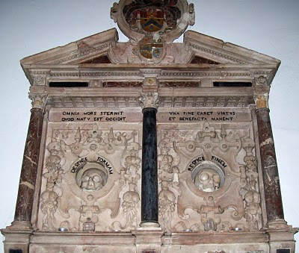Photo 2010 by Barbara Holliman
We are all immigrants from the past...from our families.....

THURSDAY, OCTOBER 7, 2010

When We Were English, Part XXI
by Glenn N. Holliman
Weddings and Witches
In the Hertfordshire Archives is a book entitled Hertfordshire Parish Registers by Phillomore's, 1907, 3 volumes. Of course out of print and I had precious few hours to review it. It is on my list to revisit some day. However, I did find several weddings of Holyman females to local males. For the record, they are listed below.

By the way, the first two marriages were from yet another village, just a few miles also from Tring - Berkhamsted. Below is a view of its High Street in 2010.
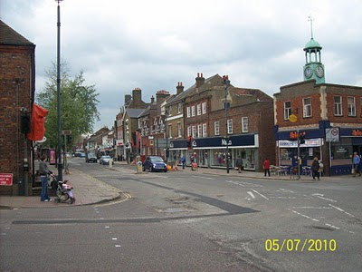
The Berkhamsted Marriages:

Francys Hadden to Margery Hollyman on 6 May 1601.

Henry Lawrence to Jane Hollyman (Holeman) on 7 February 1638.

Here are two Tring marriages in the same publication:

William Hollyman to Grace Neelie on 20 July 1607 (This is the son of William of Tring whose will we reviewed in When We Were English, Part XIX).

Goff Babylong to Anna Holliman on 7 May 1634

So above some more information for the Holyman history trail in England. Cousin Maxine Wright has ordered Tring Parish microfilm and hopefully may find yet our hidden John Holyman who died in Virginia in 1650. My on-site research has failed to turn him up, but I did find a host of very interesting Holymans who impacted English and American religious history. Hopefully when I return to England next spring I can collect some DNA samples from possible ancestors and search again in local archives.

Sometimes it is not what one finds in genealogical research, it is also what one does not find. And sometimes, one may feel bewitched and frustrated not to collect more information. That leads me to my closing historical tidbit you may enjoy.

While reading in the Tring library the 1940 work by Arthur MacDonald, That Tring Air, I found that the year 1596 must have been very stressful to our ancestors. Our John Holyman would have been 24 years old at the time, and perhaps observed the following outbreak of, well, witchcraft in his own community!!
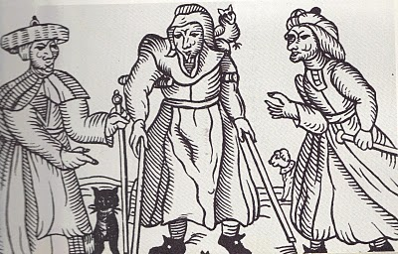Above a 16th century drawing of three English witches. Rather ugly creatures. Note the black cat.
That year in Tring, one Alice Crutch 'bewitched one Hugh Walden who languished and died'. Nor did the episode of nefarious deeds end there. Another woman, named Elizabeth, put a curse on Thomas Grace's valuable horse and it died!!

For their witchery, these two ladies were 'suspended by neck until dead'.

So this Hallowed Eve, think on all the quaint customs of England and Europe that passed through our families to our New World, which we celebrate to this day!

THURSDAY, OCTOBER 14, 2010

When We Were English, Part XXII
by Glenn N. Holliman

Are the Holymans from Bedford, rather than Tring?
On the map below, one can see Bedford within the red circle almost due north of London. Tring (unnamed) is located at the red dot just northeast of London. Click on map to enlarge.
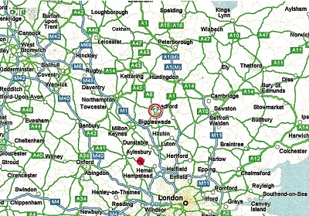

As readers of this blog know, I have spent the past four months expounding on research of our Holyman (Holliman, Holleman, Holloman, etc.) origins conducted earlier this year in England. In the late 1990s, a Holyman family tree was posted on the Internet, and many of us took it as gospel. This site, still posted, lists one John Holyman (1572 - 1650) of Tring, Hertfordshire as the English father of our Holliman families in America. A John Holyman really did die in 1650 in Virginia, as recorded by Virginia records.

However, a continuing search of Internet archives, family trees, research by others, and my own exploration in the Hertfordshire Archives has failed to turn up this elusive character in Tring or surrounding villages, although we have found an abundance of Holymans with some fascinating biographies. I trust they are our relations in some form or fashion.

However, this begs the question concerning John Holyman - have we been looking in the wrong places?

Alas, thanks to research by cousins Maxine Wright, Joe Parker and others, an interesting parish register has turned up in Bedford, Bedfordshire, England. The parish is St. Mary's, now a redundant facility administered by a trust. Bedford is located approximately 50 miles north of London, and about 25 miles or so from Tring. (See map above) The following information is taken directly from the parish register, and can be found in RootsWeb and LDS internet files.

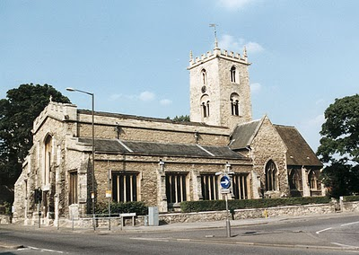St. Mary's parish church, although closed, still stands just south of the River Ouse in Bedford. A few blocks away are the Bedfordshire and Luton Archives.

For those of you cognizant of the names of early Virginia Hollimans, these Bedford names are nothing less than amazing. Remember our Christopher Holyman, Sr. arrived 1650 (the same year John died) along with a woman named Judith, believed to be his mother or sister. Another Christopher Holliman and another Judith arrived in 1653. Our Christopher Sr. was first married to a woman (our great grandmother!) named Mary.

Be aware, according to colonial records, a Thomas was already in Virginia at Martin's Hundred, one of America's first real estate developments (so to speak).

Now look at these names from the St. Mary's parish register of Bedford!

1576 - Thomas Holman baptized March 4 in Bedford.

1609 - A Thomas married Helena Poynard on Oct. 23. Their children are listed below.

1610 - September 16, one John Holliman baptized. BINGO! Is this our elusive John, the reputed American founder of our family who died in South Hampton, Virginia in 1650? John married a Mary Parrell on July 25, 1641.

1612 - On September 13, Ellenora Holliman baptized.

1613 - On November 14, Joan Holliman baptized.

1616 - Thomas Holloman baptized on March 20. Is this the Thomas of Martin's Hundred near Jamestown who took land in the 1630s?

1618 - Christopher Hollaman baptized on September 2. Is this our Christopher Holyman Senior who immigrates to Jamestown in 1650, raises a large family, makes his earthly fortune and dies 1691?! Is this my generation's 8th or 9th great grandfather?

1621 - Judith Holliman baptized on February 11. Is this the Judith who arrives in Jamestown with Christopher in 1650 or later in 1653?!

1623 - On May 14, Eleanor Hollyman baptized at St. Mary's.

1625 - Stephen Holloman baptized on December 24.

1628 - Mary Holiman baptized on September 13.

So the question is begged - have we found the Holyman family that settled in Isle of Wight, Virginia in the early 1650s?

If we have, then Thomas and Helena Poynard of Bedford, Bedfordshire are our English fore parents, and not John Holyman of Tring!

I will leave you here to ponder on the above, and to allow me time to gather further notes 'to push this envelope'. Again, this research belongs to Maxine, Joe and someone who entered the above in LDS records. My continuing thanks to them. If I have omitted others, please allow me to correct the record and give credit where credit is due.

This Holyman history gets more and more interesting....(if you are addicted to family history!)

TUESDAY, OCTOBER 26, 2010

When We Were English, Part XXIII
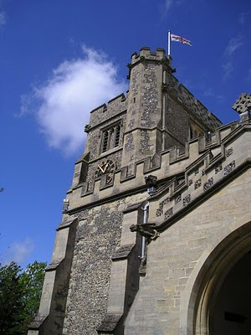by Glenn N. Holliman

Before We Leave England (for a while anyway)

As readers of this blog know, I have been writing of English Holymans (aka Holliman, Holloman, Holleman, etc.) for the past twenty-three articles, often from my research on-site in the Tring, Hertfordshire area. These articles owe much to the work of others who 'plowed ground' before me.

In this space, it is time to return to the Holliman story in the North American Colonial period, the 17th century when our ancestors arrived in Virginia. Before doing so, I want to sum up my findings (responsibility for errors and incorrect interpretations are mine) and suggest where more work is needed. (Above the parish church of St. Peter's and St. Paul's in Tring, Hertfordshire. Photo 2010 by Barbara Holliman.)

Findings

1. I have not found evidence that John Holyman (1572 - 1650) who died in Virginia is our great grandfather, nor have I found information that this elusive, but widely reported fore bearer of our family name, is from the Tring, Hertfordshire area. This person is recorded in a widespread web site as the 'founder' of the American Hollimans, and the father of Christopher Holyman, Sr. (1630 ca - 1691).

2. In and around the Tring area were many Holymans in the 15th to 17th centuries, some such as Ezekiel Holliman who immigrated to Massachusetts and helped found the American Baptist Church. Another Holyman was the Roman Catholic Bishop of Bristol (1495 - 1558) during the reign of Queen Mary Tutor. The 'manor' farm of The Rt. Rev. John Holyman still exists in Cuddington, Buckinghamshire and can be visited. I think it probable that these persons are distant cousins and great uncles and aunts.

3. Research by Joe Parker, Maxine Wright and others (LDS records i.e.) reveals that a Holyman family lived not far from Tring in Bedford, Bedfordshire in the late 1500s and 1600s. As I expounded in my last posting, these names - John, Thomas, Christopher and Judith - are the names that show up in recorded records in Virginia from 1630s to 1650s. I join Joe and Maxine in believing it highly probable this is our 'Founding Family'.

4. DNA testing conducted through Tina Peddie's good offices this summer revealed I and others are descendants of Christopher Holyman, Sr. (D 1691) of Virginia who immigrated from England in 1650 with his probable sister, Judith.

Work to be Done

1. Continue to research the Tring records in the 16th and 17th centuries looking for this John Holyman. There are more files and registers to explore.

2. Dig deeper into the family history of the Thomas Holyman family of Bedford (this Thomas was born in 1576). This can be done on-line and on-site at the Bedford-Luton Archives. I have plans to visit these archives in the spring of 2011, Good Lord willing. I note an LDS record lists Thomas Holyman's father as a John Holyman. As a wealth of information was found in the Hertfordshire Archives and Tring library, I strongly suspect a richness of material awaits a Holliman researcher in Bedford and at the National Archives in Kew (a suburb of London).

3. Establish relationships with Holyman's in Bedford and Tring and kindly ask for DNA testing.

4. Explore what ties exist between Bedford Holymans and Tring Hollimans. Geographically speaking, these communities are only twenty five to thirty miles apart, but in the 1500s, this was a two day walk. It is possible (probable?) that a Holyman from Tring moved to Bedford in the 1400s or 1500s and established a family.

5. Do not ignore other Holymans in England in the 17th century. A recent researcher on the Tina Peddie Hollyman chat room noted a Christopher Holyman was born in the early 1600s in Worcestershire, England. As with all genealogical research, be open minded and willing to change interpretations based on the evidence and critical inquiry.

To Summarize

Whether Tring or Bedford, the Holliman line is English, no ifs, ands or buts. Our great grandparents brought to Virginia the customs and culture of England - its forms of government, justice, religion and social mores. Of course, this culture was modified in a new environment that was, ironically, both hostile and welcoming.

To know from whence you come, study the history of England - it is our story. The Stuart, Tutor and Plantagenets - these are the monarchs of our family. The Normans, the Vikings, the Angles and Saxons, the Romans and Celts - these peoples too are part of our DNA, our genetic code, our human family.

Next posting, this story returns to Colonial America and the founding of a new nation.

MONDAY, AUGUST 8, 2011

When We Were English, Part XXIV
Back to England for More Research!
by Glenn N. Holliman
As I have written in earlier posts, in the spring of 2010, my wife and I did considerable research on the Holyman family in the Tring, Hertfordshire and Cuddington, Buckinghamshire areas of England. The two villages are approximately a dozen or so miles apart, and in the 15th to 17th Centuries contained families named Holliman (Hollyman, etc.)

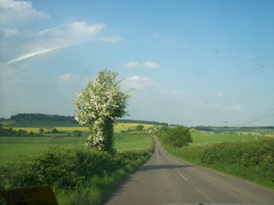

A highway leads from Cuddington, Buckinghamshire through the English countryside. The Rt. Rev. John Holyman and other Holymans were born in Buckingham, Bedfordshire and Hertfordshire in the 1400s and 1500s. More and more evidence suggests these persons are the ancestors of the Virginia Hollimans of the 17th Century.

As described several of these Holymans became prominent; one The Rt. Rev. John Holyman (1495 – 1558) was the Roman Catholic Bishop of Bristol, England and was caught up in the English Counter Reformation. Another Holyman, Ezekiel, a great nephew of Bishop Holyman, ironically helped found the Baptist Church in Rhode Island.

Additional research by cousins in the States in 2010 revealed parish records of St. Mary’s in Bedford, Bedfordshire, England that registered a Holliman family that in the early 1600s gave birth to children named, among others, Christopher (b 1618) and Judith ( b 1621)). Two persons with these names migrated to Jamestown, Virginia in 1650.

Judith disappears to history (probably married to one of the surplus males in the colony) and Christopher to marry, have six children and prosper financially. He left a plantation of 1,020 acres at his death in 1691, and is credited with being the founder of all the Hollimans and various spellings in the now United States.

And So to Bedfordshire
So in the spring of 2011, my wife and I sailed to England to research further the Holliman family (with its various spellings). In addition to American cousins doing considerable research, we have been assisted by a family researcher in Bedfordshire, one Peter Smith, seen below in the photo with the author in May 2011. We are reviewing materials over lunch at the Swan Hotel in Bedford, Bedfordshire, north of London.

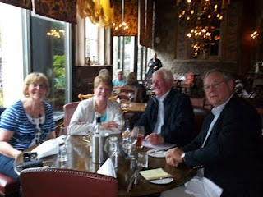
In May 2011, two couples met at the historic Swan Hotel in Bedford, Bedfordshire, England to review genealogical materials pertinent to the Holyman family. John Bunyan, author of Pilgrim's Progress, lunched here in the middle 1600s. Left to right are Maureen Smith, Barbara Holliman, my wife, Peter Smith, a family historian and member of the local genealogical society, and yours truly. One can observe that not all family history research and sharing occurs in a musty archives. More of that later.
Peter had not found (nor did I) Holymans in Bedford before the 1609 marriage of Thomas Holyman, and the subsequent birth of his children. Peter, in his research, however, had found a John Holman born 1560 in Woburn, Bedfordshire, approximately 15 miles south of Bedford and 15 miles north of Tring, Hertfordshire. This John married early – 1575, but no wife is named.
While young, it may have been a required marriage as one Thomas Holiman was born in Woburn in 1576. Two other children are recorded of that marriage – Robert, b 1581 and Joan, 1586, both born in Woburn. Hmmm…..interesting. Could this Thomas be Christopher Holyman, Sr.’s father? Some believe this Woburn, Bedfordshire Thomas is an ancestor of ours.
Next posting in Woburn, Bedfordshire....

SATURDAY, AUGUST 13, 2011

When We Were English, Part XXV
Are We Bedfordshire Holymans?
by Glenn N. Holliman
According to parish records, Thomas Holiman (Holyman) of Bedford, who may or may not have been born fifteen or so miles south in Woburn, married at St. Peter’s Church in Bedford in 1609 to Helenara Poynard. Roger Smith suggests the name Helena might be Eleanor, and Poynard, which is not yet found in other Bedford records, may be P’nard or Peynard. Spellings were not yet ‘settled’ nor are the handwriting of parish administrators always legible.

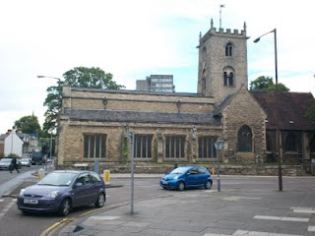
St. Mary's parish is today an archaeological trust facility, and has long since ceased to be a place of Anglican worship. The building and cemetery stand on a busy street corner, two blocks from the river and across the street from Bedford College. Imagine if you will four hundred years ago, no automobiles, only muddy streets, horse carts and the Holyman couple having their children baptized in this parish. How many of them now reside in the cemetery? We don't know.

Again according to parish records, this couple had the following children, all baptized at St. Mary’s Church in south Bedford, two blocks from the River Great Ouse (a wonderful name!).

John, b 1610 (was he named after a grandfather?)

Eleanor, b and d 1612 (may have been named after her mother)

Joan, b 1613

Thomas, b 1616 (named after his father)

Christopher, b 1618 (the believed to be emigrant to Jamestown, Virginia in 1650)

Judith, b 1621 (the believed to be emigrant to Jamestown, Virginia in 1650)

Eleanor, b 1625 (named after her mother and deceased sister)

Stephen, b 1625

Mary, b 1628

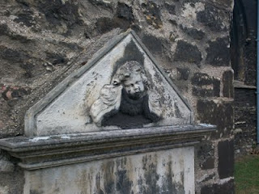

Tombstones were rare in 17th Century England (as in Virginia). This one of a grieving angel in St. Mary's grave yard, is only from the 1800s. Coal smoke and pollution have worn away the stone carving. The cemetery, like the church, is abandoned but the lawn is kept up and the grass mowed. Do our 8th great grandfather, Thomas, and his wife lie in these grounds?

As discussed in earlier articles, a John Holiman died in Virginia in 1650, and a Thomas Holiman (or Holman) took possession of land at Martin’s Hundred, Virginia in 1636. Are John and Thomas from this same family, and is this the encouragement that led to Christopher and Judith to leave for Jamestown, Virginia?

Encouragement Christopher and Judith undoubtedly had, but the 1636 Thomas in Virginia is most probably not the off spring of Thomas who married in Bedford in 1609. Parish records indicate a Thomas Holiman married in 1639 at St. Paul’s, Bedford, and my guess this is the second son of the 1609 marriage. Tragically, a son Matthew, died was buried at St. Paul's in 1640.

Next posting….a visit to Woburn and the Heritage Center there.

THURSDAY, AUGUST 18, 2011

When We Were English, Part XXVI
ARE WE WOBURN, BEDFORDSHIRE HOLLIMANS?
by Glenn Holliman

Woburn is the home of the Dukes of Bedford, whose families have occupied the Abby property there since the 1500s when Henry VIII dissolved the monasteries. For centuries the village was a staging station for travelers moving north and south from and to London, approximately 40 miles to the south. The town today was rebuilt after a fire in the early 1700s, and retains a Georgian architectural look as viewed in the photograph below.

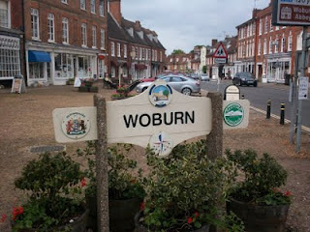

The name Holman concerns me. In other shires, Holyman is plainly written, as it is in Bedford St. Mary’s parish records. One grants handwriting is often a guess as many of the parish clerks were near illiterate in the late 1500s and letter formation had not yet finalized as it is in today’s English script.

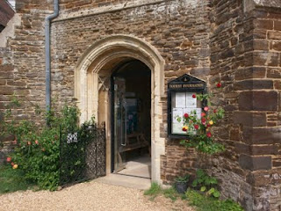

Photographed below is an index of Woburn parish records located in the Heritage Centre (pictured above - the former parish church which is now the museum and Centre). Beginning in 1538, Henry VIII’s chancellor, Thomas Cromwell, required all churches to record all baptisms, marriages and burials. This Cromwell helped convict Anne Boleyn of treason that led to her beheading. Later Chancellor Cromwell lost his own head to Henry’s bad temper!

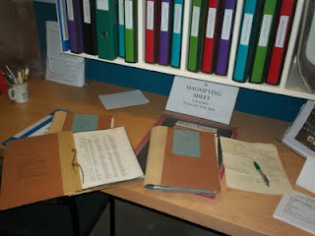

In these Woburn records (pictured above), one will find a host of Holmans
and Hollmans but that middle vowel is always missing, no ‘i’, ‘e’ , ‘o’ or ‘y’. Hmmm….There are numerous families whose head of households were named Robert, John, William and Thomas. There is even one Judith Holman, baptized February 16, 1609, daughter of Kath Holman and Henry Dally….hmmmm….born evidently out of wedlock.
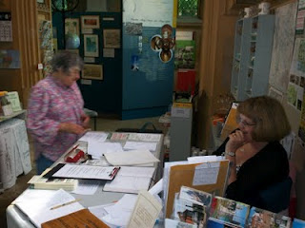
Above, as is common in England, kindly volunteers and staff do all they can to assist Americans in their search for English ancestors.

Yes, there is a Thomas Holman, son of Jn Holman, baptized March 4, 1576, but nary a Christopher born, married or died in Woburn between 1567 and 1670. But if Thomas moved to Bedford, married and had his children, one would not expect to discover such in Woburn. So Woburn cannot be ruled out totally even though the name does not quite match.

Let’s go back to Bedford and search some more.

TUESDAY, AUGUST 23, 2011

When We Were English, Part XXVII
A LOOK DEEP INTO THE BEDFORDSHIRE ARCHIVES
by Glenn N. Holliman

Last June, with the help of Bedfordshire family historian, Peter Smith (photo below), we explored the Bedfordshire, England Archives.

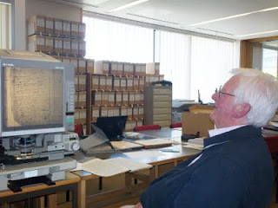

In addition to our reading microfilm of 17th Century parish records, the archivists (see photo below) open the files of the almost 400 year old Bishop’s Transcripts (copies held by the dioceses of parish records).

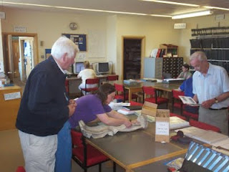

I held the transcripts and viewed the names of Christopher and Judith Holyman (see below), born in 1618 and 1621. The father’s name is given as Thomas.

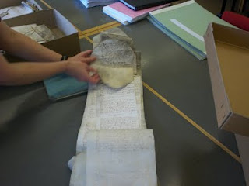

If there be any question about the authenticity of these two persons, that is put to rest.
Is this then truly the Christopher who sailed to Jamestown and inhabited the Isle of Wight County? Were there other Christopher’s in England at this time? Can we find more evidence to support the Bedford thesis or disprove it?

Can we find the birthplace of Thomas Holyman who married in 1609 and sired Christopher Holyman, born 1618? When did this Thomas die and where? The parish records do not tell us, yet.

Are there other places and archives in England to investigate?

Let’s keep looking….

MONDAY, AUGUST 29, 2011

When We Were English, Part XXVIII
ARE WE WORCESTERSHIRE HOLLIMANS?
by Glenn N. Holliman

Cousin Jeanette Holiman Stewart pointed out in 2010 that there were numerous Hollymans living in Worcestershire, England in the 1500 and 1600s, according to the International Genealogical Index. Could one of these Holymans be the origin of our Christopher Holyman, Sr., founder of the American family?

Could one be Thomas or John Holiman who lived in Virginia in 1636 and 1650 respectively? Or other Hollymans who appeared in the 1650s and 1660s?

Worcester is located 40 miles or so east by northeast from our cottage near Stow in the Wold, so we took a day and motored over to the Family Heritage Centre there.

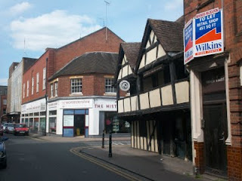
Above on the corner of this Worcester photograph stands the Heritage Centre of Worcestershire which holds many family records. We spent several hours exploring the files and local histories. Unfortunately the parish records were not indexed as in Bedfordshire, which means one must go through reams of microfilm, time which we did not have on this trip. Yes, there is more investigation to do in Worcester, but we found considerable Holyman information which I share in the next post.

The Tutor building in the foreground (above) is one of the oldest structures in the shire, dating back to the 1400s. Did some of our ancestors enjoy a pint of ale in that former inn, now preserved in a historical trust?

Oh, yes, many Hollimans lived in Worcestershire in previous centuries! They left many wills. Would we find evidence that this area, 80 or so miles west of Buckingham and Bedford Shires, could be the origin of the American Hollimans, or at least some of them?

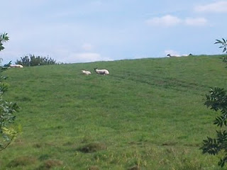

Just a few miles from the center of Worcester, one encounters a countryside still providing pasture of the sheep. Wool was and is a source of wealth for the English farmer. This particular pastoral scene (photo above) is in Leigh, Worcestershire. Many Holymans lived in and around this village in the 1500s.

My search of the various archives of England made very evident to me that groups of Holyman families lived in several parts of the country in the 15th to 17th Centuries. From where did they originate and why were they scattered?
Distant cousin Jim Maule of Philadelphia, Pennsylvania shared a theory with me recently as to why there are several locations where obviously dozens of Holymans lived. He believes the 14th Century Black Death and the decrease in available labor led many persons to move about the country, financially bettering themselves. Hence pockets of Holymans in several parts of England. Makes sense.

Next post, a listing of Holymans found in Worcestershire - they left many wills!

MONDAY, SEPTEMBER 5, 2011

When We Were English, Part XXIX
A Look at the Holymans of Worcestershire
by Glenn N. Holliman

During my visit to the Worcestershire Archives I explored several volumes. My first was Wills and Administrations , Volume 1, 1451 – 1600 by the Worcestershire Historical Society, 1904. These names are indexed for wills as follows. Unfortunately transcripts of the wills have not been published thus requiring, eventually, a look at all the wills to build a family tree.

Spellings of towns vary as certain names were spelled by sound.

1541 – Richard Holyman, Sturbridge.
1553 – Thomas Holyman, the Elder, Lye. (Leigh).
1558 – Elizabeth Holyman, Lyghe (Leigh).
1575 – Hufrey Holyma(n), Blakesall, Wolverley.
1582 – Thomas Holyman(n), Woluley (Wolverley), a M. bond to Alice Stower.
1593 – Thomas Holliman, husbandman, Lyghe (Leigh).
1596, Nov. 23 –William Holliman, victualer, St. Peter’s, Worcester.
1597, Feb. 13 – Thomas Holliman, husbandman, Leigh.

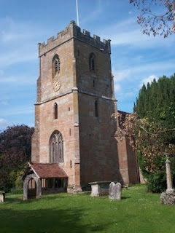
The parish church of St. Edburga at Leigh, Worcestershire. Holymans must lie in the church cemetery.

Then from Wills and Administrations, Probate Registry of Worcester, 1601 – 1652, one finds:

1607 – Roger Hollyman, labourer, Kidderminister.
1608 – Thomas Holliman, husbandman, Leigh.
1610 – John Holliman, Purshullgreene.
1611 – Humfrey Holleymon, yeoman, Wolverley.
1614 – Ann Hollyman, widow, Leigh.
1627 – Samuel Hollyman, Wolverly.
1629 – Francis Holliman, Chadisley (Chaddesley) Corbertt, a scythe smith left a total of 82 pounds (A sizeable sum in the 17thCentury. A scythe smith was a metalworker.)
1642 – Richard Hollyman, yeoman, Leigh.

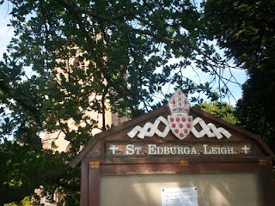

Next post, a few more Hollyman names and some thoughts....

SATURDAY, SEPTEMBER 10, 2011

When We Were English, Part XXX
Some More Names and Thoughts on Worcester Holymans
by Glenn N. Holliman
From the Calendar of Wills and Administrations of the Consistory Court of the Bishop of Worchester, 1661 – 1699, we have more names of Holymans who wrote wills. In Bedfordshire, there are few wills of Holymans; in Worcestershire during the same time period, many. Strange. The archivist in Bedford told me only about 5% of the population in that shire wrote wills in the 1600s. More did so in Worcester.

1672, Aug. 21, John Hollyman, Bromsgrove.
1687, May 9 – Hugh Hollyman, Leigh.
1691, Aug. 7, Thomas Holliman, Bromsgrove.

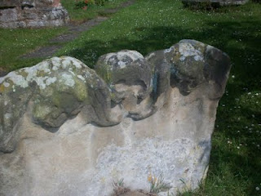
At the Leigh St. Edburga parish from a 1700s tombstone, these eroded figures of two children and grisly skull remind us that young people died often before reaching adulthood.
As my research time was limited, I cannot say that a Judith and Christopher Holyman or other Virginia Holymans did not come from Worcester. Additional hours must be dedicated to reading the microfilm of each will (looking for names) and parish records, as no parish index exists for Worcestershire (sigh…). Only then will be able to rule out or welcome Worcestershire as the ancestral home of at least some of the Hollimans. So much more work to be done.

BUT no name of Christopher or Judith leaped out as such as surfaced in Bedford, England. So for now, I still favor the Bedford Holymans as the origin of our Virginia family.

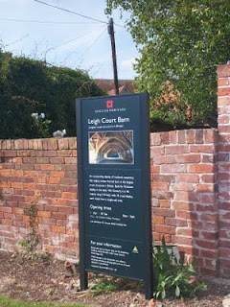
Adjacent to St. Edburga parish is the medieval tithe barn, now maintained by English Heritage. Members of the community were required to support the church (and the civil functions it carried out) through a 10% 'tax' on their harvest. Hence the need for a parish barn to hold the 'tithe'.
A closing thought – the Severn River runs south from Worcester into the Bristol Channel. Bristol, we are told by historians, was the chief port for English relocating to the American colonies. So if one wanted to immigrate to America, Worcestershire would be a convenient location from which to begin an odyssey to the New World.

Therefore as a note of interest, as Christopher and Judith Holyman were transported to Virginia in 1650 sponsored by a man named John Cox, I found this recording in “The Complete Book of Emigrants, 1607-1660” by Peter Wilson Coldham, Baltimore, Genealogical Publishing, 1987:

“April 9, 1650 – Sir Henry Chicheley to be released and allowed to pass to Virginia on the usual security . Pass also for Thomas Cox and Robert Pigge to go to Virginia.” Hmm....

Next a visit to the Buckinghamshire Archives, still searching for the ancestors of Christopher Holyman, Sr. (1618 - 1691)....

SUNDAY, SEPTEMBER 18, 2011

When We Were English, Part XXXI
ARE WE BUCKINGHAMSHIRE HOLLIMANS?
by Glenn N. Holliman
As one recalls in 2010, I began my research in Hertfordshire before discovering the Holyman 15th Century farm in Cuddington, Buckinghamshire. So in June 2011, after exploring the Shire Archives in Bedford and Worcester, with the help of family historian, Peter Smith, delved into the Aylesbury, Buckinghamshire Archives.
And there, I found treasure!
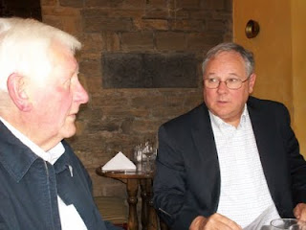
Family history 'detective' Peter Smith and the writer discuss findings over lunch.
A look at the Buckinghamshire Probate Records wills index revealed a plethora of Holliman names. Unfortunately, the wills are not printed out but must be viewed in the original one at a time. Here are their names. Note the ones from Cuddington, the home of the former Holyman Farm and manor house.
1521 – John Holyman, Cuddington. (see articles posted August 15, 2010 for all Cuddington names) I insert a note here on August 2012. My research now indicates this John Holyman (d 1521) is the father of John (d 1531) who is the father of Thomas Holyman (d 1558) who is the father of Christopher of Cuddington/Sherington (d 1688) who is the father of Thomas of Bedford who is the father of Christopher, Sr. (1618-1691). GNH
1525 – Joan Holyman, Chesham, Leicester.
1525 – John Holyman, Chesham.
1525 – William Holyman, Chesham.
1533 – John Holyman, husbandman, Cuddington.
1545 – William Holyman, husbandman, Cuddington.
1547 – Elizabeth Holyman, Cuddington.
1557 – William Holliman, husbandman, Cuddington (estate valued at 18 pounds).
1558 – John Holyma(n), husbandman, Cuddington.
1573 – Leonard Holyman, weaver, Cholesbury. (see article posted September 7, 2010 for Leonard Holyman)
1589 – Christopher Hollyman, Sherington, testator. (Yes, my eyes doubled, nay tripled, in size when I spotted this one!)
1598 – John Holyman, weaver, Cholesbury.
1600 – John Holyman, husbandman, Cuddington
1603 – Francis Holliman, yeoman, Cuddington.
1607 – Richard Holyman, labourer, Haddenham.
1618 – John Holeman, shoemaker, Newport Pagnell.
1623 – Thomas Holliman, the elder, yeoman, Cuddington.
1624 – Joseph Hollyman, Haddenham.
1638 – Robert Hollyman, yeoman, Cuddington.
1648 – Richard Holyman, yeoman, Haddenham.
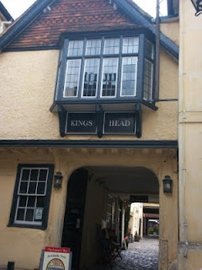
Several blocks from the Aylesbury Archives is the Kings Head Pub, one of the few ever listed in England's National Trust. Henry VIII and Anne Boleyn spent the night here on at least one occasion. Whilst in the Archive's the wives of Peter Smith and Glenn Holliman retired for a repast here (after some shopping on High Street!)
Next Post - following up on Christopher Holyman (1589)!

TUESDAY, SEPTEMBER 27, 2011

When We Were English, Part XXXII
A Treasure Found - the Will of Christopher Holyman, 1589! by Glenn N. Holliman
I could not look at all of the Holliman wills in the Buckinghamshire Archives, but three that seemed to match time, place and name, I explored closely. Now I am not talking about microfilm.
The actual wills were hand carried to me by a lady garbed in a white coat, much like a physician. She placed three 'ancient' parchments in front of me on a pillow so bindings would not break, and then (gasp) with my uncovered but clean fingers, I turned the pages and held in my 21st Century hands a will signed in 1589 by Christopher Holyman!!!

Was I holding a document signed by my 9th great grandfather???? Could this be the grandfather of Christopher Holyman, Sr. (1618 – 1691) of Isle of Wight, Virginia? Let me tell you what I found and what it may, repeat, may mean.
Click twice and the document should enlarge. I have yellowed the names, the first one being Christopher Hollyman! Note Thomas Hollyman is the second child.
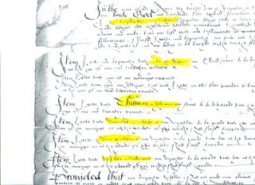

1. This Christopher Hollyman lived in Sherington, Buckinghamshire.

2. He had children, whose names I make out to be:

A. John
B. Thomas, a minor in 1589
C. Dorothy (?), a minor
D. Ellin, a minor
E. (?) lloy, a minor
F. Ami, a minor
The wife’s name was Margaret. He appointed his brother, Thomas Hollyman, as executor. Were these persons my 9th great grandmother and a very great uncle?
Yes, for 4 pounds, 20 pence (about $7) I asked for a copy of the will. It did not reproduce well but here is part of it above. But there was the signature by an English Christopher Hollyman – chills down my back at this point at this point. Darn, I forgot to film the document, I was so excited.

So I race to the Sherington, Buckinghamshire parish records to ascertain the baptism records, marriage and burial records of this Hollyman family. Tragedy!! No parish records from Sherington UNTIL 1603. Curses, no way to find out the birth dates of the children.

What next?

TUESDAY, OCTOBER 4, 2011

When We Were English, Part XXXIII
ARE WE FROM SHERINGTON, NEAR MILTON KEYNES, BUCKINGHAMSHIRE? by Glenn N. Holliman
On a tip from Buckinghamshire family historian Peter Smith, I ventured in June 2011 to the local history section of the Milton Keynes library, about 15 miles north of Aylesbury, Buckinghamshire. Hopefully there I would find the missing parish records of Sherington, Buckinghamshire, looking as I was for more information on Christopher Holyman (d 1589).
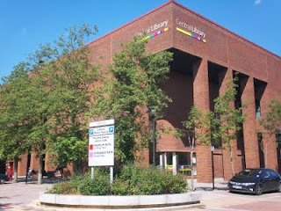
The modern library and local history room in Milton Keynes is located a 1960s planned development section featuring plenty of parking, rectangle office, brick store blocks and urban boredom.
Milton Keynes is a medieval market town that received a planning make over in the 1960s. Now a ‘planned community’ of round-abouts and rectangular business plazas, several blocks in length, it does feature plenty of parking even if there be a dreary sameness to its governmental and commercial centre. Charm, there is none.
Alas, the parish records I sought were still ‘missing’ and after several hours of squinting at microfilm of 17th Century wills, baptisms and burials from 1603 to 1720, I came up with precious few clues on the Holyman family. However, sometimes it is not what one finds, but what one does not find. Evidently, the Holyman family, citizens of Sherington in the late 1500s, did not live there in the 1600s after this 1589 Christopher’s death.
So where did the children go? To Bedford twelve or so miles away and a thriving community in the early 1600s especially if one be a second son, such as Thomas Holyman?
Well, as I was about to leave (my parking was expiring), I glanced at the shelf of local parish publications. My eye caught a title – “Fiefs and Fields of a Buckinghamshire Village” by A.C. Chibnall. The work was published in 1965 by Cambridge University Press of Cambridge. I flipped to the index, not expecting to find anything, when, lo and behold, up popped the names Christopher Holyman and Thomas Holyman!
On page 178 of the work, I find this: “Two leading inhabitants (of Sherington) Edward Ardes and Christopher Hollyman, visited the bishop in 1575 in Buckden to lodge a complaint on rector Henry Barlow, a dissolute fellow.”
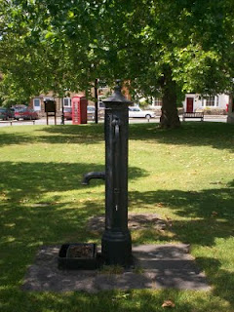
Ye ole village pump stands even today on the small village green in Sherington. The now disappearing British Telephone red box is in the background, and across the street, a closed facility labeled, I think ironically given our family history, the Virginia Store!
Another page over on 179, the author reports Christopher Hollyman serving in Queen Elizabeth’s guard and leasing the rectory for 50 pounds annum. This Christopher Hollyman (p. 188) died in 1589 after securing more land from his ‘good friend Richard Ardes’ (probable son of Edward Ardes).
Remember in his 1589 will, Christopher Hollyman records a second son, a minor, named Thomas Hollyman. Well, on pages 193 and 194 of Chibnall’s tome, we are told of a grammar school, 6 or 7 miles from Sherington in Lathbury. One of the 14 boys listed as attending in 1596 was a Thomas Hollyman! This would make him the right age to be married in 1609 twelve miles away in Bedford!
The circumstantial evidence is building that we have found the father and grandfather of Christopher Holyman, Sr. (1618 - 1691)....

TUESDAY, OCTOBER 11, 2011

When We Were English, Part XXXIV
Have We Found the English Family of Christopher Holyman, Sr. of Virginia? by Glenn N. Holliman
Let’s play family history detective. Here are the facts and what can be deduced.
Christopher, according to family historian Peter Smith of Bedfordshire, was an uncommon first name in the 1500s and 1600s, so locating the name in 1589 is important. In all my research, I have not found it ANY WHERE ELSE in England attached to the surname Holyman or one of its various spellings, except, of course, for the 1618 birth of Christopher Holyman in Bedford.
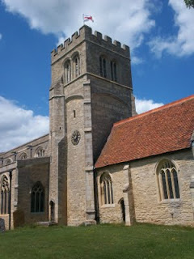
The parish church in Sherington, Buckinghamshire is named after St. Laud of France. It is just possible that my generation's 9th great grandfather, Christopher Holyman's dust, may be embedded in the grounds surrounding this 19th Century restoration.
First names are often repeated from one generation to another. Thomas of 1589 and 1595, is he the same Thomas Hollyman who marries in Bedford, Bedfordshire at St. Peter’s in 1609?

And the Christopher Holyman born in Bedford in 1618 to Thomas, is he a grandson and named after the 1589 Christopher of Sherington, Buckinghamshire?

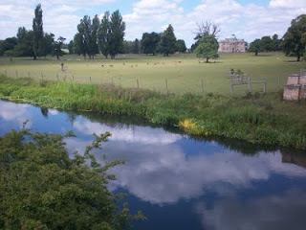
The Great River Ouse (yes, that is the name of this lazy 'river') flows from Sherington to Bedford. Here the stream meanders past Tyringham House, a great county estate a few miles west of Sherington. Yes, the river flows west for a bit and then turns north and finally east, moving through Bedford and eventually to the North Sea.
Sherington is upriver on the Great River Ouse which flows through Bedford, two blocks from St. Mary’s parish where Christopher Holyman, b. 1618, was baptized. Sherington is approximately 12 walking miles from Bedford. Hmmmm.....

We can find no records of Holymans in Sherington parish records after 1602 (and no records exist prior to 1603, except 1576 and no Hollymans that year).

No records exist in Bedford, Bedfordshire prior to 1609 on Hollymans.

No records exist in Bedford recording the death of Christopher Holyman, b. 1618, or his sister, Judith, b 1621, in Bedford. (Of course not if they died in Virginia!)
The clues point to a connection....

WEDNESDAY, OCTOBER 19, 2011

When We Were English, Part XXXV
A Cuddington, Buckinghamshire Connection? Maybe So
by Glenn N. Holliman
In the 1580s, Robert Holyman of Cuddington had real estate dealings with Thomas Tyringham, whose home was in the near village of Nether Winchendon, Buckinghamshire, and may have had family in Tyringham near Sherington. (See article posted July 28, 2010) Could a Robert Holyman relative be our Christopher Hollyman of 1589 in Sherington? Could this be the tie to the Cuddington Holymans, approximately 30 miles south of Sherington?

A scenario can be constructed that Christopher Holyman, Sr. who died Isle of Wight, Virginia in 1691, was the son of Thomas Hollyman, probably born in Sherington, Buckinghamshire who by 1609 was earning a living in Bedford, Bedfordshire and married that year at St. Peter’s parish.

And this Thomas, a second son who inherited some assets, but not family property, from Christopher Holyman (will of 1589) of Sherington, is the same Thomas Hollyman who went to grammar school in Lathbury, Buckinghamshire in 1595.

And while more research is needed, this 1589 Christopher Hollyman of Sherington may have moved to the area from the central part of Buckinghamshire, the Cuddington, Tring or Cholesbury area, perhaps being born sometime from 1520 to 1550. Perhaps!

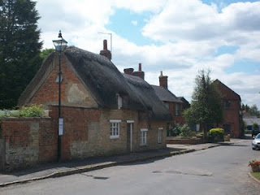
Thatched roofs in Sherington, Buckinghamshire. Did Holymans centuries past sleep and live under threshes?
Now who then is the Christopher 1589’s father?!!! Are we on the edge of taking the family tree another one hundred years or so back in time, to the time when The Rt. Rev. John Holyman, Counter-Reformation Bishop, was born in 1495 in Cuddington, Buckinghamshire? (See blog article of September 2010.)
Notwithstanding the significant number of Holliman families in Worcestershire, is this Christopher Hollyman of Sherington, Buckinghamshire the grandfather of the Christopher Holyman who sailed to Virginia in 1650? Have we found my generation’s 9th great grandfather?

And indeed, are we a few more bits of research from tying the Cuddington/Tring Holymans to the Sherington and Bedford Holymans? Are we pushing the family history back to the 1400s!

SATURDAY, APRIL 7, 2012

When We Were English, Part XXXVI
Additional Clues to our British Origins
By Glenn N. Holliman
In the summer of 2011, cousin Bob Holloman informed me that he had found a reference on the web to a work held by the National Library of Wales at Aberystwyth. It was entitled "Hollyman, A One-Name Study, Volume I" and was written by Bob Hollyman-Mawson.
Encouraged by our American Bob to make contact with the English Bob, who lives in Carnarvon, Wales, I subsequently achieved this aim on Facebook. After a favourable response, we corresponded via email, which resulted in a visit to the west Welch country by yours truly in November 2011.

Robert Hollyman-Mawson has proved a wealth of family information and put me into contact with other Hollymans in the U.K. His work also gave me an essential clue as to the American Holliman’s origins in England, an important piece of information I discuss in the next posting.
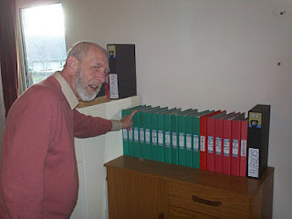
Bob Hollyman-Mawson, left in photo, has an organized and comprehensive collection of records on the last 400 years of his Hollyman ancestors. Pictured are just a portion of his volumes of meticulous research maintained in the study of his Carnarvon, Wales’s home.

Born in Kirkby-in-Ashfield, Nottinghamshire, England, Bob has lived all but a few months of his life in Wales in historic Carnarvon where the Princes of Wales are invested. A Royal Navy sailor in his youth, he is active in veteran organizations and is an avid student of U.S. Civil War history. A Hollyman descended through his mother and grandmother, he has amassed records of Hollymans (and associated spellings) from around the world. Bob is now preparing materials to post on his future website in due course.

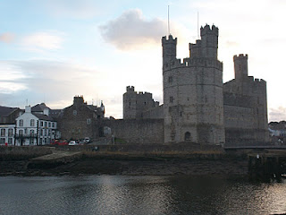
Carnarvon Castle overlooks the harbour of this former Roman settlement, the most western outpost in Britannia of that ancient empire. The white building to the left of the archway is called the Anglesey Hotel, which overlooks the Menai Straits and the Isle of Anglesey. This is where I stayed the night during my visit to Carnarvon.

Below are the ruins of a Roman settlement now looking west to the city of Carnarvon. On this 1,800 year old site are the remains of the Segontium Roman Fort, which reposes both adjacent to and across the way from Bob's place of residence.
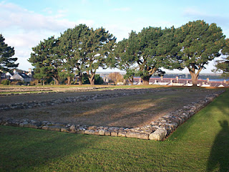
Carnarvon, a historic Welsh city which incorporates thousands of years of human habitations, reminds American Hollimans of the complexity of our British heritage. We are composed of Neolithic, Celtic, Roman, Angle, Saxon, Jute, Danish, Viking and French Norman DNA.
Mix this together, stir for several thousand years and one becomes British. Sail to the New World, add yet more cultures and races, plus several hundred additional years and one becomes an American.
More on Bob Hollyman-Mawson and his insights in the next post….

SATURDAY, APRIL 14, 2012

When We Were English, Part XXXVII
Additional Evidence of Buckinghamshire Roots
By Glenn N. Holliman

This article continues my series on Holliman English Roots and my 2011 revealing visit with another Holliman genealogist, Bob Hollyman-Mawson of Carnarvon, Wales. The photo below captures Bob along the Carnarvon waterfront. Bob has always felt the call of the sea serving aboard a British aircraft carrier in the 1960s. During my visit to his sea port city in late 2011, we explored our families' histories.
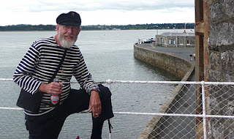
In previous articles at this site, I have presented evidence that American Hollimans have English roots. A quick summary of my thesis is as follows:

- Christopher Holyman, Sr., who arrived in Jamestown, Virginia in 1650 and died in 1691, had been born in 1618 in Bedford, Bedfordshire, England, (My generation’s 7th great grandfather)

- and that his father was Thomas Holyman of Bedford, who was schooled and raised in the late 1500s in nearby Sherington, Buckinghamshire, and is listed in his father’s will as a second son, (If this thesis be correct, Thomas is my 8th GGF)

- and that Thomas’s father was one Christopher Holyman whose will was administered in Sherington, Buckinghamshire in 1589, (Making this Christopher my 9th GGF)

- and now thanks to information provided by Bob Hollyman-Mawson, the above Christopher, according to his will, died in 1588 in Cuddington, Buckinghamshire, evidently Christopher’s childhood home and the location of a prominent Holyman family.

- and further in 1558, one Thomas Holyman died in Cuddington and in his will left legacies to several children, one being a Christopher Holyman! Serious question – is this Christopher Holyman the gentle man who died in 1588 in Cuddington and whose will was proved in Sherington, 30 or so miles north, the same Christopher listed in this 1558 will?
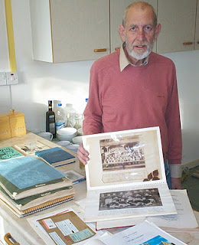

Right, Bob Hollyman-Mawson shows a display and photographs of his Hollyman research. He has in hand information from the original records concerning the wills of Christopher Holyman (1589) and Thomas Holyman (1558), both of Buckinghamshire, England.
Bob is a post-graduate of the University of Wales, Bangor where he earned an honours degree in Linguistics with the English Language as well as a Certificate in Teaching English as a Foreign Language. He is fluent in the Welsh language, still spoken by over a million persons.
Is this Thomas Holyman who died in 1558 in Cuddington my generation’s 10th great grandfather?!
If so, then we seem to have found the missing piece of evidence tying the American Holymans to the paradoxical families of The Rt. Rev. John Holyman, Roman Catholic Bishop of Bristol, and enemy of the Reformation and Ezekiel Holyman, a Nonconformist and a founder of the Baptist Church in Rhode Island, USA!

Next posting, the quest continues....

SATURDAY, APRIL 21, 2012

When We Were English, Part XXXVIII
by Glenn N. Holliman
Questions Concerning Those English Ancestors...
In previous posts, I shared some startling information provided by the research of Bob Hollyman-Mawson of Wales that my generation's tenth great grandfather was quite possibly Thomas Holyman of Cuddington, Buckinghamshire.
This Thomas, whose will was probated in 1558 in Cuddington, is of the same family that produced two outstanding Roman Catholic and Protestant leaders in the 16th and 17th centuries.
So what additional must be done to drive even deeper into the Holyman past? Being a Holliman, I made a list and here it is.
1. Learn more about Christopher Holyman who died in 1588, the suspected grandfather of our Christopher Holliman who died in 1691 in Virginia.

2. Study carefully the original will of Thomas Holyman (1558) of Cuddington, Buckinghamshire.

3. Discover the name and details of this Thomas Holyman’s father and ancestors.
4. Ascertain how long the Holyman family had been in the Cuddington, Buckinghamshire area. Additional information is now surfacing from another source, family genealogist Peter Smith of Bedfordshire, suggesting that the Holyman’s may have originated in London. So it is back to the Buckinghamshire Archives I will be going, probably with the assistance of my good friend below.
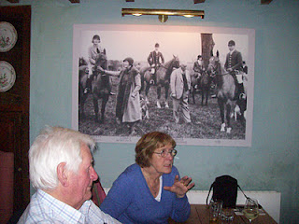
Above, in the fall of 2011, family historian Peter Smith and his wife, Maureen, discuss English history with the writer at the Swan Inn, Swinbrook, England. The photograph in the back ground is of the famous Mitford family that lived in Swinbrook in that lovely part of England called the Cotswolds.
Peter believes the Hollyman families emerged from the London area before moving north and west to Buckinghamshire, Hertfordshire, Worcestershire and Somerset during the late Middle Ages.
5. Discover how connected Bob Hollyman-Mawson’s family, whose origins are in the Bristol and Somersetshire, England area of the middle 1600s, is to the Buckinghamshire Holymans. Below, Fred Cooper, left, of Bristol, England, another Hollyman genealogist, discusses outside of his home November 2011 with this writer his thoughts on Somerset Hollymans. Fred has written a 400 page tome (which I am holding) on his research into the family since the 1600s. Soon, I will be sharing Fred's incredible research with readers.
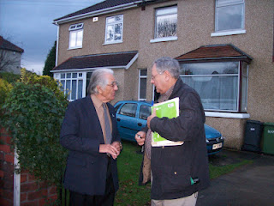

But before exploring the probable Somerset and Buckinghamshire Holyman connections and Fred's excellent work, let’s continue our close look at the Holyman’s of Cuddington….

MONDAY, APRIL 30, 2012

When We Were English, Part XXXIX
A Deeper Look into Buckinghamshire Roots
By Glenn N. Holliman

Cuddington, some nine miles from Aylesbury and forty or so miles east of London, was and is a small village. There is a pub and an ancient village church. If you look below at this hand drawn map provided by Carolyn Stonham, a professor who lives in Holyman House (1698) on the site of the 15thCentury Holyman Manor House (long since decayed), one can understand better the dimensions of the small town.

This map is in three parts. The bottom half shows Cuddington in relationship to Aylesbury (right) and the M-40 (left), a major motorway which flows west toward Oxford and east toward London.

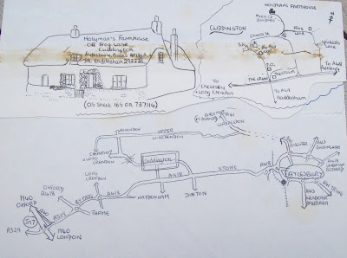

The upper right part of the map is a visual of the village with the Holyman Farm in the upper middle. The left upper part of the map is the 1698 Holyman House where Professor Stonham lives today, a thatched roofed cottage. Unfortunately the remains of sticky tape have marred the map a bit.

If one recalls my last article, I advanced the thesis that one Thomas Holliman of Cuddington (will – 1558) is a direct grandfather of mine. Hmmm…if so who begat Thomas and when and from where did these Cuddington Holymans appear?

Below is another document Professor Stonham shared with me and which my wife copied with our digital camera. This is a muster and tax roll representing two generations. The muster certificate is from 1522 and the manorial survey from 1555.

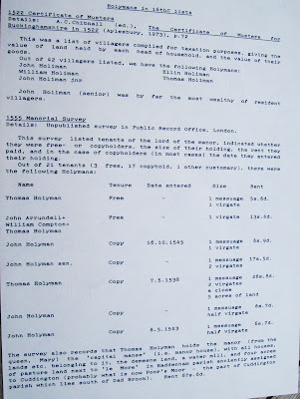

Notice that a Thomas Holliman is listed on both. In the earlier document, John Holiman is the wealthiest. In the later document, Thomas Holyman (Holiman) is recorded as the person with the most wealth. Is this Thomas my generation’s 10th great grandfather?

This Thomas Holyman did quite well, holding the manor and land granted by Queen Mary Tudor. Let’s reflect a bit….Mary Tudor tried in her reign from 1553 – 1558 to restore the Roman Catholic Church to England. Her Cardinal Pole appointed a parish priest and former monk, John Holyman of Cuddington, as Bishop of Bristol. John died in 1558, one month after Queen Mary.

Did the Holyman family in Cuddington benefit from the benevolence of the Queen because the family, especially The Rt. Rev. John Holyman, was loyal to the old faith, the Roman Catholic Church?

Did the fortunes of the Holymans begin to unravel with the establishment of the Protestant Church of England during the long reign of the next queen – Elizabeth from 1558 – 1603?
Did the surviving Holymans flow with the times?

One notes from published sources that Christopher Holyman (will – 1589) of Cuddington and Sherington is listed as a member of Queen Elizabeth’s guard. Hmmm….much to consider and a lot of questions that cannot be easily if ever answered.

Let's keep researching and pondering....

SATURDAY, MAY 12, 2012

When We Were English, Part XL
by Glenn N. Holliman

That Holyman Manor House

Below is the site of the 15th Century Holyman Manor House in Cuddington, Buckinghamshire as it looked in 2010. Today it is pasture land as part of the remaining Holyman farm.

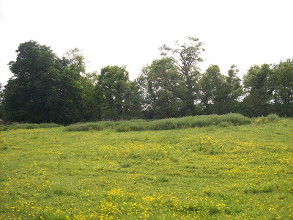
In 1851, a survey was done of the farm and the document below records what was left over a century and a half ago.

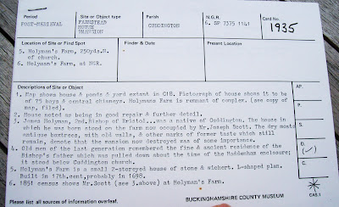

Notice item 3 above in this statement about a post-medieval site. James (an error; it is John) Holyman is listed accurately as the 2nd Bishop of Bristol. A Mr. Joseph Scott lived on the property in the middle 1800s. Dry moats, box trees and old walls still stood at that time and that ‘the mansion now destroyed was of some importance’. Item 4 states that house lasted until the early 1800s. A smaller 1698 stone and thatched cottage as well as stables do remain in 2010.

What might have this manor house looked like?

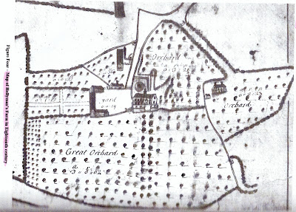
The map above from the 1700s gives us some idea of the size of the farm and a look at the Holyman manor house. It appears to be three floors (dormer windows and attic as the 3rd floor) with a small tower and wind vane on top center.

By the 1700s, the Holymans must have been producing considerable cider judging from the number of apple orchards.

What more can be learned? I must return to the archives in Aylesbury, Buckinghamshire for more research. For now, thanks to the current owner (Caroline Stonham) of the Holyman farm in Cuddington, we have the above and a view into our ancestral past.

Next a Visit to more Hollymans in the United Kingdom!

SUNDAY, MAY 20, 2012

When We Were English, Part XIL
A Visit with Distant Cousins
by Glenn N. Holliman
After visiting Bob Hollyman-Mawson in Carnarvon, Wales, United Kingdom in November 2011, he and I drove over to the quaint village of Porthmadog to rendezvous with a retired chemist (that's a pharmacist in the U.S.), another Hollyman. Peter Hollyman's family left Somerset in the 1800s and moved to Cardiff and other cities across the channel from England.
Peter Hollyman on the left below and Bob Hollyman-Mawson do what Englishmen do when in Wales (or England or Scotland) and that is enjoy a glass of bitter at lunchtime. This picture and others were taken in Porthmadog which lies at the foot of the Snowdonian mountain chain.
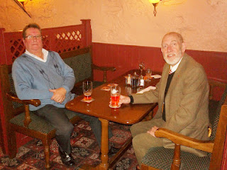
Peter is retired after a career as chemist and owner of several shops. His grandparents hail from Somerset, but the family moved to Cardiff in the 1800s. In time, Peter matriculated at the University in Cardiff, Wales majoring in pharmaceutics. After a stint in London, he moved his growing family west to Wales in the middle 1970s.
Below, three distant cousins in Wales on a blustery day in November 2011. Left to right and enjoying life after six decades are Bob Hollyman-Mawson, Glenn Holliman (the writer of this blog) and Peter Hollyman.
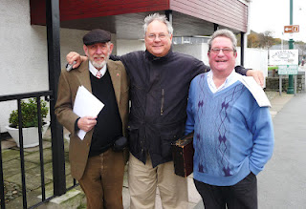
What I learned from Peter is, that like Bob, his family came out of Somerset near Bath, England. Unfortunately the family research cannot take either back past the early 1600s. Question - how are the Somerset (and now Welsh Hollymans) related to the Holymans of Buckinghamshire in the 1500s? Did the Rt. Rev. John Holyman (1495-1558) take along some nephews with him when in 1554 he assumed the Episcopate in the Diocese of Bristol? Bob has some hints he and I will share later in other posts.
Another theory is that Hollymans in Worcestershire floated down the Severn River (easy enough to do) and landed in Somerset. As I wrote last year in this space, we have records of Hollymans (spelled several ways of course) inhabiting the west country of England.
Below, Peter Hollyman points to Transportation Island in the Porthmadog bay where ships used to drop their ballast and load Welsh slate from the Snowdonian mountains. Peter is pointing also to the east, and to the east I drove to learn more about the Somerset Hollymans.
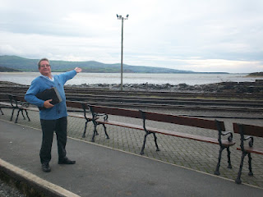
In later writings, more about our United Kingdom roots thanks to cousins such as Bob and Peter....

Wednesday, August 8, 2012

When We were English, Part XIIL -A Visit to Fred Cooper of Bristol, England - a Hollyman Family Researcher Extraordinaire by Glenn N. Holliman
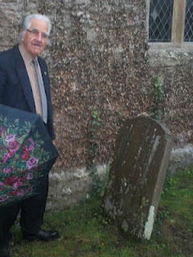
As I have written on more than one occasion, meeting and visiting with cousins, near and far, is one of the delights of family history. Thanks to a generous introduction by Bob Hollyman-Mawson, an English cousin who lives in Wales, my wife and I enjoyed a November 2011 day touring with Fred Cooper, a retired engineer, living in Bristol, England.
Although the showers flowed from the heavens during much of our expedition, we all three enjoyed a pub lunch and looked upon the many monuments of Hollymans in Somerset who have lived before us.
In 2011, Fred Cooper with an ubiquitous British umbrella led us on a fascinating tour of various cemeteries and parish churches where his wife's ancestors, Hollymans, are resting. This photo was taken at the parish church in Abotts Leigh on a hill overlooking the Gordano Valley.
Fred's late beloved wife, Sheila Wallace Cooper, is a Hollyman, descended through her mother, Caroline Hollyman Wallace, late of Abbots Leigh, a small farming community west of Bristol, Somerset, England.
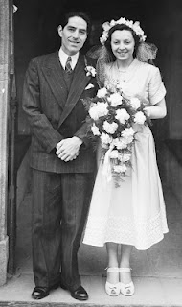
Right, Fred and Sheila on their wedding day in the 1952. It proved to be a most happy marriage producing two surviving sons. Sheila's grandfather was Alfred William Hollyman and great grandfather, John Hollyman. All were farmers living in the community of Abbots Leigh in Somerset.
Since the 1700s, these families of Hollymans have lived also in other Somerset villages such as Kenn, Clevedon and Clapton overlooking and in a picturesque valley known as Gordano. Today the busy M-5 runs through the lush green valley south to Devon.
In the 1800s, part of the family crossed the Severn Estuary, and settled in Wales, ancestors of Peter Hollyman of Pwllheli, whose story and pictures were displayed in an early blog article. (Go to the Archives feature of this blog and type in Peter's name to refresh one's memory.)
Below the map helps our understanding of places. X marks the location of Abbots Leigh, just west of Bristol, England. Further west and south is Clevedon, where another major Hollyman branch settled and thrived. The body of water bordering Clevedon is the Severn Estuary which divides England from Wales. Note the major motorway, the M5 running north and south through the Gordano Valley.
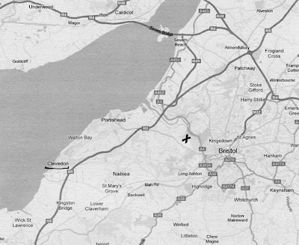
Next post we continue to explore Hollyman sites in Somerset....

Thursday, August 16, 2012

When We were English, Part XIIIL
by Glenn N. Holliman
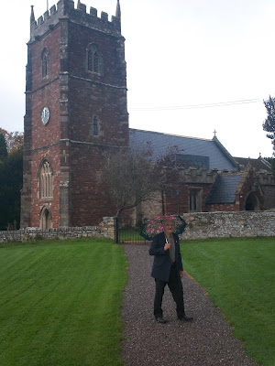
A Visit to Abbots Leigh, Somerset....
Fred Cooper on a showery day stands in front of The Church of the Holy Trinity, Abbots Leigh, where his wife and her ancestors rest.
In the late autumn of 2011, distant cousin Fred Cooper, who married into the Somerset, England Hollyman family, took my wife, Barb, and me on a tour of Hollyman sites west of the Cathedral city of Bristol, England.
Readers of this blog will remember that from 1554-1558, one John Holyman, served as Roman Catholic bishop of the Bristol diocese. John Holyman as born in Cuddington, Buckinghamshire, and after a dangerous career in the priesthood during Tudor times, held the Episcopate during the reign of Mary Tudor.
Fred pauses by a Hollyman family memory stone. In honour of his believed late wife, Sheila Wallace Cooper, whose mother was a Hollyman, Fred has gathered an impressive amount of genealogical data on her family. At his passing, Fred intends that a copy of the massive work on Somerset Hollymans goes to the Bristol archives.
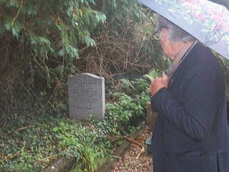

The village of Abbots Leigh has a fascinating history. While on the run after his disastrous defeat at Worcester in 1651, Charles II took refuge in the manor house in Abbots Leigh. He rested for three days before moving on. As several histories of the era state, the Norton family, who sheltered the disguised stranger, had no idea who he was until after he had left!

While staying at Abbots Leigh, Charles deflected suspicion by asking a soldier, who had been in the King's personal guard, to describe the young King's appearance and clothing at the recent battle. The trooper looked at Charles and remarked, "The King was at least three inches taller than you."

Today the historic Monarch's Way footpath passes through the village. Horse riders in 2011 take advantage of a modern roadway to find their own way through Abbots Leigh on a rainy day.
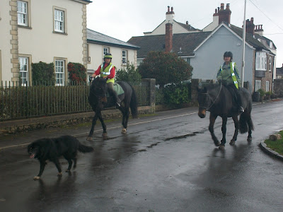

Next more Hollyman ancestors in Abbots Leigh....

Thursday, August 23, 2012

When We Were English, Part XIVL
by Glenn N. Holliman
The Hymn of Abbots Leigh
In 1942, England was fighting in the third year of World War II. The Americans had entered the war but had their own serious troubles in the Pacific. The Soviets faced the bulk of Hitler's armies. The British Army struggled with Rommel's African Corp, and Nazi U-Boats sank record numbers of ships off the U.S. coast and throughout the North Atlantic.
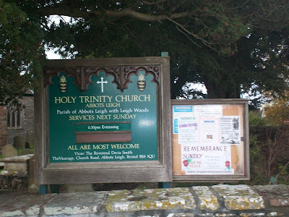
After the 1940 Blitz, the British Broadcasting System had moved its wireless service from bombed out central London to Bristol, a long stone's throw from Abbots Leigh. As Internet references state, the BBC needed a new melody for a popular inspirational hymn that up until then had been set to the same tune as 'Austria', a German speaking country then incorporated into the Third Reich. Such just would not do during wartime.

A BBC composer, Cyril Vincent Taylor, an occasional Precentor of Bristol Cathedral, lived near Abbots Leigh, and composed in those dark days of 1942 a new melody. He named it 'The Hymn of Abbots Leigh'. Christians throughout the world know it best by the name "Glorious Things of Thee are Spoken". One likes to think that the Hollymans sleeping in the Holy Trinity Church grounds might in their slumber have heard echoes of this joyful anthem. Below, a Hollyman gravestone in Abbot Leigh.
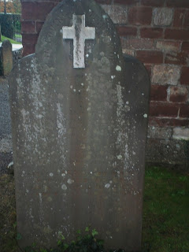
The fields of Abbots Leigh have for hundreds of years provided excellent crop and grazing land. The farm house below is where ancestors of Hollymans have lived, including Sheila Wallace Cooper, whose mother, Caroline, descended from the Hollymans.
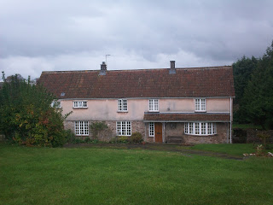

Next the Hollymans of Clevedon....

Saturday, September 1, 2012

When We Were English, Part XVL
by Glenn N. Holliman
Hollymans in the Parish Church Cemetery in Clevedon, Somerset
As those of you,who have been reading the past few articles know, that on a rainy day in the late autumn of 2011, distant cousin Fred Cooper of Bristol, England, kindly gave a day to show my wife and me places where persons by the surname of Hollyman had once lived. After a visit to Abbots Leigh, he guided us into the Gordano Valley along the M-5 to the town of Clevedon, a community of over 21,000 today.
Below an arial view of Clevedon from Wikipedia (the photo is in the public domain) and its 19th Century bathing pier visible jutting into the Bristol Channel.
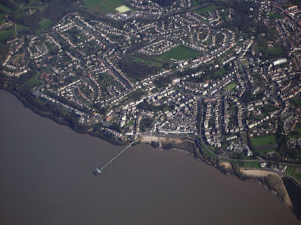
Various Internet history sites tell of Clevedon being listed in the 11th Century Doomsday Book, and the 12th Century Church of St. Andrew's as being possibly constructed on Saxon era foundations. Remains of an Iron Age fort can be found on a local hill.
Below, the entrance to the Anglican Parish at Clevedon where for generations Hollymans worshipped and now lie buried.
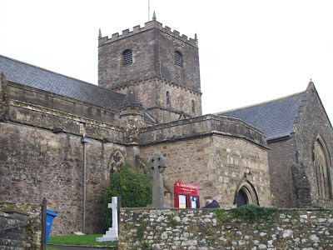
There are few things more melancholy than an English parish cemetery. Below arranged on a hillside overlooking the Bristol Channel is the cemetery of St. Andrew's where persons with the last name of Hollyman are resting. The parish name is from Andrew, one of the disciples who fished, and remains the patron saint of fishermen.
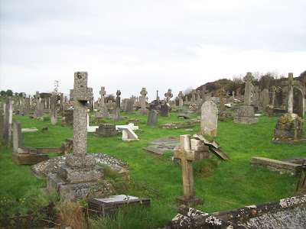

Monday, September 10, 2012

When We Were English, Part XVIL
by Glenn N. Holliman
Somerset, England...A Home for Hollymans
In the late Fall 2011, Bob Hollyman-Mawson of Wales arranged a visit for my wife and me to call on Fred Cooper, related by marriage to the Hollyman families of Somerset, England. For the past few articles, I have been giving a tour of the area and reproducing some photos I took of locations where Hollymans lived.
In the house below lived in the 19th Century a family named Hollyman. Today, still occupied, the white stucco, thatched roof home in Clevedon is bracketed by roses and protected by a stone fence.
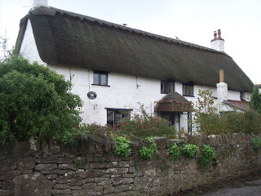
Our genial guide for our tour of Greater Bristol, England was Fred Cooper, a devoted genealogist who has catalogued hundreds of his wife's ancestors. Below in his Bristol home, Fred shows some of his research to Barbara Holliman.
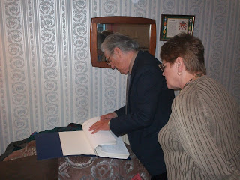
Below, Fred relaxes in an English pub after a morning of sharing with two Americans his knowledge of Hollymans in Abbots Leigh and the Gordano Valley, a picturesque part of Somerset where the Bristol Channel serves as a water bridge uniting England and Wales. Thanks to Fred's kindness and an introduction by Bob Hollyman-Mawson, American and British cousins were brought closer together.
Our thanks to both for a greater understanding of our U.K roots.
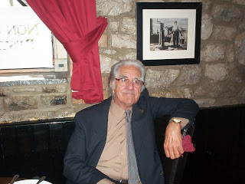
Wednesday, December 12, 2012

When We Were English, Part XVIIL
by Glenn N. Holliman
RETURN TO ENGLAND, Part 1

On two occasions in 2012, I had the opportunity to travel to England to research further my Holyman family roots. During this time I was assisted by family historian Peter Smith of Bedfordshire and professional genealogist Anne Holmes of Buckinghamshire.
Their research and my own examinations of original source materials continue to deepen my understanding of my ancestral families before the immigration of Christopher Holyman and his sister to Virginia in 1650.
In this space for several years, I have been writing of my findings, inviting the reader into my search to discover the roots of the Hollimans. Many of you have been 'walking' with me. If one desires to review earlier writings, please go to the 'Archives' section of this home page or just click over the name of a person or location in "Labels' portion of the home page.
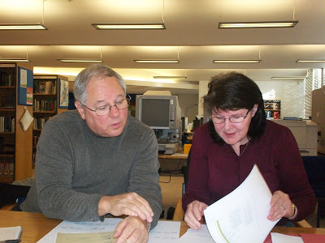
Above, Glenn Holliman, left, and right, genealogist Anne Holmes of Buckinghamshire, England examine Holyman records of the 16th Century in the archives in Aylesbury, Buckinghamshire, United Kingdom in November 2012.
Briefly what new findings do I have to report.

1. Thanks to the research of Anne Holmes, the scenario of the Holyman family from John Holyman, d 1521 in Cuddington, Buckinghamshire to his great grandson, Christopher Holyman, d 1588 in Sherington, Buckinghamshire appears solid. This thesis is backed up by translated wills and parish records which will be examined in future articles.
2. The thesis that I have been promoting that Christopher Holyman of Sherington (d 1588) is the father of Thomas Holyman of Bedford and the grandfather of our Christopher Holyman (d 1691) in Ile of Wight, Virginia is not disproved and continues to be a very plausible explanation of lineage.
3. Thanks to Anne Holmes we know Thomas of Bedford lived near St. Mary's Parish on Caldwell Street, which even today runs in front of the church. His wife, Eleanor Holyman, died in 1553 and is buried in that churchyard cemetery.
4. A fascinating piece of information is that Thomas Holyman was a shoemaker, a cordwainer if you will! While an honorable profession, this seems a comedown on the social ladder for the Holymans of Cuddington who were substantial landowners just a half century earlier. However, he did own the Blue Boar Inn lease which he sold for 40 pds in 1640, a tidy sum in that era. Let's call him a craftsman and a businessman.
Below, the bridge connects then north side of the Great River Ouse in Bedford to the south side. Behind the high rise hotel on the left stands St. Mary's parish church and Caldwell Street, the lane (then) that housed the residence and business (es) of Thomas Holyman (b bef. 1587 - d bet. 1646-1652).
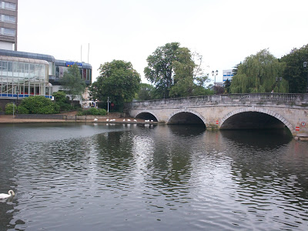
5. Anne will continue to investigate the Bedford records to add context to our family story. As yet, we have not found burial records for Thomas and Eleanor's children named Christopher and Judith (we have of their other children) thus strengthening the argument that the Christopher who arrived in Virginia in 1650 and died there in 1691 is indeed from Bedford, Bedfordshire, England.
We will follow the story wherever additional research may lead!

Friday, December 21, 2012

When We Were English, Part XVIIIL
by Glenn N. Holliman
Return to England, Part II
In the last post, I began to share the findings of my recent trip to England, and especially the research of professional genealogist Anne Holmes. My thesis, which Ms. Holmes has endorsed, is that one John Holyman of Cuddington, Buckinghamshire, England (d 1521) was the father of John Holyman, same community (d 1533) and this Holyman was the father of Thomas Holyman, again Cuddington (d 1558). One of Thomas's sons was Christopher Holliman (d 1588) of Sherington, Buckinghamshire.
It is my thesis that Christopher of Sherington was the father of Thomas Holyman of Bedford, Bedfordshire and the grandfather of Christopher Holyman, who died in Virginia in 1691, the founding father of almost all American Hollimans (and various spellings). This is a long winded way of saying that John Holyman, d 1521, would be my 12th great grandfather!
We do not yet know the date of John Holyman of Cuddington's birth, but he died in 1521 leaving a will. As a way of perspective Henry VIII, the great Tudor king, was 30 years old that year and still married to Catherine of Spain. Henry would forsake his Roman Catholic allegiance to Rome in the 1530s, a decision that would shake the foundations of the country and the Holymans in particular.
As Ms. Holmes observes, the Holymans were on the rise financially and socially in the 1500s. One relation, another John Holyman, would be appointed Bishop of Bristol by Queen Mary Tudor, Henry's first daughter, in 1554. Another ancestor, Christopher Holyman (d 1588 and 9th great grandfather of mine) would marry into the prominent Lee family of Hartwell House fame near Aylesbury.
We have the will of John Holyman (d 1521) which demonstrates the affluence of the expanding family. We know Holymans had lived in Cuddington since at least the 1440s, and one did not leave a will unless one had wealth to pass on to descendants.
John's will (below) is available on line at http://www.bucksvoice.net/brs/online-volumes/volumes-11-19/. The will is found on two pages in E.M. Elvy's (pub. 1975) The Courts of the Archdeanonry of Buckinghamshire 1483-1523 in Vol. 19 of the Bucks Record Society.
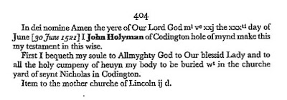

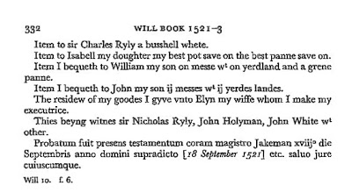
What do we learn from this will?
1. John asked to be buried in St. Nicolas parish cemetery. It is safe to say his remains are some where in the photograph of the church yard in Cuddington, Buckinghamshire. The memorials visible date from the late 18th and early to middle 19th Centuries and later, as few outside stones are legible before 1800. Pictured are the author, family historian Peter Smith and his wife, Maureen November 2012.
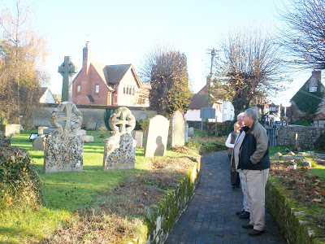
2. John left a bequest to the 'mother church' of the Diocese of Lincoln of which Cuddington belonged in the 16th Century. Remember until the 1530s and the upheaval of Henry VIII's divorce, England was Roman Catholic. However, a Reformation was sweeping western Europe and concerning matters of faith, much was about to change.
3. Daughter Isabell seems to be left only a pot and pan. Household items were of great value in England at this time, and as later in the American colonies, were often included in wills. One suspects Isabell was married and cared for by a husband. Could that husband have been Sir Charles Ryly who was left a bushel of wheat?
4. Son William Holyman, while receiving some land, also inherited 'a grene pot'. Anne Holmes, whom I sourcie throughout this article, suggests this may have actually been a grain vat, a large vessel or structure used in agricultural work. Also William, evidently the second son, was left a 'messes', that is a messuage or a dwelling house with a 'yard land', a term for an area of land associated with a building, anywhere from 15 to 40 acres.
5. John Holyman, from whom American Hollimans reading this are descended, received the greater value of the farm land, being two dwelling houses and two yard lands.
6.Wife Elyn, whose last name unfortunately is lost, received the residue of the worldly goods.
7. Note the witnesses - another Ryly, another 'sir' if you will, suggesting the deceased John enjoyed enhanced community status. Was Isabell the wife of Nicholas or Charles Ryly? In addition to a John White, John Holyman, presumably my generation's 11th
greatgrandfather, signed the will.
To Ms. Holmes I owe a debt of continuing gratitude for her interpretations and explanation of the wording of the will. More of her important insights in the next posts.

Wednesday, January 2, 2013

When We Were English, Part XIL
by Glenn N. Holliman
Return to England, Part 3, The John Holyman Will of 1533
In my last post, we examined the will of the person I believe to be my generation's 12th great grandfather, John Holyman of Cuddington, Buckinghamshire, England. With this article, we begin a review of his elder son, my very probable 11th great grandfather, John Holyman's will. Here is a portion of the 1533 will, with other sections to follow in my next articles.
Each line of the will is numbered and the explanations refer to the numbered lines. Genealogist Anne Holmes of Buckinghamshire is due the credit for her transcription and interpretations of a will almost 500 years old! (Although any errors are mine alone.)
This will is markedly different from John's father's which we examined in my last post. The Reformation is sweeping Europe and is engulfing England. King Henry VIII has fallen in love with Anne Bolyen and in early 1533 married her, she several months pregnant with a child who would become Queen Elizabeth I.
The Pope had refused Henry a divorce from his still living first wife, Catherine of Spain and mother of Mary Tudor. When a conservative Archbishop of Canterbury died, Henry appointed Thomas Cramner, a supporter of the growing Protestant tide. Cramner hastily granted Henry his divorce and conducted the rites of marriage for Henry and Anne.
Into this gathering maelstrom which divided the clergy and laity of England, strode a monk, Brother John Holyman of Cuddington, baptised in 1495 at the same font from which his probable uncle and cousin, the John Holymans, d 1521 and d 1533, had been sprinkled with holy water. As I have written earlier Brother John Holyman boldly stood at St. Paul's Cross in London and on several occasions decried the divorce, the remarriage and the growing radicalism of many English concerning their faith.
With this background of the early 1530s, we can better understand the will of John Holyman of 1533. The first 20% is a homage to the Roman Catholic Church. The will of John's son Thomas Holyman in 1558 will read very much differently, much more Protestant. Again my thanks to genealogist Anne Holmes for this transcription taken from the original will in the Aylesbury, Buckinghamshire archives.
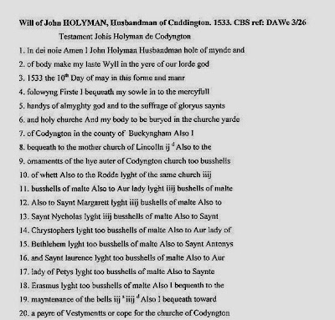

Line 1 - John identifies himself as a husbandman, a term to describe a free tenant farmer or small landowner. A yeoman farmer, higher up in social status, would have had more acreage than a husbandman. As the Oxford Companion to Local and Family History (1996) states the words yeoman and husbandman were gradually replaced in the 18th and 19th centuries in England by 'farmer'. Interesting that this John describes himself as a husbandman, as the Holymans rose economically and socially in the 1500s.
Line 6 - He directs, as did his father, to be buried in the St. Nicolas church yard, Cuddington.
Line 8 - He leaves a bequest to the Diocese of Lincoln cathedral.
Lines 9 -18 - John Holyman leaves bequests, bushels of malt barley, for the holy lights on the High Altar and for the altars of St. Mary, St. Margaret, St. Nicolas, St. Christopher, our Lady of Bethlehem, St. Antony, St. Laurence, our Lady of Peter's light and St. Erasmus or Elmo. This tells us the parish is still Roman Catholic with numerous altars and chapels for various saints. In 1534, Henry VIII will have himself proclaimed the head of the English Church replacing the Roman Catholic pope. English churches will soon change.
It is not unusual to find in English parishes even today the posting of legacies to the local church. This one in Cuddington, Buckinghamsire recognizes one Nicholas Almond for his bequests in his will. However, no sign hangs for John Holyman whose bequests were made when the parish was Roman Catholic and not Anglican. Photograph November 2012.
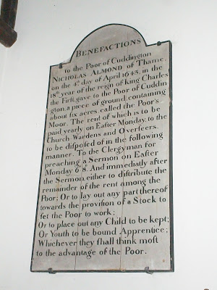

Line 19 - Bells remain to this date in St. Nicolas in Cuddington.
Line 20 - He leaves funds for the purchase of a pair of vestments or cope, another indication of John's support of the Roman faith, then under growing criticism in an England in political turmoil due to Henry VIII's 'Great Matter' - the divorce of Queen Catherine and remarriage to Anne Bolyen.
His cousin, nephew or in-law, Brother John Holyman, later Roman Catholic Bishop of Bristol, would have approved mightily of this will!
Wednesday, January 16, 2013

When We Were English, Part L
by Glenn N. Holliman
A Continued Look at John Holyman's 1533 Will and What It Means....
With our last post, we began a review of the 1533 will of John Holyman of Cuddington, Buckinghamshire focusing on his bequests to St. Nicolas Roman Catholic Church. In this article we continue our review of his estate plans and note a significant increase in family wealth when compared to his father's 1521 will. As genealogist Anne Holmes (who transcribed these wills) observes, the Holymans in the 1500s were a family on the rise socially and economically.
Below Cuddington in the distance. This photograph was taken on a small rise southwest of the village. Undoubtedly some of this land was at one time in the Holyman family. Note the sheep grazing just as they did five centuries ago. November 2012
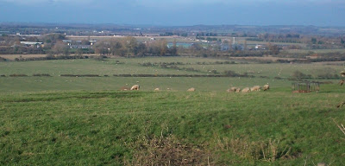
Below the next section of John Holyman's 1533 will
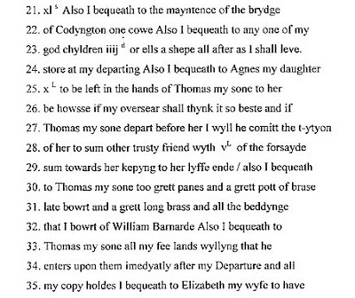
Line 21 - A cow is left to help maintain the Cuddington bridge over the River Thames, a tributary of the larger Thames. No public works departments in the Tudor era!
Line 23 - A legacy is left to unnamed God Children.
Line 24 - Ten pounds is left for his daughter Agnes as a trust to be held by her brother Thomas or if she outlives him, another trusted friend. In essence this is called a 'life estate' in the 21st Century legal terms. According to Anne Holmes, the equivalent value today would be approximately $5,000. Agnes received the income as long as she lived. This oversight by the elder son of his sister gives us an insight to the much more restricted rights women had in England at that time.
Line 30 - Various house hold items are left to son Thomas. Metal pots and pans were valuable items during this era.
Line 33 - The heart of the will is the leaving of fee lands (lands held without conditions attached) to Thomas and his copy holds to his wife Elizabeth. Through Line 52, John goes into great detail describing what must be done with any grain harvested. The carefulness by which he articulates his farm activities gives us a clue to his organizational and management skills that must have been somewhat responsible for the increase affluence of this branch of the family.
Line 35 - 'A copy hold was a form of customary tenure by which a tenant held a copy of the entry in the roll of the manorial 'court baron', which recorded his or her possession of a holding on agreed terms.' - The Oxford Companion to Local and Family History (1996). Ms. Holmes states copy hold lands were subject to manorial custom and an obligation to undertake certain services for the Lord of the Manor e.g. military service.
﻿
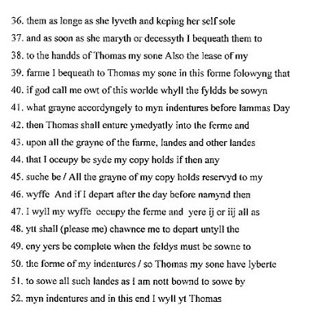
Line 41 - Lammas Day was not a religious holiday, but prior to 1572 and the change in the English calendar, was August 1st. The Oxford Companion to Local and Family History, while recognizing some dispute about the matter, states it was a date that allowed for a second mowing of hay. Again we see John Holyman reaching beyond his grave to dictate farming practises! Anne Holmes notes it was traditionally the festival of the wheat harvest. Lammas means loaf-mass from the Anglo Saxon hlaf-mas.
Line 50 - An indenture is a formal contract in this case concerning use of fields. The formal agreement would be copied twice, signed and then cut or torn in two at the indent, with each party having an identical statement of the bargain.
Next posting, John Holyman continues to list his considerable wealth...and leaving most of it to his first born son, Thomas....

