Were the Holymans Royalists Escaping the English Civil War? Part I by Robert Holloman

Why did the Holymans come to Virginia at the time they did? A descendant of Christopher Holyman, Sr., Robert Holloman, who holds a B.A. in History from the University of Virginia, recently shared this hypothesis with me. With his permission, I share it with the larger family. This is interesting reading, and points out more research is needed. This is part one of two articles.- Glenn N. Holliman

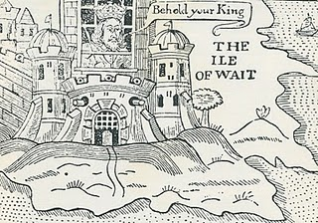
Ironically near the end of the English Civil War in 1648, the English King Charles the First was incarcerated by Commonwealth troops on the Isle of Wight, England (not of course Isle of Wight County, Virginia where the Holymans were to live). In this political cartoon Isle of Wight is labeled the Ile of Wait as the leaders of the rebellion, Oliver Cromwell, and others were trying to decide what to do with the defeated King. A court found the King guilty of treason, and he went to the executioner's block (see below).

“One approach I have recently been exploring is to investigate whether there is a connection between the events of the English Civil War and the emigration of the Hollimans to Virginia. Bedfordshire, England an area that gave strong support to Parliament against King Charles. If the Bedford Hollimans were royalist supporters there may be records of fines they paid since royalists were required to pay to Parliament to either avoid military service or to support Parliament's campaigns.

As John, Thomas, Christopher and even Stephen Holliman of Bedford would have been of age to serve in the military, there may be records that can reveal if any had served and in what capacity. The National Archives at Kew has a guide to researchers about records it holds of the English civil war and other potential sources - http://www.nationalarchives.gov.uk/records/research-guides/civil-war-soldiers.htm.

Could John Holliman have been a Royalist Supporter?

John Holliman's emigration to Virginia and his possession of a cutlass as evidenced by his will (1650) intrigues me. As we know, Virginia (and Maryland) remained supportive of royalists through 1651 when Cromwell sent a fleet to suppress Virginia. His representatives replaced the governor, William Berkeley, who had been appointed by Charles in 1641. This is the same William Berkeley who later in his second stint as governor would pardon Christopher Hollyman and his son after Bacon's rebellion in 1676.

I think if John (Holyman who died 1650) had emigrated from England in the 1640's, it could be he was a royalist supporter. Northampton County in Virginia where he died had previously been called Accomac Shire and was renamed Northampton County by the Virginia colony in 1644 to honor Lord Compton, Earl of Northampton, a royalist military leader who died at the battle of Hopton Heath in 1643.

Judith and Christopher Holliman - Royalists or Puritans?

Another interesting question for me is reconciling the multiple Jamestown landing records for Christopher and Judith Holleman. As there are records indicating both Christopher and Judith's arrivals in both 1650 or 1653, to me these two dates represent very different political regimes in the Virginia colony. The unapologetic, royalist era ended in March 1652 when Richard Bennett became governor. He was one of the few Puritans in the Virginia Land Company and also part of a major founding family in Isle of Wight County that over the years recruited hundreds of settlers to Virginia.

While there is strong evidence that the marketing campaigns of the Virginia company and its landholders presenting Virginia as a paradise attracted Englishmen of all persuasions between 1645 and 1670, the change of Governors in 1652 may have resulted in the perception of greater opportunity in Virginia for those who had supported Parliament and Puritans in particular.

Who were those Sponsors?

Related to this, I have been attempting to track down information on the named sponsors of Judith and Christopher (and William in 1656) Holliman: John Cos(x),Thos. Wilkinson, John Sheerlock and Thomas Rolph (William's sponsor). Both the Wilkinsons and the Coxes are known to have property in Isle of Wight County in the time period of Christopher and Judith's arrivals and the Cox and Wilkinson families later intermarried.

There is a recent 2006 book on the history of the Wilkinsons entitled the Wilkinsons of Isle of Wight, Surry and Sussex Counties and related families (including Cox) by Gene Cox Wilkinson and George Carroll Wilkinson. I have recently attempted to contact the authors to see where in England these families had originated and any information on Cox and Wilkinson's activities in the years of Christopher and Judith, but have had not had success as yet.” – Robert Holloman, a descendant of Christopher Holyman, Sr.

The King represented Divine Right Rule. Parliament forces fostered representative democracy. The Royalist forces were eventually defeated in battle, the King imprisoned and tried for treason. King Charles I lost his head (see below) and the Commonwealth came into being. In 1660 the monarchy was restored and King Charles II came to the throng. The Stuarts always had troubles with various Parliaments and in 1688, James II was forced from the throne. He fled to France rather than losing his head (literally) as had his father..
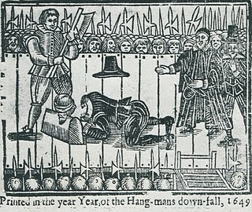
Comment on the above intriguing article by Robert Holloman, distant cousin, is most welcome.....Another article on possible Royalist connections continues in the next posting.

