From Barbara Poston Church (lottabessen@atlanticbb.net)
Sept 14, 2014
via WikiTree
I have a Pryor Lee Stansberry born 1833 died 1866 on my family tree. I just found WIKI had this today, and look forward to your reply. My family is primarily from the areas in and surrounding Knoxville. My tree is incomplete (novice). I'm not on Ancestry other than an editor for the 'Poston Family Tree'. There are many Luke, William and Solomon Stansberry's on the tree, I have exact dates for some, but I'm not on to see them. Pryor stands out. I show Pryor's siblings as follows; William F. 1826-1862 (my Great-Great Grandfather); married Rachael Reed; Albert G. 1837-1890; Rev. John M. 1830-1904; James 1832-; and Luke 1835-; If he is who I think he is... His father was Solomon H. Stansberry 1808-1877, mother was Solomon's 1st wife, Fannie F. Gibson 1809-1871; Solomon's Father was Luke 1789-1848, mother Rachael Tobias (no dates). Luke's father is listed only as Stansberry with no dates or wives; Rachael's father is Samuel Tobias Jr, no dates or wives listed; His father was Samuel Tobias, SR, no dates or wives listed. I do not show a wife or children linked directly to Pryor. I'd love to know if I should add them. My Great Grandfather Lewis T. Stansberry1831- May 19, 1902 (married to Lucinda F. Lindsay) and his brother David H. were both killed in the Fraterville mine explosion, in what is now known as Lake City, TN., you can search it and the Coal Creek , TN coal mine disasters on Wiki.

I’m up early most mornings, training for a triathlon. Glad you are back. Gotta love it when the dog inherits the estate. I’d like to add the Stans...y’s you have to my tree, It shows me the option, but I don’t click till I know what I might mess up e.g. if I add to my tree does it take away from yours? I think I found the test tree, but I can’t see the source info. Jeanie wanted me to see. The info I keyed in was done with a magnifying glass. The long page with the missing 5 ancestors has a tiny spot on the edge that says 1860 census. I obviously have the genealogy bug, I can’t possibly thank you and Jeanie enough for letting me contribute. I’m learning far more than I’m contributing. You have blogs! I find that fascinating, Glenn, I don’t know what a blog is. Can I subscribe to a blog? Just go there click once and BINGO every time something goes on it I’ll get an email? Do you have a you tube channel? They have a subscribe button, never used it... I warned you I wasn’t computer savvy. The attachment won’t open. Added you to safe senders, still can’t open it. The net book says it does not have the capability. The only way I could get it is if you send in PDF... I think it will open as an attachment that way. Worth a shot, you have my curiosity roaring! If you have a link to it I may be able to go to the link and download it as a PDF... This is Windows 7 Starter, to say it is limited is an understatement ‘Word’ isn’t included.

Barbie-lotta | 5:00 AM (1 hour ago)
to Jeanie, me

I got an error message either I’ve not been invited (I clicked on the invite) or the tree no longer exists. Based on the paperwork I have for Solomon. They are labeled One Family Group Record (Identification Information) at the top. Please keep in mind this netbook has no templates or Excel, all of this is done by hand.There are no dates these were taken. I am including what I have on his second wife Rachel Roberts on the same document title. I have 3 documents. The first one below shows '”millwright” directly beneath the document title, above his name.
Husband: Name in full: Solomon Stansberry Wife: Maiden name in full: 1. Francis Gibson Husband’s Name: Solomon Stansberry
Residence: Blank both are deceased.
Date of birth: 8, Dec. 1804 Place: Burke Co. N.C. Date of Birth: 22, May 1809 Place: SC
Date of marriage: 1827 Place: Knox, Tenn. (marriage is crossed through for Francis)
Date of Death: 1, Mar. 1879 (age 75) Place: Knox, Tenn Date of Death: 30, Aug. 1871 Place: Knoxville, Knox, Tenn.
Date of Burial: That area is blank. Place: New Hopewell Cem. Knox Co. Tenn. Below the line above nothing else noted under Francis Gibson in that section.
He Married: 2 times: #2. Rachel Roberts On this document there is nothing on that side noted about Rachel Roberts
His Father’s Name: Luke Stansberry
His Mother’s maiden name: Nancy Hoddix
3 lines of notes. *Glenn this is in reference to the lawsuit over the estate through Tennessee Heirs, Inc.. I’ll go into a few items of particular after I finish these. I don’t know if you have any of the documents I have. Pryor is below. The names ‘Comfort’ and ‘Tobias’ appear on the most confusing document I have, listed as a Pedigree.
Tennessee Heir’s Inc. claims Luke as the father. The next line references the law suite. The next: Estate claims Luke’s father is Captain Tobias Stansberry__________

Jeanie, this document lists 13 children. None of which are Rachel and Solomon’s. If the lines are blank beside them, they are blank here.
1. Amanda Lived in Knoxville, Knox , Tenn. Married to:(no first name) King__
2. Luke____________________________________________________________________________________________________________________________
3. John Milton______________________________________________________________________________________________________________________
4. William F. Where married: Sevier, Tenn. Married to: Elizabeth Reed___
5. Albert Gottlieb Born: 5, Sept. 1837 Where married: Knoxville, Knox, Tenn 28, July 1858 Married to: Martha Susan Carlisle
6. Pryor____________________________________________________________________________________________________________________________
7. Andrew H. Born: 1842* Must be twins_____________________________________________________________________________________________
8. Mary E. Born: 1842*__________________________________________________________________________________________________________
9. Benjamin F. Born: 1845___________________________________________________________________________________________________________
10. Thomas G. Born: 1847___________________________________________________________________________________________________________
11. Frances E. Born: 1850___________________________________________________________________________________________________________
12. Nancy Died: 1886_____________________
13. James___________________________________________________________________________________________________________________________

Document 2/3.
All of Solomon's information is the same on this document. *Date of marriage crossed through no date. Wife: 2. Rachel Roberts Born in: Louisville, Knox, Tenn__
This document shows the sex of the children before the number.
M. 1. Edward Judson Born: 6 May 1873 ‘Lake City’ Coal Creek Anderson Tenn .When married: 13, Oct 1885 Living: Memphis Tenn Married to: Eva French Hightower_
F. 2. Mattie__________________________________________________________________________________________________________________________
F. 3. Maggie_________________________________________________________________________________________________________________________
** I have 2 with Mattie and Maggie. All of the information is the same except the birth order. Maggie is listed before Mattie on the second document. Both, same notes.
“The names are nicknames.What are the real names?” “Two youngest daughters adopted out in 1879 after death of father-No trace”

*Glenn here is a bit of what I have on the argument over the estate. The oldest one I have is a statement from my grandmother Lois Stansberry Jan. 13, 1932 Cambell County. It lists her father as Lewis, the son of William, the son of Solomon which was the son of Luke. I have the contract Thomas J. Stansbury March 26, 1951 and Tennessee Heirs, Inc. "’Thomas J. Stansbury believes himself to be an heir of Tobias and Luke Stansbury’ The only documents I have with the spelling Stansbury are in regards to the estate, except my grandmother’s statement, the documents that appear to be from census and one of the names on the letterhead.
On the Letterhead for Tennessee Heirs, Inc. The Directors are listed *some names I’d not noticed some do not appear to be relatives/family members.:
*Roy N. Stansberry Chairman: O. B. Hines: W. M. Julian: James S. Palmer: * Carl Stansbury : W. H. Suffridge: James A. Trent: George S. Warren.
All are in order by date, I’m not keying all of them in at one time. I have a letter to T.J. Stansberry dated March 20, 1951 from the census bureau stating the census records from 1880 are in very poor condition. This letter from Tennessee Heirs is dated June 23, 1951 Verbatim, condensed.
To whom it may concern: RE: Stansbury estate:
We now have contract with Edward J. Stansbury of Memphis Tenn. where by all of the Luke Stansbury heirs, that come into this corporation by July 4th 1951, will all share and share alike (equally) Edward J. Stansbury we believe is the closest living heir, and under Maryland laws may exclude all others in a more remote degree of relationship.For further information please contact our office. Our attorney will be in Baltimore all next week with one of the largest and best law firm there, and information in our files reflect that we have a good claim Thank you Mrs. Elsie Carr P. S. I will be in office to confer with anyone who is interested.
On the documents referenced above with the two daughters from the marriage to Rachael Roberts Edward Judson Stansberry. My grandmother’s letter dated 1932 is Stansberry. Her date of death was long after 1951. This must have been a sizable estate for it to go on for 20 years... Glen, when did the battle start, who got the estate, when was it settled, how was the surname spelled? I’d love to know where Captain Tobias Stansberry came from.
arbie-lotta | Sep 15 (6 days ago)
to Jeanie, me

Fantastic! I do not know what a TEST TREE is, I’ll need instruction on it. I am not computer savvy, have no idea what a blog is... but am open minded and extremely curious!
I don’t know if either of you have photos, I’m going to add some here. I am only a guest on Ancestry (can’t possibly afford membership), and am hoping they will not ‘close’ me out from the tree. I am not allowed to view the documents etc. in the hints. I’ve included the tree, or a portion of it above. It was incorrectly named the Poston Tree, that is my father’s side. Stansberry is my mother’s side. Enjoy the photos. I have a few to go through, but none of mine are this old. I have the old documents, the only way I how to get them into this (netbook) is to take photos of them. Some are quite faded e.g. William F. Stansberry appointed Sargent (spelled Sergent on the document) in Company H of the 13th Regiment of Tennessee April 1, 1864. Given under the Head Quarters of the Regiment at Lenoir Tennessee the 16th day of (appears to be January) 1865. The majority of the documents are far too large to fit on a scanner bed.
I am curious to know if either of you are aware of the Stansberry dispute over the estate? Tennessee Heirs represented some of the Stansberry’s. Thomas J. Stansberry argued he was due the entire estate under Maryland Law. I know some were from Maryland, I don’t know which ones. As I said, there are missing dates, first names and wives on the tree. The version of the tree I printed is in super micro print, I have to use a magnifying glass to read it.
I have no idea where, when or from where the Stansberry’s entered the US. My mother, her siblings and my grandmother (daughter of Lewis Stansberry) were all dark skinned. My mother said they were ‘Black Dutch’. Terms such as those are often used in the south to ‘hide’ black ancestry. I’d found the name Gorsuch as a maiden name for Dorcas, when I researched it I found (among other’s) a Gorsuch who entered the US aboard a slave ship in New Orleans.
5 Attachments
Preview attachment Lewis Tillery Stansbury Photo.jpg

Preview attachment David H. and Lewis Tillery Stansberry Longfield Monument.jpg

Preview attachment William F Stansberry and Elizabeth Reed census.jpg

Preview attachment William F. Stansbury 1840 census.jpg

Preview attachment Poston Family Tree Ancestry.htm

Jeanie Bond | Sep 15 (6 days ago)
to me, LottaBessen

Glenn,
Our family has a presence on WikiTree. It has finally born fruit!! The lady below contacted me through WikiTree and I'm passing her on to you. The public tree on WikiTree does not have all the information that I've added from your tree to the TEST TREE, so some of what is revealed here, we already knew. On the other hand, I don't know what else you might share with one another. I'll be inviting her to an updated TEST TREE within the next few days.

Barbara,
Glenn is the driving force behind the disimination of our genealogy. His mother is a Stansberry. He has a delightful blog that he will undoubtedly invite you to. Within a few days, I'll send you an invitation to the tree on which we keep the Stansberry information... as well as a whole lot of other folks, of course.

From Barbara Poston Church (lottabessen@atlanticbb.net)
Sept 14, 2014
via WikiTree
I have a Pryor Lee Stansberry born 1833 died 1866 on my family tree. I just found WIKI had this today, and look forward to your reply. My family is primarily from the areas in and surrounding Knoxville. My tree is incomplete (novice). I'm not on Ancestry other than an editor for the 'Poston Family Tree'. There are many Luke, William and Solomon Stansberry's on the tree, I have exact dates for some, but I'm not on to see them. Pryor stands out. I show Pryor's siblings as follows; William F. 1826-1862 (my Great-Great Grandfather); married Rachael Reed; Albert G. 1837-1890; Rev. John M. 1830-1904; James 1832-; and Luke 1835-; If he is who I think he is... His father was Solomon H. Stansberry 1808-1877, mother was Solomon's 1st wife, Fannie F. Gibson 1809-1871; Solomon's Father was Luke 1789-1848, mother Rachael Tobias (no dates). Luke's father is listed only as Stansberry with no dates or wives; Rachael's father is Samuel Tobias Jr, no dates or wives listed; His father was Samuel Tobias, SR, no dates or wives listed. I do not show a wife or children linked directly to Pryor. I'd love to know if I should add them. My Great Grandfather Lewis T. Stansberry1831- May 19, 1902 (married to Lucinda F. Lindsay) and his brother David H. were both killed in the Fraterville mine explosion, in what is now known as Lake City, TN., you can search it and the Coal Creek , TN coal mine disasters on Wiki.

On Mon, Sep 15, 2014 at 4:55 PM, Barbie-lotta <lottabessen@atlanticbb.net> wrote:
Fantastic! I do not know what a TEST TREE is, I’ll need instruction on it. I am not computer savvy, have no idea what a blog is... but am open minded and extremely curious!
I don’t know if either of you have photos, I’m going to add some here. I am only a guest on Ancestry (can’t possibly afford membership), and am hoping they will not ‘close’ me out from the tree. I am not allowed to view the documents etc. in the hints. I’ve included the tree, or a portion of it above. It was incorrectly named the Poston Tree, that is my father’s side. Stansberry is my mother’s side. Enjoy the photos. I have a few to go through, but none of mine are this old. I have the old documents, the only way I how to get them into this (netbook) is to take photos of them. Some are quite faded e.g. William F. Stansberry appointed Sargent (spelled Sergent on the document) in Company H of the 13th Regiment of Tennessee April 1, 1864. Given under the Head Quarters of the Regiment at Lenoir Tennessee the 16th day of (appears to be January) 1865. The majority of the documents are far too large to fit on a scanner bed.
I am curious to know if either of you are aware of the Stansberry dispute over the estate? Tennessee Heirs represented some of the Stansberry’s. Thomas J. Stansberry argued he was due the entire estate under Maryland Law. I know some were from Maryland, I don’t know which ones. As I said, there are missing dates, first names and wives on the tree. The version of the tree I printed is in super micro print, I have to use a magnifying glass to read it.
I have no idea where, when or from where the Stansberry’s entered the US. My mother, her siblings and my grandmother (daughter of Lewis Stansberry) were all dark skinned. My mother said they were ‘Black Dutch’. Terms such as those are often used in the south to ‘hide’ black ancestry. I’d found the name Gorsuch as a maiden name for Dorcas, when I researched it I found (among other’s) a Gorsuch who entered the US aboard a slave ship in New Orleans.

My great grandfather was Lewis Tillary Stansberry, he and his brother, David H. were killed in the Fraterville Coal Mine Explosion in Coal Creek TN (May 1902). Coal Creek is now Lake City. They are on the monument at Longfield Cemetery on Find-A Grave. His wife was pregnant with my grandmother (Lois D. Stansbury Brown) when the explosion occurred. .
You may have lost family members there.
There is another monument at Leachfield (sp?) Cemetery and a great article about it on Wiki.It wiped out the males (old enough to work in the mine) in just about every family.
Also on WiKi search Coal Creek, they had quite a war over the mine using prisoners.
You may have lost family in the battles.
My memory fails me, but I believe I originally emailed Jamie about the Stansury family. I already had Pryor. That is when I connected with you guys.

We need to do this story on the blog. Let me get back to you. So the attached photo is your great grandfather! I am putting this on my to do list which I fear is lengthy at this time as I am the local history writer for county and town bicentennials (Perry County, PA). Too much of a good thing!
My internet will be disconnected March 20th. I learned so much from each of you. I managed to get one side back to 1066, another (Church) back to 1395. Few made it to my trees, I couldn’t print the trees that did have info. I have bits written down. I use a netbook (no word program) and it can’t be connected to my 15 year old printer. So no photos made it through.  Thanks to each of you (my many cousins) for sharing your vast knowledge and connecting quite a few family members. Keep up the good work, make those trees grow! I’ll miss you all so very much.  Barbara Poston-Church-Stansbury-Williamson-Brown-Gorsuch-Sharpe (only 2 were researched by me).  Click here to Reply, Reply to all, or Forward  14.38 GB (95%) of 15 GB used  Manage  Terms - Privacy  Last account activity: 32 minutes ago  Details  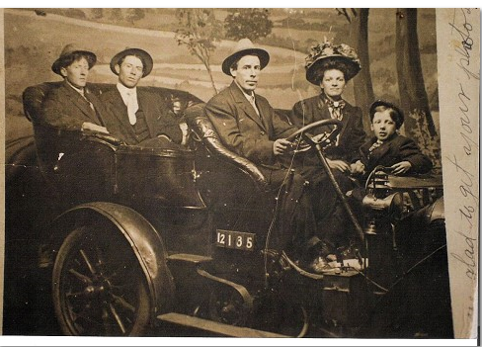 |  | People (6)  Barbara Church  lottabessen@atlanticbb.net
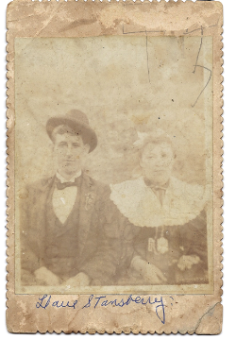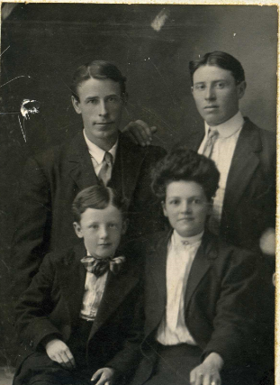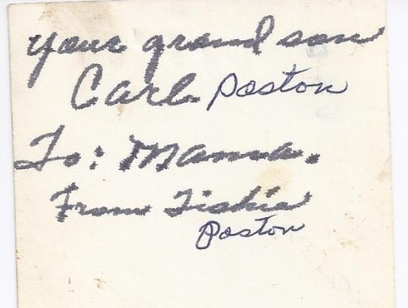
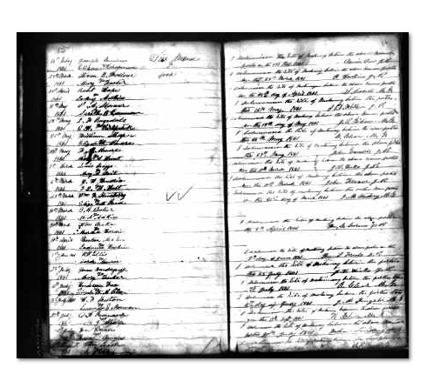 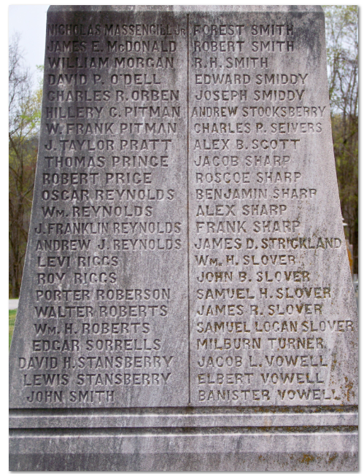 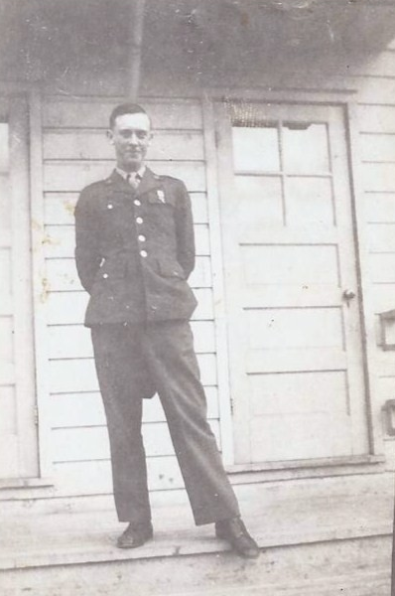Carl Poston in uniform
1840 Stansbery Census My device has passed away. I cannot open emails. I will close my account soon.
Glenn, you are a master of geneology. You have my respect and admiration. You had done most of my family tree on my mom's side. Thank you. I'd still like to talk sometime about the mine explosion that took the lives of Lewis Tillary and David Stansbury on that dreadful day in December 1902. My grandmother Lois D. Stansbury was born shortly after the explosion. You have my address and my permission to share it with Jamie and Lo Marie.
Jamie, twas you who created the Poston tree on Ancestry and invited me as a guest. Thank you. My only regret is I was never able to see the stories, photographs, hints or print the tree. Lo Marie should be on it. Her mother was my paternal grandmother's (Tishia Poston's) sister.
Lo, life has been unkind to you. Your courage and tenacity to endure so many losses and remain active in researching the family is worthy of praise. Thank you for sharing. I knew little of my father's family, with the exception of Tishia and my aunt. The sweet soul who endured the firm kick of the first equine I ever sat upon without blinking an eye.
Listen up folks, if you care about someone who wants to ride a horse or own one...avoid the dreaded, though still popular Shetland pony. They may be small but they are mighty little beasts.
Not many can say their grandmother whistled them beautiful songs till they fell asleep; or would tell me her real name and take her silken hair from the tight bun only if I promised not to share the name. I don't think she'd be displeased I shared it with you Lo-you already knew it.
To all of you, it is nice to know the number of GG's one can count. It is far better to know their stories. How they lived, why they relocated, how so many mourned the death of children to 'the fever' or the mine in Coal Creek. A town that exists only in history and their stories.
There were many lives lost in the coal mines where our ancestors lived. There were many who suffered and died during the "death march" on the Trail of Tears. It is their footprints in time that make us who we are.
Walking in their footprints is the greatest joy a geneologist could feel for hours of research, time spent amongst the dusty treasures in attics, and drinking coffee till the wee hours. Hanging on every word from the mouth of someone who knew.
My gratitude to all of you is beyond any words I can write.
A moment of silence for the loss of my device and spellcheck please.
I look forward to hearing from you all (pardon me, ya'll) soon.
You know my name, from my email address I am easily identifiable in a crowd...August 9, 2015
