Welcome to Washington County TNGenWeb
Genealogy, History, Washington County, Tennessee
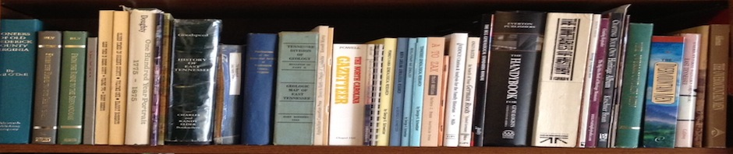
Skip to content
- Home
- About the County
  - County History
  - Century Farms
  - FAQ
  - Historical Markers
  - Historical Sites
- Research Aids
  - Communities
  - Genealogy & Historical Societies
  - Folk Medicine Lexicon
  - Family Assn, Newsletters & Web Sites
  - Funeral Homes
  - Goodspeed Index
  - Libraries and Archives
  - Local Genealogy & History Books
  - Lookup Volunteers
  - Newspapers
  - Tennessee Counties Formation
- Records & Data
  - Baptismal Records
  - Cemeteries
  - Churches
  - Deeds
  - Marriage Records Index
  - Military Index
  - Mills
  - Miscellaneous Records
  - Obituaries
  - Schools
  - Southern Claims Commission
  - VA Records Index
  - Wills & Estate Index
- Queries
- Links
  - Our Neighbors
  - Our Friends
  - Washington Co. E-mail List
- Surname Registry
- What’s New

Col. Samuel Bayless
East Tennessee Drafted Militia
Colonel Samuel Bayless
Waddle, Captain Jonathan; CPT
Boatright, William; 1LT
Brock, George; 2LT
Goodin, Lawson; 3LT
Hopson, James; ESN
Grisham, Thomas; SGT
Hunt, Smith ; SGT
Job, Enoch ; SGT
Little, Isaac ; SGT
Brown, Thomas; SGT
Conkin, John ; CPL
Ford, Thomas ; CPL
Nelson, Moses ; CPL
Starnes, Jacob ; CPL
Hair, Isaac ; CPL
Bean, David; CPL
Carroll, Henry; Drummer, prom to Drum Major 16 November 1814
Bayles George
Bayles, Hezekiah; prom to Quartermaster SGT 15 November 1814
Bell, John B.
Blakely, William
Boring, William
Bowling (Bolling), Phillip; prom 24 December 1814
Brick______, William
Briles, Michael; disch 18 November 1814
Briles, William
Brown, David
Brown, John
Brown, Joshua
Brown, William
Capp, John; subst for Thomas Ramsey 13 November 1814
Carson, Moses; driving his own wagon until 20 January 1815
Chapman, Robert
Chapman, Samuel
Clayton, Daniel
Clingham, George
Cofman, Conrod
Cofman, Jacob
Courtney, William
Daniel, Zachariah
Davison (Davis), Thomas; artificer 10 February 1814
Donworth, Thomas; disch 18 November 1814
Doser, William
Dunkin, Andrew
Dunkin, James; disch 18 November 1814
Faubush, Andrew
Finch, Thomas
Floid, Isaac
Ford, Ezekial
Fulkerson, Abram
Garland, Joshua
Garland, Joseph
Good, David
Graham, Charles
Grisson (Grayson), Prior
Hampton, Jesse
Hampton, Robert
Helms, Henry; prom 13 November 1814
Hite, Jacob
Hummins, Thomas
Hunley, Lankston
Isles, William
Jackson, William; disch 18 November 1814
King, Billy F.; d in service 25 April 1815
Kirland, Joseph
Lafollet, Jeremiah
Layman, Amassa
Layman, Joseph
Little, Jacob; d in service 10 April 1815
Lott, John
McCracken, Robert; disch 18 November 1814
McCray, Phillip; subst 15 November 1814
McClure, Robert
McGee, George
McGinnis, John
Mathis, Thomas; enl 10 December 1814
Messer, Joseph
Milom, Edward
Milom, Robert
Mitchell, John
Mitchell, William
Murry, John
Nelson, William
Norris, Carland
Odle, Reuben
Painter, Jacob P.
Painter, William
Price, Thomas
Sands, Isaac
Shanks, Moses
Shields, Zachariah
Stansberry, Elijah
Tilson, Joseph
Tilson, Thomas; disch 18 November 1814
Watts, Adam
White, David
Winkle, Abraham
Willet Francis; driving his own wagon during the tour
Williams, Samuel
Wolf, Joseph
Yeager, Daniel
Bobb – servant of Colonel Bayless
Edward – servant of Major William C. Roadman
Abstracted with permission from History of Washington County Tennessee, 1988 by The Watauaga Association of Genealogist, PO Box 117, Johnson City, TN 37605-0117.
Welcome to Washington County TNGenWeb
Proudly powered by WordPress.

