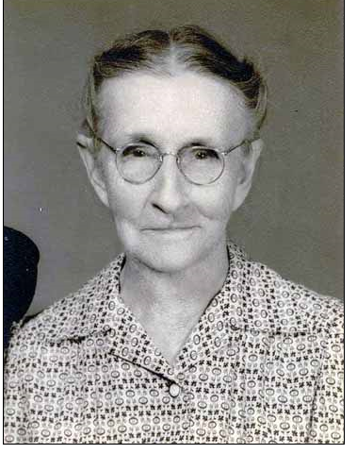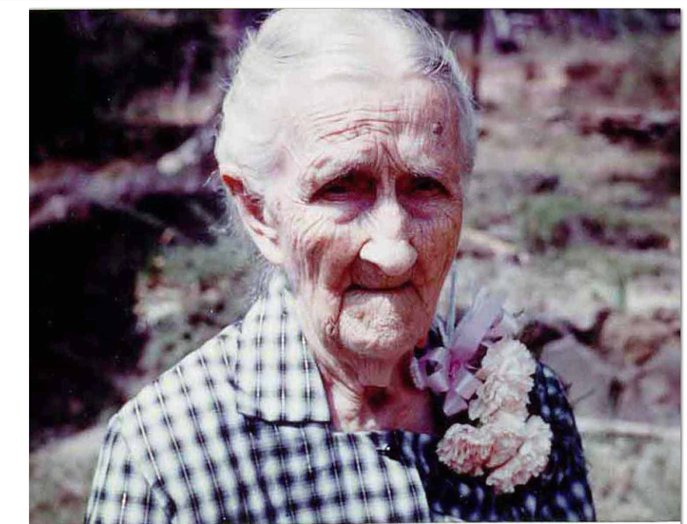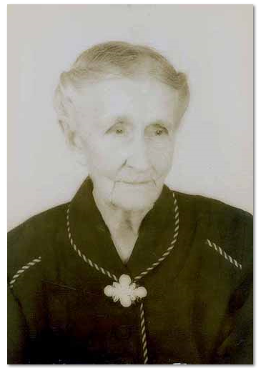Belzy Ann Blakeney was the second of 3 children of William Blakeney and Elizabeth Clanton. She was born on Sept. 18, 1859, and died on March 16, 1960, nearly 101 years old. She was raised primarily by her grandfather, Thomas Blakeney. She married George Washington Baker who was born on March 13, 1851 and died on Nov. 21, 1928. They had 12 children. The last two died in infancy and one girl died at age 7, and the remainder reached old age: 6 girls, 3 boys. All were born in Fayette County, AL, in or near Newtonville. Belzy Ann and husband are buried in the Newtonville (=Shepherd) Cemetery, as are several of their children.

PHOTOS:

Belzy Ann 1. Made in 1925. She was 66.
Belzy Ann 3. Made in 1956. She was 97.
Belzy Ann 2. Made in 1960 at her 100th birthday party, Fayette, AL.

