NOW REVEALED:
THE SECRET LIFE OF BISHOP HOLLIMAN!
By Glenn N. Holliman, Autumn 2009

Most of the family knows of the trajectory of Bishop Holliman’s life: Born in 1919, he grew up in Irondale, Alabama during the Depression, served four years in the Navy during World War II, and married Geraldine Stansbery as the war ended. In the late 1940s, he taught at Shades Cahaba and Shades Valley in Birmingham, and then in 1952 entered a thirty year career in the Social Security Administration.

Every time he was promoted, the family moved, first to Johnson City, Tennessee, then Columbia and Florence, South Carolina, Gadsden, Alabama and finally Cookeville, Tennessee in 1964. Along the way came three children, grand children, great grandchildren and much civic and church service. After retirement he continued his civic work and wrote for the Cookeville, Tennessee newspapers.

In 1990, he married Anne MacLaughlin of Hartsville, South Carolina, and after her early death to cancer, Ellen Cox of Gadsden, Alabama in 2001.

But now on his 90th birthday, the truth can finally be revealed. Behind this sober, stable life is a startling story that will both shock and amaze his grand children and the relatives who thought they knew the real Homer Bishop.

For his children, Glenn, Becky and Alice, we always suspected there was more to our father than just a mild mannered temperament, a father slow to anger, and always ready with a smile, a quip and ever sober advice.

Recently I have had access to his papers and photographs, and have quizzed him intensely on this revealed life. Finally, after confronting him with the overwhelming evidence, this modest man opened up, and now we see how his work has affected the history of our times. We can all be proud!

Here then for the first time is the rest of the story!!!

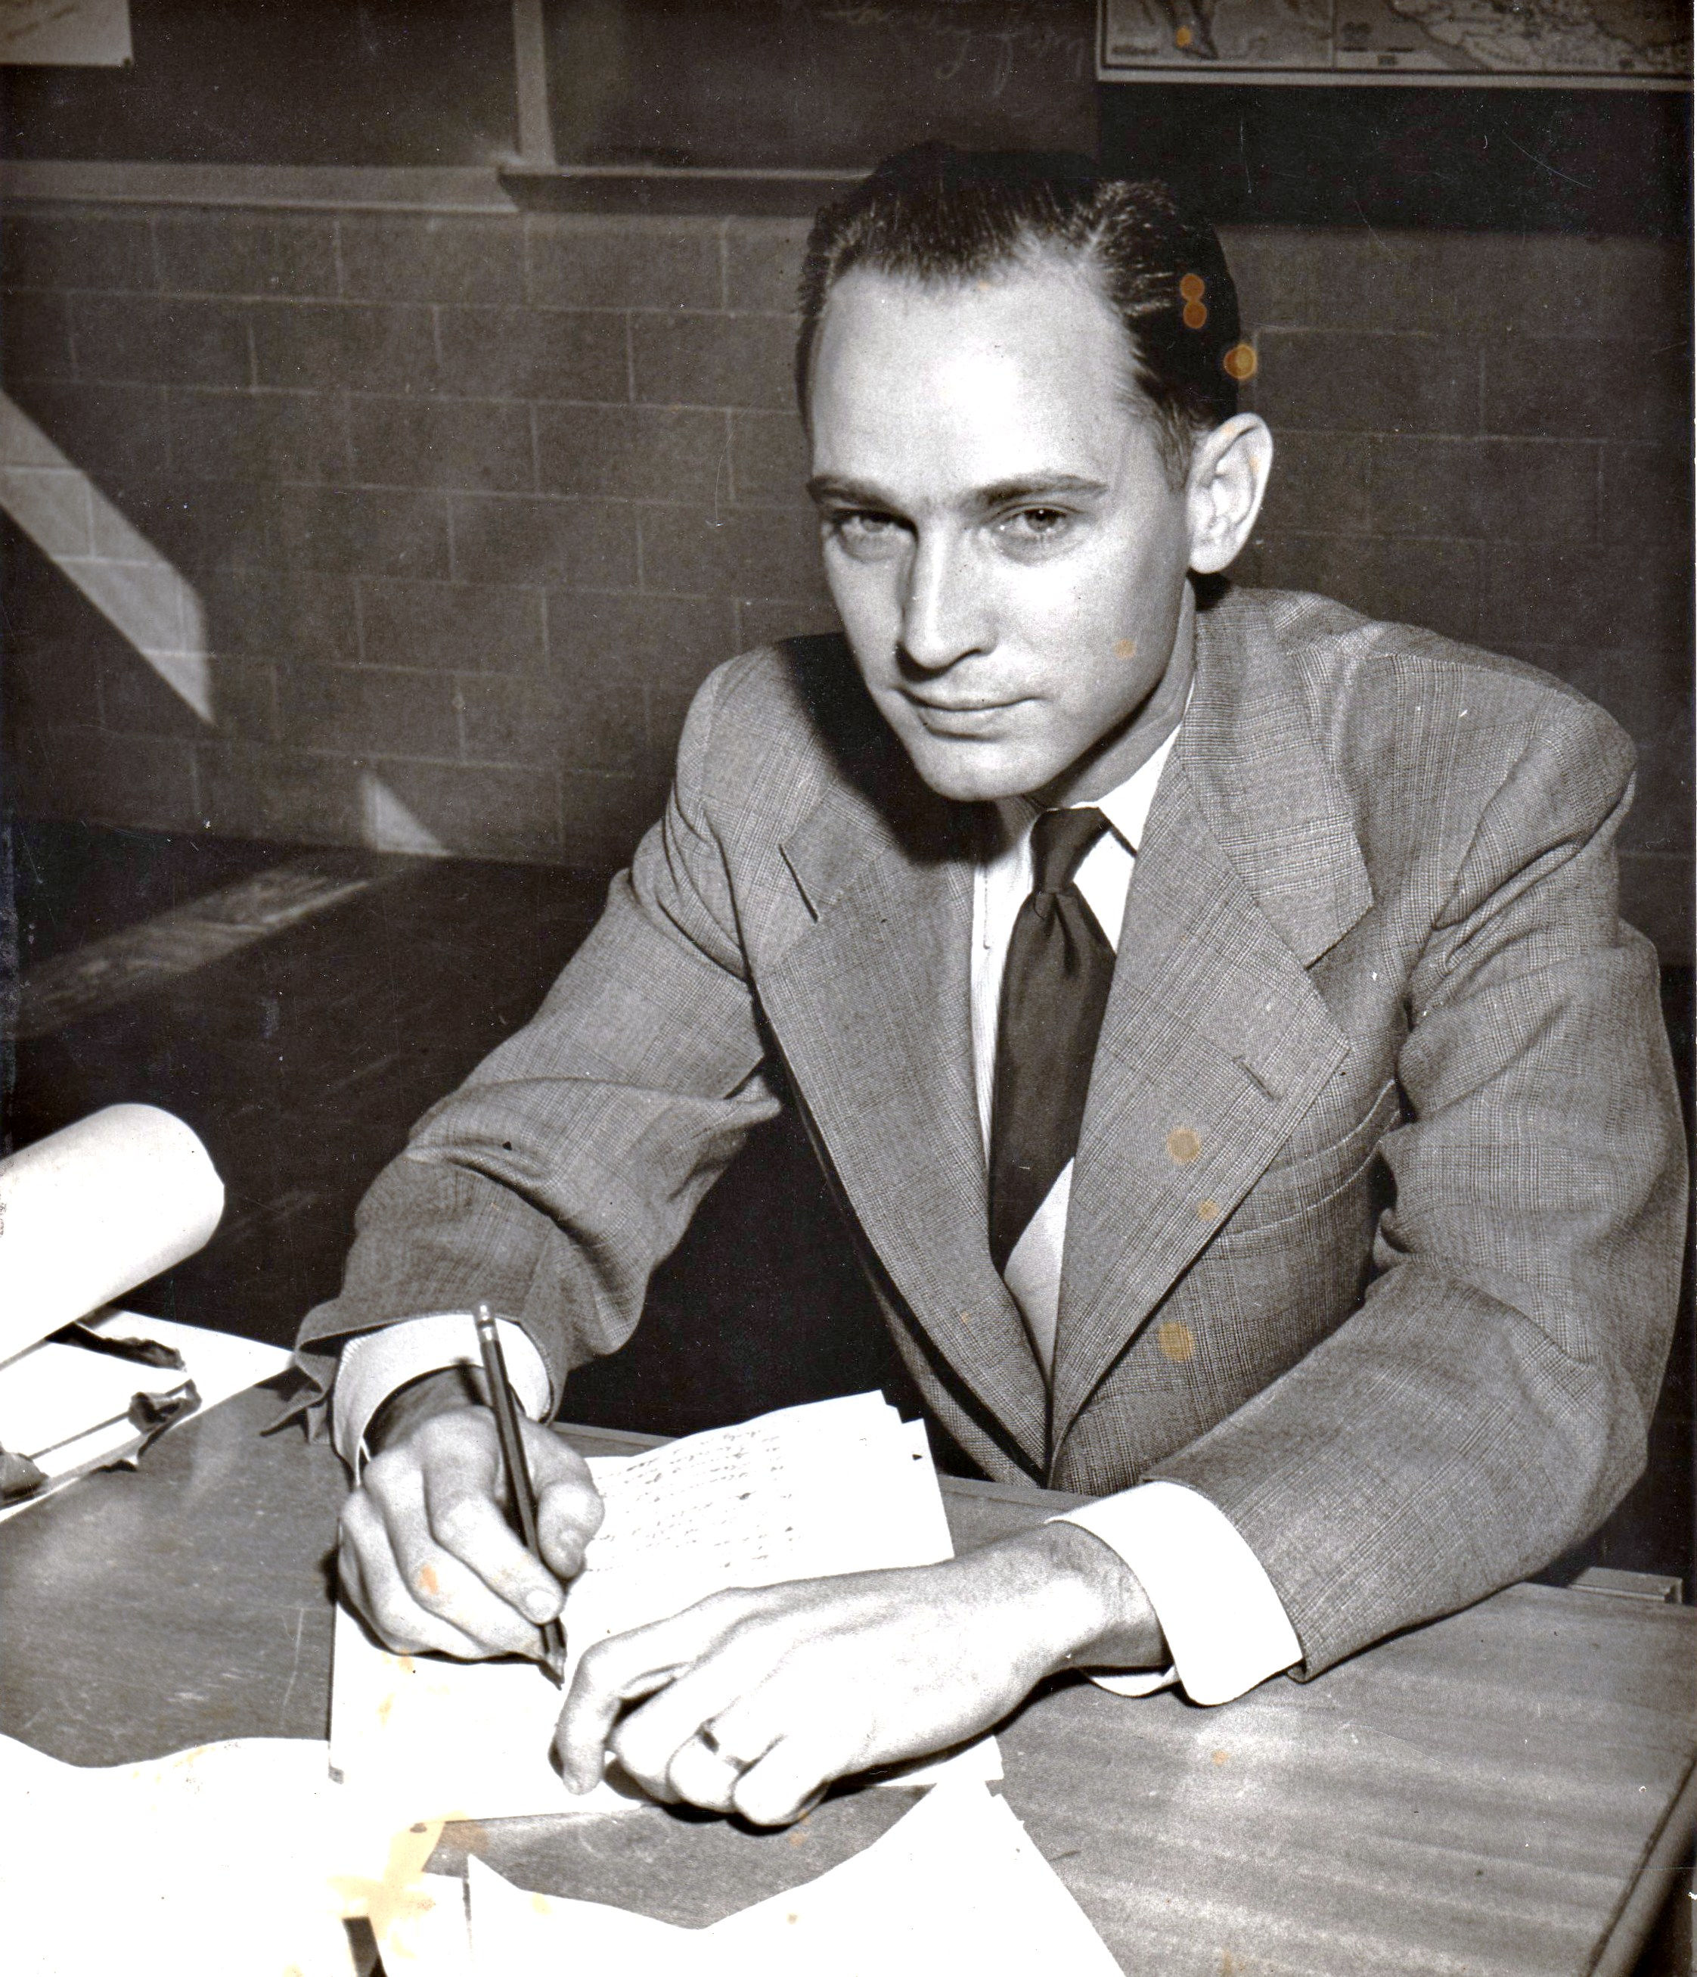

H. Bishop Holliman, the Real Story Revealed!
His daughter, Alice Holliman Murphy, a Texas-trained nurse psychologist, has always suspected something strange about this file photograph of her father. “The eyes look too cunning, or at least that was always my take on this 1951 photograph of him grading civics papers. What are those spots on the photographs?”

His nephew, Vance Sherwood, Jr., a Ph.D. in clinical psychology in Knoxville, Tennessee has expressed similar concerns through the decades. Observed Dr. Sherwood recently:

‘Uncle Bishop has always moved through life in an understated fashion, not psychotic, but certainly exhibiting denial or non-confrontational tendencies on occasion. Perhaps it was too much exposure to my own father’s over wrought reaction to the 1964 Presidential election (from which my father, Vance Sr., never recovered) or his University of Tennessee football fantasies which he shared very often with my Uncle Bishop who rooted for Alabama. I have never known which.

My mother, Louise, and her sister, my Aunt Gerry, would often remark on these personality traits. But then again, God love them, these two devoted sisters were always remarking on every one’s personalities!”

Recently, Dad confessed to my older sister, Becky Holliman Payne, a high school English teacher (who is good at hearing confessions, generally from her pregnant female 11th graders) that yes, at that time in his life (1951), he had just gone undercover with the FBI! They engaged him to look at first for communist subversives in the Alabama school system. Later it was corrupt labor unions and organized crime.

Actually in this photo, Dad is writing in invisible ink for a later ‘drop’ with another agent, perhaps his brother, Euhal Holliman of Irondale. He was interrupted by the school photographer, which somehow explains the spots on the photograph (don’t ask how – still a state secret).

The ring in the picture, which Mother always believed was the wedding ring she had given him in 1945, had had a decoder mechanism installed, similar to the same one Captain Midnight used in Space Command, a popular movie serial of the day.

Dad always wore a suit, tie and white shirt for security reasons. The tie clasp, not seen in this photograph, had a small capsule of concealed tear gas ready for instant use. Inside of every jacket, he holstered a 45 pistol.

As far as I know, he had to use the gun only once in a late 1950s South Carolina take-down of organized thieves, although he may have had need of it when serving on early Government Death Panels.

The tear gas often came in handy at Methodist Church official board meetings, family reunions at the Herrin’s and when Social Security codgers complained too vociferously about their benefit checks. – Glenn N. Holliman 2009

“Holliman Coaches 1940 North Carolina’s Women Tennis Doubles Teams”- The All American Tennis Magazine 1941



Dashing young Bishop Holliman, Birmingham-Southern’s tennis captain, finds time to coach a dazzling duo at the ever-so swank Methodist Church Camp at the Lake Junaluska, North Carolina racket club.

Holliman gleefully stated: “It’s been a swell summer here in the North Carolina mountains. The girls are great, eager and happy to receive my wicked serve (if you get my drift). Actually it is something of a grind – on the court by 10 am, long lunches, naps in the afternoon, and then more practice. By 5 pm, it is cocktail hour, lovely dinners on the veranda overlooking the Smokies and then lingering evenings. Yeah, I guess you could say I am a lucky guy, but, gee, if you have talent, as my father advises me, use it!

Actually I credit my older sisters Vena Holliman Daly and Loudell Holliman Ferrell with teaching me doubles tennis.

The whole story of the Depression and its effect on my family is overblown. We really grew up in the shadow of the Irondale Country Club. When not churning butter or wringing chicken necks. Momma served as president of the Women’s Annual Cotillion. Daddy directed the annual golf tournament when not shoveling coal in our furnace or working six days a week for the Birmingham street car company.

For my siblings, it was either tennis or golf. My younger brother, Ralph, chose golf and parlayed contacts made on the links into a successful business career for a national food company. Unfortunately, older brothers, Melton and Euhal, came along too early to benefit from anything other than the swimming pool, but they did meet some swell girls by the diving board.”
“Diviner Irondale Sailor on Leave Dates Two Girls at One Time!”- The Birmingham News, 1943

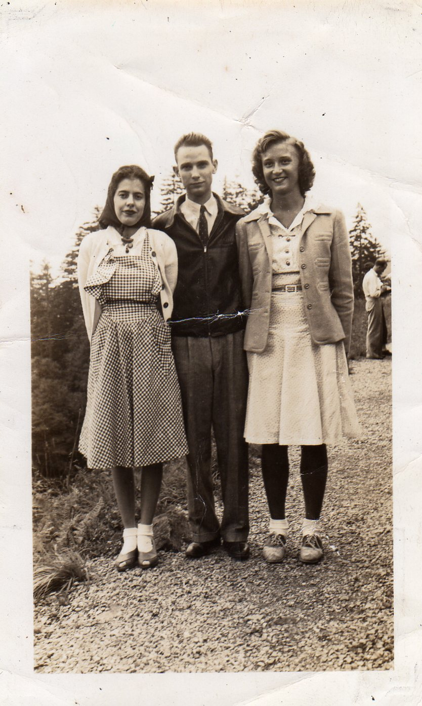

“Actually it is not as difficult as one might think”, reports Holliman. “I have been in the Navy for over a year now, and have come to understand how to entice women. See, a lot of the lobs on the ship give me tips on catching and holding dames. So whether on shore leave or a pass to home, I have an edge up on the college boys who stayed behind.

I guess it is just experience and a certain way with women that runs in my family. My father certainly has it. My brother-in-law, Charles Ferrell, who went to grad school up north, gave me additional tips that have come in awfully handy when you have only a three day pass and time is of the essence.”

“Dandy Dresser Dazzles South Carolina Lassie”

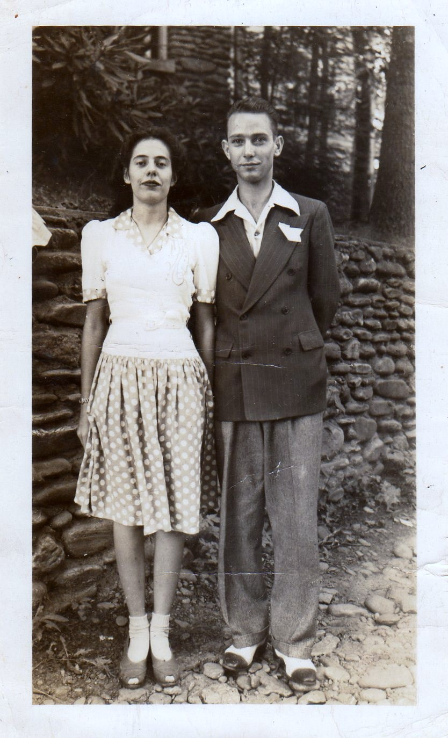
This is a 1942 photo of Bishop Holliman and his later second wife, the late Anne MacLaughlin of South Carolina. In a letter just discovered, Anne exclaims, “Bishop blew me away, that snappy dresser. From his Vitalisized short hair style, to the large flare collars, to that elegant handkerchief tucked in his suave doubled-breasted, doubled-paneled jacket to those two-toned, bucked shoes. Any girl in white bobby soxes would have been a goner!”

“G.I. Bride Models New Fur Coat for Birmingham Southern Tennis Team Fund Raiser”- The Birmingham News 1948

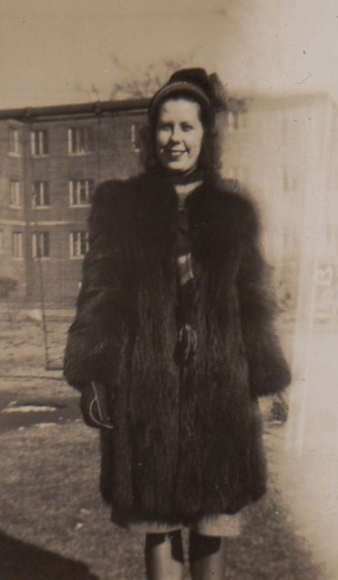

One of Birmingham’s new fresh faces, Geraldine Stansbery Holliman, models a mink coat in the shadow of Legion Field. Its cold for these new G.I. wives this second year after the war, but few look cuter than this young mother of one from Philadelphia, now a G.I. bride in Alabama.

Gerry, as her friends and family call her, observes “My husband, Bishop, a history teacher at Shades Cahaba, surprised me this Christmas. While we struggle on an instructor’s salary, Bishop saved his money in the Navy and had it invested by his brother-in-law, Robert Daly, a well respected and very wealthy banker in Woodlawn.

Robert figured out that after the War many soldiers and sailors would begin long delayed marriages and a boom in babies would occur. So he took all of Bishop’s savings and invested them in Gerber’s Baby Food and Tidy Day Diapers stock. We have made a killing. Hence the fur coat. Isn’t life grand!

Bishop is a real tennis pro, very accomplished with doubles teams. We are auctioning this little thing off to raise funds for tennis at the college. It seems the right thing to do for the school and the sport. Besides, he can get me another one next year!”

“Senator Taft Bids Holliman’s Support for President” – The Homewood Gazette

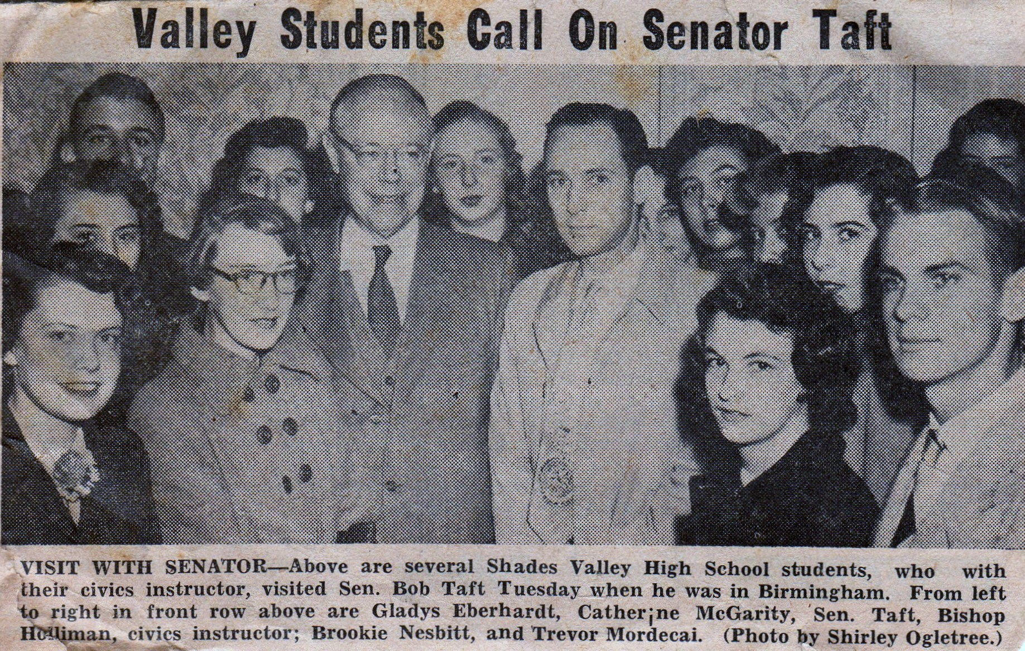

Stating he could not win the Republican nomination for President in 1952 without the help of Alabama, Senator Robert Taft of Ohio pleaded yesterday for the assistance of Jefferson County’s 1951 Teacher of the Year, H. Bishop Holliman of Trussville, Alabama, here surrounded by some of Holliman’s young supporters.

Holliman replied: “No one has greater admiration for Senator Taft and his views of the corrupt Truman administration than me. However, I cannot make a commitment at this time. My former Supreme Commander in Europe, General Dwight Eisenhower, has communicated with me, and asked me to remain neutral until he decides if he will be running in 1952.

As chair apparent of the Alabama Republican Party delegation to Chicago next year, I have to be attentive to their wishes and those of General Eisenhower, whom we all admire.

I further state there is no truth to the rumor that either Senator Taft or General Eisenhower have discussed with me the Vice Presidency. We will cross that bridge when we come to it. Frankly I am intrigued by the anti-communist record of the junior U.S. Senator from California as a possible Veep. This name is Mixson, Hixon or something like that. I understand he is a person of outstanding integrity, and that’s what we need after Truman, honest men in the White House!”

Also, this would be something I would have to discuss with my wife. Frankly, I hope to spend more time with my growing family so I am doubtful about the whole thing.”

Bishop’s 2009 note: “Actually I had recently agreed to go undercover for the FBI, and could not see how I could juggle politics, teaching, a society wife who always was planning parties, two young children, and communist party meetings twice a week. Gerry would never have understood if I had pursued the nomination so it went to Nixon instead.”

“Bishop Holliman launches forerunner of Tonight Show on local Television”
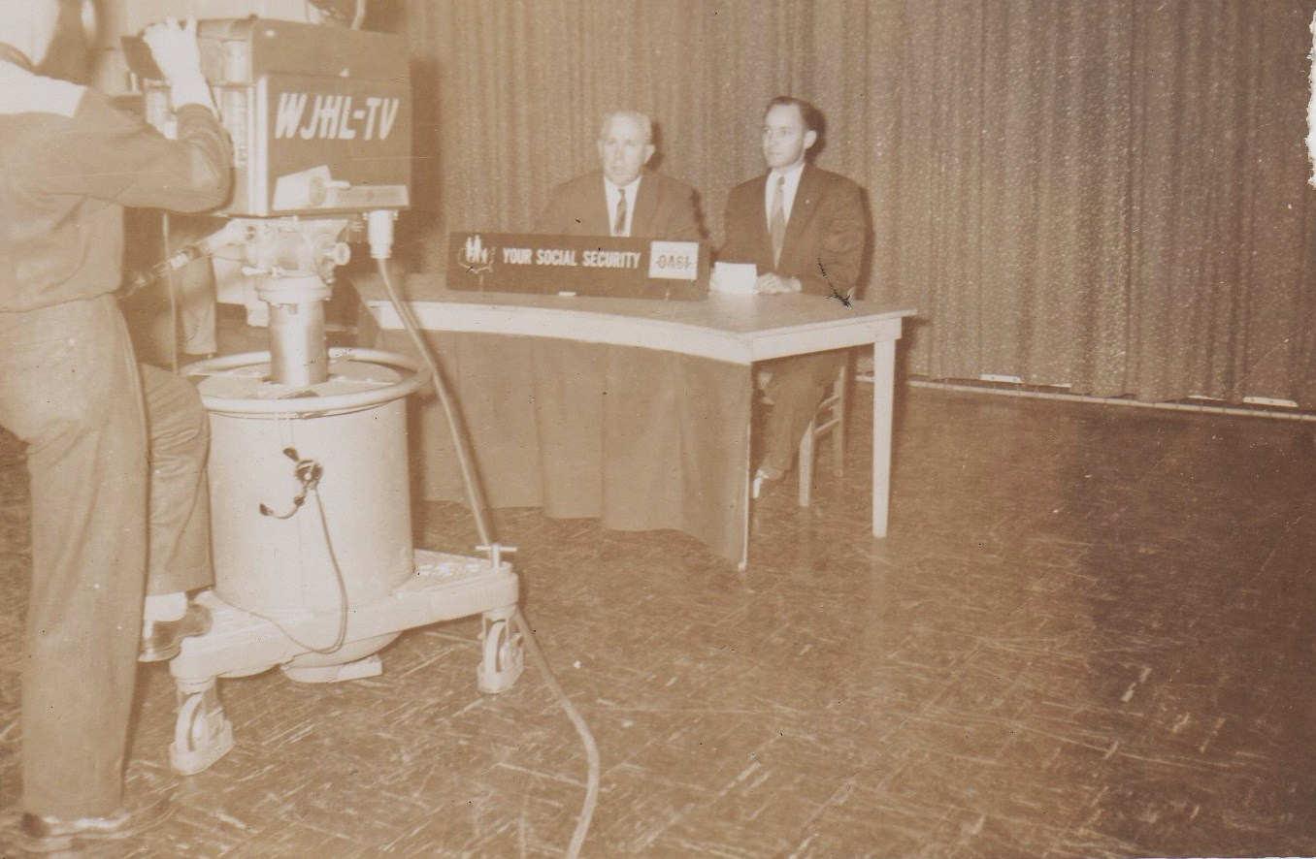

“That’s me on the right interviewing the actor who played editor Perry White in the TV. Superman series in the early 1950s. The program was so successful that I spun it off into syndication. I was able to interview all sorts of people from both the left and right wings of the political spectrum. That was helpful in my undercover work during the Joe McCarthy era.

However, I failed to listen to my niece, Mary Daly Herrin, who said her new husband was interested in the law, and he felt I should copyright the concept.

Well, I never did (not the last time I would make such a mistake – see Global Warming). Before the decade was out Jack Parr and later Johnny Carson copied the idea. My program was cancelled, and seeing no reason to remain in Johnson City, Tennessee, I took a promotion and moved to South Carolina. Fortunately new adventures awaited me there.”

“Holliman Appointed to Government Death Panel”- Recently Declassified FBI Document

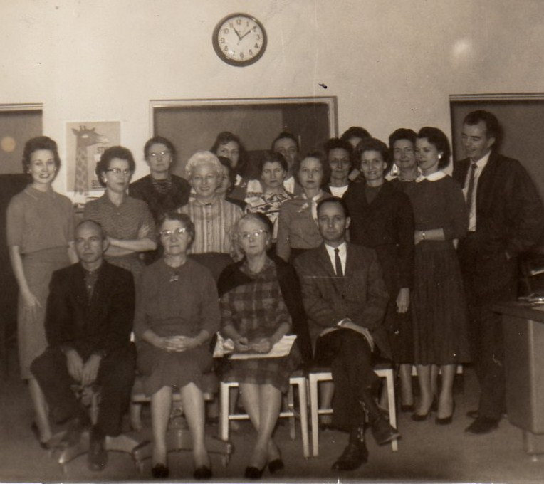

Sitting front row right is Bishop Holliman, in this 1960 Florence, SC file photo of one of the U.S. Government’s first ‘death panels’. The two old ladies in the middle front row are in for DPR (Death Panel Review). The photo has been altered to protect participants. When asked about this program, Holliman recently replied:

“Governor Sarah Palin nailed it! This clandestine service began when the country faced a serious problem in the late 1950s. The nation was in a major recession, and President Eisenhower asked the Social Security System if there anything we could do to reduce the outgo of benefits to seniors. The system was in danger of going bankrupt. You see, taxes to the system were down due to the recession.

It was top secret in those days. I could not even talk about it with Gerry. We had a designated conference room we called the DPRR (Death Panel Review Room) where a few of us met in each regional office and sorted through records of persons receiving benefits. Our methods were primitive in those days with note cards and written records. Today with computers and databases the whole process has been streamlined.

Without the DPR system, Social Security and Medicare would have been bankrupted a long time ago. I am sure with today’s levels of efficiency, any new national health reform measure quickly will reach the high standards we sought to attain in the early 1960s!”

“G-Man Sends Crooks to Jail!”- The Gadsden Times 1962

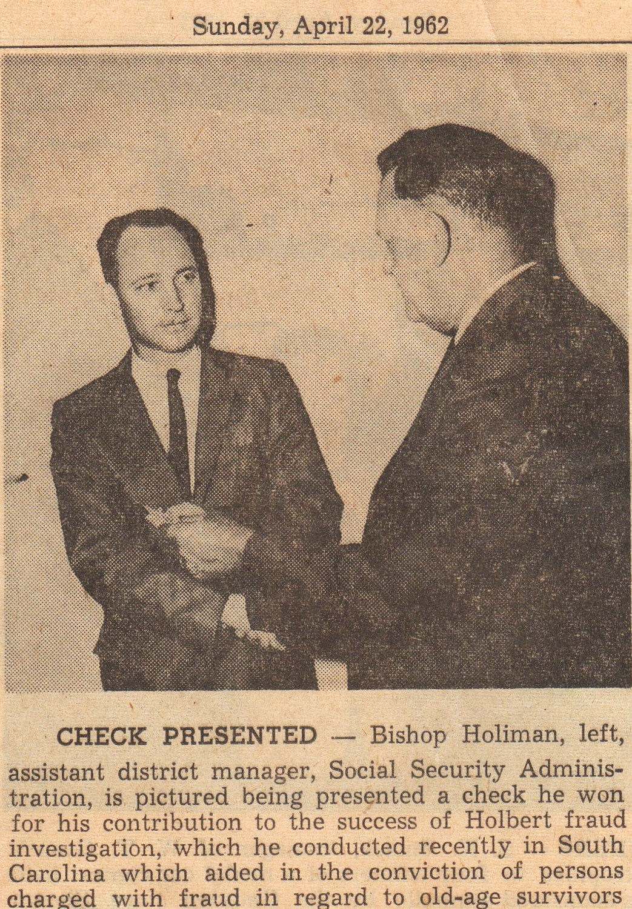

“Here I had to surface my identy briefly. FBI Director J. Edgar Hoover, pictured above, presented me a reward check for breaking up a vicious gang of white collar thugs in Conway, South Carolina. Fortunately I had my 45 pistol always with me.

With the reward check, I bought a 1962 green Rambler which helped me to maintain my cover. Gerry, the children and I had just moved from South Carolina to Gadsden, Alabama.

I liked uncover work, and did a lot of work with my brother, Euhal Holliman, a major player in breaking corrupt labor unions in the South. He and I used to put in a good word with Mr. Hoover for each other. While Social Security and Methodist Church meetings provided cover, I actually had quite a career as a ‘silent’ agent. A lot of it I still can’t talk about for national security reasons.”

END OF PART I

