Tuesday, July 16, 2013

From the Galaxy of Holliman Cousins
By Glenn N. Holliman
From Westminster Abby to the Sipsey River....
Not many Americans can claim a family floor plaque in London's hollowed Westminster Abby, the site of British coronations and stately funerals. However, one will find there a monument to the forerunner of the Blakeneys in the United States.
While beyond the purview of this space to provide an intensive history of the lineage of the Blakeneys (they are kin to this writer by 19th Century marriages in Fayette County, Alabama), I do want to proclaim the writing skills of a distant cousin of mine and a direct scion of the esteemed Lord William Blakeney.
That person is Reed Blakeney, whose American lineage takes his descendants from the Carolinas to Alabama, his home state. While most of his life he was a successful businessman, he has found the talent and time to write several page turners on Southern history. Below, Reed with one of his books, A Mulberry Summer, a story based on a true event of racial strife in Georgia in the 1940s.

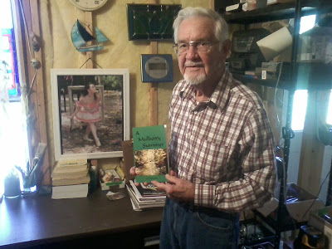

My interest in Reed's handiwork was tweaked by a closer cousin, Dr. Rhodes Holliman, a specialist in Holliman, Blakeney and Baker family histories, all of whom hale in part from the Newtonville, Fayette County, Alabama area. I wrote Reed, and he mailed me a copy of his work, Sipsey which is based on a true story of one of his descendants in Newtonville. Earlier this summer, I had the opportunity to visit with him and his wife, Penny, in his central Georgia home.﻿

The work captures the trek of a family from upper South Carolina to west Alabama when the state was little more than a frontier in the 1830s. One will find an Indian maiden, Mobile brothels, steamboats, cotton plantations, mixed race relationships, Civil War violence and finally human acceptance and reconciliation. I could not put the book down, and not just because the local farm of the Holloman (sic) family popped up in the story from time to time.

In the middle 1830s, the United States Government, led by President Andrew Jackson forcibly removed the remaining Native American tribes from east of the Mississippi to Oklahoma. Creek, Cherokee, Choctaw and Chickasaw land opened in Alabama. Once again Alabama Fever struck the southeast, and young families from the Carolinas picked up their children, livestock and also their slaves and moved as whole neighborhoods west to virgin lands.

Among these neighbors in Anson County, North Carolina and Lancaster County, South Carolina were families such as Holliman, Blakeney, Yerby, Lucas, Pyler, Hughes and others who settled in Tuscaloosa County and in the southeast corner of Fayette County, along the Sipsey River. At one time primitive steamboats up from Mobile plied the Tombigbee River and steered into the swallower Sipsey transporting cotton and pioneers.
Reed Blakeney's book Sipsey encompasses the frontier spirit and conflicted lives that helped built a state and settled families. You can find the book and others by the author on Amazon.com.
And if you are a Holliman, Blakeney or other Fayette County descendant, you will find much more than snippets of the lives of our ancestors.
More on the Blakeneys in the Next Post....

Sunday, August 4, 2013

From the Galaxy of Holliman Cousins - Blakeneys Continued
by Glenn N. Holliman
More on the Blakeneys, a branch of the Alabama Hollimans....
Below, two distant cousins by marriage, Reed Blakeney of Social Circle, Georgia and yours truly, met last springtime. I am holding a copy of Reed's excellent work, Sipsey, a historical novel based on the life of Thomas Blakeney (1807-1896) of Newtonville, Fayette County, Alabama, a book we examined in our last article.
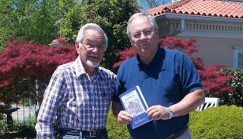

Unlike a similar work, Margaret Mitchell's famed Gone with the Wind, Reed's tome has not yet been snatched up by Hollywood, but I frankly think Sipsey is a better read. This too is a story of the Old South, not a romance of fancy, exaggerated fiction, but rather a gritty, sometimes violent, sometimes loving, always anguished and accurate portrayal of the antebellum South that passed slowly from an 1830s Alabama frontier to the turbulent years of a Civil War.
Below, Reed in his working room where the background wall posts photos of his Blakeney ancestors. The Blakeneys and Hollimans lived on neighboring farms in 19th Century Fayette County, Alabama and intermarried on occasion.
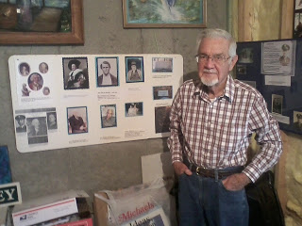
Below, one of Reed's most famed ancestors was Thomas Blakeney, the inspirational character for Sipsey. Thomas Blakeney entered life 1807 in Chesterfield County, South Carolina, the son of Revolutionary war hero, Captain John Blakeney who rode with Frances Marion.
He moved to Alabama prior to 1831, and married Sarah Roberts (1807-1861) about 1831 in Tuscaloosa. This couple had eight children, one being William Blakeney, who died 1863 in the War. 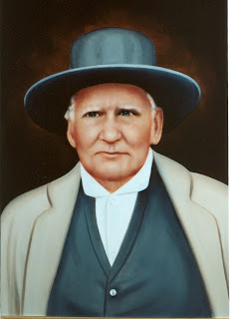
Thomas remarried Martha Nevins in 1862 from which there were no more children. He prospered in Fayette County, owning 2,800 acres, a cotton gin and at one time seven slaves. Thomas died June 2, 1896 in Newtonville, Alabama. However, there is more to Thomas Blakeney's story, a fascinating chapter of passion, cultural turmoil and redemption. With the research of Dr. Rhodes Holliman, we will take this story further in the next article.
This and the Blakeney's ties to the Alabama Hollimans and descendants will be explored in the next posting.

Sunday, August 18, 2013

From the Galaxy of Holliman Cousins - Blakeneys, Part 3
by Glenn N. Holliman
More on the Blakeneys, a branch of the Alabama Hollimans....
The last two posts, I have been writing of the Blakeney family of Fayette County, Alabama. A distant cousin, Kenneth Bowling of Texas, wrote asking how the Holliman family is related to the Blakeneys. The Hollimans are related in at least two ways (and probably more).
First, the eight child of Thomas Blakeney (1807-1896) the subject of the last article in this space, was Mary 'Polly' Blakeney (1835-1896). In 1853 she married Warren C. Holliman, the son of Charles and Barbara Walters Holliman, also of Newtonville, Alabama as was 'Polly'. This couple had eight children of whom many descendants still reside in the area. Polly is buried in Chapel Hill Cemetery in Fayette County, but unfortunately her married last name is spelled 'Halliman' on her gravestone.
The second Holliman connection is through Thomas Blakeney's first born son, William Blakeney (see below), who died in the Civil War. He was a 3rd Sergeant in the 41st Alabama Infantry, CSA. William came home on furlough in 1862, where, according to family tradition, he was exposed to measles. There are conflicting stories, but on his return to his unit, then outside of Chattanooga, Tennessee, he became ill, developed pneumonia and died in Charleston, Tennessee in 1863.
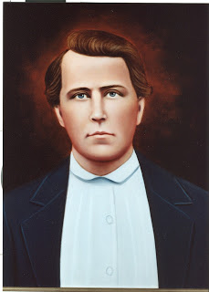
William's widow was Elizabeth Clanton Blakeney who later married Thomas Ashcraft by whom she had another child, Thomas Ashcraft, Jr. William and Elizabeth had given life to one daughter, Belzy Ann Blakeney who married George Washington Baker on November 27, 1878.
In 1880, Belzy Ann gave birth to Elizabeth Baker, who in 1899 married James Monroe Holliman, a great uncle of this writer. James Monroe was the father of the late Cecil Rhodes Holliman and Charles Baker Holliman. Cecil's son is Dr. Rhodes Holliman who has followed in his father's footsteps in cataloguing Holliman and associated family histories. There well could be other Holliman-Blakeney connections and this writer would welcome hearing about them.
Below, left to right, ca 1912, Charles and Cecil Rhodes Holliman and their mother, Anne Elizabeth Baker Holliman, grand daughter of William Blakeney, great grand daughter of Thomas Blakeney.
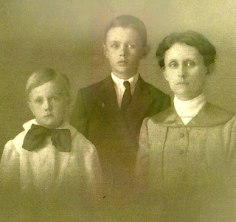
However, let us return to Thomas Blakeney, the great, great grandfather of Reed Blakeney, who wrote the book, Sipsey. Sipsey is the thinly disguised story of Thomas' passionate relationship with his housekeeper slave after the death of his first wife. The unnamed person was an alluring woman of Cherokee and African-American heritage. The couple had two children, a boy Jerry, and a girl named Sarah.
In time, Thomas married another white woman, who quickly sent the mixed race woman packing, perhaps to an Indian reservation. The children remained, and after the Civil War with the collapse of slavery, Thomas had them apprenticed to him so he could look after their welfare.
The late Walt O. Holliman has written in a Blakeney history that Tom, realizing his sons and particularly his step-sons, would make it untenable for the mulatto children after his death, is said to have given Jerry and Sarah a measure of gold he had buried during the Civil War. With this generous legacy Thomas also provided them with a horse and wagon and as much farm equipment as it would carry and sent them 'off into the sunset'.
However Jerry did not go very far and compassionately looked after his father, Thomas, in his declining years.

Author and family historian Reed Blakeney has established that Jerry settled in North River, Tuscaloosa County, Alabama and married a woman whose maiden name was 'Driver'. Reed made contact with two of Jerry's grandchildren - Walter and Willie, who lived in Birmingham, Alabama. Walter Blakeney was the son of Posey Blakeney, who was the son of Jerry.
Evalina Blakeney Greene, the youngest daughter of Jerry, lived in Tuscaloosa. Reed visited her when she was in her nineties and remembers a very refined lady. Evalina's only son, Dr. Jim Green, is a retired professor from Oberlin College in Ohio and an aficionado of art, music and literature.

Walter Blakeney has told Reed that the alluring woman and mother of Jerry did come back to visit Alabama after Jerry married. Walter chuckled and observed that on that occasion Jerry's mother spent more time with Thomas than with her children! Thomas carried her back to the train station in his buggy. Apparently the attraction remained.
Out of the cultural confusion and ethnic chaos of human slavery on the near frontier of the Ante-bellum South, emerged a love story and a compassionate human being, Jerry Blakeney, whose DNA can only be called American - a combination Cherokee, African, Irish and English. Below a stately and imposing photograph of Thomas Blakeney's son, Jerry Blakeney (1857-1955).
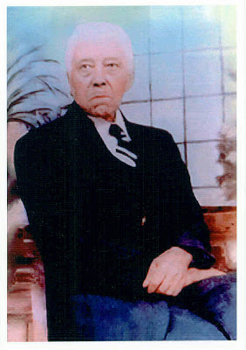

My thanks to the late Walt O. Holliman, Dr. Rhodes Holliman and Reed Blakeney for a reading of their research and photographs on this American family. Reed kindly shared his insights on this story of love and compassion, which he has turned into a beautiful book, Sipsey.

