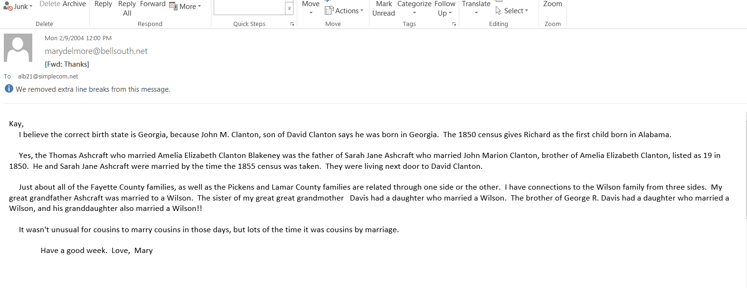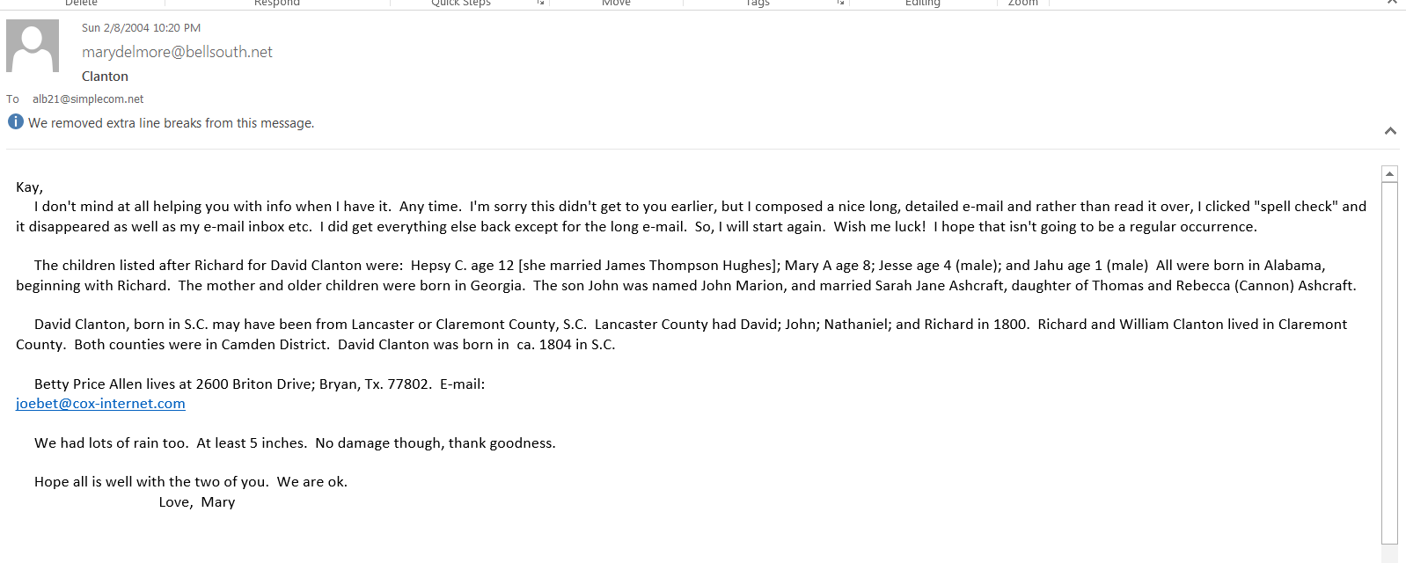Children of Elizabeth Corder and William Blakeney

John Thomas Blakney-he was born Dec. 25, 1849 and died May 13,1928. He married Lydia Ann Nabors in 1868. They are buried at Mt. Zion Primitive Baptist Church Cemetery in Pickens County, Al. (Ashcraft Corners)

James Vincent Blakney- he was born on May 1, 1853 and died on April 30, 1936. He was married to Evelyn Shepherd, 1873, and Sarah Elizabeth Thornton, 1881.Sarah and Vincent are buried at Ashcraft Memorial Cemetery, Ashcraft Corners, Fayette County, Alabama. According to Reed Blakeney he was named after his mother’s brother.

Children of Elizabeth Clanton and William Blakeney

Newton David Blakeney-he was born Feb. 8, 1857 and died Nov. 5, 1937. He married Molly Lindsey in 1883. They are both buried at Chapel Hill Cemetery on County Road 12, west of Newtonville in Fayette County, Alabama.

Belza Ann Blakeney-she was born Sept. 18, 1859 and died March 16, 1960. She was 100+ years old. She married George Washington Baker 27 Nov. 1878. They are both buried at Shepherd Baptist Church Cemetery at Newtonville in Fayette County, Alabama.

Martha Jane Blakeney-she was born in 1860 and died in 1936. She married Thomas Raymond Wright in 1878. Both are buried at Chapel Hill Cemetery, County Road 12, west of Newtonville in Fayette County, Alabama.

Children of Elizabeth Clanton Blakeney Ashcraft and Thomas Ashcraft

Thomas Sidney Ashcraft (Jon-Tom), he was born May 25, 1867 and died March 21, 1949. Possibly buried in Fayette County.
He was married five (5) times, not necessarily in order:
- Sally D. Lindsey, born May 17, 1866, d/o James M. Lindsey and Nancy J. Walden. She died and is buried near Nashville, Arkansas.Sallie and Jon-Tom were living there at the time of her death. (Children from this marriage)
- Florence Geer: She died in childbirth, the baby died also.
- Ida ----------
- Mrs. Julia Smith, August 4, 1930, Fayette, Alabama
- Monica ----------

PageMary contacted Betty Price Allen in Bryan, Texas with this information. Betty is a descendant of John Clanton, 1850 census, who is the son of David Clanton and brother to Amelia E.; Betty has done a lot of research on the Clantons in this area and feels certain that this is our Amelia Elizabeth Clanton. She has found no record of another Clanton female named Amelia E. Interestingly; John Marion Clanton married Sarah Jane Ashcraft. Sarah was the daughter of Thomas Ashcraft and Rebecca Cannon Ashcraft. This is the same Thomas that married Elizabeth Clanton.

Mary Davis Elmore has done research on many families in West Alabama and she is
related to the Ashcrafts. (Her grandmother was an Ashcraft.) She is also Adolph’s cousin on the Davis side of his family.

1850 Federal Census of Pickens County, Al (microfilm, Tuscaloosa Public Library) House number 1714, family number 1762
Clanton, David, 46, farmer, born SC
Epsebeth, 40, f, born Ga.
Sarah J., 20, f, born Ga.
John, 19, m, farmer, born Ga.
Amelia E., 16, f, born Ga.
Richard W., 14, m, born Ala
Hepsey C., 12, f, born Ala
David S. 10, m, born Ala
Mary, 8, f, born Ala
Jessie, 4, m, born Ala
Jahot (?) 1, m, born Ala

I am inclined to believe that this is our Elizabeth. Based on her age of 16 in 1850 she would have been about 22 when she married William and about 33 when she died. This census record indicates that she was born in Georgia.

Doc,

I have sent you copies of the material on the two wives of William along with some correspondence with Mary Elmore.

Al and I have just been discussing the relationship with the children of wife one and wife two. John Thomas and Vincent were half brothers to Newton, Belzy Ann and Martha Jane. We couldn't decide how to refer to them in the next generation.???? I have never heard of a half uncle. Uncle seems ok to me.

The church pictures are very nice. Good work.

Al gave me a digital camera for anniversary but I swaped it for a regular 35 mm camera. Did not want to tax my brain with learning a new system.

Let me know if the copies do not come through ok.

Kay
Doc,

I have sent you copies of the material on the two wives of William along with some correspondence with Mary Elmore.

Al and I have just been discussing the relationship with the children of wife one and wife two. John Thomas and Vincent were half brothers to Newton, Belzy Ann and Martha Jane. We couldn't decide how to refer to them in the next generation.???? I have never heard of a half uncle. Uncle seems ok to me.

The church pictures are very nice. Good work.

Al gave me a digital camera for anniversary but I swaped it for a regular 35 mm camera. Did not want to tax my brain with learning a new system.

Let me know if the copies do not come through ok.

Kay

