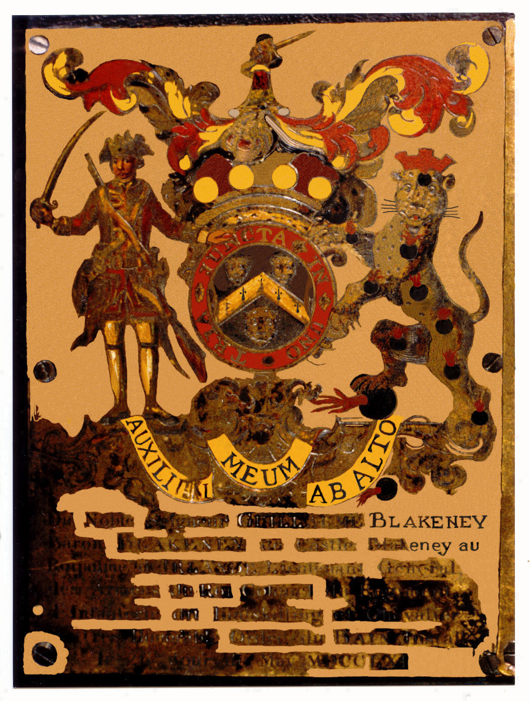
Blakeney Stall Plate at Westminster Abbey, London

