It is my understanding that this "Thomas Blakeney" was born in 1800 and died in 1892 (buried at Chapel Hill). He was born in Chesterfield County SC. Later he moved to Fayette County, Alabama. He was married to Sarah Roberts and had 8 chldren (William, Polly, Elizabeth, Kizziah, Samantha, Jane, James and John T). Sarah died in 1861 and he later married Martha Evans. At the time of his death he owned 2000 acres of land and a cotton gin. Thomas' home still stands today in Fayette County. It is a beautiful "dog trot" Chestnut log cabin.

Here is where I got the info I sent you earlier today regarding the blakeney’s

http://boards.ancestry.myfamily.com/surnames.blakeney/28.34.36.37.38.39.40.41.42.44/mb.ashx

From: Glenda Norris [mailto:glendanorr@bellsouth.net]
Sent: Tuesday, April 19, 2011 7:29 PM
To: Glenda Norris
Subject: FW: The Blakeneys

From: Glenda Norris [mailto:glendanorr@bellsouth.net]
Sent: Tuesday, April 19, 2011 7:18 PM
To: 'glennholliman@embarqmail.com'
Subject: The Blakeneys

Thomas Blakeney took in my great great grandmother Belzy Ann Blakeney and her siblings after the death of their father William…who died from diseases of the war…after he died, his wife abandoned her children by William…Thomas took them in and raised them. Another thing about Thomas is that he was one of the few who owned slaves…he had one favorite female slave of which he had children by…my uncle has told me that they still come to the Blakeney reunions… ☺
His homestead is restored and is still in newtonville…we will visit it in October if you want to.

The 1880 census of Fayette County, ALA., shows that Thomas Blakeney was then 79 years old, his first wife had died and he remarried to Martha Evans. They had no children, in 1880 census Martha Evans was 60 years old. Thomas Blakeney maintained in his home a number of persons, not closely related, but who shared his bounty. Among them were "Rebecca Roberts, age 60 who never married, and who was a sister to Sarah Kemp, Thomas's first wife. Also included was Bellzy Ann Blakeney, his Granddaughter, who was the daughter of William Blakeney, his son, and Elizabeth Clanton, half sister to T.A.C. Clanton, until she married George Washington Baker, on November 27, 1878. George Baker, born in Walker County, ALA, on March 13, 1851, was a son of Francis Richard Barker and wife Marth Ann Jones Baker. This set of Bakers had 12 children. George W. Baker died at Fayette County, ALA., on November 21, 1928. Rebecca Roberts had charge of the rearing of this Grandaughter and other children of William Blakeney, deceased. OK Thomas settled in Fayette County, ALA., and his wife Sarah had 8 children, they were: (1) Elizabeth (2) Samanatha (3) William B. Blakeney born in 1832 in SC., died 1863 near Charleston, TN. (4) James B. Blakeney (5) Jane (6) John Thomas (7) Kizzie and (8) Mary "Polly" Blakeney born January 6, 1835 in Fayette County, ALA., died February 8, 1896 in same. NOW-- Mary "Polly" Blakeney born January 6, 1835 married Warren C. Holliman in 1853, he was from Newtonville, Fayette County, ALA.. They had 8 children. "Polly" is buried at Chapel Hill Cemetery, Fayette County, Ala., (her last name is mispelled as "Halliman" on her Gravestone. NOW William B. Blakeney born 1832 above married Sarah Roberts (Not Sarah Kemp Roberts the wife of Thomas Blakeney) and had 2 children: (1) James Thomas Blakeney born 1883 and (2) James Vincent Blakeney NOW John Thomas Blakeney above-number 6 of 8 children of Thomas and Sarah married Lydia Duck Nabors and had a son named Lee Boyd Blakeney born 1883 and died in 1954, he married Amelia Godfrey, they had the following 10 children: (1) William Grady (2)Glennie Lee (3) Linnie Mae (4) Revis Duin (5) Thomas Graves (6) Gracie (7) Cadmus (8) Robert Lee (9)James Reed born September 11, 1928 and number(10) Montie Raye. NOW James Reed Blakeney born September 11, 1928 in Palmetto Community, Pickens County, ALA., married Donna Rosalie Braddy, they had the following children: (1) Deborah Gail (2) Diana Lynn (3) Reida Marie and (4) Rhonda Lee. NOW-- Bellzy Ann Blakeney had a full brother and sister, they were Martha Jane who married Thomas Raymond Wright and Brother Newton Blakeney who married Mollie Lindsay. NOW--William B. Blakeney that married Elizabeth Clanton, volunteered for service in the Civil War. He was a 3rd Sergeant in the 41st Alabama Infantry, CSA. William came home on furlough in 1862, where, according to family tradition, he was exposed to measles, on his return to his unit in Tennessee, he became ill of measles and pneumonia, which were epidemic at the time and died somewhere in either Tennessee or Kentucky. Widow Elizabeth Clanton Blakeney later married Thomas Ashcraft, by whom she had one son, Thomas Ashcraft Jr., who died during the 1930's in Birmingham, ALA. After the death of Elizabeth Clanton Blakeney Ashcraft, her widower, Thomas Ashcraft, again married and by this marriage two other children were born (1) Henry Ashcraft and (2) Zenie Ashcraft. NOW the houses of Blakeneys in SMITH COUNTY per the censes of June 1850. FIRST WAS: The house of James Thomas Blakeney age 53, Farmer born in 1797, his wife Martha Matilda Page Blakeney age 54 born in 1796 and 5 children: (1) Arabella Blakeney Ainsworth born 1817 died 1850. (2) Elenora Blakeney age 19 born 1831. (3) Alvin Blakeney age 17 born 1833. (4)Mathida Blakeney age 21 born 1829. (5) Lucy S. Blakeney age 11 born 1839. (6) William T. Blakeney age 6 born 1844. The house of Hugh Blakeney age 30 farmer born 1820 (son of James Thomas Blakeney) Hugh's wife Nancy Yelverton Blakeney age 32 born 1818 and children (1)Albert Blakeney age 6 born 1844. (2) Elizabeth Blakeney age 5 born 1845. (3) William Blakeney age 4 born 1846. (4) Alfred T. Blakeney age 3 born 1847. (5) mary Blakeney age 2 born 1848. (6) Dave Blakeney age 6 months born 1850. BORN AFTER THE CENSUS OF 1850 WAS (7) Lovick Blakeney born 1851. (8) Simeon Blakeney born 1852. (9) Susan C. Blakeney born 1855. (10) Martha Blakeney born 1856. (11) Thomas L. Blakeney born 1857. (12) Jefferson D. Blakeney born 1858. (13) Infant Blakeney born 1860. (14) Hugh Blakeney born October 20, 1863 and died October 4, 1937. (15) Unknown NOW--This Hugh blakeney born october 20, 1863 married Emma H. Mclaurin on December 25, 1886 when she was 15 years old and they had 11 children. Emma was born on August 3, 1871 and died September 23, 1941. Their children were (1) Ola Blakeney born 1871 died September 23, 1941. (2) Eula Blakeney born 1890 died 1975. (3) Hugh Ree Blakeney (4)Houston Marshall Blakeney born June 26, 1895 died October 11, 1917 (5) Herman Blakeney born 1896. (6) Lilly Blakeney born 1900 (7) Willie Blakeney born january 20, 1903 died April 1, 1903. (8) Ione Blakeney born 1906 died 1984. (9) Pearl Grace Blakeney born 1907 (10) Mildred Blakeney born 1911 (11) harold Blakeney born 1915 died 1981. NOW-- Alfred T. Blakeney born December 1, 1847 died February 22, 1914..he married Caroline Ainsworth and had a son named James Albert "Jim" Blakeney, he was born on March 5, 1873 in Smith County and died November 24, 1948. james Albert "Jim" married his first wife Edna Ware born March 1874 and died 1908 and his second wife Amanda Robertson. Jim donated land in 1898 for the New Hope School. he had 11 sons and daughters.. The house of Jacob Blakeney son of James Thomas Blakeney. Jacob age 25 a farmer jacob died on december 5, 1889 in Smith County. His wife Eliza Jernigan Blakeney born 1825, they had 13 children. Eleven were born after the censes of 1850. The two that were born were: 91) Erasmas Blakeney age 1, born 1849. and (2) james marion Blakeney age 1 month born May 5, 1850 in Smith County and died September 23, 1939 in Raliegh, MS he married Kizzar Elizabeth Walters born May 4, 1850 or 1854 and died January 7, 1946. James Marion Blakeney and Kizzar Elizabeth Walters Blakeney had 10 children. Barney Blakeney born May 17, 1884 was one of the ten. Barney married Lillie Wedgeworth, her father was lake Wedgeworth. Lillie was born on December 22, 1888 and died december 24, 1964. Barney and Lillie had the following children: (1) Earl (2)Lois (3)Lucille (4) Minnie Merle (5) Cleo (6)Clifton (7) L.D. (8) Mary Jo... Now Barney Blakeney is buried in Bay Springs, MS. THE HOUSe of Robert Blakeney a son of hames Thomas Blakeney. He had now married as of the censes of 1850 but had a farm of his own. He later married Annie Blair. More later

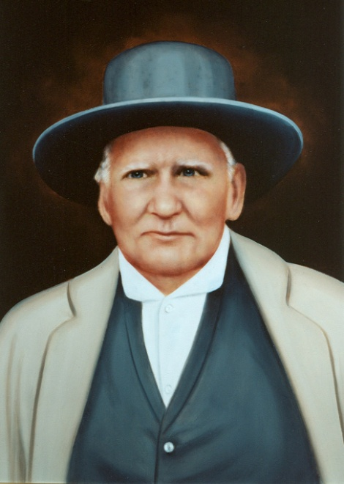
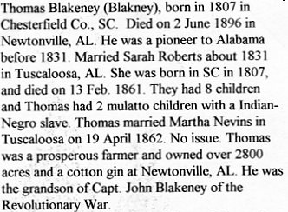
I also want to write a piece on one of my 3-great grandfathers (Thomas Blakeney, 1807 - 1896) who had 7 slaves. He sired 8 white children with his white wife and 2 mulatto children with a Cherokee-black slave. I have a fascinating story of his life before and after the Civil War and photos of him and his mulatto son. This son lived 104 years ! I have his Last Will and his Probated Adoption Papers to be able to retain his mulatto children after the Emancipation Proclamation. He raised all of his kids, and my great grandmother and her two siblings after they were orphaned by the War.
