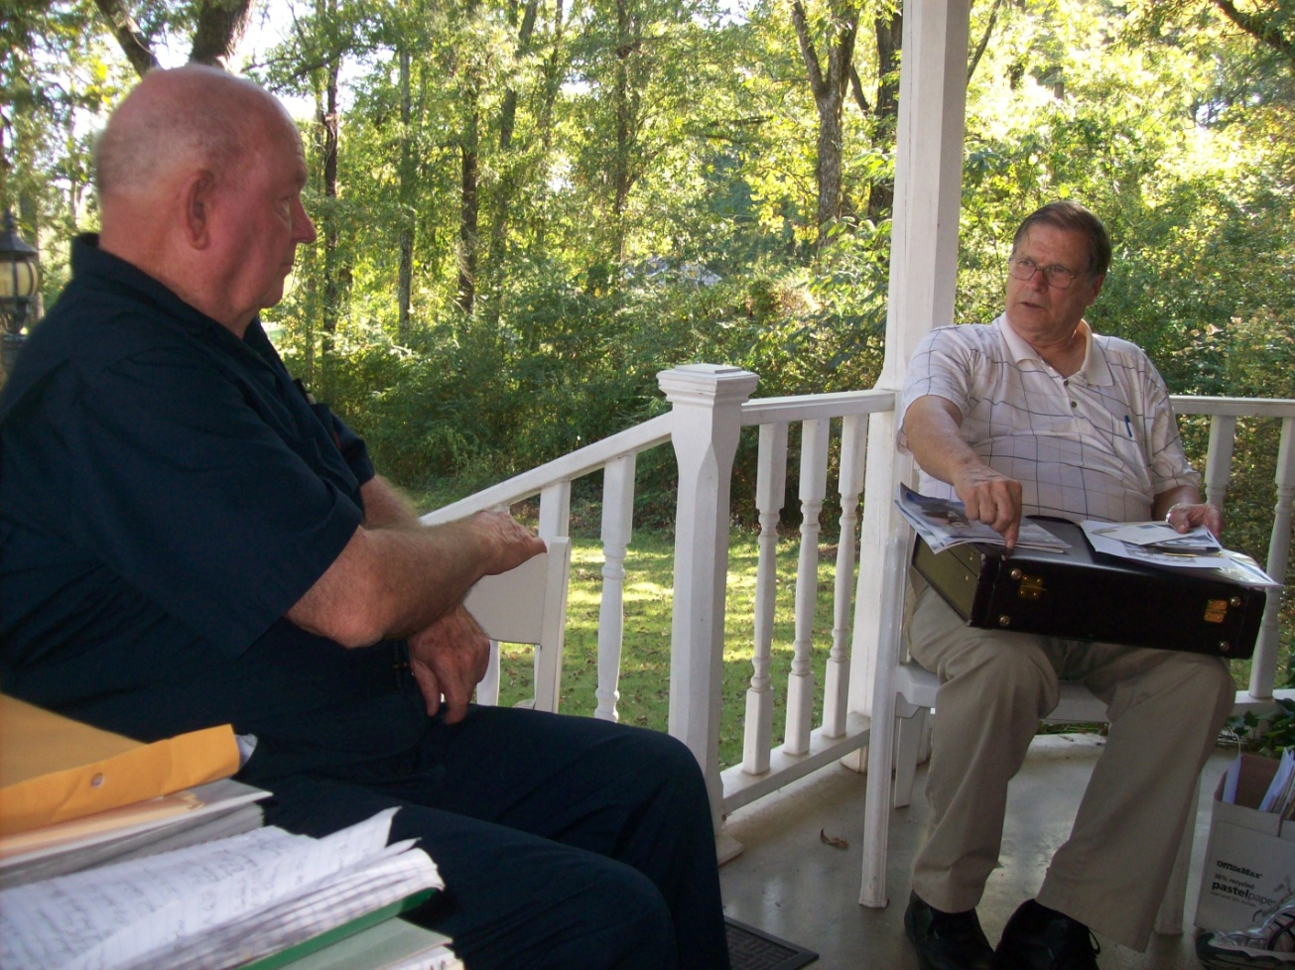

Lynn Holliman, a native of Texas, springs from the James Grantson Holliman (1750-1836) branch of the family tree, and is very knowledgeable of the Carolina Hollimans and those who migrated to Georgia. His recent genealogical travels were to North and South Carolina to research the Hollimans who lived along the border between those states in the early 1800s. Above he, right, and Joe Porter visit at the 2011 Holliman Family Seminar in Alabama.

