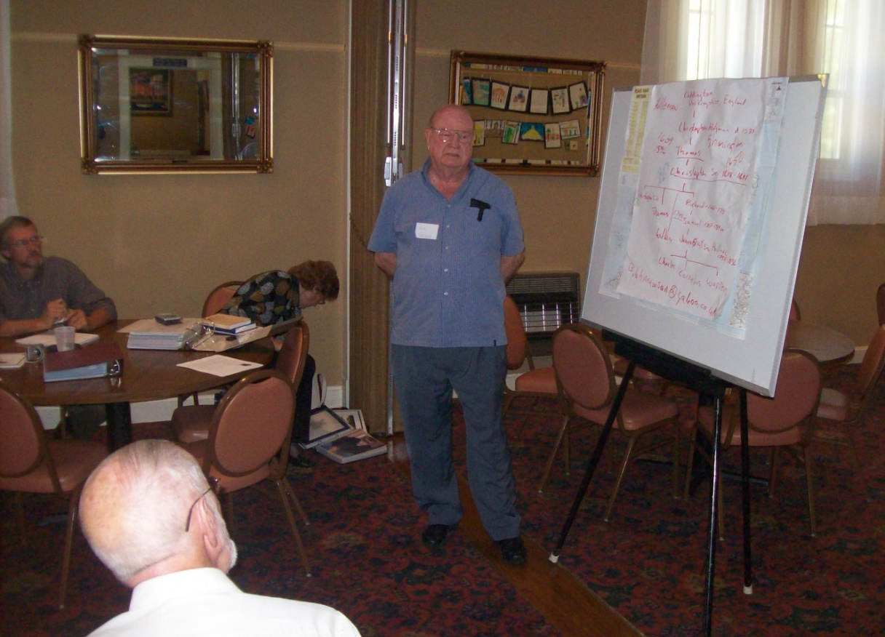
Joe Parker of Texas has a DNA test to prove that he is one of the great grandsons of Christopher Holyman, d 1691, in Isle of Wight, Virginia. No one may know more about the thousands of Holliman who have lived since then than Joe Parker. He is a living database for Holliman family history in America. Above he lectures at a family seminar in 2011 in Fayette, Alabama. He generously shares his vast knowledge with his many distant cousins.

