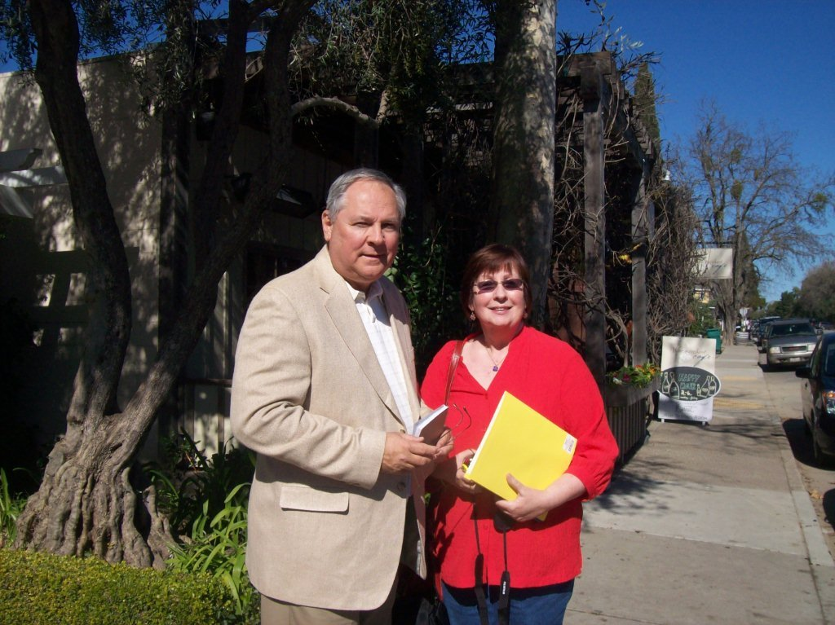
Above in 2011 Tina Peddie and Glenn Holliman exchanged notes in her home state of California. An accomplished genealogist with a gift for leadership, Tina managed the reprint and expansion of George A. Holleman's 1952 classic work on Holyman family history in the 1980s. In 1999, she created a public web forum for the extensive Holliman clan. More than anyone, this descendant of Christopher Holyman, d 1691 in Isle of Wight, Virginia, has brought together the distant cousins for this first American Holyman.

