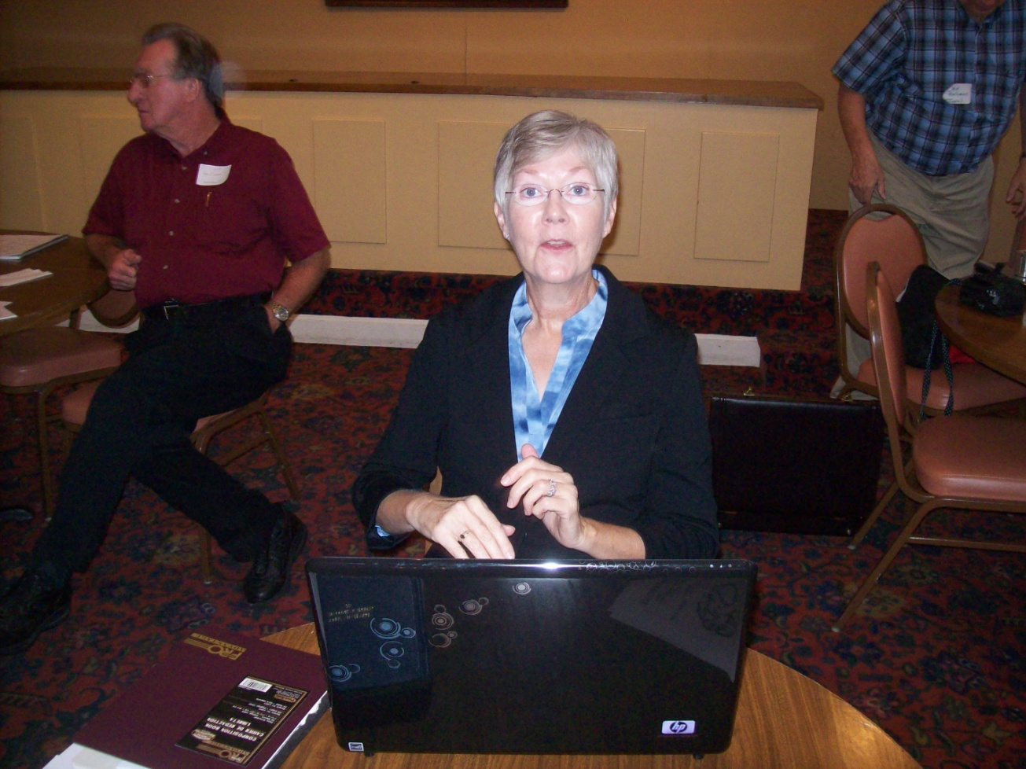

Jeanette Holiman Stewart of Texas is the conscientious keeper of the ever expanding MyFamily Hollyman Family Tree. Above she is recording information at the Holliman Family seminar in 2011 at Fayette, Alabama. The work she has done and continues to do to enlarge and edit the 'official' branches of the myriad Hollimans (and their various spellings) is nothing short of stupendous. All interested in Holyman history continue to owe Jeanette a great debt of gratitude. Mention a Holyman name and she can probably recite the names of one's great grandparents!

