The fellow in the photo with his cousin (Mary) and sister (Edna) is Carlie Edgar Wilson. I've attached a copy of the photo that Clinton sent me with this young man's identification.
In 1900 he was living with his parents on Oscar Wilson Road. He is counted twice in 1910: once on April 10th when he is working for a Charles C. Riley raising cattle in a stock yard at Hoodoo Pct, Malheur Co., Oregon, and a second time with his parents and siblings on the 26th of April.
According to my data base, he was born in February 1891. but his WWI draft registration says he was born 21 Sep 1891 and his WWII draft registration says he was born 01 Sep 1893.
The idea that he "went west as a young man" is true. As noted above, in 1910 he was in HooDoo, OR, and in 1917 he was living in Westfall, Malheur Co., OR, and, in 1942, he was living in LaGrande, OR, and going by the name of Carl Edgar Wilson. Malheur and LaGrande are both in south eastern Oregon where a lot of sheep and cattle ranching takes place.
In 1917, his occupation was "Vaquero" for the Pacific Livestock Company and he is unmarried.
(Here's a cool website giving a glimpse into the life he might have led 'in the west': http://www.ohs.org/education/oregonhistory/historical_records/dspDocument.cfm?doc_ID=AA8D2A86-E6A2-4CAA-54E13F5DC13C82FF)
In 1942 "Hattie Wilson," live at the same address as Edgar was given as the person who would always know his address, but I can find no marriage record.... yet

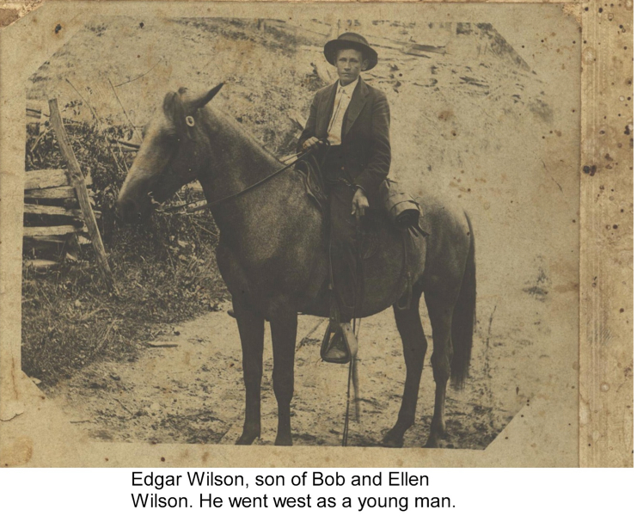
Apr 6 (2 days ago)
to Jeanie, Clinton, me

according to his mothers bible he was born on sept 1, 1891. I just sent this infor to clinton and glenn. my cousin Jackie Farrington(Bob, Torrence, Virgina, Jackie) spent a about 10 years in oregon growing up. she and her mom visited their unclle edgar and aunt Hattie often.. i think Jackie said they had no children. I am sending the tif pics Jackie daughter and i scanned this week. do you want Ellen's bible births and deaths. should i add u to my list when i send stuff to clinton and glenn??
the second pic is Lee wilson, Charles Osborne, Edgar Wilson,Oscar Wilson, Witt Wilson Bruce Donnelly
Perdy Grogan(dated Lee Wilson), Edna Osborne,Hattie Wilson, Torrence Wilson Donnelly, Neva Wilson, Olive Wilson

to Jennifer, Jackie, Jeanie, Clinton, me

just talked to jackie, she gave me some history about uncle "ed "(edgar). she stayed with Uncle ed and aunt hattie every summer in oregon. she lived in oregon from 1953-1961.edgar married a Loraine Wallace from Mountain City TN the first time. they went out west together, she thinks..they seperated and she ran a prostitution house in Pendelton Or. Not sure when Hattie and edgar got married. had no children.Edgar met Hattie when she was cook for sheep herders. I understand he died first and that he and Hattie were buried in Freewater??she did not understand why as that was not where they lived. she went to his funeral..night night

Conley was my great uncle and oldest son of rebecca and John.
dont know the Osborne but thought you might.
Oh yes I am going to Jeane Wilson in two weeks. She lives in Ashe County and is the widow of Ernest Wilson.( Issac, John, Bessie, Ernest)
She has granny Becky's Bible. Her son is the one who has Issac sword. am hoping she has some pics we don't have....Aunt Bessie is the one who looked after granny becky and got the house when Becky died. got a lot of family things..
night night

