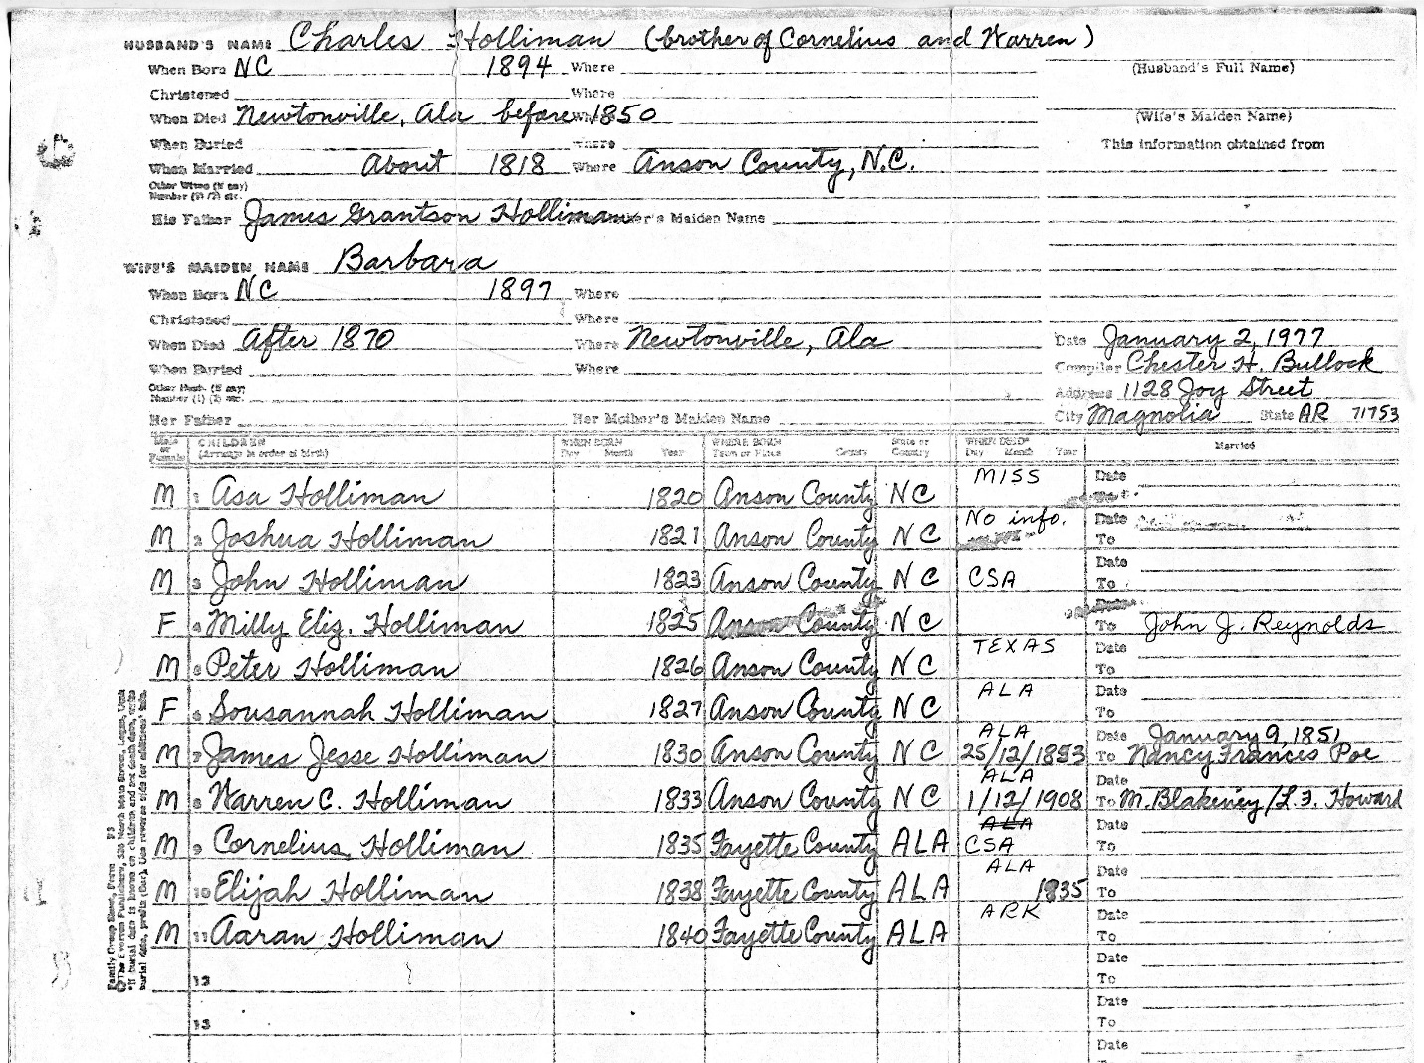

Note, birth dates should read 1794 and 1797 – GNH 2017

