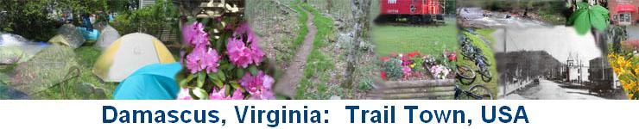

Damascus Stories
The House That Played
The year was 1897. I was seven years old when my parents, George and Frances Osborne, left Boone, North Carolina to make their home on a farm near Blountville, Tennesee.
Our furniture was packed in wagons. Father, Mother, Aunt Alta Osborne and baby son, Lawrence, and I rode in a beautiful black surrey, one of those that inspired the song, "Surrey With the Fringe On Top". The trip was a lark for my five older brothers as they walked, ran along beside, or sometimes rode the furniture-bearing wagons. I helped care for Baby Lawrence. He wore long white dresses and petticoats, all tucked and lace-trimmed. It kept us all busy keeping him happy on such a long trip. We traveled along with other wagons until we reached Damascus. Here our trail turned westward. My father was very impressed with the Damascus Community, and I think he secretly planned to return there to live.
One of the highlights of our journey happened just north of Damascus. The Beaver Creek had to be forded at what was later known as Vail's Mill. The furniture laden wagons had gone ahead and were across the creek. Our horses had entered the water, slowly pulling the aurrey. As we reached the half-way mark in the river, one of the wheels hit a large rock, and we could not move. After much splashing, wading, pulling, and pushing, we reached the bank. The wheel was repaired and we were on our way again. The rest of the journey was uneventful.
After we had settled on the farm and had things going smoothly, my father bought and successfully operated a large mercantile store in Blountville.
The depression had ended and news of the rapidly developing town of Damascus reached us. In 1908 my family left Blountville and returned to Damascus. My father bought and operated a mercantile store near the center of town. He also bought a big white house near the store and Mother rented rooms to some of the many people moving into town. Damascus had really grown since our first trip. There were several stores, a bank, two churches, and numerous lovely houses between the two rivers. Before there had been only three houses and a store. By 1910 the first train came to Damascus. The main street was a wide smoothly scraped road with board sidewalks on each side. The Damascus Light and Power Company supplied the town with electricity. R. Dave Wright, who would later be my husband, was an employee of this company.
After living in Damascus for two years, my parents moved again. This time we moved to Afton, Tenessee; there my father owned and operated a larger store. In 1911 Dave Wright came to Afton to ask me to be his wife. We were married in Greenville, Tennessee and came back to Damascus to live.
Our first home was a small upstairs apartment in the telephone office building. Dave continued to work for the Damascus Llght and Power Company. Later we bought and moved into the house now owned by Ollie Weaver.
The Damascus Light and Power Company was bought by the Appalachlan Power Company, and Dave became manager of the Damascus Branch. We bought and moved into the house presently owned by Harold "Joe" Lamb.
Dave was always interested in anything involving electricity. He operated the moving picture machines for years. When radio came into being, he built a miniature house containing a speaker and hung it on a wire over the street in front of our house. Music could be heard on the street in the lower end of town.
At the death of my sister-in-law, her three children came to live with Dave and me. The two girls, Doris (Mrs. E. F. Akers) and Gladys (Mrs. Howard Adama), lived with us until they married and moved into their own homes. Their brother, Bascome, entered the navy, when he became of age.
Due to illness, Dave retired from Appalachian Power Company in 1952. We built more rooms to the radio shop. Hazel and Wayne McConnell lived there until they built their own home below Damascus in 1965. When Dave passed away, I sold the big house and moved into the smaller one. It is my home today.
Pearl 0. Wright

