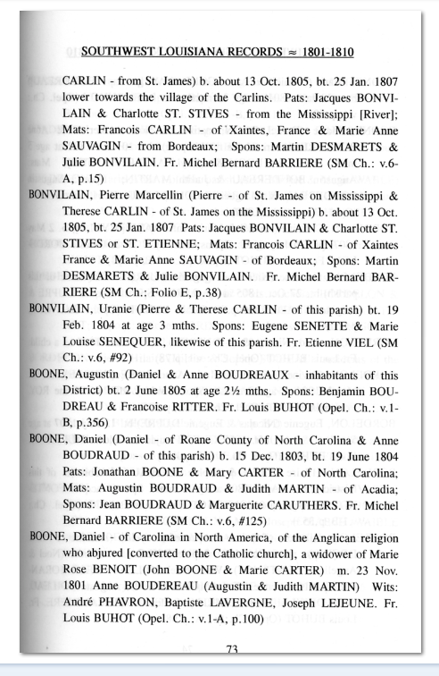 Burleigh Family and Boone family
have a connection

I am so far off center that I am not on most of your reader’s radar. But when Shirley Sorrell had a picture of my great grand father, Jesse Jenkins and his mother Anna Widby who married Roland Jenkins I knew there was a place for me. And when you started talking about your connection to Daniel Boone my ears really pricked up. My husband’s family, descendants of Robert Burleigh have a Cajun relative who married a man named Daniel Boone. Not THE Daniel Boone, but same name. So am I in the game again? Well, not me, but my children? My children ARE related to my husband’s ancestors as well as mine.

Are you familiar with the Father Hebert books? Probably not. He was a Catholic priest who compiled over 40 volumes of abstracts of church and civil records from more than a dozen Louisiana parishes. (Parishes in Louisiana are the equivalent of counties in most other states.) These books are the genealogical bible for us in Louisiana. I was amassing my husband’s family documents. His gg grand father was James Burleigh son of the Louisiana progenitor Robert Burleigh from North Carolina. James’ daughter-in-law was Adelaide Boudreaux sister of Anne Boudreaux. She married Daniel Boone. That is when I took a detour to look into Boudreaux – Boone genealogy.

Southwest Louisiana Records, Church and Civil Records, Volume 1-B (1801 – 1810) complete reversion by Rev. Donald J. Hebert, page 73. This record under BOONE gives a three for one. The last Boone entry is for the marriage of Daniel and Anne. The one above is for the birth of their son Daniel and the one before that is for the birth of their son Augustin. On page 82 the marriage is recorded under Boudreaux.

Anne Boudreaux daughter of Augustin and Judith Martin married 23 Nov 1801 Daniel Boone of Carolina in North America, of the Angelican religion – who abjured [converted to the Catholic church] widower of Marie Rose Benoit. Daniel was the son of John Boone and Marie Carter. Witnesses were Andre Phavron, Baptiste Lavergne, Joseph Lejeune, Fr. Louis Buhot (Opel. Ch.:v.1-A, p.100)

Anne’s father, Augustin Remy Boudreaux, is a proven Revolutionary War Patriot. He was with Galvez (Spanish governor and General) in the Attakapas Militia. Spain was an ally of the Revolutionists though not technically at war with England. Keeping the Mississippi river open was an important contribution.

So now the Boones have a Cajun Revolutionary War Patriot, a connection to their Cajun ancestry and all those wonderful Boudreaux - Thibodeaux jokes.

Thibodeaux: Why you have X at the end of your name?
Boudreaux: Same as you, that’s my mark.
Heaux, heaux, heaux.

In paragraph 2, line 6, I said James' daughter-
I should have said James' wife (line 7) was Adelaide Boudreaux, sister of Anne Boudreaux.
In paragraph 5, I said Anne's father, Augustin Remy Bourdreaux
I should have said Anne's grandfather, Augustin Remy Boudreaux
I apologize for being so sloppy.
I will try to add this to Dorothy Ruth Jenkins Family Tree on ancestry.com to be shared as a public tree for all to see very soon. This is mardi gras weekend, a VERY BIG EVENT in Lafayette, Louisiana, which diverts time from genealogy.

I mentioned in my e-mail to you I would be contacting the Boone Family expert. Well Cousin Dorthy replied to me in a hurry. Maybe it's from the close relationship we have. As I told you I don't do a lot of research on the majority of the Boone family. That's what our Societies senior genealogist is for.

So is there a connection between your husband & children and The Daniel Boone? The answer is YES. As I suspected, the chances of a Boone from Rowan County being related to Squire and Sarah Boone are about 98%. When you contacted Glenn you might have been wondering if your husband's Boone family was part of of our Boone family. Here is Dorthy's reply:

"As to this Daniel Boone, who married first Marie Rose Benoit in August 1800 and she died 3 April 1801. They had no children. He married second 23 Nov 1801 to Ann Boudreaux and they had 7 children. He died between November and December 1817 near Beaumont, TX killed by Indians. He was not killed at the Alamo as many stories say. On page 73 of your downloads, he is the same Daniel Boone. He is the son of Jonathan Boone who married Mary Carter, he the son of Squire Boone, Sr and Sarah Morgan. The children of Jonathan Boone and Mary Carter have been contrived and inflated through the years. I think the son Daniel escaped due to the fact

"As to this Daniel Boone, who married first Marie Rose Benoit in August 1800 and she died 3 April 1801. They had no children. He married second 23 Nov 1801 to Ann Boudreaux and they had 7 children. He died between November and December 1817 near Beaumont, TX killed by Indians. He was not killed at the Alamo as many stories say. On page 73 of your downloads, he is the same Daniel Boone. He is the son of Jonathan Boone who married Mary Carter, he the son of Squire Boone, Sr and Sarah Morgan. The children of Jonathan Boone and Mary Carter have been contrived and inflated through the years. I think the son Daniel escaped due to the fact that he went to LA as a young man and sort of got lost in the Boone folly that intrigues so many to claim what they are not. His daughter Uranie was just two or so when he died and her mother died when she was about age 15. Although I have completed a lot of census work on this line not much has ever been known about them in reality."

Your husband, and children, are my cousins. Jonathan Boone is a younger brother of my Sarah Boone Wilcoxson. It's great you found the family blog and contacted Glenn. Glenn often forwards queries to me, knowing if I don't have the research information I will either start digging or contact someone who has the information.

I would appreciate you sending all information you and husband has on his family line from Squire & Sarah Boone to your children. I will forward it to Dorthy Mack so she can fill in some blanks with the Boone family. Doing this is totally voluntary. Dorthy is discrete in sharing information. I encourage your family to go to the Boone Society web site. I attached a copy of our most recent Society newsletter. I also attached a photo of my daughter Wendy, my wife Elogene and me at the 2014 Boone Society Family Reunion in Pineville KY.

wife Elogene and me at the 2014 Boone Society Family Reunion in Pineville KY.

I am not sure where you live. Don't know if your family has any knowledge of the areas of the country where the Boone Family lived in Pennsylvania and North Carolina. I grew up in Boone NC a short drive from Davie County and Mocksville where the Boone's settled after moving from PA. Knowing where someone I correspond with lives gives me an idea of just what to include or expand on in correspondences. No need in going on and on about areas where the recipient knows as much or more than me of the areas.

I am in contact with over a dozen Boone family cousins. I love to correspond and share information. That's one reason Glenn forwarded the e-mail. I have a passion for Revolutionary war Patriots, especially the five I have documented in my direct blood line. Two of them are Sarah Boone Wilcoxson and her husband John. With proper documentation direct descendants of Sarah and John are eligible to join the Sons of the American Revolution (SAR) or the Daughters of the American Revolution (DAR). I lend a hand with cousins who are researching their lines and gather documentation to file an application to one of them. I am an officer of Thomas Nelson Jr. Chapter of the SAR. I have a good feel for what documentation is acceptable to the SAR and DAR. I also have several record copies of SAR and DAR applications that can help applicants.

Glenn,

Though Dotty's family is not from the Greer line her husband and children are definitely kin. I am glad you forwarded her e-mail to me. It seems information she sent is filling in gaps in the Boone family line. Nice that I could go in a different direction with the Boone line and yet another excuse to run to Dorthy for help. Please keep sending people my way.

Cousin Gary

