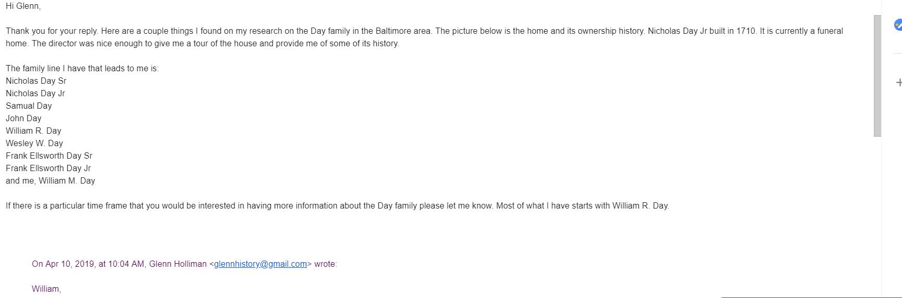
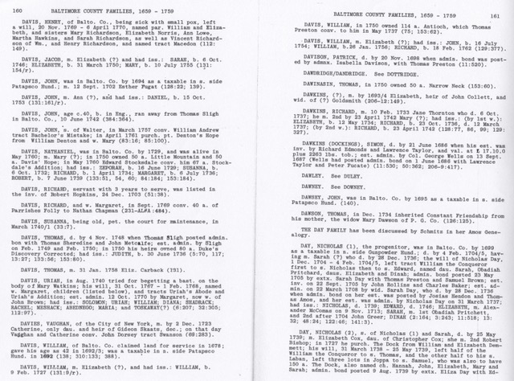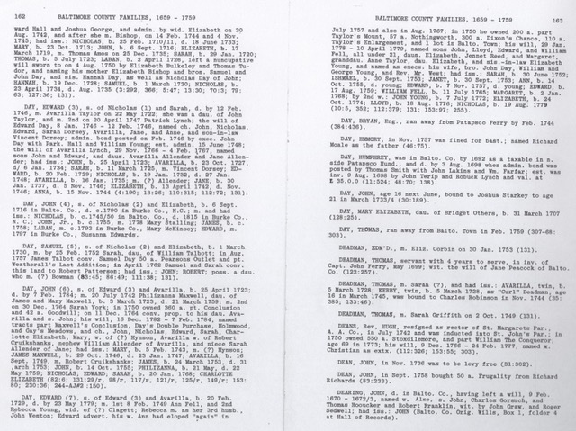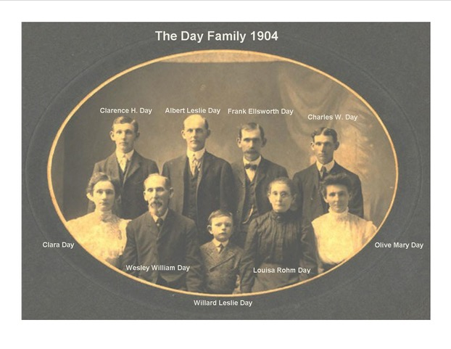

Nicholas Day. Nicholas Day originally came from Wales and was born there perhaps in 1620, although 1630 is more likely. The next record of him occurs 22 February 1658, when "he with seven other men (all named) and two women, Elizabeth Gaibe and Catherine Roads," (Faulkner), having been bound out to Richard Owens, the latter "granted them their freedom and so notified his 'Lordships Grace,' the Crown of England that they were entitled to 50 acres of land.
Since the usual pattern at the time was for those who could not pay their own way to be 'transported' in exchange for seven years indentured labor, we may infer from this that Nicholas Day was so transported: that his assets in Wales were not great enough to cover the cost of transportation; and that his actual voyage took place about seven years prior to obtaining h is freedom, or about 1651.
If he was in fact born in 1620, he would have been 31 art the time of the trip. A 1630 birthdate would have made him 21, which appears more reasonable. His oldest child, Nicholas Day, Jr, was born about 1685, when Nicholas Day, Sr was 55 or 65, depending on his birthdate.
When next heard from it is June 6, 1693. He is listed as Nicholas Day, Sr of Anne Arundel Co., Md, and for 1200 pounds of tobacco he obtains 200 acres of land at Gun Powder Falls on Gun Powder River Northeast of Baltimore. Also that year, for 3000 pounds of tobacco, Thomas Bruins sells him 150 acres of land named Lesser Chance, and on November 5, 1693, Nicholas Day bought a part of the tract known as William the Conqueror. From this, several additional inferences can be made
. There are no records showing whether Nicholas Day owned land in Ann Arundel County during the 36 years between 1658 and 1693; but he apparently lived there and became prosperous enough to be able to make the purchase outlays for the land in Baltimore County. If he was born in 1620, he would now be 73, rather old for a new venture, with his oldest child not older than 10, and probably several younger children on the scene as well. A 1630 birthdate would make him 63 at this time--which appears more reasonable. "He was taxed for land on the north side of the Gunpowder from 1699--1706.(4) His will, dated December 1, 1704 and proved February 2, 1705, is on file in the Hall of Records
and the following is a transcription made from a photostat of it.:
In the name of God Amen this first Day of December one thousand Seven hundred and four I Nicholas Day of Baltemore County being Sick and weak in body but perfect Strength and Memory thaks to all mighty God for and Calling to minde the uncertaine Estate of this Transitory life Doe Constitute and ordaine and Declaire this my last will and testament in manner and forms following--
Revoaking and by these presents testamt or wills hereto fore by me made and Declared Either by word or wrighting and this to be Taken only for my last will and testament and none other
viz I give my Soul to all mighty God my Saviour and Redeemer in hume and by the merrits of Jesus Christ I trust and beleive assurdly to be Saved and to have full remission and forgiveness for all my that my Soul with my body at the genrall Day of Resurrection Rise againe in Joy and through the merritts of Christs Death and passion posses and inheritt the Kingdoms of heaven prepared for his Elect and my body to buried in such manner as it Shall please my Executr. and hreafter whom I shall appoint
and now for the Settling of my Temporall Estate first I Desire that all my Just Debts that I owe in right to any man Shall well and truely paid or ordered to be paid in Due time after this my Decease by my Executr. however named
Item I give unto my Sonn Nicholas Day all that tract of Land at Gundpowder Called or Knowne by the Name William the Concour to the said Nicholas Day and his heirs for Ever and for want of such heirs after his Decease to be Deemed the proper right and Intrest of my Second Sonn Knowne by the name of Edward Day to him and his heirs for Ever.
Item I give unto my Sonn Nicholas Day all that parts of my Stock of hoggs that is of his proper Marke and alsoe I give to my Daughter Sarah Day all that parte of my Stock ofhoggs that is of her proper markes.
Item I give unto Obediah Prichett Six young Sows with pig or piggs by them Due alsoe I give unto Walter Pardue four young Sow Shoats
Item I give unto my Two youngest Daughters Elizabeth Day and Dinah Day all that part of land whereon I now live to be Equally Divided between them after the Death of my Loveing wife Sarah Day to them and their heirs for Ever as for my personal Estate I do ordaine it to be Equally Devided between my wife and five Children
and lastly I Doe hereby Constitute and ordaine and apoint my above Said true and loveing wife Sarah Day to be my Sole and only Executrix of this my last will and testamt as witness my hand and Seale the Day and year above written
Signed Sealed and Delivered the marke of in the presence of: Nicho ND Day Seal his
John Whittaker Feby 2nd 1704/5 mark Then Came John Whittaker and Catherine her his wife John Deaver and Hannah his wife Cath. Whittaker the wittnesses to the above written will mark and proved the Same in comon forme before me. John Deaver
Hannah Deaver Henry Wriothesley Depty Com of Baltimore County
In the testamentary proceedings in 1736, the bond of Sarah Day was made by Nicholas Day with Josiah Hendon and Thomas Amos. Nicholas and Sarah Day had five children named in Nicholas' will. Rationale for the range of their birthdates is provided in the childrens' entries.
- 1. Nicholas, Jr, b. c. 1685, bet 1674 & 1695 (+)
- 2. Sarah, b. bet 1683 and 1686 (+)
- 3. Edward, b. betw 1675-1687 and 1694-1704 (+)
- 4. Elizabeth, b. bet 1684 and 1695 (+)
- 5. Diana, born bet 1689 and 1700 (+)
view all 11
Nicholas Day's Timeline
1625 | 1625 | Birth of Nicholas  1620-30 Wales
1684 | 1684  Age 59 | Marriage of Nicholas to Sarah Day  Baltimore, Maryland, X-Unknown
1685 | 1685  Age 60 | Birth of Nicholas Day, II  Baltimore, Maryland, USA
1686 | September 19, 1686  Age 61 | Birth of Sarah Greer (Day)  Baltimore, MD
1689 | 1689  Age 64 | Birth of Edward Day  Baltimore, Maryland, United States
1693 | 1693  Age 68 | Birth of Elizabeth McComas  Baltimore, Maryland, United States
1694 | 1694  Age 69 | Birth of Dinah Marice Day  Baltimore, Maryland, USA
1704 | February 4, 1704  Age 79 | Death of Nicholas  Baltimore, MD, USA
1959 | February 6, 1959  Age 79 | baptised (LDS) on 2/6/1959
1960 | January 21, 1960  Age 79 | endowed (LDS) on 1/21/1960

Day Family Related Websites

http://www.acw70indiana.com

http://www.acw70indiana.com/70thindiana/companyf.htm#top

https://www.findagrave.com/cemetery/91894/memorial-search?firstname=&lastname=Day&cemeteryname=&page=1#sr-153453580

http://www.findagrave.com/cgi-bin/fg.cgi?page=gsr&GSiman=1&GScid=91894&GSfn=&GSln=Day

http://www.resacabattlefield.org/FoRstart.html

http://www.rootsweb.ancestry.com/~ksdickin/1893bios/1893daywesleyw.html

http://skyways.lib.ks.us/genweb/archives/dickinson/military/1883.txt

http://sites.rootsweb.com/~ksdickin/1893bios/1893daywesleyw.html

http://www.georgiadivision.org/bor_reenactment.html

https://www.findagrave.com/memorial/5626329

https://www.geni.com/people/Nicholas-Day-I/4587391352890086655

https://www.findagrave.com/cemetery/2256768/memorial-search?firstname=&lastname=Day&cemeteryname=&page=1#sr-30722724

http://www.angelfire.com/pa/DayFamilies/WallysLine1.html

https://www.familysearch.org This site is free to join and has a good family chain. Start with Wesley W. Day.

https://www.findagrave.com/memorial/116163472/nicholas-day

https://www.genealogy.com/ftm/h/e/n/Elaine-Hensley/WEBSITE-0001/UHP-0577.html

https://www.genealogy.com/ftm/h/e/n/Elaine-Hensley/WEBSITE-0001/UHP-0579.html

http://fwosborne.blogspot.com/search/label/Sr.%20Nicholas%20Day

https://ia802604.us.archive.org/11/items/seventiethindian00merri/seventiethindian00merri.pdf

https://msa.maryland.gov/megafile/msa/stagsere/se1/se5/003400/003475/pdf/msa_se5_3475.pdf

http://www.baltimoregenealogysociety.org/BCGShome/projects/bcgs-burial-project/

http://ironbrigader.com/2014/04/14/future-president-benjamin-harrison-70th-indiana-infantry-battle-resaca-georgia/

https://www.findagrave.com/memorial/5626329

https://www.findagrave.com/memorial/5626331

https://www.geni.com/people/Nicholas-Day-I/4587391352890086655

https://www.geni.com/people/David-Anthony-Day/6000000006419364111

https://www.myheritage.com/names/maria_teppa

https://www.legacy.com/obituaries/theneworleansadvocate/obituary.aspx?pid=180843063

https://msa.maryland.gov/megafile/msa/stagsere/se1/se5/003000/003400/003475/pdf/msa_se5_3475.pdf

http://www.virtualharford.com/joppatowne.html

https://www.findagrave.com/memorial/31310148/ishmael-day

https://sites.google.com/site/mdoffmd/home

https://www.findagrave.com/memorial/116393633/nicholas-day

https://www.genealogy.com/ftm/h/e/n/Elaine-Hensley/WEBSITE-0001/UHP-0573.html

https://www.genealogy.com/ftm/h/e/n/Elaine-Hensley/WEBSITE-0001/UHP-0577.html

https://en.wikipedia.org/wiki/Ishmael_Day

http://www.angelfire.com/pa/DayFamilies/WallysLine1.html
http://so-many-ancestors.blogspot.com/2014/11/those-places-thursday-day-deans-king.html

http://www.stjohnskingsville.org/wp-content/uploads/2015/07/A-History-of-St-Johns-Kingsville-May-2015.pdf

http://www.kingsville-md.us/history/index.html

https://www.genealogy.com/ftm/h/e/n/Elaine-Hensley/WEBSITE-0001/UHP-0577.html

