Some Notes on a West Alabama Family by Laura Vonceil Duckworth, Reform, Alabama.

This is second in a series of four postings on the family and ancestors of Laura Vonceil Duckworth, a descendant of Christopher Holyman (1618 - 1691) of Isle of Wight, Virginia.

"My ancestor, Charles Holliman migrated to Fayette County, Alabama with his two brothers, Warren and Cornelius, from the family home in Lancaster, South Carolina of their father, James Grantson Holliman (1850 – 1836) in 1836.

Elijah’s Civil War record would take pages to tell. For now, I continue to share my family tree below with several photographs. My great grandmother, his second wife, Permelia Gibson Holliman, was the 7th child of Tillman Gibson of Fayette, Alabama.

My grandmother, Laura Jannie Holliman (29 August 1873 – 6 December 1936) married Virgil Constantine Clemmons, son of Woodson Clemmons and Rebecca Reece Clemmons. Jannie is buried at Bethlehem Baptist Church Cemetery, Reform, Alabama, Pickens County along with her husband. These are my grandparents, Jannie and Virgil Clemmons. Their photographs are below.
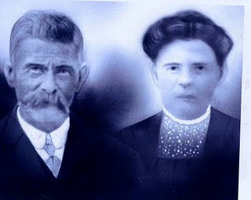

Their children are Melinda Elizabeth ‘Lizabeth’ Clemmons (1893 – 1895), William Edward Clemmons, Thomas Tillman Clemmons, Elvin Elijah Clemmons, Charlie Dennis Clemmons, Minnie Lee Clemmons and Mamie Lou Clemmons.

On July 12, 1935, the extended family gathered in Lamar County, Alabama for Elijah Holliman’s 96th birthday. He was the oldest Confederate veteran in his county when he died May 11, 1937.
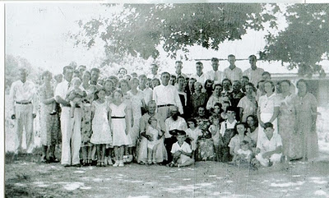

Above the family of Elijah Holliman, center for his birthday in Reform, Alabama in 1935. Assistance is sought from his family to identify persons in the photo below. Please email glennhistory@gmail.com with names.

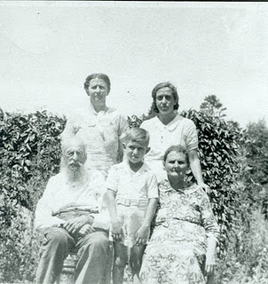
Above at the 1935 reunion are front row left to right, Elijah Holliman, his great, great grandson, Sonny Cunningham and Mary Elizabeth Shaw, Elijah's daughter by his first wife, Mary Shaw. Back row, left to right are granddaughter, Pattie Holliman Whaley and great granddaughter Mary Sue Whaley Cunningham.

One of the children of Virgil and Jannie Holliman Clemmons was my mother, Mamie Lou Clemmons (14 August 1918 – 13 January 1984) who married my father, Dewey Delmer Bonner on 29 December 1937.

Their seven children were Dewey Max Bonner (13 June 1939), Laura Vonceil Bonner Duckworth (18 December 1941), Shelby Marie Bonner McDaniel (13 June 1944), Johnnie Mae Bonner Babb (20 January 1946), Jimmy Keith Bonner (25 November 1950), Clayton Gregory Bonner (5 November 1953), and Frances Marilyn Bonner Elmore (12 March 1956)."

Next week, another posting of Vonceil Duckworth's family tree....
Some Notes on a West Alabama Family by Laura Vonceil Duckworth, Reform, Alabama.
“My great grandfather was the famed Civil War veteran Elijah Holliman, born on 12 July 1838 in Newtonville, Fayette County, Alabama. He was the son of Charles and Barbara Walters Holliman who emigrated from South Carolina in 1836.
Photo of Elijah in uniform to be added
Elijah married three times. His first marriage was to Mary Shaw of whom three children were born: Sarah Melisa Holliman, Mary Elizabeth Holliman an Peter Aaron Holliman.
His second marriage was to Permelia Gibson (b 1834). She is my great grandmother. From this union there were two children: William Green Holliman and Laura Jane (Jannie) Holliman, my grandmother. Unfortunately I do not have a photograph of Permelia or even know where she is buried.
Charles Holliman had migrated with his two brothers, Warren and Cornelius, from the family home of their father, James Grantson Holliman (1850 – 1836) who had lived in both North and South Carolina.
Elijah’s Civil War record would take pages to tell. For now, I share my family tree below with several photographs, the first being young Elijah (1838 – 1937) in his Confederate uniform from the War. His mother, Permelia Gibson Holliman was the 7th child of Tillman Gibson of Fayette, Alabama.
My grandmother, Laura Jannie Holliman (29 August 1873 – 6 December 1936) married Virgil Constantine Clemmons, son of Woodson Clemmons and Rebecca Reece Holliman. Jannie is buried at Bethlehem Baptist Church Cemetery, Reform, Alabama, Pickens County along with her husband. These are my grandparents, Jannie and Virgil Clemmons.
Their children are Mind Elizabeth ‘Lizabeth’ Clemmons (1893 – 1895), William Edward Clemmons, Thomas Tillman Clemmons, Elvin Elijah Clemmons, Charlie Dennis Clemmons and Mamie Lou Clemmons.
In 1935, the extended family gathered in Lamar County, Alabama for Elijah Holliman’s 98th birthday. He was the oldest Confederate veteran in his county when he died in 1937. Group photo to be added

On of the children of Virgil and Jannie Holliman Clemmons was my mother, Mamie Lou Clemmons (14 August 1918 – 13 January 1984) who married my father, Dwey Delmer Bonner on 29 December 1937.
Vonceil, please check the names and dates below. Some of this ran together and could not tell who was whom or married to whom.

Their children were Dewey Max Bonner (13 June 1939), Laura Vonceil Bonner Duckworth (18 December 1942), Shelby Marie Bonner McDaniel (13 June 1944), Johnnie Mae Bonner Bobb (20 January 1946), Jimmy Keith Bonner (19 November 1950), Clayton Gregory Bonner (5 November 1953), and Frances Marilyn Bonner Elmore (12 March 1956).
Dewey Max Bonner married Dorothy Faye Holliman, daughter of Kenneth Holliman, son of Frank and Kesta Howard Holliman in June 1958. Their children are Ginger Fay Bonner Hicks (13 May 1960), Franklin Max Bonner (12 April 1964), Camelia ‘Millie’ Diane Bonner Elkins and Jeffrey Dale Bonner.
Photo of Vonceil to be added
Laura Vonceil Bonner married Lonnie Morris Duckworth on 14 December 1962. These are their children – Kenneth Morris Duckworth (7 February 1964) and Michael Keith Duckworth (19 November 1967).
Shelby Marie Bonner married Allen Wilson McDaniel. They have one child, Allen Mitchell McDaniel. Johnnie Bonner married Charles Babb, and their children are: Steven Gregory Babb, Kristen Michell Babb Hill, and Jimmy Keith Bonner.

Two children: Amanda McDaniel Sullivan, Bandon Keith Bonner. Clayton Grergory Bonner married Linda Ann Junkin Bonner (now divorced). Their children are Jason Gregory Bonner and Lezlee Ann Bonner Kyles. Mills Frances Marilyn Bonner married Jimmy Donald Elmore. Their children are: Jacky Elmore, Jared Donald Elmore and Jala Dawn Elmore.
Photo of Tyler to be added
Tyler Duckworth, grandson of Vonceil Duckworth, is the son of Kenneth Morris Duckworth and Judy Renee Gray Duckworth. Tyler is the latest generation descended from Christopher Holyman, Sr. (1618 – 1691) who was born in England and died in Virginia.

Photo of Mamie Louis and Virgil Clemmons to be added
My mother, Mamie Lou Clemmons, a descendant of Hollimans, had a great influence on my life. She always was at home taking care of seven brats. Very few times was a switch used, but she used her soft voice for corrections, teaching us that it was wrong to talk about others. If we couldn’t say anything good about other people, it was best we didn’t say anything. Never take anything for granted. Always give a helping hand when you can, as you never know when you might need help. Learn and use your mistakes when have children of your own. Always tell the truth and then you don’t get into trouble because your daddy has checked the mileage of the old care. Other people will look at you and know what kind of parents you have by the way you act. Your education can never be taken away.

Mom’s parents passed away while she was still a teenager. She dropped oiut of school in the ninth grade, and she married at the age of nineteen. Dewey D. Bonner was fourteen years older, but he provided well for her. H always said she was different from any of the other women he had dated.

Never in my life did I hear my mother utter a curse word. One of the greatest things I ever heard her say was, “The greatest thing I get out of life is helping others.” What a tribute to leave behind. She passed away on January 13, 1864 in UAB Hospital in Birmingham, Alabama from complications of acute leukemia. She was diagnosed tgwo weeks before while in a hospital in Columbus, Mississippi. She had a heart attach the day she left that hospital and a stroke the same night. What a defeat!@ Or was it? She longed to see her husband whom had passed away 16 May 1979. I say she was received with open arms.”

