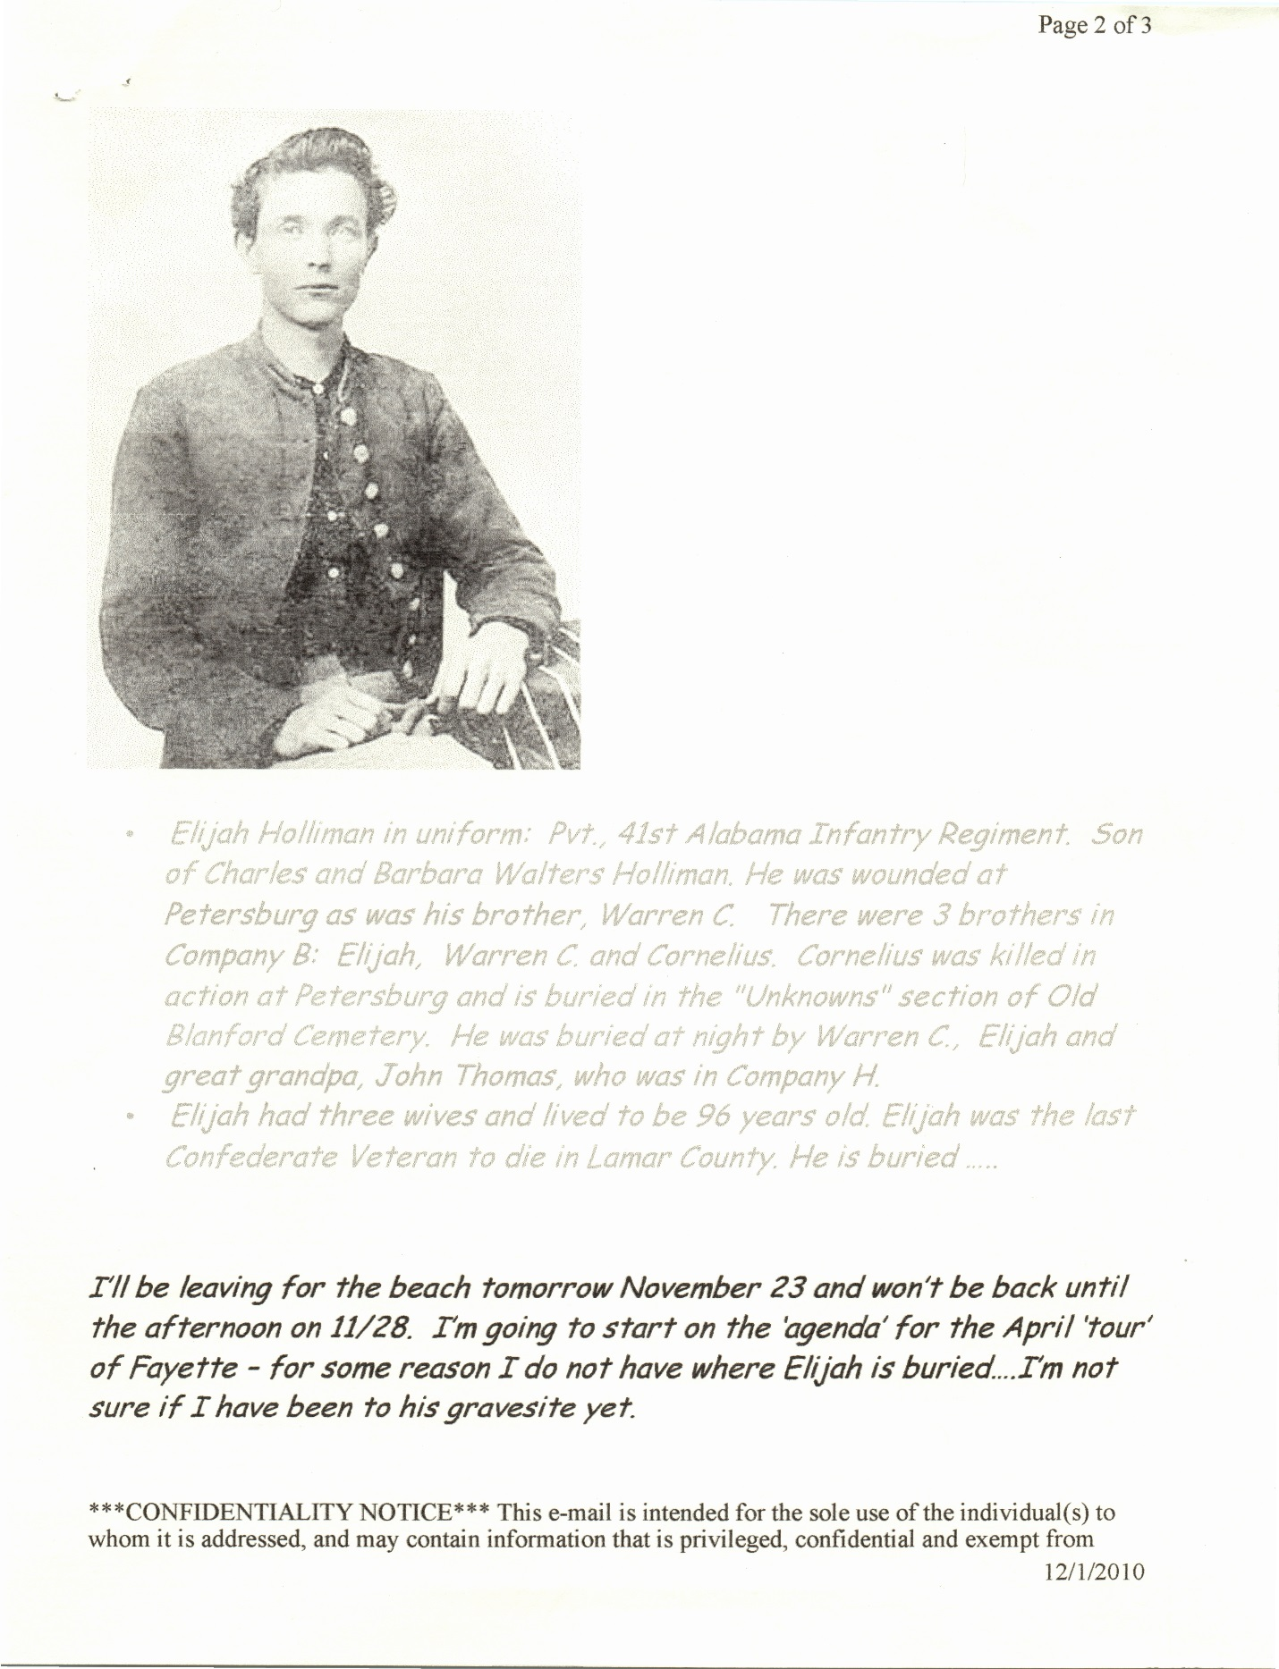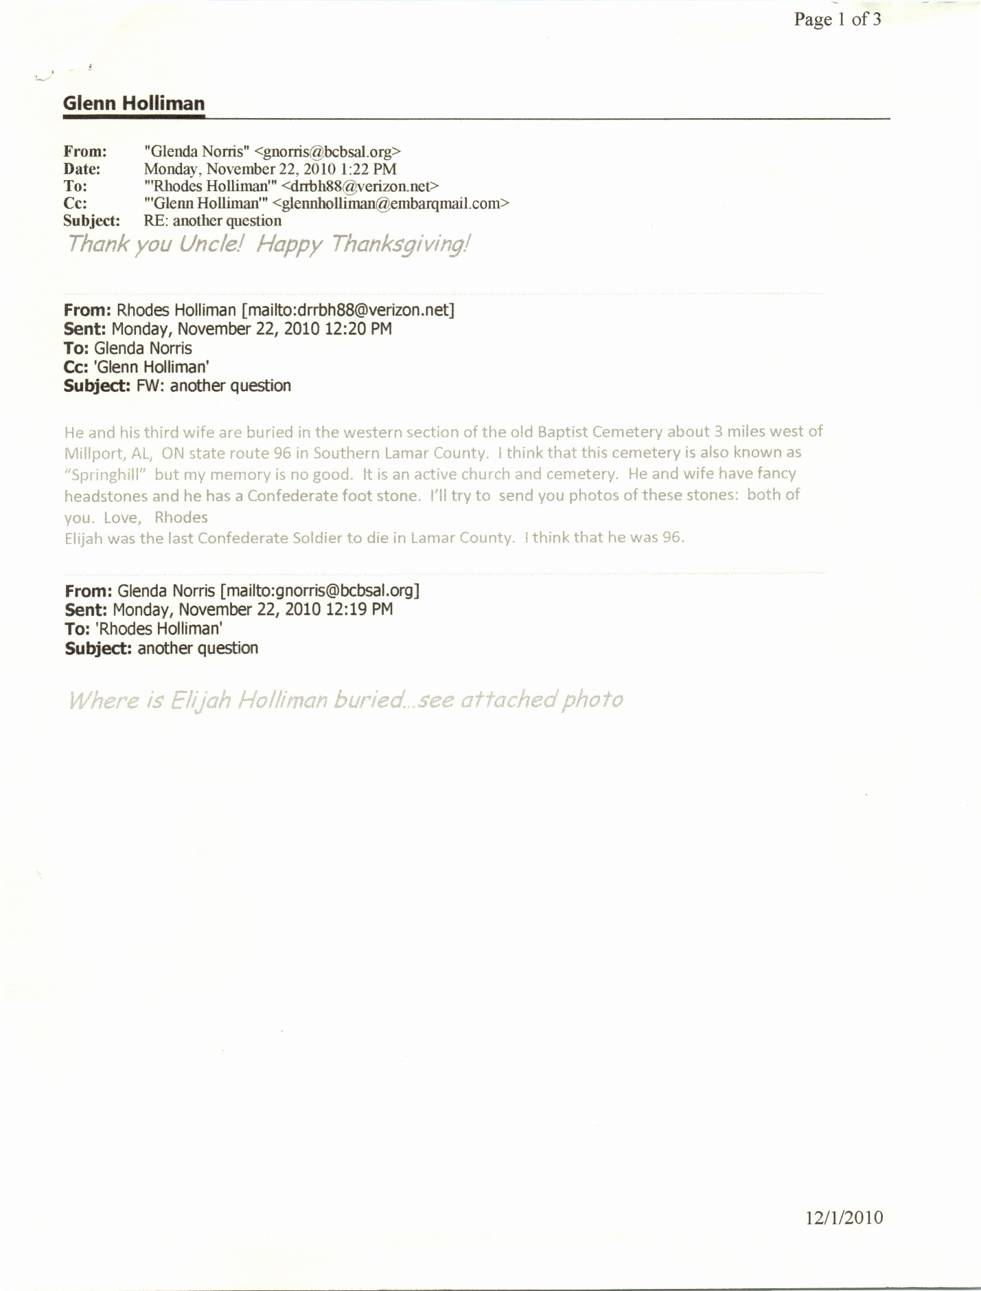Elijah Holliman records
Biography - 2
Obituary - 3
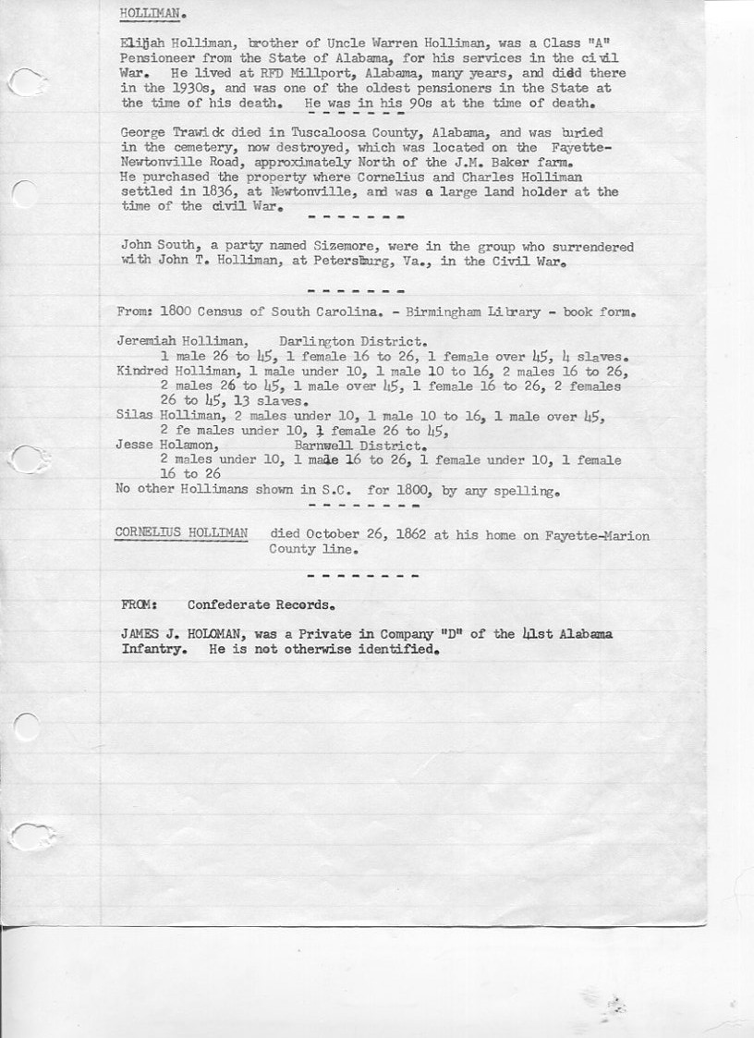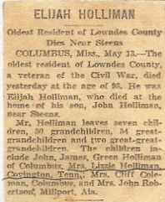

----- Original Message -----
From: Rhodes Holliman
To: Glenda Norris
Sent: Monday, October 15, 2007 12:41 PM
Subject: Murder most foul !

Dear Glenda:

I think that the Hollimans around west TN are descendants of offspring of Pvt. Elijah Holliman, Co. B, 41st Ala. Infantry or Warren Holiman, brother of Cornelius. Elijah was a cousin to John Thomas. Elijah lived in Millport, AL, and was married 3 times. At age 96 he had a flock of children at his birthday party. Several of his kids moved to west TN and their descendants still live there. Some went to Arkansas and their descendants moved to TN.

I may be able to get a definitive answer from cousin Maxine Wright of Mountain Home, Arkansas. Elijah was her great grandpa. She still visits relatives around Memphis and may know something about this.

I was searching for material on Silas Holliman, son of Isaiah. Isaiah was a son of Lt. James Franklin Holliman and his first wife, Rebecca Utley Stewart. Don't know where Silas is buried. Probably in Tuscaloosa County. You know where James Franklin and Rebecca are buried. Isaiah is buried in Springhill at Bluff near Mary Polly. Isaiah's old dilapidated house stands to the right of the road as you pass out of Bluff going toward the Holliman Cemetery. You asked me about this old house last year. The dog trot house we visited, where you got in the attic, belonged to William Bailey H., brother of Isaiah.

Silas would be your cousin about three times removed. He murdered his landlord in a most interesting and baffling circumstance. I am getting materials together to write a story on this event for Southern Times. When I get the manuscript organized, I'll send you a copy.

I'm writing Eddy Smith, Clerk of the Court, in Fayette to see if he can find any info on the trial of Silas Holliman. I don't know the date of the event. Probably about 1900 + or -

Love, Uncle Rhodes

