Monday, August 23, 2010

When We Were English, Part XV
Making Sense of Our Cloudy and Confusing English Past
by Glenn N. Holliman
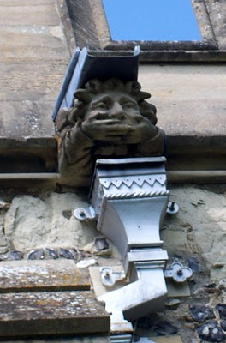This gargoyle on the parish church at Tring, Hertfordshire, England represents the challenges to discover our Holliman roots. The 'past', this gargoyle, seemingly does not wish to tell us what we long to hear....who are our ancestors? Photos by Barbara Holliman

Indeed, new research provided by cousins Maxine Wright and Joe Parker is moving the focus of our search from Tring to Bedford, Bedfordshire, England, approximately 35 miles to the north.

In the meantime, I continue to share some findings in Buckinghamshire and Hertfordshire, about 25 to 30 miles northwest of London. Below is a map of the villages where Holymans lived in the 16th and early 17 centuries: Cuddington, Tring, Cholesbury, Berkhamstead and Aldbury. They are overshadowed in a yellow marker. Double click to make larger.

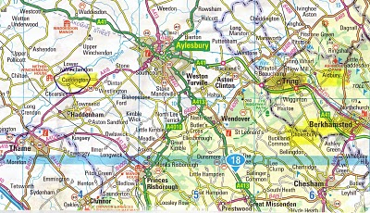
The gargoyle at the top of this posting is from the Tring parish in the photo below.
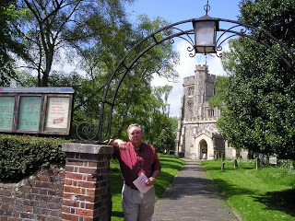
In the photo above, I stand in front of the Tring, Hertfordshire parish church, which has been reconstructed several times since its 11th century founding. The present structure was erected in 1470. In this sacred space in England some of our distant ancestors probably worshiped and their remains may linger in the ground behind me.
After visiting the Tring parish church a first time in 2005, my wife and I stepped down the block to visit a charity shop (seeking yet more royal coronation ware, a vice of mine). The kind clerk showed us the local telephone book. Yes, seven or eight Hollimans were listed in the local exchange. Hmm… Later we motored to a pub for roast lamb and red wine (and I remember little more that day!).
Next posting, we continue to explore the villages and paperwork that connects Holymans in Cuddington to Cholesbury and Cholesbury to Tring and Tring to Berkhamsted and Aldbury.

Wednesday, August 25, 2010

When We Were English, Part XVI
by Glenn N. Holliman
Connecting Cuddington Holymans to Cholesbury Holymans and Tring Holymans
Note: Cousin Jeanette Stewart recently shared in a Holliman chat room information on the Holyman and Weedon (Wedon) families of Hertfordshire, England from the English Origins of New England Families. Before reviewing her excellent research, I had been preparing the article below which echoes and strengthens her findings. In future postings, I will attempt to weave her public work into the growing narrative of the Holymans in Tring and Cuddington, England in the 16th and 17th centuries. My thanks to Jeanette, Joe Parker and all for making available to the larger Holliman, Holleman, Hollimon, etc. families their increasing knowledge of our historic roots.

Last spring my cousin Maxine Wright, a relentless researcher in pursuit of Holliman origins, mailed me the following information of one Richard Wedon, who lived in Botley, a small village near Cholesbury and Tring. As one can read in the first paragraph of this p. 187 of The Register, published 1954, Richard had to pay a fine in 1567 for breaking the head on another man's servant. Hmmm....

Richard must have matured because nine years later, in 1576 he married Jayne Holyman in Cholesbury, near Tring. The information below states that this Jayne Holyman was from 'a yeoman family of good standing in Cuddington', descendents of Bishop John Holyman, whose life we have reviewed in previous blogs.

Several other items leap out at us. Richard and Jayne had a son named James who evidently immigrated to Rhode Island! Did James join a cousin named Ezekiel of Tring in Rhode Island?One remembers that Ezekiel Holyman, an Anabaptist, baptised Roger Williams the founder of Rhode Island!
Notice that Richard Wedon writes a will in 1618 (it is probated in 1624, presumably the year of his death). The will is witnessed by William Holyman. Double click to enlarge.
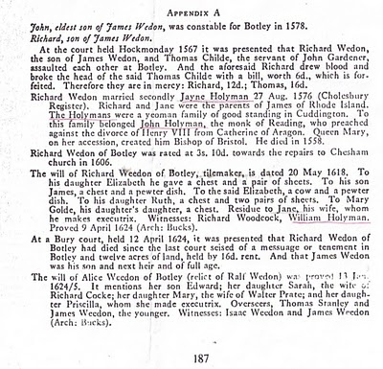
Now the issue grows more complicated. Above we have Jayne Holliman married to Richard Wedon. Below in another section of the Register, we have a John Holyman appearing in marriage in 1593 and dying a few years later. Goodbye to this John who had no children.

However, now William Holyman, the eldest son of another William Holyman, appears again (noticed who witnessed Richard Wedon's will), baptized June 1583 and his sister Priscilla February 1584/5. They have a brother named Ezekiel.

This Ezekiel according to many web sites and those who have researched Baptist Church history is the Ezekiel who sailed to Massachusetts and helped found Rhode Island!

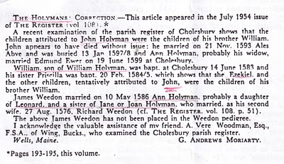
Notice in the next paragraph an Ann Holyman married another Wedon May 1586, and is noted as a probable daughter of Leonard Holyman and a sister of Jane Holyman.

Confusing? Yes, but stay with me. In the next blog, we are going to examine Leonard Holyman and his offspring. In web sites, Leonard is listed as the father of Ezekiel Holyman.

So, two thoughts emerge:

1. Leonard Holyman and other Holymans of Tring and Cholesbury, including Ezekiel, are indeed descendants of Bishop John Holyman of Cuddington.

2. Bishop John Holyman, a devout Roman Catholic, therefore is probably a great or great great uncle or cousin of Ezekiel Holyman, who was religiously antithetical by 180 degrees, to his prominent descendant, an Anabaptist in America! For those interested in religious history this is an amazing journey for a family. One generation burns Protestants at the stake; another helps establish the Baptist Church in Rhode Island.

So are all these interesting Holymans our direct ancestors? Ancestors, most probably yes; direct, we still do not know.

The elusive John Holyman, who died in Virginia in 1650 and is named in various web sites as the father of Christopher Holliman, Sr. (whom we know is the father of the American Hollimans), still has not appeared in the Tring records many of us have researched.

More in the next posting on resolving this mystery. Is our Christopher Sr. really from Bedford, Bedfordshire, another 30 miles or so up the road from Tring? Stayed tuned for more research....

Thursday, October 7, 2010

When We Were English, Part XXI
by Glenn N. Holliman
Weddings and Witches
In the Hertfordshire Archives is a book entitled Hertfordshire Parish Registers by Phillomore's, 1907, 3 volumes. Of course out of print and I had precious few hours to review it. It is on my list to revisit some day. However, I did find several weddings of Holyman females to local males. For the record, they are listed below.

By the way, the first two marriages were from yet another village, just a few miles also from Tring - Berkhamstead. Below is a view of it's High Street in 2010.
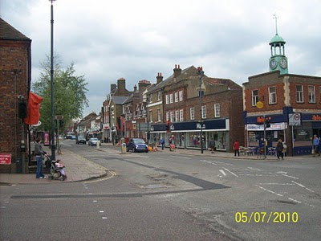
The Berkhamstead Marriages:

Franncys Hadden to Margery Hollyman on 6 May 1601.

Henry Lawrence to Jane Hollyman (Holeman) on 7 February 1638.

Here are two Tring marriages in the same publication:

William Hollyman to Grace Neelie on 20 July 1607 (This is the son of William of Tring whose will we reviewed in When We Were English, Part XIX).

Goff Babylong to Anna Holliman on 7 May 1634

So above some more information for the Holyman history trail in England. Cousin Maxine Wright has ordered Tring Parish microfilm and hopefully may find yet our hidden John Holyman who died in Virginia in 1650. My on-site research has failed to turn him up, but I did find a host of very interesting Holymans who impacted English and American religious history. Hopefully when I return to England next spring I can collect some DNA samples from possible ancestors and search again in local archives.

Some times it is not what one finds in genealogical research, it is also what one does not find. And sometimes, one may feel bewitched and frustrated not to collect more information. That leads me to my closing historical tidbit you may enjoy.

While reading in the Tring library the 1940 work by Arthur MacDonald, That Tring Air, I found that the year 1596 must have been very stressful to our ancestors. Our John Holyman would have been 24 years old at the time, and perhaps observed the following out break of, well, witchcraft in his own community!!
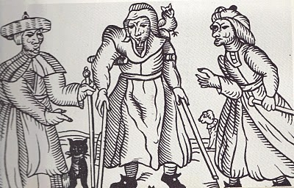Above a 16th century drawing of three English witches. Rather ugly creatures. Note the black cat.
That year in Tring, one Alice Crutch 'bewitched one Hugh Walden who languished and died'. Nor did the episode of nefarious deeds end there. Another woman, named Elizabeth, put a curse on Thomas Grace's valuable horse and it died!!

For their witchery, these two ladies were 'suspended by neck until dead'.

So this Hallowed Eve, think on all the quaint customs of England and Europe that passed through our families to our New World, which we celebrate to this day!

