Ulyss and Pearl Caine Holliman and their Descendants
by Glenn N. Holliman
1912 or 1914? Is the Baby Euhal or Loudelle?
The baby is Euhal Holliman, 1912-1989.
The 1910 U.S. Census lists Ulyss and Pearl Holliman living in Precinct 1 in Fayette, Alabama. Granted the numbers might be somewhat inaccurate with Ulyss listed as age 26 (b 1884 which is correct), but Pearl as 21 on April 15, 1910, which would make her born in 1889 Traditionally the family lists her birthday as February 1887.
What is the age of the below photograph and who is the baby? On the left is Vena Holliman Daly and on the right is Melton Holliman. The third child born was Euhal Holliman in 1912 when Melton was four and Vena 2 1/2 years of age. Melton appears about 5 or 6 in this photo and Vena could be 3 or 4, making this picture of a one-year old Euhal in his stroller. Loudelle would be born in 1914, and conceivably this could be her as a baby, but why would not Euhal be included? Perhaps there is a missing photo. Can any family member definitely identify whether this be Euhal or Loudelle Holliman Ferrell?
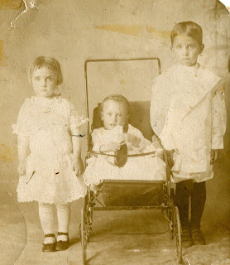
Having a picture taken was still a formal and expensive process in 1912. Melton is dressed in a quasi-feminine outfit typical of the formal attire of young boys of that day. Vena is also wearing leggings and a very fancy dress. The 1910 Census does not list a trade or profession for Ulyss. One can surmise this photograph was an financial extravagance for a growing, young family for whom the breadwinner was probably a mill worker in the local lumber yard. Employment opportunities in Fayette were limited at the time, and Ulyss was not a farmer. As his family grew, so did expenses.
When regular and more lucrative employment beckoned in the 'Magic City' of Birmingham later in the decade, the family would move.
More later.....

Ulyss and Pearl Caine Holliman and their Descendants
by Glenn N. Holliman
Euhal Arlington Holliman (1912 - 1989),
the Third Child of Ulyss and Pearl Holliman
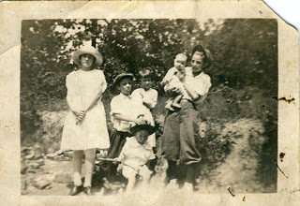
The Ulyss and Pearl Holliman family moved to Irondale from Fayette, Alabama in 1917, and Ulyss settled in to his new job at the Birmingham Electric Company. The above photograph is from 1924. Left to right: Vena, Euhal holding Virginia, Bishop in front with the stick, and Melton holding the youngest, his brother Ralph Holliman. Vena is dressed formally (age 15) and both Euhal (age 10) and Melton (age 16) are wearing the style of the time, knickers. (This style of boy's pants is frozen in time today as the uniform of baseball players.) Note Euhal, Melton and Bishop (only 4) are all wearing caps or hats.
Melton was born in 1908, and before the Great Depression in 1927, he obtained a position in his Uncle Floyd Caine's drug store. Euhal came of age right in the middle of the Depression, and jobs were scarce. He went to work for a local grocery store, and spent his career in the food business.
He met a pretty young lady named Edna Westbrook (below) and in 1936 they married. Six children were eventually born of this union which lasted 54 years!
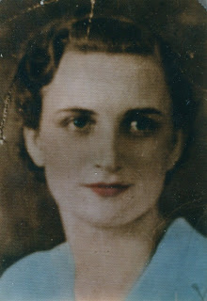

Edna Westbrook Holliman (1916 - 1992), a native of Cherokee County, Alabama, married Euhal July 9, 1936. Edna is the daughter of Annie Josie Naugher Westbrook and Thomas Edward Westbrook. Daughter Tommie Holliman Allen believes they met in East Lake, Alabama, when Edna's sister's boyfriend, later Tommie's uncle, introduced them. Edna was 18 when this picture was taken.

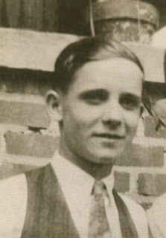
This is young handsome Euhal, probably about 1935.
A hard worker all his life, he was a leader in the Irondale Lion's Club, his labor union and in retirement, the Irondale Auxiliary Police. Super market chains appeared in America after World War II, and wages were low and benefits few. A leader in the labor union movement, Euhal helped organize and lead grocery workers to better compensation and working conditions during his career at chains Jitney Jungle, Piggly Wiggly, Kroger and Brunos as produce manager, before retiring in 1972.
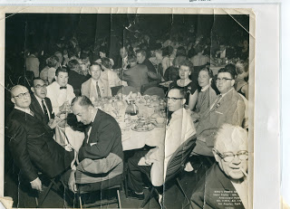
Euhal, center right, in the white coat at a national union convention in California in 1956.
Like his three brothers, he took his physical for the Army in World War II, but due to age and having four children to support, he was not called up. The family lived in Gadsden, Alabama in the 1940s until the middle 1950s. In 1956, they moved to the Ulyss and Pearl Holliman home in Irondale, living there for the rest of Euhal and Edna's lives.
Next Posting, the Children of Euhal and Edna....
Note: The information and opinions expressed in these family biographies are those of the writer alone. Comments, corrections and additions are most welcome. The purpose of these articles is to capture a period and family in American history and to pass this legacy along to future generations who share the common bond of family .My thanks to Tommie Holliman Allen and Bishop Holliman for the pictures.

Ulyss and Pearl Caine Holliman and their Descendants
by Glenn N. Holliman

The Children of Euhal and Edna Westbrook Holliman
Euhal and Edna Westbrook Holliman were fortunate to have six children, five of whom survive to this day.
They are:
Melton Terry and Alvin Jerry Holliman, twins (b 1940) - Jerry died of heart disease in his home state of Alaska in 2003. This cute 1941 picture was taken on the Holliman family lawn in Irondale, Alabama.
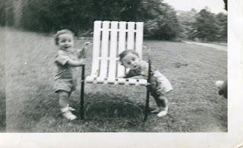

Ann Holliman Phillips (b 1943) is in the right of the picture below, held by her mother, Edna. Euhal holds newborn baby Jean Holliman. Euhal's family lived in Gadsden, Alabama in the 1940s and through the middle of the 1950s. This picture again seems to have been taken in Irondale in 1944.
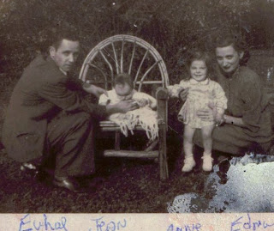

Mary Jean Holliman (b 1944) At the 1970 family reunion at E.C. and Mary Daly Herrin's home in Irondale, this picture was taken of Jean, Billy and their mother, Edna. In the far right is Carol Daly, Robert Daly, Jr's wife, holding their son, John Daly.

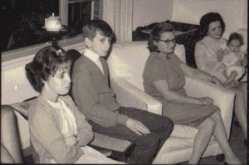
Tommie Holliman Allen (b 1954), is pictured in November 2010 at the Irondale Cafe with her Uncle Bishop Holliman. Some of the space occupied by the Irondale Cafe is the same location as the Daly Hardware Store from 1944 until its closing in the early 1960s. The store was owned by brothers Robert, Sr. (Vena's husband) and George Daly.
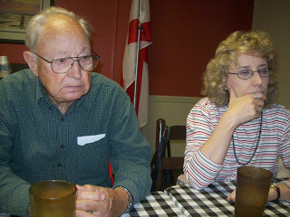

Billy Holliman (b 1955) - Below is the 50th Anniversary celebration for Edna and Euhal. Left to right are Tommie, Jean, Ann, Euhal, Edna, Terry, Jerry and Billy Holliman in this 1985 photograph.
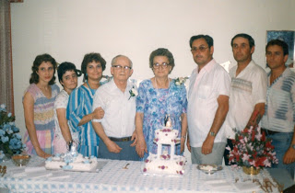

Next, An Alaskan memorial to Jerry Holliman....
Note: The information and opinions expressed in these family biographies are those of the writer alone. Comments, corrections and additions are most welcome. The purpose of these articles is to capture a period and family in American history and to pass this legacy along to future generations who share the common bond of family .My thanks to Tommie Holliman Allen for pictures.

Jerry Holliman, a Remembrance
Jerry in 1954, at school in Gadsden, Alabama, age 14.
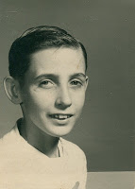
My first cousin, Jerry, died in 2003 at age 62 of a heart attack while on a fishing trip in Alaska. He is the first of the nineteen first cousins of the seven children of Ulyss and Pearl Holliman to pass away. Perhaps Jerry, although too young to leave his family, died in circumstances he might have chosen - fishing in his beloved Alaska. One of the great pleasures of his father, Euhal, was joining the twin sons, Jerry and Terry, searching for salmon in Alaskan rivers.
Jerry was six years older than me, and the last time I saw him was around 1960. Bob Daly and I were teamed up against the twin brothers playing tackle football on the Daly lawn in Irondale. As a kid, it was always a thrill to be included in games with my older male cousins. While in the Army at Ft. Bragg, NC, Jerry briefly visited our home in Florence, South Carolina.
Another memory I have is of the two brothers, probably in the mid-1950s, having a brotherly tussle in the dark parking and storage area under Grandmother Holliman's house in Irondale. It was spooky and dank under the house, and I always was afraid to explore it. So I watched from the outside as the two boys engaged in fist-a-cuffs. I think their father broke up the fight.
Brothers always have brotherly quarrels, especially so twin brothers seeking their own identity. Perhaps that is what attracted Alaska to them, the 49th new state with opportunities and a chance to build a life. Our branch of the Holliman family had lived in the south since 1650, and in the early 1960s both brothers migrated to the Great Northwest. Their immigration personifies the Holliman diaspora of our generation. Terry had been stationed in the state during the service, and he must have told Jerry of the attractiveness of the Alaskan outdoors.
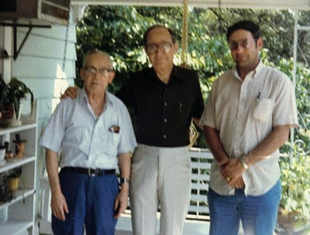
The above photo of Euhal, Bishop and Jerry Holliman was taken in 1985 on the porch of the old Holliman home in Irondale.
This thoughtful memorial to Jerry was published by Alaskan Airlines in July, 2003 in Anchorage.
"Jerry, 62, died July 16 of a heart attack while on a fishing vacation in Kenai with his wife, Dona Holliman, also an Alaska Airlines employee. 'We feel this emptiness in our hearts with the sudden loss of a friend like Jerry,' said Davis Burris, Anchorage CSM. 'He touched the lives of everyone he came into contact with everyday, and that was almost everyone in the Anchorage station.'
In 1995, Jerry received the highest honor that an Alaska employee can receive: Customer Service Legend. As native of Alabama, Jerry moved to Anchorage and began his career with the airline in 1964. He was the station's top seniority ramp service agent. In addition to his wife, a 39 year lead CSA - air freight agent, Jerry is survived by a daughter and son-in-law, Renee Holliman and Kevin McKinney, two grand daughters and several siblings, including an identical twin brother, Terry."
No doubt Euhal and Edna, both hard-working individuals, would have been proud to read how others felt about Jerry. I know his cousins are.
Next, the Fourth Child of Ulyss and Pearl Caine Holliman....

