Exploring further Holleman History in Old Virginia - Part 8
by Glenn N. Holliman

This continues the stories of Hollemans who remained in the Isle of Wight County, Virginia from the time of Christopher Holyman's acquisition of land in 1661 to the present day. The historical interpretation is the writer's alone as are any errors of fact or omission. Critique and comment welcome.

As has been written, the founder of most Holleman (Holliman, etc) offspring in the United States can be traced to English immigrant Christopher Holyman (1618-1691), who in 1684 patented 1,020 acres along the Blackwater River adjacent to Surry County. As the decades and centuries slipped by, descendants spread throughout (mainly) the southern and southwestern colonies (later states) and by the post World War II era, throughout the United States.

As we have noted in previous articles, in 1830, descendant Wilson Holleman (1800 - 1873) constructed a large Federal period house on some of the original Holyman land. This era represented a time of both economic and political prosperity for this branch of Hollemans. Althought, not a 'great planter', Wilson was one of the wealthiest persons in the Eastern District, the Mill Swamp area, of Isle of Wight County. His brother, Joel Holleman (1800? - 1844?), was a rising politician, soon to serve in the U.S. House of Representative. Joel built his career on that of their father, Josiah Holleman, a commissioner, state representative and, for a while, the sheriff of the county.

Let us step back to the birth of Wilson and Joel's father, Josiah Holleman (1771-1848), a son of Jesse (1735-1821) and Charity Cofer (1748-1810). The Cofers were and remain a prominent name in Isle of Wight County. A Revolutionary War veteran, Jesse was a great, great grandson of Christopher Holyman and a founder of the Mill Swamp Baptist Church, reportedly the first Baptist Church in Virginia. Christopher Holyman had arrived in Virginia as an Anglican (Episcopalian), but the First Great Awakening, an emotional religious revival of the 18th Century, led many persons to create and join fledgling Baptist congregations.

Below, Mill Swamp Baptist Church, ca 1910, Isle of Wight, Virginia. From the Isle of Wight Museum
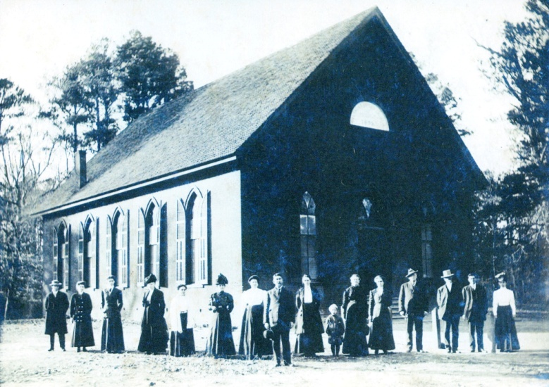

When Josiah was born in 1771, Virginia was part of Great Britain, and the Appalachian Mountains were the western boundaries of colonies. At his death, the United States stretched from the Atlantic to the Pacific Ocean, and California was about to become a state (1850). The changes which occurred by the end of Josiah's life were immense as the young nation both expanded, fought wars with England, Mexico and Native Americans and attempted to maintain a fragile federal union.

By 1818, Josiah, a planter and slave holder, served as jailer of Isle of Wight County, a member of the Virginia House of Delegates, county sheriff and until his death, often served as a commissioner (justice of the peace). Through his political work, he left a paper trail that offer insights into the South's 'Peculiar Institution', human slavery. When we examine both his legal records and the Federal Censuses of the antebellum Isle of Wight County, an amazing picture emerges of a conflicted and fearful society. The story is quite different than that of Margaret Mitchell's popular and highly romanticized "Gone With the Wind" which portrayed only wealthy planters and docile contented slaves.

As evidence of this restless and anxious society, one only has to look to the neighboring county of Southampton, Virginia. In 1831, the greatest fear of whites slaveholders occurred when Nat Turner, a young black slave, roused a band of fellow slaves, attacked their masters in the dead of night and eventually murdered 55 whites. Before the rebellion was put down, over 200 blacks were killed. This was the most violent uprising of North American slaves in U.S. history, and news of this most violent white nightmare come true, swept the South.
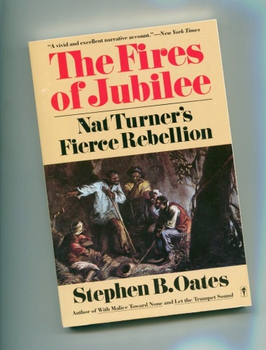
Of course, the reverberations were felt strongly in adjoining counties such as Isle of Wight, the site of Holleman plantations. Source: "The Fire of Jubilee" by Stephen B. Oates, New York, Harper and Row, 1975. There are many books on this rebellion.

African slavery began in Virginia in 1619, just a few miles from Isle of Wight County, when the first European ship deposited its human cargo at Jamestown. As former Secretary of State, Condoleezza Rice, herself descended from slaves, has written, 'American's birth defect' had grasped the colonies. By 1793 and invention of the cotton gin, African-American slavery accelerated its march across the untilled and fertile fields of the southern United States.

As Oates has observed, slavery, while more and more a perceived economic necessary by the early 1800s, was also 'a family heirloom left by some sadistic relative'. And that inheritance ate away at the soul and unity of the nation, conflicting many whites and leading to a fearful and racially authoritative culture in the South. Half slave and half free, the union dissolved in 1861 into a bitter, deadly Civil War.

In our next postings, through the career and life of Josiah Holleman and two of his sons, we will see elements of that fear played out in vivid detail.

Draft - ARTICLE 2

by Glenn N. Holliman

Sources:

Guide to the Isle of Wight County (VA) Free Negro and Slve Records, 1785-1861. Barcode number: 1186868, Collection in the Library of Virginia

Helen Haverty King's "Historical Notes on Isle of Wight, Virginia"

Federal Censuses of 1830, 40, 50, 60 and 70s

Encyclopedia of Virginia by Susanna Michele Lee

The Fire of Jubilee, Nat Turner's Fierce Rebellion by Stepehn B. Oates

Timeline for Josiah, Wilson and Joel Holleman

p. 131 - 135 - first slaves in Warrosquoyacke, later Isle of Wight, in 1623, four.
1650 - 300 Negroes in Virginia
1670 - 2,000
1700 - 6,000
1730 - 114,000
1782 - 270,000 slaves and 296,000 free Negroes (double check)

1771 - Josiah born Isle of Wight County, Virginia, 31 December. Tobacco main crop at first, but as tobacco wore out the land, planters turned to other crops. IOW did not have plantations comparable with the huge cotton farms of the deep south. Many farmers did not own slaves, those who did had only a few.

1774 - p. 294 - 1786, VA disestablish the Church of England. Believed the first Baptist Church in Virginia was formed in Isle of Wight early in the 18th century. It may have been at the present site of Mill swamp Baptist Church. p. 307 - charter members of Mill Swamp Baptist in 1794 were Atkinsons, Cofers, Joneses, Hollemans, Bells and Wombles.

1782 - VA General Assembly passed an Emancipation Act allowing in a will or other instrument in writing, to emancipate and set free his or her slaves...to enjoy full freedom...10,000 slaves were freed in the next decade. Timothy Tyne of Isle of Wight County freed in his will 81 slaves in 1802 and left them 2,600 acres, the largest emancipation in the history of the county.

1791 - On 10 January, Josiah married Nancy Clark in Southampton Co, VA. Nancy was born 13 Apr 1769. She died 23 Jun 1844.
They had the following children:
Rebecca Holleman, born 6 March 1792 and married Ludwell Gwaltney on 27 Nov 1809.
Martha Holleman born 17 Nov 1793.
William Henry Holleman born 25 Nov 1795, died 1836. Married Jacky T. Peters on 29 July 1815.
Bennett Holleman born 4 Nov 1797, died 9 Mar 1847 in Farmersville, Illinois.
Joel Holleman born 1 Oct 1799, died 5 Aug 1844 in Smithfield, Virginia. Married Caroline Carroll on 22 Nov 1828, who was born 1810. She died in 1842. Joel later married Emily W. Carroll.
Polly HOLLEMAN was born 15 Aug 1801.
Wilson HOLLEMAN was born 30 May 1803. He died 26 Jun 1873.
Wilson married (1) Susan CLARY on 30 Oct 1823. Susan was born 14 Jan 1799. She died 4 Apr 1825.
Wilson also married (2) Ann NICHOLSON on 18 Aug 1828. Ann died 15 Dec 1868.
John HOLLEMAN was born 28 Jan 1805. He died 3 Jul 1853.
Mary HOLLEMAN was born 30 Jan 1807.
Mary married Moses ATKINS on 15 Mar 1840.
Elizabeth HOLLEMAN was born 6 Mar 1809
Elizabeth married Josiah GRAY on 3 Mar 1823.
1799 - April 1, in his will one Robert Lawrence "Fully persuaded that freedom is the natural right of all mankind and that it is my duty to do unto others as I would be done in the like situation, and having under my care a negro girl, Jane, now in her minority, age 13 years, whom I do here by emancipate and set free, after she shall obtain lawful age...agreeable to the Act of 1782". Later Lawrence freed to other slaves by writ as did others by will and contract.

1818 - Josiah, Jailer for Isle of Wight, detained James alias David Thomson, runaway slave. Numerous writs signed by Josiah and others elude to fact of runaway slaves were an on going issue.

1821 - Josiah, Appointed school commissioner. There were ten, one for each military district int the county. In addition, he and Exum Eley were overseers of the poor in the Broadwater District, now the southern part of the Hardy District.

1821 - p 575 - Josiah Holleman, member House of Delegates 1821-1829

1824 - Josiah elected to Virginia House of Delegates

1825 - Josiah elected to Virginia House of Delegates

1823 - 1845 - Josiah Commissioner of Isle of Wight

1832 - p 577 - Joel Holleman, Virginia House of Delegates 1832-1836, 1841, Speaker of Virginia House 1842-1844. Joel was a Smithfield, VA attorney. HOLLEMAN, Joel, a Representative from Virginia; born near Smithfield, Isle of Wight County, Va., October 1, 1799; completed preparatory studies; was graduated from Wake Forest College, Wake Forest, N.C.; studied law; was admitted to the bar and commenced practice at Burwell Bay; member of the State house of delegates 1832-1836; member of the State senate 1836-1839; elected as a Democrat to the Twenty-sixth Congress and served from March 4, 1839, until 1840, when he resigned; again a member of the State house of delegates 1841-1844, and served as speaker; resumed the practice of law; died in Smithfield, Va., August 5, 1844; interment in Ivy Hill Cemetery.
Holleman was first elected to the Virginia House of Delegates in 1832. He moved to the Senate of Virginia in 1836.
Holleman was elected to the Twenty-sixth Congress, taking office in 1839. At the time of his election, he made a public statement that he would resign his seat if the Whigs won his district in the 1840 presidential election. After William Henry Harrison did so, Holleman resigned.^{[1]}
He was reelected to the House of Delegates in 1841 and became Speaker the following year.
He died in Smithfield, Virginia, August 5, 1844. He was interred in Ivy Hill Cemetery.^{[3]}

1836 - p 514 - Isaac, emancipated by Josiah Holleman, registered Aprl 4, 1836

1836 - 39 - p 581 - State Senate, Joel Holleman 1836-39

1837 - County tax rolls published free persons of color who were delinquent in paying taxes. Such persons could be hired out. Court records reveal such names as Tynes, Wilsons, Holloways, Lawrence and Newbys.

County records state wages were paid to night patrols who were employed to insure slaves were not off plantations. Sample tickets, 'patrol tickets' are in the IOW records to allow persons off the masters's property. Fear of runaways and insurrections.

1839/40 - Joel Holliman serves in the U.S. House of Representative.

1842 - March 5, Josiah, commissioner 'directed the clerk to give the above Negro his papers' of freedom. One free man of color by birth, Beaver Jack Wilson, had lost his papers by fire and was replacing them.

1846-47 - Josiah Sheriff of Isle of Wight

1848 - Josiah died 15 March, Isle of Wight County, Virginia

1851 - p. 223 - survey taken in 1851 of a never built canal from Pagan Creek to the Blackwater to cross Atkinson's Bridge at Mill swamp Church, past WilsonHolleman's and Mr. Gray's houses and straight to Proctor's Bridge over the Blackwater River.

p. 261 - 1885 census indicated barely 3/5ths of white children could read and only 1/2 could write. In 1900 average session of school was 5.2 months.

1852 - p 521 - a George Holleman as #2029, a free Negro between 1852 - 1862

1862 p 558 -John R. Holleman, enlisted Mar 16, 1862 at Beaver Dam, spent most of the time in hospital and on furlough, Company 7, 61st Virginia Artillery, Isle of Wight Avengers

p 567 -A.S. Holleman, Co. A, 41st Virginia Infantry; pro. Lt. June 1862, wounded at Spotsylvania, May 12, 1864; on Hardesty's list

US Congress 1839 for one year - p 584, an attorney in Smithfield

1863 p. 178 - End of 1863 almost all slaves were gone and more Confederate recruits were requested. High inflation.

1870 - In 1860, Wilson had a personal worth of over $12,000, mainly it seems in human beings, his 17 slaves. In the 1870 census, his personal worth had declined to approximately $250 as the humans held in bondage had been freed. He had his house, his land and a position as postmaster of Mill Swamp. In 1873, Wilson died. The house and land continue to this day in the Holleman family.
Notes:
(1) The following information was copied from old courthouse records … it makes for interesting reading:

ALGERNON SIDNEY HOLLEMAN—was born in Isle of Wight county August 4,1838,a son of Wilson and Ann (Nicholson) Holleman. His mother came to this county in 1827, and died here September 15, 1868; his father died June 25, 1873. The great, great grandfather of Algernon S. was John Holleman, an early and respected settler of Virginia; his great grandfather was Jesse Holleman, a soldier of the Revolution; his grandfather was Josiah Holleman, who served in the war of l812, with captain's commission, for about six months, a portion of the time stationed at Norfolk. Josiah Holleman died March 15, 1848. John E. Holleman, brother of Algernon S. enlisted in the Confederate army in 1861, April; and served until sent to the hospital at Richmond in 1863, where he died July 3, 1863. Algernon S. Holleman was a soldier of the civil war, enlisting as private in Company A. 41st Virginia Infantry, May 15 1861, and in June, 1862, was promoted to lieutenant. He was in active service until wounded in the battle of Spotsylvania. May 12, 1864. He was then sent to the hospital at Richmond, where he lay when the Federal forces entered the city. He was held prisoner about thirty days, and paroled May 18. 1865. In Isle of Wight county, December 21, 1871, he married Martha B. Jones, and their one child, Anna Cassandra, was born September 23. 1880. His wife is a daughter of Robert T. and Lucy Ann (Bell) Jones, and was born in Isle Of Wight County, September 25. 1839. Her father died February 21, 1881, and her mother died December 2, 1882. Mr. A. S. Holleman has a farm of 388 acres, with abundance of marl to make it productive. He has 100 acres devoted to grain, peanuts and fruits. His land lies in Hardy district, where he has been three years judge of elections. Smithfield, Isle of Wight County, Virginia, is his post office address.

