Exploring further Holleman History in Old Virginia - Part 8
by Glenn N. Holliman

This continues the stories of Hollemans who remained in the Isle of Wight County, Virginia from the time of Christopher Holyman's acquisition of land in 1661 to the present day. The historical interpretation is the writer's alone as are any errors of fact or omission. Critique and comment welcome.

As has been written, the founder of most Holleman (Holliman, etc) offspring in the United States can be traced to English immigrant Christopher Holyman (1618-1691), who in 1684 patented 1,020 acres along the Blackwater River adjacent to Surry County. As the decades and centuries slipped by, descendants spread throughout (mainly) the southern and southwestern colonies (later states) and by the post World War II era, throughout the United States.

As we have noted in previous articles, in 1830, descendant Wilson Holleman (1803 - 1873) constructed a large Federal period house on some of the original Holyman land. This era represented a time of both economic and political prosperity for this branch of Hollemans. Although, not a 'great planter' (defined as owning more than 20 slaves), Wilson was one of the wealthiest persons in the Eastern District, the Mill Swamp area, of Isle of Wight County. His brother, Joel Holleman (1799 - 1844), was a rising politician, soon to serve in the U.S. House of Representative. Joel built his career on that of their father, Josiah Holleman (1771-1848), a commissioner, state representative and, for a while, the sheriff of the county.

Let us step back to the birth of Wilson and Joel's father, Josiah Holleman (1771-1848), a son of Jesse (1735-1825) and Charity Cofer (1748-1810). The Cofers were and remain a prominent name in Isle of Wight County. A Revolutionary War veteran, Jesse was a great, great grandson of Christopher Holyman and a founder of the Mill Swamp Baptist Church, reportedly the first Baptist Church in Virginia. Christopher Holyman had arrived in Virginia as an Anglican (Episcopalian), but the First Great Awakening, an emotional religious revival of the 18th Century, led many persons to create and join fledgling Baptist congregations.

Below, Mill Swamp Baptist Church, ca 1910, Isle of Wight, Virginia. From the Isle of Wight Museum
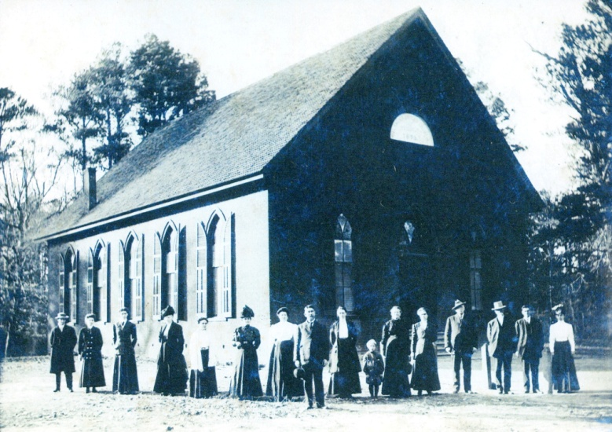

When Josiah was born in 1771, Virginia was a colony of Great Britain, and the Appalachian Mountains were the western boundaries of the southern colonies. At his death, the United States stretched from the Atlantic to the Pacific Ocean, and California was about to become a state (1850). The changes which occurred by the end of Josiah's life were immense as the young nation both expanded, fought wars with England, Mexico and Native Americans and attempted to maintain a fragile federal union.

During his life, Josiah, a planter and slave holder, would serve as jailer of Isle of Wight County, a member of the Virginia House of Delegates, county sheriff and until his death, often served as a commissioner (justice of the peace). Through his political work, he left a paper trail that offer insights into the South's 'Peculiar Institution', human slavery. When we examine both his legal records and the Federal Censuses of the antebellum Isle of Wight County, an amazing picture emerges of a conflicted and fearful society. The story is quite different than that of Margaret Mitchell's 1930s popular and highly romanticized "Gone With the Wind" which portrayed only wealthy planters and docile contented slaves.

As evidence of this restless and anxious society, one only has to look to the bordering county of Southampton, Virginia. In 1831, the greatest fear of whites slaveholders occurred when Nat Turner, a young black slave, roused a band of fellow slaves, attacked their masters in the dead of night and eventually murdered 55 whites. Before the rebellion was put down, over 200 blacks were killed. This was the most violent uprising of North American slaves in U.S. history, and news of this white nightmare come true, swept the South.
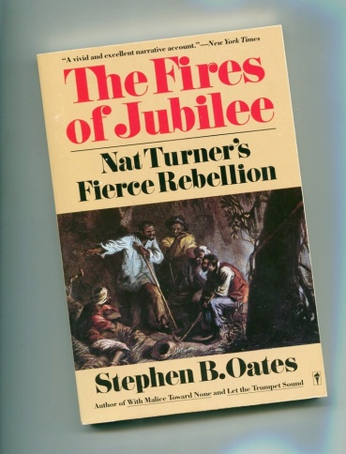
Of course, the reverberations were felt strongly in adjoining counties such as Isle of Wight, the site of Holleman plantations. Source: "The Fire of Jubilee" by Stephen B. Oates, New York, Harper and Row, 1975. There are many books on this rebellion.

African slavery began in Virginia in 1619, just a few miles from Isle of Wight County, when the first European ship deposited its human cargo at Jamestown. As former Secretary of State, Condoleezza Rice, herself descended from slaves, has written, 'American's birth defect' had grasped the colonies. By 1793 and invention of the cotton gin, African-American slavery accelerated its march across the untilled and fertile fields of the southern United States.

As Oates has observed, slavery, while more and more a perceived economic necessary by the early 1800s, was also 'a family heirloom left by some sadistic relative'. And that inheritance ate away at the soul and unity of the nation, conflicting many whites and leading to a fearful and racially authoritative culture in the South. Half slave and half free, the union dissolved in 1861 into a bitter, deadly Civil War.

In our next postings, through the careers and lives of these Isle of Wight Holleman, we will see elements of that fear played out in vivid detail.

