From Glenda, Jan. 7, 2011

This is the church off of 171 before you get to the Fayette County Line. Here is where Cornelius Holliman’s first wife is buried, my guess is one of these piles of rocks…note the monument in front of the church…you will see C. Holloman’s name…as well as C Lucas…my thought is that that would be Cornelius Holliman AND Charles Daniel Lucas…
My Uncle has told me that Charles Daniel Lucas and Cornelius owned land on both sides of the county lines….

Uncle Rhodes, can you remind me WHO lived in the old dog trot house close to the Stewart/Holliman cemetery? I have a photograph of it…and will send if needed….if my memory is correct – I believe you told me that the land still belongs to Holliman’s

This old house is on the way to the Stewart/Holliman Cemetery. Uncle Rhodes said the land still belongs to “Holliman’s”. The third picture is the ‘memorial’ site that a distant cousin created – this cousin is a direct descendant of James Franklin Holliman. Unfortunately, the markers are duplicates, a lot of the dates are incorrect…so it has become a source of confusion for those who don’t know the ‘story’. As you know James Franklin Holliman is the son of Uriah and Mary Polly Lucas Holliman and the brother of John Thomas Holliman. Enjoy the photo’s. Glenn, I plan to insert some of these photo’s in the agenda I’m creating…I plan to go to Fayette soon and take some more pictures.

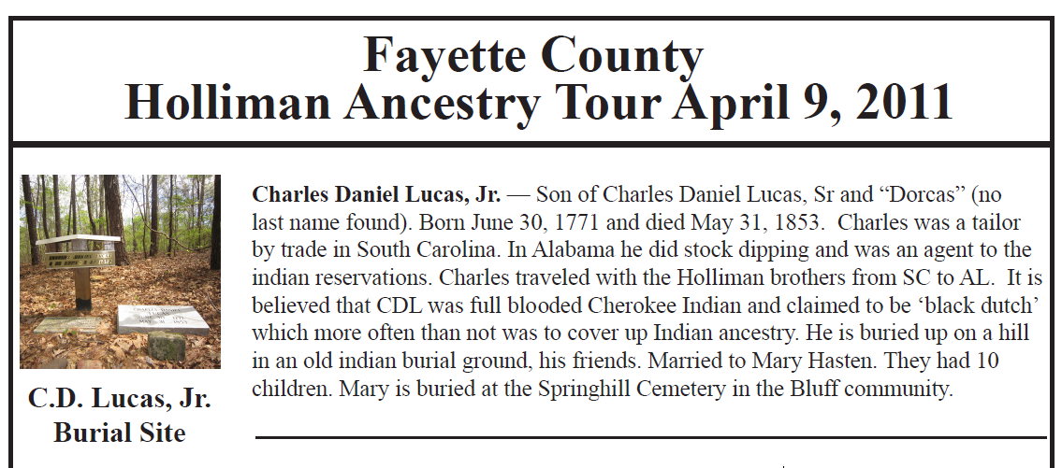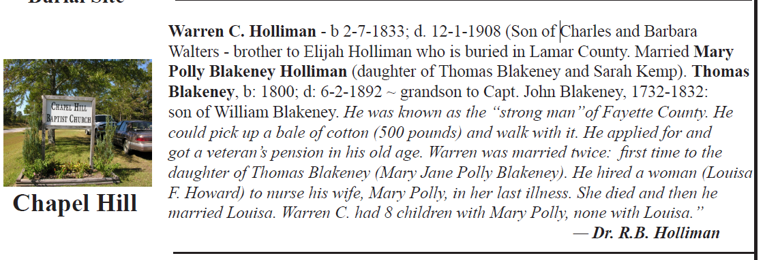

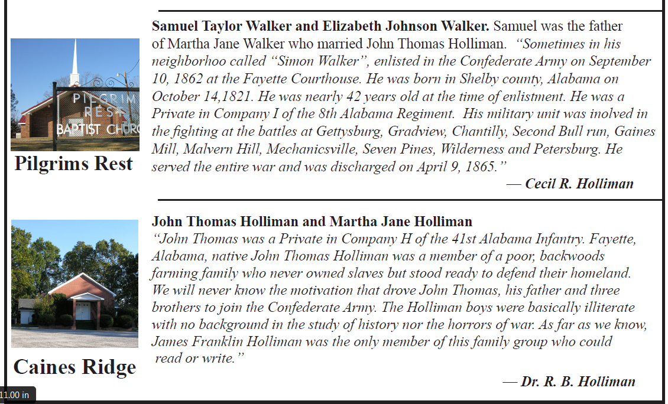

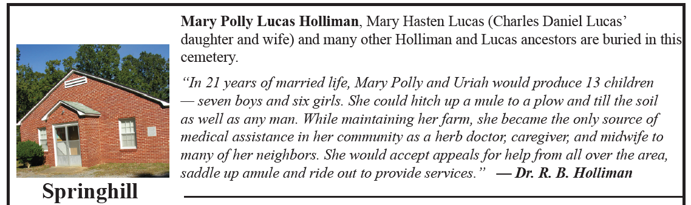

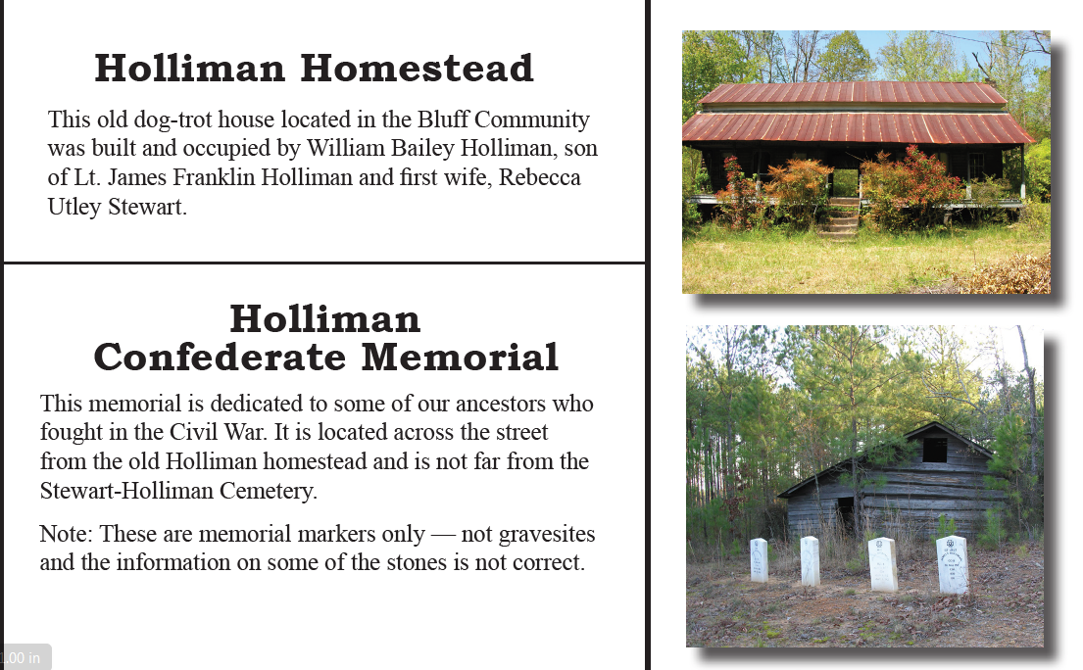

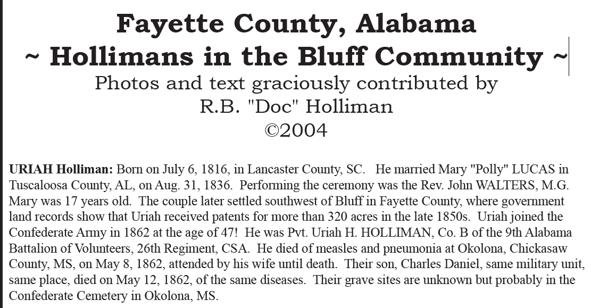

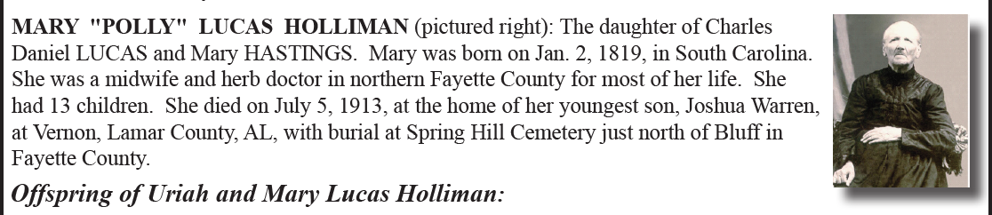

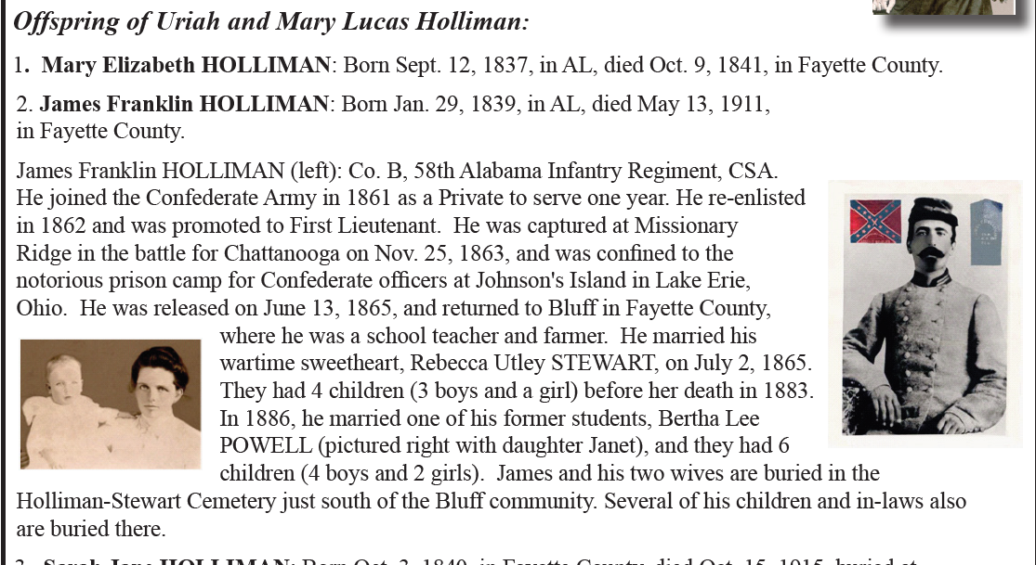

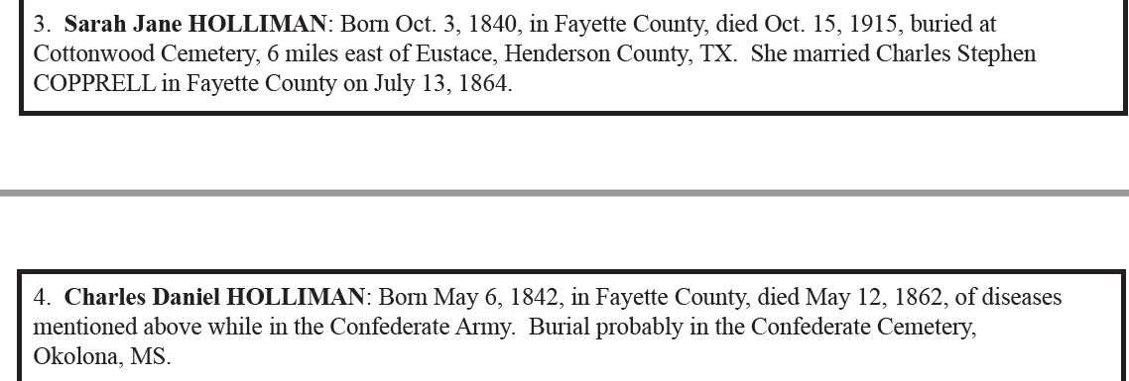

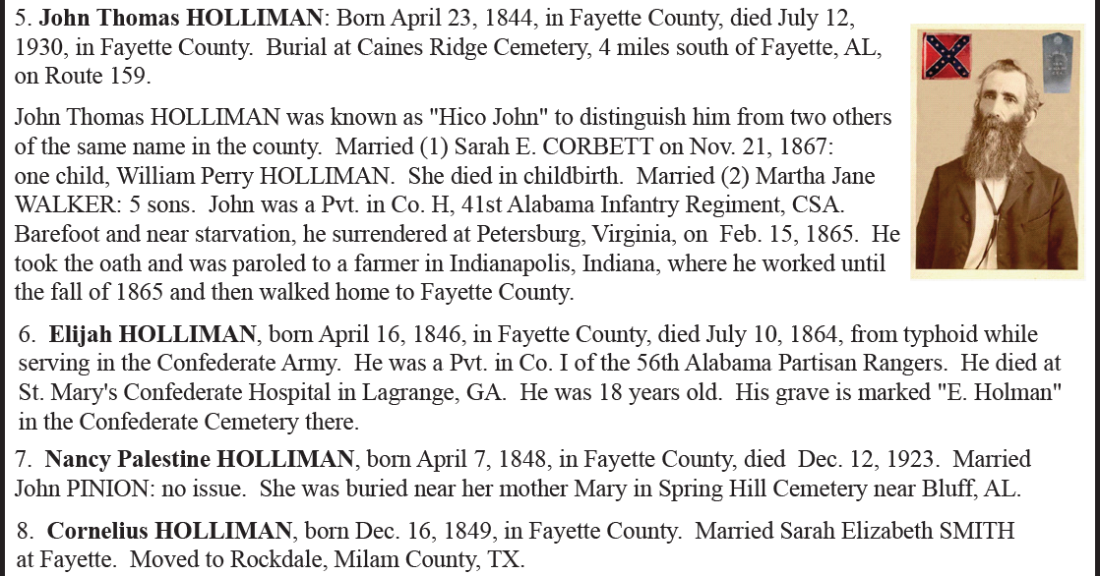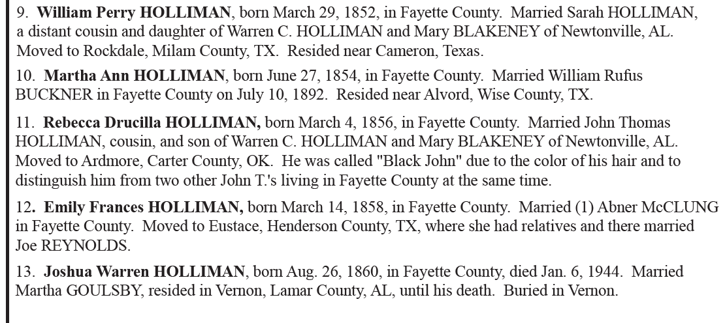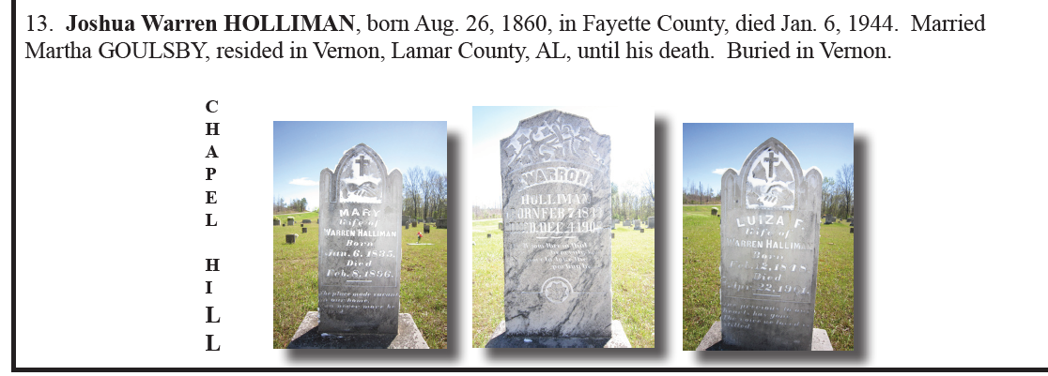

Back to the 19th Century...A Series of Articles on the Hollimans and Related Families of Fayette County, Alabama

By 1836, several sons of James Grantson Holliman (1750 - 1836) and other associated families had migrated to Fayette County, Alabama from Lancaster, South Carolina. Cornelius (1792 - 1862), Charles (1795 - 1850) and Warren Holliman (1801 - 1876) were part of the westward movement of the American nation and my family in the 19th Century.

Warren would later move on to Arkansas and father many Holliman descendants in that part of the United States. Cornelius, Charles and many of their descendants remained in Fayette County and adjoining counties to this day. Many others went to Mississippi, Louisiana and Texas.

An Excursion into History....
On April 9, 2011, Glenda Norris, a descendant of James Grantson and Cornelius Holliman families, led fifteen of her distant cousins through the cemeteries of her many great grandparents to share their stories. She would be the first to tell you that she stands on the shoulders of her grandfather, Cecil Rhodes Holliman, and his son, her uncle, Dr. Rhodes Holliman. The research about to be shared comes from their hands, also of the late Walt Holliman, a descendant of James Grantson and Charles Holliman, his son.

The first stop of the tour was Charles Daniel Lucas, Jr. burial site. It was unseasonably hot for April (92f) even for the Deep South. But that didn’t slow anyone down. Everyone was more than willing to take a short ‘hike’ into the woods, up a small hill and then a left turn into the forest to view the ‘old Indian burial ground” where Charles Daniel Lucas, Jr. gravesite is located.

Here is a photo of everyone getting ready to make the short hike to see Charles Daniel Lucas’ grave. Left to right are: Jeanette Holiman Stewart (Austin, Texas), Glenn Holliman (Newport, Pennsylvania), Lenwood Holliman (Gordo, Alabama), James Franklin Holliman (Sulligent, Alabama), Bishop Holliman (in cap from Avilla, Indiana), Vonceil Laura Duckworth (Reform, Alabama), Wally and Tommie Holliman (Irondale, Alabama), Faye Gardner (Kennedy, Alabama), Bill Holliman (Horn Lake, Mississippi), Jean Holliman (Irondale, Alabama), Joey Holliman (Florence, Alabama) and Tyler Duckworth (Reform, Alabama and at age 15, the youngest on the trip). Obscured is Robert Holliman and taking the photograph is Norman Holliman (both brothers from Marysville, Tennessee).

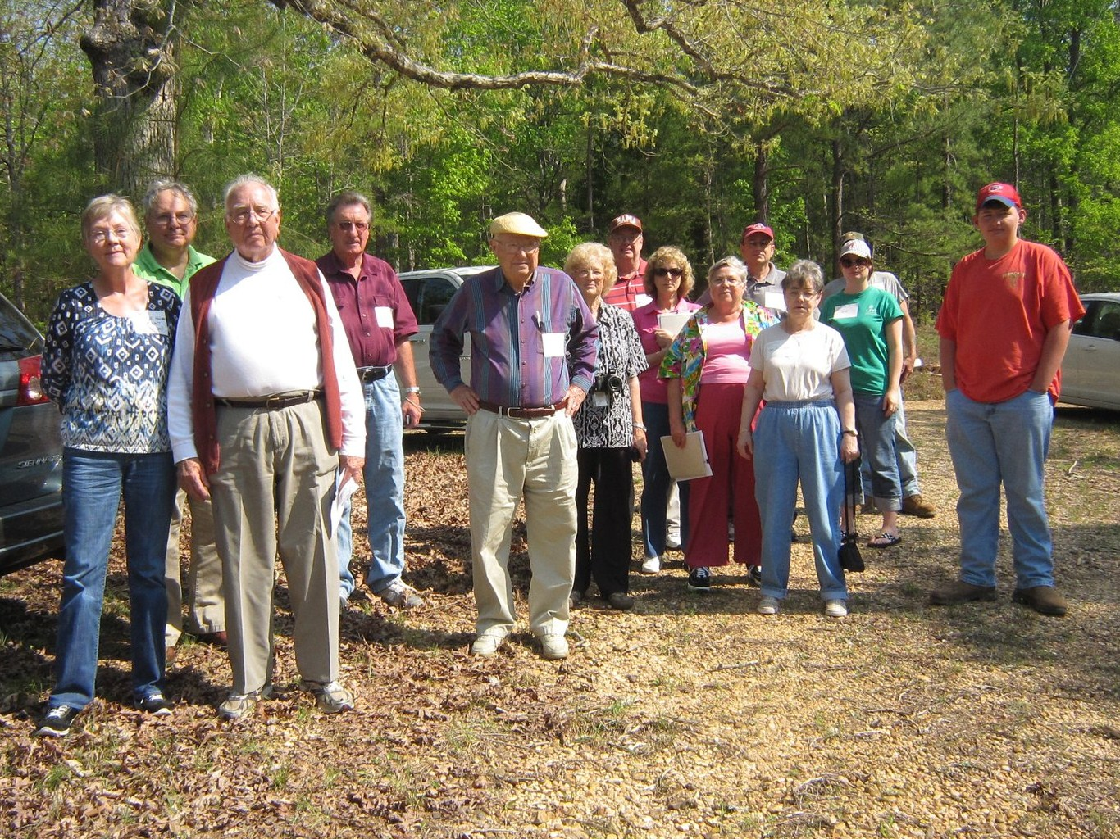
All the above are either descendants of Charles (about 1795 - before 1850) or Cornelius Holliman (1792 - 1862). Of course, all have the DNA of Christopher Holyman, Sr. (1618 - 1691), the Englishman who left Bedford, Bedfordshire and immigrated to Jamestown, Virginia in 1650.

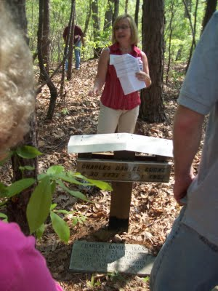

Above, Glenda Norris shares information at the grave site of her 4th great grandfather, Charles Daniel Lucas Jr. whose daughter, Mary 'Polly' Lucas married Uriah Holliman, a son of Cornelius Holliman. Below are her comments which she credits to Rhodes Holliman, her uncle. It was Rhodes who, as a boy in the 1930s, would hike several miles into the piney woods, dodging a few snakes to re-discover the location for the family. Several monuments now mark this spot.

"Charles Daniel Lucas, Jr. was the son of Charles Daniel Lucas, Sr. and “Dorcas” (no last name found). It is believed that the mother of Charles Daniel Lucas could be a Catawba Indian, from the PeeDee River area in Marlboro County, South Carolina. She was only 13 years old when she married Charles Daniel Lucas, Sr. Charles Jr. was born on June 30, 1771 and died May 31, 1853. He was a tailor by trade in South Carolina. Charles Daniel was a traveler and migrated from South Carolina to Alabama before the Holliman brothers. CDLJR first homesteaded 80 acres in Marengo Co., Al. on 10-20-1823 and also 80 more acres in Marengo Co., Al. on 04-15-1824, then on 12-01-1826 he homesteaded 80 acres in Fayette Co., Al., and then on 10-16-1834 he homesteaded 40 acres in Tuscaloosa Co., Al. The homestead in Fayette Co. is almost touching hwy. 171 at the Fayette/Tuscaloosa Co. line, on the East side of the road. The land in Fayette Co. & Tuscaloosa Co. is connected. He was a deacon at the Springhill Church in Tuscaloosa County, it is thought that he and Cornelius were ‘founders’ of this church. He earned his living 'stock dipping' and as a Creek Indian agent. He claimed to be ‘black Dutch’, a term at the time to obscure one's possible Indian ancestry but this has not been proven only speculated. He was a man of large stature (6’4” - 6’6”) and had great strength. It has been passed down through generations that Charles Daniel killed a panther with his bare hands.
His burial site is in southern Fayette County, Newtonville area off of CR100 (Walnut Lane). At one time this land belonged to Charles Daniel Lucas and his home was not far from the burial site. His grave is on a ridge line, over looking a ravine. The site is an Indian burial ground as he chose to be buried with his friends.
Charles Daniel was married to Mary Hasten. They had 10 children together. Family historians suggest that Charles Daniel ‘over disciplined’ one of his grandchildren. It is reported that he struck the child with his cane. This did not go over very well with his family and because of his temper his wife, Mary and the rest of his children left him and moved to the Bluff community. Due to this estrangement Mary Hasten Lucas was buried at the Springhill Cemetery, 20 or so miles north of this pioneer’s resting place.
When Charles Daniel Lucas was born, George III, was sovereign over the American colonies. When Charles Jr. died Franklin Pierce had just become president of the United States, a union on the verge of dissolving."

For additional information on Charles Daniel Lucas, Jr., go to Archives and the February 13 and 26, 2010 editions of this blog. Rhodes Holliman incorporated his own research and that of his father, Cecil Holliman and the late Walt Holliman to create some excellent articles that are available for all to read.

More soon on both our Virginia Colonial past and the Holliman Migrations across the Southern United States from the 17th to the 19th Centuries....Information and your written insights always welcome as we share together.
by Glenn N. Holliman

Back to the 19th Century...A Series of Articles on the Hollimans and Related Families of Fayette County, Alabama

This is my last post on the April 9, 2011 Fayette County, Alabama excursion organized by my second cousin, Glenda Norris. Working with information from her Uncle Rhodes and Grandfather Cecil Rhodes Holliman, Glenda scheduled the day, and even did a 'test drive' before leading 15 of her distant cousins on a trip through family history. Below in the Tuscaloosa County, Spring Hill Baptist Church Cemetery, Glenda in the background cleans a tombstone while her husband, Scott, and Norman Holliman look on. Robert Holliman in the foreground takes photos.
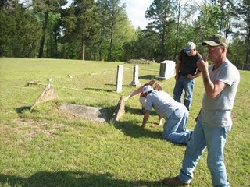

In this cemetery is the unmarked grave of my generation's third great grandmother, Elizabeth Holliman, wife of Cornelius. They led their family by horse and wagon in 1836 from Lancaster County, South Carolina near the North Carolina line through George to west Alabama. Here on recently released Indian land, the family purchased land and began farming. Two brothers, Warren and Charles Holliman, made the trek also, although Warren moved on in a few years to Arkansas to put down roots and establish the Holliman name there. In the photo below, 91 year old H. Bishop Holliman, who visited Fayette County for the first time in the 1920s (He was born in Irondale, Alabama in the 1919) explores the cemetery.
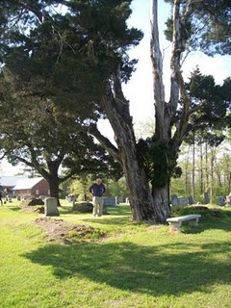

Several earthen and rock slab grave sites dot the Spring Hill Cemetery. In one of these resting places, may be the remains of Elizabeth Holliman, pioneer Mother and Grandmother
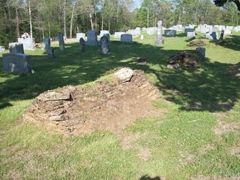

Next post, we return to study earlier Hollimans in both Colonial Virginia and North Carolina....
Plan now to attend the Holliman and Associated Families Genealogical Round Table at the Fayette County, Alabama Civic Center, 10 am to 3 pm, Saturday, October 15, 2011. For information and reservations for lunch, contact Glenda Norris at gnorris@bcbsal.org or Glenn Holliman at Glennhistory@gmail.com. Sessions to include Tracing the Holymans from England to Alabama, Holliman Farm Sites in Fayette County and sharing of information on Associated Families. All invited!

MONDAY, MAY 2, 2011

The Hollimans of Alabama
by Glenn N. Holliman
Back to the 19th Century...A Series of Articles on the Hollimans and Related Families of Fayette County, Alabama
We continue our series of the April 9, 2011 tour of Holliman sites in Fayette County, Alabama led by Glenda Norris, descendant ofChristopher Holyman, Sr (1618 - 1691).
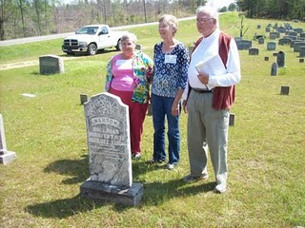
Above at the Chapel Hill Cemetery near Newtonville, Alabama are from left to right: Faye Gardner (Reform, Alabama), Jeanette Holiman Stewart (Austin, Texas) and Lenwood Holliman (Gordo, Alabama). In this April 9, 2011 photograph, they stand behind the grave of Civil War veteran Warren Holliman (1833 - 1908), a son of Charles Holliman (1795 - 1852), of whom the three are descended. Warren is misspelled Warron on his tombstone.
Warren Holliman's story...
In 1836, numerous children accompanied the three brothers, Cornelius, Charles and Warren Holliman, on their journey from the North Carolina/South Carolina border to Fayette County. One of the children of Charles Holliman and wife, Barberry (sometimes Barbara) Walters, was their son, Warren, age 3 at the time.
According to U.S. Census records Fayette County had a population of over 3,000 in 1830, and would more than double in size to over 6,000 in 1840 as immigrates moved west to the yet untitled soil of Alabama.
Warren married Mary Polly Blakeney, the daughter of Thomas and Sarah Kemp (or Roberts?) Blakeney. Thomas (1800 - 1892) was a son of William Blakeney and a grandson of Capt. John Blekeney (1732 - 1832). The Blakeneys had migrated to Alabama from Chesterfield, South Carolina. Warren and Polly would have 11 children, 3 girls and 8 boys which helped entrench the Holliman name in the area.
Warren's generation came of age as the American Union dissolved and Civil War engulfed our ancestors. Warren and his two brothers, Cornelius and Elijah, and cousins (including my great grandfather, John Thomas Holliman) joined with other Fayette Countians in enlisting in the 41st Alabama Infantry Regiment. Warren was known as the 'strong man' of the county. He could pick up a bale of cotton (500 pounds) and walk with it!
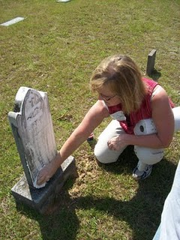
Glenda Norris uses a genealogical technique she learned from Rhodes Holliman, the application of shaving cream to faded tombstones, to reveal hidden names and dates. This is Warren Holliman's grave site.
In the next post, Warren Holliman's historic war service with the 41st Alabama Infantry Regiment....
Posted by Glenn N. Holliman at 1:25 AM 0 comments
Labels: Faye Gardner, Glenda Norris Jeanette Stewart, Lenwood Holliman,Warren Holliman

MONDAY, APRIL 25, 2011

The Hollimans of Alabama
by Glenn N. Holliman

Back to the 19th Century...A Series of Articles on the Hollimans and Related Families of Fayette County, Alabama
Below are observations by Holliman family historian, Glenda Norris. She credits much of her knowledge to Dr. Rhodes Holliman, her uncle. It was Rhodes who, as a boy in the 1930s, would hike several miles into the piney woods, dodging more than a few snakes to re-discover the location for the family. Several monuments now mark this spot.

Glenda Norris reports:
"Charles Daniel Lucas, Jr. was the son of Charles Daniel Lucas, Sr. and 'Dorcas' (no last name has been found). It is believed that the mother of Charles Daniel Lucas, Jr. could be a Catawba Indian from the Pee Dee River area in Marlboro County, South Carolina. She was only 13 years old when she married Charles Daniel Lucas, Sr., a tailor. Their son, Charles Jr., was born on June 30, 1771 and died May 31, 1853."

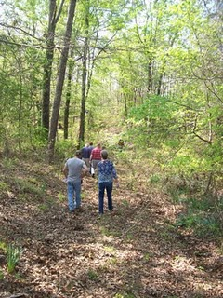
Above, on April 9, 2011, Holliman and Lucas descendants take the trail to the Lucas and Indian graves which are located several hundred yards through the woods off County Road 100 in south Fayette County.
"Charles Daniel Lucas, Jr. was a traveler and migrated from South Carolina to Alabama before the Holliman brothers. His first homestead was in Marengo County, Alabama where he purchased 80 acres on October 20, 1823 and then 80 more the next spring. Two years later, he established a homestead in Fayette County, and still ambitious, 40 acres on October 16, 1834 in Tuscaloosa County.
The Fayette and Tuscaloosa properties were connected, almost touching Highway 171 on its east side. He was a deacon at the Spring Hill Baptist Church in Tuscaloosa County. A monument at the church celebrates he and Cornelius Holliman, a son-in-law, as ‘founders’ of this church.
Charles Jr. earned his living 'stock dipping' and as a Federal Indian agent. Newtonville, Alabama straddled the line between the territory of the Chickasaw (north) and the Choctaw (south). By 1836, all these land claims were extinguished. In a dreadful and, even in that day, controversial act, most of the Native Americans remaining were removed to Indian Territory (present day Oklahoma).
With the dispersal of the tribes, the Federal government sold the land to immigrant families from the south east U.S. - the Hollimans, Lucases and other associated families.
Charles Lucas, Jr. claimed to be ‘black Dutch’, a term at the time to obscure one's possible Indian ancestry but this has not been proven, only speculated. He was a man of large stature (6’4” - 6’6”) and had great strength. It has been passed down through generations that Charles Daniel killed a panther with his bare hands.
His burial site is in southern Fayette County, Newtonville area off of County Road 100 (Walnut Lane). At one time this land belonged to Charles Jr. and his home was not far from the burial site. His grave is on a ridge line, over looking a ravine. The site is an Indian burial ground as he chose to be buried with his friends."
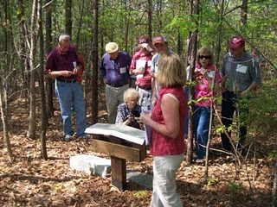
Glenda Norris, foreground, provides information at the internment site and memorials to Charles Daniel Lucas, Jr. The site contains numerous Choctaw or Chickasaw Indian burials, disturbed in an earlier century by grave robbers.
"Charles Daniel Jr. was married to Mary Hasten (in some places spelled Hastings). They had 10 children together. Family historians suggest that Charles Daniel ‘over disciplined’ one of his children with his cane. This did not go over very well with his family and because of his temper, his wife, Mary and the rest of his children left him and moved to the Bluff community. Due to this estrangement Mary Hasten Lucas was buried at the Spring Hill Cemetery, 20 or so miles north of this pioneer’s resting place."

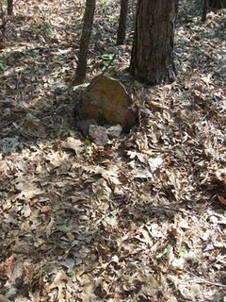
This original stone marker stands on the burial site of Charles Daniel Lucas, Jr., pioneer and Indian agent, who helped open Northwest Alabama to Anglo and African American settlement in the early 19th Century.
When Charles Daniel Lucas, Jr. was born, George III, was sovereign over the American colonies. When Charles Jr. died, Franklin Pierce had just become president of the United States, a union on the verge of dissolving."

For additional information on Charles Daniel Lucas, Jr., go to Archives and the February 13 and 26, 2010 editions of this blog. Rhodes Holliman incorporated his own research and that of his father, Cecil Holliman and the late Walt Holliman to create some excellent articles that are available for all to read. Some of the general information for these postings comes also from Robert Scott Davis's book, "Tracing your Alabama Past" (University of Mississippi Press, 2003).

More soon on the Holliman migrations across the Southern United States from the 17th to the 19th Centuries....Information and your written insights always welcome as we share together.
Posted by Glenn N. Holliman at 7:25 AM 0 comments
Labels: Charles Daniel Lucas, Glenda Norris, Mary Hasten Lucas
Newer PostsOlder PostsHome
Subscribe to: Posts (Atom)

