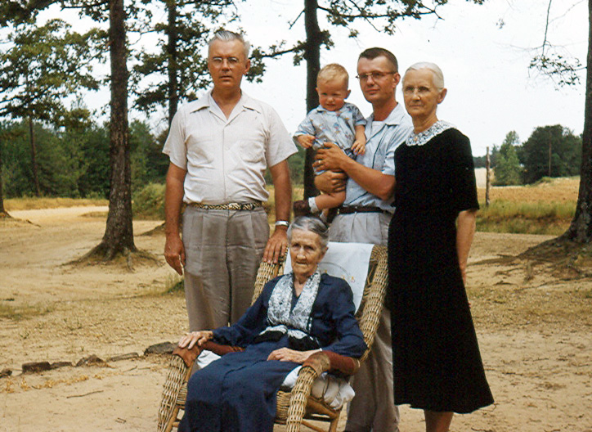

Five living generations involving Hollimans, Bakers and Blakeneys:

Front yard of the homesite of Eura Carter and Mae Baker Carter, northern Tuscaloosa County on Rt. 171, 1955.

Infant: Cecil James Holliman, now 54 years old: Cecil James Holliman, M.D.

Father: Rhodes Burns Holliman, Ph.D., M.D., now 80 years old.

Grandfather: Cecil Rhodes Holliman, Esq., died in 1983.

Great Grandmother: Elizabeth Anne Baker Holliman, died in 1975.

Great - Great Grandmother: Belzy Ann Blakeney Baker, died in 1960 at age 101.

FYI

