http://www.wopi.com/history.html

My Aunt Louise's Greatest Adventure, Part 1
by Glenn N. Holliman
Louise Stansbery Sherwood (1915-2006) lived a long and gentle life as a housewife in Knoxville, Tennessee. She is a maternal aunt of mine, she the grand daughter of G.W. (1847 - 1927) and Frances Wilson Osborne (1851-1940). In 1919, she attended as a child of four the Wilson Reunion held on the farm where her great grandfather, Isaac Wilson, had been killed just 55 years earlier.
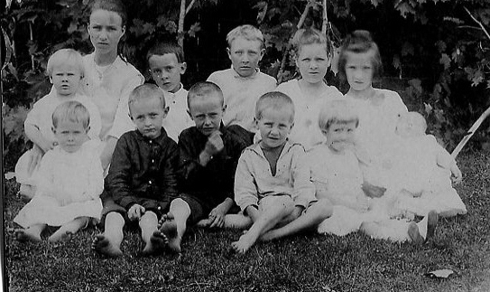 Louise is on the front row, far right while an older cousin holds her brother, Charles Stansbery, Jr.
Louise, the daughter of Charles S. and Mayme Torrence Osborne Stansbery, although born in Afton, Tennessee grew up in Bristol, Tennessee, a mountain or two east of her parents' roots in Ashe and Watauga Counties, North Carolina. Her parents separated in 1930, and she went to work immediately after high school graduation in the depths of the Great Depression in 1933. Her jobs were retail clerk at Kresse's and waitress at King's Department Store. Times were very hard for the family, and her small pay check kept her mother, sister and brother in groceries.
Then in January 1935, her life accelerated. She had been blessed with good looks and a winning personality. She was conjoled (I am sure) into the Miss Bristol, Tennessee beauty pageant, and she won! There was a preliminary contest on January 23, 1935 and then the finals on January 29.
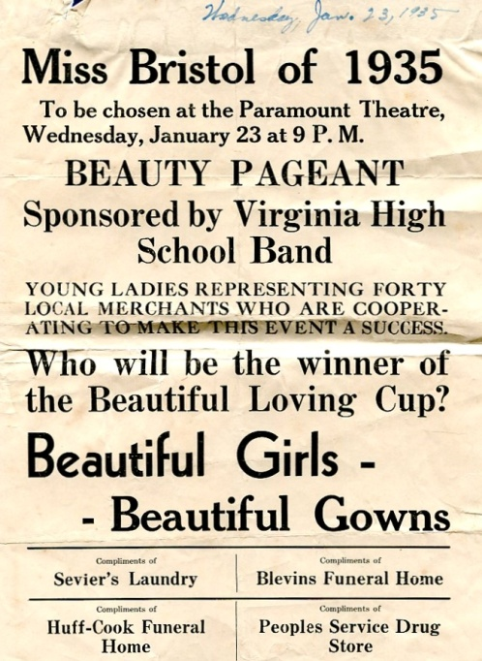
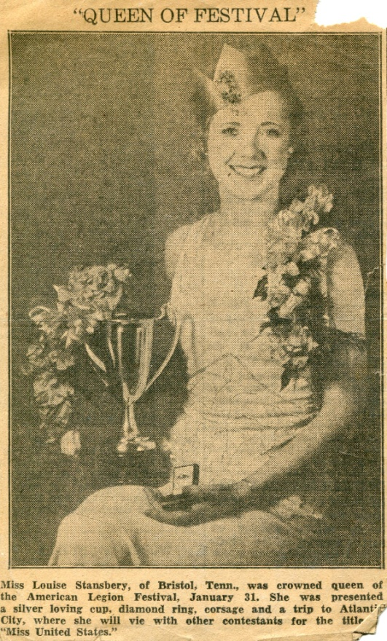
The newspaper clipping of the time states she would vie for Miss United States at Atlantic City. The family has no oral history or memorabilia of such as contest, but she did attract the attention of the local radio station, WOPI. Founded by W.A. Wilson, the station went on the air in 1929, the first air castle between Roanoke, Virginia and Knoxville, Tennessee. Wilson was a promoter; WOPI stood for 'Watch Our Popularity Grow'.

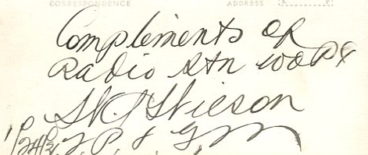
With radio in its infancy, local station owners branded together in the International Radio Club, a trade organization run by one Jack Rice, an entrepreneur of his day. The purpose of the 'club' was to promote radio and the sharing of ideas. There was an annual convention and in December 1935, that convention was held in Havana, Cuba. Jack Rice, an aggressive promoter, dreamed up the idea of a beauty pageant for the IRC as a way to attract attention and capture some publicity. When all said and done, 24 local broadcasters (there were about 65 members that year) tapped local 'pageant queens' and paid their expenses to Havana. For Bristol, Tennessee, it was the small town dime store clerk, my Aunt Louise, and she embarked on the great adventure of your young and sheltered life to date!
