A Visit with Fred Cooper of Bristol, England - a Hollyman Family Researcher Extraordinaire by Glenn N. Holliman, USA, with editing by Bob Hollyman-Mawson, Wales, UK
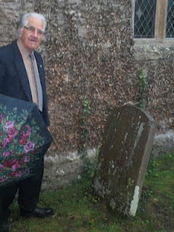
As I have written on more than one occasion, meeting and visiting with cousins, near and far, is one of the delights of family history. Thanks to the generous introduction by Bob Hollyman-Mawson, an English cousin who lives in Wales, my wife and I enjoyed a November 2011 day touring with Fred Cooper, a retired engineer, living in Bristol, England.

Although the showers flowed from the heavens during much of our expedition, we all three enjoyed a pub lunch and looked upon the many monuments of Hollymans who had lived before us.

Above, in 2011, Fred Cooper with an ubiquitous British umbrella led us on a fascinating tour of various cemeteries and parish churches where his wife's ancestors, Hollymans, are resting. This photo was taken at the parish church in Abbots Leigh on a hill overlooking the Gordano Valley.

Fred's late beloved wife, Sheila Wallace Cooper, is a Hollyman, descended through her mother, Caroline Hollyman Wallace, late of Abbots Leigh, a small farming community south of Bristol, Somerset, England.

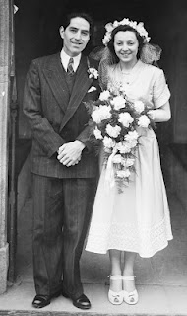
Fred and Sheila on their wedding day in the 1952. It proved to be a most happy marriage producing two sons. Sheila's grandfather was Alfred William Hollyman and great grandfather, John Hollyman. All were farmers living in the community of Abbots Leigh in Somerset.

Since the early 1600s, families of Hollymans have lived in other Somerset villages such as Kenn, Clevedon and Clapton overlooking and in a picturesque valley known as Gordano. Today the busy M-5 runs through the lush green valley south to Devon.

In the 1800s, part of the family crossed the Severn Estuary, and settled in Wales, ancestors of Peter Hollyman of Pwllheli, whose story and pictures were displayed in an early blog article. (Go to the Archives feature of this blog and type in Peter's name to refresh one's memory.)

Below the map helps our understanding of places. X marks the location of Abbots Leigh, just west of Bristol, England. Further west and south is Clevedon (underlined), where another major Hollyman branch settled and thrived. The body of water bordering Clevedon is the Severn Estuary which divides England from Wales. Note the major motorway, the M5 running north and south through the Gordano Valley.
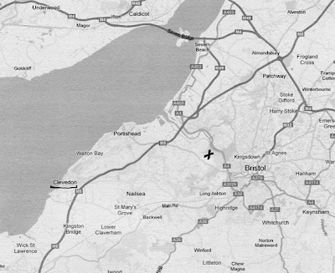

Next post we continue to explore Hollyman sites in Somerset....

