Continuing our tour of Shirley Sorrell's Family Album....
Our continued thanks to cousin Shirley Sorrell for sharing this magnificent collection of Wilson family photographs of the descendants of Isaac (1822-1864) and Caroline Greer Wilson (1828-1911). These families lived along the North Fork of the New River in Ashe County, North Carolina.

While limited agricultural land meant that some children of prolific parents such as Wilson descendants had to move west, others remained to engage in age-old subsistence farming. These turn of the 20th Century photographs capture the last generation of an agricultural era now gone.

Edgar Osborne and Conley Wilson, ca 1907. Edgar, born 1893, the son of Walter Raleigh and Effie Lewis Osborne, was one of the many who migrated to Oregon.
Conley, a son of John and Rebecca Wilson Wilson, elected to stay in North Carolina
and farmed until his death in 1957.

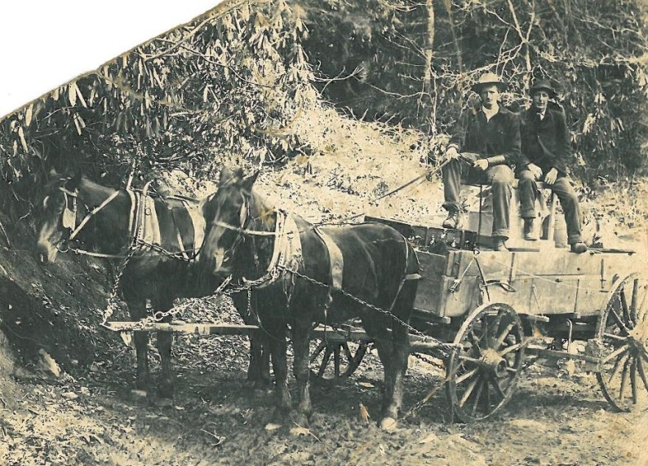

"Prior to 1872, all plows hoes, shovels and other implements used in Ashe County were homemade from iron ore taken from the mines of Ashe and forged in Ashe County forges." - P. 208, Ashe County, a History by Arthur Lloyd Fletcher, McFarland Publishers, Jefferson County, North Carolina, 1963 (reprinted 2006).
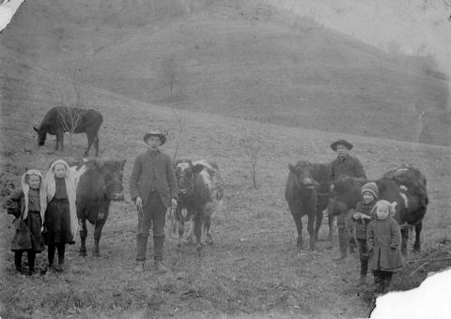
Above, 1907 ca Sutherland, NC Callie, Minnie, John, Don, Preston and Ruth Wilson. John Wilson (1855-1928) and his wife, Rebecca Wilson Wilson (1862-1954), were the parents of ten children who grew to maturity.

"The cutting and shocking of corn was first practiced in 1882...Commercial fertilizer was not used prior to 1891. There were no facilities for soil testing in thos days and Ashe county farmers saw no need for it." - Fletcher, p. 208

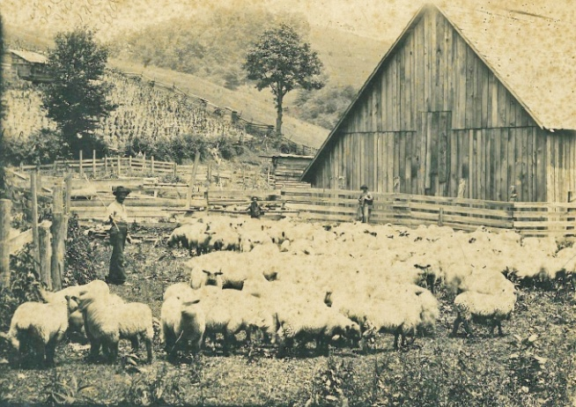
Above and below, Bob and Ellen Wilson's farm in Sutherland, North Carolina

"In 1925, it took 10 to 15 acres of corn to feed a team of horse. By 1963, less than one acre of corn will feed a team of horse for a year." - Fletcher, p. 213
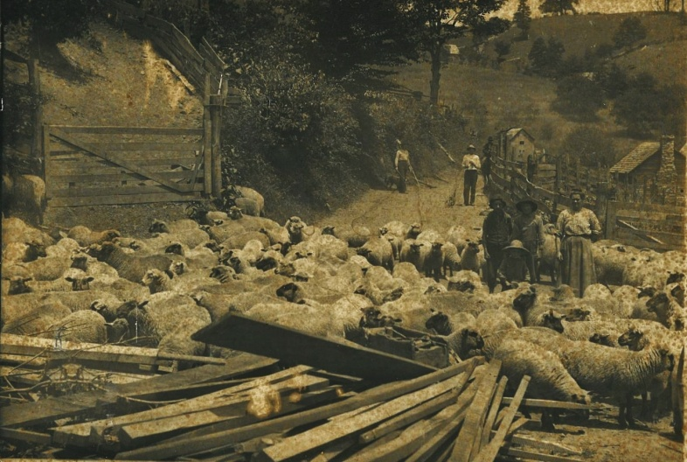
"One man, plus the proper machines, could do the work formerly done by ten men or more. There was no farm work waiting for the boys finishing high school...." Fletcher, p. 216

"The exodus from American farms marked the end of self-sufficiency and an uprooting of families from their heritage. In 1900 40% of the U.S. work force was in agriculture. Today the number is about 2%" - Atlantic Monthly, June 2013

